**Software Installation Steps**

1-Copy this word file to the virtual machine in home/Lucene open it from there

2- Copy the file javaInst.sh in this folder too

3- Now we are installing Java JDK and set the JAVA_HOME

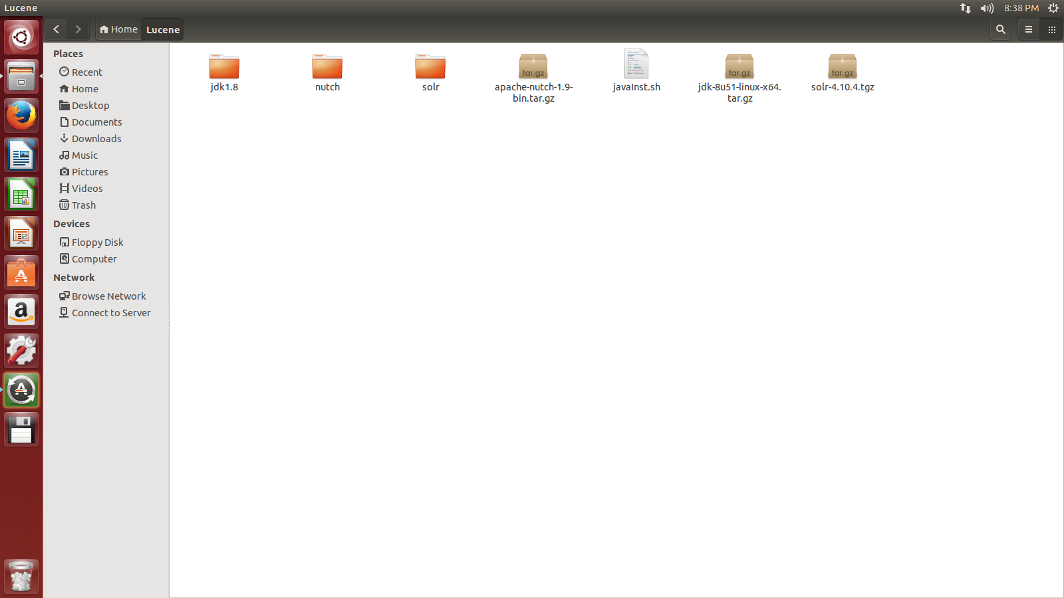

**Step 1:** press ctrl + alt + t opens a new terminal (black screen)

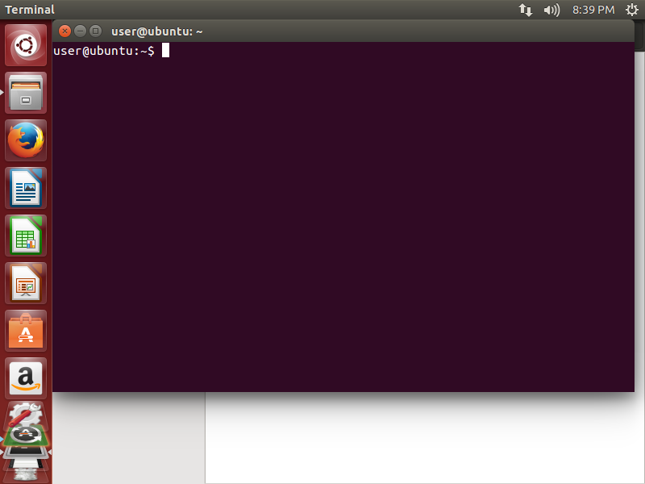

**Step 2:** paste the following line in the terminal

**sudo bash Lucene/javaInst.sh**

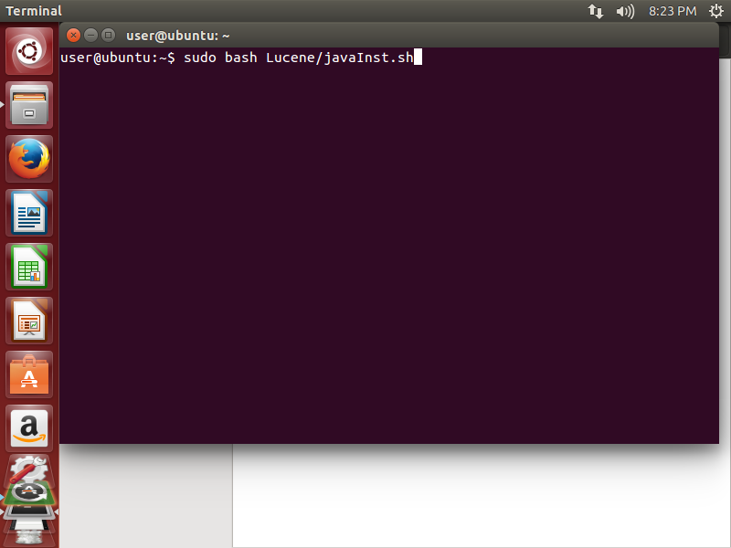

This window will appear

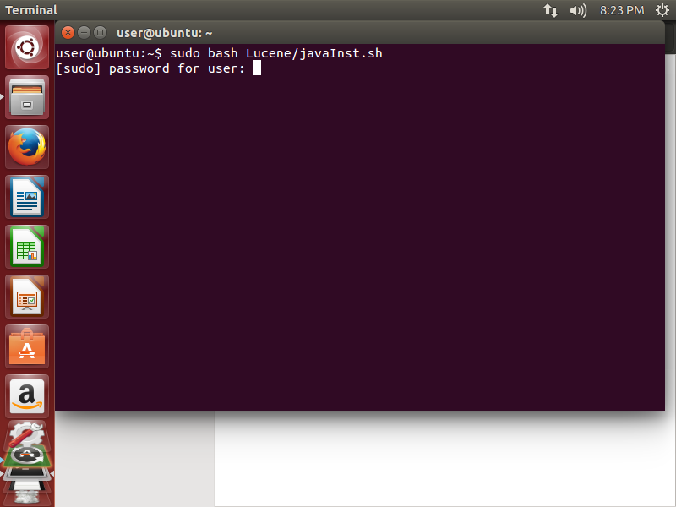

**Step 3:** Enter the password 123 press Enter

This window will appear

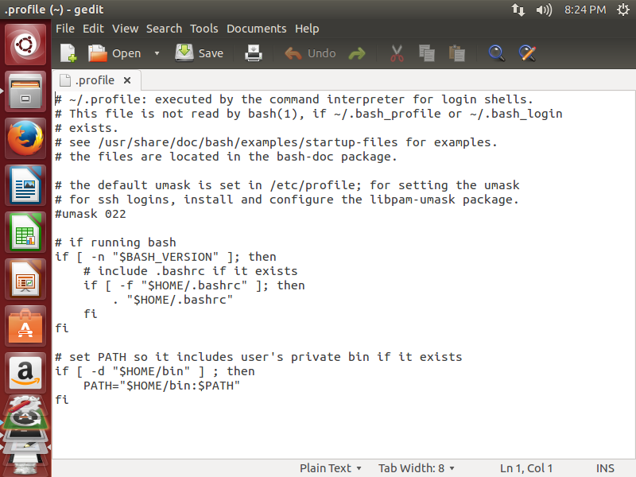

**Step 4:**

Press ctrl + end to go to the last line in the file shown above

Press enter to create a new line

Paste this :

**JAVA_HOME=/usr/lib/jvm/jdk1.8**

**export JAVA_HOME**

**PATH=$PATH:$JAVA_HOME**

**export PATH**

save and close

you will see something like this in the terminal

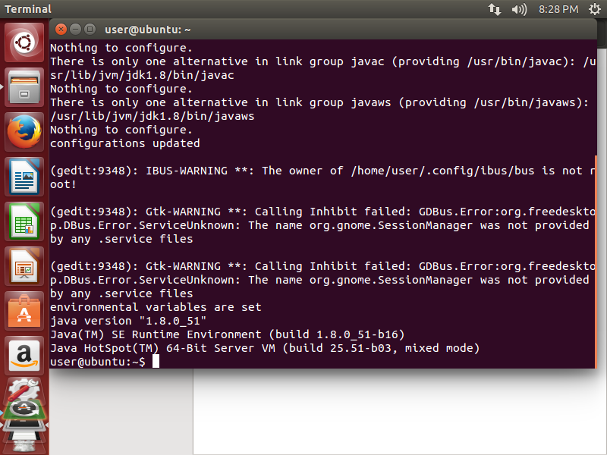

Check to see that the last two lines, you must see the same in urs

Paste this

source ~/.profile

press enter

paste this

echo $JAVA_HOME

you must this

