System Analysis

System analysis a problem solving- technique and also be the analysis of the role of a proposed system and the identification of the requirements that it should meet, where it is a detailed study of various operations performed by a system and their relationships within and outside the system .

The goal of the analysis phase is to truly understand the requirements of the new system and develop a system that addresses them or decide a new system isn’t needed[1].

"The analysis phase answers the questions of who will use the system, what the system will do, and where and when it will be used"[ 2].

We choose the follow structure development approach. After we are worked a preliminary investigation in the previous phase and determined the rules and objectives we will analysis the system by collecting data using information gathering techniques such questionnaire identify user requirements and then study the operations performed by the system through the charts (use case - DFD) .

Stakeholders: 4.1

"The Stakeholders define the human society that has some effect on the success or otherwise of the project"[3].

Stakeholders in our project :
1-Family Members
2-Guests
3-Administration

4.2 Gathering Information:
Information gathering (Fact-finding ) is techniques to gather information about
system problem , discover and analyze information system requirements. Information gathering define system requirements and differentiate between functional and nonfunctional requirements[3].

4.2.1 interview :

Interview is a dialogue between an interviewer and a respondent who may be one or more than one. Interview conducted on TV, telephone , newspaper or radio. The interview typically reads a series of questions from a questionnaire prepared for this
purpose and records the response of the respondent.

4.2.2 Questionnaire:

A questionnaire is a research instrument in specified form consisting of a series of questions designed for the purpose of gathering information from respondent for the study and statistical analysis of the responses.

The questionnaires sample in (Appendix A) and the statistical result from the questionnaire in (Appendix B).

4.2.3 Observation:

The act of watching something attentively by using the senses to obtain information , and record or notation of the act ,it can be human or mechanical.

4.3 Requirements Specification:

The main objective of family gathering is to share the features like photo and video also the member of family know the last news about the family.

4.3.1 Functional requirements for Family project:

Few of functional requirements of this new proposed system are as under.

1. First of all there can be three levels of access we can gibe to members of this web site like Normal , Guest and Administrator .
2. Members which will have Normal level of access they can view anything on the site and add anything but can only edit or delete items they have added themselves, This is recommended status for most family members.
3. Guest Members can view the site but they cannot add, edit or delete anything .
This might be for friends or people to whom we want to show out wed site, but do not want to them to be able to add or change the contents of the web site.
4. Administrator can do anything on the site like add, edit, delete any item. He will be the only one member who can edit, delete or block the status of other members.
5. Member with normal access first of all they have to register with the web site by providing their personal information.
6. After registration members will be able to participate in the following sections.

- News
- Calendar
- Photo Galleries
- Share Recipes
- Address Book
- Email

4.3.2 Non-Functional Requirements:
non-functional requirement specifies how the system should behave:
"A non-functional requirement is a statement of how a system must behave, it is a constraint upon the systems behavior"[9].

The non-functional in our system is high security ,easy to use , maintain privacy, high storage capacity , less time and cost.

4.4 Process Modeling:

"Process modeling is a way to graphically represent the system under study as processes that capture, manipulate, store and distribute data between a system and its environment and among system components" [4].

There are many techniques that can be used for modeling process so we are talking in some of these process.

4.4.1 Use Case Diagram:

"A use case shows how users interact with the system and how the system will responds to our users’ actions. The use case considers the actors, goals of the actors, and interactions of the users and the system. It begins with a user’s goal and ends when that goal has been completed. Throughout, the steps users take and the way the system or website responds are noted for usability research purpose "[5].

Figure 4.1 use case representation.
use case
System
Actor
System Boundary

The use case of the proposed system is shown in figure 4.2 .

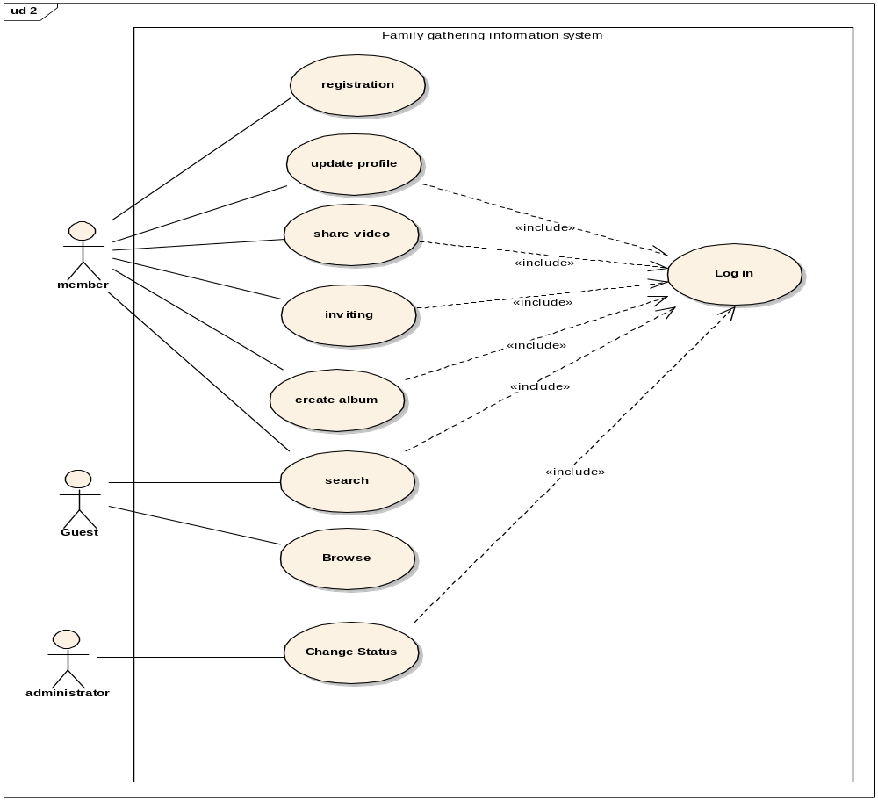

Figure 4.2 Family Gathering Use Case Diagram.

4.4.2 System Analysis Use Case:

We are describe the use cases.
Login use case:

Brief Description

The login use case enables member to login in the website.

Step-by-step Description

- The Member open site.
- Then enter his name and Password, in the space provided on the site.
- And pressed on the button login.
- Then enter into the Site.

Possible Alternatives
1. The member enters his name or password incorrectly.

Register use case:

Brief Description

The Register use case enables user to register in the website.

Step-by-step Description

- The user open site.
- Then selects registration.
- The user enters his/her name and password and the private email.
- Then fills personal information is optional.
- Then finally pressed the button registration.
- All information’s for the members is stored in a database for this site.

Create use case:

Brief Description

The create use case enables user to create for any features that he/she wants .

Step-by-step Description

- See login use case.
- The member select create.
- Then chose any thing from features that exist in the website.
- The member make for himself feature, for example create album.
- Finally the member pressed on the button save.

Share use case description:

Brief Description

The share use case enables user to share any features that he/she wants .

Step-by-step Description

- See login use case.
- Enter the member of any features for him.
- Then show him from a set of choices is the share.
- Then select the members who want to share with them.
- Finally the member pressed on the button share and thereby participates.

Inviting use case description:

Brief Description

The inviting use case enables user to invite any member in the website.

Step-by-step Description

1. See login use case.
2. Then show him from a set of choices is the inviting.
3. The member selects the inviting.
4. Then it will show all e- mails in the address book.
5. Member chooses people who will invite them.
6. Then member send a letter inviting for the persons invited.

Search use case description:

Brief Description

The Search use case enables user to search any member in the website.

Step-by-step Description

- The guest enter site or member login (see login use case).
- Choose the search for member.
- Enter the name of the person or e-mail who wants to search for him.
- Then show him the person who is searching.

Possible Alternatives
1.The result of the search is not found the person who is searching.

Change status use case description:

Brief Description

The change status use case enables admin to change any process operating
within the site.

Step-by-step Description
- See login use case.
2. The admin monitored site and Sure that the updates work correctly in the site.
3. And working to correct the errors and problems within the site.

Update use case description :

Brief Description

The Update use case enables member to update data in the personal file.

Step-by-step Description

- See login use case.
- The member selects update to modify and change any information in
the personal file.
- When the member is finish, then save the changes.

Brows Use case description:

Brief Description:

The Brows use case enables guest brows the site.

Step-by-Step Description :
1. Guest enter site.
2. The site is opened.
3. Guest brows the site and member profile .

4.4.3 Data flow diagrams:
"A process model used to depict the flow of data through a system and the work or processing performed by the system "[7].

Context diagram is the highest level DFD.

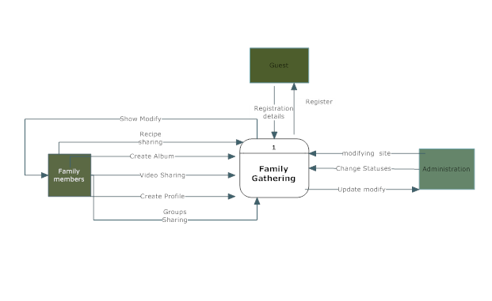

Figure 4.3: Family Gathering Context Diagram.

We are represent every use case in separate DFD shown below .

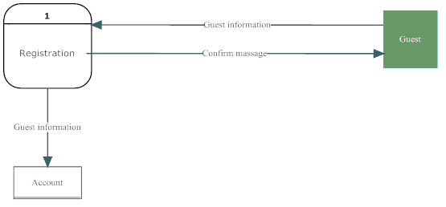
Figure4.4 Family gathering Data Flow Diagram__ Register use case

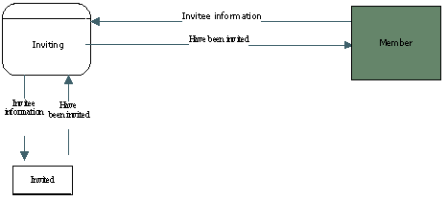

Figure4.5 Family gathering Data Flow Diagram__ Inviting use case

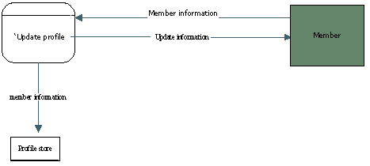

Figure4.6 Family gathering Data Flow Diagram__ Update profile use case

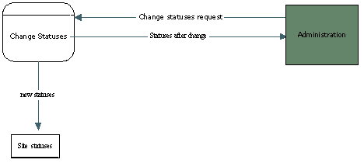

Figure4.7 Family gathering Data Flow Diagram__ Change Status use case

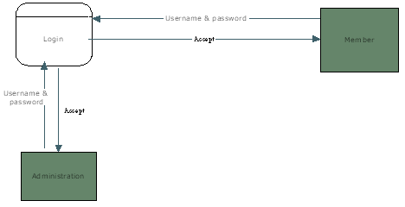

Figure4.8 Family gathering Data Flow Diagram__ Login use case

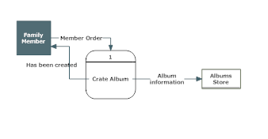

Figure4.9 Family gathering Data Flow Diagram__ Create Album use case

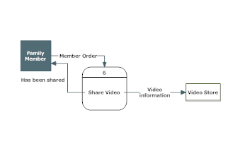

Figure4.10 Family gathering Data Flow Diagram__ Share Video use case

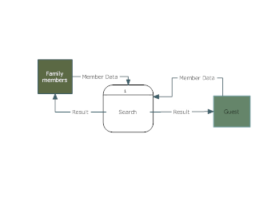

Figure4.11 Family gathering Data Flow Diagram__ Search use case

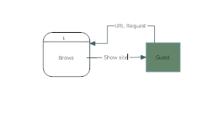

Figure4.12 Family gathering Data Flow Diagram__ Brows use case

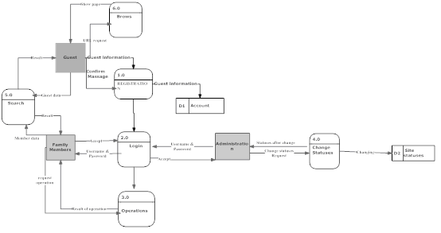
Figure 4.13 Family Gathering DFD level-0

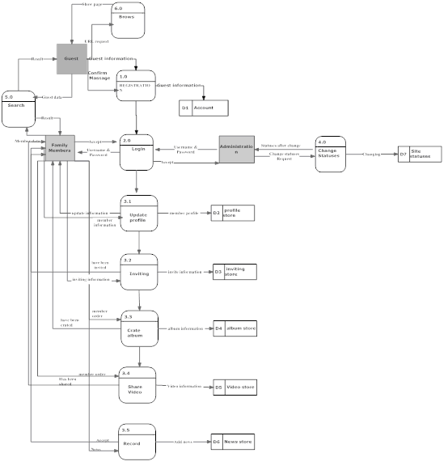

Figure 4.14 Family Gathering DFD level-1 .

4.5 Data Modeling:
" A data model describes the data that support the processes in an organization .During the analysis phase the data modeling present the logical organization of data without indicating how data are store ,created so that analysis can focus on the without being distracted by technical details"[2].

Data dictionary: 4.5.1

Table 4.1 : member
constrain | size | Data type | description | attribute
ــ | 3-15 char | text | member First name | f_mame
ــ | 3-15 char | text | Member middle name | m_name
ــ | 3-15 char | text | Member last name | l_name
ــ | 3-30 char | text | Email of the member | Email
ــ | 8 digit | number | Private number for access | password
PK | 8 digit | number | Unique number for every member | ID
ــ | 12 digit | number | Number of member mobile | Mobil_no
ــ | 3-15 char | text | Name use in access | User name
ــ | 3-15 char | text | Either block or activ | Status

Table 4.2: family member
constrain | size | Data type | description | attribute
ــ | 3-15 char | text | Family name | F_mame
ــ | 3-15 char | text | Family member name | F_M_name
FK | 3-30 char | text | Email of the member | Email
ــ | 3-15 char | text | Relation between Family member and member | relation
ــ |  | text | Either man or women | sex
FK | 8 digit | number | Number of member | Member_ID

Table 4.3 : family_news
constrain | size | Data type | description | attribute
ــ | 3-30 char | text | Topic of the news | News_topic
PK | 4 digit | number | Unique Number of the news | News_ID
ــ | 10 char | date | date of the news | News_date
ــ | 3-50 char | text | What is the news | Description

Table 4.5 : photo_gallery
constrain | size | Data type | description | attribute
PK | 4 digit | number | Unique Number of the gallery | Photo_ID
ــ | 3-15 char | text | Name of the image | Image_name
ــ | 4 digit | number | Unique Number of the image | Image_ID
FK | 8 digit | number | Number of member | Member_ID

Table 4.6: address book
constrain | size | Data type | description | attribute
PK | 4 digit | number | Unique Number of the book | Book_ID
ــ | 3-15 char | text | Family member First name | F_name
ــ | 3-15 char | text | Family Member middle name | M_name
ــ | 3-15 char | text | Family Member last name | L_name
ــ | 3-15 char | text | City of Family Member | City
ــ | 3-15 char | text | street of Family Member | street
ــ | 3-15 char | text | state of Family Member | state
ــ | 8 digit | number | Z.P of Family Member | Z.P
ــ | 3-30 char | text | email of Family Member | email
ــ | 10 digit | number | phone of Family Member | Phone_no
FK | 8 digit | number | Number of member | Member_ID

Table 4.7 : invite
constrain | size | Data type | description | attribute
ــ | 10 char | date | Date of transmission | date
ــ | 3-30 char | text | Email of the receiver | Email
ــ | 3-15 char | text | Subject of the invite | Subject
FK | 8 digit | number | Number of member | Memder_ID
FK | 3-15 char | text | Family member name | F_M_Name

4.5.2 ER Diagram:

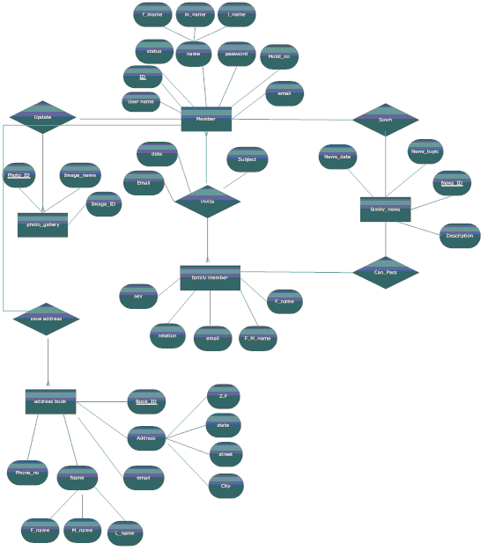

References

http://media.wiley.com[1] URL:
[Last accessed April 11, 2008].

[2] Alan Dennis and Barbara Haley Wixom , Systems Analysis & Design, an applied approach. New York:Wiley,2002.

http://www.volere.co.uk/stakegoalsscope.htm[3] URL:
[Last accessed April 22, 2008].

[4]URL:
http://highered.mcgraw-hill.com/sites/007340294x/student_view0/chapter5/learning_objectives.html
[Last accessed April 3, 2008].

[5] Olayele Adelakun Ph.D,"ProcessModeling",Session4,
http://facweb.cs.depaul.edu/yele/Course/IS421/S4/session_4.htm
[Last accessed April 14, 2008].

http://usability.about.com/od/usabilitytesting/g/usecase.htm[6] URL:
[Last accessed April 3, 2008].

[7] Ian Sommerville,"SE7 Web" ,http://www.cs.st-andrews.ac.uk/~ifs/Books/ [Last accessed April 11, 2008].

[8] Jeffery L. Whitten, Lonnie D. Bentley and Kevin C. Dittman , Systems Analysis & Design Method, 6th ed . New York: McGraw Hill,2004.

http://usability.about.com/od/usabilitytesting/g/usecase.htmURL: [9]
[Last accessed April 11, 2008].

[10] URL:
http://www.lessons-from-history.com/Level%203/functional%20vs%20non-functional.html
[Last accessed April 20, 2008].

Appendix(A)

Questionnaire on The Family Gathering

Site social bridge between family members in different places , so this site can download an unlimited number of photos, videos and links for family members and so we can share our family pictures singled and video clips and also to know the latest news from the family of an individual marriage or the birth and Other News, which reduces cost and time.

Name:( optional)………………………………………………………………………………

1) Have you ever participate in a similar sites?
Yes No

2) Do you think that this site can play an important role for community?

Yes No

3) Do you face difficulties in communicating with your family with members?

Yes No
If the answer is yes, go to the next question, if not completed

4) Do you think that the site will reduce these difficulties?

Yes No

5) Do you think that this site helps to communicate in less costly and less time?

Yes No

6) Do you think that this site will preserve the privacy of the family?

Yes No

7) Are you looking for fun in this site?

Yes No

8) Do you think that registration is important before access to the site?

Yes No

9) Can the site replace other means of communication?

Yes No

10) Do you think that the site will increase communication links between family members?

Yes No

11) Do you think that the site would be acceptable in our society?

Yes No

12) Do you like the idea of this site?

Yes No

Appendix(B)

Questionnaire Statistics

1)Have you ever participate in a similar sites?
-Yes
-No
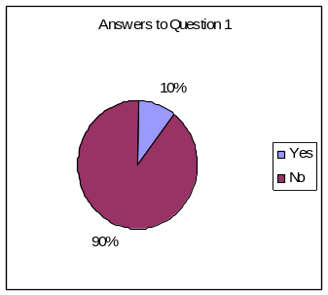

2)Do you think that this site the importance of community?
-Yes
-No
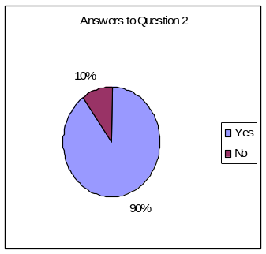

3)Do you face difficulties in communicating with your family when travel or Westernizing?
-Yes
-No
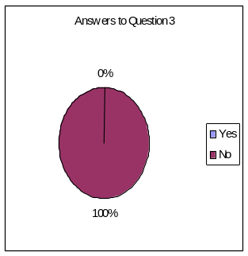
If the answer is yes, go to the next question, if NO not completed
4)Do you think that the site reduces these difficulties?
-Yes
-No
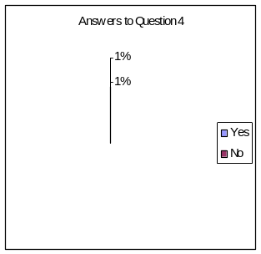
5)Do you think that this site helps to communicate in less costly and less time?
-Yes
-No

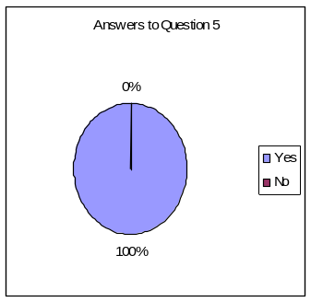

6)Do you think that the site preserves the privacy of the family?
-Yes
-No
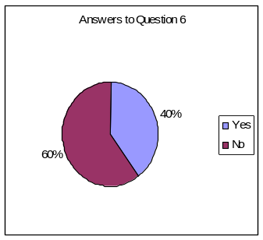

7)Do you find fun in this site?
-Yes
-No
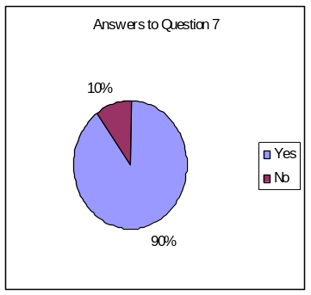

8)Do you think that registration is important before access to the site?
-Yes
-No
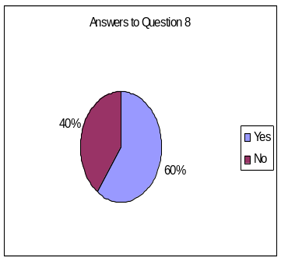
9)Can the site to replace other means of communication?
-Yes
-No
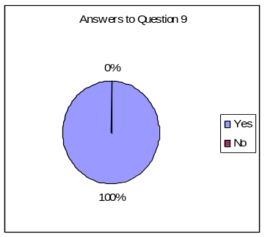

10)Do you think that the site will increase communication links between family members?
-Yes
-No

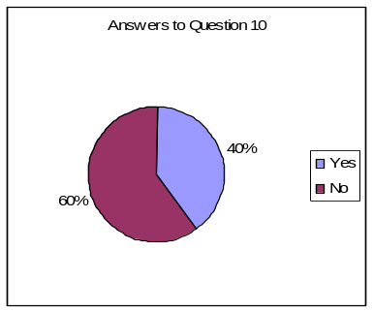

11)Do you think that the site would be acceptable in our society?
-Yes
-No
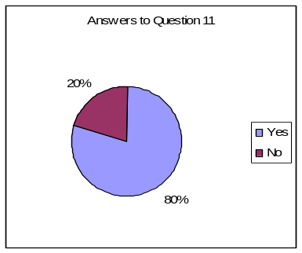

12)Do you like the idea of this site?
-Yes
-No
