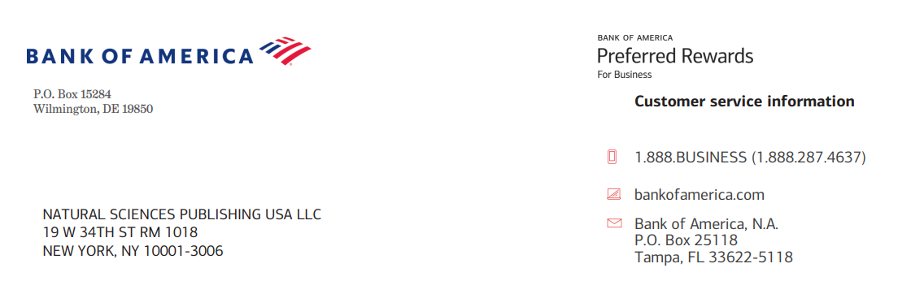
Invoice No. 062426
Publication Fees of Accepted Paper
Prog. Frac. Diff. Appl.
https://www.naturalspublishing.com/

Title: A Unified Transform Approach for Analyzing Fractional Differential Models with Diverse Fractional Operators

Authors: Mohd Khalid, SK Ashadul Rahaman, Salman Zaheer, Ausif Padder, Mohamed Hafez, Sudesh Nair Baskara, and Ali Akgul,

Ref. PFDA062426B  Deadline 7 July 2026 | Total Charge in US Dollars $2100.00  Discount 30%  Total Charge $1050.00.00

For payment, please use Bank transfer to:
Beneficiary Name | Natural Sciences Publishing USA
Bank Name | Bank of America
Bank Branch | 1293 Broadway, NYS-149-01-01, New York, 10001
NSP Address | 19 W 34th St. RM 1018, New York, NY 10001-3006
SWIFT Code | BOFAUS3N
Account Number | 483052729147
Wire routing number | 026009593
E-mail | nsp@naturalspublishing.com
Telephone | +1 (646)556-1606
