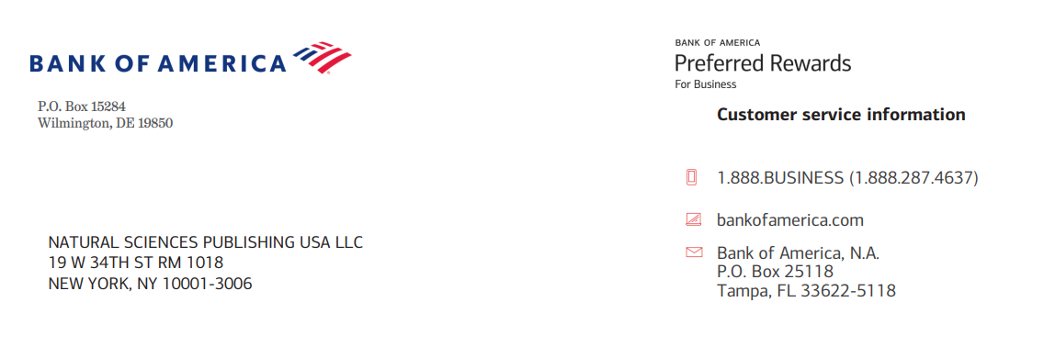
Invoice No. 027326
Publication Fees of Accepted Paper
Prog. Frac. Diff. Appl.
https://www.naturalspublishing.com/

Title: Fractional ordered Kinesiology Model Simulation for the Endurance of the Human Body Postures.

Authors : Aashima Bangia, Rashmi Bhardwaj, Asokan Vasudevan, Naeema Darwish Khamis Al Maashari, Yafang Yan, Khin Yadanar Htun.

Ref. PFDA027326A  Deadline 18 August 2026 | Total Charge in US Dollars $2100.00  Discount 30%  Total Charge $1050.00.00

For payment, please use Bank transfer to:
Beneficiary Name | Natural Sciences Publishing USA
Bank Name | Bank of America
Bank Branch | 1293 Broadway, NYS-149-01-01, New York, 10001
NSP Address | 19 W 34th St. RM 1018, New York, NY 10001-3006
SWIFT Code | BOFAUS3N
Account Number | 483052729147
Wire routing number | 026009593
E-mail | nsp@naturalspublishing.com
Telephone | +1 (646)556-1606
