Problem 5

# Summarizability Potential Problems:

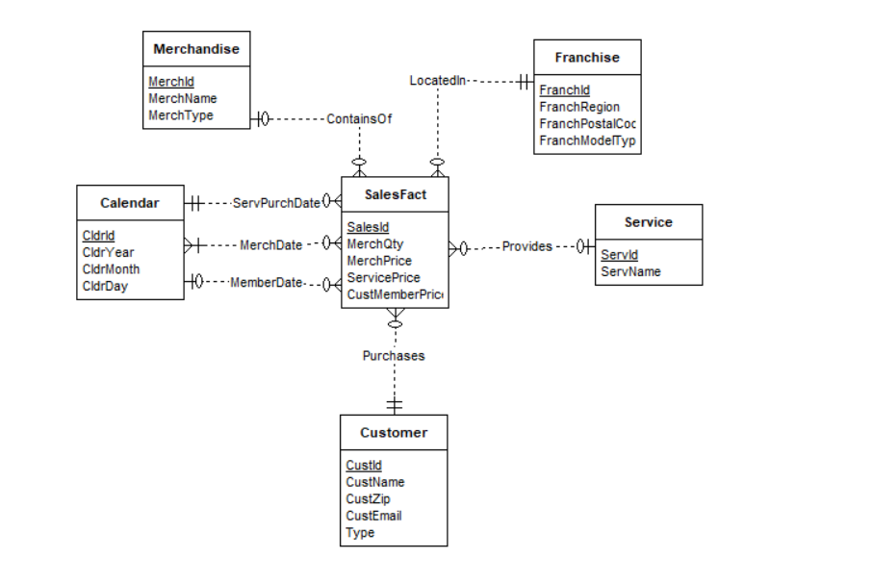

* Fact-Dimension incomplete 1-M relationships:
  + **ContainsOf** relationship between the **Merchandise** dimension and **SalesFact** fact table, it can be resolved by making a default value to the record with no merchandise.
  + **Provides** relationship between **Service** dimensionand **SalesFact** fact table, it can be resolved by making a default value to the record with no service.
  + **MemberDate** relationship between **Calendar** dimension and **SalesFact** fact table, it can be resolved by making a default value to the record with no service.
* Fact-Dimension non-strict M-N relationship:
  + **MerchDate** relationship between **Calendar** dimension and **SalesFact** fact table, it can be resolved by making the relationship strict, or making a second level for the relationship.