Question 3.2

# 3. Regional and Category Analysis Dashboard:

2) For the South region and its largest selling Category, analyze the different metrics available and determine some of the possible causes or problematic Subcategories that could be contributing to the region’s poor performance.

# Answer:

Poor profit for some sub categories

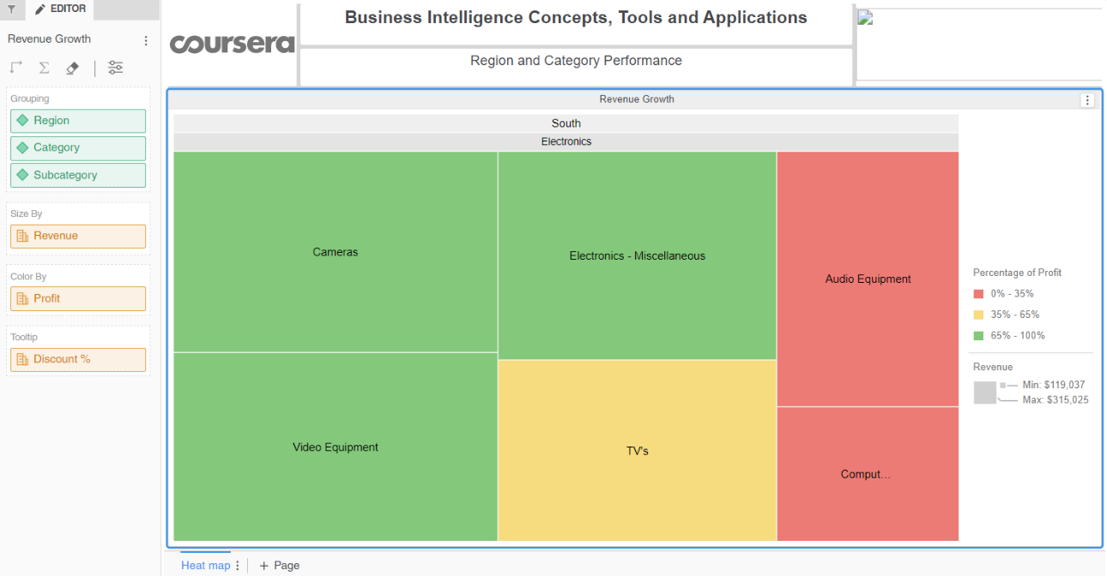

Poor revenue for some sub categories

