Question 4

1. **What is the emissions per capita of Canada?**

# Answer:

Emissions Per Capita for Canada: 17.72

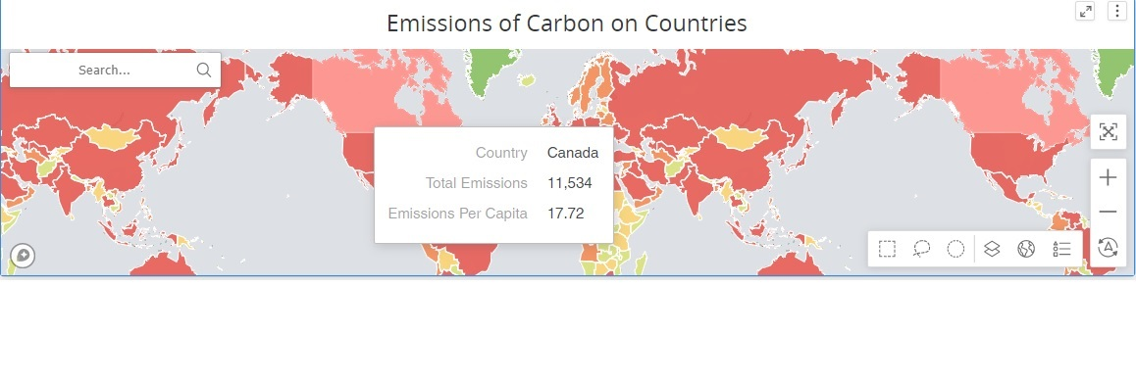

1. **What is the overall trend in worldwide emissions?**

# Answer:

Increasing

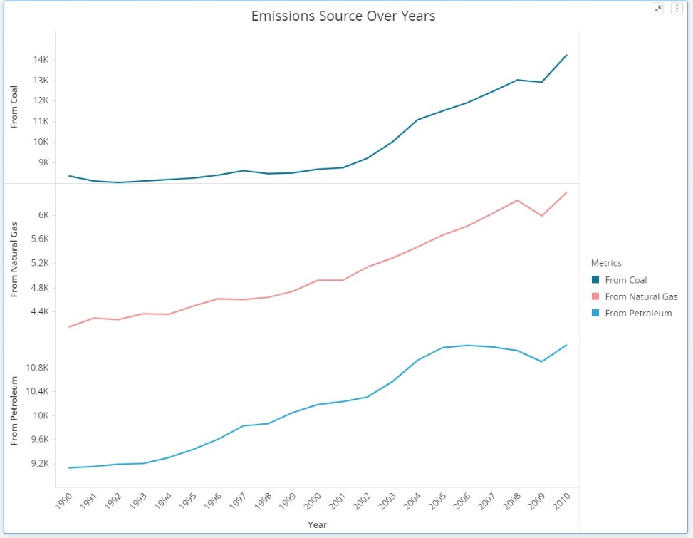

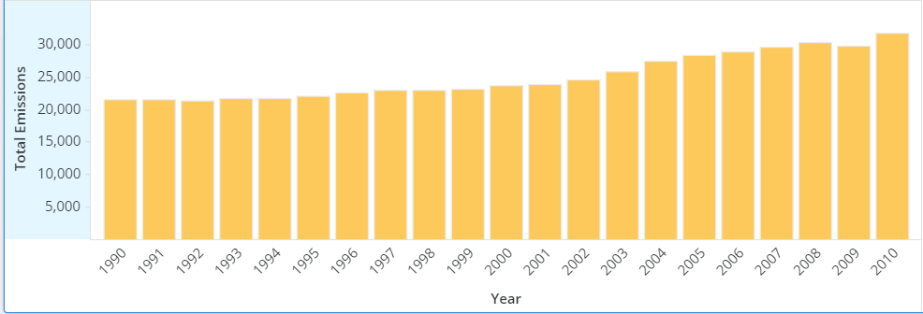

1. **Notice that overall emissions declined in 2009, the only year in the total number of years surveyed that indicates emissions decreases in all three emissions sources. Why is that? What broader socio-political context might explain this single yearly decrease?**

# Answer:

Because the impact of the recession on industrial production and overall energy use in United States and Canada. 