Project Summary

# Revenue & Order Performance Analysis for 3 Locations

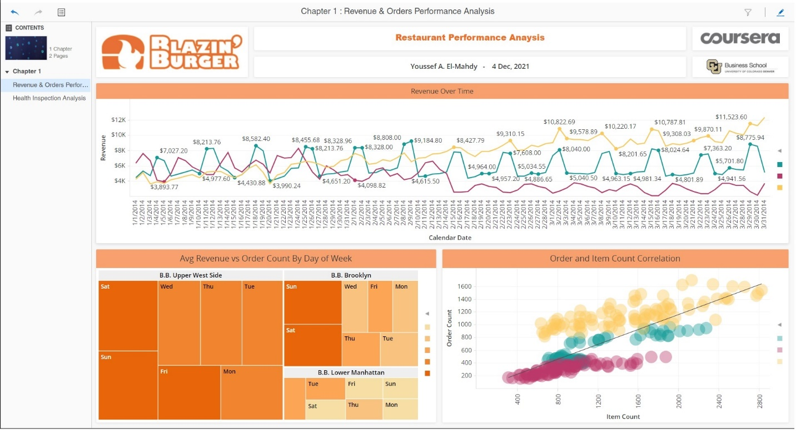

From the analysis we find that:

1. The restaurant location that has the worst performance is: B. B. Lower Manhattan.
2. It has the lowest revenue over time and lowest order count.

With more analysis and investigation for the Health Inspection Score for the 3 locations ..

# Health Inspection Analysis for the 3 Locations:

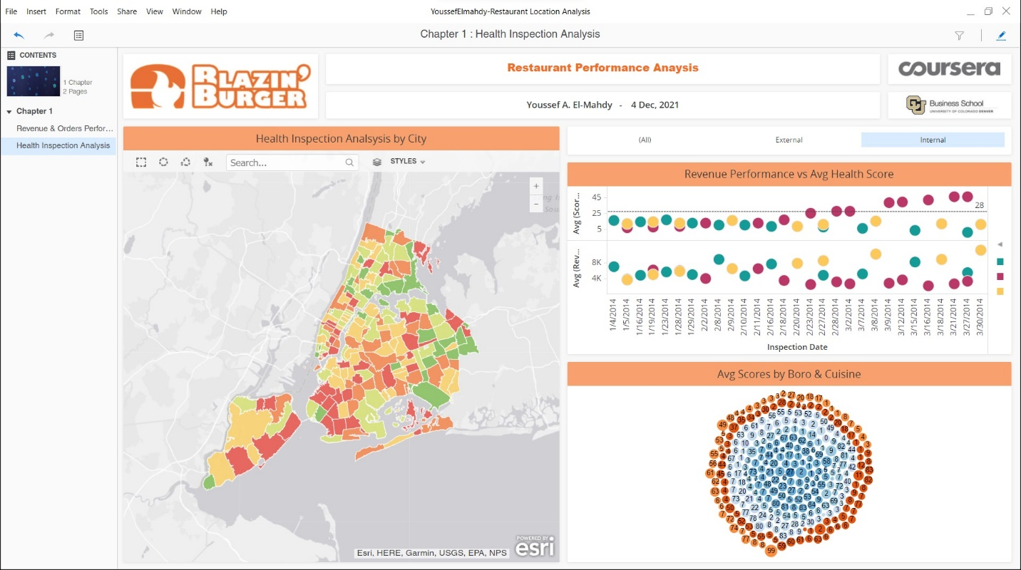

From the analysis we find that:

1. With more score for health inspection (which is bad) we found that the revenue is getting lower.
2. It means that the health inspection score is one of the factors for the bad performance of B. B. Lower Manhattan franchise.

With these datasets we can also make analysis for:

1. Revenue distributed over cities (or states).
2. Number of orders distributed over cities (or states)
3. Orders over time.
4. Grade over locations.