Arab Open University - Egypt

Faculty of Computer Studies
Computer Science Department
Zameel:
Student Housing Marketplace with
Lifestyle-Based Roommate Matching
Chapters 1 and 2
Hossam Adel Mohamed Mahmoud
Student ID: 23515018
TM471A: Final Year Project
Fall 2026/2027
Supervisor: Dr. Al Shaimaa Moustafa Moustafa

Table of Contents
Chapter 1 Introduction 1
1.1 Problem Definition 1
1.2 Significance of the Problem 1
1.3 Project Objectives 2
1.4 Scope of the Project 2
1.5 Project Methodology 3
1.5.1 System Use Cases 4
1.5.2 Student User Flow 5
1.5.3 Landlord User Flow 6
1.6 Structure of the Report 7
Chapter 2 Literature Review 8
2.1 Background 8
2.1.1 Student Housing and Location-Based Discovery 8
2.1.2 Lifestyle Matching and AI-Assisted Explanations 8
2.1.3 Secure Mobile and Cloud Services 9
2.2 Related Projects 10
2.2.1 Project 1: Student.com 10
2.2.2 Project 2: HousingAnywhere 10
2.2.3 Project 3: RoomSync 11
2.2.4 Comparison and Project Gap 11
2.3 Related Research 12
2.3.1 Amole: Residential Satisfaction in Student Housing 12
2.3.2 Sacerdote: Peer Effects Among College Roommates 13
2.3.3 Tintarev and Masthoff: Recommendation Explanations 13
2.3.4 Research Comparison and Implications 14
2.4 Summary 14
References 16

List of Figures
Figure 1-1 Iterative Development Methodology 3
Figure 1-2 High-Level Use-Case Diagram 4
Figure 1-3 Student User-Flow Diagram 5
Figure 1-4 Landlord User-Flow Diagram 6

Chapter 1 Introduction
Finding accommodation for university study involves more than locating an affordable room. Students also need to consider travelling distance, available beds, household rules and the habits of the people sharing their living space. Research on student housing shows the relevance of the residential environment to satisfaction (Amole, 2009). Zameel addresses this context through a mobile marketplace for students and landlords, initially focused on Egyptian university locations. The project proposal combines accommodation discovery and booking requests with AI-assisted explanations of roommate lifestyle compatibility (Mahmoud, 2026).

1.1 Problem Definition
The problem identified in the proposal is the fragmentation of accommodation information across social media posts, informal contacts and inconsistent listings. Students may need to contact several advertisers simply to establish the rent, precise location, available beds or household restrictions. Information about prospective roommates is even less structured: differences in sleep schedules, cleanliness expectations, noise tolerance or smoking preferences may remain unclear until students move in. These are the project's motivating problems, not findings from a completed local survey (Mahmoud, 2026).
Landlords face a related coordination problem when listing details and booking conversations are maintained separately. An enquiry does not necessarily indicate a reservation, and several students may request the same remaining bed. Zameel therefore aims to connect property information, explicit request states and optional lifestyle comparisons within one workflow, without implying that software alone can verify property quality or guarantee compatible roommates.

1.2 Significance of the Problem
For students, clearer information can support comparisons before spending time on unsuitable properties. Describing daily living preferences may also encourage discussion before a shared-housing decision. Sacerdote (2001) demonstrates that roommate peer environments can matter for academic and social outcomes, although this does not establish that a compatibility application improves those outcomes. For landlords, explicit availability and request records could reduce administrative ambiguity. The project's practical value is consequently better-informed coordination, rather than a promised reduction in conflict or rent. Academically, Zameel provides a setting for combining mobile software engineering, geospatial discovery, access control and explainable AI while examining the limits of automated recommendations.

1.3 Project Objectives
The aim is to develop a mobile application that helps students discover and request shared accommodation while understanding potential lifestyle agreements and conflicts. The five objectives follow the proposal (Mahmoud, 2026):
1. Develop student and landlord profiles with authentication, role-appropriate navigation and access permissions that protect users' records.
2. Allow landlords to create and maintain listings containing photographs, location, rent, amenities, house rules and bed capacity.
3. Enable students to discover and filter accommodation through maps, university-based location information and detailed property views.
4. Implement booking requests, landlord acceptance or rejection, reservation status and consistent available-bed tracking to reduce conflicting reservations.
5. Develop AI-assisted comparisons of stated lifestyle preferences that provide an estimated compatibility score, matching factors and potential conflicts, with clear explanations of their limitations.

1.4 Scope of the Project
The proposed system serves students seeking accommodation and landlords offering shared properties. Its scope includes profiles, optional lifestyle preferences, map-based discovery, listing management and a booking-request workflow. English and Arabic interfaces support the local context. The proposed AI component will use a model through a secure server-side function. Service credentials will remain outside the mobile application, and the project does not claim that a custom machine-learning model has been trained (Mahmoud, 2026).
The current prototype is narrower than this target. It includes authentication, onboarding, profile and lifestyle-preference handling, landlord listing management, university-centred discovery and student/landlord booking screens. Requests start as pending; acceptance and cancellation use server-side capacity rules. Listing-photo management, amenity/house-rule editing and model integration remain outside the completed user journeys. Earlier project notes describe rule-based matching; this report retains model-assisted matching as the proposal's intended extension, not as implemented functionality. Repository presence does not establish hosted or physical-device acceptance (Zameel, 2026).
Online payments, legally binding tenancy contracts, independent property inspections and guaranteed roommate outcomes are outside the initial scope. Authentication and university selection must not be presented as verified student enrolment. Compatibility estimates will support a student's decision, not replace consent, direct discussion or checks on the accommodation.

1.5 Project Methodology
An iterative development approach allows the project to establish a working foundation before adding higher-risk features. Figure 1-1 summarises the process; feedback may return development to an earlier stage.
1. Requirements and review: translate the proposal into student and landlord scenarios, examine related work, and define scope and acceptance conditions.
2. Design: organise screens, data relationships, request states and access rules, separating presentation, state management and data access.
3. Incremental development: build mobile features with separate presentation, state-management and data-access layers; extend the existing discovery foundation with booking and secure model integration.
4. Verification: use unit and widget tests, database checks and device testing to examine normal flows, invalid inputs, unauthorised access, capacity conflicts and service failures.
5. Evaluation and refinement: assess task completion and explanation clarity, compare AI output with an explicit preference baseline, and revise weaknesses. User evaluation and claims of improved outcomes require evidence still to be collected.
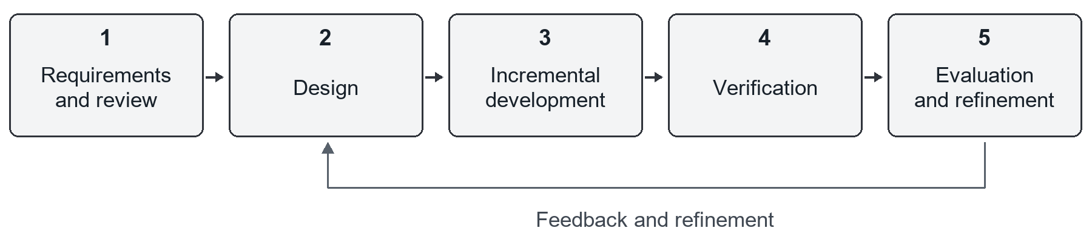
Figure 1-1 Iterative development methodology for Zameel (author's design).

1.5.1 System Use Cases
Figure 1-2 summarises the main student and landlord goals within the Zameel system boundary. Lines show actor participation, not the order of actions. Dashed styling identifies the proposed compatibility feature; it neither exposes private answers to landlords nor makes booking decisions.
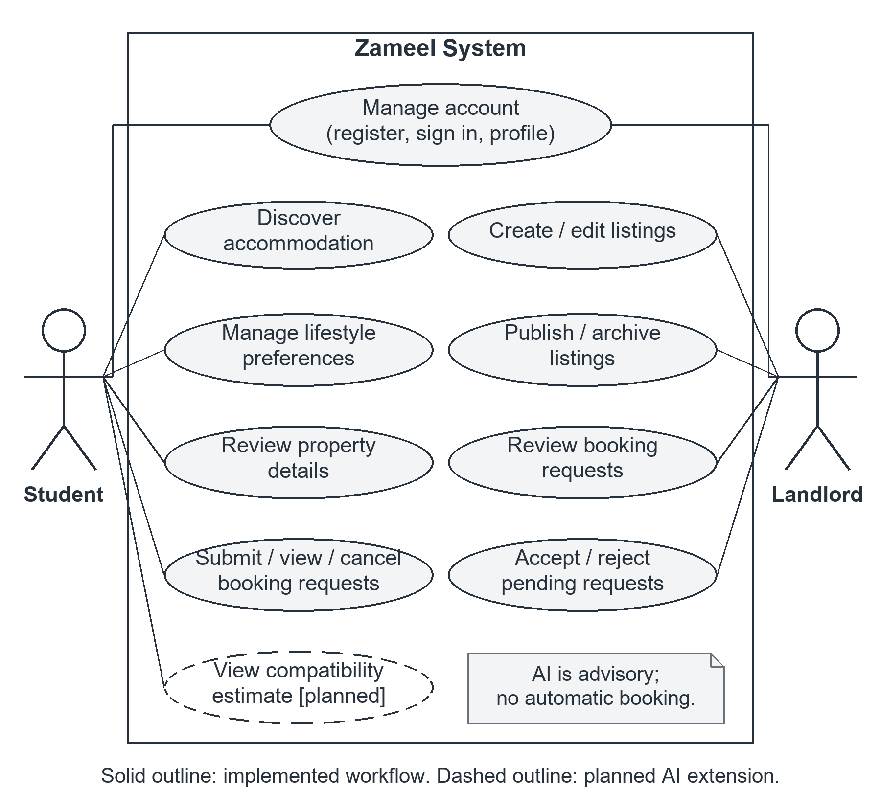
Figure 1-2 High-level use-case diagram for Zameel (author's design).

1.5.2 Student User Flow
Figure 1-3 shows the student journey from sign-in to request tracking. Browsing and booking do not require quiz completion or an AI result. The dashed branch is the proposal's optional model-assisted extension, including unavailable results. A pending request reserves no bed; cancelling an accepted request releases the reserved bed.
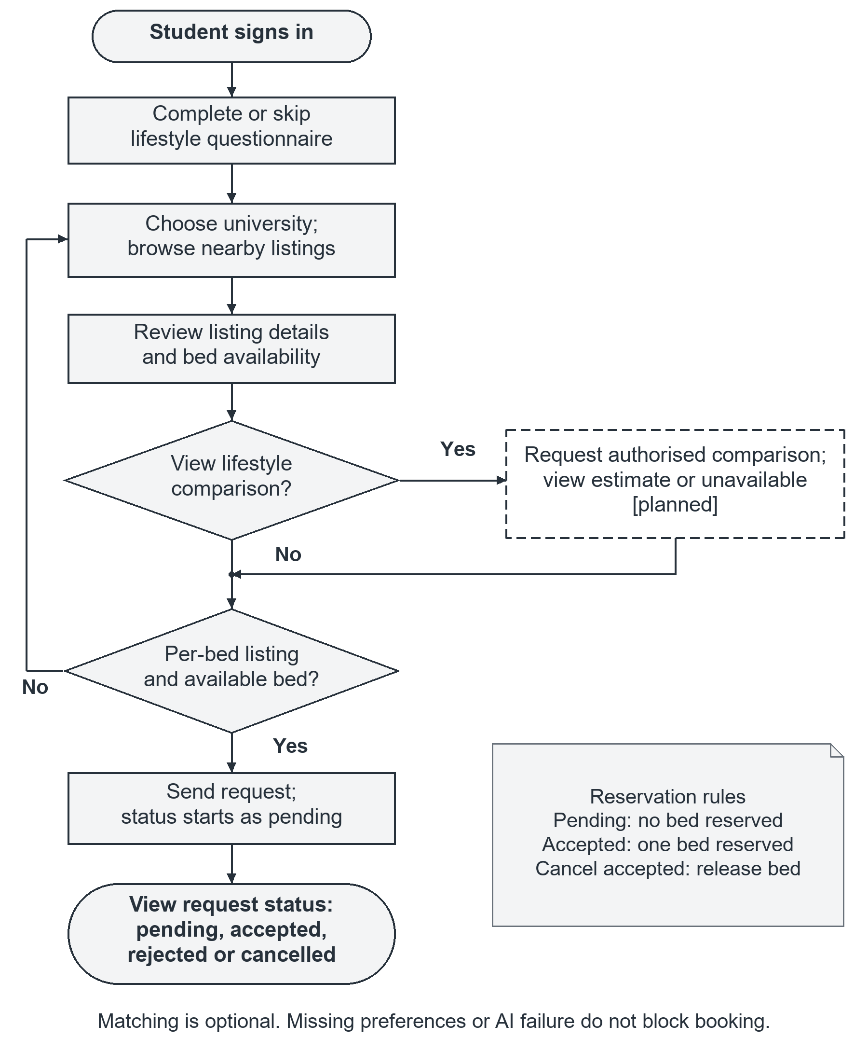
Figure 1-3 Student user-flow diagram with optional planned matching (author's design).

1.5.3 Landlord User Flow
Figure 1-4 connects listing publication to landlord request review. Walking-route success affects university discovery but is not a publication gate. Accepting a request rechecks eligibility and capacity under a database lock; rejection or failed acceptance does not consume a bed. The diagram summarises normal outcomes; stale or conflicting records require reloading the authoritative status.
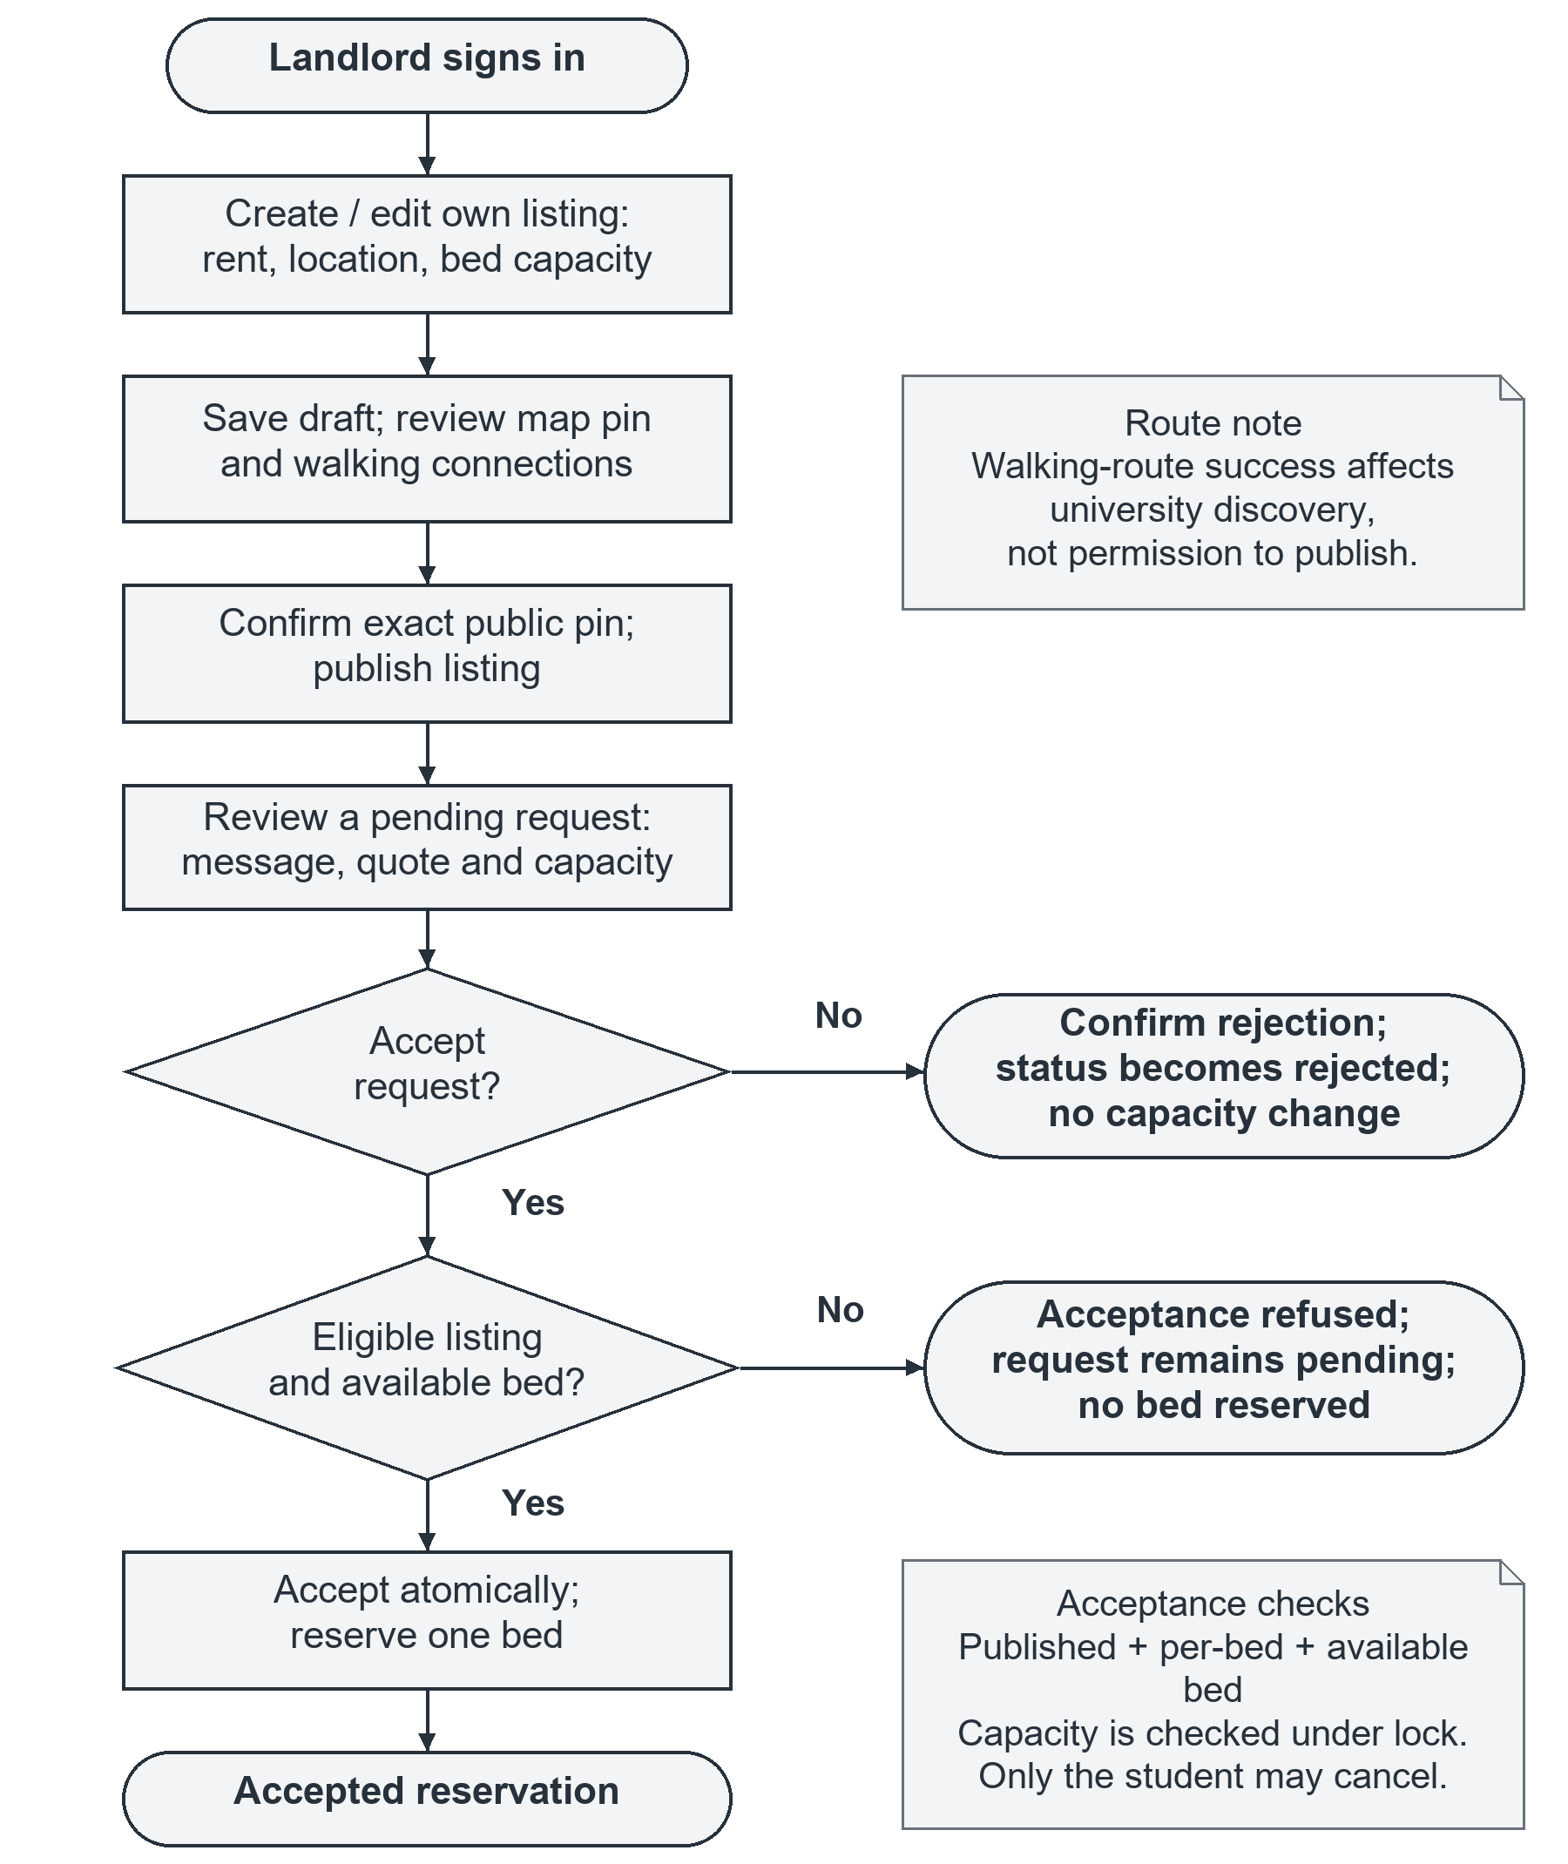
Figure 1-4 Landlord user-flow diagram with booking capacity checks (author's design).

1.6 Structure of the Report
This report contains two chapters. Chapter 1 introduces the problem, significance, objectives, scope and methodology. Chapter 2 reviews the background, compares related platforms and research, and identifies the gap addressed by Zameel. The references document the sources cited in these chapters.

Chapter 2 Literature Review
This chapter reviews the ideas and existing work that inform Zameel. It connects student housing, location-based discovery and lifestyle matching, then compares three commercial platforms and three research studies. The review is a focused selection, not a systematic review or an exhaustive audit of competitors. Commercial documentation establishes advertised functions; academic evidence is considered separately when discussing residential experience, peer effects and recommendation explanations.

2.1 Background

2.1.1 Student Housing and Location-Based Discovery
Student housing is both a physical environment and a shared social setting. A property can meet a student's budget while still being unsuitable because of its facilities, location or expectations about everyday behaviour. Amole (2009) examines residential satisfaction in student housing, supporting a broader view than accommodation as a price alone. For a marketplace, the practical implication is to organise relevant attributes consistently so that students can compare alternatives. A photograph, rent figure or location pin provides useful evidence about one aspect of a property, but none alone establishes overall suitability.
Location-based discovery also requires a distinction between geographic proximity and actual access. A straight-line distance is useful for identifying nearby candidates, whereas a walking route follows the available network and may be longer. A routing service can supply walking-distance and travel-time estimates between locations. Zameel's current university-centred discovery uses walking information around a selected university. Such estimates remain dependent on mapping data and the chosen campus point; they are not guarantees of journey time, route safety or accessibility (Zameel, 2026).
Availability is a separate decision variable. In shared housing, the advertised unit may be a bed rather than an entire apartment. The system must distinguish total capacity, accepted reservations and pending requests. A pending enquiry should not silently become a confirmed reservation. Equally, a displayed bed count is only as reliable as the records behind it: bookings made outside the application can make an otherwise consistent database incomplete. These distinctions justify explicit statuses and careful wording instead of an unconditional promise of real-time availability.

2.1.2 Lifestyle Matching and AI-Assisted Explanations
Lifestyle matching compares self-reported preferences rather than diagnoses personality. Relevant questions can concern sleep schedules, shared-space cleanliness, noise, guests and smoking. Preferences may be negotiable, whereas a non-negotiable household rule is a constraint. Treating both as interchangeable numerical inputs could hide an important conflict inside a favourable overall score. Missing answers should also remain unknown rather than be interpreted as agreement. RoomSync illustrates that lifestyle questions and compatibility scores already exist in student-housing software, so these features alone are not a novel contribution (RoomSync, n.d.).
A rule-based approach compares answers using explicit rules or weights. Its advantages are traceability and repeatability, but weights still express assumptions and need evaluation. Zameel's earlier notes describe this direction, whereas the project proposal specifies model-assisted analysis. The proposed extension will submit authorised, structured preferences through a secure server-side function and request a compatibility estimate, matching factors and potential conflicts. This is an application of an existing model, not evidence that the project has trained or validated a new prediction model (Mahmoud, 2026; Zameel, 2026).
Natural-language explanations may help a student understand why two profiles appear compatible, but fluent wording does not demonstrate correctness. A result must remain grounded in the supplied answers, distinguish uncertainty and avoid unsupported personal inferences. A numeric score should be labelled as an estimate, not a probability that two people will live together successfully. Tintarev and Masthoff (2007) examine explanation benefits and evaluation; for Zameel, this motivates testing whether an explanation supports informed decisions rather than merely sounding persuasive.

2.1.3 Secure Mobile and Cloud Services
A shared backend allows listings and user records to be accessed through one mobile application, but authentication alone does not determine what each user may do. The system design uses record-level access restrictions in the database, so permissions remain enforced even when a request bypasses the interface. Server-side ownership and role checks complement interface restrictions. A landlord should manage only authorised listings, and a student should not obtain unrestricted access to another student's private preference data (Zameel, 2026).
The model integration introduces further responsibilities. A secure server-side function must verify the requester, retrieve only permitted preferences and keep service credentials off the mobile device. Names, contact details and precise addresses are not necessary for comparing lifestyle answers and should not be included without a justified purpose. The response should be validated before display, with a clear unavailable state if the service fails. These safeguards are design requirements, not a claim that choosing a cloud service or model automatically provides privacy, reliable scoring or legal compliance.

2.2 Related Projects
Student.com, HousingAnywhere and RoomSync were selected because they cover complementary parts of the proposed journey: student accommodation booking, landlord-tenant transactions and roommate self-selection. They are compared using their public product documentation. Where a reviewed page does not describe a feature, the comparison states that limitation of the evidence rather than asserting that the product cannot provide it.

2.2.1 Project 1: Student.com
Student.com is a student-accommodation marketplace whose booking guide distinguishes three routes: Enquire, Apply and Instant Book. An enquiry leads to discussion with a property; an application provides more information for confirmation; instant booking includes an online form and contract stage (Student.com, n.d.). This is a useful example of connecting accommodation discovery with clearly differentiated commitments. It also demonstrates why an interface should explain whether the user is merely expressing interest or actually completing a booking.
The reviewed guide does not describe a lifestyle-based comparison with prospective residents before a property request. That is the gap relevant to Zameel, rather than a claim that Student.com lacks all roommate-related services. Zameel proposes to attach optional compatibility explanations to the accommodation decision while retaining a simpler request-and-acceptance process. The lesson is clarity, not imitation of every transaction feature: contracts and payments shown in commercial booking journeys are outside Zameel's initial scope. Its smaller prototype should not imply equivalent booking guarantees or service coverage.

2.2.2 Project 2: HousingAnywhere
HousingAnywhere connects tenants with landlords and property managers for online rentals. Its official guide describes searching listings, communicating with landlords, applying to rent and paying to confirm a stay. It also advertises identity checks, landlord verification and Tenant Protection, including holding the first month's rent for 48 hours after move-in (HousingAnywhere, n.d.). These functions demonstrate that trust in a housing marketplace depends on operational processes and transaction safeguards, not only on attractive listings or successful account registration.
The reviewed workflow serves a wider rental audience and does not document the specific combination of student-to-resident lifestyle explanations and university-centred shared-bed discovery proposed for Zameel. This provides a narrower integration opportunity, not evidence of superior safety or market coverage. Zameel can adopt clear listing fields, transparent request status and role-specific controls while recognising that it does not reproduce HousingAnywhere's verification and payment-protection arrangements. A student should still check the property and clarify the agreement with the landlord; a Zameel profile is not an independent certification of either party.

2.2.3 Project 3: RoomSync
RoomSync is the closest functional comparison for the matching component. Its official workflow starts with residents signing leases and being invited into a matching environment. Residents create profiles, search, chat and send or accept match requests; administrators review matches and prepare placements. Custom lifestyle questions contribute to compatibility scores, while residents can filter profiles using lifestyle and housing preferences (RoomSync, n.d.). Unlike a general property catalogue, the product explicitly helps people choose whom to live with.
Its documented starting point differs from Zameel's proposed journey. RoomSync focuses on residents within a managed housing process after the lease stage, whereas Zameel aims to connect discovery of landlord listings with lifestyle information before an accommodation request. The reviewed page does not establish how its score is validated or whether it provides the specific factor-by-factor AI explanations proposed here. Zameel can learn from voluntary self-selection and mutual choice without claiming to invent compatibility scoring. It should also avoid assuming that adding a model makes matching better: the quality and usefulness of that extension remain questions for evaluation.

2.2.4 Comparison and Project Gap
Together, the platforms show that accommodation discovery, booking and roommate matching are established ideas. The project gap is their integration in a focused Egyptian student-housing workflow, using local university context, shared-bed records and optional explanations before commitment. Table 2-1 summarises the comparison. Zameel's contribution is a proposed combination and adaptation, not proof that no existing product offers a similar combination or that a student prototype outperforms established services.
Table 2-1 Comparison of related platforms and implications for Zameel.
Platform | Documented Focus | Gap Relative to Zameel | Design Implication
Student.com | Student housing with enquiry, application and instant-booking paths. | The reviewed guide does not describe lifestyle comparison before requesting housing. | Keep enquiry and confirmation distinct; add optional preference explanations.
HousingAnywhere | Online rentals, landlord contact, verification and payment protection. | The reviewed flow does not document the proposed shared-bed and lifestyle combination. | Use clear records and statuses; do not imply equivalent protection.
RoomSync | Invited residents, lifestyle scores, mutual match requests and placements. | The documented process begins after signing a lease, rather than open property discovery. | Connect voluntary matching information to a pre-request housing journey.
Source: author's comparison of Student.com (n.d.), HousingAnywhere (n.d.) and RoomSync (n.d.). Gaps refer only to the reviewed documentation; Zameel capabilities describe the proposed target.

2.3 Related Research
The following studies address different parts of the problem: satisfaction with accommodation, the influence of roommates and the design of recommendation explanations. Amole (2009) and Tintarev and Masthoff (2007) are discussed on the basis of their abstracts; Sacerdote (2001) was reviewed in full. Their findings inform design choices but do not constitute an evaluation of Zameel.

2.3.1 Amole: Residential Satisfaction in Student Housing
Amole (2009) investigated residential satisfaction through questionnaires involving 1,124 respondents at four residential universities in southwestern Nigeria. The study considered objective and subjective housing attributes and used frequency analysis, factor analysis and categorical regression. Its abstract reports relationships between satisfaction and social qualities, particularly social density, as well as kitchenette, bathroom and storage facilities. Building configuration and bedroom conditions also mattered. This supports treating accommodation as a combination of physical facilities and shared residential conditions rather than judging it only by price or general appearance.
The study's relevance to Zameel is the need to expose meaningful housing attributes before a student requests accommodation. Bed capacity, facilities and house rules can provide context alongside lifestyle answers. However, the research examines satisfaction within particular institutional residences, not an open rental marketplace or an automated roommate recommendation service. Its statistical associations do not establish that matching similar preferences causes satisfaction, and the Nigerian setting cannot supply local Egyptian satisfaction rates or preferences.
The gap addressed by Zameel is therefore operational: translating relevant housing information into a searchable, comparable mobile workflow and linking it to optional discussion of living habits. The paper does not provide validated scoring weights or a ready-made questionnaire for this application. Those choices require separate justification and user evaluation rather than being inferred from its results.

2.3.2 Sacerdote: Peer Effects Among College Roommates
Sacerdote (2001) analysed records for 1,589 Dartmouth College students using roommate assignments that were random within groups defined by gender and housing responses. The housing responses included smoking, studying with music, late hours and neatness. The study found evidence of peer effects on first-year academic performance and fraternity or sorority participation, but did not detect an effect on choice of major. Effects also differed by outcome and by whether the relevant social setting was the room or the dormitory.
This provides a stronger reason to consider roommate circumstances than assuming that a shared address has no influence. Nevertheless, the lifestyle questions were part of the assignment controls, not proof that matching students on those answers produces successful relationships. The paper also discusses the reflection problem: roommates can influence one another simultaneously, so a correlation between their grades is not automatically a directly interpretable causal effect. Its highly selective US college setting further limits transfer to Egyptian shared rentals.
For Zameel, the unresolved issue is how students understand and use lifestyle information before choosing accommodation. The application can make such information easier to discuss, but it should not promise improved grades or reduced conflict. Unlike this study's outcome analysis, the proposed software initially offers an advisory comparison; evidence about subsequent living experiences would require a separate, consent-based longitudinal study.

2.3.3 Tintarev and Masthoff: Recommendation Explanations
Tintarev and Masthoff (2007) surveyed explanations in recommender systems, illustrating the discussion with examples from existing applications. This is a literature survey, not a new participant questionnaire. The abstract identifies seven possible advantages of explanation facilities and discusses explanation-quality evaluation, recommendation presentation and user interaction. Its contribution is a framework for considering what an explanation is intended to achieve, rather than treating any accompanying sentence as sufficient evidence that a recommendation is understandable or useful.
The study is relevant to the proposal's requirement to show matching factors and potential conflicts instead of an unexplained score. Zameel could, for example, explain agreement on quiet study conditions while separately identifying conflicting sleep preferences. That example is a proposed interface behaviour, not a result established by the paper. Explanations should refer to declared answers, indicate missing information and allow students to recognise when a conclusion does not describe their circumstances.
The research does not evaluate Egyptian housing, modern models or roommate compatibility scores. Its gap relative to this project is therefore domain-specific implementation and evaluation. Zameel needs to assess both whether a generated explanation accurately reflects the inputs and whether users understand its advisory status. An agreeable or readable explanation can still accompany an incorrect inference.

2.3.4 Research Comparison and Implications
The studies provide complementary evidence rather than interchangeable results. Amole examines reported housing satisfaction; Sacerdote investigates peer outcomes using assignment records; Tintarev and Masthoff organise knowledge about explanations. Their populations, methods and outcome measures differ, so they cannot be combined into a single compatibility formula. Together they motivate attention to physical housing conditions, shared-living circumstances and the communication of recommendations. None validates the proposed model's scoring, establishes suitable local weights or demonstrates that Zameel improves students' decisions.
A proportionate evaluation should begin with explicit test profiles covering agreement, conflict and missing answers. Generated explanations can then be checked against those inputs and an interpretable rule-based baseline, including whether a hard conflict is hidden by a high score. Repeated requests should also be examined for inconsistent conclusions. Later, consent-based user tasks can investigate comprehension, usefulness and the ability to recognise uncertainty. These are proposed evaluation activities, not completed experiments, and they must remain separate from tests of booking correctness or claims of long-term roommate success.

2.4 Summary
The review identifies a practical integration opportunity rather than a new theory of roommate compatibility. Housing research motivates attention to the residential experience; roommate research shows that shared environments can matter; explanation research provides criteria for presenting recommendations responsibly. Existing platforms supply concrete examples of structured booking journeys and lifestyle-based self-selection. These strands support Zameel's proposal to connect university-centred accommodation discovery, shared-bed booking requests and optional explanations of stated preferences.
They do not establish that a model can predict successful cohabitation or that the prototype has achieved the full proposed workflow. The appropriate direction is to complete the missing functions, protect preference data, make uncertainty visible and evaluate whether explanations help students make informed choices. Housing suitability, personal consent and operational booking correctness must remain separate from an AI-generated estimate.

References
Amole, D. (2009) 'Residential satisfaction in students' housing', Journal of Environmental Psychology, 29(1), pp. 76-85. doi: https://doi.org/10.1016/j.jenvp.2008.05.006
HousingAnywhere (n.d.) How it works. Available at: https://housinganywhere.com/renting (Accessed: 29 October 2026).
Mahmoud, H.A.M. (2026) Zameel: Student Housing Marketplace with Lifestyle-Based Roommate Matching. TM471-A Graduation Project Proposal Form, Fall 2026-2027. Arab Open University, Egypt. Unpublished project proposal, TM471-proposal-23515018.docx.
RoomSync (n.d.) How it works. Available at: https://www.roomsync.com/how-it-works (Accessed: 29 October 2026).
Sacerdote, B. (2001) 'Peer effects with random assignment: Results for Dartmouth roommates', The Quarterly Journal of Economics, 116(2), pp. 681-704. doi: https://doi.org/10.1162/00335530151144131
Student.com (n.d.) How to book on Student.com. Available at: https://www.student.com/how-it-works (Accessed: 29 October 2026).
Tintarev, N. and Masthoff, J. (2007) 'A survey of explanations in recommender systems', in 2007 IEEE 23rd International Conference on Data Engineering Workshop. Los Alamitos, CA: IEEE Computer Society, pp. 801-810. doi: https://doi.org/10.1109/ICDEW.2007.4401070
Zameel (2026) Project context, milestones and prototype source code. Unpublished project repository. Workspace version reviewed 1 November 2026.

