Arab Open University - Egypt

Faculty of Computer Studies
Information Technology and Computing Department
Local Service On-Demand Platform
Salahly: Trusted Home Services and AI-Assisted Request Drafting
Chapters 1 and 2
Introduction and Literature Review
Yousef Mohamed Naser
Student ID: 22511298
Supervisor: Dr. Ramy
TM471A: Final Year Project | Fall 2026/2027
31 October 2026

Abstract
Finding suitable home-service professionals can involve uncertain availability, unclear prices and limited evidence of reliability. Salahly addresses this problem through a bilingual mobile platform that connects customers with local service providers. The proposed solution combines structured service requests, provider verification, competitive quotations, transparent matching and job tracking. An optional model, accessed through an API provider, is intended to help customers describe photographed problems without presenting its output as a confirmed diagnosis. The current prototype provides authentication, service discovery, provider onboarding and private customer request management; the complete marketplace and customer-facing assistant remain planned extensions. This report introduces the problem, objectives, scope and development methodology, then critically reviews related platforms and research. The review identifies requirements for usable assistance, accountable reputation mechanisms and privacy-conscious implementation.
Keywords: home services; service requests; provider matching; trust; AI assistance.
Table of Contents
Abstract I
Chapter 1 Introduction 1
1.1 Problem definition 1
1.2 Significance of the Problem 1
1.3 Project Objectives 1
1.4 Scope of the Project 2
1.5 Project Methodology 3
1.6 Structure of the Report 4
Chapter 2 Literature Review 5
2.1 Background 5
2.1.1 Local service marketplaces and request lifecycles 5
2.1.2 Secure mobile architecture and information handling 6
2.1.3 AI-assisted problem description 7
2.1.4 Matching, reputation and inclusive interaction 8
2.2 Related Projects 9
2.2.1 Project 1: Direct professional selection 9
2.2.2 Project 2: Request-led professional discovery 9
2.2.3 Project 3: Managed home-service booking 10
2.2.4 Comparison and project gap 10
2.3 Related Research 11
2.3.1 Online feedback and reputation mechanisms 11
2.3.2 Detecting deceptive reviews 11
2.3.3 Human-AI interaction and user control 12
2.3.4 Research synthesis and evaluation implications 12
2.4 Summary 13
References 14

List of Figures
Figure 1-1 Proposed system use-case diagram 3
Figure 1-2 Iterative project methodology flowchart 4
Figure 2-1 Service-request process and proposed fulfilment flow 6
Figure 2-2 Proposed AI-assisted drafting flowchart 8

List of Tables
Table 1-1 Prototype boundary and proposed extensions 2
Table 2-1 Comparison of related service platforms 11
Table 2-2 Research comparison and design implications 13

Abbreviations
AI Artificial intelligence
API Application programming interface
RLS Row-level security
RTL Right-to-left

Chapter 1 Introduction
Home maintenance depends on effective communication between customers and skilled professionals. A customer may recognise a visible symptom, such as a leaking pipe or a damaged fitting, without knowing the appropriate trade or the information a technician needs. The project proposal identifies reliance on informal contacts, uncertainty about availability and difficulty assessing reliability as motivations for a local service platform (Salahly project, 2026a). Salahly therefore brings service discovery and structured problem reporting into one mobile workflow. Its intended contribution is a clearer, more accountable service process rather than a replacement for professional inspection.

1.1 Problem definition
The central problem is the absence of a consistent, traceable connection between describing a household fault, finding a suitable provider and agreeing what work will be performed. An incomplete description can lead to unsuitable enquiries, repeated clarification and quotations based on different assumptions. Informal recommendations may help, but they do not necessarily provide comparable evidence of skills, availability or previous work. Research on online feedback also shows that reputation mechanisms require deliberate design; merely displaying ratings does not resolve every trust problem (Dellarocas, 2003).
The project consequently asks how a mobile application can support understandable requests, controlled information sharing and informed provider selection. Photo-based assistance introduces a second challenge: an uncertain model suggestion must not become a false technical diagnosis or an instruction to undertake hazardous repair work.

1.2 Significance of the Problem
For customers, better request information could reduce avoidable clarification and make competing offers easier to compare. For providers, structured enquiries could improve visibility and preparation before a visit. For platform operators, recorded decisions and service events could support fair complaint handling. These are expected benefits, not measured outcomes of the current prototype. The problem also has a security dimension because addresses, household photographs and credential images are sensitive. Arabic-friendly interaction, readable feedback and a manual alternative to AI assistance are therefore central requirements rather than optional presentation features.

1.3 Project Objectives
The aim is to design and develop a secure, Arabic-friendly mobile platform connecting customers with suitable local home-service providers. The following objectives preserve the direction of the proposal (Salahly project, 2026a):
1. Provide customer, service-provider and administrator workflows with authenticated access and server-enforced permissions.
2. Support service requests containing a category, description, photographs, location and preferred time, followed by comparable provider quotations.
3. Develop transparent rule-based matching using eligibility, distance, ratings, availability and relevant experience, while retaining customer choice.
4. Integrate optional photo-based assistance through a protected backend so that the model returns tentative, editable request information.
5. Support accountable service completion through job tracking, notifications, ratings, complaints and warranty handling, with suspicious-review screening investigated as a trust extension.

1.4 Scope of the Project
The target application covers household maintenance and repair categories for customers, local service providers and a future administrator workflow. Figure 1-1 presents this proposed scope, not a statement that every use case is complete. The inspected prototype already contains customer and provider accounts, bilingual service discovery, provider onboarding, credential submission and private customer request creation, history and cancellation. Administrative credential decisions currently require a trusted operator operation rather than an administrator application (Salahly project, 2026b).
The current form records a manually entered address and an optional preferred time; it does not book an appointment. A standalone server-side AI experiment exists, but it is not connected to the customer request interface. Table 1-1 distinguishes this baseline from the wider proposal. Automated payments, emergency dispatch, guaranteed fault diagnosis and training a new model are outside the present scope. Hosted security acceptance, real-device evaluation and operational data-retention procedures remain necessary before a real-user deployment.
Table 1-1 Prototype boundary and proposed extensions
Area | Current boundary | Proposed extension
Accounts and access | Customer/provider accounts; ownership-based policies. | Administrator interface and operational oversight.
Service requests | Manual draft, private submission, own history and cancellation. | Provider feed, quotations, selection and job tracking.
Provider information | Skills, area labels, weekly hours and credential review records. | Geographic matching and explainable ranking.
AI and trust | Separate API experiment; no integrated assistant or review system. | Editable assistance, reviews, complaints and warranty workflows.
Source: Author's synthesis of the sources discussed in this section.
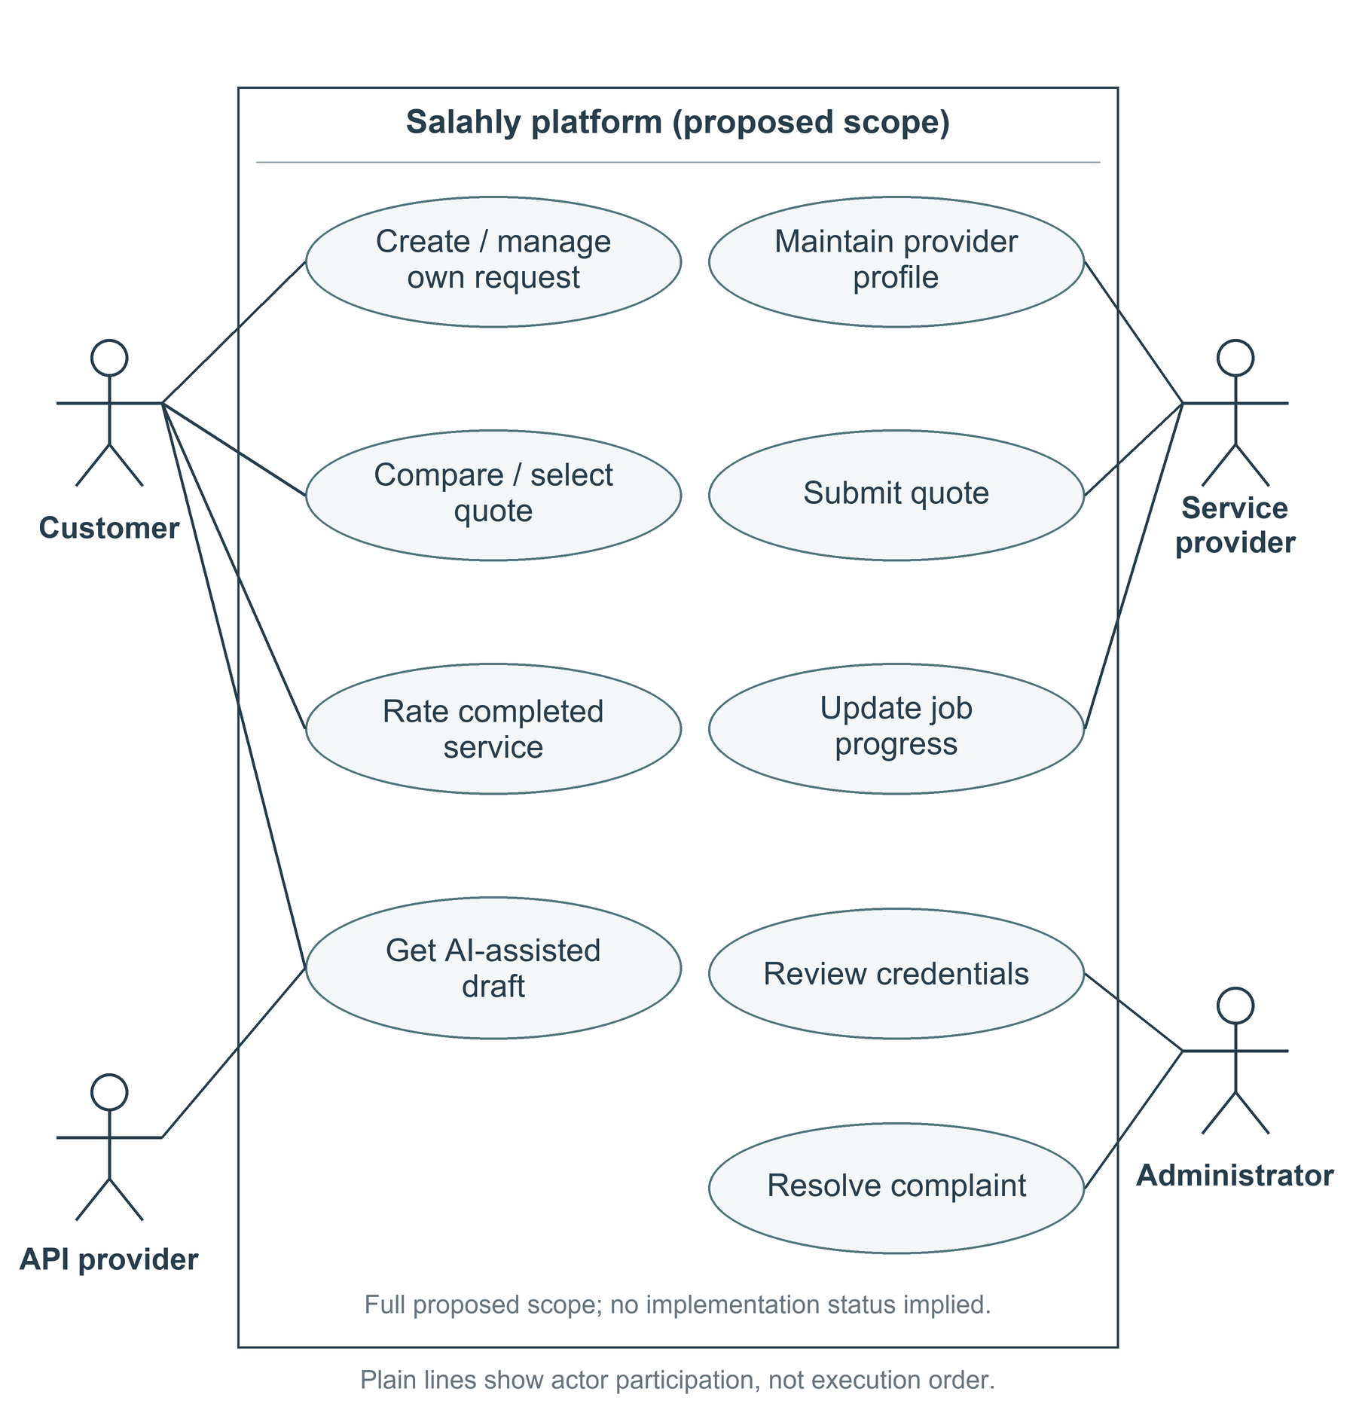
Figure 1-1 Proposed system use-case diagram
Source: Author's design from the proposal. Full proposed scope; current implementation is bounded by Table 1-1.

1.5 Project Methodology
An incremental development methodology is used to keep the proposal aligned with a testable prototype. First, the proposal, related platforms and research are reviewed to identify stakeholder needs and risks. Second, these needs are translated into feature boundaries, acceptance criteria and data-access rules. Third, workflows and interfaces are designed before implementing a small vertical feature through presentation, state handling, repositories and backend policies. This separation keeps data access and business rules outside interface rendering.
Each increment is then checked using appropriate unit, widget, integration and permission tests, followed by review of interaction and error states. Existing automated tests provide a foundation, but their presence does not establish production performance or a completed user study. The planned evaluation should measure task completion, request clarity, authorization failures and the usefulness of assisted drafts. Failed acceptance criteria return the increment for revision; accepted work is documented before the next scope item is selected. Figure 1-2 summarises this iterative process.
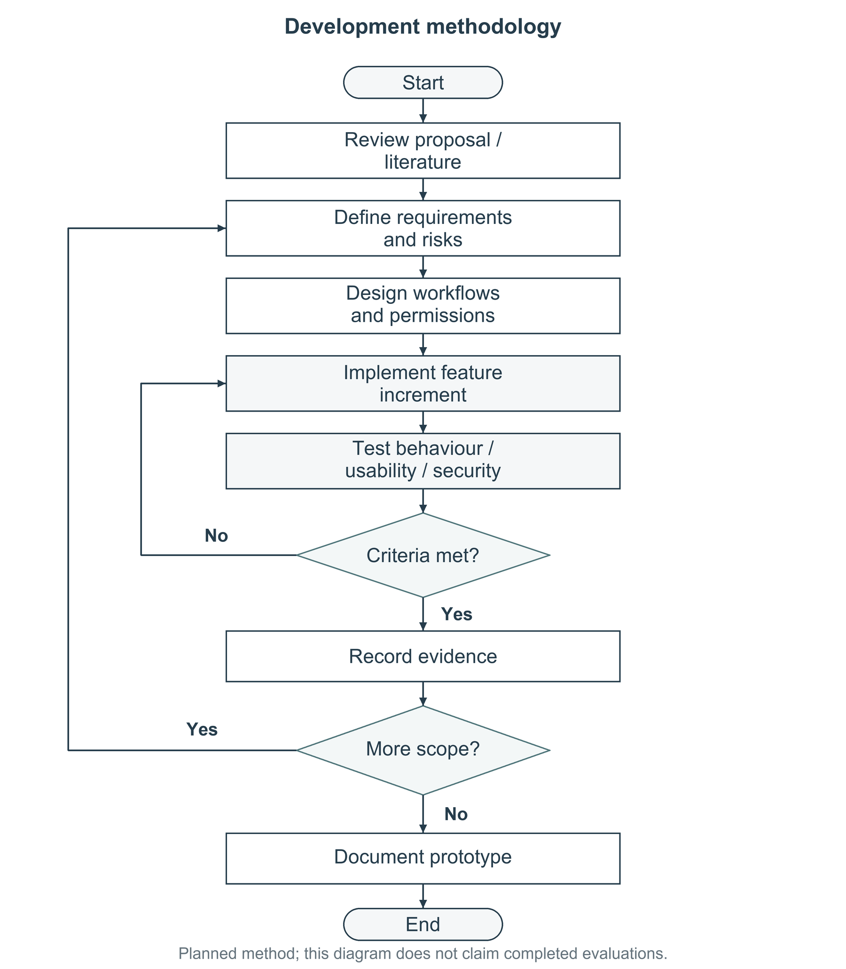
Figure 1-2 Iterative project methodology flowchart

1.6 Structure of the Report
Chapter 1 defines the project. Chapter 2 reviews its background, related platforms and research. References follow. Detailed requirements and analysis belong to Chapter 3, which is not included here.

Chapter 2 Literature Review
This chapter examines the ideas needed to develop Salahly as a trustworthy local service platform. It combines a conceptual background with a focused comparison of three operational platforms and three scholarly studies. The review is a structured narrative review, not an exhaustive systematic survey. Platform descriptions establish publicly documented workflows, while research provides evidence about reputation, deceptive reviews and human-AI interaction. Neither source type is treated as proof that the proposed application will achieve the same outcomes.

2.1 Background

2.1.1 Local service marketplaces and request lifecycles
A local service marketplace connects demand from customers with the capabilities and availability of nearby professionals. Unlike purchasing a standard physical product, household repair often begins with uncertain requirements. A customer may describe a symptom, while a provider needs information about access, materials and the likely extent of work. A service request therefore acts as a shared information object: category, description, photographs and location help establish a common starting point before a quotation is accepted.
Three lifecycle objects should remain distinct. A request expresses a need; a quotation proposes a scope and price; an agreed job records the commitment to perform work. Treating a preferred time as a confirmed appointment would confuse these stages. The current prototype implements only the first object, with a local draft followed by an open request and optional cancellation. Submitted details are not freely editable, and cancellation does not erase their history. Uncertain submission outcomes are reconciled before allowing draft changes. Provider visibility, quotations and job progression belong to the planned extension (Salahly project, 2026b).
Figure 2-1 connects these concepts while separating the implemented request core from proposed fulfilment. The distinction matters when assessing progress: storing a request is useful functionality, but it does not demonstrate that a suitable professional has accepted it or that the service has been delivered.
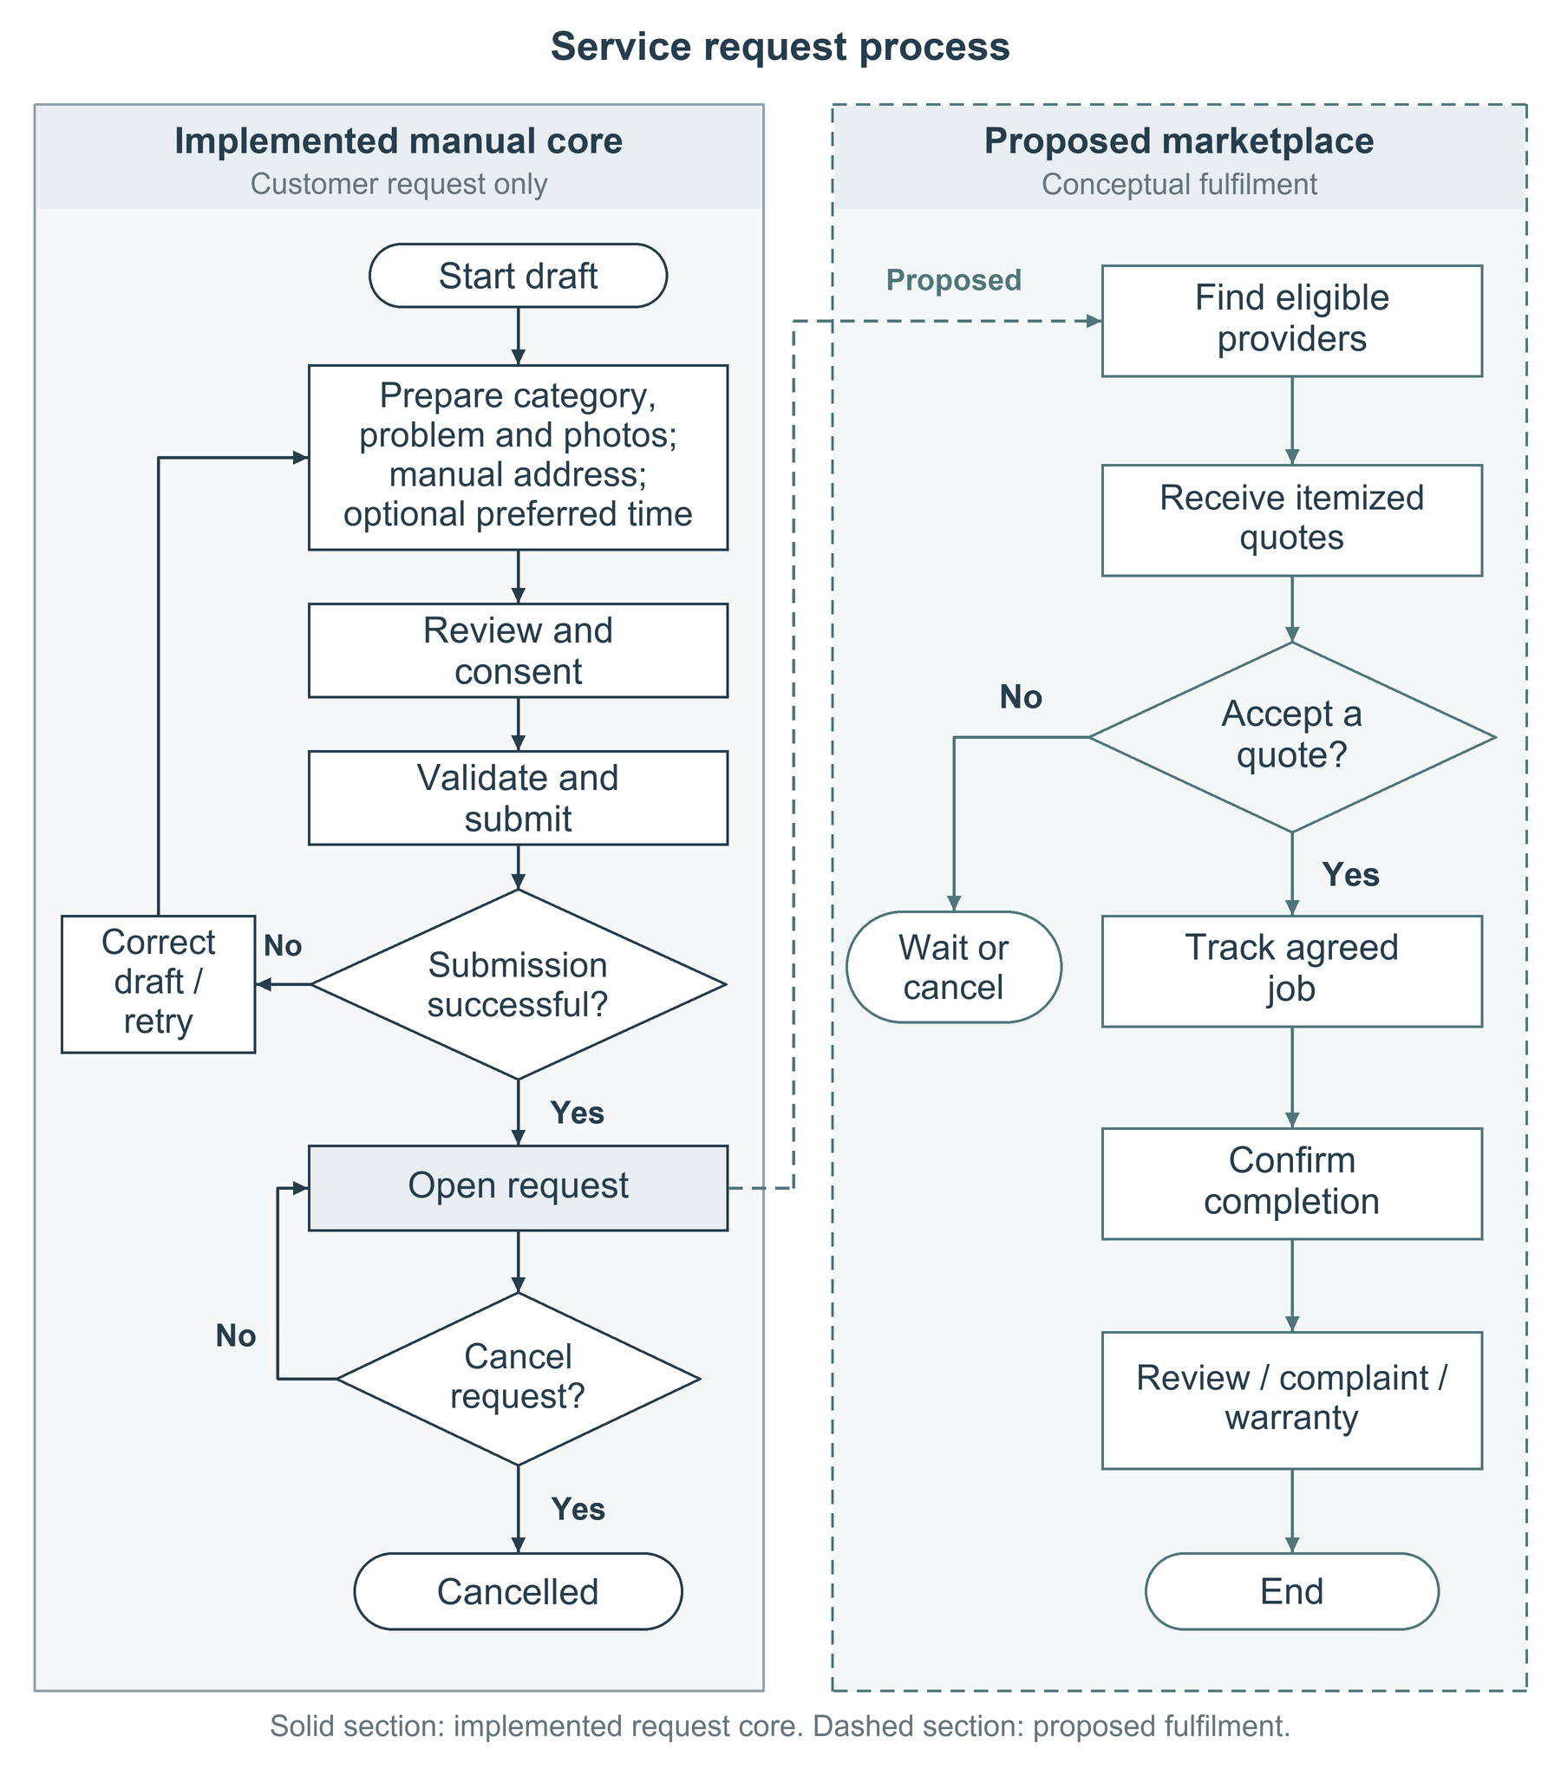
Figure 2-1 Service-request process and proposed fulfilment flow

2.1.2 Secure mobile architecture and information handling
A maintainable mobile architecture separates interface presentation, feature state, repositories and backend operations. In the current project, screens communicate through feature controllers and repositories rather than directly performing backend calls. A managed backend supplies authentication, relational records and private file storage. A separate demonstration mode uses in-memory records; it is not evidence of durable cloud storage or offline synchronization. This distinction prevents demonstration behaviour from being mistaken for production capability (Salahly project, 2026b).
Authentication identifies the account, whereas authorization decides which records and operations it may access. Hiding a button is insufficient because a client can issue requests outside the intended interface. Ownership rules and controlled server operations must therefore protect request records, photographs and verification decisions. The prototype contains these policy definitions, but their deployment and behaviour with real accounts still require hosted integration checks. Public discovery should not imply public access to household addresses or identity evidence.
Privacy also extends beyond access control. A photograph may reveal possessions, people or embedded location metadata. Consent, limited collection, controlled retention and an account-erasure process should be specified before collecting real-user evidence. Cancellation and deletion serve different purposes. Sharing photographs with an external API provider introduces an additional processing boundary that must be explained separately from storing a manual service request.

2.1.3 AI-assisted problem description
A vision-capable model can analyse a photograph alongside a short description and suggest a service category, issue summary or clarification question. For this project, the appropriate role is assistance with communication, not autonomous fault certification. A visible stain, for example, does not establish the condition of concealed pipework. A useful interface should therefore communicate uncertainty and allow the customer to correct or dismiss every suggestion. These requirements align with guidance on setting expectations, supporting correction and limiting services when uncertain (Amershi et al., 2019).
The design treats the API provider and model as replaceable dependencies behind a backend interface. Credentials should remain server-side, and responses should be checked before reaching the interface. The current experiment demonstrates a request-response connection and limited parsing checks, but not a completed customer-facing workflow. Authentication and consent enforcement, strict response validation, bounded inputs and a usable fallback must be completed and tested before integration. Prompt instructions alone are not a verified safety mechanism (Salahly project, 2026b).
Figure 2-2 presents the intended assisted-drafting process. A customer may decline assistance and continue manually. If assistance is selected, permitted input passes through backend checks and the returned suggestion is reviewed before normal request submission. The model must not independently accept a quotation, set a contractual price or change a job state. External-service failure should leave the manual route available. Risk-management guidance supports considering such failures throughout design and evaluation rather than assuming that a plausible response is trustworthy (Autio et al., 2024).
No new model is trained in the current project. A future evaluation dataset should contain appropriately consented examples and independently reviewed categories, including unclear or unsuitable images. Dataset selection, label quality and realistic language coverage must be documented before reporting accuracy. No diagnostic benchmark result is claimed here.
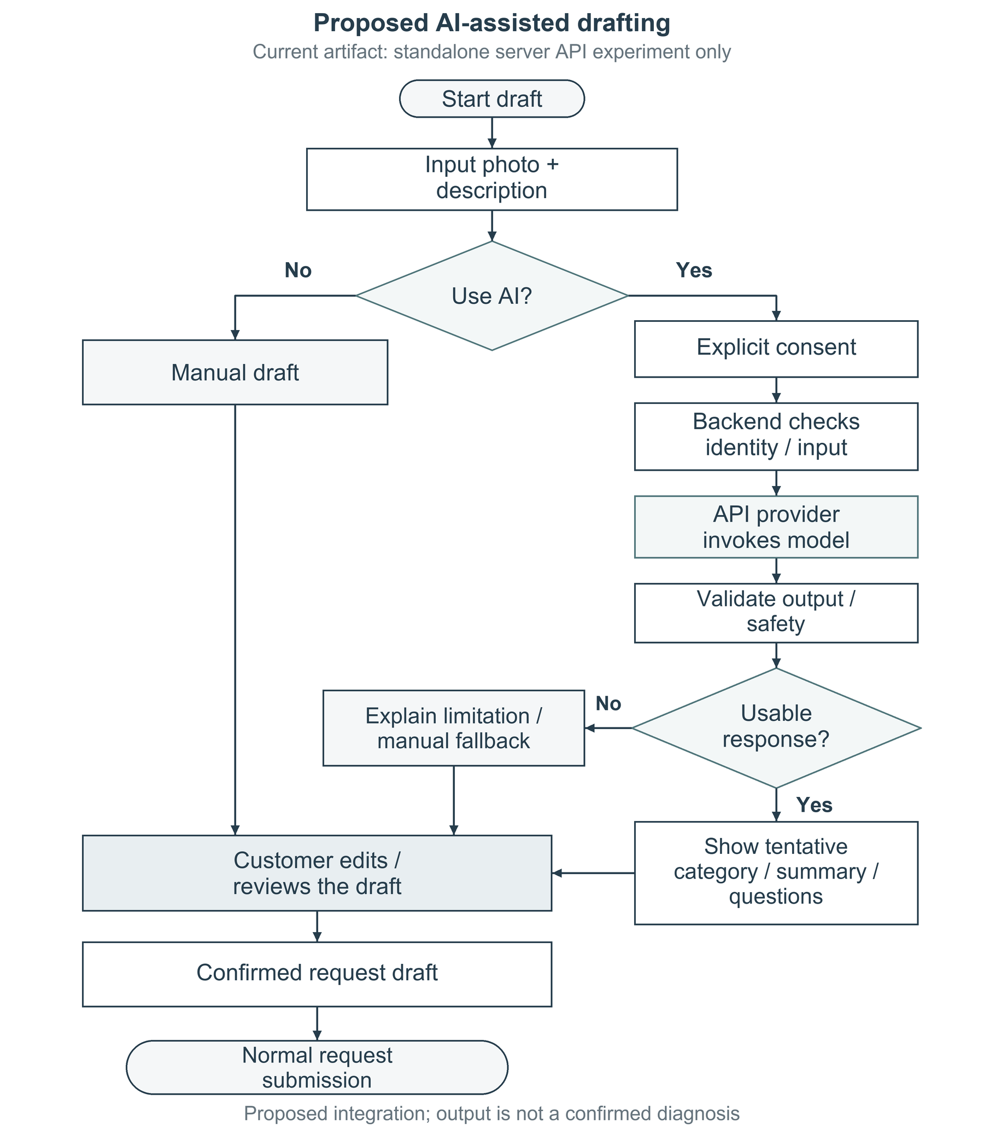
Figure 2-2 Proposed AI-assisted drafting flowchart
Source: Author's design informed by Amershi et al. (2019). The complete guarded workflow remains a proposed integration.

2.1.4 Matching, reputation and inclusive interaction
Provider matching should begin with eligibility, not popularity. Relevant skills, approved participation and actual coverage determine which providers may be considered; distance, availability, experience and ratings can then support an explainable ranking. The proposal favours a rule-based approach rather than a trained recommendation model. However, current area labels and weekly hours are only onboarding information, not a functioning geographic matching service. Reliable location handling and explicit ranking rules remain implementation work (Salahly project, 2026a, 2026b).
Ratings also need context, including the number and relevance of completed jobs. Otherwise, a small number of favourable reviews can dominate comparison or disadvantage new providers. Arabic and English interaction should preserve meaning across forms, dates, validation and right-to-left layouts. These considerations connect technical ranking with usability and fair participation: a matching result is not helpful if the customer cannot understand why it was presented or how to choose differently.

2.2 Related Projects
Three platforms were selected to illustrate different approaches: choosing a professional directly, requesting responses from professionals, and booking a managed service. Their official public descriptions were reviewed on 31 October 2026. This is a feature-level comparison, not a security audit or a measured usability study. Where a reviewed page does not document a feature, this is identified as an evidence limit rather than proof that the feature is absent throughout the platform.

2.2.1 Project 1: Direct professional selection
Taskrabbit describes a workflow in which a customer selects a task and location, compares nearby professionals by rates, skills and reviews, and discusses details before booking. Its public page also describes identity checks, background checks and an in-application payment process (Taskrabbit, n.d.). This approach makes provider choice visible and reduces dependence on an informal recommendation alone. It provides a useful reference for presenting profiles and availability before a customer makes a commitment.
For Salahly, the limitation of this reference is its emphasis on selecting a professional for an already understood task. The reviewed workflow does not establish how an uncertain photographed fault becomes an editable, structured request that several providers can quote against. Salahly proposes to address that part of the problem through optional assisted drafting and itemised offers. It should still retain the reference platform's clear customer choice rather than automatically assigning whichever provider receives the highest score. This is a difference in project emphasis, not a claim that direct selection is inherently inferior.

2.2.2 Project 2: Request-led professional discovery
Bark asks customers to describe what they need, helps identify professionals, and encourages comparison through profiles, reviews and websites. Its customer workflow also asks users to leave feedback after the work (Bark, n.d.). This is relevant to a request-first marketplace because the customer begins with a need rather than an individual provider. It also demonstrates how structured enquiries can connect a wide range of services to a common discovery process.
However, the reviewed customer page concentrates on discovery and comparison. It does not document the detailed job-state controls, evidence handling or warranty process required by this proposal. Salahly's intended response is to retain a traceable connection between the original request, the accepted offer, progress evidence and later complaint handling. Its local maintenance focus can also support category-specific questions instead of a single generic enquiry form. The present prototype does not yet deliver those extended lifecycle controls, so this comparison identifies design work rather than an achieved competitive advantage.

2.2.3 Project 3: Managed home-service booking
Urban Company presents an on-demand home-service model based on selected professionals, visible prices and service-quality assurance. Its official page describes trained professionals and prices shown before booking (Urban Company, n.d.). This approach demonstrates the importance of reducing uncertainty about both price and delivery. It is especially relevant when the service can be described as a relatively standard task with a predictable scope.
Uncertain repair work may not fit a fixed service description before inspection. The reviewed overview does not explain the specific open, multi-quotation request workflow proposed for Salahly. The project therefore uses standard categories for discovery while allowing providers to explain labour, materials and assumptions in an itemised quotation. This flexibility also creates responsibility: price changes must be agreed transparently rather than hidden behind an initial estimate. The managed-service reference highlights that verification and complaint handling require operational processes, not merely profile badges. Salahly cannot claim equivalent assurance simply because credential submission exists in its prototype.

2.2.4 Comparison and project gap
Table 2-1 summarises the comparison. All three references support aspects of discovery or trust, but they organise customer choice differently. The resulting gap is not the invention of online service booking. It is the integration of understandable problem reporting, transparent quotation comparison and an accountable lifecycle for the intended local context. Arabic-friendly interaction and optional assistance should be evaluated with intended users rather than asserted to be universally better than existing products. The project also needs to demonstrate that private information is shared only at the appropriate stage. These requirements narrow the contribution to a feasible, testable workflow instead of an unsupported claim of platform-wide superiority.
Table 2-1 Comparison of related service platforms
Reference approach | Documented strength | Implication for Salahly
Direct selection  (Taskrabbit) | Rates, profiles, reviews and pre-booking discussion. | Preserve informed choice; add a shared, editable problem description.
Request-led discovery  (Bark) | Describe the need and compare professional responses. | Connect discovery to a traceable agreed-job lifecycle.
Managed booking  (Urban Company) | Visible pricing and operational quality assurance. | Use clear quotation assumptions and genuine review operations.
Source: Author's synthesis of the sources discussed in this section.

2.3 Related Research
The selected studies address three complementary risks: whether reputation can support trust, whether reviews can be misleading, and how uncertain assistance should interact with users. They are foundational rather than recent benchmarks of household repair. Their findings must therefore be translated into domain-specific requirements and evaluated locally. The newer risk-management profile provides a supplementary perspective on external generative services (Autio et al., 2024).

2.3.1 Online feedback and reputation mechanisms
Dellarocas (2003) examines how online feedback mechanisms extend word-of-mouth communication and considers their design, evaluation and use in electronic markets. The study is relevant because a service platform depends on users forming expectations about people they have not previously hired. It supports treating reputation as part of a wider interaction mechanism rather than assuming that an average score alone creates trust. Accountability depends on how feedback is obtained, connected to a transaction and interpreted.
The limitation for this project is that the work is a broad conceptual review, not an evaluated implementation of an Arabic-friendly home-maintenance application. It does not supply Salahly with a complete provider-verification workflow or a tested local ranking rule. The project can address part of that application gap by linking future ratings to completed jobs, retaining review context and separating credential approval from self-reported skills. Complaint evidence should supplement ratings where a dispute requires investigation. Whether these measures improve user confidence remains an empirical question for later evaluation, not a finding established by citing the study.

2.3.2 Detecting deceptive reviews
Ott et al. (2011) investigate deceptive opinion spam and compare automated approaches using a labelled dataset of truthful and deliberately deceptive reviews. Their results demonstrate that deceptive text can appear convincing to readers and that computational signals can be useful under controlled experimental conditions. This directly informs the proposal's suspicious-review feature: a trustworthy platform should not assume that every positive or negative review accurately represents a genuine service experience.
Important transfer limits remain. The study's reviews concern a different service setting, and deliberately collected deceptive text is not identical to naturally occurring manipulation in a local marketplace. Language, writing style and platform incentives can change the signals available to a model. Consequently, the study does not justify importing an accuracy claim into Salahly or selecting a model without suitable evaluation data. The current repository contains neither a review system nor a validated detection component.
A proportionate project response is to establish transaction-linked review eligibility first, then investigate suspicious-review screening as decision support. Any later model should flag cases for authorised review rather than automatically punish a provider. Evaluation must consider false accusations as well as missed manipulation, using precision, recall and documented reviewer decisions. These safeguards make the research relevant without overstating its generalisability.

2.3.3 Human-AI interaction and user control
Amershi et al. (2019) propose eighteen human-AI interaction guidelines and evaluate them through multiple rounds, including a study involving forty-nine design practitioners and twenty AI-enabled products. Particularly relevant principles are making capabilities and limitations clear, supporting efficient dismissal and correction, and reducing the scope of assistance when uncertainty remains. The value for Salahly is that these principles translate abstract trust goals into observable interface behaviour.
The study is not a benchmark of visual household diagnosis and does not demonstrate safety for hazardous maintenance situations. Its broad interface guidance also needs adaptation to Arabic wording, photographs of private homes and users with differing technical knowledge. Salahly can address part of this contextual gap with tentative wording, editable category and summary fields, optional follow-up questions and an obvious manual route. User confirmation must occur before a suggestion becomes a submitted service request. Evaluation should compare assisted and manual task completion and ask whether users correctly understand the output's limitations, rather than judging success solely by fluent text.

2.3.4 Research synthesis and evaluation implications
The studies complement one another rather than offering interchangeable solutions. Reputation research explains why feedback mechanisms matter; deceptive-review research questions the reliability of their inputs; human-AI research explains how uncertain automated output should be presented. Table 2-2 maps these lessons to the project. Together they support a human-controlled system in which records, explanations and correction routes are at least as important as an automated suggestion.
The research gap is therefore an integration and evaluation gap. A later study should test whether structured drafts improve clarity, whether matching explanations support informed selection, and whether review controls reduce abuse without unfair exclusions. Technical checks should verify ownership boundaries and safe behaviour during failed uploads or unavailable external services. A documented dataset, evaluation protocol and failure analysis are prerequisites for any model-performance claim. The present chapters establish these evaluation questions; they do not report an experiment, a production deployment or a proven improvement in repair quality.
Table 2-2 Research comparison and design implications
Study | Contribution and limit | Project response
Dellarocas (2003) | Explains feedback mechanisms; not a local-service implementation. | Transaction-linked ratings, review context and complaint evidence.
Ott et al. (2011) | Studies deceptive text on a dataset; transfer is not guaranteed. | Investigate flags with local evaluation and human review.
Amershi et al. (2019) | Validated interaction guidance; not a repair-safety benchmark. | Editable suggestions, clear uncertainty and manual fallback.
Source: Author's synthesis of the sources discussed in this section.

2.4 Summary
The review identifies a coherent direction for Salahly: structured requests should establish shared understanding; eligibility and explainable matching should support, not replace, customer choice; reputation should be linked to genuine service events; and model output should remain optional and correctable. Existing platforms illustrate alternative discovery and booking patterns, while the research exposes limits in ratings, review authenticity and automation. The project's contribution is the planned combination of these ideas in a local, bilingual service workflow. The inspected prototype supplies the account, onboarding and request foundations, but quotation handling, the extended job lifecycle and integrated assistance still require implementation and evaluation. These conclusions will guide the detailed requirements in the next report stage.

References
Amershi, S., Weld, D., Vorvoreanu, M., Fourney, A., Nushi, B., Collisson, P., Suh, J., Iqbal, S., Bennett, P.N., Inkpen, K., Teevan, J., Kikin-Gil, R. and Horvitz, E. (2019) 'Guidelines for human-AI interaction', Proceedings of the 2019 CHI Conference on Human Factors in Computing Systems, Paper 3, pp. 1-13. doi: 10.1145/3290605.3300233.
Autio, C., Schwartz, R., Dunietz, J., Jain, S., Stanley, M., Tabassi, E., Hall, P. and Roberts, K. (2024) Artificial Intelligence Risk Management Framework: Generative Artificial Intelligence Profile. NIST AI 600-1. Gaithersburg, MD: National Institute of Standards and Technology. doi: 10.6028/NIST.AI.600-1.
Bark (n.d.) How it works. Available at: https://www.bark.com/en/gb/how-it-works/ (Accessed: 31 October 2026).
Dellarocas, C. (2003) 'The digitization of word of mouth: Promise and challenges of online feedback mechanisms', Management Science, 49(10), pp. 1407-1424. doi: 10.1287/mnsc.49.10.1407.17308.
Ott, M., Choi, Y., Cardie, C. and Hancock, J.T. (2011) 'Finding deceptive opinion spam by any stretch of the imagination', Proceedings of the 49th Annual Meeting of the Association for Computational Linguistics: Human Language Technologies, pp. 309-319. Available at: https://aclanthology.org/P11-1032/ (Accessed: 31 October 2026).
Salahly project (2026a) Local Service On-Demand Platform. TM471-A graduation project proposal. Arab Open University, Egypt. Unpublished project document supplied with the project.
Salahly project (2026b) Salahly prototype: application source, database migrations and milestone record. Unpublished software project. Working copy inspected 31 October 2026. Evidence includes MILESTONES.md, request/provider repositories, access-control migrations and the experimental AI endpoint.
Taskrabbit (n.d.) How Taskrabbit works. Available at: https://www.taskrabbit.com/how-it-works (Accessed: 31 October 2026).
Urban Company (n.d.) Quality home services, on demand. Available at: https://www.urbancompany.com/ (Accessed: 31 October 2026).

