PALESTINIAN ROOTS PLATFORM
ورذج
Juthoor
System Design Report
Functional and technical requirements, system architecture, technology
stack, frontend design, backend and database, and process flows.
Version | 1.0

Date  Source  Flow reference Audience | 21 October 2026  github.com/yossefbouz/juthoor, main branch  Process Flow Diagram v1.2, reviewed 11 October 2026 Project team, partners and reviewers
Every figure and status in this report was read from the repository code, database migrations and project logs on the date above. Items marked “Partly built” or “Not built” are open work, listed with suggested
actions in section 10.  Juthoor · System Design Report · October 2026 | 1 / 18


CONTENTS
What this report covers
1 | Summary | 7 | Backend and database
2 | Summary | 7
2 | Functional requirements | 8 | Process flows
3 | Functional requirements | 8
3 | Technical requirements | 9 | Quality, testing and delivery
4 | Technical requirements | 9
4 | System architecture | 10Gaps, risks and next steps
5 | System architecture
5 | Technology stack | A |  | Database table inventory
6 | Frontend design | B | Glossary
How to read the status marks
Built | Present in the code on the main branch and reachable in the app.
 | Exists, but does not yet meet the full requirement. The gap is named in the same row.
  Partly built
 | Required by the process flow or specification, with no implementation in the code.
  Not built
1 · SUMMARY
Juthoor at a glance
Juthoor, Arabic for “roots”, is a bilingual genealogy platform that helps Palestinians worldwide rebuild, connect and preserve their family trees. It is Arabic first and right to left, follows the GEDCOM 7 genealogy standard, and links separate family trees into one shared Palestine Tree through a probabilistic matching engine.
33 | 36 | 48 | 110
pages in the web app | database tables | database migrations | row-level security policy

 |  |  | definitions
57 |  |  | 17
  456
  116
SQL functions, including the | Palestinian villages and | unit test cases, plus 6 end- | database test files
matching engine | places seeded | to-end specs | database test files
State of the build
Core family trees are built. Users can create trees by hand or import GEDCOM files, edit people and relationships on a visual chart, and export the tree again.
Search is built. Family Finder searches across trees with Arabic normalisation, phonetic matching and Latin to Arabic transliteration.
The matching engine is built and set to review only. Automatic merging is off by default. Matches go to an admin queue or to both tree owners.
Privacy for living people is partly built. Search, the people list and the relationship path hide living people’s details. The GEDCOM export does not yet.
Contact, moderation and access logging are not built yet. They are listed in section 10 together with the decisions they depend on.
Juthoor · System Design Report · October 2026 2 / 18




2 · FUNCTIONAL REQUIREMENTS
What the platform must do
Requirements follow the eight modules of Process Flow Diagram v1.2, plus the specification rules
for tree building and matching. Status is taken from the code.
ID | Requirement | Where in the app | Status

1.0 Sign in and register
1.1 | Register with email, confirmed by an 8-digit email code | /sign-up | Built
1.2 | Sign in by password, email code or social account; reset a forgotten | /login, /forgot-password
  Built
password
1.3 | Verify identity with a government ID and family evidence, reviewed by an | /verify, /admin/verifications | 
administrator
1.4 | On registration, find the new user in the Palestine Tree and link the | Add-yourself page exists;
  Not built
 | account after confirmation | no automatic match

2.0 Home and information
2.1 | Home page, Who we are, Why we are doing this, How it works, Contact us | /, /about, /why, /how,
  Built
/contact
2.2 | Privacy policy and terms of use, in Arabic and English | /privacy, /terms

3.0 Trees

3.1 | List the trees a user owns or belongs to | /tree, /dashboard | Built
3.2 | View and edit a tree on a chart and in a 360° person view | /tree/[id]/chart, /person/[id]
  Built
3.3 | Horizontal, vertical and fan chart layouts | One chart layout today
  Partly built
3.4 | Create a tree by hand or by importing a GEDCOM file up to 5 MB | /dashboard/new, import | Built
dialog
3.5 | Export a tree as a GEDCOM file, leaving out living people | Export works; no living filter
  Partly built
3.6 | Access rights: request read or write access, with proof of family for write; | /dashboard/requests | Built
owner approves
3.7 | Palestine Tree: one combined view over all linked trees | Link overlay built; no
  Partly built
combined chart
4.0 Individual search
4.1 | Search by first, father’s, grandfather’s and family name, with phonetic | /search
  Built
matching
4.2 | Filter by village or town and by district | /search place filter | Built
4.3 | See how you are connected to a person | Degrees path on search | 
4.4 | View achievements and contribution to the cause | Person story panel | Built
4.5 | View a person’s photos and documents | Person attachments
  Built
4.6 | Reach a person’s family through a request, not by phone number | Relay table only
  Not built

5.0 Family search and 6.0 Village search

5.1 | Search by family name and open a family page | /families,
  Built
/families/[surname]
5.2 | Family photo gallery and document archive | No screen
  Not built
Juthoor · System Design Report · October 2026 |  |  |  | 3 / 18


ID | Requirement | Where in the app | Status
6.1 | List villages and towns with a district filter; open a village page with | /villages, /villages/[id] | Built
history and photos
7.0 Pictures and 8.0 Documents
7.1 | Upload photos and documents to a person, tagged by type, in private | Person page
  Built
storage
7.2 | Search all pictures and all documents by name, place and date | No screen
  Not built

Specification rules for tree building and matching

R1 | Record women under their maiden name | Add-person form
  Built
R2 | Every child is linked to a mother; an unknown mother gets a placeholder | Add-relative action | Built
that can be filled in later
R3 | When a man has several wives, pick the right mother for each child | Mother picker
R4 | A child inherits the father’s surname and village by default | No default today
  Not built
R5 | Matching runs as an end-of-day batch over 25 weighted fields | Batch built; no schedule set
  Partly built
R6 | Scores of 450 or more merge automatically; lower scores go to admin | Switch built, off by design
  Partly built
review
R7 | Admin resolves each match: merge, reject or defer; owners are notified | /admin/review, in-app | Built
notices
Juthoor · System Design Report · October 2026 | 4 / 18

3 · TECHNICAL REQUIREMENTS
How the platform must behave
Non-functional requirements for security, privacy, language, standards, performance and operations.
 | Requirement | How it is met today | Status
  Area
Security | Every table is protected at the | Row-level security on all application tables, with shared | Built
Security | database layer | access helpers such as can_access_tree and is_admin | Built
Security | Users cannot raise their own | A trigger blocks changes to the admin flag through the public
Security | permissions | API. The migration is committed with this report; confirm it is
applied in production
Security | Identity documents are kept | Private storage bucket; only the uploader and administrators | Built
Security | apart and private | can read | Built
Privacy | Living people are private by | Masked in search, the people list, relationship paths and
  Partly built
 | default | match cards. Not yet in the GEDCOM export or the tree chart
loader
Privacy | Every view of private data is | Only match decisions are logged
  Not built
logged
Language | Arabic first, right to left, with a | Arabic layout by default, locale switch, bilingual copy and
  Built
 | full English version | legal texts
Standards | GEDCOM 7 import and export | Parser and serializer keep original record IDs and create new
  Built
 | without losing record | ones without collisions
identifiers
Search | Arabic name variants and Latin | Arabic normalisation, phonetic keys, trigram similarity and a
  Built
 | spellings find the same person | Latin to Arabic transliteration table
Performance | 95% of pages load in under 2 | Cached auth claims and bulk tree loading; not yet measured
  Partly built
 | seconds | in production
Availability | 99.9% uptime | Single server with a health check on deploy; no redundancy
  Not built
or uptime monitoring
Mobile | Usable from 360 px wide | Responsive layout; not formally tested at 360 px
  Partly built
screens, for users in camps
Accessibility | WCAG 2.1 AA | Accessible Radix UI components; no audit yet
  Partly built
Compliance | Data protection review before | Privacy policy drafted; the privacy contact email is still a
  Partly built
public launch |  | placeholder; hosting region not documented
Delivery | Every change is checked and | CI runs type-check, lint and build; deploy runs after CI passes
deployed automatically |  | on main. Database migrations are applied by hand
Juthoor · System Design Report · October 2026 |  |  | 5 / 18


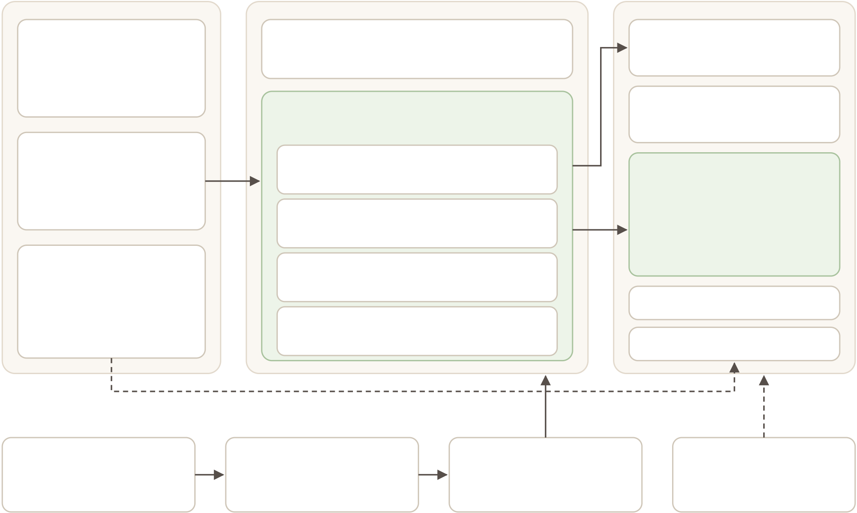
4 · SYSTEM ARCHITECTURE
Three tiers and a delivery pipeline
The browser talks to a Next.js server on a private server. The Next.js server talks to Supabase, which holds the database, sign-in, file storage and live updates. Most business rules live inside the database, so they apply no matter which client calls it.
USERS AND BROWSER | PRODUCTION SERVER (VPS) | SUPABASE (HOSTED)
People and roles | Caddy | Auth
Guest, registered user | Caddy | Password, email code, social
Guest, registered user | TLS certificates and reverse proxy | Password, email code, social
Tree owner, collaborator
Platform administrator | HTTPS | Next.js 16 app server | auth | API layer
Web browser | HTTPS | Node 22, run as a systemd service | user JWT | PostgREST tables and RPC
Web browser | HTTPS | Proxy | user JWT | PostgreSQL
Arabic first, right to left
Arabic first, right to left | HTTPS | Refreshes the session, guards private pages | user JWT | PostgreSQL
English switch | HTTPS | Refreshes the session, guards private pages | user JWT | 36 tables, row-level security
Desktop and mobile | HTTPS | Server Components | user JWT | 57 SQL functions
React 19 client UI | HTTPS | Load data for each page request | user JWT | Matching engine in SQL
 |  |  |  | Arabic phonetic search
 |  |  |  | Version 17 in production
React 19 client UI | HTTPS | Server Actions | user JWT | Version 17 in production
Tree chart and 360° view | HTTPS | Validated writes: next-safe-action and Zod | user JWT | Storage: 3 private buckets
Forms and search
Live tree updates | HTTPS | Route handler | user JWT | Realtime channel
Live tree updates | HTTPS | GEDCOM import and export | user JWT | Realtime channel
Realtime websocket: live tree changes
DELIVERY PIPELINE
GitHub repository | CI workflow | Deploy workflow | Database migrations
main branch and pull requests | Type-check, lint, build | SSH, pull, build, restart | Applied by hand
main branch and pull requests | Playwright and pgTAP jobs | Health check after restart | through the SQL editor
Figure 1. Runtime components and the delivery pipeline. Solid arrows are requests; dashed arrows are live or manual connections.
How a request flows
1. The browser calls the server. Caddy terminates TLS and passes the request to Next.js.
2. The proxy checks the session. It refreshes the Supabase session cookie and sends signed-out visitors away from private pages.
3. Server code calls Supabase as the user. Data loaders and server actions use the user’s token, so every query passes through row-level security.
4. The database enforces the rules. Policies decide which rows the user may see. Security-definer functions handle sensitive steps such as search masking, access approvals and match decisions.
5. The page renders on the server. Interactive parts such as the tree chart hydrate in the browser and subscribe to live changes.
Trust boundaries
The web app holds no service key. No code in the web app uses the Supabase service role, so a server bug cannot bypass row-level security.
Administrators are a database flag. Admin pages check the flag on the server, and the database refuses any attempt to set it through the API.
Files are private. Attachments, proof of family and identity documents sit in three private buckets with their own access policies.
Juthoor · System Design Report · October 2026 6 / 18

5 · TECHNOLOGY STACK
What we are using
A TypeScript monorepo managed by pnpm and Turborepo. The web app is in apps/web ; the
database schema, tests and seeds are in apps/database .
Frontend
 | Technology | Version | Role
  Layer
Framework | Next.js, App Router | 16.2 | Server rendering, routing, server actions, route handlers
UI library | React | 19.2 | Components and client interactivity
Language | TypeScript | 6.0 | Typed code across app and tests
Styling | Tailwind CSS | 4.1 | Utility styling with right-to-left support and design tokens
Components | shadcn/ui on Radix UI, lucide | latest | Accessible dialogs, menus, tabs, sheets, sidebar
icons
Forms | react-hook-form with Zod | 7.72, 4.3 | Form state and validation shared with the server
Server calls | next-safe-action | 7.10 | Typed, validated server actions with friendly bilingual errors
Data caching | TanStack Query | 5.96 | Client-side caching where pages need it
Tree layout | relatives-tree and a custom | 3.2 | Family chart with pan, zoom and connectors
chart
Genealogy | parse-gedcom and an in-house | 2.0 | GEDCOM 7 import and export
serializer
Arabic text | jslingua and in-house phonetic | 0.13 | Transliteration and name folding in the browser
rules
Motion and charts | Framer Motion, Recharts | 12, 2.15 | Animation and statistics
Fonts | Noto Kufi Arabic, Hanken | Google | Arabic and Latin typography
Fonts | Grotesk, Amiri, Cairo | Fonts | Arabic and Latin typography
Backend and data
Layer | Technology | Version | Role
Platform | Supabase, hosted | managed | Database, auth, storage, realtime, API
Database | PostgreSQL | 17 prod, | Schema, row-level security, business logic in SQL
15 local
Extensions | pg_trgm, unaccent, uuid-ossp | bundled | Similarity search, accent folding, identifiers
Auth | Supabase Auth with | 0.10 | Password, email code and social sign-in with cookie sessions
@supabase/ssr
Client SDK | supabase-js | 2.101 | Queries, RPC calls, storage and realtime
Runtime | Node.js | 22+ | Runs the Next.js server
Tooling and delivery
 | Technology | Version | Role
  Layer
Monorepo | pnpm workspaces, Turborepo | 9, 2.2 | Package management and task running
Unit tests | Vitest with Testing Library | 4.1 | Logic and component tests
End-to-end tests | Playwright | 1.51 | Browser tests against a local Supabase stack
Database tests | pgTAP | bundled | Tests for policies, masking and the matching engine
Lint | oxlint | 1.58 | Fast lint in CI
CI and deploy | GitHub Actions | hosted | Checks on every push; deploy to the server after checks pass
on main
Hosting | Linux VPS with Caddy and | self- | Runs the web app behind TLS
systemd |  | managed | Runs the web app behind TLS
Juthoor · System Design Report · October 2026 |  |  |  | 7 / 18


6 · FRONTEND DESIGN
How the web app is built
The frontend is organised in four layers. Pages render on the server by default; only interactive
parts run in the browser.
Routes  App Router groups  Components  UI building blocks  Data layer  Server-only modules  Supabase clients Session aware | Public pages | Auth pages | App pages | Admin pages |  | GEDCOM API
 | shadcn/ui on Radix | Tree chart, 360° view | Forms with Zod |  | Search, villages, families
 | Public loaders | User server actions | Admin guards |  | Query cache, realtime
 | Server client with cookies | Browser client for realtime |  |  | Middleware session refresh
Figure 2. Frontend layers, from routes at the top to the Supabase clients at the bottom.
Route map
 | Routes | Who can open them
  Area
Public | /, /about, /why, /how, /contact, /privacy, /terms | Everyone
Sign-in | /login, /sign-up, /forgot-password, /update-password, /auth/auth-code-error | Everyone
Dashboard | /dashboard, /dashboard/new, /dashboard/requests, /dashboard/connections | Signed-in users
Trees | /tree, /tree/[id], chart, people, person/[id], add-person, add-self | Signed-in users with tree
access
Discovery | /search, /families, /families/[surname], /villages, /villages/[id] | Signed-in users
Verification | /verify | Signed-in users
Admin | /admin/review, /admin/verifications | Administrators only
API | /api/tree/[id]/gedcom: GET exports, POST imports | Signed-in users, checked by
row-level security
Design system  Colours are defined once as tokens and switch for dark mode. The palette is olive, gold, terra and stone on a warm cream background. | Language and direction  The page starts in Arabic with right-to-left layout. A locale switch changes copy and direction. Layout uses logical start and end classes so the sidebar and panels mirror
correctly in both languages.
Olive | Gold | Terra | Cream | Key screens  Tree workspace. Chart with pan and zoom, add-relative buttons on each card, ghost cards for missing parents.
#3E7030 | #D4A31E | #B4532A | #F7F3ED
Arabic text uses Noto Kufi Arabic with Cairo and Amiri as fallbacks. Latin text uses Hanken Grotesk with Inter as fallback.
 |  |  |  |  | 360° person view. Parents above, children below, siblings and
 |  |  |  | spouses beside.
 |  |  |  |  | Admin review. Side-by-side match cards with agree, disagree
and missing marks.
Juthoor · System Design Report · October 2026 8 / 18

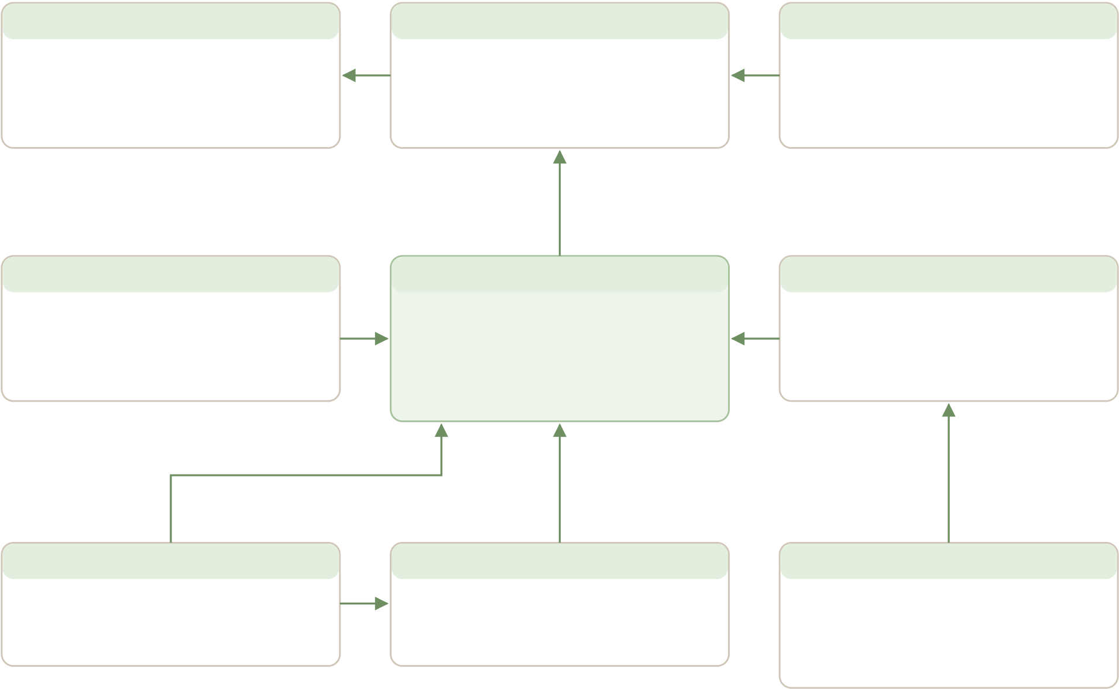
7 · BACKEND AND DATABASE
Where the data lives and how it is protected
The database follows the GEDCOM 7 model: people, names, events, families and places. Around
that core sit access control, media, verification and the matching engine.
Tables by domain
 | Tables | Purpose
  Domain
Genealogy core | trees, persons, person_names, events, families, family_children, | The family record in GEDCOM
Genealogy core | places | shape
Users and access | profiles, tree_members, identity_verifications | Accounts, roles, access requests, ID
checks
Content and media | person_profiles, person_attachments, place_profiles | Stories, photos, documents, village
pages
Search | match_paths, name_variants | Cached relationship paths, name
dictionary
Matching | match_features, match_features_dirty, match_block_keys, | Feature vectors, candidate pairs,
Matching | match_block_skips, matches, matching_runs, app_settings, | scores, runs, settings, opt-outs,
Matching | person_privacy_holds, eval_pairs, eval_runs | evaluation
Linking and review | person_links, merge_log, match_hints, match_audit, notifications, | Confirmed links, undo log, owner
Linking and review | contact_relay, overlay_refresh_queue | hints, audit, notices, anonymous
relay
profiles | owner | trees | tree | tree_members
id = sign-in account | owner | id, name, description | tree | tree_id, user_id
display_name, display_name_ar | owner | owner_id | tree | role: owner, collaborator, read-only
preferred_language | owner | is_public, private by default | tree | status: pending, approved, rejected
is_admin, protected by trigger | owner | gedcom_filename, imported_at | tree | proof_url, requester_note
tree
person_names | person | persons | person | events
person_id | person | id, tree_id | person | person_id or family_id
given_name, surname | person | gender | person | event_type: birth, death, marriage
lang, name_type, is_primary | person | display_name_ar, display_name_en | person | date_value, date_year
normalised and phonetic columns | person | is_living | person | place_id
gedcom_xref, notes
child | place
partners
family_children | family | families | places
family_id | family | id, tree_id | name_ar, name_en
child_id | family | partner1_id | district, coordinates
pedigree: birth, adopted, foster | family | partner2_id | depopulated_year
456 villages and places seeded
Figure 3. Core genealogy tables. Arrows point from a table to the table it refers to.
Juthoor · System Design Report · October 2026 | 9 / 18

7 · BACKEND AND DATABASE, CONTINUED
Security, search and storage
Security model
Mechanism | What it does
Row-level security | Every application table has policies. Tree data is readable when the tree is public, owned by the
user, or the user is an approved member. Writes need owner or collaborator rights.
Access helpers | can_access_tree, can_write_tree, is_tree_owner, is_tree_member and is_admin are shared by the
policies.
Definer functions | Search, access approvals, match decisions and link changes run as security-definer functions with a
pinned search path. Each one checks the caller itself.
Living-person masking | is_person_living treats anyone without a death record and born less than a century ago, or with no
birth year, as living. Search hides their birth year and village from non-members; relationship paths
show “Hidden relative”.
Match privacy | Owners never read the raw match table. They see a masked card view. Pairs with a living person
are never merged by an admin; both owners must accept.
Admin guard | A trigger blocks any change to the admin flag made through the public API.
Storage policies | Files live under a folder named after the uploader. Policies allow the uploader, the tree owner or
administrators, depending on the bucket.
Family Finder search
Search runs in one database function. It normalises Arabic spelling, builds phonetic keys and compares names with
trigram similarity. It scores given name, family name, father, mother, birthplace and birth year, and returns a score
breakdown. Private trees are redacted, and living people lose their birth year and village unless the searcher is the
owner or an approved member.
Storage buckets
 | Contents | Who can read
  Bucket
person-attachments | Photos and documents tagged to a person, such as portraits, | Anyone who can read that person’s
person-attachments | certificates and land deeds | tree
proof-of-family | Evidence uploaded with a write-access request | The requester and the tree owner
verification-docs | Government IDs and family evidence for identity checks | The uploader and administrators
Juthoor · System Design Report · October 2026 |  | 10 / 18

7 · BACKEND AND DATABASE, CONTINUED
The matching engine
The matching engine finds the same person recorded in different family trees. It is written in SQL and follows the Fellegi-
Sunter method used in record linkage.
Stage | What happens
1. Change queue | Triggers on people, names, events and families put the person and close relatives into a queue
whenever data changes.
2. Features | Each queued person gets a feature vector: transliterated, normalised and phonetic names for self,
parents, grandparents and spouses, plus life facts.
3. Blocking | Several blocking passes pick candidate pairs from different trees. Caps stop oversized groups from
slowing the run.
4. Scoring | score_pair weighs 25 fields. Hard vetoes reject pairs with a different gender, the same tree, birth years
more than 15 years apart, or a privacy hold.
5. Routing | Pairs with a living person become masked hints for both owners. Other pairs go to the admin review
queue. Automatic merging is switched off by default.
6. Linking | A confirmed link joins two records. Links form the Palestine Tree overlay. Any link can be revoked,
which removes its notifications, relay tokens and cached paths.
Open point. The batch function exists, but no schedule is defined in the repository. Running it nightly needs a scheduled job in

Supabase or on the server.
Environments and migrations
Local. The Supabase CLI runs the full stack in Docker. A reset builds all 48 migrations from scratch, and a demo seed
creates trees, people, matches and verifications.
Production. Hosted Supabase on PostgreSQL 17. Migrations are applied by hand after testing locally. The security
fixes of 12 October 2026 are now recorded in the migrations folder.
Types. The TypeScript database types are maintained by hand. Running the type generator overwrites them, so each
new table is added manually.
Juthoor · System Design Report · October 2026 | 11 / 18

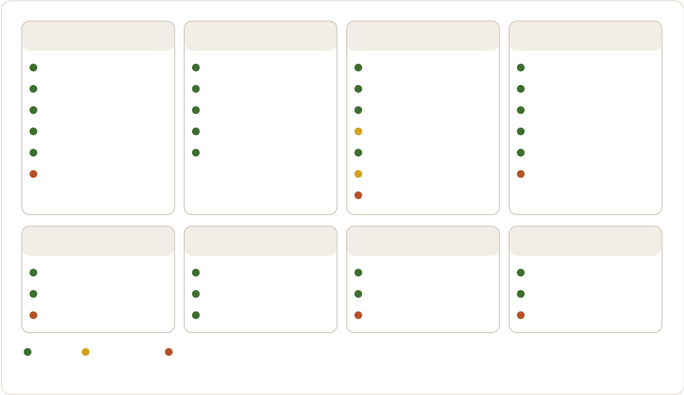
8 · PROCESS FLOWS
The eight modules and their status
This map follows Process Flow Diagram v1.2. Each line is one step from the diagram, marked by
what the code does today.
1.0 | Sign in and register | 2.0 | Home and information | 3.0 | Trees | 4.0 | Individual search
Sign up with email code |  | Home page |  | My trees list |  | Name chain, phonetic
Password, code or social |  | Who we are, why, how |  | Chart, 360° view, edit |  | Village, district filter
Forgot password |  | Contact us |  | Create or import GEDCOM |  | How you are connected
Identity verification |  | Privacy policy and terms |  | Export GEDCOM |  | Achievements, contribution
Add yourself to a tree |  | Arabic and English switch |  | Access requests |  | Photos and documents
Link account to a person |  |  |  | Palestine Tree overlay |  | Contact by request
Vertical and fan views
5.0 | Family search | 6.0 | Village search | 7.0 | Pictures | 8.0 |  | Documents
Search by family name |  | List with district filter |  | Upload photo to a person |  | Upload document to person
Family page |  | Village page and history |  | Type tags, private storage |  |  | Access follows the tree
Family gallery, archive |  | Village photos |  | Search all pictures |  | Search all documents
Built | Partly built | Not built |  | Admin review and verification screens also exist, outside the eight modules.
Figure 4. Module map from Process Flow Diagram v1.2 with the build status of each step.
How the flow review comments are reflected
Comment | Point raised on 11 October 2026 | Where the build stands
G1 | Define PFT, IFT and VCC | Defined in the glossary, appendix B
G2 | Use one name per role and list all | Roles in the code: guest, registered user, tree owner, collaborator, read-only
G2 | roles | member, administrator. No moderator role
#4 | Anyone could claim to be an existing | No claim flow exists. Identity checks are per account; write access needs owner
#4 | person | approval
#6 | Social login, sign out and delete | Social sign-in and sign out are built. Account deletion is not
account
#8 | Privacy policy, terms, FAQ and a | Privacy policy, terms and the switch are built. No FAQ page
language switch
#18 | Choose the district first, then the | The village picker shows each district but does not filter by it first
village
#19 | Search results must respect privacy | Built: birth year and village are hidden from non-members
for living people
#20 | One access check with an access- | Built as one check with a request-access path, figure 6
denied branch
#21 | Show the shortest path instead of | Built: the shortest path, with hidden names for living people
every connection
Juthoor · System Design Report · October 2026 | 12 / 18

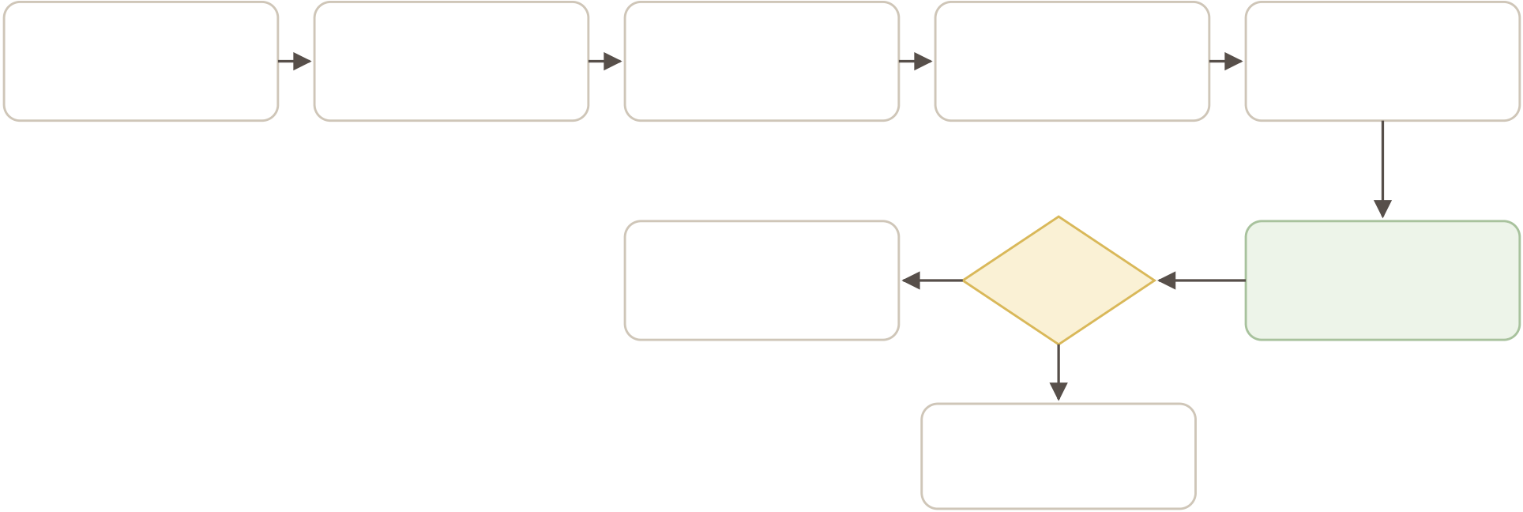
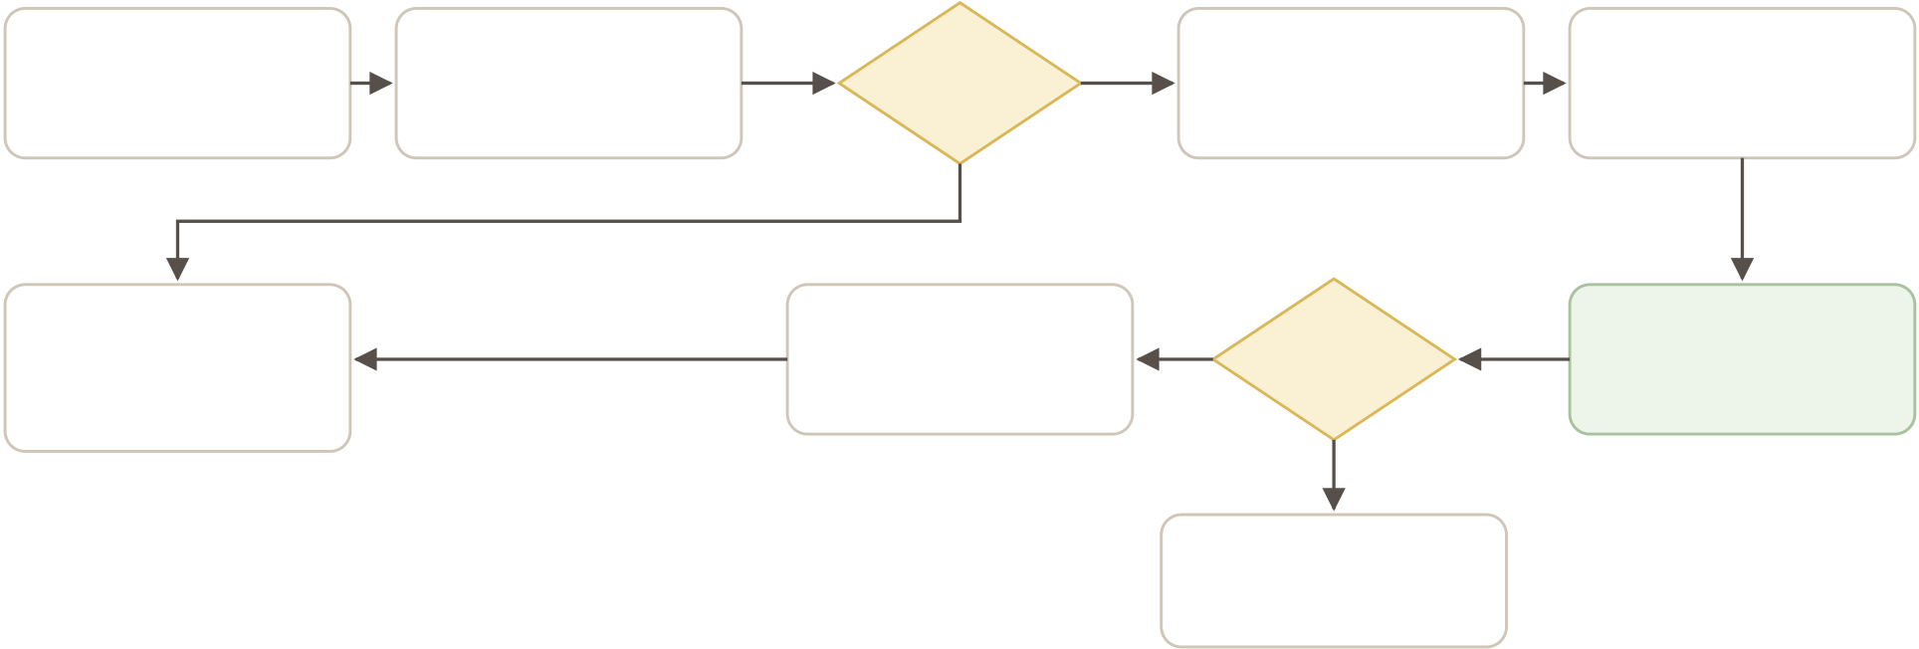
8 · PROCESS FLOWS, CONTINUED
Three key flows
A. Registration and identity verification
Sign up | Confirm the | Profile created | Yes | Create a tree | Upload ID and
email and password | 8-digit email code | automatically | Yes | or add yourself | family evidence
Documents stay in a private bucket. | 8-digit email code | Verified account | Yes | Approved? | Administrator
Only the user and administrators
Only the user and administrators | 8-digit email code | can manage records | Yes | Approved? | reviews documents
can open them.
No
Rejected with note
user may resubmit
Figure 5. Process steps 1.1 and 1.2 as built. Matching a new user to an existing person, step 1.1.2, is not built.
B. Requesting access to a family tree
Search finds | Open the | Public or | No | Request read or | Write access needs
a relative | family tree | member? | No | write access | proof of family
Yes
View the tree | full view | Member access | Yes | Approved? | Tree owner
living details hidden | full view | granted by role | Yes | Approved? | reviews the request
unless a member
No
Rejected
with a reason
Figure 6. Access requests. The access check sits right after a tree is opened, as the flow review asked.
Juthoor · System Design Report · October 2026 | 13 / 18

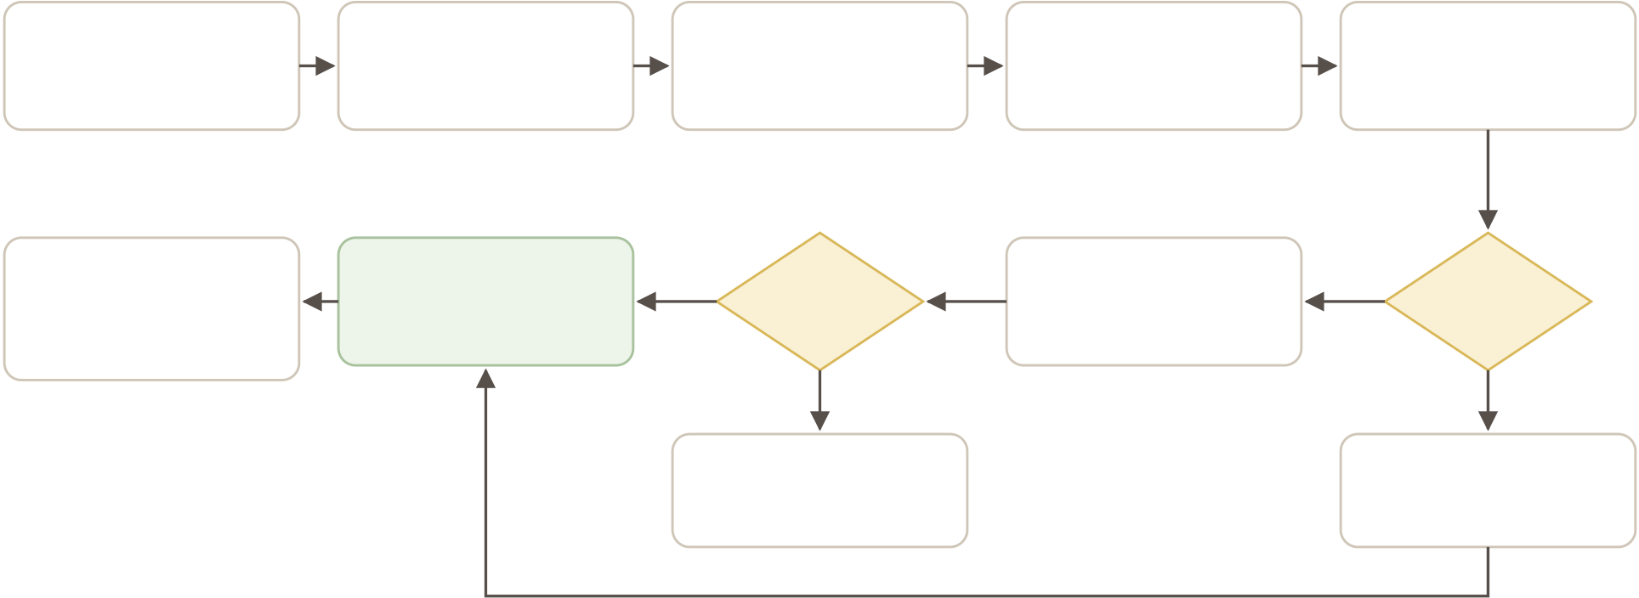
8 · PROCESS FLOWS, CONTINUED
Matching flow and roles
C. Matching records across trees
Person data | Change queued | Yes | Batch refreshes | Blocking finds | Yes | Score each pair
added or edited | for matching | Yes | name features | candidate pairs | Yes | on 25 fields
Palestine Tree | Confirmed link | Yes | Both | Masked hint to | Yes | Living

overlay updated | between records | accept? | both tree owners | person?
owners notified
No No
Silent decline Admin review
no link is made merge, reject, defer
merge
Automatic merging is switched off by default. High scores still go to review until precision is measured.
Figure 7. The matching flow. Any confirmed link can be revoked later, which removes it from the overlay.
Roles and what each can do
 | Who | Can do
  Role
Guest | Not signed in | Read the public information pages and sign up
Registered user | Any signed-in account | Create trees, search, verify identity, request access to other trees
Tree owner | The creator of a tree | Everything on the tree; approve or reject access requests; accept or
decline match hints; place privacy holds; import and export
Collaborator | Approved member with write | Add and edit people, relationships, stories, photos and documents
access
Read-only member | Approved member with read | See the full tree, including details of living people
access
Administrator | Account with the admin flag | Review matches, review identity documents, edit villages and village
pages
Juthoor · System Design Report · October 2026 | 14 / 18

9 · QUALITY, TESTING AND DELIVERY
How changes are checked and shipped
Automated tests
Suite | Size | What it covers
Unit tests | 19 files, 116 cases | GEDCOM parsing and export, phonetic rules and their parity with SQL,
privacy helpers, password policy, error messages, tree layout rules
Database tests | 17 pgTAP files; 183 | Row-level security, living-person masking, search masking, feature
Database tests | assertions passed in the | building, blocking, scoring, review views and link functions
last recorded run, 12 July
2026
End-to-end tests | 6 Playwright specs | Public pages, page access for guests and users, private items, admin
merge, reject and defer, owner accepting a connection
GitHub workflows
Workflow | When it runs | What it does
CI | Every push and pull request | Installs with a frozen lockfile, type-checks, lints and builds the web
app
Deploy | After CI passes on main, or by | Connects to the server by SSH, resets to main, installs, builds,
Deploy | hand | restarts the service and runs a health check
Integration tests | Pull requests from people | Starts Supabase locally, builds the app and runs Playwright
with write access
Release and versions | Changesets and release tags | Version bumps and changelog

Pushing to main deploys to production. Database migrations are not part of the deploy. A migration must be applied to

Supabase before the code that needs it reaches main.
Repository layout
apps/web | Next.js app: pages, components, data layer, tests
apps/database/supabase/migrations | 48 ordered SQL migrations
apps/database/supabase/tests | pgTAP database tests
apps/database/supabase/demo | Local demo seed: accounts, trees, matches and verifications
docs | Matching engine plan, auth notes, loop log and this report
scripts/walkthrough | Scripts that record the product walkthrough video
.github/workflows | CI, deploy, integration tests, release
Juthoor · System Design Report · October 2026 |  | 15 / 18


10 · GAPS, RISKS AND NEXT STEPS
What to fix or decide before launch
# |  | Why it matters | Suggested action | Priority
  Finding
1 | GEDCOM export includes | Any signed-in user can export a public tree, | Filter living people from | 
1 | living people | including birth years and villages of living | shared exports; check
1 | living people | relatives | export rights on the server
2 | Two definitions of “living” | The people list uses a flag; search uses an age | Use the database age rule | 
2 | Two definitions of “living” | rule. They can disagree | everywhere
3 | Tree chart loads life data | Non-members of a public tree may see living | Apply the same mask as the | High
3 | without masking | people’s details on the chart | people list | High
4 | Views of private data are | The privacy policy promises logged access to | Add an access log and
  Medium
 | not logged | identity documents | record ID document views
first
5 | Access logic lives in several | Rules can drift between the database helper, | Make one database function
  Medium
 | places | the search function and the web code | the single source
6 | Contact by request is not | Families cannot reach each other after a match | Wire the existing relay table
  Medium
 | built |  | to a request screen
7 | No moderator role or | Every review falls on platform administrators, | Decide roles, then add a
  Medium
 | appeal path | who can all open ID documents | moderator role with
narrower rights
8 | Contribution to the Cause is | Political details about living people could be | Keep the field for deceased
  Medium
 | open for living people | published in public trees | people only, or remove it
9 | Matching batch has no | Matches only appear when someone runs the | Add a nightly scheduled job
  Medium
 | schedule | batch
10 | Hosting region and AI | The law that applies and what providers keep | Record the region and
  Medium
 | provider terms not | are unknown | provider terms in the privacy
 | documented | are unknown | policy
11 | Privacy contact email is a | Users cannot exercise their data rights | Set a real address before
  Medium
 | placeholder |  | launch
12 | Project docs are out of date | The README and progress tracker describe an | Refresh them from this | 
12 | Project docs are out of date | earlier stage | report
Decisions needed from the steering group
1. Shared people. Who approves when one person sits in several family trees.
2. Villages and places. Who builds and maintains the list, and which sources count. 3. Moderators. How many, which languages, who appoints them, and where an appeal goes. 4. Hosting. Which country, which law, and what AI providers may keep.
5. Contribution to the Cause. Remove the field, or keep it only for deceased people.
Juthoor · System Design Report · October 2026 | 16 / 18

APPENDIX A
Database table inventory
 | Purpose
  Table
profiles | One row per account: display names, language, admin flag
trees | A family tree, its owner and whether it is public
tree_members | Members, roles and access requests with proof
persons | A person in a tree
person_names | Arabic and English names with normalised and phonetic
forms
events | Birth, death, marriage and other events with date and place
families | A couple, and the unit children belong to
family_children | Links a child to a family, with pedigree type
places | Villages, towns and cities with districts and coordinates
place_profiles | Village history pages, edited by administrators
person_profiles | Achievements and contribution to the cause
person_attachments | Photos and documents attached to a person
identity_verifications | ID check requests and their review
match_paths | Cached relationship paths, stored without names
name_variants | Dictionary of name spellings
match_features, match_features_dirty | Per-person matching features and the change queue
match_block_keys, match_block_skips | Blocking keys and skipped oversized groups
matches | Scored candidate pairs, admin only
matching_runs, app_settings | Batch run history and engine settings, including the auto-
merge switch
person_privacy_holds | Owner opt-outs that exclude a person from matching
eval_pairs, eval_runs | Labelled pairs and results for measuring match quality
person_links, merge_log | Confirmed links between records and the undo log
match_hints | Masked accept or decline queue for tree owners
match_audit | Log of every match status change
notifications | In-app notices for owners
contact_relay | Anonymous, expiring contact tokens; not yet used by the app
overlay_refresh_queue | Deferred refresh of the Palestine Tree overlay
private_items, items, content_blog_posts, content_blog_post_comments | Left over from the starter template; candidates for removal
Views: match_review_cards, v_match_explanations, and the materialised view person_identity_groups that forms the Palestine Tree
overlay.
Juthoor · System Design Report · October 2026 | 17 / 18

APPENDIX B
Glossary
PFT | Palestine Family Tree. The combined tree formed by linking all individual trees.
IFT | Individual Family Tree. One user’s own tree.
VCC | Village, city or camp. A place of origin.
GEDCOM | The standard file format for exchanging genealogy data. Juthoor uses version 7.
Row-level security | Database rules that decide, row by row, what each user may read or change.
RPC | A database function called through the API.
Fellegi-Sunter | A statistical method for deciding whether two records describe the same person.
Blocking | Grouping records by shared keys so only likely pairs are compared.
pgTAP | A testing framework that runs tests inside PostgreSQL.
Server action | A server function called from a form or button in Next.js.
Juthoor · System Design Report · October 2026 |  | 18 / 18

