MALAMTEAM

The MalamTeam Benchmark Platform
Prove it, run it, and keep it healthy.
A full-lifecycle platform for NVIDIA GPU infrastructure: it deploys itself to your hardware, benchmarks and stress-tests direct liquid cooling against air, streams telemetry continuously, analyzes the results with honest statistics, and predicts component wear before it becomes downtime.
DOCUMENT  MalamTeam Benchmark Platform Whitepaper | AUDIENCE  Infrastructure & procurement leaders
VERSION  Revision B, full lifecycle | CLASSIFICATION  Public (method details withheld)
The implementation behind this platform, including its architecture, algorithms, data pipeline and source code, is proprietary and is not disclosed in this document.

Executive summary

Replace guesswork with evidence across the whole lifecycle
AI compute is now thermally bound, yet the decisions around it (which cooling to choose, how densely to build, when to service) are still made on spec sheets and guesswork.
The MalamTeam Benchmark Platform replaces guesswork with evidence across the entire hardware lifecycle: automated installation, live benchmarking and stress testing, continuous telemetry, statistical analysis, and datasheet-grounded predictive maintenance. It is a single system that serves you from the first boot to the last hour of service life. This paper focuses on the business value the platform delivers; the implementation itself is proprietary.
5 stages, 1 platform  Install, test, observe, analyze and predict in one continuous loop instead of five disconnected tools. | 15+ workloads  A standardized GPU and CPU benchmark and stress battery, run on live hardware with no synthetic mode. | Years of history  Telemetry retained and archived so questions asked next year still have data to answer them.

The challenge

Four blind spots, one expensive consequence
Each of these is manageable on its own. Together, they mean a multi-million-dollar GPU estate is being run on instinct.
Throttling you can’t see  Dashboards show that a GPU is “busy,” but not that it is running below its rated clocks. The loss is continuous and goes unmeasured. | Claims you can’t compare  Vendors quote ideal conditions on different gear and workloads. There is no common yardstick to settle a decision.
Failures you can’t anticipate  Heat shortens component life, yet failures still arrive unannounced, as downtime rather than as an early warning you could plan around. | History you never kept  Without durable, queryable records, you can’t prove a regression, justify a refresh, or show an auditor how the fleet behaved last quarter.

The platform at a glance

One continuous loop, not five disconnected tools
Most teams piece this together from an install script, a benchmark harness, a monitoring stack and a spreadsheet. The MalamTeam platform delivers it as one system, with each stage feeding the next.
STAGE 01  Deploy  Installs itself and the test tooling onto your hosts, on any supported OS, even air-gapped. | STAGE 02  Test  Runs the paired benchmark and stress battery on identical servers, live. | STAGE 03  Observe  Streams per-component telemetry continuously and retains the history. | STAGE 04  Analyze  Aggregates with medians & variance and computes the paired delta. | STAGE 05  Predict  Bands each component by risk against datasheet ratings and recommends service.
Telemetry and prediction continue to run long after the benchmark ends, informing the next decision.

Capabilities

What each stage actually does for you
Stage 01: Deploy

Zero-touch, air-gap-ready installation
Standing up a benchmark and monitoring stack across mixed hardware typically takes a week of manual effort. With this platform it takes a single command: the platform resolves the right packages for each host’s operating system and installs them, online or fully offline.
- Installs itself and the full test toolchain across supported Linux families automatically
- Selects the correct package set for each OS, with no per-server script editing
- Ships as one self-contained bundle for fully air-gapped sites that never connect to the internet
- Node-locked and license-gated, so a deployment runs only where it is authorized
Stage 02: Test

Benchmarks and stress tests, on real hardware
Short benchmarks flatter cooling; sustained load exposes it. The platform runs both: a full workload battery for peak numbers, and long-duration stress and soak runs that drive hardware to its thermal limits, which is exactly where air cooling falls behind and liquid cooling pulls ahead.
- A standardized GPU and CPU battery covering compute, inference, I/O and network workloads
- Sustained stress and soak runs that surface throttling, instability and thermal drift
- Paired execution on identical servers at the same time, so cooling is the only variable
- Every thermal throttling event is detected and placed on a timeline

Stage 03: Observe and remember

Telemetry is the asset. History is the advantage.
A live chart tells you what is happening now. A year of queryable history tells you whether things are getting worse, whether the last change helped, and what to buy next. The platform is built to keep both, affordably.
Full fidelity  Live & recent  Every signal at native resolution for real-time charts and incident forensics.  last days | Summarized  Short-term trend  Rolled up to keep trends sharp while the data footprint shrinks.  weeks | Coarse  Long-term trend  Coarser roll-ups for capacity planning and quarter-over-quarter comparison.  months | Archived  Cold store  Exported to a durable, open-format archive that remains queryable for audits.  years

Why the history pays for itself
Prove a regression  When performance drops, compare against the baseline already captured instead of relying on memory. | Justify the refresh  Show how components aged and throttled over time, and turn a refresh request into an evidence-backed case. | Answer the auditor  Durable history answers “how did the fleet behave last quarter?” even after the live rows are gone.
Designed to keep history affordable
Storing everything at full resolution forever is too expensive, which is why most teams end up keeping nothing. Tiered roll-ups and an open-format cold archive preserve the signal while reducing the cost. When automatic offload is disabled, data is retained rather than silently dropped.

Stage 04: Analyze

Honest statistics, not lucky peaks
A single screenshot of a good run proves nothing. The platform reports the full shape of the data, including central tendency and spread, so every result stands up to a skeptical reviewer, and the paired comparison attributes each difference to cooling alone.
- Medians, run-to-run variability and within-run variance for every workload
- Paired-comparison deltas computed on identical hardware
- Throttle-event timelines alongside the throughput story
- Procurement-grade output: reproducible, exportable, auditable
Stage 05: Predict

Preventive maintenance you can schedule
The platform tracks every component and scores it against published reliability data, turning heat-driven wear from an unplanned outage into a planned service window. It never estimates a figure that the vendor has not published.
- Per-component risk bands for GPU, VRM, fans, pump/CDU, storage, memory and PSU
- Grounded in vendor datasheet ratings; when a rating is missing, the platform reports it as missing instead of guessing
- Rated MTBF shown as a risk band; endurance and SMART wear shown as per-unit percentages
- Concrete recommendations with service windows, for example “inspect within 14 days”

The physics, measured

Where air sags, liquid holds
A representative view of sustained performance over a long stress run. The air-cooled curve steps down as the chip throttles; the liquid-cooled curve stays near its ceiling.
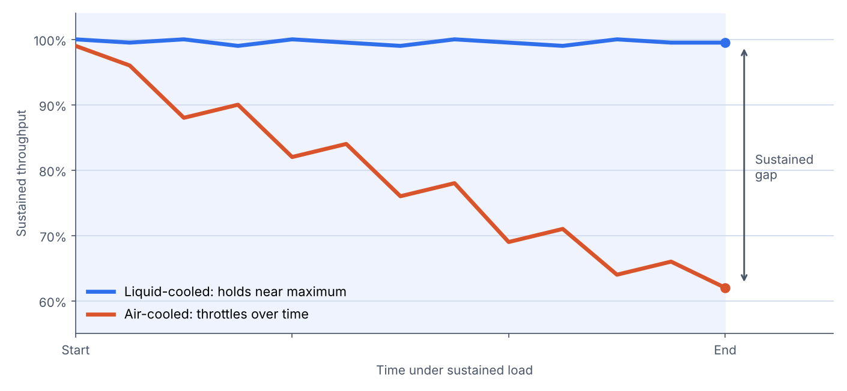
Representative illustration with normalized axes. The curves depict the thermal behavior the platform measures, not specific test results.

What makes it unique

Built to be trusted by engineers and auditors alike
01 | One lifecycle, one system  Install, test, observe, analyze and predict in a single platform, instead of five tools held together with scripts.
02 | True paired testing  Identical hardware, identical workload, same time. The only controlled difference is cooling, so the result is not open to debate.
03 | Statistical honesty  Medians, spread and variance instead of a single lucky peak. Confidence is reported explicitly.
04 | No invented numbers  Reliability figures are taken from named vendor datasheets. A missing rating is left out, never estimated.
05 | History as an asset  Tiered retention and open-format archive keep years of queryable telemetry without runaway storage cost.
06 | Runs anywhere, even offline  Deployable fully air-gapped and node-locked, for secure facilities that never touch the public internet.

An honest assessment

Advantages and trade-offs
A platform built on honest measurement should be equally transparent about itself. Below are its strengths, along with the considerations to plan for.
ADVANTAGES | CONSIDERATIONS
Evidence over claims. Reproducible, paired, statistically honest results you can put in a procurement decision.  Whole lifecycle in one place. From automated installation to predictive maintenance, with fewer tools, fewer hand-offs and fewer surprises.  Finds the weakest hour, not just the best second. Stress and soak runs expose throttling that short benchmarks hide.  History that compounds. The longer it runs, the more valuable it becomes for trends, regressions, refresh cases and audits.  Trustworthy by design. No fabricated ratings; a missing figure is shown as missing.  Secure and self-contained. Air-gap deployable, node-locked, read-oriented access to your fleet. | Best comparison needs paired hardware. The cleanest proof uses two matched servers; without a pair you still get telemetry and PdM, but not a like-for-like delta.  Testing takes hardware offline. A rigorous benchmark window occupies the servers under test, so it should be scheduled rather than run in the background.  Predictions are only as good as the datasheets. Where no vendor rating exists, that component is covered by telemetry only, rather than by an estimated figure.  History has a storage footprint. Even with tiered roll-ups, long retention consumes storage, which should be budgeted deliberately.  It measures and advises; it does not control. By design it will not reconfigure or power-cycle your fleet; all actions remain with your team.  Initial setup needs access. Credentials and reachability to the target hosts are required to deploy and observe.

Where it fits
BEST FIT WHEN  - You are choosing or defending a cooling or density strategy and need proof  - You run high-TDP GPUs where thermal headroom decides throughput  - You operate secure or air-gapped facilities  - You want to catch component wear before it becomes downtime | PROBABLY NOT NEEDED WHEN  - You run a handful of lightly-loaded machines that never approach thermal limits  - You only need a one-off number and will never look at trends again  - You require an active control plane that reconfigures hardware for you

Competitive landscape

Why the alternatives fall short
Each existing approach addresses part of the problem. An integrated, evidence-first platform addresses all of it.
Capability | Vendor spec sheets | Generic DCIM / monitoring | Manual benchmarking | MalamTeam Platform
Automated, repeatable deployment (auto-install) | No | Partial | No | Yes
Identical-hardware paired comparison | No | No | Partial | Yes
Live benchmark + stress / soak testing | No | No | Partial | Yes
Statistical analysis (variance / CoV) | No | No | No | Yes
Thermal throttle timeline | No | Partial | No | Yes
Continuous component telemetry | No | Yes | No | Yes
Multi-year historical archive | No | Partial | No | Yes
Datasheet-grounded predictive maintenance | No | Partial | No | Yes
Auditable, no-fabrication data policy | No | No | Partial | Yes
Air-gapped / offline deployment | No | Partial | Partial | Yes
Yes: fully addressed. Partial: partly addressed. No: not addressed. Positioning is indicative and reflects typical offerings in each category rather than any specific product.

Advantages & outcomes

What the proof is worth
01 | More sustained compute per rack  Holding boost clocks instead of throttling turns the same silicon into more usable throughput, and better cooling enables denser, higher-TDP deployments.
02 | Procurement-grade ROI  Reproducible, independent numbers replace vendor claims in the business case, giving engineering and finance a figure they can both approve.
03 | Fewer surprise failures  Predictive maintenance converts heat-driven wear from an unplanned outage into a scheduled, predictable intervention.
04 | Decisions backed by history  Years of queryable telemetry turn capacity planning, regression hunts and refresh cases from opinion into evidence.
05 | Trust that survives scrutiny  An auditable method and a no-fabrication data policy mean the results hold up when a skeptical reviewer digs in.

Enterprise-ready, secure by construction
- Air-gapped delivery: ships as a single self-contained bundle that installs and runs with no internet connection.
- Node-locked licensing: each deployment is bound to its authorized hardware, with tamper-resistant, anti-rollback enforcement.
- Least-privilege access: connects to target systems through a constrained, read-oriented model: measurement, not control of your fleet.

Conclusion

Stop estimating. Start proving.
The cooling decision, and the density, refresh and maintenance decisions that follow, should not rest on a spec sheet. Bring two identical servers and the platform will deploy itself, benchmark and stress-test both, and deliver the numbers, the history and the maintenance plan. It then continues to verify that advantage for the life of the fleet.
Next step: Request a paired evaluation on your own hardware.
Disclaimer: This whitepaper describes capabilities and business value only. The implementation (architecture, algorithms, data pipeline and source code) is proprietary and intentionally not disclosed. Benchmark figures and chart curves shown are illustrative and representative, not specific test results. Competitive positioning is directional and does not reference any single named product.

