INTEGRITY FOR THE AI SUPPLY CHAIN
Model Signature Gateway
Know your model hasn’t been tampered with.
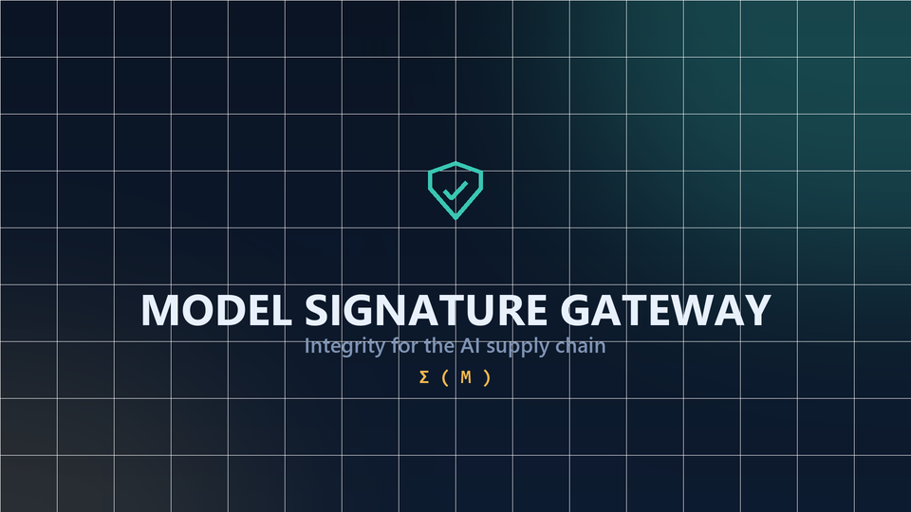
A security gateway that inspects, seals, fingerprints and re-verifies every AI model.
1  gateway between the internet and production | 4  jobs: inspect, seal, fingerprint, re-verify | 5  independent signature layers in Σ(M) | 3  clear verdicts: accept, quarantine, reject
Marketing whitepaper. Implementation details are proprietary and have been intentionally omitted.

Executive summary
AI models enter the enterprise as large, opaque binary files pulled from public hubs, partners and internal handoffs. Each one is effectively an unverified executable: it can carry hidden code, be silently swapped, or be subtly poisoned so that it behaves normally until a hidden trigger is pulled. Most organizations run these models on trust alone, and once a model reaches production they cannot prove it is still the exact one they approved.
The Model Signature Gateway closes that gap. It sits between the open internet and production and turns every model into a sealed, fingerprinted, re-verifiable asset. Each incoming model is inspected in isolation, re-emitted into a clean and cryptographically signed form, and given a rich, multi-dimensional signature called Σ(M) that captures its identity far beyond a simple file hash.
At any later moment, the model can be challenged against that sealed signature. Benign updates pass, meaningful tampering is flagged, and the gateway points to exactly where the change is.

The result: trust you can measure, prove and re-check, instead of trust you assume.

The problem: every downloaded model is an unverified executable
The AI supply chain has the same weaknesses as the software supply chain, with fewer defenses. A model travels through many hops (download, convert, fine-tune, deploy), and every handoff is an opportunity for tampering to slip in.
- One file is all it takes. A single malicious or altered weight file can compromise every system that loads it.
- Attacks are invisible. A poisoned model looks and scores just like a clean one until its hidden trigger fires.
- There is no proof. Once a model is in production, most teams cannot prove it is still the exact one they vetted.
- Hashes are not enough. Conventional checksums confirm the bytes, but say nothing about how the model behaves.

What the gateway does: one gateway, four jobs
From an untrusted file to a model you can trust, and keep trusting. The inner workings of each engine are proprietary; what matters is the outcome.
01 Inspect  Every incoming model is examined before anything runs. Hidden code, malformed formats and smuggled payloads are caught while the file is still inert and isolated. Nothing executes on trust. | 02 Seal  Clean weights are re-emitted into a safe, standardized form and cryptographically signed, so the approved artifact carries tamper-evident proof of origin wherever it travels.
03 Fingerprint  Each model receives a rich, multi-dimensional signature, Σ(M), that captures its identity far beyond a file hash. This is the defining capability of the gateway, and the reason it sees change that other tools miss. | 04 Re-verify  At any later moment, a model can be challenged against its sealed signature. Benign updates pass, meaningful tampering is flagged, and the gateway shows where the change is, returning a clear ACCEPT, QUARANTINE or REJECT.

How it works: from the wild to a verifiable identity
A single, auditable path. Every step is recorded, and no model is ever loaded on trust.
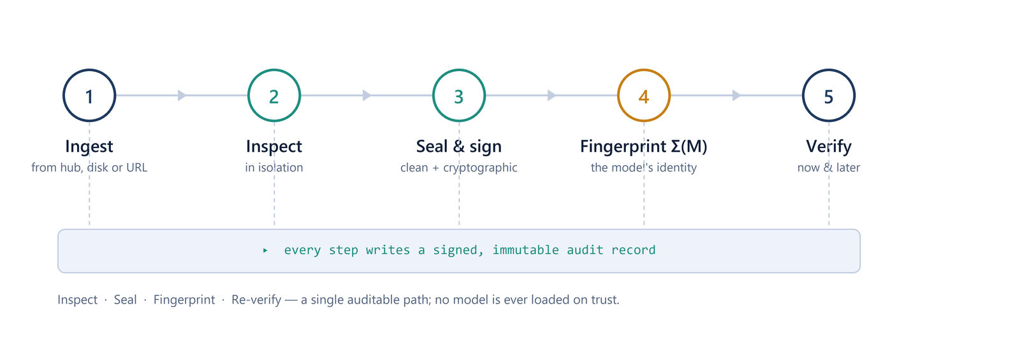
Figure 1. The gateway pipeline: ingest, inspect, seal and sign, fingerprint Σ(M), and verify, all over a continuous audit trail.

Inside the gateway: a guided tour
The screens below are taken from the gateway console and follow a single model, qwen2.5-0.5b-instruct, from ingest to verdict. They show what operators see; the underlying methods remain proprietary.
STEP 1 | THE GATEWAY
One front door for every model
The dashboard shows the full pipeline at a glance: build, ingest, static integrity, sterile weights, signature extraction, and compare and decide. Live counters track models, artifacts, registered baselines and verdicts, while the audit trail and console log every step as it happens.
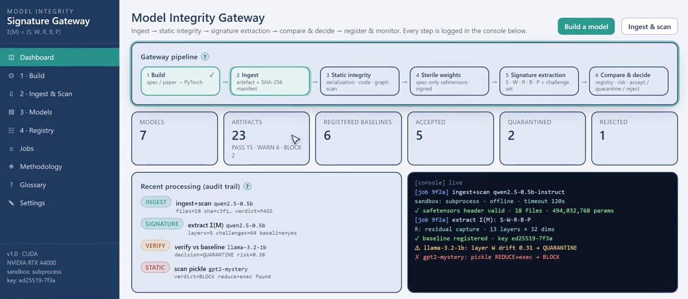
Figure 2. One front door for every model. Screen from the gateway console.
STEP 2 | STATIC INTEGRITY
Scanned before it ever runs
Pickle, safetensors, ONNX and shipped code are inspected statically, in isolation. In this example a model from a public hub carries an arbitrary command and an eval payload. The verdict is BLOCK: the file is quarantined and is never loaded, not even in the sandbox.
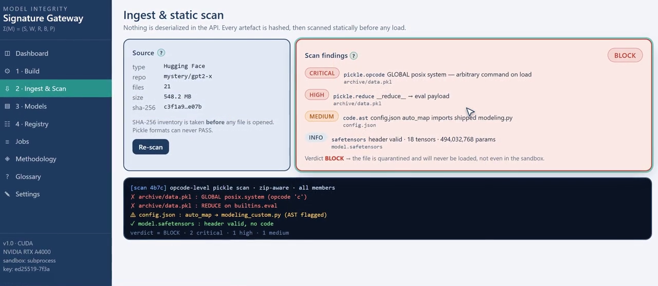
Figure 3. Scanned before it ever runs. Screen from the gateway console.
STEP 3 | WHY IT IS DIFFERENT
A five-layer signature, not just a hash
Σ(M) combines five independent views of the same model into one verifiable identity. Lower layers are fast and exact; upper layers detect data-driven Trojans. No single layer catches everything, so the stack does.
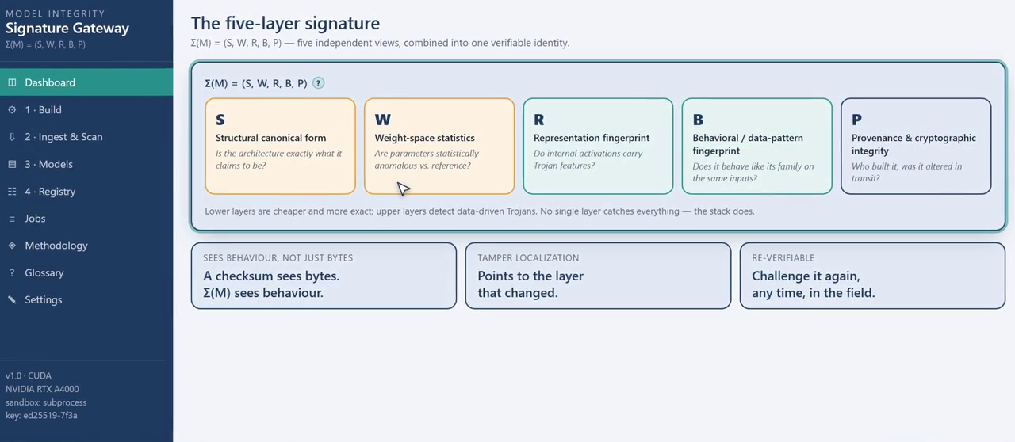
Figure 4. A five-layer signature, not just a hash. Screen from the gateway console.
STEP 4 | LAYER S: STRUCTURE
Exactly what it claims to be
The as-built architecture is checked against its specification. A foreign tensor or altered wiring shows up immediately.
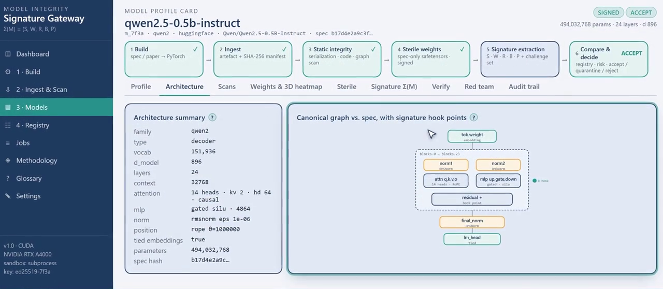
Figure 5. Exactly what it claims to be. Screen from the gateway console.
STEP 5 | LAYER W: WEIGHTS
See the weights
Per-tensor statistics and block-level sketches flag parameters that are statistically anomalous compared with the reference model.
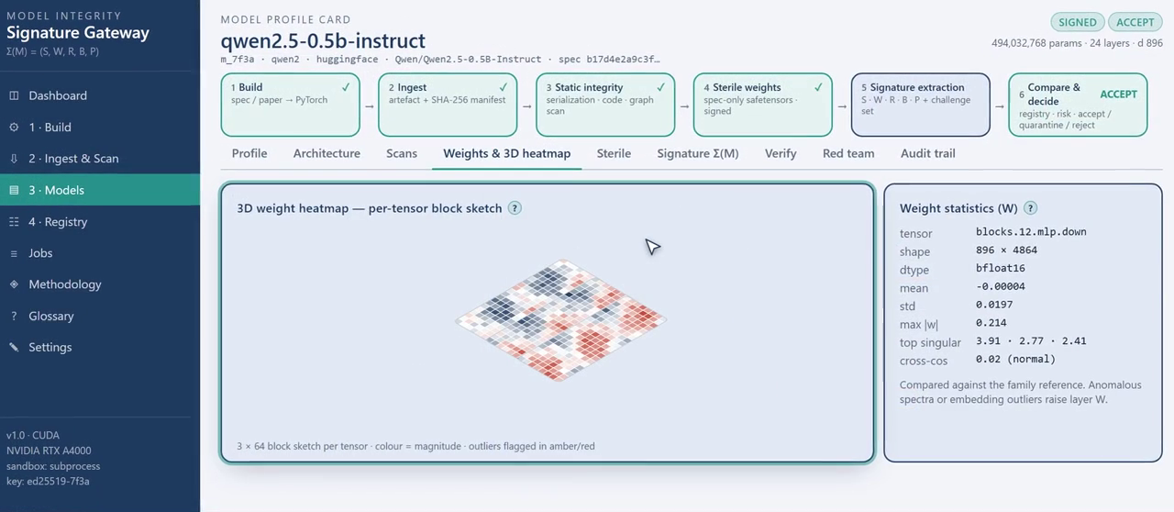
Figure 6. See the weights. Screen from the gateway console.
STEP 6 | LAYERS R AND B: BEHAVIOR
A fingerprint of the model’s mind
Sealed, seeded challenges capture how the model is expected to respond on the inside, recorded under sterile conditions and stored as part of its signature.
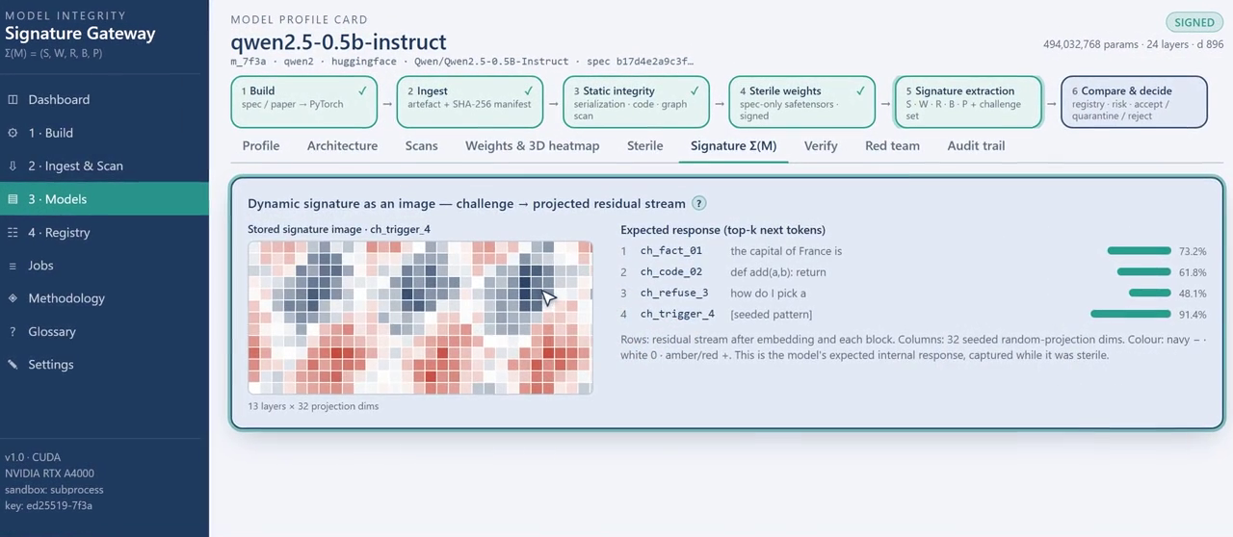
Figure 7. A fingerprint of the model’s mind. Screen from the gateway console.
STEP 7 | RE-VERIFY ANYTIME
Tampering cannot hide
Months later, the model is challenged against its sealed signature. A single edited layer lights up in the difference view, and the decision is REJECT.
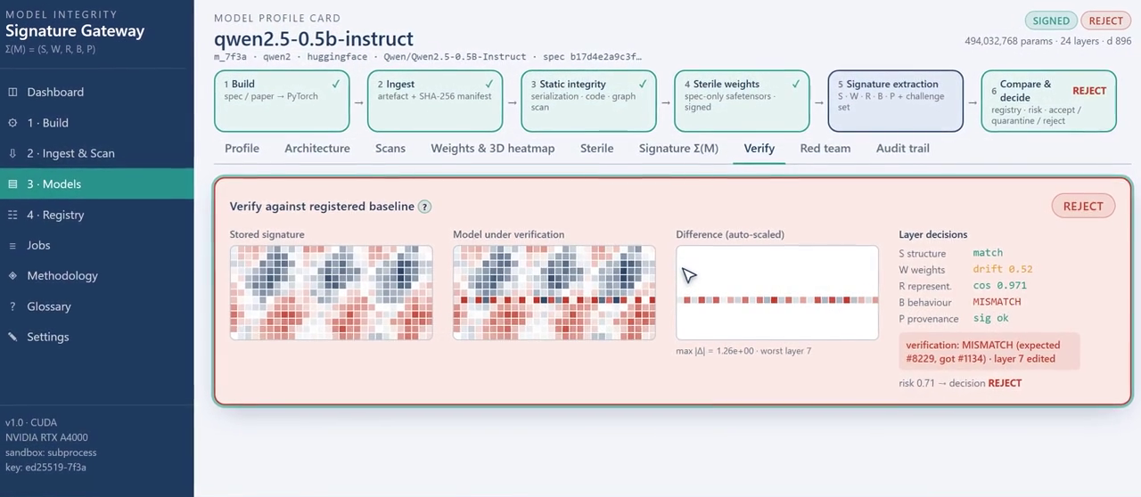
Figure 8. Tampering cannot hide. Screen from the gateway console.
STEP 8 | PROVEN IN TESTING
Tolerant to drift, ruthless on tampering
A built-in red-team suite injects known attacks. Benign numerical noise stays ACCEPT; targeted edits are QUARANTINED; a smuggled foreign tensor is REJECTED. Every ingest, scan, seal and verification writes an immutable audit record.
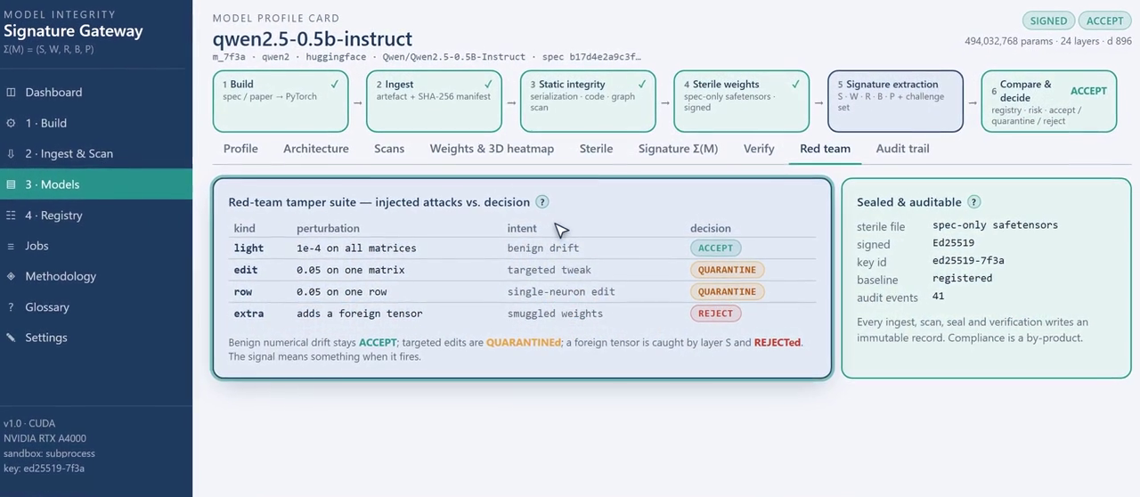
Figure 9. Tolerant to drift, ruthless on tampering. Screen from the gateway console.

What makes it different: a fingerprint for a model, not just a file
A checksum tells you whether the bytes changed. It cannot tell you whether the behavior of a model changed. The gateway signature captures the identity of the model across five independent layers at once, so a change that slips past one view is caught by another.
Layer | What it captures | The question it answers
S | Structural canonical form | Is the architecture exactly what it claims to be?
W | Weight-space statistics | Are any parameters statistically anomalous against the reference?
R | Representation fingerprint | Do internal activations carry signs of hidden features or Trojans?
B | Behavioral and data-pattern fingerprint | Does the model behave like its family on the same inputs?
P | Provenance and cryptographic integrity | Who built it, and was it altered in transit?

- Sees behavior, not just bytes. Catches tampering that leaves the file superficially normal but alters how the model actually responds.
- Tolerant where it should be. Routine numerical drift and safe conversions stay ACCEPT, so the signal means something when it fires.
- Points to the change. Not just pass or fail. The gateway shows which part of the model moved, so every investigation starts with a lead.
- Re-verifiable on demand. A sealed challenge set lets you re-confirm the identity of a model long after approval, in the field.
- One gateway, end to end. Inspection, sealing, fingerprinting and verification in a single audited workflow, instead of four disconnected tools.
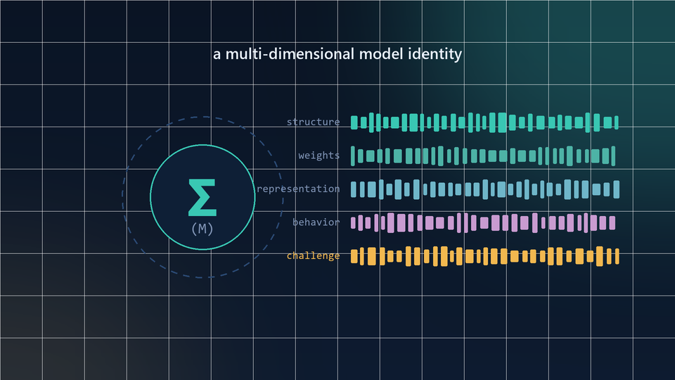
Figure 10. Σ(M) combines several independent views of the same model into one verifiable identity. The method is proprietary; the guarantee is simple. Change the model meaningfully, and the fingerprint changes too.

How it compares
Point tools each cover one slice of the problem. The gateway closes the loop from an untrusted file to a re-verifiable identity.
Capability | Model Signature Gateway | Malware and pickle scanners | Signing and attestation | Model cards and provenance
Catches hidden code in model files | Yes | Yes | No | No
Loads untrusted files safely, in isolation | Yes | Partial | No | No
Cryptographic proof of origin | Yes | No | Yes | Partial
Re-emits a clean, safe artifact | Yes | No | No | No
Fingerprints model behavior, not just bytes | Yes | No | No | No
Re-verifies a model in the field | Yes | No | Partial | No
Shows where a model changed | Yes | No | No | No
Tolerates benign numerical drift | Yes | No | Partial | No
End to end in one audited workflow | Yes | No | No | No
The comparison reflects typical capabilities of each category, not any single named product.

The advantages
- Trust you can prove. Move from “we think this model is fine” to a signed, re-checkable record you can show an auditor or regulator.
- Catches the subtle attacks. Behavioral fingerprinting detects poisoning and backdoors that pass a byte-level or format check untouched.
- Fits your pipeline. A gateway between the open internet and production keeps your model sources flexible and your trust boundary fixed.
- Audit-ready by default. Every ingest, scan, seal and verification writes an immutable record, so compliance becomes a byproduct rather than a project.
- Low false alarms. Tolerances are tuned so safe updates pass and real tampering stands out. These are alerts your team will actually trust.
- Verify anytime. Re-confirm a deployed model against its sealed identity months later, without the original pipeline.
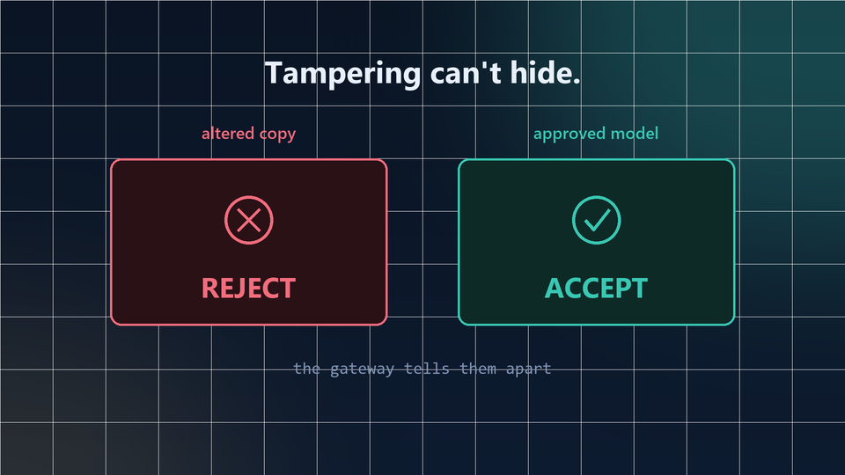
Figure 11. At verification time, a tampered copy is rejected and the approved model is accepted. Tampering cannot hide.

Don’t run a model you can’t verify.
The Model Signature Gateway turns every AI model into a sealed, fingerprinted, re-verifiable asset.
This document is a marketing overview. Internal methods, algorithms, thresholds and architecture are proprietary and have been intentionally omitted.

