Reflection AI Beam
Research Baseline for Building a Beam-Class Open MoE Language Model
Published details · architecture · benchmarks vs. Anthropic, OpenAI, Google, Meta and open-weight peers · KPI targets · recommendations · download links
Prepared for: Yossi Avni
Date: 14 October 2026
Information cut-off: public sources available up to 13–14 October 2026 (nine days after Beam's announcement)
Status of Beam weights at cut-off: announced, not yet published (Apache 2.0 promised for October 2026)

Reading guide: every Beam number in this document is vendor-reported unless marked otherwise. Items marked “estimate” or “*” are analyst or author inferences, not Reflection disclosures. Re-check Section 11 links and the Beam technical report once released; several architecture fields are expected to be filled in by it.

Contents

Right-click the table of contents in Word and choose “Update Field” to refresh page numbers.

1. Executive summary
Reflection AI announced Beam on 5 October 2026: its first open-weight model, a sparse Mixture-of-Experts (MoE) transformer with 501 billion total parameters and about 23 billion active per token (“501B-A23B”). It is text-only, aimed at coding, reasoning and agentic workloads, was pretrained from scratch on 23.8 trillion tokens, extended to a 1-million-token context, and then post-trained with an unusually large reinforcement-learning (RL) run on 10,500 NVIDIA GB300 GPUs for about four weeks.
Its headline claim is efficiency rather than raw leadership: Reflection says Beam matches Z.ai’s GLM-5.2 on advanced reasoning with 3–4× less inference compute. On Reflection’s own table Beam trails Kimi K3 and Qwen 3.8 Max on most rows, is roughly at parity with GLM-5.2, and sits clearly behind the closed frontier (Claude Fable 5.1, GPT-6-series, Gemini 3.x) on the hardest benchmarks such as Humanity’s Last Exam.

Key takeaways for a team building a Beam-equivalent model
- The target is achievable at mid-scale. Beam is the smallest model in its competitive set (Figure 3). A ~500B-A20–25B MoE trained on 20–25T curated tokens plus heavy agentic RL is the right reference design.
- RL compute is the differentiator. Beam’s RL phase used ~1.7× the GPUs of pretraining for a similar duration, across ~1M environments and >100M rollouts. Budget for post-training compute ≥ pretraining compute.
- Data quality over quantity. Reported curation discarded ~95% of raw web tokens. A data engine (filtering, synthetic code/math, executable environments) is the longest-lead item in the plan.
- Architecture is mainstream 2026 practice. Interleaved sliding-window/global attention, fine-grained experts, auxiliary-loss-free balancing, SandwichNorm, gated attention and FP32 residuals are all published techniques; none is proprietary.
- Budget estimate: ~10M GB300-hours in total (≈2–3M pretraining + ≈7M RL), on the order of US$30–60M of compute at market rates, plus data and staff (Section 9).
Terminology: the request mentioned “PKI”; this document interprets it as KPI (Key Performance Indicators) — the benchmark and efficiency targets a new model must reach. Section 8 defines them.

2. Reflection AI: company background
Item | Detail
Founded | 2024, by former Google DeepMind researchers
Founders | Misha Laskin (CEO); Ioannis Antonoglou (CTO, co-creator of AlphaGo)
Mission | An American open frontier lab: open-weight models competitive with leading Chinese open models (DeepSeek, Qwen, Kimi, GLM)
Funding | US$2B round Oct 2025 led by NVIDIA (~US$800M), at US$8B valuation; reported talks in Mar 2026 for US$2.5B at ~US$25B pre-money; one aggregator lists US$27.5B (May 2026, unconfirmed)
First product | Asimov — a code-research agent (waitlist in 2025–26)
First model | Beam, announced 5 Oct 2026; weights promised under Apache 2.0 in October 2026
Recent news | Reports (Oct 2026) of early talks in which NVIDIA could acquire, invest further in, or license technology from Reflection — a reason to mirror weights promptly once released

Do not confuse with “Reflection Llama-3.1 70B” (2024, by Matt Shumer / HyperWrite) — an unrelated fine-tune with a similar name.

3. Beam: everything published so far
Attribute | Value | Confidence / source
Model type | Sparse Mixture-of-Experts decoder-only transformer | Reflection launch post
Total parameters | 501B | Reflection
Active parameters / token | ~23B (≈4.6% of total) | Reflection
Layers | 52 | Secondary coverage
Attention | Interleaved local (sliding-window) and global attention | Reflection; 3:1 ratio is an analyst reading
Attention gating | Elementwise gating on attention output | Reflection
Normalisation | SandwichNorm (pre- and post-sublayer norm) | Reflection
Residual stream | Depth-based residual scaling; FP32 residual accumulation | Reflection
Experts | Fine-grained routed experts, learned top-k router; counts not disclosed | Reflection
Load balancing | Auxiliary-loss-free (expert-bias) balancing with cosine decay of bias updates; busiest expert ≈1.04× mean load | Reflection
Modality | Text only | DataCamp, TrendingTopics
Pretraining data | 23.8T tokens; ~95% of raw web tokens discarded in curation | Reflection; curation figure from MarkTechPost
Pretraining compute | 6,144 NVIDIA GB300 GPUs, < 4 weeks | Reflection / coverage
Context window | 1M tokens after mid-training; 262,144 tokens in beta API | MarkTechPost; Kingy AI
RL phase | 10,500 GB300 GPUs, ~4 weeks, >100M rollouts, ~1M coding/agentic/STEM environments, ~1.3B sandboxes, 256K max rollout context | Reflection; MarkTechPost
Efficiency claim | Matches GLM-5.2 on reasoning at 3–4× lower inference compute (excludes prefill and serving overhead) | Reflection; RuntimeWire caveat
License | Apache 2.0 (promised) | Reflection
Availability (14 Oct 2026) | Waitlisted beta API; weights, model card and technical report not yet published | OrcaRouter, OpenModelWeights
Pricing | No public rate card; not yet on Artificial Analysis index | eesel.ai, OrcaRouter
Not disclosed | Tokenizer & vocabulary, hidden size, head counts, expert count / top-k / shared experts, optimizer, MTP, precision recipe | —

4. Architecture deep-dive
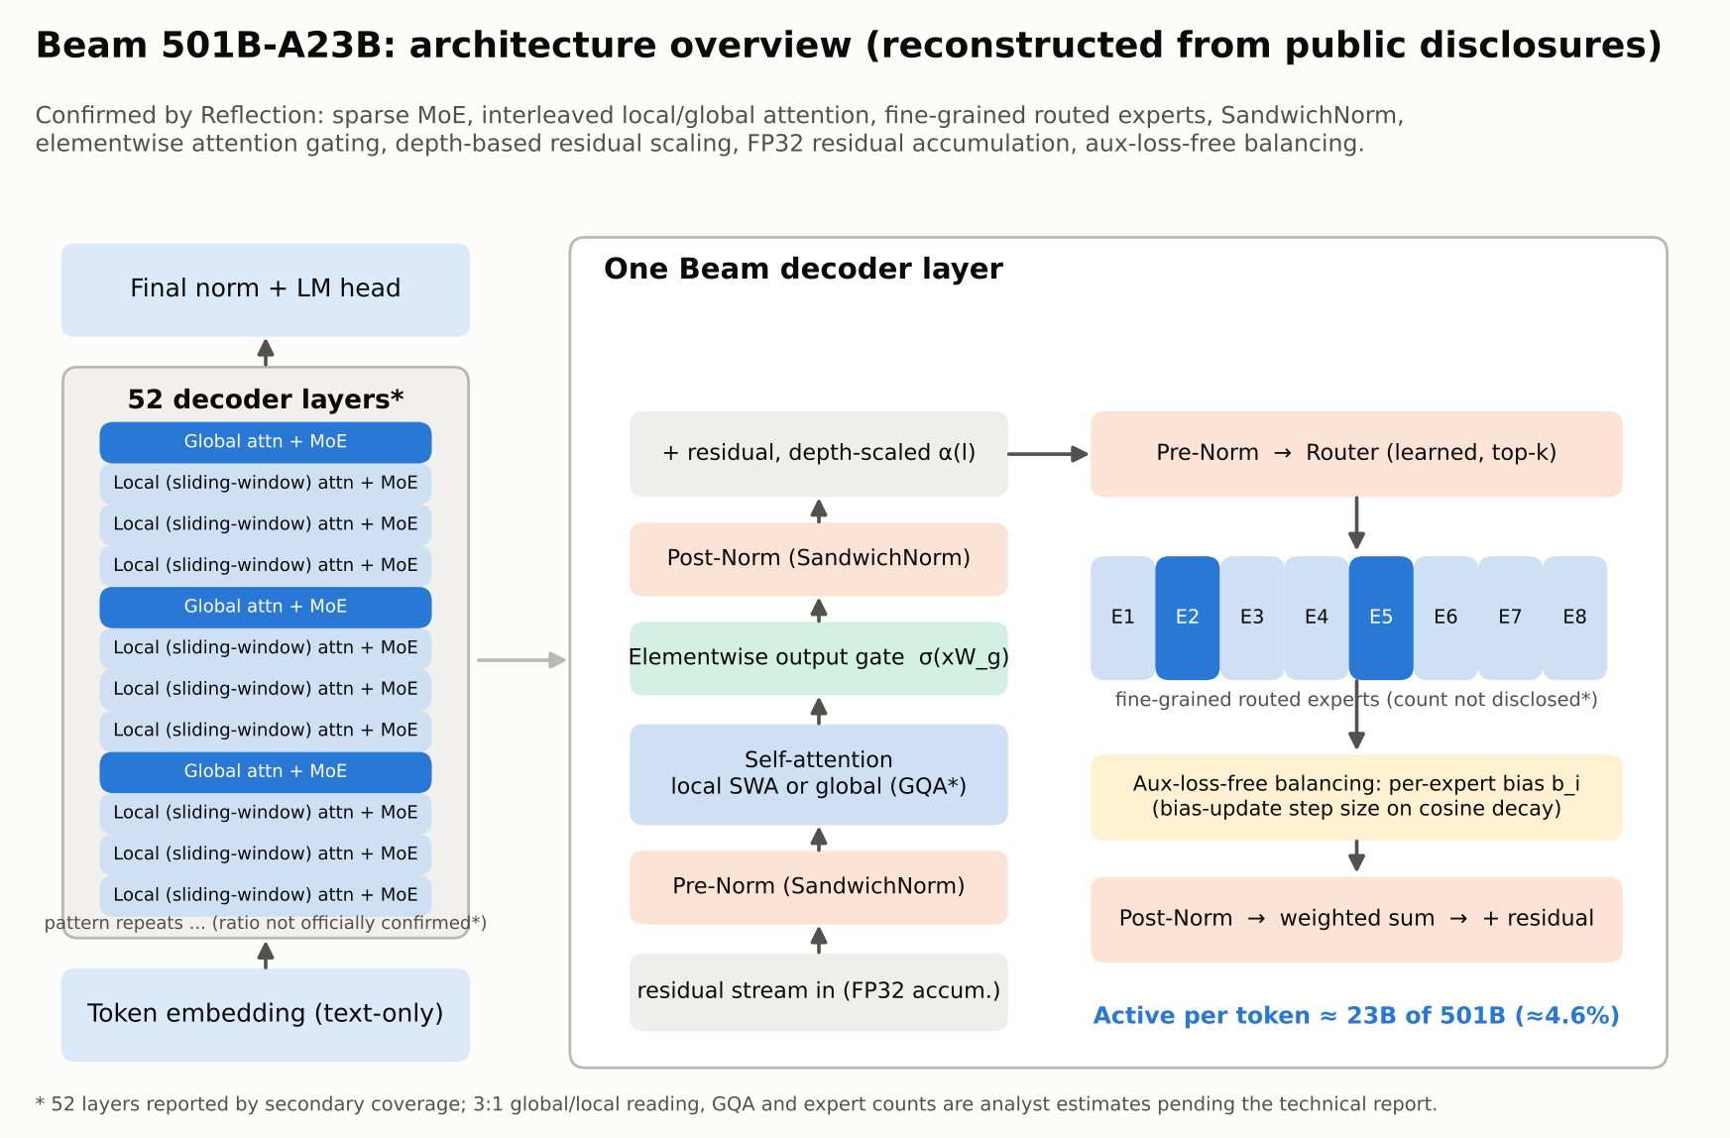
Figure 1 — Beam architecture reconstructed from public disclosures. Starred items await the technical report.

4.1 Sparse MoE backbone
Every layer replaces the dense feed-forward block with a bank of many small (“fine-grained”) experts. A learned router scores all experts for each token and dispatches it to the top-k. Only ~23B of 501B parameters are touched per token, so per-token FLOPs resemble a ~23B dense model while capacity resembles a ~500B model. Fine-grained experts (DeepSeekMoE lineage) give the router more combinations and improve specialisation.

4.2 Auxiliary-loss-free load balancing with cosine-decayed bias updates
Instead of adding a balancing loss that fights the language-modelling objective, each expert carries a bias b_i that is added to its routing score only for top-k selection. After each step the bias is nudged up for under-loaded experts and down for over-loaded ones. Reflection’s contribution is to decay the bias-update step on a cosine schedule so routing stabilises late in training. Reported result: the busiest expert averages only 1.04× the mean load — near-perfect utilisation, which matters for expert-parallel throughput.

4.3 Interleaved local / global attention
Most layers use sliding-window (local) attention whose KV cache is bounded by the window; periodic global layers attend over the full sequence. This cuts KV-cache memory and long-context FLOPs roughly in proportion to the share of local layers, which is how a 1M-token context becomes affordable. The same pattern appears in Gemma 3, MiMo-V2.6 and other 2026 models.

4.4 Stability components
- SandwichNorm: normalisation both before and after each sub-layer, bounding activation growth in deep, sparse networks.
- Elementwise attention gating: a learned sigmoid gate on the attention output; known to suppress attention sinks and loss spikes and to help long-context extrapolation.
- Depth-based residual scaling: scaling residual branch contributions by layer depth for stable signal propagation.
- FP32 residual accumulation: the residual stream is accumulated in FP32 even when matmuls run in low precision (BF16/FP8), avoiding drift over 52 layers.

5. Training recipe
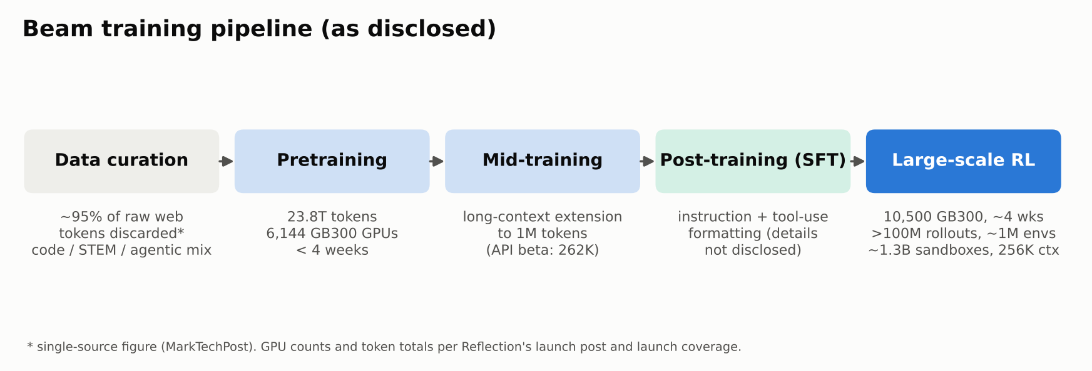
Figure 2 — Beam’s disclosed training pipeline.
Phase | Disclosed facts | What it implies for a replication
Data curation | Aggressive filtering (~95% of raw web discarded) | Invest in classifiers, dedup, decontamination and synthetic code/math before training
Pretraining | 23.8T tokens on 6,144 GB300 GPUs in < 4 weeks | ≈ 3.3×10^24 training FLOPs (6·N_active·D); needs ≈ 20–35% MoE MFU
Mid-training | Context extension to 1M tokens | Staged RoPE/window extension with long-document and repository-level data
SFT | Not detailed | Tool-use, multi-turn agent traces and reasoning formats seed the RL policy
RL | 10,500 GB300, ~4 weeks, >100M rollouts, ~1M environments, ~1.3B sandboxes | Asynchronous RL infrastructure, sandbox orchestration and verifiable rewards are core engineering

Observation: In GPU-hours Beam’s RL phase (≈7.1M GB300-hours) was roughly 2–3× its pretraining phase. This inverts the classic ratio and reflects the 2026 consensus that agentic capability is mostly bought in post-training.

6. Performance vs. leading models

6.1 Model scale in context
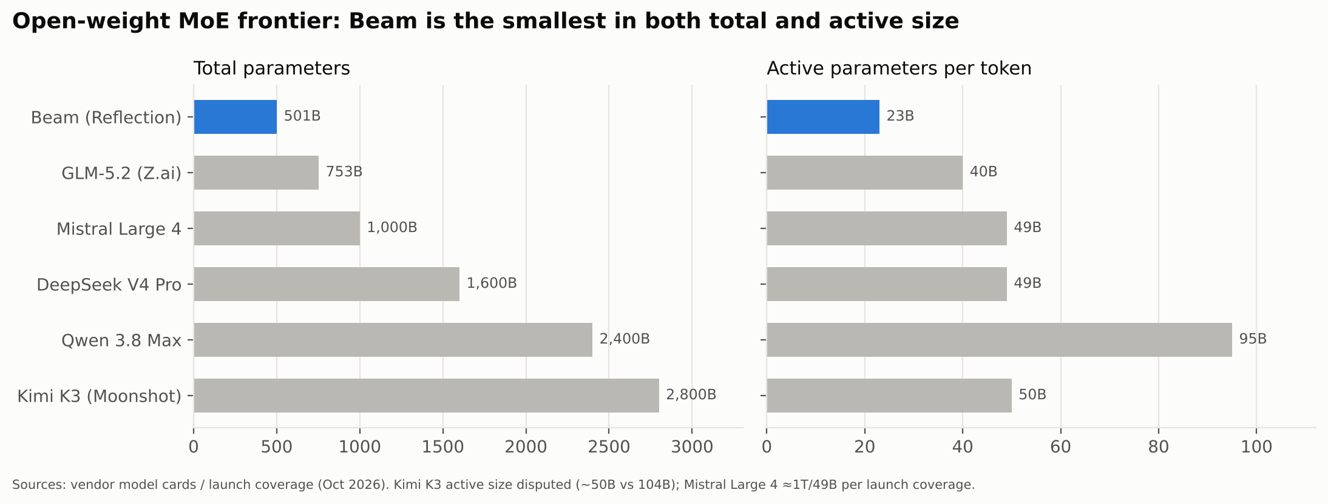
Figure 3 — Total and active parameters of Beam and its open-weight competitors.
Model (developer) | Total params | Active params | Open weights?
Beam (Reflection AI) | 501B | ~23B | Promised, Apache 2.0
GLM-5.2 (Z.ai / Zhipu) | ~753B | ~40B | Yes
Mistral Large 4 (Mistral AI) | ~1T | ~49B | Per launch coverage
DeepSeek V4 Pro (DeepSeek) | ~1.6T | ~49B | Yes
Qwen 3.8 Max (Alibaba) | ~2.4T | ~95B | Base checkpoint; hosted Max adds features
Kimi K3 (Moonshot AI) | ~2.8T | ~50B (disputed; some report 104B) | Yes
Claude Fable 5.1 / Opus 5.5 (Anthropic) | Undisclosed | Undisclosed | No (API only)
GPT-6 Astra / GPT-6.1 Sol (OpenAI) | Undisclosed | Undisclosed | No (API only)
Gemini 3.1 Pro / 3.8 Flash (Google) | Undisclosed | Undisclosed | No (API only)
Llama 4 Maverick (Meta) | ~400B | ~17B | Yes (Llama license)

6.2 Beam vs. open-weight peers (Reflection’s launch table)
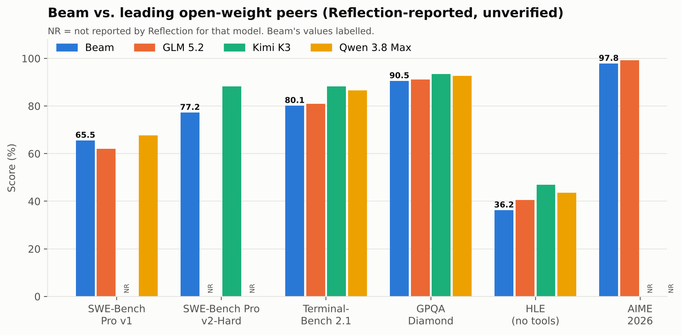
Figure 4 — Reflection-reported scores; NR = not reported.
Benchmark | Beam | GLM 5.2 | Kimi K3 | Qwen 3.8 Max
SWE-Bench Pro v1 | 65.5 | 62.1 | NR | 67.7
SWE-Bench Pro v2-Hard | 77.2 | NR | 88.2 | NR
SWE-Bench Verified | 80.9 | NR | NR | NR
Terminal-Bench 2.1 | 80.1 | 81.0 | 88.3 | 86.6
GPQA Diamond | 90.5 | 91.2 | 93.5 | 92.6
HLE (no tools) | 36.2 | 40.5 | 46.9 | 43.6
AIME 2026 | 97.8 | 99.2 | NR | NR

Reading: Beam beats GLM-5.2 on SWE-Bench Pro v1 and is within ~1 point on Terminal-Bench and GPQA, but trails it by 4 points on HLE. Kimi K3 and Qwen 3.8 Max lead every row on which they report. Beam’s value proposition is therefore per-token efficiency (Figure 6), not absolute leadership.

6.3 Beam vs. the closed frontier (Anthropic, OpenAI, Google) and Meta
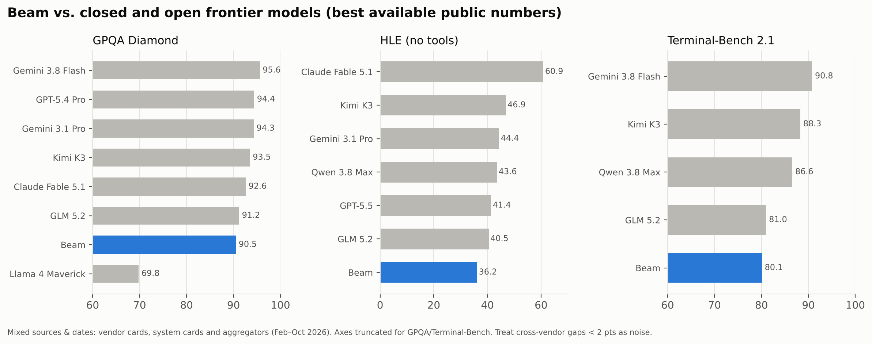
Figure 5 — Best available public numbers; versions and dates differ across vendors.
Model | GPQA Diamond | HLE (no tools) | Terminal-Bench 2.1 | Notes
Beam (Reflection) | 90.5 | 36.2 | 80.1 | Vendor-reported, Oct 2026
Claude Fable 5.1 (Anthropic) | 92.6 | 60.9 (65.0 w/ tools) | — | SWE-bench Pro 81.2; Terminal-Bench 4.0 55.8 (Sep 2026 system card)
Claude Opus 5.5 (Anthropic) | — | — | — | Comparable published scores not found; trails GPT-6.1 Sol by 2.2 pts on AutomationBench per one source
GPT-6.1 Sol (OpenAI) | — | — | — | Terminal-Bench Science 57.0; OSWorld 2.0 71.4; DeepSWE 71.9–75.2
GPT-5.4 Pro / GPT-5.5 (OpenAI) | 94.4 (5.4 Pro) | ~41.4 (5.5) | — | Earlier 2026 generation
Gemini 3.8 Flash (Google) | 95.6 | 54.9 (HLE-Verified) | 90.8 (89.4 alt.) | Sep 2026; SWE-Bench Pro 61.6
Gemini 3.1 Pro (Google) | 94.3 | 44.4 | 68.5 (v2.0) | Feb 2026
Llama 4 Maverick (Meta) | 69.8 | — | — | Apr 2025; latest open Llama; Meta’s new Muse line is closed
Groq | n/a | n/a | n/a | Groq builds LPU inference hardware and hosts others’ open models; it does not train frontier LLMs

How to read the frontier comparison
- Closed-model vendors increasingly publish newer benchmark versions (Terminal-Bench 4.0, SWE-bench Pro, OSWorld 2.0) while open-model vendors publish Terminal-Bench 2.1 and SWE-Bench Pro v1/v2, so direct like-for-like numbers are sparse. Gaps under ~2 points are within harness noise.
- On the least-saturated benchmark (HLE, no tools) Beam’s 36.2 is ~25 points behind Claude Fable 5.1 and ~8 points behind Gemini 3.1 Pro — the clearest measure of the frontier gap.
- GPQA Diamond is near saturation (90–96% for all frontier and top open models); it no longer separates models well.
- Groq is relevant as a deployment target (very high tokens/s for open MoE models) rather than as a competitor. NVIDIA licensed Groq’s LPU technology in Dec 2025 (~US$20B).

6.4 Efficiency: reasoning per active parameter
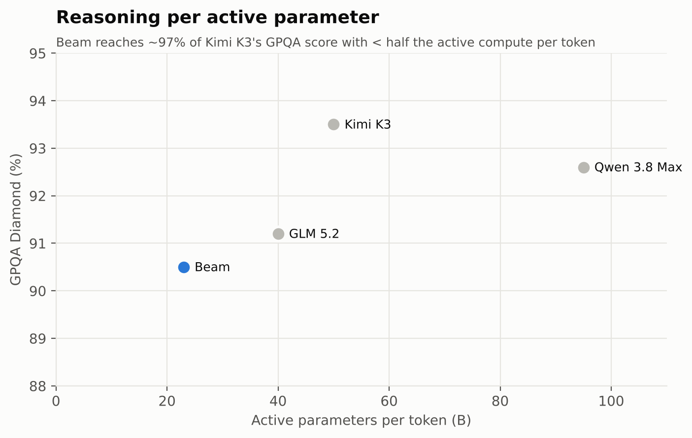
Figure 6 — GPQA Diamond vs. active parameters per token (open-weight models).
Beam reaches ~97% of Kimi K3’s GPQA score with under half of its active parameters, and ~98% of Qwen 3.8 Max’s with under a quarter. For serving cost, active parameters drive decode FLOPs while total parameters drive memory footprint; at 501B total, Beam fits on a single 8×GB300 node in FP8 (≈0.5 TB weights) — a practical advantage over 1.6–2.8T-parameter peers.

7. What is still unknown (open questions)
Unknown | Why it matters for replication | Expected source
Expert count, top-k, shared experts, expert width | Determines active/total ratio, routing granularity and expert-parallel layout | Technical report / config.json
Hidden size, heads, KV heads, window size, global ratio | Determines KV-cache size and long-context cost | config.json
Tokenizer & vocabulary | Affects code/multilingual efficiency and compatibility | Tokenizer files
Optimizer (AdamW vs. Muon) and LR schedule | Muon has shown ~2× token efficiency at scale | Technical report
Precision (BF16 / FP8 / NVFP4) | Drives GB300 throughput and stability | Technical report
Data mixture proportions | Biggest driver of coding/agentic quality | Technical report (partial at best)
RL algorithm & reward design | GRPO/PPO variant, async off-policy correction, reward models vs. verifiers | Technical report
Independent benchmark results | All scores are vendor-reported | Artificial Analysis, LMArena, Vals, SWE-bench leaderboards

8. KPI targets for a Beam-equivalent model
A new model is “Beam-equivalent” if it meets the following KPIs on an identical evaluation harness. Run Beam itself through the same harness once weights ship — that is the only fair baseline.
KPI | Beam reference | Minimum target | Stretch target
SWE-Bench Pro v1 | 65.5 | ≥ 65 | ≥ 68 (Qwen 3.8 Max)
SWE-Bench Verified | 80.9 | ≥ 80 | ≥ 83
Terminal-Bench 2.1 | 80.1 | ≥ 80 | ≥ 86
GPQA Diamond | 90.5 | ≥ 90 | ≥ 92
HLE (no tools) | 36.2 | ≥ 36 | ≥ 42
AIME 2026 | 97.8 | ≥ 97 | ≥ 99
Active parameters / token | ~23B | ≤ 25B | ≤ 20B
Total parameters | 501B | ≤ 550B | ≤ 400B
Context window (effective) | 1M (262K served) | ≥ 256K with RULER ≥ 85% | 1M
Decode throughput, 8×GB300 FP8 | Not published | Measure Beam; match it | +20%
Inference compute vs. GLM-5.2 at equal quality | 3–4× lower | ≥ 3× lower | ≥ 4× lower
Expert load imbalance (max / mean) | 1.04× | ≤ 1.10× | ≤ 1.05×
License | Apache 2.0 | Permissive open weights | Apache 2.0 + open data card

9. Proposed reference design and compute budget

9.1 Starting-point configuration (to be validated by ablation)
Component | Proposed choice | Rationale
Size | ~480–520B total, 20–24B active, ~52–60 layers | Matches Beam; fits one 8-GPU node in FP8
Experts | 256 routed fine-grained experts + 1 shared, top-8 | DeepSeek-V3/V4-style granularity; ablate 128/256/384
Routing | Aux-loss-free bias balancing with cosine-decayed update rate; sequence-level balance check | Reproduces Beam’s 1.04× load
Attention | 3:1 sliding-window (4–8K window) : global, GQA or MLA on global layers, gated output | Bounded KV cache, 1M-context capable
Norm / residual | SandwichNorm (RMSNorm), depth-scaled residuals, FP32 residual accumulation, QK-norm | Stability at low precision
Position encoding | RoPE on global layers with YaRN-style extension; NoPE/partial RoPE as ablation | Long-context extrapolation
Prediction head | Multi-token prediction (1–2 extra heads) | Denser training signal + speculative decoding
Tokenizer | ~160–200K BPE vocabulary, code- and multilingual-aware | Compression on code and non-English text
Optimizer | Muon for matrix params (per-expert), AdamW for embeddings/norms | ~2× token efficiency in published studies
Precision | FP8 (block-scaled) training, ablate NVFP4 on GB300 | Throughput on Blackwell-class GPUs

9.2 Compute and cost estimate
Phase | Estimate | Assumptions
Pretraining | ≈ 3.3×10^24 FLOPs → ≈ 2–3M GB300-hours | 6 × 23B active × 23.8T tokens; 20–30% MFU on ~2.5 PFLOP/s BF16-dense (higher with FP8)
Mid-training (long context) | ≈ 0.2–0.4M GB300-hours | ~1T tokens at growing sequence length
RL | ≈ 7M GB300-hours | 10,500 GPUs × 28 days, as disclosed for Beam
Ablations & scaling pilots | ≈ 1–2M GPU-hours | 1–7B and ~60B-A3B models
Total | ≈ 10–12M GPU-hours | ≈ US$30–60M at US$3–5 per GPU-hour, excluding staff and data
These are author estimates derived from Beam’s disclosed GPU counts and durations, not Reflection figures.

9.3 Program roadmap
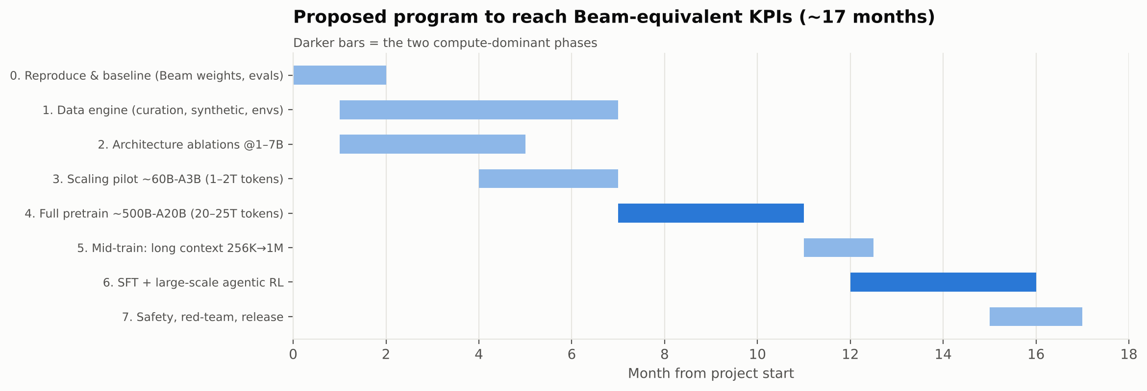
Figure 7 — Proposed ~17-month program to reach Beam-equivalent KPIs.

10. Recommendations from current research

10.1 Architecture
- Adopt fine-grained MoE with aux-loss-free balancing from day one. It is now standard (DeepSeek-V3/V4, Beam). Add Reflection’s cosine decay on bias updates and monitor max/mean expert load per layer.
- Use hybrid attention for long context. Interleave sliding-window and global layers (Beam, MiMo-V2.6); evaluate compressed/sparse global attention as in DeepSeek-V4 for 1M-token contexts, and dynamic sparse attention for decode.
- Gate attention outputs and use SandwichNorm + QK-norm. Cheap insurance against loss spikes during multi-trillion-token runs.
- Add multi-token prediction. Improves sample efficiency and gives a built-in speculative decoder (used by DeepSeek-V3/V4, MiMo-V2.6).

10.2 Optimisation and precision
- Evaluate Muon. Moonlight reported ~2× compute efficiency vs AdamW; DeepSeek-V4 trains with Muon and orthogonalises each expert separately; 2026 studies find it scales better with batch size.
- Train in FP8, pilot NVFP4. Blackwell/GB300 FP4 throughput is roughly double FP8; keep FP32 master weights and residual accumulation as Beam does.
- Use WSD (warmup-stable-decay) learning-rate schedules so that intermediate checkpoints can be annealed for evaluation and mid-training branches.

10.3 Data
- Build the data engine first. Model-based quality classifiers, aggressive dedup, benchmark decontamination, and synthetic code/math with execution-verified answers. Beam’s ~95% discard rate signals how strict this must be.
- Collect repository-level and long-document data for mid-training; include agent traces (terminal sessions, tool calls) for SFT.

10.4 Post-training and agentic RL
- Plan RL compute ≥ pretraining compute. Beam’s 10,500-GPU RL run and MiMo-V2.6’s RL-for-self-improvement framing both point the same way.
- Invest in environments, not just prompts. Target 10^5–10^6 verifiable environments (unit-test-graded repos, terminal tasks, math/STEM checkers, web/tool tasks) with a sandbox fleet that scales to billions of executions.
- Use asynchronous, off-policy-corrected RL (GRPO-family objectives with importance-ratio clipping) to keep inference and training GPUs saturated; support 128K–256K rollout context.

10.5 Evaluation
- Evaluate on unsaturated, contamination-resistant suites: SWE-bench Pro (OpenAI no longer uses SWE-bench Verified for frontier coding), Terminal-Bench 2.x/4.0, HLE, AIME of the current year, RULER/long-context, and agentic suites (OSWorld, τ-bench).
- Report with confidence intervals and fixed harnesses; re-run competitors yourself. Vendor-to-vendor gaps of 1–2 points are noise.

10.6 Strategy
- Fine-tune before you pre-train. Once Beam (Apache 2.0) ships, a Beam- or GLM-based fine-tune is the fastest way to validate your data, RL stack and evaluation harness before committing ~US$50M to pretraining from scratch.
- Differentiate on one axis. Beam’s angle is efficiency per active parameter; pick yours (e.g., domain specialisation, multimodality, on-device distillation, or a sub-10B-active model).
- Mirror open checkpoints immediately on release — Apache 2.0 grants are irrevocable, but hosting can change if ownership does.

11. Download links and access
Beam status (14 Oct 2026): weights are not yet downloadable. Reflection has promised Apache 2.0 weights, a model card and a technical report in October 2026; early access is via a waitlisted beta API.
Model / resource | Where | Status
Reflection Beam — announcement | reflection.ai/blog/introducing-beam | Live
Reflection Beam — weights | huggingface.co (search “reflection”) | Pending (promised Oct 2026)
DeepSeek V4 family | huggingface.co/deepseek-ai | Open weights
Kimi K3 (Moonshot) | huggingface.co/moonshotai | Open weights
GLM-5.x (Z.ai) | huggingface.co/zai-org | Open weights
Qwen 3.x (Alibaba) | huggingface.co/Qwen | Open weights
Mistral (Mistral AI) | huggingface.co/mistralai | Open weights (check license per model)
Llama 4 (Meta) | huggingface.co/meta-llama | Gated, Llama license
gpt-oss (OpenAI open-weight) | huggingface.co/openai | Open weights
Claude (Anthropic) | console.anthropic.com | API only
GPT-6 family (OpenAI) | platform.openai.com | API only
Gemini (Google) | aistudio.google.com | API only
GroqCloud (fast inference of open models) | console.groq.com | API (hosted open models)

Clickable links:
- Reflection — Introducing Beam
- Hugging Face search: Reflection models
- DeepSeek on Hugging Face
- Moonshot AI (Kimi) on Hugging Face
- Z.ai (GLM) on Hugging Face
- Qwen on Hugging Face
- Mistral AI on Hugging Face
- Meta Llama on Hugging Face
- OpenAI on Hugging Face
- Anthropic Console
- OpenAI Platform
- Google AI Studio
- GroqCloud Console
Exact Beam repository IDs could not be verified before release; use the Hugging Face search link and confirm the publisher is Reflection’s verified organisation.

12. Sources
- Reflection — Introducing Beam (launch post)
- Reflection on X — Beam announcement
- TechCrunch — Reflection debuts Beam
- SiliconANGLE — Beam with 501B parameters
- Fortune — Reflection AI unveils Beam
- MarkTechPost — Beam 501B open-weight MoE
- DataCamp — Beam explained
- MindStudio — Beam explained
- Latent Space AINews — Reflection Beam 501B-A23B
- Kingy AI — Specs, benchmarks & API limits
- Munder Difflin — Beam explained
- RuntimeWire — Beam benchmark scores
- OrcaRouter — Weights not out
- eesel.ai — Specs, access and price
- OpenModelWeights — Beam preview
- Wikipedia — Reflection AI
- Anthropic — Claude Fable 5.1 & Mythos 5.1 System Card
- llm-stats — Claude Fable 5.1
- Vellum — GPT-6.1 Sol benchmarks
- BenchLM — GPT-6.1 Sol
- DataCamp — Gemini 3.8 Flash
- OpenRouter — GPQA Diamond leaderboard
- Digital Applied — Gemini 3.1 Pro benchmarks
- ComputingForGeeks — Open-source LLM comparison 2026
- DeepInfra — Kimi K3 vs DeepSeek V4 Pro vs GLM-5.2
- Codersera — Llama 4 guide 2026
- Voiceflow — Groq in 2026
- DeepSeek-V4 technical report (arXiv)
- MiMo-V2.6: Scaling RL Towards Self-Improvement (arXiv)
- Muon is Scalable for LLM Training (arXiv)
- SOAP, Muon, and Beyond (arXiv)
- SWE-Bench Pro Verified (arXiv)

Appendix A. Glossary
Term | Meaning
MoE | Mixture-of-Experts: layers with many expert sub-networks, only a few active per token
501B-A23B | 501B total parameters, 23B active per token
Aux-loss-free balancing | Load balancing via per-expert routing biases instead of an extra loss term
SWA | Sliding-window attention: each token attends only to a recent window
GQA / MLA | Grouped-query / multi-head latent attention: ways to shrink the KV cache
SandwichNorm | Normalisation before and after each sub-layer
MTP | Multi-token prediction: extra heads predicting tokens further ahead
Muon | Optimizer that orthogonalises momentum updates for matrix parameters
MFU | Model FLOPs Utilisation: achieved / peak hardware FLOPs
GPQA Diamond | Graduate-level science multiple-choice benchmark
HLE | Humanity’s Last Exam: expert-written questions at the frontier of knowledge
SWE-Bench Pro / Verified | Real GitHub issue-fixing benchmarks; Pro is harder and less contaminated
Terminal-Bench | Agentic tasks performed in a real terminal
AIME | American Invitational Mathematics Examination problems

