EXECUTIVE BRIEFING
Building a Beam-Class LLM
Should we develop a new open model that competes with Anthropic, OpenAI, Google, xAI and Meta? Findings, options, investment and the decision requested.
Item | Detail
Prepared for | Yossi Avni and the executive / investment committee
Date | 19 October 2026
Read with | Beam_Executive_Summary.pptx (18 slides, with animated explainers on slides 4–5) — this briefing follows the same storyline
Evidence base | Beam_Research_Baseline.docx v2.0 (37 pages, 42 sources)
Reading time | ≈ 15 minutes
Decision requested | Approve Stage 1 (≈ US$11M; first model in 3–6 months) and the choice of target market

Estimates of cost, GPU-hours and headcount are the author’s, derived from Reflection AI’s disclosed training scale. Benchmark figures are vendor-reported unless described as independent.

1. One-page summary

Situation
Reflection AI released Beam 1.0 on 16 October 2026: a 501-billion-parameter open-weight model (23.4B active per token) under the permissive Apache 2.0 licence, built for coding and agentic work and launched with 40+ partners including AWS, Google Cloud, Microsoft Azure and NVIDIA. It shows that a well-funded start-up can train a credible large model in under two years, and it makes a strong, free starting point available to anyone.

Complication
Beam is efficient but not frontier-class. On the only independent single-scale comparison (Artificial Analysis Intelligence Index) it scores 30 — versus 44–46 for the best Chinese open models and Grok 4.7, ~53 for OpenAI’s GPT-6 Astra and Google’s Gemini 4 Argon, and 58 for Anthropic’s Claude Opus 5.5. Meanwhile enterprises are concentrating spend on closed models: Anthropic (40%) and OpenAI (27%) lead, and open-weight models’ share fell from 19% to 11% in a year.

Resolution
- Do not race the leaderboard. Matching Anthropic/OpenAI/Google requires US$1B+ per model generation.
- Build where closed models cannot follow: sovereign and on-premises AI, regulated industries, domain specialists, under-served languages, and cost-sensitive agent workloads.
- Start from Beam’s open weights (Stage 1, ≈ US$11M). Prove the data, reinforcement-learning and evaluation capability and win first customers within 6 months.
- Gate further investment. Only at month 9, with proven demand and ≥ US$150M secured, commit to continued pre-training (≈ US$56M) or a from-scratch model (≈ US$175M).

Key numbers
30 vs 58 | US$11M → US$175M | 11% | 3–6 months
Beam vs. leader, independent index | Adapt Beam → build from scratch (2-yr, indicative) | Open-weight share of enterprise API spend | Time to a first adapted model

2. What Reflection AI has built
Attribute | Beam 1.0
Size | 501.3B total parameters; 23.4B active per token (≈4.7%)
Design | Mixture-of-Experts: 256 experts, 8 used per token; 52 layers; 512-token sliding-window attention with full-context attention in only 9 layers; 1M-token context
Training | 23.8T tokens on 6,144 NVIDIA GB300 GPUs (< 4 weeks), then reinforcement learning on 10,500 GB300 GPUs for ~4 weeks across ~1M coding/agent tasks
Release | Apache 2.0 weights in BF16, FP8 and NVFP4; speculative-decoding drafter; Mirror CLI agent harness; day-0 support in vLLM, SGLang and Transformers
Company | Founded 2024 by ex-Google DeepMind researchers; US$2B raised Oct 2025 led by NVIDIA; reported valuation talks at ~US$25B in 2026
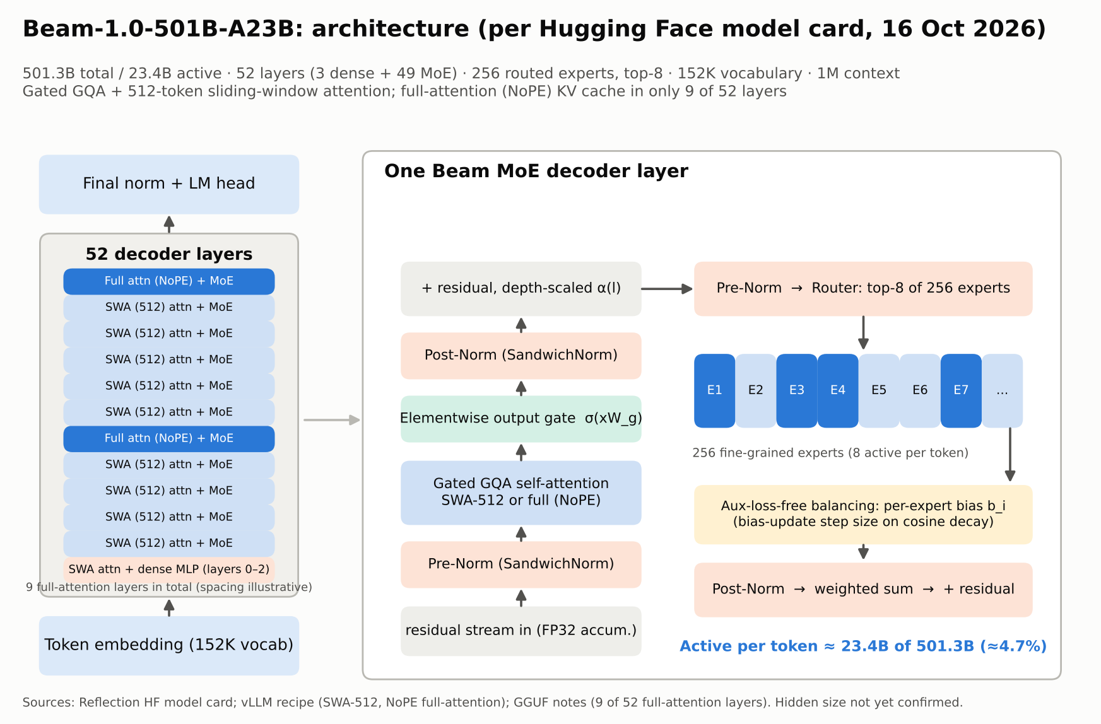
Beam 1.0 architecture (from the research baseline, Figure 1).
Why it matters to us: every major design choice in Beam is a published technique, and its weights can be used commercially. The barrier to entry for a capable open model has fallen from hundreds of millions of dollars to roughly ten million for an adapted model.

3. How Beam compares with the leading vendors
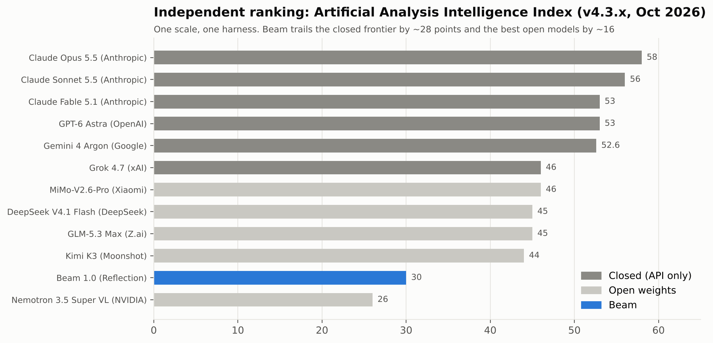
Independent ranking on one scale (Artificial Analysis, October 2026).
Vendor | Flagship | Open weights? | Independent index | Strategic posture
Anthropic | Claude Opus 5.5 / Sonnet 5.5 | No | 58 / 56 | Capability leader; largest enterprise share
OpenAI | GPT-6 Astra | No (gpt-oss open line) | ≈ 53 | Consumer reach; premium pricing
Google | Gemini 4 Argon / 3.8 Flash | No (Gemma open line) | 52.6 | Multimodal; cloud distribution; cheap fast tier
xAI | Grok 4.7 | No | 46 | Low price ($2/$6 per 1M tokens) and speed
Meta | Muse Spark (closed); Llama 4 (open) | Partly | n/a on same index | Distribution; frontier models now closed
Chinese labs | MiMo, GLM, DeepSeek, Kimi | Yes | 44–46 | Best open scores at the lowest prices
Reflection | Beam 1.0 | Yes (Apache 2.0) | 30 | US provenance; efficiency; ecosystem

Reading the gap: Reflection’s own launch table placed Beam level with GLM-5.2. Independent testing did not confirm this. The lesson for us is to measure every claim — ours and competitors’ — on our own independent harness.
Beam’s real strengths: it reaches answers with ~40% fewer output tokens than the median model, runs on a single 8-GPU server in 4-bit precision with ≤ 1.7 points quality loss, and is free to modify and resell.

4. Where a new model can win
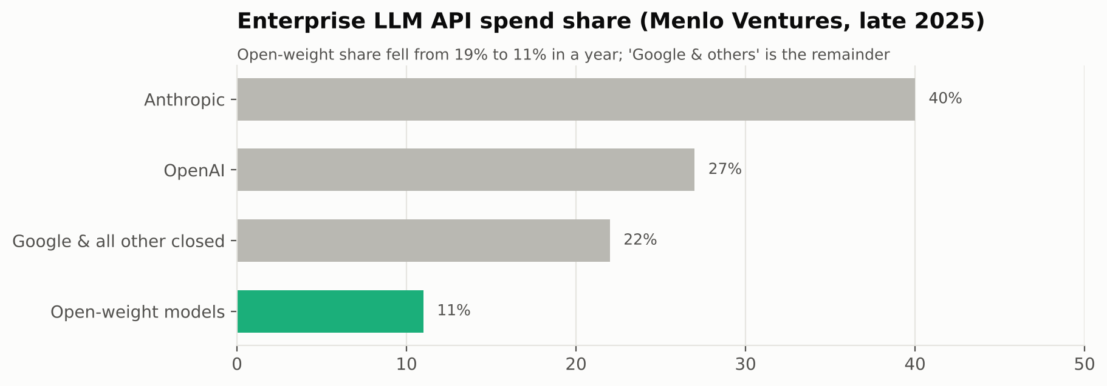
Enterprise LLM API spend share (Menlo Ventures, late 2025).
Segment | Why closed vendors are weak here | What we would need
Sovereign & government | Weights cannot leave vendor clouds; Chinese models are often barred | US/EU/allied provenance, on-prem packaging, security accreditation
Regulated industries | Data-residency and audit requirements | Private deployment, audit logs, model documentation
Vertical specialists | General models are not trained on proprietary workflows | Domain data and RL environments from design partners
Under-served languages | Low commercial priority for global vendors | Targeted data (e.g., Hebrew, Arabic, regional European languages)
High-volume agents | Per-token pricing makes scale expensive | Low serving cost; Beam’s token efficiency

Recommendation: choose one primary and one secondary segment before Stage 1 starts. The choice drives data acquisition, evaluation design and the first customers.

5. Options and investment
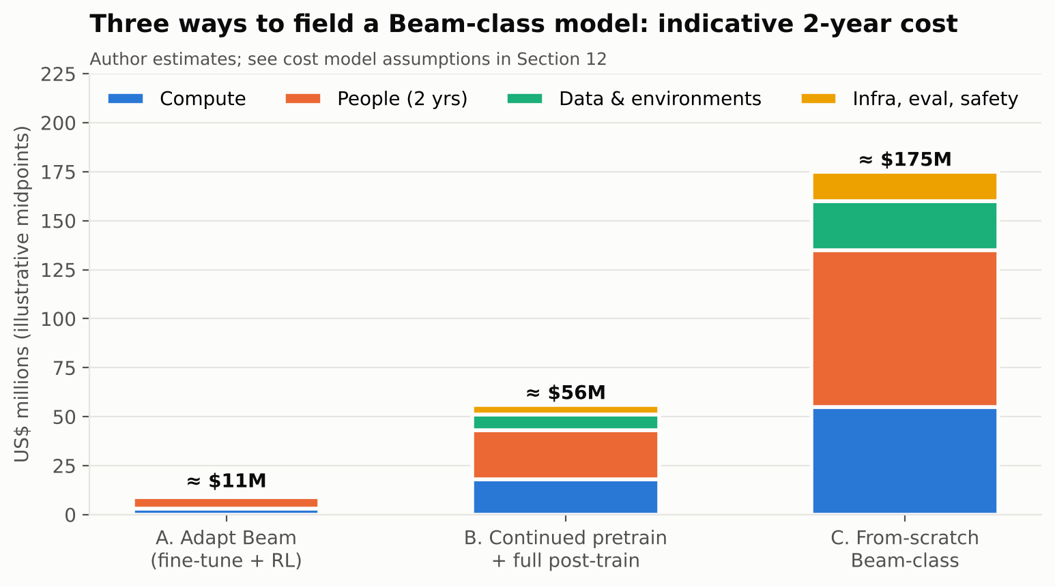
Indicative two-year cost by route (author estimates).
 | A. Adapt Beam | B. Continue pre-training | C. Build from scratch
What | Fine-tune and reinforcement-learn Beam for our segment | Add 3–6T domain tokens to Beam, then full post-training | Own architecture, tokenizer and 24T+ token training run
2-year cost | ≈ US$11M | ≈ US$56M | ≈ US$175M
Time to first model | 3–6 months | 9–12 months | 15–18 months
Team | 15–25 | 40–60 | 80–120
Expected capability | Beam + domain gains | Beam + 5–10 points in domain | Beam parity; path to next tier with more capital
IP | Apache 2.0 derivative | Substantially modified derivative | Fully owned
Main risk | Limited differentiation | Data cost; forgetting | Execution and capital

5.1 Stage 1 budget (option A, indicative)
Line item | US$M | Notes
Compute | 3 | ≈ 0.5–1M GPU-hours for fine-tuning, RL and evaluation
People | 6 | 15–25 staff (RL, data, infra, evaluation, product) over the programme
Data and RL environments | 1 | Licensing, annotation, design-partner environments
Infrastructure, evaluation, safety | 1 | Serving stack, red-teaming, third-party evaluation
Total | ≈ 11 | Excludes go-to-market spend

5.2 Higher ambition levels
Level | Independent target | Indicative cost | Who realistically plays
1. Beam parity | ≈ 30 | US$11–175M | Start-ups, sovereign programmes, enterprises
2. Open-frontier parity | ≈ 45 | US$300–500M | Well-funded labs (Chinese labs, Reflection’s next model)
3. Closed-frontier challenger | ≥ 53 | US$1B+ per generation | Anthropic, OpenAI, Google, xAI, Meta

6. Roadmap and decision gates
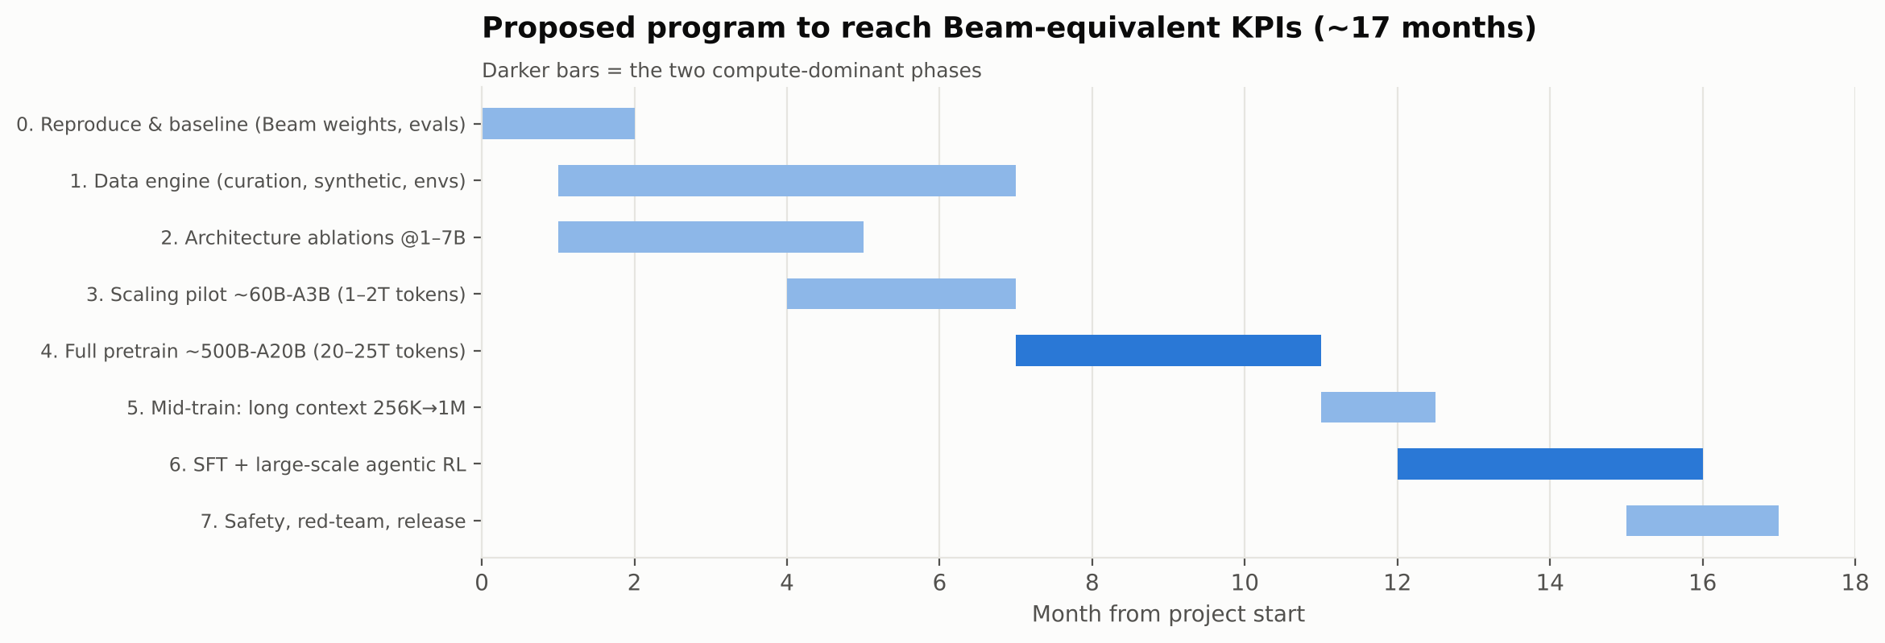
Programme roadmap; Stage 1 covers phases 0–2 and the adapted-model release.
Gate | Month | Go criteria | Decision
G0 Baseline | 1 | Beam and peers reproduced on our harness within ±2 points | Confirm Stage 1 plan
G1 Adapt | 6 | Adapted model +5 points on domain evaluations; first paying pilot | Continue / pivot segment
G2 Scale | 9 | Demand proven; pilot model meets scaling targets; ≥ US$150M secured | Fund option B or C, or stay at A
G3 Pre-train | 11 | Stable full training run | Continue / stop
G4 Release | 17 | Level 1 KPIs met independently; safety report; ≥ 10 partners | Launch

7. Principal risks
Risk | Likelihood | Impact | Mitigation
Frontier keeps moving away | High | High | Compete in segments, not on the general leaderboard
Chinese open models at near-zero prices | High | Medium | Sell provenance, sovereignty, support and domain quality
Our own claims fail to replicate | Medium | High | Independent harness and third-party evaluation from day one
GPU cost / availability | Medium | High | Multi-provider reservations; 4-bit (NVFP4) training and serving
RL infrastructure underestimated | High | High | Build environments and sandboxes from month 1
Talent and legal exposure | Medium | High | Equity and academic partnerships; data-provenance tracking; legal gates
Reflection ownership change | Medium | Medium | Mirror Beam 1.0 weights now — the Apache 2.0 grant is irrevocable

8. Decision requested and first 90 days

8.1 Decisions requested
- Approve Stage 1 (option A): ≈ US$11M programme budget; first adapted model in 3–6 months.
- Select the target segment: recommended primary — sovereign / regulated on-premises AI; secondary — one vertical or language market chosen with design partners.
- Authorise partnerships: one GPU cloud for compute reservations and two to three design-partner customers.
- Schedule Gate 2 review for month 9 to decide on options B or C.

8.2 First 90-day plan
Weeks | Workstream | Deliverable
1–2 | Programme set-up | Mirror Beam 1.0 weights; GPU reservation; core hires (RL lead, data lead, infra lead)
1–4 | Evaluation | Independent harness; Beam, GLM, Kimi, DeepSeek re-run on all KPI benchmarks (Gate 0)
2–8 | Market | Segment selection; 2–3 design-partner agreements; domain evaluation sets
3–10 | Data | Domain corpus acquisition and filtering; synthetic data pipeline
4–12 | RL environments | First 10,000 verifiable domain tasks running in sandboxes on Mirror CLI
8–12 | First experiments | Fine-tuned and RL-trained Beam checkpoint; first domain results vs. base Beam
12 | Review | 90-day report to the committee: results, spend, pipeline

9. Presenter guide to the executive deck
Suggested timing: 25 minutes presentation + 20 minutes discussion. Slides 2, 4–5, 8, 13 and 16 carry the argument; slides 4–5 are click-by-click animations — click to advance each step; the others can be shortened if time is tight. Speaker notes with the same points are embedded in the PowerPoint file.
Slide | Title | Key message / talking point
1 | Building a Beam-Class LLM | Frame the decision: whether and how to build a new open model against the leading vendors.
2 | The answer up front | Three numbers: 30 vs 58 (gap), US$11–175M (cost range), 11% (open share). Verdict: buildable, but win on control and cost, not rank.
3 | Beam 1.0: what Reflection AI shipped | 501B / 23.4B active, 256 experts, 1M context, Apache 2.0. Released 16 Oct with 40+ partners.
4 | Architecture built for cheap tokens (animated, 4 clicks) | Click through how one token is processed: router → 256 experts → only 8 run → ≈21× less compute than a dense model of the same size.
5 | Why each token costs less (animated, 5 clicks) | One cost lever per click: sparse experts (21×), short memory in most layers (window slides; memory ≈17%), 4-bit weights (1.0 → 0.28 TB), drafter and ~40% fewer output tokens; then the capability trade-off.
6 | Training: post-training is the big bill | RL used ~2–3× the GPU-hours of pre-training. Environments, not just GPUs, are the long pole.
7 | On its own numbers, Beam trails open peers | Vendor table: level with GLM-5.2, behind Kimi K3 and Qwen 3.8 Max.
8 | Independent tests: a 28-point gap | The key slide. Independent index: Beam 30, open leaders 44–46, closed frontier 53–58.
9 | The vendor landscape | Closed vendors compete on capability; Chinese labs on price; we need a third reason to exist.
10 | Enterprise spend favours closed models | Anthropic 40%, OpenAI 27%; open share down to 11%. Growth is real but goes to the top models.
11 | Where a new open model can win | Six segments; ask the room which one or two we can credibly own.
12 | Three levels of ambition | Level 1 now; Level 2 is a funded option; Level 3 is a hyperscaler bet.
13 | Three routes to a Beam-class model | A ≈ US$11M, B ≈ US$56M, C ≈ US$175M. Recommend A first.
14 | Staged roadmap with decision gates | Gate 2 at month 9 is the real investment decision.
15 | Key risks and how we manage them | Biggest risks are strategic (moving frontier, price war) and RL infrastructure.
16 | Recommendation and next steps | Ask for approval of Stage 1 and the segment choice.
17 | Appendix: Beam architecture detail | Full technical diagram, for questions.
18 | Sources and notes | Point to the 37-page baseline for evidence.

Appendix. Key sources
- Reflection — Beam is now available
- Hugging Face — Beam 1.0 model card
- Artificial Analysis — Reflection Beam
- Artificial Analysis — Intelligence Index
- OrcaRouter — Beam 1.0 scored 30 independently
- AWS — Introducing Reflection Beam
- llm-stats — Claude Opus 5.5 launch
- The Decoder — Grok 4.7
- Hostinger — LLM statistics 2026 (Menlo Ventures data)
- BenchLM — LLM API pricing (Oct 2026)
Full source list (42 references) and all technical detail: Beam_Research_Baseline.docx.

