Advance Lane Finding

Camera Calibration
1 Briefly state how you computed the camera matrix and distortion coefficients. Provide an example of a distortion corrected calibration image.
The code for this step is contained in the first code cell of the IPython notebook. The code uses glob command to iterate over all the distorted images, insert the chessboard corners into a list and uses camera calibrate on all the distorted images to find the distortion coefficients
I then used the output objpoints and imgpoints to compute the camera calibration and distortion coefficients using the cv2.calibrateCamera() function. I applied this distortion correction to the test image using the cv2.undistort() function and obtained this result:

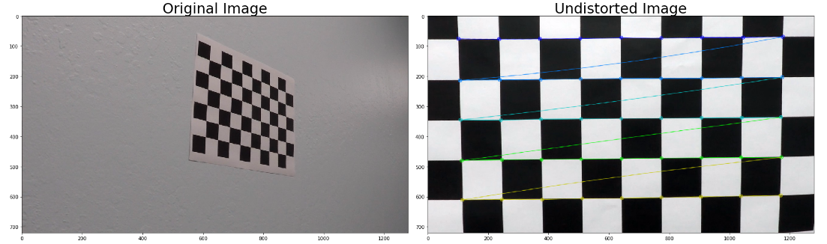

Pipeline (single images)
In the 7th code cell iterates over all the test images of the samples directory.
In this loop the code undistort the image using the undistort parameters found in the first cell, find edges using code from the 3rd cell, transform the image to “look from above” perspective using code from the second cell, fit lane lines and draw the lane using code from the 6th cell.

Undistort
Unditort is done in the first cell. All images from calibrate matrix were scanned for

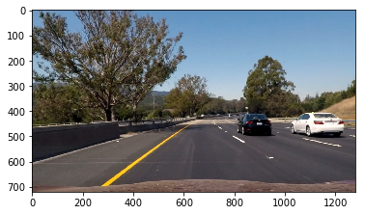
Figure 1:Undistorted Image

Lane detection
The lane detection code is done in cells 3 (auxiliary functions) and 4 (edge extraction and combination.
The lane detection uses an addition combination of Sobel on Y, Sobel on S, S and SobelXY Direction.
I found out that S contributes the most to the lane edges however it contributes the most to edge noise in case of shadows/trees, using S and SobelXY magnitude helped in removing some of this noise.
Below is an image of the edges using SobelY, SobelS, Magnitude & Angle, S & Angle
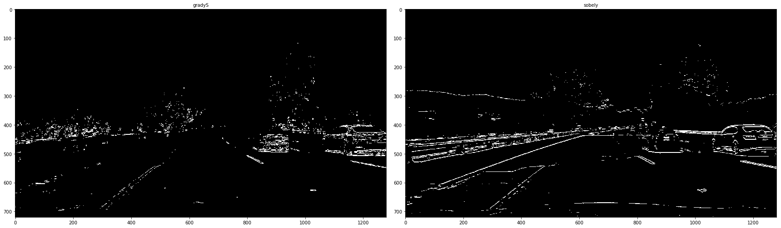
Figure 2: SobelS, SobelY
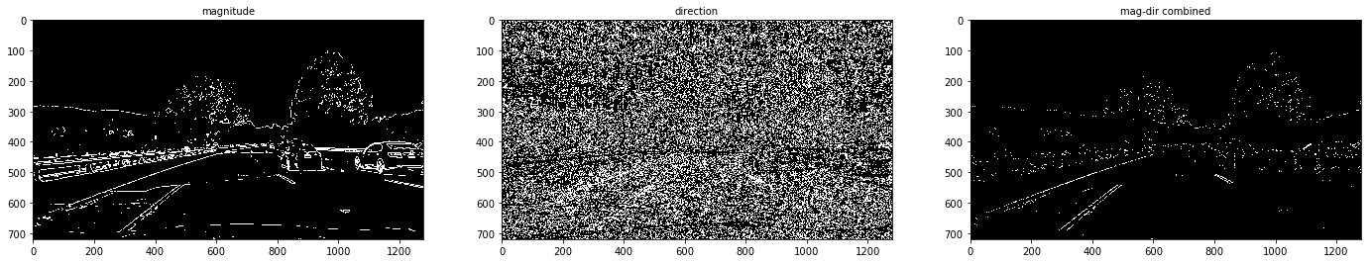
Figure 3: Magnitude-Angle combined
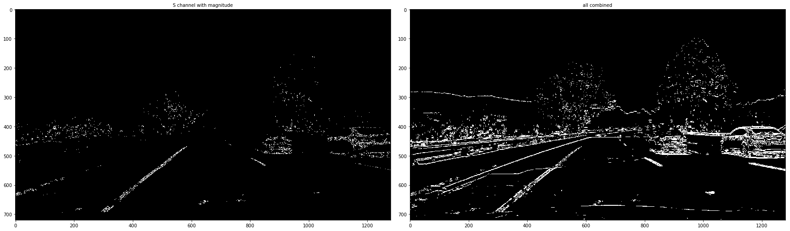
Figure 4: S-Magnitude and All combined

Perspective Transform
The code for the perspective transform coefficient calculation as well as for the inverse transform is provided in the second code cell. The parameters for the to “look from above” perspective transform were handpicked by me to remove the dashboard and include some of the side lanes to improve accuracy in case of strong curves.
Source | Destination
144,675 | 144,720
570,454 | 144,0
710,454 | 1180, 0
1180,675 | 1180, 720
The parameters used as well as the points on “strait_lines1.jpg” image used for calibration and the Transform result
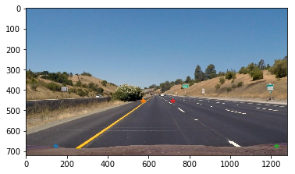
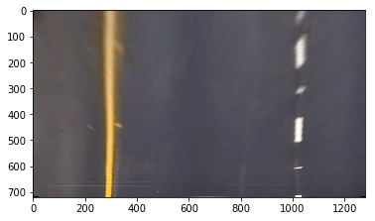

Polynomial Fit
The code in the fifth code cell performs histogram to detect the exact X location of the line followed by window filtering to eliminate image noise.
On the remaining pixels (Red & Blue), a 2nd order polynomial fit is performed to provide the yellow line.

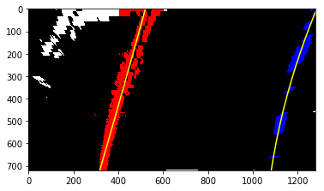
Below is the lane finding result
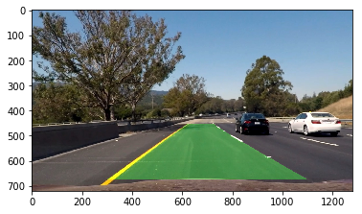

###Pipeline (video)
The video is included in the zip file of the submission

Discussion
The ways to improve are:
- Detect faulty lines in which the curvature doesn’t match
- Detect problematic line, most of the problems stems from tree shadows which cast horizontal shadows within the window, this could be detected by computing the horizontal variance of the pixels within the video
- Smoothing of the lane parameters (low pass filter or weighted averaging)
The techniques used in this project includes:
Camera calibration, edge detection using sobel on gray (Y), S(Y), magnitude of S with SobelXY angle filtering, and Sobel gray magnitude and angle, prepective transfor line detection via histogram and windowing and curve fitting.

