Model-Predictive-Control Reflection

The algorithm
1. Set N and dt.
2. Fit the polynomial to the waypoints in line 115
coeffs = polyfit(ptsx_transform, ptsy_transform, 3)

3. Calculate initial cross track error and orientation error values using polyeval(coeffs, 0) & -atan(coeffs[1]);

4. Define the components of the cost function (state, actuators, weights etc). This is done in MPC FG_eval class

5. Define the model constraints.

N & dt
N is 20 while dt is 0.150 to compensate for the computation time.
This selection enables 3 seconds prediction into the future without a complete change of the scene while 100ms enables continues update of the actuators while 3 seconds is not too far into the future to cause.

Polynomial Fitting
A polynomial is fitted to waypoints is done using the polyfit function in main.cpp we are using a 3rd degree polynomial – 4 coefficients.

MPC Model
The Model uses a 6 variable vector to handle and predict the future vehicle state:
- A four variable state vector comprising of:
  - Position (x,y),
  - Heading (ψ)
  - Velocity (v)
- Two actuators
  - Steering angle (δ) in range [-25,25] deg
  - Acceleration in the range of [-1,1]

The kinematic model can predict the state on the next time step by taking into account the current state and actuators using the following parameters equations:
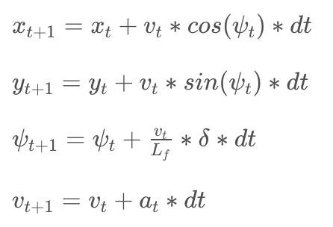
Lf measures the distance between the front of the vehicle and its center of gravity. The parameter was provided in the class and in the walkthrough.
CTE (cross track error) and heading (ψ) error (eψ) describes the error for the model.
Those errors are updated using the following equations:
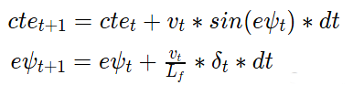

Implementation
MPC Model prediction is implemented in main.cpp lines 129-134 which uses the MPC class described in MPC.cpp to predict the state of the car in <dt> ms according to the MPC model of the following equations.

Weight tuning
The initial set of parameter set provide in the walkthrough didn’t work well. Although my initial assumption was to placing the highest value on CTE it seems that it caused the vehicle to overcompensate and get out of the lines.
Also the model has a problem in the speed setting, the model passed the reference speed set, increasing the speed weight didn’t help only lowering the speed made the speed constraint effective when the speed difference multiplied by the weight was high enough. Setting reference velocity to 30 limited the speed to 65.

