Semantic Segmentation Project (Advanced Deep Learning)

Introduction
The goal of this project is to construct a fully convolutional neural network based on the VGG-16 image classifier architecture for performing semantic segmentation to identify road area from. The network is trained and tested on the KITTI data set.
The code is based on the project walkthrough

Setup

Frameworks and Packages
Make sure you have the following is installed:
- Python 3
- TensorFlow
- NumPy
- SciPy
Also there is a need to install tqdm package which is used in the helper.py but not included in the Udacity deep-learning AMI

Architecture
A pre-trained VGG-16 network was converted to a fully convolutional network by converting the final fully connected layer to a 1x1 convolution and setting the depth equal to the number of desired classes (in this case, two: road and not-road). Performance is improved through the use of skip connections, performing 1x1 convolutions on previous VGG layers (in this case, layers 3 and 4) and adding them element-wise to upsampled (through transposed convolution) lower-level layers (i.e. the 1x1-convolved layer 7 is upsampled before being added to the 1x1-convolved layer 4). Each convolution and transpose convolution layer includes a kernel initializer and regularizer

Optimizer
The loss function for the network is cross-entropy, and an Adam optimizer is used.

Training
The hyperparameters training ranges are:
- l2 0.002-0.005
- Learning rate 0.0001 - 0.00005
- Keep probability 0.8,0.9
- Epochs 25
The code provided run the full hyperparam search afterwards we freeze the graph and optimize it for the optimal results

Results
We can see from the prints that the loss is decreasing over the epochs:
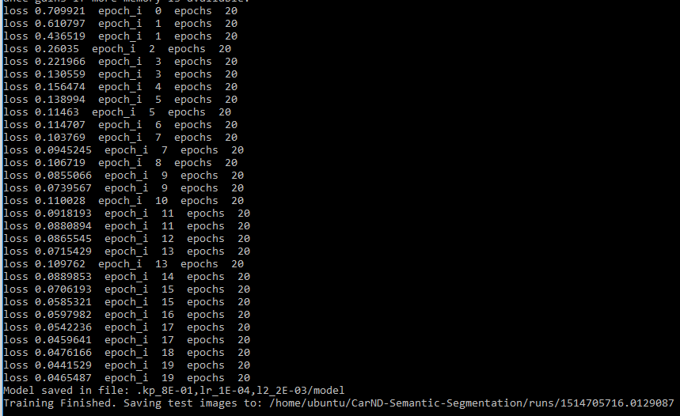

Samples
Below are a few sample images from the output of the FCN, with the segmentation class overlaid upon the original image in green.
Performance is fine, we can see that it also identifies the incoming road (image 1) 