Car Detection

Histogram of Oriented Gradients (HOG)
The code for this step is contained in the first code cell of the IPython notebook

I started by reading in all the vehicle and non-vehicle images. Here is an example of one of each of the vehicle and non-vehicle classes:
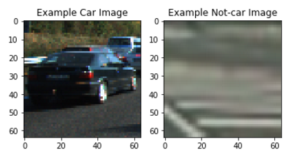
I then explored different color spaces and different skimage.hog() parameters (orientations, pixels_per_cell, and cells_per_block). I grabbed random images from each of the two classes and displayed them to get a feel for what the skimage.hog() output looks like.
Here is an example using the YCrCb color space and HOG parameters of orientations=9, pixels_per_cell=(8, 8) and cells_per_block=(2, 2). I used 9 orientations instead of 8 since 8 created too much false alarms

Hog parameters detection
I tried various combinations of parameters, the most effective and influential was HoG orientation. While exploring Hog parameters I found out that 8 orientation is too robust to change: it created many false alarms of trees detection in the left side of the image. This most of the image gradients are around vertical and horizontal axis changing this parameter to 8 removed most of those false alarms even before local image thresholding or time based filtering and tracking.

Classifier training
I trained a linear SVM on a feature vector length of 8042 which includes: Hog, Color and spatial with the parameters detailed above (9 orientations, 8 pixels per cell, 2 cells per block), on 5000 images of each type the learning phase took about 200 seconds and reached 0.999 accuracy (overfit?)
The code for the classifier is placed in the second code cell

Window Search
Comparing sliding window search to scaled window search on the five test images resulted in better results for the scaled window search so I used it.

Test Images results
Single image test code is in the 4th code cell.
In single image test YCrCb 3-channel HOG features was used as well as spatially binned color and histograms of color in a 8042 length feature vector.
Three windows size scales where used: 0.9*64, 0.9*64*2 and 0.9*64*3
Changing window size from 0.9 to 1 resulted in many misdetections on remote small cars.
This worked well for the test images which showed mostly remote (small) cars, larger windows sizes were required in the test video since it included large near cars.
Overlapping was the basic overlapping (0.5), yet I think that smaller overlapping was required for larger windows and it might have caused misdetection in some frames.
The results include:
Box SVM detection, Heatmap and final car detection.
For the five test images this resulted in 0 misdetection and 0 false alarms. 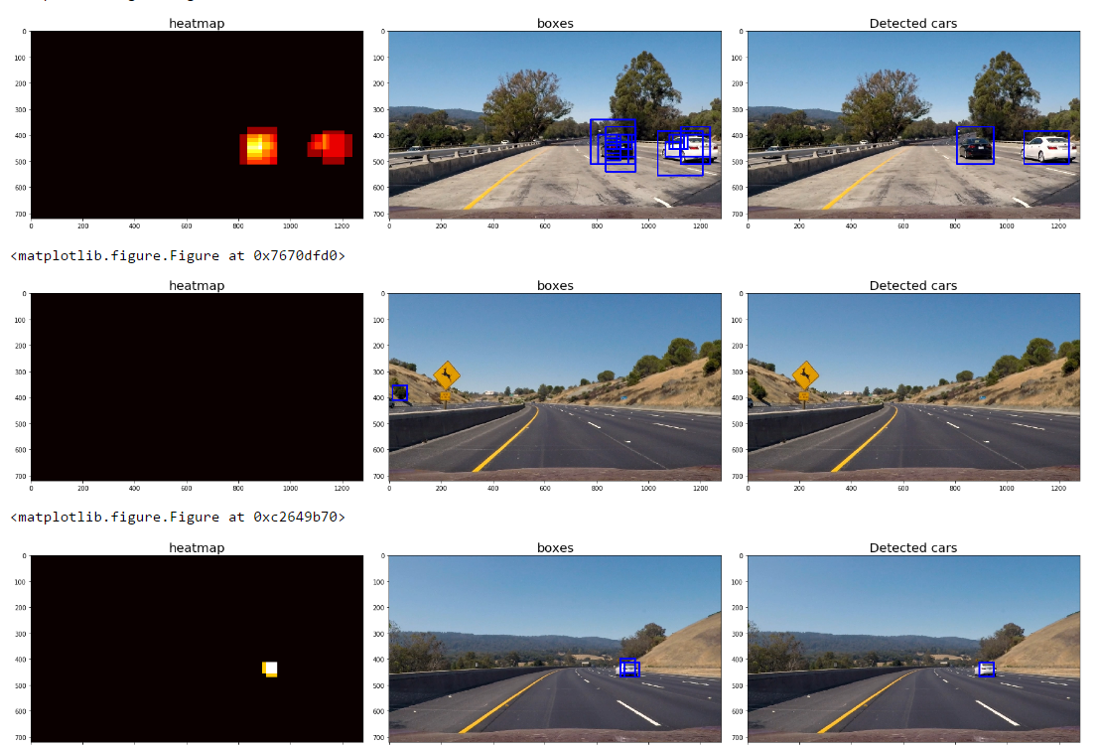
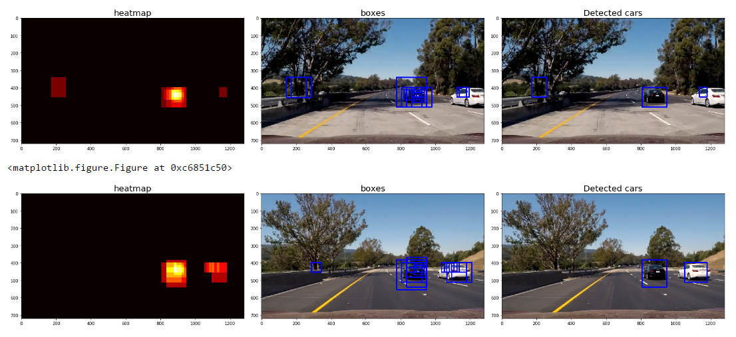

False positive removal
In the single image a simple threshold of 2 detections over a heatmap of the detections.
The area which has two detections is considered a valid car. To distinguish between the cars, label() function from scipy.ndimage.measurements was used to identify individual blobs in the heatmap. A bounding box was assigned to each detected car.
Below is an example of the boxes identified, the heatmap created, the labels created from the threshold heatmap and the final boxes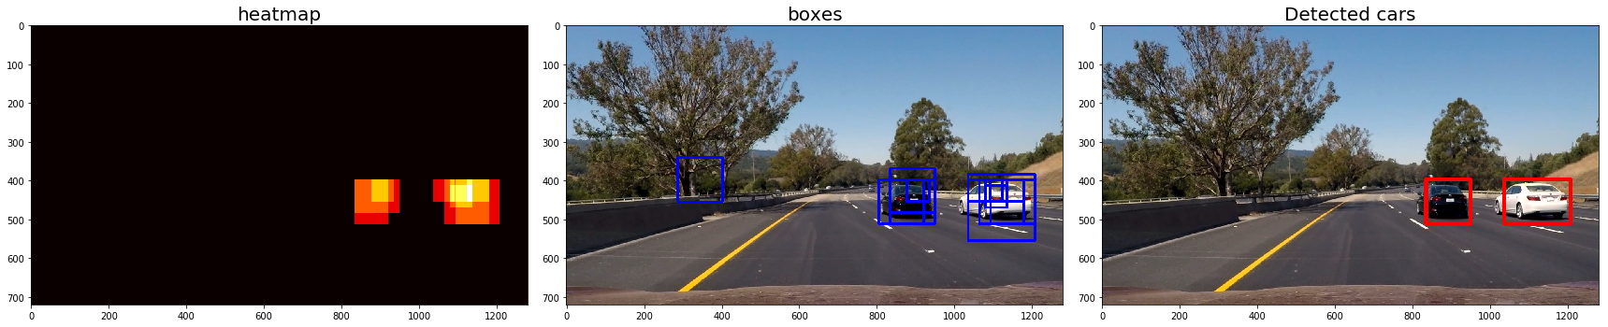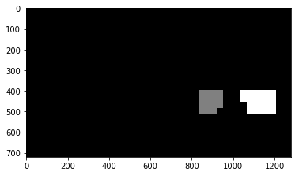

For the video, no threshold per frame was used, instead there was a need for the potential blob will appear in 4 frames out of ten frames. since vehicles are moving only a small part of the boxes would intersect so for each frame labeling was done, heat was then applied, bounding boxes were applied to the heatmap. After this step the bounding window was added to an array which was accumulated.
If 4 frames out of the last ten frames included part of the blob, this blob was detected as a car.
Video results in the GIT

Discussion – further improvement
Further optimization might include:

Time gap filtering
Time gap filtering would add the missing label (car) is missing in n (1-5) frames and appear afterwards in roughly the same location, program should complete it like a “time-base dilate” function

Exact location
Another option would be search optimization, after a car is verified, a smooth search with small step size is done to find the exact location and shape of the car

Tracker
Use of motion based tracker to detect the car (but it wasn’t in class material so I didnt use any)

Color based / based segmentation
Use color/motion based segmentation to distinguish between two cars which are partially occluded (one behind the other)

ROI car detect
Removal of false positive detection of cars on the opposite lanes and object outside of the Trapezoid ROI

