SET DATE :28/01/23

TIME: 23:59

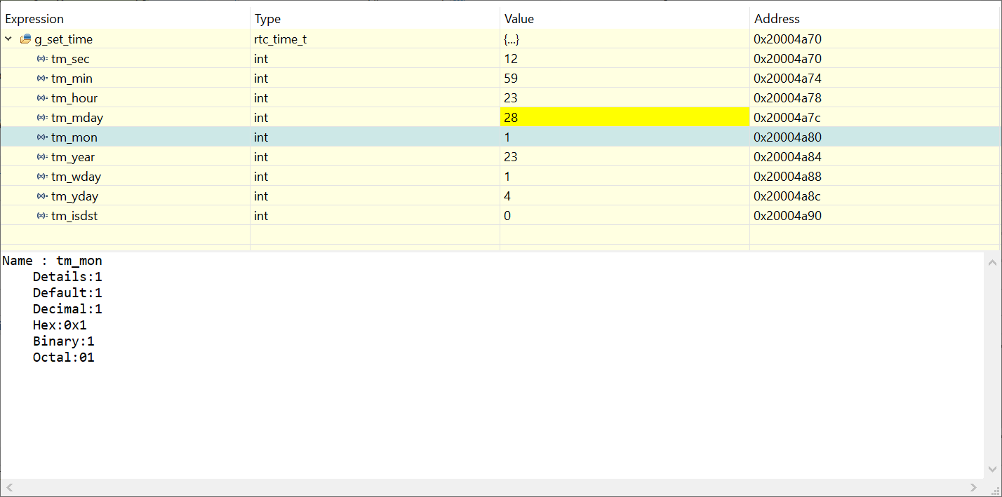

READ TIME AFTER ABOUT 1 MINUTE

