Project : Enterprise Employee Performance & Workforce Analytics System Yash Pradhan
- One to Many:-
‘Departments’ CREATE API working POSTMAN POST :
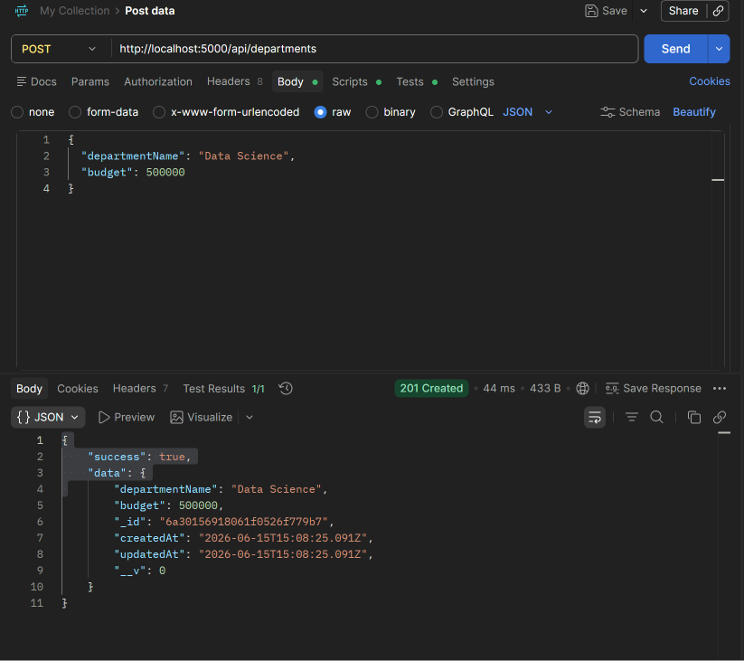
‘Employees’ CREATE API working POSTMAN POST:
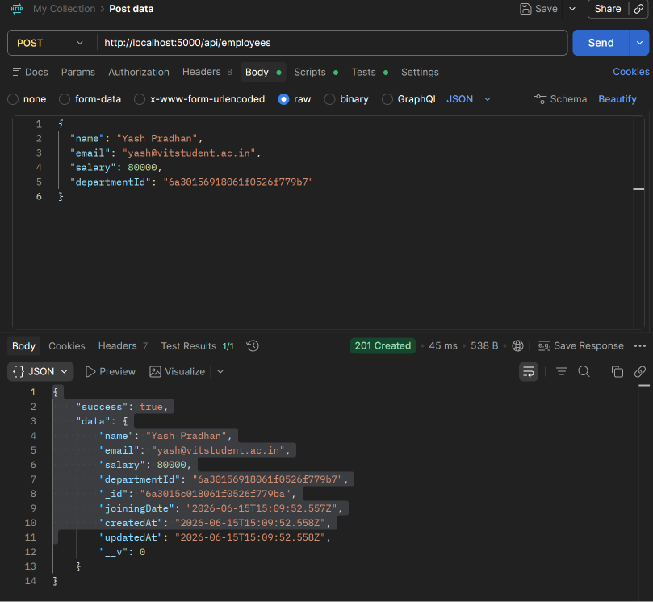
‘Departments’ READ API using POSTMAN GET:

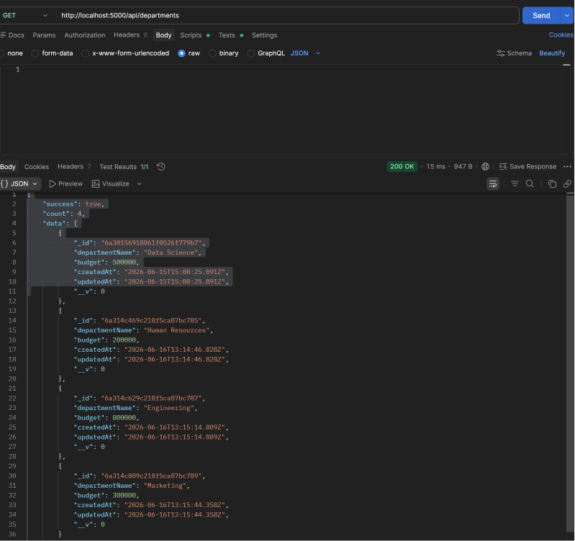

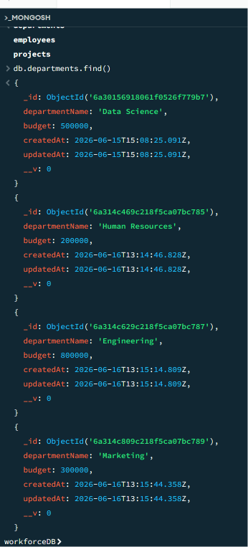
‘Employees’ READ API using POSTMAN GET:
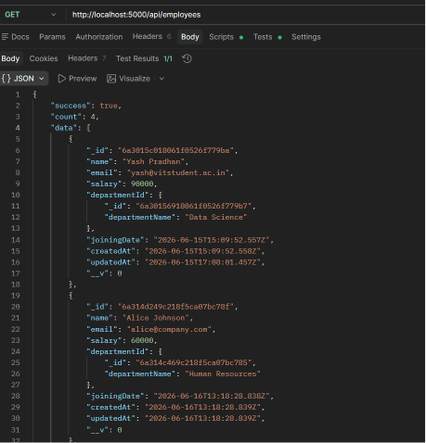

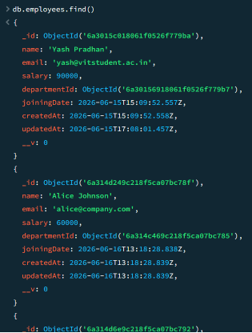
‘Departments’ UPDATE API working POSTMAN PUT:
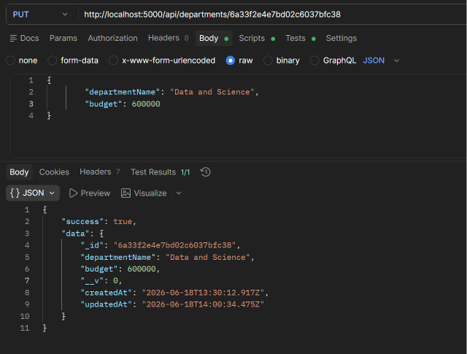

‘Employees’ UPDATE API working POSTMAN PUT:
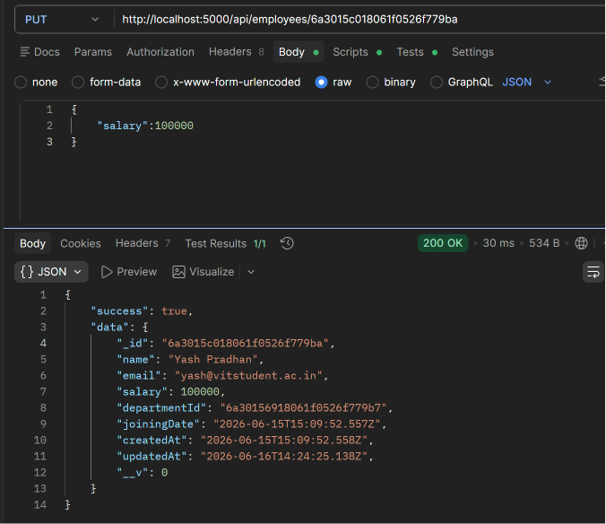
‘Departments’ DELETE API working POSTMAN:

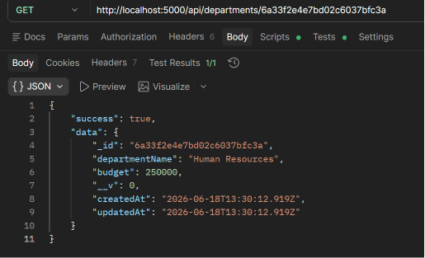
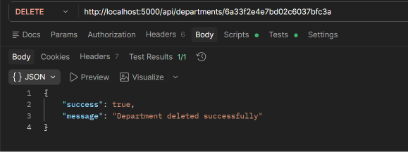
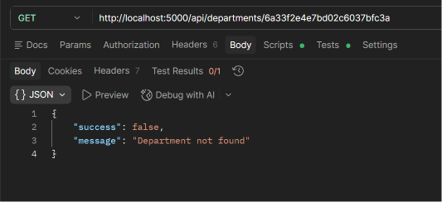
‘Employees’ DELETE API working POSTMAN:
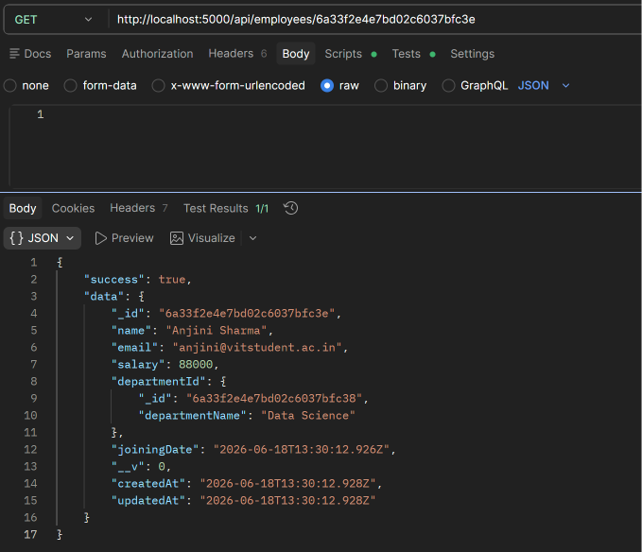
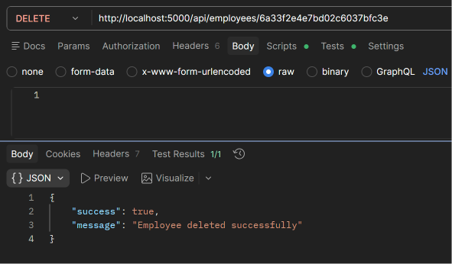

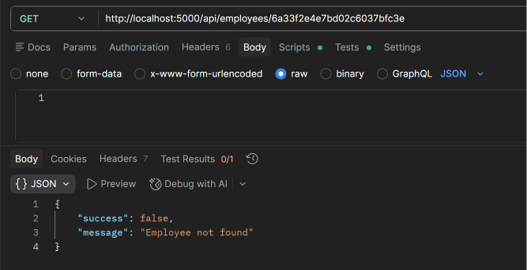

Relational Guard - Employee checks department ID POSTMAN :
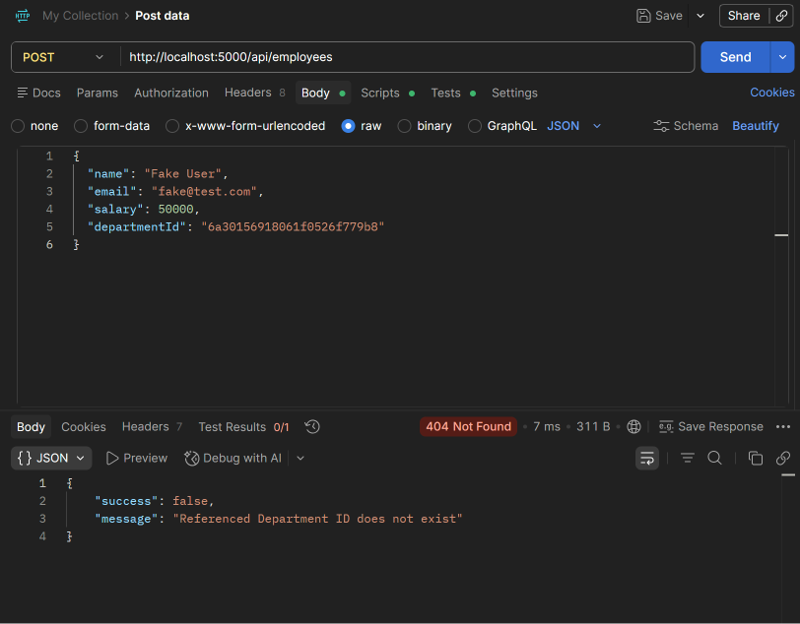

- Many to Many:-
‘Projects’ CREATE API working POSTMAN POST :
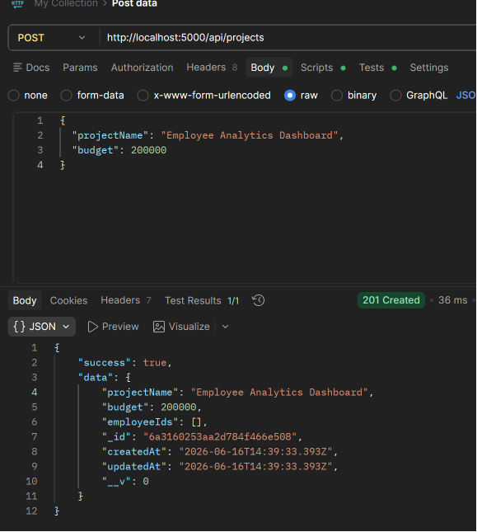
‘Projects’ READ API working POSTMAN GET:
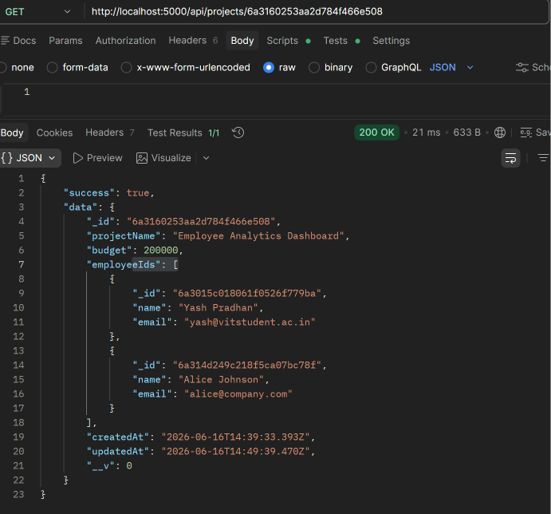
‘Projects’ UPDATE API working POSTMAN PUT:
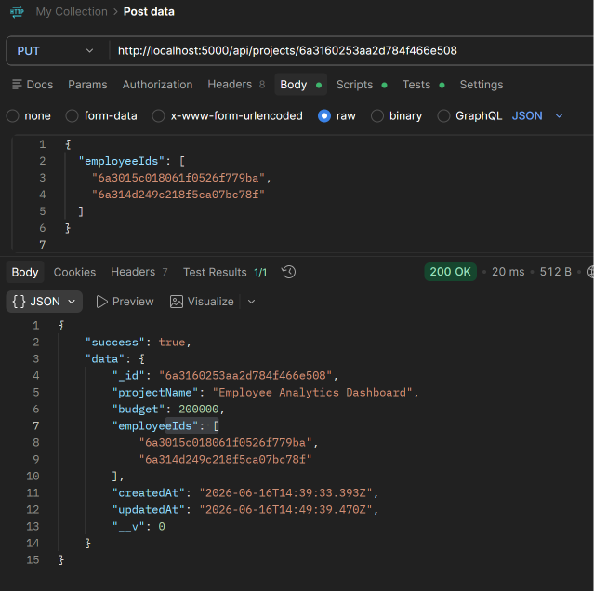
‘Projects’ DELETE API working POSTMAN :
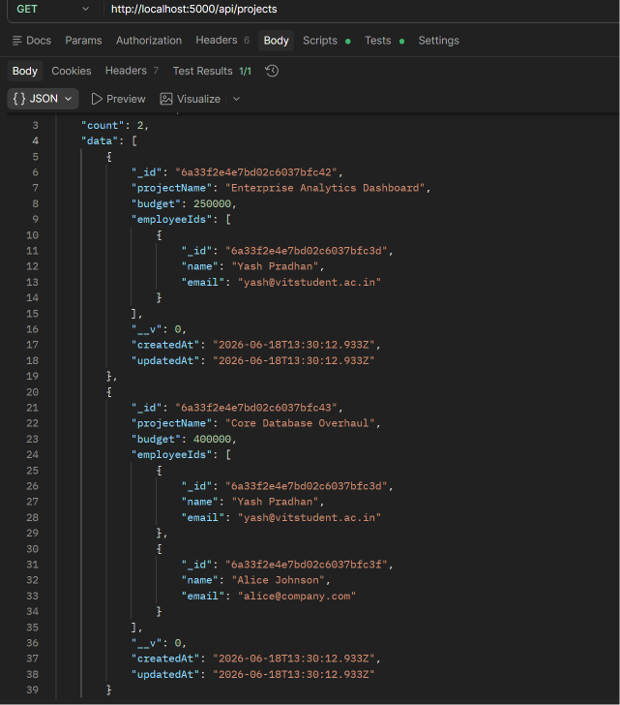
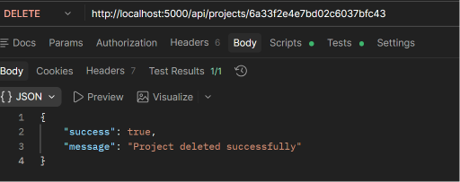

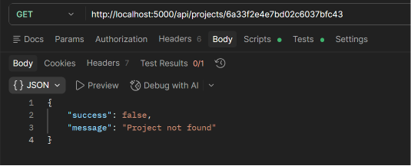

- One to Many:-
‘Reviews’ CREATE API working POSTMAN POST:

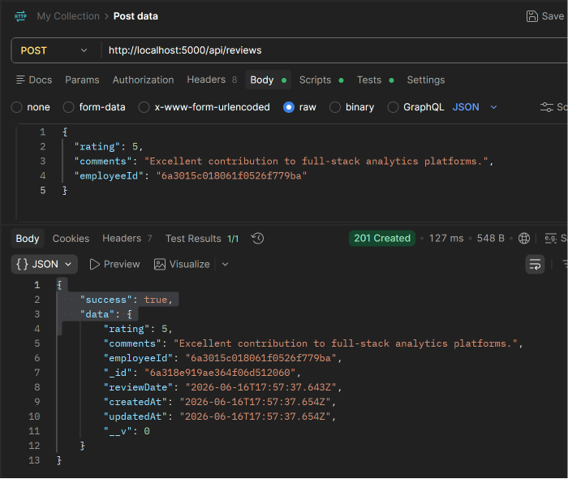
‘Reviews’ strict One to One map rejects duplicates:
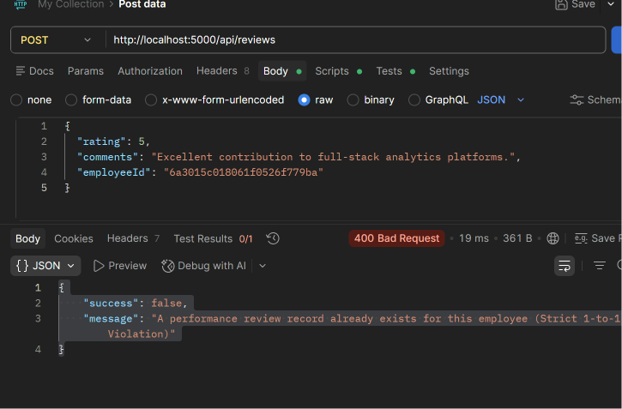
‘Reviews’ READ API working POSTMAN GET:
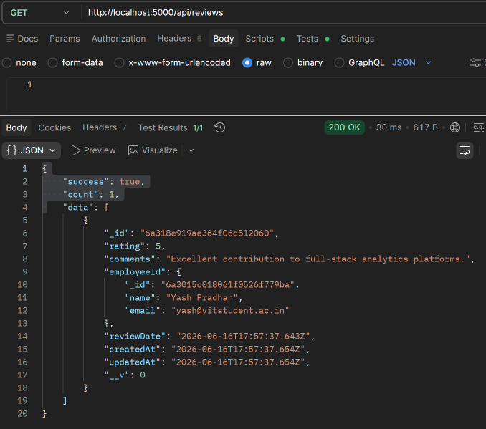
‘Reviews’ UPDATE API working POSTMAN PUT:
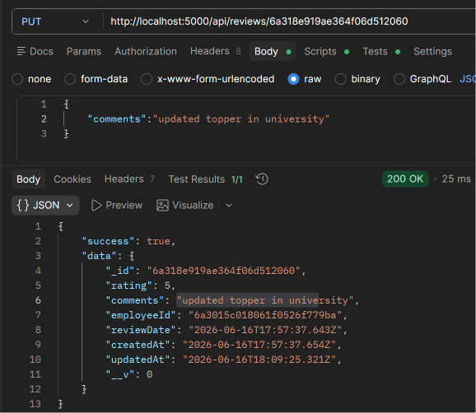

‘Reviews’ verify UPDATE working POSTMAN GET:
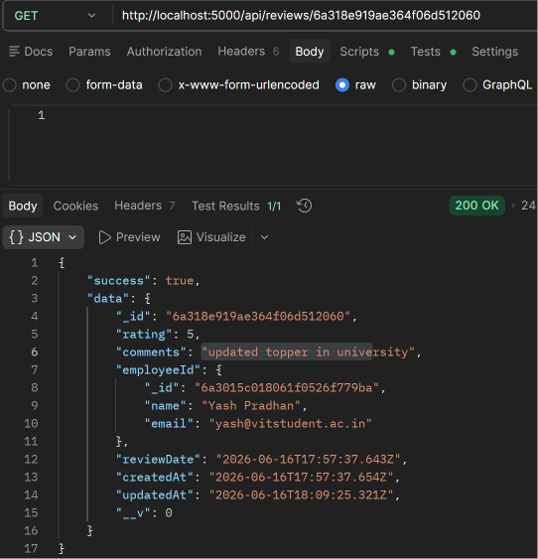
‘Reviews’ verify DELETE API working POSTMAN DELETE:
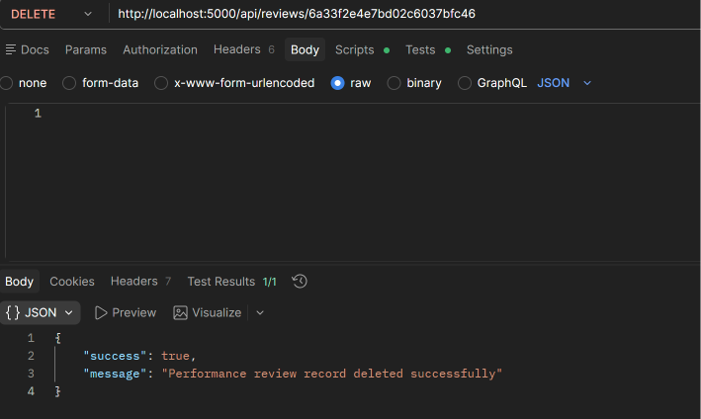

- Administrative Drop Engine using controller POSTMAN GET:
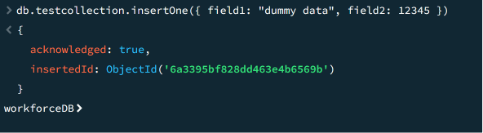

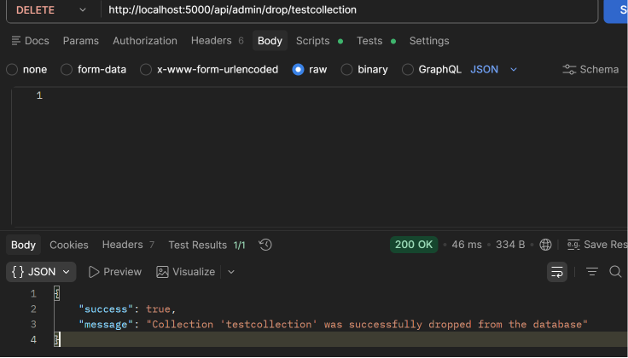

- Analytics engine using aggregation pipelines and lookups:-
Department wise analytics API working POSTMAN GET(group by ,unwind,lookup):
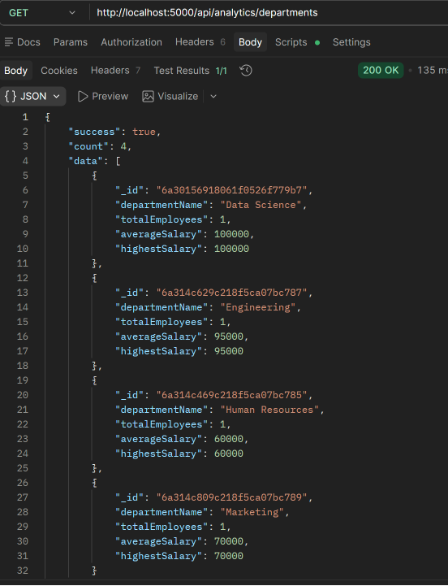
Top performer analytics API working POSTMAN GET (lookup,match,unwind,sort) :
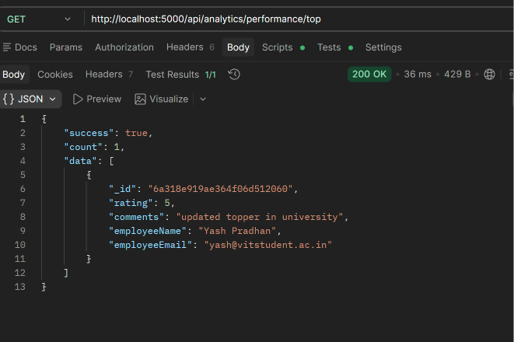
Project utilization analytics API working POSTMAN GET:
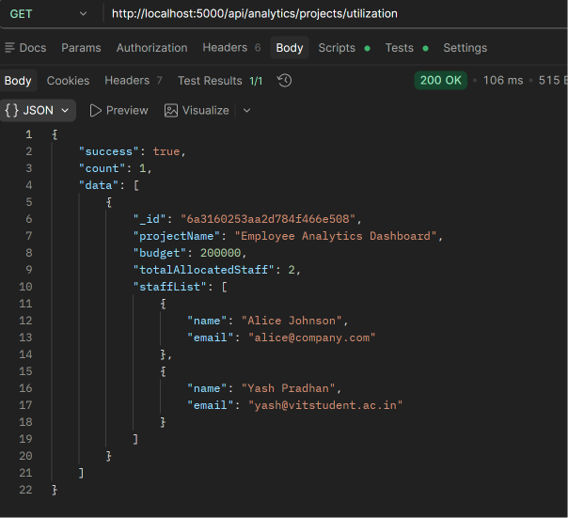
- Global Error Handling & Custom 404 Middleware
Custom Route Not Found Response working POSTMAN GET
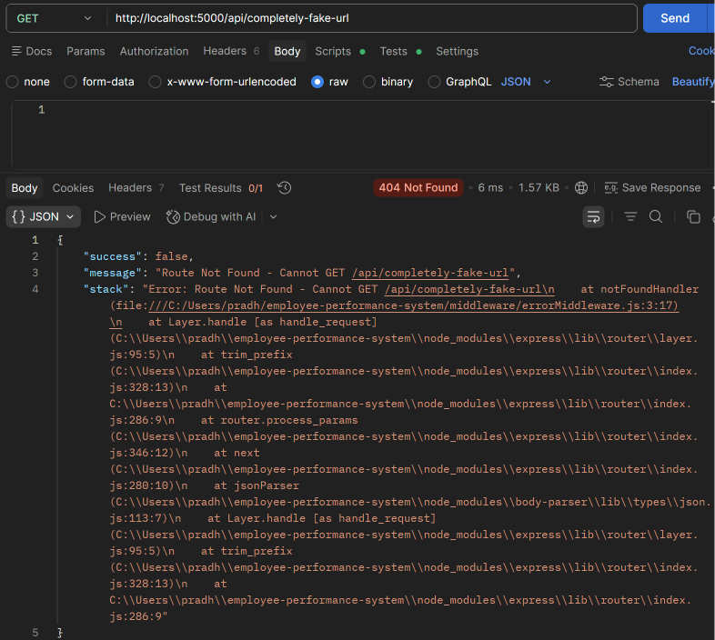
Invalid Mongoose ID Hex Length Check Response working POSTMAN GET:
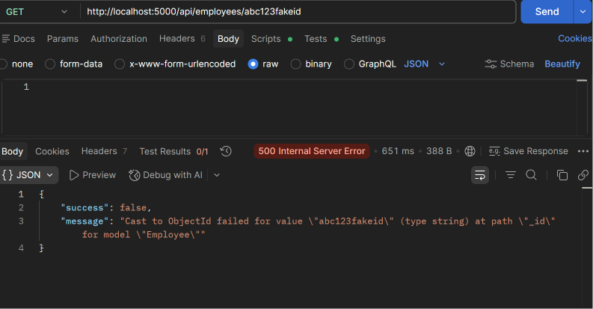
- Joi validation for bad DATA in DEPARTMENTs:
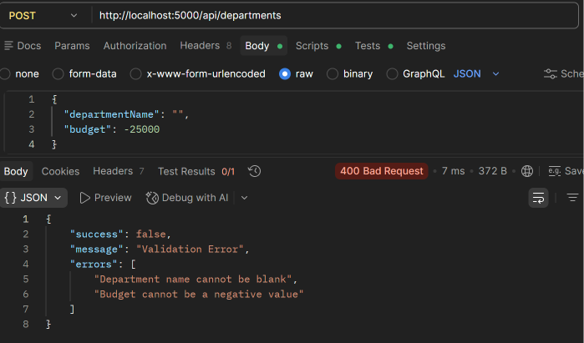
- Joi validation for bad DATA in EMPLOYEEs:
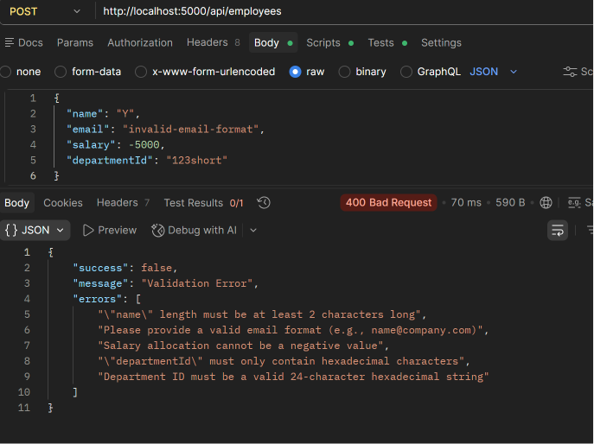
- SWAGGER :
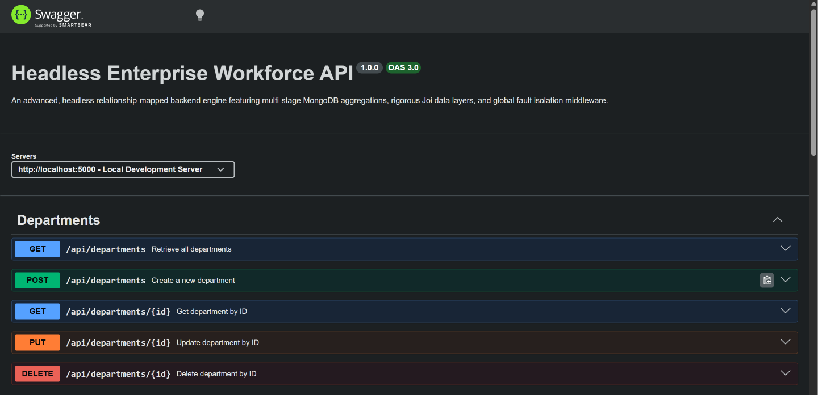
SWAGGER for employees and projects:
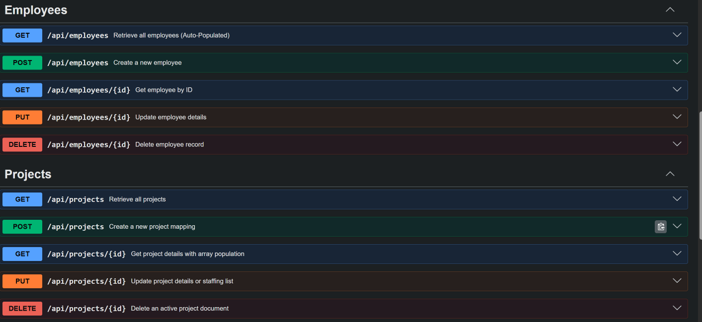
SWAGGER for performance,analytics,admin:
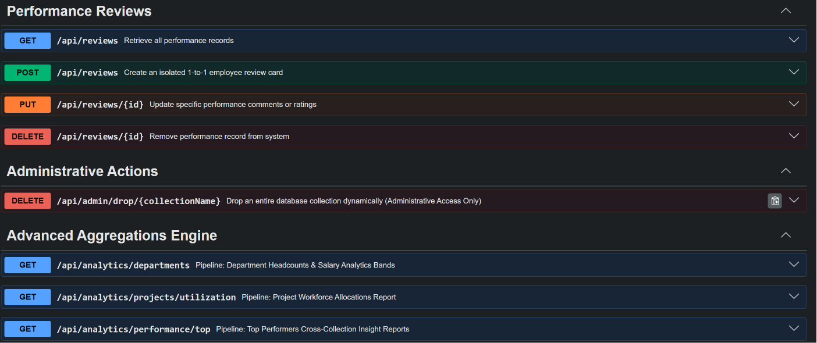
- SEEDER import mock data for testing:
