
FINAL PROJECT REPORT
COMPRESSION-AWARE VECTOR DATABASE INDEXING FOR MEMORY-EFFICIENT AND LOW-LATENCY RETRIEVAL-AUGMENTED GENERATION (RAG)
Evaluating Half-Precision (halfvec) Coordinate Representation, PostgreSQL TOAST Storage Behaviour, and HNSW Graph Indexing in pgvector
BCSE302P — DATABASE SYSTEMS LAB
FALL SEMESTER 2026–27 | SLOT L37+L38
SUBMITTED BY
Reg. No.: 24BCE0702 | YASH PRADHAN
Reg. No.: 24BCE0714 | ANJINI PANDEY
Under the Supervision of
Dr. D. Anuradha
Assistant Professor Senior Grade-1
School of Computer Science and Engineering (SCOPE)
Vellore Institute of Technology, Vellore

EXECUTIVE SUMMARY
When building Retrieval-Augmented Generation (RAG) applications with PostgreSQL and pgvector, 768-dimensional text embeddings are commonly stored using the vector(768) data type, which represents each coordinate as a 32-bit float. The measured FP32 datum size in this project was 3,076 bytes (3,080 bytes under the documented 4d + 8 formula), compared with PostgreSQL's approximate 2 KiB TOAST threshold on 8 KiB pages. In the evaluated representation schema, compression did not reduce the FP32 datum enough to keep it in the main heap, so it was stored out-of-line in a secondary TOAST relation. This project examines how storage, index size, retrieval latency, and top-K overlap changed when the same embeddings were represented as FP16 halfvec(768) datums measuring 1,544 bytes.
- Work Completed: The evaluation expanded from the 180-chunk Review 2 baseline to 1,001, 5,000, and 10,000 BeIR/msmarco chunks, supported by a 43-test automated pytest suite. We built isolated vector-only tables for FP32 and FP16 and constructed HNSW indexes (m = 16, ef_construction = 64). Stages 2–4 used 20 fixed queries and five measured passes (100 timed executions per configuration), with two warm-up passes where specified.
- Main Findings: In the evaluated vector-only schema, casting to halfvec(768) kept the tested FP16 vectors inline in the main heap, leaving 0 bytes of out-of-line TOAST data payload (an empty 8 KiB TOAST index shell remained). Total post-index relation storage fell by 55.35%–55.37% at 5,000 and 10,000 chunks, and HNSW index size fell by 49.90%–49.98%. In exhaustive exact sequential search, FP16 recorded 6.22x–7.24x lower mean latency (7.12x–8.03x lower median latency) than FP32. This observation is consistent with 93.35% fewer shared-buffer hits in the single-query Q0 diagnostics at the two Stage 4 scales; it does not establish that those buffer-hit differences caused the full latency improvement. Client-observed forced-HNSW mean latencies remained broadly similar (about 3.37–4.13 ms), and FP16 retained 0.9600 Recall@10 against uncompressed FP32 exact search.
- Practical Conclusion: For 768-dimensional embeddings in PostgreSQL, halfvec(768) cuts total table-plus-index storage by more than half and substantially reduces measured exact-search latency while retaining 0.9600 Recall@10 against the FP32 exact reference in the tested HNSW configuration.
Keywords: Retrieval-Augmented Generation (RAG); PostgreSQL; pgvector; Half-Precision Quantization (halfvec); TOAST Storage; HNSW Indexing; Shared-Buffer Access; Recall@K.

ACKNOWLEDGEMENTS
We express our sincere gratitude to our faculty supervisor, Dr. D. Anuradha, School of Computer Science and Engineering (SCOPE), Vellore Institute of Technology, Vellore, for her guidance, constructive feedback across Project Reviews 1 and 2, and continuous encouragement throughout the BCSE302P Database Systems Lab project. We also thank the School of Computer Science and Engineering at VIT Vellore for providing the academic environment needed to carry out this work, as well as the open-source maintainers of PostgreSQL, pgvector, Ollama, and the BeIR/msmarco dataset whose software and data resources made our empirical evaluation possible.
Candidates: Yash Pradhan and Anjini Pandey.

TABLE OF CONTENTS
EXECUTIVE SUMMARY i
ACKNOWLEDGEMENTS ii
LIST OF TABLES v
LIST OF FIGURES vi
LIST OF ABBREVIATIONS vii
SYMBOLS AND NOTATIONS viii
1. INTRODUCTION 1
1.1 BACKGROUND 1
1.2 MOTIVATIONS 1
1.3 SCOPE OF THE PROJECT 2
2. PROJECT DESCRIPTION AND GOALS 3
2.1 LITERATURE REVIEW 3
2.2 RESEARCH GAP 6
2.3 OBJECTIVES 6
2.4 PROBLEM STATEMENT 7
2.5 PROJECT PLAN 8
3. TECHNICAL SPECIFICATION 9
3.1 REQUIREMENTS 9
3.1.1 Functional 9
3.1.2 Non-Functional 9
3.2 FEASIBILITY STUDY 10
3.2.1 Technical Feasibility 10
3.2.2 Economic Feasibility 11
3.2.3 Social Feasibility 11
3.3 SYSTEM SPECIFICATION 11
3.3.1 Hardware Specification 11
3.3.2 Software Specification 12
TABLE OF CONTENTS (CONTINUED)
4. DESIGN APPROACH AND DETAILS 13
4.1 SYSTEM ARCHITECTURE 13
4.2 DESIGN 15
4.2.1 Data Flow Diagram 15
4.2.2 Class Diagram 15
5. METHODOLOGY AND TESTING 17
5.1 MODULE DESCRIPTION 17
5.2 TESTING 18
6. PROJECT DEMONSTRATION 20
6.1 REPRESENTATION TABLES AND HALF-PRECISION CASTING 20
6.2 EXACT AND HNSW SEARCH QUERY PATTERNS 21
6.3 TIMING AND QUERY-PLAN VERIFICATION 21
7. RESULT AND DISCUSSION (COST ANALYSIS AS APPLICABLE) 22
7.1 STORAGE, TOAST BEHAVIOUR, AND HNSW BUILD TIMES 22
7.2 EXACT AND FORCED-HNSW LATENCY 25
7.3 RECALL@K AND PAIRWISE TOP-K AGREEMENT 27
7.4 QUERY PLANS, BUFFERS, AND PLANNER BEHAVIOUR 32
7.5 RESOURCE COSTS, IMPLICATIONS, AND LIMITATIONS 36
8. CONCLUSION AND FUTURE ENHANCEMENTS 38
8.1 CONCLUSION 38
8.2 FUTURE ENHANCEMENTS 39
9. REFERENCES 40
APPENDIX A — SAMPLE CODE 42
APPENDIX B — TANGIBLE OUTCOME — PUBLICATION/PATENT 44

LIST OF TABLES
Table 2.1: Comparison of FP32, FP16 halfvec, and codebook quantization 5
Table 2.2: Project execution plan and milestone progression across stages 8
Table 3.1: Functional and non-functional requirements of the implemented benchmarking system 9
Table 3.2: Experimental hardware and software specifications 12
Table 4.1: Multi-database layout and isolation policy across project stages 14
Table 5.1: Functional responsibilities of Python modules in src/ 17
Table 5.2: Automated pytest verification suites and experimental timing boundaries across stages 19
Table 7.1: Coordinate datum size comparison for 768-dimensional vectors 23
Table 7.2: Disaggregated storage footprint and HNSW build durations across 1,001, 5,000, and 10,000 chunks 24
Table 7.3: Stage 4 v2 client-observed latency across all six configurations at 5,000 and 10,000 chunks 26
Table 7.4: Representation-specific Recall@K against uncompressed FP32 exact sequential scan ground truth 29
Table 7.5: Pairwise top-K candidate-set overlap fraction between FP32 HNSW and FP16 HNSW 30
Table 7.6: Stage-specific EXPLAIN (ANALYZE, BUFFERS) diagnostic observations 32
Table 7.7: PostgreSQL query optimizer cost estimates and representation-specific plan selection across scales 35

LIST OF FIGURES
Figure 1: Implemented system architecture and compression-aware benchmarking pipeline 13
Figure 2: Level-1 Data Flow Diagram (DFD) of the implemented system 15
Figure 3: UML database entity-relationship and procedural module diagram 16
Figure 4: Physical storage footprint comparison across 1,001, 5,000, and 10,000 chunks 25
Figure 5: Stage 4 v2 client-observed latency 27
Figure 6: Representation-specific ANN Recall@K (zero-based 0.0–1.0 axis) 30
Figure 7: Pairwise top-K candidate-set agreement between FP32 HNSW and FP16 HNSW 31
Figure 8: Q0 diagnostics at 5,000 and 10,000 chunks from EXPLAIN (ANALYZE, BUFFERS) 34

LIST OF ABBREVIATIONS
Abbrev. | Full Term | Abbrev. | Full Term
ACID | Atomicity, Consistency, Isolation, Durability | IQR | Interquartile Range (P75 - P25)
ANN | Approximate Nearest Neighbor | KiB / MiB | Kibibyte (1,024 B) / Mebibyte (1,048,576 B)
BLCKSZ | PostgreSQL Block Size (8,192 B / 8 KiB) | KNN | k-Nearest Neighbors
DDL / DML | Data Definition / Manipulation Language | LLM | Large Language Model
DFD | Data Flow Diagram | MS MARCO | Microsoft Machine Reading Comprehension
FP16 / halfvec | IEEE 754 16-Bit Half-Precision Float | NPU | Neural Processing Unit
FP32 / vector | IEEE 754 32-Bit Single-Precision Float | PQ / SQ | Product / Scalar Quantization
FSM / VM | Free Space Map / Visibility Map Forks | RAG | Retrieval-Augmented Generation
GUC | Grand Unified Configuration (PostgreSQL) | RDBMS | Relational Database Management System
HNSW | Hierarchical Navigable Small World Graph | TOAST | The Oversized-Attribute Storage Technique
IEEE | Institute of Electrical & Electronics Eng. | WAL | Write-Ahead Log

SYMBOLS AND NOTATIONS
Symbol / Notation | Mathematical or Database Meaning
d ; u, v in R^d | Embedding dimensionality (d = 768) and 768-D chunk/query vectors
d_cos(u, v) / <=> | Cosine distance operator in pgvector: 1 - (u . v) / (||u||_2 ||v||_2)
N ; K | Relation chunk count (180, 1,001, 5,000, 10,000) and top-K cutoff (K in {3, 5, 10})
m | Maximum bidirectional HNSW links per node on upper graph layers (m = 16)
ef_construction | Dynamic candidate list size during HNSW index build (ef_construction = 64)
ef_search | Dynamic candidate priority-queue size during HNSW query search (ef_search = 40)
Top-K_FP32_Exact(q) | Ground-truth top-K chunk ID set from exhaustive FP32 exact scan for query q
S_FP32(q), S_FP16(q) | Top-K candidate ID sets returned by FP32 HNSW and FP16 HNSW for query q
Recall@K | Mean top-K overlap fraction |Top-K_FP32_Exact(q) intersect Top-K_Cand(q)| / K
Agreement@K | Mean pairwise top-K overlap fraction |S_FP32(q) intersect S_FP16(q)| / K

Chapter 1

1. INTRODUCTION

1.1 BACKGROUND
Retrieval-Augmented Generation (RAG) grounds Large Language Model (LLM) responses by coupling a parametric sequence-to-sequence generator with a non-parametric dense-vector memory over an external document corpus (Lewis et al., 2020). To support semantic retrieval, document passages are segmented into chunks and mapped into high-dimensional vectors using neural embedding models such as nomic-embed-text (768 dimensions) (Ollama, n.d.). Rather than maintaining a separate standalone vector store alongside a relational database, many production systems use PostgreSQL with the pgvector extension (Kane & pgvector Contributors, n.d.) so that document text, foreign-key metadata, and vector indexes share a single ACID-compliant storage engine. However, PostgreSQL organizes relation data into fixed-size 8 KiB pages (BLCKSZ = 8192) designed for compact scalar tuples rather than multi-kilobyte floating-point coordinate arrays (PostgreSQL Global Development Group, n.d.).

1.2 MOTIVATIONS
When 768-dimensional embeddings are stored in standard 32-bit single-precision format (vector(768)), each vector datum occupies 3,076 bytes as measured empirically by pg_column_size(embedding) (3,080 bytes under the documented 4d + 8 formula). In the evaluated representation schema, this datum exceeded PostgreSQL's approximate 2 KiB oversized-attribute threshold (TOAST_TUPLE_THRESHOLD) and was stored out-of-line in a secondary TOAST (pg_toast) table (PostgreSQL Global Development Group, n.d.). This out-of-line storage creates two practical problems: secondary TOAST tables and 32-bit HNSW indexes consume substantial disk and memory space, and exhaustive sequential scans must follow pointers and reassemble TOAST chunks for every row.
Converting coordinates from 32-bit floats (vector(768)) to 16-bit half-precision floats (halfvec(768)) reduces the datum size to 1,544 bytes. In the tested schema, this size remained below the approximate 2 KiB TOAST threshold and the FP16 vector stayed inline in the main 8 KiB heap page. Our motivation is to measure how storage, buffer work, and query latency change when halfvec(768) is used for exact sequential scans and HNSW approximate indexes, and whether 16-bit coordinate precision affects top-K retrieval overlap.

1.3 SCOPE OF THE PROJECT
This project evaluates the database storage and vector retrieval layer in PostgreSQL 18.4 with pgvector 0.8.4 across BeIR/msmarco subsets (BeIR / MS MARCO Dataset Repository, n.d.) of 180 chunks (Review 2 baseline on a monolithic table) and 1,001, 5,000, and 10,000 chunks (Stages 1–4 on dedicated vector-only representation tables). We measure disaggregated physical storage (heap, TOAST data, TOAST index, primary-key index, HNSW index, and auxiliary forks), 100-trial client retrieval latency across Exact Search, Forced HNSW, and Planner-Selected modes, single-query EXPLAIN (ANALYZE, BUFFERS) diagnostics, planner path selection, ground-truth Recall@K, and pairwise top-K candidate agreement. We do not claim to measure downstream LLM answer generation quality, human relevance judgments (qrels), cold-disk paging beyond PostgreSQL's 128 MB shared_buffers, or general asymptotic scaling laws beyond the tested 5,000- and 10,000-chunk Stage 4 v2 sizes.
Chapter 2

2. PROJECT DESCRIPTION AND GOALS

2.1 LITERATURE REVIEW
Our investigation connects peer-reviewed research on retrieval-augmented generation, graph-based approximate nearest-neighbor (ANN) search, vector compression, and ANN benchmarking with the physical storage mechanics of PostgreSQL and pgvector:
- RAG and Dense Vector Retrieval (BeIR / MS MARCO Dataset Repository, n.d.; Lewis et al., 2020; Ollama, n.d.): Lewis et al. (2020) formulated Retrieval-Augmented Generation (RAG) for knowledge-intensive NLP tasks by combining a pre-trained parametric generator with a non-parametric dense-vector retriever indexed over external text passages. Because the retriever must identify the top-K highest-similarity passages from large corpora such as MS MARCO (BeIR / MS MARCO Dataset Repository, n.d.) using dense embeddings (in our pipeline, 768-dimensional nomic-embed-text vectors (Ollama, n.d.)), the storage footprint, query latency, and top-K recall of the vector index directly govern retrieval efficiency.
- Graph-Based Approximate Search via HNSW (Kane & pgvector Contributors, n.d.; Malkov & Yashunin, 2020): To avoid exhaustive O(N d) linear scans over all N vectors, Malkov and Yashunin (2020) introduced Hierarchical Navigable Small World (HNSW) graphs, which organize vectors into nested proximity graphs with exponentially decaying node density across upper routing layers and a dense base layer (Layer 0). Greedy search descends from coarse upper-layer entry links to fine-grained Layer-0 neighborhoods using three core hyperparameters—maximum links per node (m), build-time candidate list size (ef_construction), and query-time priority-queue width (ef_search) (Malkov & Yashunin, 2020)—which are implemented directly in pgvector (m = 16, ef_construction = 64, ef_search = 40 in our experiments) (Kane & pgvector Contributors, n.d.).
- Vector Compression and Quantization (Guo et al., 2020; Jégou et al., 2011; Kane & pgvector Contributors, n.d.): Storing uncompressed 32-bit floating-point coordinates in memory and on disk creates substantial capacity and bandwidth costs as vector collections grow. Jégou et al. (2011) introduced Product Quantization (PQ), which partitions a d-dimensional vector into M orthogonal subvectors (distinct from the HNSW graph degree parameter m) and quantizes each subspace using a learned codebook of 2^b centroids (b bits per subquantizer, yielding an M x b-bit code) with distances estimated via lookup tables. Whereas PQ and Scalar Quantization (SQ) define compact code formats, Guo et al. (2020) formulated anisotropic vector quantization as a quantization loss objective tailored to maximum inner-product and cosine similarity search—penalizing reconstruction error parallel to a vector more heavily than orthogonal error when optimizing codebooks so that relative similarity rankings are better preserved. Although learned codebook methods (Guo et al., 2020; Jégou et al., 2011) produce compact codes whose length depends on the chosen M and b, they require offline training on representative data; while a fixed codebook does not itself change when new SQL rows are inserted, incoming data whose distribution shifts away from the training sample may become less well represented by the existing centroids, potentially motivating recalibration or retraining. In contrast, coordinate-level IEEE 754 half-precision quantization (halfvec(768) in pgvector (Kane & pgvector Contributors, n.d.)) deterministically casts each 32-bit coordinate to a 16-bit binary16 float (1,544 B datum size vs. 3,076 B measured for vector(768)) without codebook training, while supporting native HNSW indexing (halfvec_cosine_ops) (Table 2.1).
- ANN Benchmarking vs. Relational Storage Mechanics (Aumüller et al., 2020; Kane & pgvector Contributors, n.d.; PostgreSQL Global Development Group, n.d.): Aumüller et al. (2020) established the ANN-Benchmarks framework, demonstrating that approximate search methods must be evaluated across multiple competing dimensions—specifically top-K recall against exact ground truth (Recall@K), query latency/throughput, and index build cost. However, ANN-Benchmarks (Aumüller et al., 2020) evaluates standalone in-memory indexing libraries in isolation from relational database page management. Inside PostgreSQL (PostgreSQL Global Development Group, n.d.), relation pages are fixed at 8,192 bytes (BLCKSZ = 8192). For oversized attributes above the approximate TOAST threshold, PostgreSQL attempts compression; values that remain too large are stored out-of-line in pg_toast. In the evaluated schema, the measured vector(768) datum (3,076 B) was not compressed enough to avoid out-of-line storage, whereas halfvec(768) (1,544 B) remained inline within the primary 8 KiB heap pages (Kane & pgvector Contributors, n.d.; PostgreSQL Global Development Group, n.d.).
Table 2.1: Comparison of FP32, FP16 halfvec, and codebook quantization
Comparison Aspect | FP32 Baseline (vector(768)) (Kane & pgvector Contributors, n.d.) | FP16 Quantization (halfvec(768)) (Kane & pgvector Contributors, n.d.) | Learned Codebook & Scalar Quantization (PQ (Jégou et al., 2011), SQ; Anisotropic Objective (Guo et al., 2020))
Encoding & Design Role | IEEE 754 32-bit float (4 B/dim) | IEEE 754 16-bit float (2 B/dim) | PQ: M subquantizers x b-bit learned codebooks (Jégou et al., 2011); SQ: scalar buckets (anisotropic loss (Guo et al., 2020) defines training objective)
768-D Datum Footprint | 3,076 B measured (3,080 B formula) | 1,544 B (49.80% empirical reduction) | Configuration-dependent: M x b bits for PQ (Jégou et al., 2011) (depends on chosen subquantizers M and bits per code b)
PostgreSQL Heap / TOAST (PostgreSQL Global Development Group, n.d.) | Observed out-of-line in pg_toast in the evaluated schema | Inline in the 8 KiB heap page in the evaluated schema | Inlined if encoded representation is below ~2 KiB threshold
Training & Distribution Shift | None (native SQL inserts) | None (deterministic SQL cast) | Requires offline codebook/range fitting (Guo et al., 2020; Jégou et al., 2011); distribution shift in new data may motivate retraining
Evaluated in This Project | Yes — Stages 1–4 Baseline | Yes — Stages 2–4 Primary Target | Reviewed as literature context (Guo et al., 2020; Jégou et al., 2011); not implemented in benchmark

2.2 RESEARCH GAP
The foundational literature reviewed above investigates RAG architecture and dense retrieval (Lewis et al., 2020), HNSW proximity-graph construction and search (Malkov & Yashunin, 2020), learned subspace and anisotropic vector quantization (Guo et al., 2020; Jégou et al., 2011), and standardized in-memory ANN benchmarking (Aumüller et al., 2020), while official PostgreSQL and pgvector documentation defines page storage, TOAST thresholds, and vector/halfvec data types (Kane & pgvector Contributors, n.d.; PostgreSQL Global Development Group, n.d.). However, standalone ANN benchmarks (Aumüller et al., 2020) and algorithmic quantization studies (Guo et al., 2020; Jégou et al., 2011) do not directly measure how coordinate precision interacts with PostgreSQL's 8 KiB page layout, out-of-line pg_toast storage, shared-buffer access patterns, and query-planner cost model.
Within the literature reviewed, our project addresses a focused database-engineering setting: empirically comparing vector(768) (FP32) and halfvec(768) (FP16) inside PostgreSQL 18.4 and pgvector 0.8.4 on dedicated vector-only representation tables. Specifically, our experiments measure how half-precision representation affects (1) disaggregated heap, TOAST data, TOAST index, and auxiliary fork storage, (2) standalone HNSW index footprint and single-run build duration, (3) 100-trial client retrieval latency across exact sequential scans, forced HNSW scans, and planner-selected execution, (4) recorded EXPLAIN diagnostics and representation-specific planner transitions between Seq Scan and Index Scan, with Q0 identity confirmed only for the Stage 4 5,000- and 10,000-chunk diagnostic records, and (5) representation-specific Recall@K and pairwise top-K candidate agreement across 1,001, 5,000, and 10,000 MS MARCO chunks.

2.3 OBJECTIVES
1. Disaggregated Storage Auditing: Quantify byte and MiB footprints across datums, main heaps, TOAST data tables, TOAST indexes, primary-key indexes, HNSW indexes, and auxiliary forks (_fsm, _vm) at 1,001, 5,000, and 10,000 chunks.
2. Controlled Latency Benchmarking: Measure FP32 and FP16 client retrieval latency across Exact Search (Seq Scan), Forced HNSW (Index Scan, ef_search = 40), and Planner-Selected modes over 20 pre-embedded queries, 2 warm-ups, and 5 alternating passes (100 timed trials per configuration).
3. Retrieval Fidelity & Agreement Analysis: Evaluate representation-specific Recall@K (K in {3, 5, 10}) against uncompressed FP32 exact ground truth alongside pairwise top-K candidate agreement between FP32 HNSW and FP16 HNSW.
4. Query-Plan & Optimizer Cost Inspection: Inspect recorded single-query EXPLAIN (ANALYZE, BUFFERS) plan samples; Q0 identity is confirmed for the Stage 4 5,000- and 10,000-chunk diagnostics, but not for the 1,001-chunk samples. Use them to record shared-buffer hits, server execution times, and planner costs where recorded.

2.4 PROBLEM STATEMENT
Problem Statement
In the evaluated schema, storing 768-dimensional FP32 vectors (vector(768), 3,076 B measured) exceeded the approximate 2 KiB TOAST threshold and resulted in out-of-line pg_toast storage; measured FP32 HNSW indexes were approximately twice the size of the FP16 indexes. This project measures whether half-precision coordinate representation (halfvec(768), 1,544 B) eliminates out-of-line TOAST data payloads, reduces base and HNSW index storage, changes query latency, and preserves top-K nearest-neighbor overlap across 1,001, 5,000, and 10,000 MS MARCO text chunks.

2.5 PROJECT PLAN
Table 2.2 summarizes the actual stage-by-stage progression of the project from initial problem formulation in Review 1 through the completed Stage 4 scaling experiments and final synthesis.
Table 2.2: Project execution plan and milestone progression across reviews and experimental stages.
Project Phase / Milestone | Scope & Corpus Scale | Key Technical Work Completed & Verified Outcome
Review 1 Milestone | Problem Formulation | Defined the four-way RAG trade-off (memory, storage, latency, Recall@K) and surveyed ANN indexing and vector compression.
Review 2 Prototype & Stabilized Baseline | 100 docs / 180 chunks (compression_aware_rag) | Implemented ingestion, chunking (300/50), Ollama nomic-embed-text embeddings, and stabilized 180-chunk baseline (2.180 ms exact vs. 2.270 ms HNSW; 11/11 pytest).
Stage 1: Dataset Scaling & Atomic Caching | 550 docs / 1,001 chunks (compression_aware_rag_exp) | Built deterministic HF streaming downloader with atomic .tsv.tmp caching and JSON provenance manifest (msmarco_1k_chunks.meta.json; 19/19 pytest).
Stage 2: FP32 vs. FP16 Exact Evaluation | 550 docs / 1,001 chunks (Dedicated vector tables) | Created chunks_embedding_fp32 and chunks_embedding_halfvec; verified 60.11% base storage reduction, 0 B TOAST data on FP16, and 1.86x exact speedup (27/27 pytest).
Stage 3: 1k HNSW Indexing & Plan Check | 550 docs / 1,001 chunks (HNSW m=16, ef_c=64) | Built FP32 and FP16 HNSW indexes (49.90% index reduction); evaluated Forced vs. Planner-Selected modes and 1.0000 Recall@3/5/10 (34/34 pytest).
Stage 4: 5k & 10k Scaling (v1 -> v2 Audit) | 2,729 docs (5k) & 5,457 docs (10k) (..._scale) | Validated 1,001/1,001 SHA-256 key-set match; ran 6-config Stage 4 v2 benchmark (100 trials/config, GUCs outside timer) and fork-reconciled storage audit (43/43 pytest).
Final Synthesis & Report | Cross-Stage Audit | Compiled verified CSV assets (chart1–chart4), reconciled Stage 4 v1 vs. v2 methodology, and prepared final academic report.

Chapter 3

3. TECHNICAL SPECIFICATION

3.1 REQUIREMENTS

3.1.1 Functional
The system was designed to satisfy six core functional requirements (FR-1 through FR-6 in Table 3.1): streaming and caching BeIR/msmarco passages with provenance manifests, segmenting passages into deterministic character chunks (300/50), generating 768-dimensional embeddings via local Ollama (nomic-embed-text), populating isolated FP32 (vector(768)) and FP16 (halfvec(768)) representation tables via in-database casting, building HNSW indexes (m = 16, ef_construction = 64), executing exact and HNSW similarity queries across controlled planner modes, and computing disaggregated storage, latency, Recall@K, pairwise agreement, and EXPLAIN (ANALYZE, BUFFERS) diagnostics.

3.1.2 Non-Functional
The three non-functional requirements (NFR-1 through NFR-3 in Table 3.1) focus on experimental reproducibility, measurement isolation, fail-closed database safety guards, automated testability (43/43 passing tests), and resource efficiency. Table 3.1 distinguishes between system design requirements and properties that were experimentally validated.
Table 3.1: Functional and non-functional requirements of the implemented benchmarking system.
Req. ID | Category | Requirement Description | Implementation & Validation Status
FR-1 | Functional | Stream BeIR/msmarco passages into atomic local TSV caches with JSON metadata manifests. | Implemented in src/ingestion.py & src/scale_experiment.py; SHA-256 verified.
FR-2 | Functional | Segment passages deterministically (chunk_size=300, overlap=50) with zero-overshoot slicing at 5k and 10k. | Implemented in src/preprocessing.py; verified exact 5,000 and 10,000 row counts.
FR-3 | Functional | Generate 768-D embeddings locally via Ollama nomic-embed-text and cast to halfvec(768) in SQL. | Implemented in src/embeddings.py & SQL ::halfvec(768); 1:1 row parity verified.
FR-4 | Functional | Build HNSW indexes (m=16, ef_construction=64) on FP32 (vector_cosine_ops) and FP16 (halfvec_cosine_ops). | Implemented in src/hnsw_experiment.py & src/scale_experiment.py; verified via pg_indexes.
FR-5 | Functional | Execute exact, forced HNSW (ef_search=40), and planner-selected retrieval modes; capture plan diagnostics where recorded, with Q0 identity confirmed for Stage 4 5k/10k samples. | Six Stage 4 v2 timed configurations (chart4_latency.csv); separate single-query diagnostic observations summarized in Table 7.6.
FR-6 | Functional | Audit disaggregated storage (pg_relation_size, pg_toast, _fsm, _vm) and compute Recall@K & Agreement@K. | Validated in chart1_storage.csv, chart3_hnsw_recall.csv, chart3_pairwise_agreement.csv.
NFR-1 | Non-Functional | Strict multi-database isolation so baseline and external databases cannot be mutated by scaling scripts. | Enforced by assert_test_database, assert_allowed_db, and assert_scale_mutation_db.
NFR-2 | Non-Functional | Unbiased client latency measurement without connection setup, embedding inference, or GUC overhead inside timer. | Validated in Stage 4 v2 by pre-computing query vectors and moving SET GUCs outside timer.
NFR-3 | Non-Functional | Automated regression testing across all pipeline modules. | Validated via 43/43 passing pytest tests in 10.27 s on compression_aware_rag_test.

3.2 FEASIBILITY STUDY

3.2.1 Technical Feasibility
The project is technically feasible on a standard local development workstation because PostgreSQL 18.4 and pgvector 0.8.4 provide native C-level support for both vector(768) and halfvec(768) data types, cosine distance operators (<=>), and HNSW indexing (vector_cosine_ops and halfvec_cosine_ops) (Kane & pgvector Contributors, n.d.). Local embedding generation is handled offline via Ollama serving nomic-embed-text (Ollama, n.d.), and the 10,000-chunk representation tables and HNSW indexes (79.20 MiB FP32; 35.35 MiB FP16) fit comfortably within local NVMe storage and PostgreSQL's 128 MB shared_buffers.

3.2.2 Economic Feasibility
No financial costing or monetary budget was required or measured for this project. Every software component—PostgreSQL, pgvector, Python, psycopg, pytest, Ollama, nomic-embed-text, and the Hugging Face BeIR/msmarco dataset—is open-source or publicly available at zero licensing cost, and all benchmarks executed on existing student laptop hardware without paid cloud database instances or commercial embedding API fees. From a qualitative resource perspective, reducing inclusive relation storage by 55.35%–55.37% and HNSW index size by 49.90%–49.98% allows a given memory and disk allocation to hold roughly twice as many indexed 768-dimensional vectors.

3.2.3 Social Feasibility
From an academic and engineering standpoint, the project promotes resource-conscious database design and reproducible evaluation. By demonstrating how coordinate-level half-precision storage avoids unnecessary out-of-line TOAST overhead and halves index memory footprints on local hardware, the work supports more efficient use of computing resources and provides a transparent, fully tested benchmark framework that other students and practitioners can inspect and reproduce.

3.3 SYSTEM SPECIFICATION

3.3.1 Hardware Specification
All experiments ran on a single local Windows 11 laptop whose hardware profile was verified from Windows Task Manager (Table 3.2): an Intel Core Ultra 9 185H processor, 32 GB installed RAM (approximately 31.4 GB available to Windows), Intel Arc integrated graphics, an NVMe SSD, and an Intel AI Boost NPU. Neither the integrated GPU nor the NPU is claimed to have accelerated PostgreSQL query execution or Ollama embedding generation.

3.3.2 Software Specification
Table 3.2 lists the software and database parameters from the Stage 1–4 benchmark reports: PostgreSQL 18.4, pgvector 0.8.4, Python 3.13.x, psycopg 3.3.4, pytest 9.1.1, and local Ollama serving nomic-embed-text (768 dimensions), configured with shared_buffers = 128 MB, maintenance_work_mem = 64 MB, and work_mem = 4 MB. Earlier summary artifacts contain conflicting environment notes (PostgreSQL 18.0/pgvector 0.5.0, work_mem = 64 MB, Python 3.13.2 versus 3.13.14, and Ollama 0.4.7 versus 0.32.13). This report treats the Stage 1–4 benchmark records as primary for PostgreSQL 18.4, pgvector 0.8.4, and work_mem = 4 MB. The exact Ollama runtime version remains unverified because the stage reports do not record it.
Table 3.2: Experimental hardware and software specifications.
Category | Component / Parameter | Verified Specification & Configuration Note
Hardware | Processor (CPU) | Intel Core Ultra 9 185H (verified from host Windows Task Manager)
Hardware | System Memory (RAM) | 32 GB installed RAM (~31.4 GB available to Windows)
Hardware | Graphics, Storage & NPU | Intel Arc integrated graphics; NVMe SSD; Intel AI Boost NPU present (no GPU/NPU acceleration claimed)
Software | Operating System | Windows 11 (win32 platform)
Software | Database & Vector Extension | PostgreSQL 18.4 with pgvector 0.8.4 (older README/handoff note 18.0 / 0.5.0 badge)
Software | Python & Libraries | Python 3.13.x (3.13.14 / 3.13.2), psycopg 3.3.4, datasets, requests, pytest 9.1.1
Software | Embedding Runtime | Local Ollama serving nomic-embed-text (768d; exact Ollama version unresolved across sources: handoff lists 0.4.7, Review 2 lists 0.32.13)
DB Config | Memory Parameters | shared_buffers = 128 MB; maintenance_work_mem = 64 MB; work_mem = 4 MB (handoff lists 64 MB)
DB Config | HNSW & Chunking | chunk_size = 300, overlap = 50; HNSW m = 16, ef_construction = 64, ef_search = 40

Chapter 4

4. DESIGN APPROACH AND DETAILS

4.1 SYSTEM ARCHITECTURE
Figure 1 shows our implemented seven-stage system architecture. Passages from BeIR/msmarco (BeIR / MS MARCO Dataset Repository, n.d.) are streamed and saved atomically to local TSV caches with JSON metadata manifests (data/raw/*.meta.json), segmented into 300-character chunks with a 50-character overlap (src/preprocessing.py), and embedded into 768-dimensional float vectors via local Ollama nomic-embed-text (src/embeddings.py) (Ollama, n.d.). To keep variable-length passage text from confounding vector storage and scan measurements, the database schema separates the parent documents and document_chunks ground-truth tables from dedicated two-column vector representation tables (chunk_id INT PRIMARY KEY, embedding vector(768) | halfvec(768)). HNSW indexes (m = 16, ef_construction = 64) are built on each representation table, and the evaluation harness collects disaggregated storage footprints, 100-trial retrieval latencies, Recall@K, pairwise agreement, and stage-specific EXPLAIN (ANALYZE, BUFFERS) diagnostics; Q0 identity is confirmed for the Stage 4 5,000- and 10,000-chunk records.
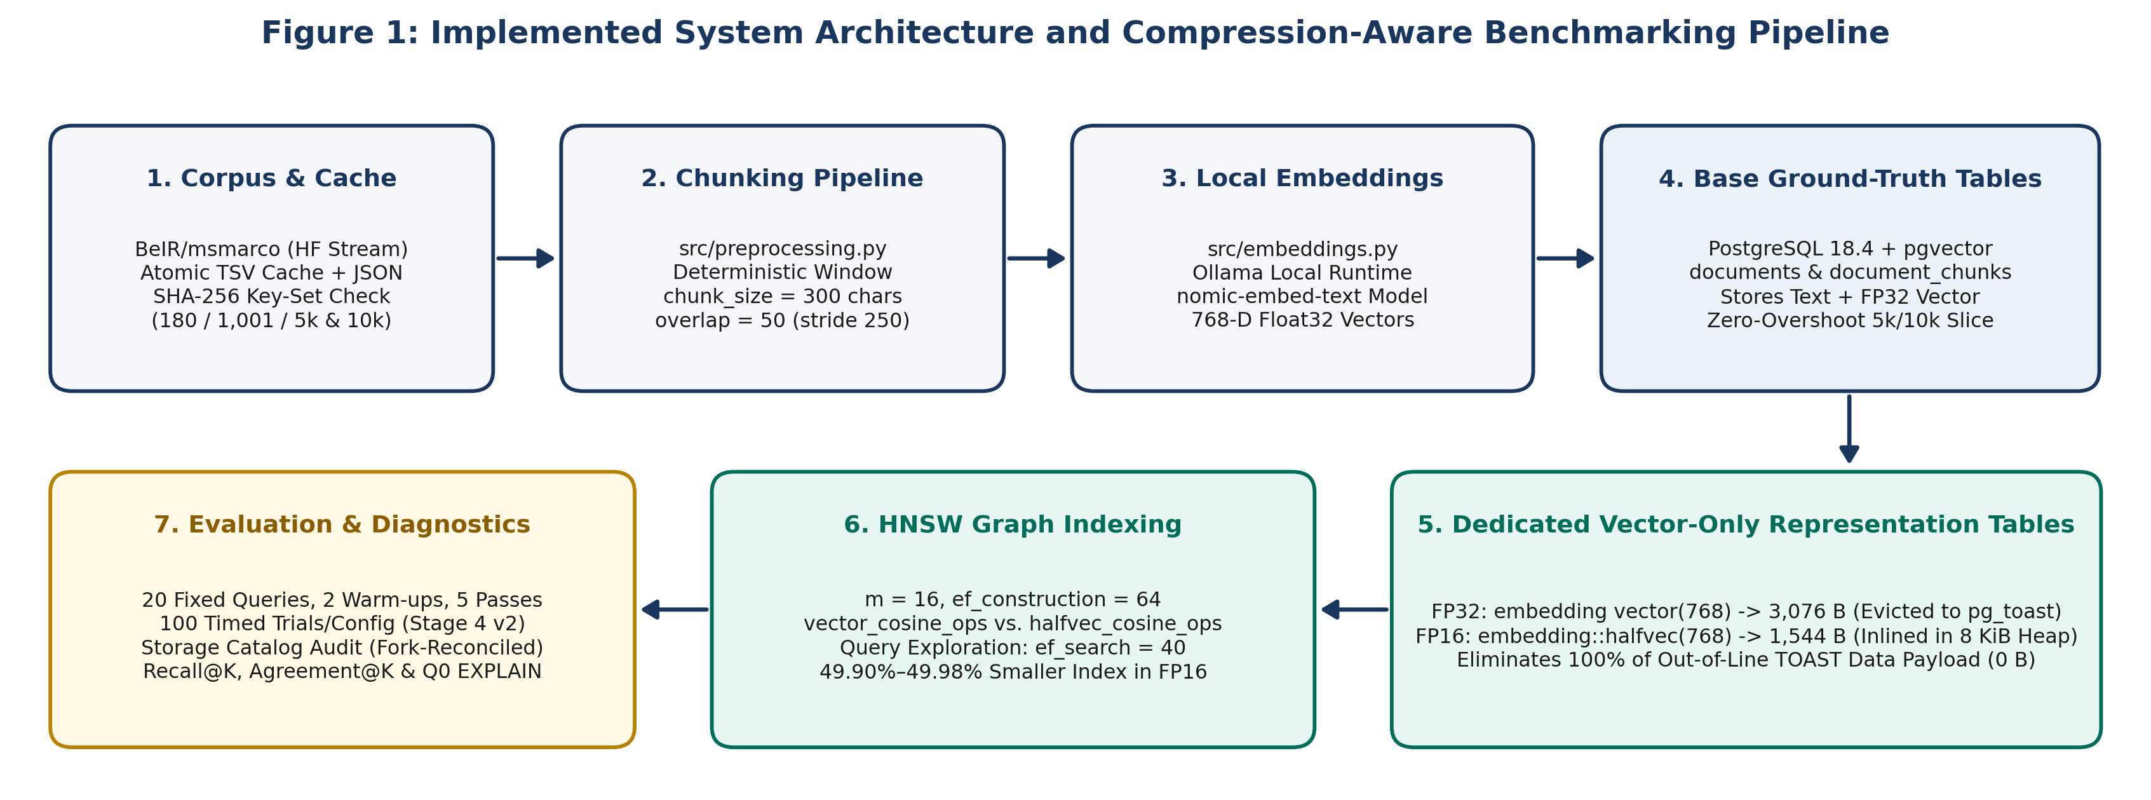
Figure 1: Implemented system architecture and compression-aware benchmarking pipeline.
To ensure strict experimental isolation across project stages, workloads are partitioned across five separate PostgreSQL databases guarded by fail-closed connection checks (Table 4.1). When Stage 4 reuses the first 1,001 embeddings from compression_aware_rag_exp, it opens the source connection in read-only mode (conn.read_only = True) after verifying 1,001 / 1,001 SHA-256 chunk-text hash matches.
Table 4.1: Multi-database layout and isolation policy across project stages.
Database Name | Project Stage & Role | Corpus Size | Tables & Indexes Stored | Isolation Policy
compression_aware_rag | Review 2 Baseline | 100 docs / 180 chunks | Monolithic documents + document_chunks + HNSW | Read-only baseline; zero modifications in Stages 1–4
smart_document_chatbot | External Course DB | 3 public tables | Separate application tables | Untouched; excluded by connection guards
compression_aware_rag_exp | Stages 1–3 Exp DB | 550 docs / 1,001 chunks | Base tables + FP32/FP16 tables + HNSW indexes | Used in Stages 1–3; read-only during Stage 4 reuse
compression_aware_rag_scale | Stage 4 Scaling DB | 5,457 docs / 10,000 chunks | Base tables + 5k & 10k fp32/halfvec tables + 4 HNSW idx | Exclusive target for Stage 4 scaling benchmarks
compression_aware_rag_test | Pytest Test DB | Ephemeral test data | Created and truncated per test via conftest.py | Enforced by autouse test-database guard

4.2 DESIGN

4.2.1 Data Flow Diagram
Figure 2 presents the Level-1 Data Flow Diagram (DFD) of the implemented system. Process P1 streams raw BeIR/msmarco records, applies deterministic sliding-window chunking (300/50), validates SHA-256 key-set parity against the 1,001-chunk baseline, and writes atomic TSV/JSON caches (D1). Process P2 reuses the 1,001 validated embeddings from compression_aware_rag_exp, generates 768-dimensional nomic-embed-text vectors for new chunks via Ollama, and populates the base PostgreSQL tables (D2). Process P3 populates the 5,000- and 10,000-chunk FP32 and FP16 representation tables via in-database casting (embedding::halfvec(768)) and builds the four HNSW indexes (D3). Finally, Process P4 executes the 100-trial retrieval benchmark across the 20 pre-embedded evaluation queries and runs separate recorded EXPLAIN (ANALYZE, BUFFERS) diagnostics. Query 0 identity is confirmed only for the Stage 4 5,000- and 10,000-chunk records. Process P5 computes fork-reconciled storage metrics, Recall@K, and pairwise Agreement@K to produce the benchmark reports and CSV artifacts (D4).
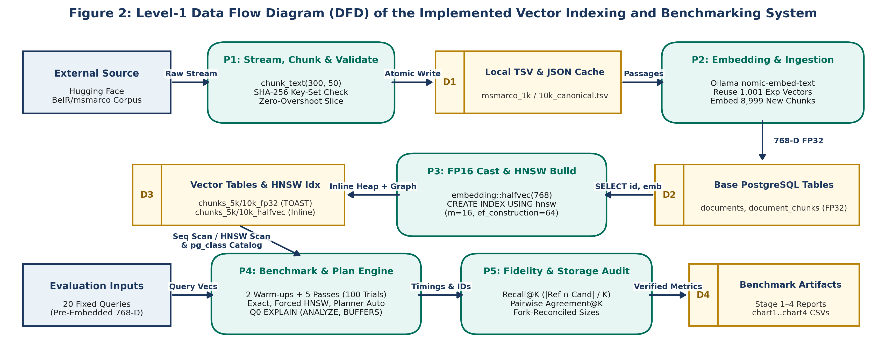
Figure 2: Level-1 Data Flow Diagram (DFD) of the implemented vector indexing and benchmarking system.

4.2.2 Class Diagram
Inspection of the project source code (src/*.py) shows that the Python implementation is organized around modular procedural functions rather than custom object-oriented Python classes. Rather than inventing fictional wrapper classes, Figure 3 presents the verified UML Database Entity-Relationship and Procedural Module Diagram. The left and center panels show the relational table entities (documents, document_chunks, chunks_{1k|5k|10k}_fp32, and chunks_{1k|5k|10k}_halfvec), primary/foreign keys (ON DELETE CASCADE), HNSW index definitions, and physical storage placement (out-of-line pg_toast vs. inline 8 KiB heap), while the right panels show the procedural Python modules that operate on those entities.
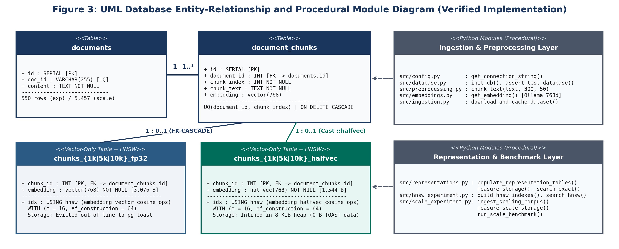
Figure 3: UML database entity-relationship and procedural module diagram (verified implementation).
Chapter 5

5. METHODOLOGY AND TESTING

5.1 MODULE DESCRIPTION
Table 5.1 summarizes the responsibilities of the implemented Python modules in src/. Across all experimental stages, passages from BeIR/msmarco (BeIR / MS MARCO Dataset Repository, n.d.) are segmented using chunk_size = 300 characters and overlap = 50 characters (250-character stride), embedded into 768-dimensional vectors using local Ollama nomic-embed-text (Ollama, n.d.), and indexed with HNSW graph parameters m = 16, ef_construction = 64, and query exploration ef_search = 40 (Kane & pgvector Contributors, n.d.; Malkov & Yashunin, 2020).
Table 5.1: Functional responsibilities of the implemented Python modules in src/.
Module File | Primary Responsibility in the Pipeline
src/config.py | Loads environment variables and builds PostgreSQL connection strings and Ollama API URLs.
src/database.py | Initializes the base documents and document_chunks schema, registers pgvector, and enforces the test-database guard.
src/preprocessing.py | Implements chunk_text(text, chunk_size=300, overlap=50) for deterministic sliding-window text segmentation.
src/embeddings.py | Queries the local Ollama nomic-embed-text HTTP endpoint and validates that returned vectors have length 768.
src/ingestion.py | Streams BeIR/msmarco from Hugging Face, writes atomic TSV caches and JSON manifests, and ingests batches into PostgreSQL.
src/search.py & src/benchmark.py | Implements the Review 2 baseline exact and HNSW search queries and the 180-chunk baseline benchmark runner.
src/representations.py | Manages Stage 2 chunks_embedding_fp32 and chunks_embedding_halfvec tables, storage catalog queries, and 20-query exact benchmarks.
src/hnsw_experiment.py | Builds Stage 3 HNSW indexes at 1,001 chunks, verifies index scan plans via EXPLAIN, and runs Forced vs. Planner-Selected benchmarks.
src/scale_experiment.py | Executes Stage 4 10k cache validation, zero-overshoot 5k/10k ingestion, fork-reconciled storage audits, and the 6-configuration Stage 4 v2 benchmark.

5.2 TESTING
Table 5.2 documents our automated pytest test suites alongside the experimental timing boundaries used at each stage. For retrieval benchmarks in Stages 2, 3, and 4, we evaluated the same 20 domain-diverse queries (EVALUATION_QUERIES), pre-computed all 20 query embeddings before starting the timing loop, executed 2 unmeasured warm-up passes to warm shared_buffers, and recorded 5 measured passes (100 timed trials per configuration) while alternating execution order (FP32 -> FP16 on even passes, FP16 -> FP32 on odd passes) over a single persistent psycopg connection. Crucially, Stage 3 (1,001 chunks) timed a session transaction/GUC block per trial (BEGIN; SET LOCAL ...; SELECT ...; COMMIT;), whereas Stage 4 v2 (5,000 and 10,000 chunks) applied session GUC settings once outside the timed loop and timed strictly cur.execute() and cur.fetchall().
Statistically, the 100 timed trials per configuration in Stages 2–4 are repeated executions of the same 20 fixed queries (20 queries × 5 measured passes), not 100 independent queries from a general population. Reported mean, median, IQR, minimum, maximum, and standard deviation describe the observed distribution of these repeated runs; no confidence intervals, significance tests, or population-level claims were established, and alternating FP32/FP16 order reduces systematic cache-order bias without eliminating all warm-cache or OS scheduling effects. Although stage-report latency tables omit a K header (and K is not assumed from Review 2's K = 3 or sampled EXPLAIN plans), src/representations.py, src/hnsw_experiment.py, and run_scale_benchmark() (src/scale_experiment.py) pass top_k = max(top_k_values) = 10 (LIMIT 10) in timed loops, distinct from K in {3, 5, 10} fidelity runs.
Table 5.2: Automated pytest verification suites and experimental timing boundaries across stages.
Milestone / Stage | Target Database | Scale | Trial Protocol & Timing Boundary | Pytest Suite
Review 2 Prototype | compression_aware_rag | 180 chunks | 5 queries x 5 runs (K=3); preliminary pre-stabilization run | 5 / 5 passed
Review 2 Baseline | compression_aware_rag | 180 chunks | 5 queries x 5 runs (25 trials, K=3); stabilized connection & plan check | 11 / 11 passed
Stage 1 (Ingestion) | compression_aware_rag_exp | 1,001 chunks | Atomic HF streaming cache & manifest validation (550 docs) | 19 / 19 passed
Stage 2 (FP16 Exact) | compression_aware_rag_exp | 1,001 chunks | 20 queries x 5 runs (100 trials/rep); dedicated tables, unindexed Seq Scan | 27 / 27 passed
Stage 3 (1k HNSW) | compression_aware_rag_exp | 1,001 chunks | 20 queries x 5 runs (100 trials/config); timed per-trial session Tx/GUC block | 34 / 34 passed
Stage 4 v2 (5k & 10k) | compression_aware_rag_scale | 5,000 & 10,000 | 20 queries x 5 runs (100 trials x 6 configs); GUCs outside timer (exec+fetch only) | 43 / 43 passed

Chapter 6

6. PROJECT DEMONSTRATION

6.1 REPRESENTATION TABLE DEFINITIONS AND HALF-PRECISION CASTING
To ensure row-level alignment rather than identical coordinate values, populate_scale_representation_tables() in src/scale_experiment.py selects the same first N rows (5,000 or 10,000) from document_chunks and stores the corresponding FP32 vectors in the FP32 table while casting those vectors to halfvec(768) inside PostgreSQL (Listing 6.1). The chunk IDs therefore align, while FP16 coordinates are the rounded half-precision representations of the corresponding FP32 values. Afterward, validate_scale_representations() verifies row counts, zero NULLs, 768 dimensions (vector_dims), and zero mismatched IDs via a FULL OUTER JOIN.
Listing 6.1: Dedicated Vector Representation Tables and In-Database FP16 Casting (src/scale_experiment.py)
CREATE TABLE IF NOT EXISTS chunks_10k_fp32 (
chunk_id INT PRIMARY KEY REFERENCES document_chunks(id) ON DELETE CASCADE,
embedding vector(768) NOT NULL
);
CREATE TABLE IF NOT EXISTS chunks_10k_halfvec (
chunk_id INT PRIMARY KEY REFERENCES document_chunks(id) ON DELETE CASCADE,
embedding halfvec(768) NOT NULL
);
-- Deterministic in-database conversion from FP32 to FP16 (halfvec)
INSERT INTO chunks_10k_fp32 (chunk_id, embedding)
SELECT id, embedding FROM document_chunks ORDER BY id ASC LIMIT 10000;
INSERT INTO chunks_10k_halfvec (chunk_id, embedding)
SELECT id, embedding::halfvec(768) FROM document_chunks ORDER BY id ASC LIMIT 10000;

6.2 EXACT-SEARCH AND HNSW RETRIEVAL QUERY PATTERNS
All similarity queries compute cosine distance (<=>), defined as one minus cosine similarity between 768-dimensional vectors u and v:
d_cos(u, v) = 1 - ( sum_{i=1}^{768} u_i v_i ) / ( ||u||_2 * ||v||_2 ) (6.1)
Listing 6.2 shows the canonical SQL query patterns verified in Stage 4 v2. In exact sequential search (search_scale_exact), Stage 4 v1 repeated the distance expression in both the SELECT list and ORDER BY clause. This duplication may have caused repeated expression evaluation or datum processing; the exact number of detoast operations was not independently profiled. Stage 4 v2 orders by the projected column alias ORDER BY distance ASC. For HNSW queries (search_scale_hnsw), the explicit operator expression ORDER BY embedding <=> %s::{cast_type} ASC is retained to match the index operator class (vector_cosine_ops or halfvec_cosine_ops).
Listing 6.2: Canonical Exact-Search vs. HNSW Index-Search SQL Patterns (src/scale_experiment.py)
-- 1. HNSW Index Creation (m = 16, ef_construction = 64)
CREATE INDEX chunks_10k_halfvec_hnsw_idx ON chunks_10k_halfvec
USING hnsw (embedding halfvec_cosine_ops) WITH (m = 16, ef_construction = 64);
-- 2. Exact Sequential Search (orders by the projected distance alias)
SET enable_indexscan = off; SET enable_bitmapscan = off; SET enable_seqscan = on;
SELECT chunk_id, (embedding <=> %s::halfvec(768)) AS distance
FROM chunks_10k_halfvec ORDER BY distance ASC LIMIT 10;
-- 3. Forced HNSW Search (retains direct <=> operator in ORDER BY for index matching)
SET enable_indexscan = on; SET enable_bitmapscan = on; SET enable_seqscan = off; SET hnsw.ef_search = 40;
SELECT chunk_id, (embedding <=> %s::halfvec(768)) AS distance
FROM chunks_10k_halfvec ORDER BY embedding <=> %s::halfvec(768) ASC LIMIT 10;

6.3 BENCHMARK TIMING AND QUERY-PLAN VERIFICATION
Listing 6.3 demonstrates how run_scale_benchmark() in src/scale_experiment.py applies session GUC settings once per pass outside the timed loop so that time.perf_counter() measures strictly cur.execute() and cur.fetchall().
Listing 6.3: Stage 4 v2 Timed Query Execution Loop (src/scale_experiment.py)
# Session GUC configuration is applied once per pass OUTSIDE the timed loop:
with conn.cursor() as cur:
cur.execute(f"SET enable_seqscan = {'on' if enable_seqscan else 'off'};")
cur.execute(f"SET hnsw.ef_search = {int(ef_search)};")
for q_idx in range(len(EVALUATION_QUERIES)):
q_emb = query_embeddings[q_idx]
start_t = time.perf_counter()
_ = search_scale_hnsw(conn, scale, rep, q_emb, top_k=10, ef_search=40,
enable_seqscan=enable_seqscan, apply_guc=False)
lat_ms = (time.perf_counter() - start_t) * 1000.0

Chapter 7

7. RESULT AND DISCUSSION (COST ANALYSIS AS APPLICABLE)

7.1 PHYSICAL STORAGE, TOAST BEHAVIOUR, AND HNSW BUILD-TIME OBSERVATIONS
At the datum level, pg_column_size(embedding) across Stages 2 and 4 returned 3,076 bytes (min = max = avg) for vector(768) and 1,544 bytes for halfvec(768)—a 49.80% empirical datum reduction (1.992x) (Table 7.1). Whereas 1,544 bytes matches the documented pgvector halfvec formula (2d + 8 = 1,544 B), 3,076 bytes is 4 bytes smaller than the documented vector formula (4d + 8 = 3,080 B, or 49.87% reduction). Both figures are preserved transparently.
Table 7.1: Coordinate datum size comparison for 768-dimensional vectors.
Datum Metric | FP32 (vector(768)) | FP16 (halfvec(768)) | Reduction (Ratio) | Storage Layout Impact
Raw Coordinate Bytes | 3,072 B (768 x 4 B) | 1,536 B (768 x 2 B) | 50.00% lower (2.000x) | IEEE 754 float coordinate array
Documented Formula Size | 3,080 B (4d + 8 B) | 1,544 B (2d + 8 B) | 49.87% lower (1.995x) | Documented varlena + dim header
Empirical pg_column_size() | 3,076 B | 1,544 B | 49.80% lower (1.992x) | 4-byte empirical vs. formula difference
Placement vs. ~2 KiB Limit | Out-of-line in the evaluated schema | Inline in the evaluated schema | 100% of TOAST data payload eliminated | Empty 8 KiB TOAST index shell remains

Table 7.2 and Figure 4 present the disaggregated storage footprints across 1,001, 5,000, and 10,000 chunks (chart1_storage.csv, where 1 MiB = 1,048,576 B and 1 KiB = 1,024 B), keeping three storage scopes distinct:
Total_Inclusive = Heap_main + TOAST_Data_main + TOAST_Idx_main + PK_Idx_main + HNSW_Idx_main + Aux_Forks_(FSM+VM) (7.1)
- Pre-HNSW Base Relation Storage: In the evaluated vector-only schema, halfvec(768) reduced out-of-line TOAST data payloads to 0 bytes at every scale (vs. 3.91 MiB, 19.53 MiB, and 39.06 MiB for FP32), while an empty 8 KiB (8,192 B) TOAST index shell remained allocated. Base relation size decreased by 60.11% at 1,001 chunks (4.13 MiB to 1.65 MiB), 60.52% at 5,000 chunks (20.20 MiB to 7.98 MiB), and 60.56% at 10,000 chunks (40.31 MiB to 15.90 MiB).
- Standalone HNSW Index Footprint & Build Times: HNSW index size (pg_relation_size) decreased by 49.90% at 1,001 chunks (3.90 MiB to 1.95 MiB) and by 49.98% at both 5,000 chunks (19.48 MiB to 9.74 MiB) and 10,000 chunks (38.89 MiB to 19.45 MiB). Single-run wall-clock HNSW construction times (0.2334 s vs. 0.1606 s at 1k; 1.4615 s vs. 1.2640 s at 5k; 3.7617 s vs. 2.6411 s at 10k) were lower for FP16 at each tested size, though these are single-run measurements rather than repeated-trial distributions.
- Post-Index Inclusive Relation Storage: Inclusive size (pg_total_relation_size, reconciled to the exact byte via _fsm and _vm auxiliary forks) decreased by 55.35% at 5,000 chunks (39.68 MiB to 17.72 MiB) and 55.37% at 10,000 chunks (79.20 MiB to 35.35 MiB). No single post-index pg_total_relation_size query was recorded at 1,001 chunks in Stage 3, so that cell is left unrecorded.
Table 7.2: Disaggregated storage footprint and single-run HNSW build durations across 1,001, 5,000, and 10,000 chunks.
Storage Component | 1,001 FP32 | 1,001 FP16 | 5,000 FP32 | 5,000 FP16 | 10,000 FP32 | 10,000 FP16
Table Heap ('main') | 57,344 B  (56.0 KiB) | 1,646,592 B  (1.57 MiB) | 262,144 B  (256.0 KiB) | 8,192,000 B  (7.81 MiB) | 524,288 B  (512.0 KiB) | 16,384,000 B  (15.63 MiB)
TOAST Data Table ('main') | 4,104,192 B  (3.91 MiB) | 0 B  (0 MiB) | 20,480,000 B  (19.53 MiB) | 0 B  (0 MiB) | 40,960,000 B  (39.06 MiB) | 0 B  (0 MiB)
TOAST B-Tree Index ('main') | 65,536 B  (64.0 KiB) | 8,192 B  (8.0 KiB) | 245,760 B  (240.0 KiB) | 8,192 B  (8.0 KiB) | 466,944 B  (456.0 KiB) | 8,192 B  (8.0 KiB)
Primary Key Index ('main') | 40,960 B  (40.0 KiB) | 40,960 B  (40.0 KiB) | 131,072 B  (128.0 KiB) | 131,072 B  (128.0 KiB) | 245,760 B  (240.0 KiB) | 245,760 B  (240.0 KiB)
Auxiliary Forks (_fsm + _vm) | 65,536 B  (64.0 KiB) | 32,768 B  (32.0 KiB) | 65,536 B  (64.0 KiB) | 32,768 B  (32.0 KiB) | 73,728 B  (72.0 KiB) | 32,768 B  (32.0 KiB)
Pre-HNSW Base Relation Total | 4,333,568 B  (4.13 MiB) | 1,728,512 B  (1.65 MiB) | 21,184,512 B  (20.20 MiB) | 8,364,032 B  (7.98 MiB) | 42,270,720 B  (40.31 MiB) | 16,670,720 B  (15.90 MiB)
Base Relation Reduction | Baseline | 60.11% lower | Baseline | 60.52% lower | Baseline | 60.56% lower
HNSW Index Size ('main') | 4,087,808 B  (3.90 MiB) | 2,048,000 B  (1.95 MiB) | 20,422,656 B  (19.48 MiB) | 10,215,424 B  (9.74 MiB) | 40,779,776 B  (38.89 MiB) | 20,398,080 B  (19.45 MiB)
HNSW Index Reduction | Baseline | 49.90% lower | Baseline | 49.98% lower | Baseline | 49.98% lower
Post-Index Inclusive Total | Not recorded  (Stage 3) | Not recorded  (Stage 3) | 41,607,168 B  (39.68 MiB) | 18,579,456 B  (17.72 MiB) | 83,050,496 B  (79.20 MiB) | 37,068,800 B  (35.35 MiB)
Inclusive Total Reduction | — | Not recorded | Baseline | 55.35% lower | Baseline | 55.37% lower
Single-Run HNSW Build Time | 0.2334 s | 0.1606 s  (31.18% lower) | 1.4615 s | 1.2640 s  (13.52% lower) | 3.7617 s | 2.6411 s  (29.79% lower)

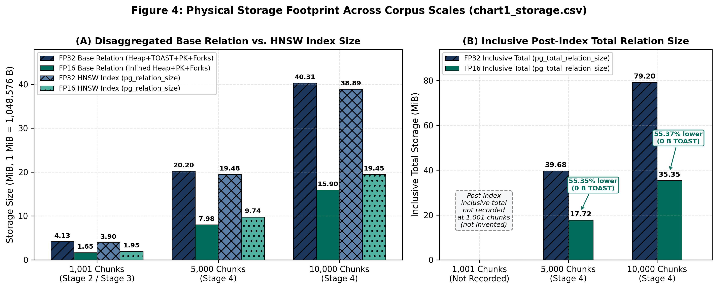
Figure 4: Physical storage footprint comparison across 1,001, 5,000, and 10,000 chunks (chart1_storage.csv).

7.2 EXACT-SEARCH AND FORCED-HNSW LATENCY COMPARISONS
In our earlier milestones, the stabilized 180-chunk baseline recorded 2.180 ms mean (2.049 ms median) for exact sequential search and 2.270 ms mean (2.125 ms median) for forced HNSW search. At 1,001 chunks on the dedicated representation tables, Stage 2 unindexed exact search averaged 3.320 ms (3.120 ms median) for FP32 and 1.784 ms (1.644 ms median) for FP16 (46.27% lower mean, 1.86x speedup). In Stage 3 (1,001 chunks, where the timer included per-trial session transaction/GUC setup), Forced HNSW averaged 3.165 ms (2.866 ms median) for FP32 and 2.984 ms (2.788 ms median) for FP16.
Table 7.3 and Figure 5 present the Stage 4 v2 latency results across 5,000 and 10,000 chunks (chart4_latency.csv; 100 timed trials per configuration with GUC statements outside the timer). In exhaustive exact search (Seq Scan), FP16 recorded 83.91% lower mean latency (6.22x speedup) and 85.96% lower median latency (7.12x speedup) at 5,000 chunks, and 86.18% lower mean latency (7.24x speedup) and 87.55% lower median latency (8.03x speedup) at 10,000 chunks, for the tested Stage 4 v2 configurations; the recorded summary statistics do not establish population-level significance. In Forced HNSW (ef_search = 40), mean latencies were broadly similar: 3.372 ms for FP16 versus 4.129 ms for FP32 at 5,000 chunks, and 3.856 ms for FP16 versus 3.674 ms for FP32 at 10,000 chunks. Although the recorded inclusive footprints at these scales were below the configured 128 MB shared_buffers capacity, that comparison does not prove complete residency during every timed trial. The available measurements do not isolate a single cause for the difference between exact-search and forced-HNSW results.
Table 7.3: Stage 4 v2 client-observed retrieval latency across all six configurations at 5,000 and 10,000 chunks.
Scale & Config | Mode & Precision | Mean (ms) | Median (ms) | IQR (ms) | Min (ms) | Max (ms) | StDev (ms) | Relative Change / Speedup vs. FP32
5k (Config 1) | FP32 Exact (Seq Scan) | 42.285 | 44.694 | 16.018 | 10.907 | 57.104 | 10.083 | Baseline (1.00x)
5k (Config 2) | FP16 Exact (Seq Scan) | 6.802 | 6.277 | 2.606 | 3.203 | 15.669 | 2.318 | 83.91% lower mean (6.22x) / 85.96% lower med (7.12x)
5k (Config 3) | FP32 Forced HNSW | 4.129 | 3.371 | 1.641 | 2.449 | 42.670 | 4.073 | Baseline (1.00x)
5k (Config 4) | FP16 Forced HNSW | 3.372 | 2.923 | 1.571 | 2.386 | 6.501 | 0.952 | 18.32% lower mean (1.22x) / 13.28% lower med (1.15x)
5k (Config 5) | FP32 Planner Auto (Idx) | 3.765 | 3.504 | 1.389 | 2.457 | 10.949 | 1.372 | Baseline (1.00x)
5k (Config 6) | FP16 Planner Auto (Idx) | 3.568 | 3.293 | 1.681 | 2.358 | 6.427 | 1.062 | 5.23% lower mean (1.06x) / 6.02% lower med (1.06x)
10k (Config 1) | FP32 Exact (Seq Scan) | 89.004 | 92.664 | 32.376 | 50.664 | 125.432 | 20.031 | Baseline (1.00x)
10k (Config 2) | FP16 Exact (Seq Scan) | 12.301 | 11.541 | 2.866 | 7.205 | 22.226 | 3.163 | 86.18% lower mean (7.24x) / 87.55% lower med (8.03x)
10k (Config 3) | FP32 Forced HNSW | 3.674 | 3.415 | 1.548 | 2.420 | 6.420 | 0.990 | Baseline (1.00x)
10k (Config 4) | FP16 Forced HNSW | 3.856 | 3.820 | 1.796 | 2.482 | 7.740 | 1.092 | 4.95% higher mean (0.95x) / 11.86% higher med (0.89x)
10k (Config 5) | FP32 Planner Auto (Idx) | 3.678 | 3.482 | 1.593 | 2.506 | 6.618 | 1.015 | Baseline (1.00x)
10k (Config 6) | FP16 Planner Auto (Idx) | 3.724 | 3.566 | 1.759 | 2.342 | 7.162 | 1.101 | 1.25% higher mean (0.99x) / 2.41% higher med (0.98x)

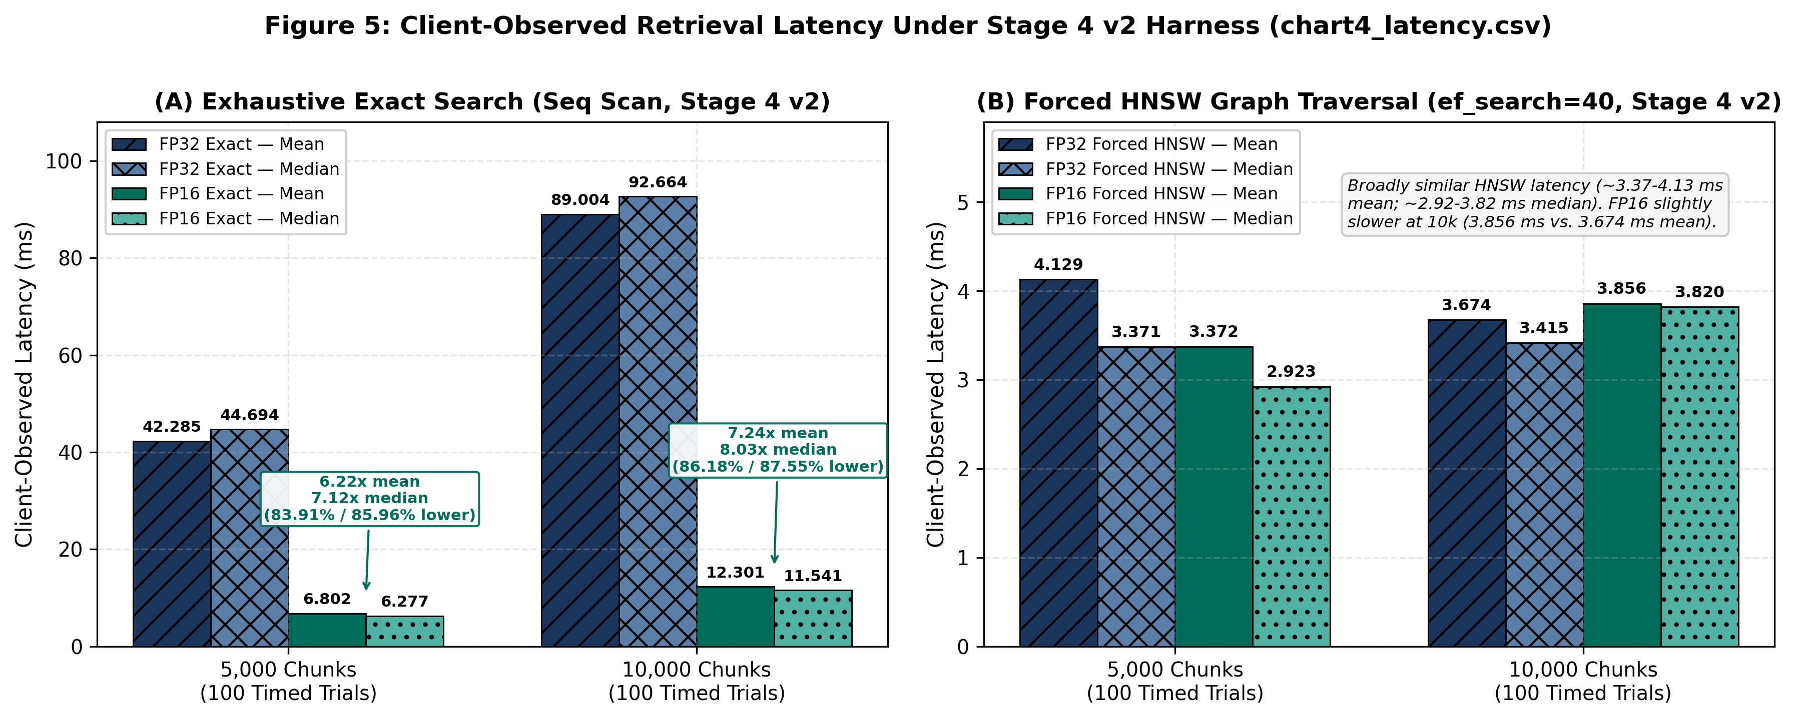
Figure 5: Client-observed retrieval latency under the Stage 4 v2 benchmark harness (chart4_latency.csv).

7.3 RETRIEVAL FIDELITY: RECALL@K AND PAIRWISE CANDIDATE-SET AGREEMENT
Following standard ANN evaluation practice of pairing latency measurements with exact-ground-truth recall (Aumüller et al., 2020), we evaluate retrieval quality using two separate set-overlap metrics averaged across the 20 evaluation queries (K in {3, 5, 10}). First, representation-specific Recall@K (chart3_hnsw_recall.csv) compares a method's top-K chunk IDs Top-K_Cand(q) against the uncompressed FP32 exact sequential scan ground truth Top-K_FP32_Exact(q) at the same scale:
Recall@K = (1 / 20) * sum_{q=1}^{20} ( | Top-K_FP32_Exact(q) intersect Top-K_Cand(q) | / K ) (7.2)
Second, pairwise candidate-set agreement (chart3_pairwise_agreement.csv) measures how closely the top-K candidates returned by FP32 HNSW (S_FP32(q)) match those returned by FP16 HNSW (S_FP16(q)) at ef_search = 40:
Agreement@K = (1 / 20) * sum_{q=1}^{20} ( | S_FP32(q) intersect S_FP16(q) | / K ) (7.3)
Equation (7.3) divides the intersection size by K (len(ref_set.intersection(cand_set)) / float(top_k) in src/scale_experiment.py), so it is a symmetric top-K overlap fraction rather than Jaccard similarity, and it does not measure semantic relevance, LLM generation quality, or internal HNSW graph connectivity.
Table 7.4 and Figure 6 (plotted on a zero-based 0.0–1.0 axis) show that unindexed FP16 exact search achieved 0.9833–1.0000 overlap with FP32 exact search across all scales (the historical Stage 2 Recall@3 = 0.9833 at 1,001 chunks equals 59/60 under Equation (7.2)'s unordered set-intersection formula; because set overlap does not measure within-set rank order, the Stage 2 report's wording about a 'minor order perturbation' is not independently established by the aggregate figure). Under HNSW (ef_search = 40), FP16 achieved 0.9600 (96.0%) Recall@10 at both 5,000 and 10,000 chunks. Notice that the 10,000-chunk FP32 HNSW sequence decreases slightly across K (0.9667 at K=3, 0.9500 at K=5, 0.9450 at K=10), and the 5,000-chunk values dip slightly from K=3 (0.9167) to K=5 (0.9100). Unlike cumulative information-retrieval recall computed against a fixed set of relevant documents, Equation (7.2) evaluates separate LIMIT K queries where both the reference set and the denominator K change with each cutoff; under this definition, overlap fractions can decrease as K increases without indicating a benchmark error, and the aggregate figures do not establish how misses are distributed across specific rank bands. Table 7.5 and Figure 7 show that pairwise top-10 agreement between FP32 HNSW and FP16 HNSW reached 0.9850 at 5,000 chunks and 0.9500 at 10,000 chunks.
Table 7.4: Representation-specific Recall@K against uncompressed FP32 exact sequential scan ground truth.
Corpus Scale | Evaluated Configuration | Recall@3 | Recall@5 | Recall@10 | Ground-Truth Reference | Source Artifact
180 Chunks (Baseline) | FP32 Forced HNSW (ef_s=40) | 1.0000 | — | 1.0000* | 180c FP32 Exact Seq Scan | baseline_benchmark.md (*10q)
1,001 Chunks (Stage 2) | FP16 Exact Search (Seq Scan) | 0.9833 | 1.0000 | 1.0000 | 1,001c FP32 Exact Seq Scan | stage2_fp16_evaluation.md
1,001 Chunks (Stage 3) | FP32 & FP16 HNSW (ef_s=40) | 1.0000 | 1.0000 | 1.0000 | 1,001c FP32 Exact Seq Scan | stage3_hnsw_benchmark.md
5,000 Chunks (Stage 4) | FP16 Exact Search (Seq Scan) | 1.0000 | 0.9900 | 0.9950 | 5,000c FP32 Exact Seq Scan | stage4_scale_benchmark.md
5,000 Chunks (Stage 4) | FP32 HNSW (vector, ef_s=40) | 0.9167 | 0.9100 | 0.9550 | 5,000c FP32 Exact Seq Scan | chart3_hnsw_recall.csv
5,000 Chunks (Stage 4) | FP16 HNSW (halfvec, ef_s=40) | 0.9167 | 0.9100 | 0.9600 | 5,000c FP32 Exact Seq Scan | chart3_hnsw_recall.csv
10,000 Chunks (Stage 4) | FP16 Exact Search (Seq Scan) | 1.0000 | 0.9900 | 1.0000 | 10,000c FP32 Exact Seq Scan | stage4_scale_benchmark.md
10,000 Chunks (Stage 4) | FP32 HNSW (vector, ef_s=40) | 0.9667 | 0.9500 | 0.9450 | 10,000c FP32 Exact Seq Scan | chart3_hnsw_recall.csv
10,000 Chunks (Stage 4) | FP16 HNSW (halfvec, ef_s=40) | 0.9500 | 0.9400 | 0.9600 | 10,000c FP32 Exact Seq Scan | chart3_hnsw_recall.csv

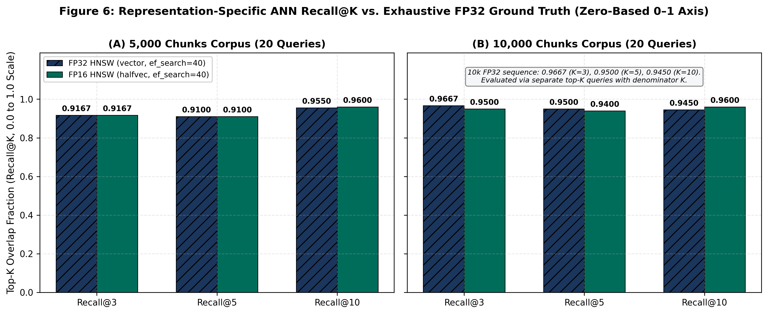
Figure 6: Representation-specific ANN Recall@K on a zero-based 0.0–1.0 vertical axis (chart3_hnsw_recall.csv).
Table 7.5: Pairwise top-K candidate-set overlap fraction between FP32 HNSW and FP16 HNSW at ef_search = 40.
Corpus Scale | Comparison Pair | Agreement@3 | Agreement@5 | Agreement@10 | Metric Formula & Source
1,001 Chunks (Stage 3) | FP32 HNSW vs. FP16 HNSW | 1.0000 (100.00%) | 1.0000 (100.00%) | 1.0000 (100.00%) | Mean |S_FP32(q) ∩ S_FP16(q)| / K (stage3_hnsw_benchmark.md)
5,000 Chunks (Stage 4) | FP32 HNSW vs. FP16 HNSW | 0.9667 (96.67%) | 0.9800 (98.00%) | 0.9850 (98.50%) | Mean |S_FP32(q) ∩ S_FP16(q)| / K (chart3_pairwise_agreement.csv)
10,000 Chunks (Stage 4) | FP32 HNSW vs. FP16 HNSW | 0.9667 (96.67%) | 0.9600 (96.00%) | 0.9500 (95.00%) | Mean |S_FP32(q) ∩ S_FP16(q)| / K (chart3_pairwise_agreement.csv)

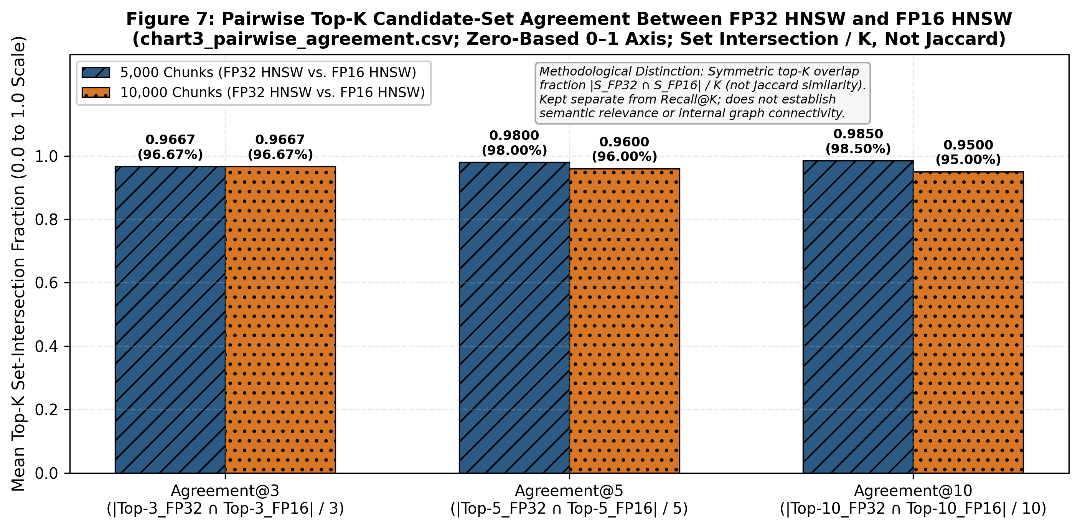
Figure 7: Pairwise top-K candidate-set agreement between FP32 HNSW and FP16 HNSW (chart3_pairwise_agreement.csv).

7.4 QUERY-PLAN, SHARED-BUFFER DIAGNOSTICS, AND PLANNER BEHAVIOUR
Table 7.6 compiles stage-specific EXPLAIN (ANALYZE, BUFFERS) plan samples. The 1,001-chunk exact-search values (3,010 FP32 hits; 201 FP16 hits) come from the Stage 2 report, and the 1,001-chunk forced-HNSW values (595 FP32 hits; 514 FP16 hits) come from the Stage 3 report; the available artifacts do not establish that these four samples used Query 0 (Q0). Figure 8 uses the explicitly identified Q0 diagnostics from chart2_q0_diagnostics.csv at 5,000 and 10,000 chunks. In exact scans, the reported FP16 hit counts are 1,000 versus 15,032 at 5,000 chunks and 2,000 versus 30,064 at 10,000 chunks (93.35% fewer at each scale). In forced-HNSW scans, the reductions are 9.28% at 5,000 chunks (753 vs. 830 hits) and 8.92% at 10,000 chunks (847 vs. 930 hits). The recorded 5k/10k Q0 plans reported shared read = 0. Shared-buffer hits count runtime page accesses, including repeated touches, and these single-query observations are consistent with—but do not prove the cause of—the 100-trial exact-search latency improvements.
Table 7.6: Stage-specific EXPLAIN (ANALYZE, BUFFERS) diagnostic observations; query identity is not confirmed for the 1,001-chunk samples.
Stage & Scale | Retrieval Mode | Vector Type | Scan Node | Shared-Buffer Hits (as reported) | Limit Node Time (ms) | Server Exec Time (ms) | FP16 Hit Reduction vs. FP32
Stage 2 plan sample (1,001c) | Exact Search | FP32 (vector) | Seq Scan | 3,010 hits | 1.795 ms | 1.801 ms | Baseline
Stage 2 plan sample (1,001c) | Exact Search | FP16 (halfvec) | Seq Scan | 201 hits | 0.398 ms | 0.404 ms | 93.32% fewer buffer hits (14.98x)
Stage 3 plan sample (1,001c) | Forced HNSW | FP32 (vector) | Index Scan | 595 hits | — | 1.267 ms | Baseline
Stage 3 plan sample (1,001c) | Forced HNSW | FP16 (halfvec) | Index Scan | 514 hits | — | 0.886 ms | 13.61% fewer buffer hits
Stage 4 Q0 (5,000c) | Exact Search | FP32 (vector) | Seq Scan | 15,032 hits | 24.527 ms | 24.540 ms | Baseline
Stage 4 Q0 (5,000c) | Exact Search | FP16 (halfvec) | Seq Scan | 1,000 hits | 2.980 ms | 2.995 ms | 93.35% fewer buffer hits (15.03x)
Stage 4 Q0 (5,000c) | Forced HNSW | FP32 (vector) | Index Scan | 830 hits | 0.560 ms | 0.571 ms | Baseline
Stage 4 Q0 (5,000c) | Forced HNSW | FP16 (halfvec) | Index Scan | 753 hits | 0.397 ms | 0.405 ms | 9.28% fewer buffer hits
Stage 4 Q0 (10,000c) | Exact Search | FP32 (vector) | Seq Scan | 30,064 hits | 54.471 ms | 54.487 ms | Baseline
Stage 4 Q0 (10,000c) | Exact Search | FP16 (halfvec) | Seq Scan | 2,000 hits | 7.792 ms | 7.810 ms | 93.35% fewer buffer hits (15.03x)
Stage 4 Q0 (10,000c) | Forced HNSW | FP32 (vector) | Index Scan | 930 hits | 0.615 ms | 0.624 ms | Baseline
Stage 4 Q0 (10,000c) | Forced HNSW | FP16 (halfvec) | Index Scan | 847 hits | 0.495 ms | 0.503 ms | 8.92% fewer buffer hits

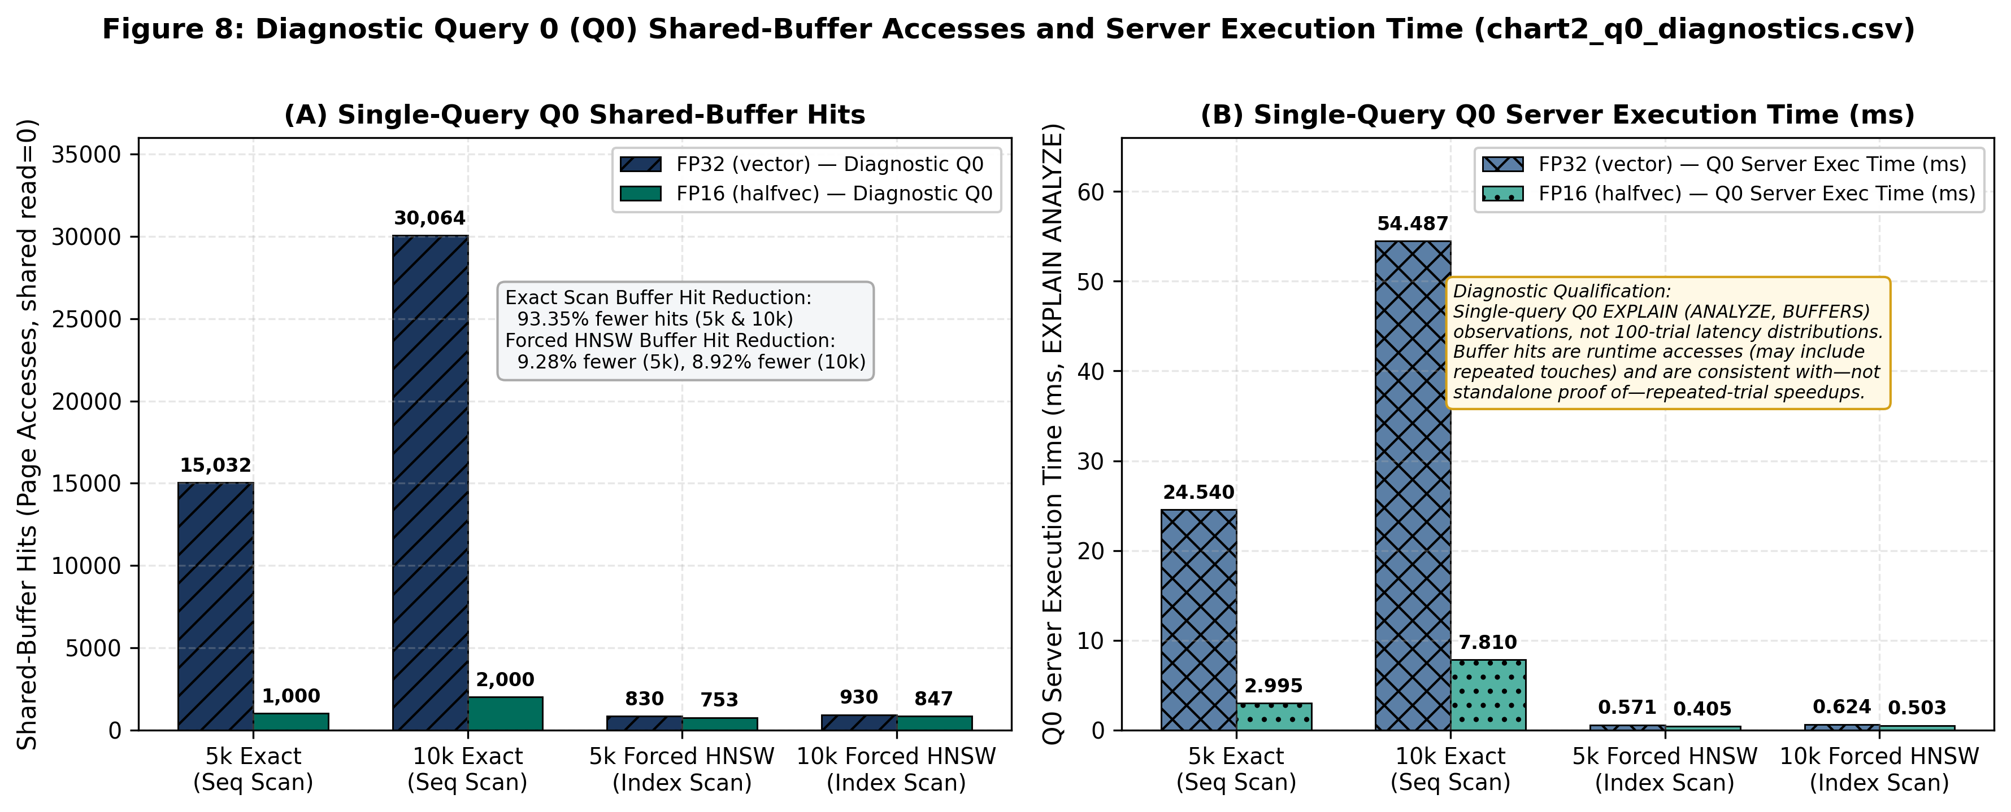
Figure 8: Query 0 (Q0) diagnostic observations at 5,000 and 10,000 chunks from EXPLAIN (ANALYZE, BUFFERS) (chart2_q0_diagnostics.csv).
Table 7.7 summarizes the execution paths selected with PostgreSQL's query planner (enable_seqscan = on) for the tested representations. At 5,000 and 10,000 chunks, the recorded forced Seq Scan + Sort costs are lower for FP32 than FP16 (202.55–202.57 versus 1170.55–1170.57 at 5k; 405.10–405.12 versus 2341.10–2341.12 at 10k). In the same recorded Stage 4 rows, the HNSW Index Scan + Limit costs are below the corresponding forced sequential-scan costs. FP32 selected Index Scan at 1,001, 5,000, and 10,000 chunks; FP16 selected Seq Scan at 1,001 chunks and Index Scan at 5,000 and 10,000 chunks. The main heaps differ substantially because FP32 vectors were stored out-of-line in TOAST, whereas FP16 vectors remained inline in the evaluated schema. These observations describe the recorded plans and costs, but they do not isolate the complete cause of the planner's choices. Unforced Stage 3 alternative-plan costs at 1,001 chunks were not recorded.
Table 7.7: PostgreSQL query optimizer cost estimates and representation-specific plan selection across scales.
Corpus Scale | Vector Type | Main Heap Blocks | Forced Seq Scan + Sort Cost | HNSW Index Scan + Limit Cost | Planner-Selected Path (enable_seqscan=on)
180 Chunks (Baseline) | FP32 (Monolithic) | < 75 blocks | 10.58–10.58  (Seq: 8.25) | 365.35–365.79 | Seq Scan (10.58 < 365.79)
1,001 Chunks (Stage 2/3) | FP32 (vector) | 7 blocks (56.0 KiB) | 41.14–41.17  (Seq: 19.51) | Not recorded | Index Scan (already selected at 1k)
1,001 Chunks (Stage 2/3) | FP16 (halfvec) | 201 blocks (1.57 MiB) | 235.14–235.17  (Seq: 213.51) | Not recorded | Seq Scan (201 inline heap blocks)
5,000 Chunks (Stage 4) | FP32 (vector) | 32 blocks (256.0 KiB) | 202.55–202.57 | 35.82–56.17 | Index Scan (56.17 < 202.57)
5,000 Chunks (Stage 4) | FP16 (halfvec) | 1,000 blocks (7.81 MiB) | 1170.55–1170.57  (Seq: 1062.50) | 511.82–529.00 | Index Scan (transitioned by 5k: 529.00 < 1170.57)
10,000 Chunks (Stage 4) | FP32 (vector) | 64 blocks (512.0 KiB) | 405.10–405.12 | 68.10–88.43 | Index Scan (88.43 < 405.12)
10,000 Chunks (Stage 4) | FP16 (halfvec) | 2,000 blocks (15.63 MiB) | 2341.10–2341.12  (Seq: 2125.00) | 548.68–566.31 | Index Scan (566.31 < 2341.12)

7.5 RESOURCE COST ANALYSIS, PRACTICAL IMPLICATIONS, AND LIMITATIONS
No financial costing or cloud-pricing evaluation was performed; cost analysis is evaluated strictly via measured system resource consumption (disk storage, buffer page touches, and execution time). At 10,000 chunks, switching from vector(768) to halfvec(768) reduces inclusive relation space by 43.85 MiB (79.20 to 35.35 MiB), HNSW index space by 19.44 MiB (38.89 to 19.45 MiB), and mean exact-scan latency across 100 timed trials by 76.703 ms/query (89.004 to 12.301 ms), while recording 28,064 fewer shared-buffer hits (30,064 vs. 2,000) in the single-query Q0 EXPLAIN (ANALYZE, BUFFERS) diagnostic (reflecting that Q0 run rather than a per-trial guarantee across all 100 trials).
Four methodological validity boundaries and source-validation notes govern these findings:
- Internal, Construct, and External Validity: Internal validity: Stage 3 timed a transaction/GUC block per trial, whereas Stage 4 v2 timed execute-and-fetch with GUCs outside the timer; the superseded Stage 4 v1 means (76.765 ms at 5k and 157.901 ms at 10k) use different timing boundaries. Each Stage 4 configuration contains 100 repeated runs of the same 20 queries (5 passes each), without confidence intervals or significance tests. Alternating FP32/FP16 order reduces, but does not eliminate, cache-order bias and OS/warm-cache effects. Construct validity: Recall@K and Agreement@K measure candidate-set overlap, not semantic relevance, human qrels, or RAG answer quality; planner costs are model units, not elapsed times. External validity: results come from one laptop, one 768-D model (nomic-embed-text), fixed HNSW settings (m=16, ef_construction=64, ef_search=40), and only 5k/10k Stage 4 v2 sizes under 128 MB shared_buffers. No asymptotic law or exact planner crossover between 1,001 and 5,000 chunks is claimed; halfvec(1536) is 3,080 B and would exceed the approximate TOAST threshold.
- Index-Build, I/O, and Memory Evidence: HNSW build times (0.2334/0.1606 s at 1k; 1.4615/1.2640 s at 5k; 3.7617/2.6411 s at 10k, FP32/FP16) are single-run observations; WAL volume and peak RAM were not profiled. The recorded Stage 4 Q0 plans at 5,000 and 10,000 chunks reported shared read = 0; shared hits count page accesses, including repeated touches, and do not prove physical disk I/O.
- Top-K Latency Parameter & Stage 2 Recall@3 = 0.9833: Stage 2–4 latency tables omit K, so K is not inferred from Review 2 or Q0 LIMIT 10 plans. The timed loops use LIMIT 10, distinct from the Recall@K runs for K ∈ {3, 5, 10}. Stage 2 FP16 exact Recall@3 = 0.9833 equals 59/60 set overlap; the report’s “minor order perturbation” is not established by set intersection, and per-query ID JSONs in benchmark_scale_10k_v2.json are unbundled.
- Numeric-Source & Rounding Discrepancies: (a) vector(768) measures 3,076 B (49.80% reduction to 1,544 B), versus 3,080 B by the 4d+8 formula (49.87%); (b) 1,001-chunk inclusive post-index size and unforced Stage 3 planner costs were not recorded; (c) the 1k HNSW build reduction is reported as 31.18% in stage3_hnsw_benchmark.md, while the displayed 0.2334/0.1606 s values yield 31.19%; (d) the 10k forced-HNSW median change is 11.86% in chart4_latency.csv versus 11.84% in the Stage 4 prose; (e) older summaries disagree on PostgreSQL/pgvector/work_mem and Ollama versions (0.4.7 vs. 0.32.13).
Chapter 8

8. CONCLUSION AND FUTURE ENHANCEMENTS

8.1 CONCLUSION
In this project, we built a reproducible, multi-database benchmarking pipeline in PostgreSQL 18.4 and pgvector 0.8.4 to evaluate how 16-bit half-precision coordinate quantization (halfvec(768)) affects storage layout, HNSW index size, query latency, and top-K retrieval fidelity on MS MARCO passage embeddings. Converting 768-dimensional nomic-embed-text vectors from 32-bit vector(768) (3,076 B measured) to 16-bit halfvec(768) (1,544 B measured) reduced datum size by 49.80%. In the evaluated schema, the 1,544 B FP16 vector datum stayed inline below the approximate 2 KiB TOAST_TUPLE_THRESHOLD. Within our dedicated vector-only representation tables, this eliminated 100% of out-of-line TOAST data payloads (0 bytes, leaving only an empty 8 KiB TOAST index shell), reduced pre-HNSW base relation storage by 60.11% at 1,001 chunks, reduced inclusive post-index relation storage by 55.35% at 5,000 chunks and 55.37% at 10,000 chunks, and reduced standalone HNSW index size by 49.90%–49.98%.
Across 100 timed trials per configuration under the Stage 4 v2 harness, the inline FP16 representation achieved a 6.22x lower mean latency (7.12x lower median) in exhaustive exact sequential search at 5,000 chunks and a 7.24x lower mean latency (8.03x lower median) at 10,000 chunks; the 93.35% reduction in shared-buffer hits observed in the single-query Q0 diagnostic is consistent with this measured latency improvement, without independently proving per-trial causality. For approximate search (ef_search = 40), forced HNSW latencies were broadly similar between FP32 and FP16 (3.372–3.856 ms FP16 vs. 3.674–4.129 ms FP32 mean), and the PostgreSQL planner automatically transitioned on the FP16 table from Seq Scan at 1,001 chunks (201 heap blocks) to Index Scan at 5,000 and 10,000 chunks (1,000 and 2,000 heap blocks). Finally, FP16 HNSW maintained 0.9600 (96.0%) Recall@10 against uncompressed FP32 exact ground truth at both 5,000 and 10,000 chunks, along with 0.9850 (5k) and 0.9500 (10k) pairwise top-10 candidate agreement with FP32 HNSW.

8.2 FUTURE ENHANCEMENTS
1. Scaling to 100k–1M+ Chunks Under Memory Pressure: Extend the corpus to 100,000–1,000,000+ vectors under constrained shared_buffers and operating-system cache conditions. Record PostgreSQL shared-buffer reads and use appropriate OS-level I/O instrumentation when physical disk-I/O evidence is required, particularly when comparing the larger FP32 and smaller FP16 indexes under memory pressure.
2. Repeated Index-Build Trials and WAL Instrumentation: Run multi-trial CREATE INDEX benchmarks across varying maintenance_work_mem and parallel worker settings while recording Write-Ahead Log (pg_stat_wal) volume and peak memory usage.
3. Higher-Dimensional Models and Alternative Quantization Methods: Evaluate 1,536- and 3,072-dimensional embeddings alongside Scalar Quantization (SQ), Product Quantization (PQ) (Jégou et al., 2011), anisotropic quantization (Guo et al., 2020), and binary quantization (bit) where halfvec exceeds 2 KiB.
4. End-to-End RAG Generation and Relevance Evaluation: Connect retrieval to official MS MARCO relevance judgments (qrels MRR@10 / nDCG@10) (BeIR / MS MARCO Dataset Repository, n.d.) and a local LLM generator (such as the Qwen stage planned in Review 2) to evaluate RAG answer quality (Lewis et al., 2020).

9. REFERENCES
Aumüller, M., Bernhardsson, E., & Faithfull, M. (2020). ANN-Benchmarks: A benchmarking tool for approximate nearest neighbor algorithms. Information Systems, 87, Article 101374. https://doi.org/10.1016/j.is.2019.02.006
BeIR / MS MARCO Dataset Repository. (n.d.). Microsoft Machine Reading Comprehension (MS MARCO) passage ranking corpus distributed via Hugging Face Datasets (BeIR/msmarco, configuration “corpus”, split “corpus”). https://huggingface.co/datasets/BeIR/msmarco
Guo, R., Sun, P., Lindgren, E., Geng, Q., Simcha, D., Chern, F., & Kumar, S. (2020). Accelerating large-scale inference with anisotropic vector quantization. Proceedings of the 37th International Conference on Machine Learning (Proceedings of Machine Learning Research, Vol. 119, pp. 3887–3896). https://proceedings.mlr.press/v119/guo20h.html
Jégou, H., Douze, M., & Schmid, C. (2011). Product quantization for nearest neighbor search. IEEE Transactions on Pattern Analysis and Machine Intelligence, 33(1), 117–128. https://doi.org/10.1109/TPAMI.2010.57
Kane, A., & pgvector Contributors. (n.d.). pgvector: Open-source vector similarity search for Postgres [Computer software]. GitHub. https://github.com/pgvector/pgvector
Lewis, P., Perez, E., Piktus, A., Petroni, F., Karpukhin, V., Goyal, N., Küttler, H., Lewis, M., Yih, W.-t., Rocktäschel, T., Riedel, S., & Kiela, D. (2020). Retrieval-augmented generation for knowledge-intensive NLP tasks. Advances in Neural Information Processing Systems, 33, 9459–9474. https://proceedings.neurips.cc/paper/2020/hash/6b493230205f780e1bc26945df7481e5-Abstract.html
Malkov, Y. A., & Yashunin, D. A. (2020). Efficient and robust approximate nearest neighbor search using hierarchical navigable small world graphs. IEEE Transactions on Pattern Analysis and Machine Intelligence, 42(4), 824–836. https://doi.org/10.1109/TPAMI.2018.2889473
Ollama. (n.d.). nomic-embed-text [Embedding model]. Ollama Library. https://ollama.com/library/nomic-embed-text
PostgreSQL Global Development Group. (n.d.). PostgreSQL 18 documentation: Chapter 66—Database physical storage, Section 66.2—TOAST (The Oversized-Attribute Storage Technique). https://www.postgresql.org/docs/18/storage-toast.html
Pradhan, Y., & Pandey, A. (2026). Compression-aware vector database indexing for memory-efficient and low-latency retrieval-augmented generation (RAG): Project benchmark codebase and experimental archive [Software and experimental archive]. GitHub. https://github.com/yoswinner/CompressionAwareRag.git

APPENDIX A — SAMPLE CODE
This appendix provides representative Python and SQL extracts from src/preprocessing.py, src/representations.py, and src/scale_experiment.py that implement deterministic chunking, disaggregated storage auditing, top-K overlap calculation, and the 20-query evaluation benchmark.
Listing A.1: Deterministic Sliding-Window Text Chunking (src/preprocessing.py)
def chunk_text(text: str, chunk_size: int = 300, overlap: int = 50) -> list[str]:
if not text or not text.strip():
return []
text = text.strip()
if len(text) <= chunk_size:
return [text]
chunks, start, step = [], 0, chunk_size - overlap
while start < len(text):
chunks.append(text[start : start + chunk_size])
start += step
return chunks

Listing A.2: Representative Storage Catalog Query Excerpt (src/scale_experiment.py)
SELECT pg_relation_size(c.oid) AS heap_bytes,
COALESCE(pg_relation_size(c.reltoastrelid), 0) AS toast_table_bytes,
COALESCE(pg_indexes_size(c.reltoastrelid), 0) AS toast_index_bytes,
pg_indexes_size(c.oid) AS table_indexes_bytes,
pg_total_relation_size(c.oid) AS total_inclusive_bytes,
pg_relation_size(c.oid, 'fsm') + pg_relation_size(c.oid, 'vm') AS heap_aux_forks_bytes
FROM pg_class c WHERE c.relname = %s;
This listing is a representative excerpt. The implementation also queries the primary-key and HNSW index relations separately and reconciles auxiliary fork sizes when computing the reported storage totals (src/scale_experiment.py).

Listing A.3: Top-K Set-Overlap Function & Representative Query Excerpt (src/scale_experiment.py & src/representations.py)
def calculate_overlap_recall(ref_ids: list[int], cand_ids: list[int], top_k: int) -> float:
if not ref_ids or top_k <= 0:
return 0.0
ref_set = set(ref_ids[:top_k])
cand_set = set(cand_ids[:top_k])
return len(ref_set.intersection(cand_set)) / float(top_k)
# Representative excerpt from EVALUATION_QUERIES (full 20-query list defined in src/representations.py):
EVALUATION_QUERIES = [
'what was the purpose of the manhattan project', # Q00 (Diagnostic Q0)
'how does photosynthesis work in green plants', # Q04
'how do vector databases store and index embeddings', # Q08
'difference between supervised and unsupervised machine learning', # Q09
# ... [Q01–Q03, Q05–Q07, Q10–Q18 omitted here; see src/representations.py] ...
'structure and biological function of human deoxyribonucleic acid dna' # Q19
]

APPENDIX B — TANGIBLE OUTCOME — PUBLICATION/PATENT
A project-related Invention Disclosure Form (IDF) has been submitted through the relevant institutional process. At the time of preparing this report, confirmation and filing details for a formal patent application were not available in the project materials reviewed. Submission of the IDF is acknowledged as an invention-disclosure outcome and should not be interpreted as confirmation that a patent application has been filed or granted.
The project has also produced tangible engineering and research deliverables, including the implemented benchmarking pipeline, automated tests, reproducible dataset caches, experimental reports, numerical result files, and comparative visualizations documenting the evaluation of FP32 and FP16 vector representations:
1. Modular Compression-Aware Benchmarking Codebase (src/): Ten modular Python source files (config.py, database.py, preprocessing.py, embeddings.py, ingestion.py, search.py, benchmark.py, representations.py, hnsw_experiment.py, and scale_experiment.py) implementing deterministic MS MARCO passage streaming, sliding-window chunking, local Ollama nomic-embed-text embedding generation, PostgreSQL vector(768) and halfvec(768) table management, HNSW indexing, and multi-mode latency/plan benchmarking.
2. Automated Multi-Database Verification Suite (tests/): An automated pytest regression suite of 43 passing unit and integration tests (test_basic.py, test_ingestion_cache.py, test_representations.py, test_hnsw_experiment.py, and test_scale_experiment.py) enforcing fail-closed database isolation and mathematical metric verification.
3. Cryptographically Validated Dataset Caches & Manifests (data/raw/): Local deterministic TSV caches and JSON provenance manifests for the Stage 1–3 1,001-chunk cache (msmarco_1k_chunks.meta.json: target_chunks = 1000, actual_chunks = 1001 across 550 documents) and the Stage 4 canonical streaming cache (msmarco_10k_canonical.meta.json, SHA-256 cdca54aa145a8343916447f9b9fcd8ddcfdb72a3129c5263f5fba3c485434e8b: target_chunks = 10000, actual_chunks = 10001 cached across 5,457 documents before zero-overshoot ingestion and benchmarking of the exact 5,000-chunk and 10,000-chunk Stage 4 evaluation corpora).
4. Stage-Specific Benchmark Reports & CSV Data Assets (docs/): Five stage-specific technical benchmark reports (baseline_benchmark.md, stage1_dataset_scaling.md, stage2_fp16_evaluation.md, stage3_hnsw_benchmark.md, and stage4_scale_benchmark.md), cross-stage synthesis documentation (final_results_synthesis.md), and five verified CSV data files (chart1_storage.csv, chart2_q0_diagnostics.csv, chart3_hnsw_recall.csv, chart3_pairwise_agreement.csv, and chart4_latency.csv).

