RANGE//LAB — Visual Application Screenshot Catalog
BCSE307L Compiler Design — Final Review 3 Photographic Evidence Pack
Project Title: | Range-Aware Edge AI Quantization Compiler
Course & Institution: | BCSE307L (Compiler Design) — Vellore Institute of Technology, Vellore
Student Team: | Yash Pradhan (24BCE0702), Anjini Pandey (24BCE0714), Ishita Srivastava (24BDS0234)
Faculty Guide: | Prof. Kanagaraj R., School of Computer Science and Engineering (SCOPE)
Milestone & Date: | Review 3 Final Report Evidence Package — October 2026

1. Document Purpose and Usage Directive
This visual screenshot catalog serves as the official photographic evidence companion for the BCSE307L Review 3 project report. Every figure embedded below is an unedited, authentic capture from the live RANGE//LAB application environment (FastAPI backend at src/api/server.py and React/TypeScript frontend). For each figure, an academic caption, system stage, input test program, proof points, and specific report placement instructions are provided.

2. Figure Index and Report Placement Mapping
Figure # | Visual Feature / Title | Application Stage | Report Placement | Dimensions
Figure 1 | RANGE//LAB Integrated Workbench Desktop Interface (Range Analysis View) | Range Analysis Stage (RangesView) & Stage Navigator | Section 6: PROJECT DEMONSTRATION – Implementations | 2244 × 1239
Figure 2 | INT8 Safety Analysis and Inferred Interval Boundary Comparison | INT8 Safety Stage (SafetyView) | Section 5: METHODOLOGY AND TESTING (5.1 Module Description – Quantization Safety) | 2244 × 1209
Figure 3 | Direct Overflow Rejection and Type Preservation | INT8 Safety / Diagnostics (SafetyView) | Section 7: RESULT AND DISCUSSION (7.2 Safety Rejection Cases) | 2244 × 1209
Figure 4 | Interactive SSA Variable Inspector Drawer for z.1 | INT8 Safety + SSAVarInspector Drawer | Section 6: PROJECT DEMONSTRATION – Implementations (Interactive Exploration) | 2244 × 1209
Figure 5 | In-Place Operand Navigation and Downstream Use Traversal for x.1 | INT8 Safety + SSAVarInspector Drawer | Section 6: PROJECT DEMONSTRATION – Implementations (Operand Traversal) | 2241 × 1199
Figure 6 | Interactive Control-Flow Graph (CFG) Visualization | CFG Stage (CFGView) | Section 4: DESIGN APPROACH AND DETAILS (4.1 System Architecture – CFG) | 2241 × 1199
Figure 7 | Dual-Engine Simulator Execution and Equivalence Verification | Simulator Stage (SimulatorView) | Section 5: METHODOLOGY AND TESTING (5.2 Testing – Simulation Validation) | 2241 × 1199
Figure 8 | Bounded Loop Analysis with Sound Iterative Narrowing | Range Analysis / INT8 Safety (RangesView) | Section 5: METHODOLOGY AND TESTING (5.1 Module Description – Loop Analysis) | 2241 × 1199
Figure 9 | Lexer Token Stream and Hierarchical AST View | AST Stage (ASTView) & Pipeline Nav | Section 5: METHODOLOGY AND TESTING (5.1 Module Description – Lexical & Syntax Analysis) | 2244 × 1286
Figure 10 | Three-Address Code and SSA Representation with φ-Node Resolution | SSA Stage (SSAView) – φ-Nodes Sub-tab | Section 4: DESIGN APPROACH AND DETAILS (4.1 System Architecture – SSA & Phi Nodes) | 2244 × 1286
Figure 11 | Static Range Analysis Table with Integrality and Convergence Metrics | Range Analysis Stage (RangesView) | Section 5: METHODOLOGY AND TESTING (5.1 Module Description – Range Analysis) | 2244 × 1286
Figure 12 | Path-Sensitive Branch Refinement and Unreachable Path Detection | Range Analysis Stage (RangesView) | Section 7: RESULT AND DISCUSSION (7.3 Branch Refinement and Unreachable Code) | 2244 × 1286
Figure 13 | Quantized IR Side-by-Side Diff and Intermediate Overflow Blocking | Quantization Stage (QuantizedView) – Diff Mode | Section 5: METHODOLOGY AND TESTING (5.1 Module Description – Quantization Transformation) | 2244 × 1286
Figure 14 | Automated Unit Test Suite and Reproducible Evaluation Terminal | Dual-Terminal Verification Console (Programmatically Rendered Terminal Summary) | Section 5: METHODOLOGY AND TESTING (5.2 Testing – Verification Suite) | 2244 × 1286

3. Detailed Screenshot Entries and Verification Evidence

Figure 1: RANGE//LAB Integrated Workbench Desktop Interface (Range Analysis View)
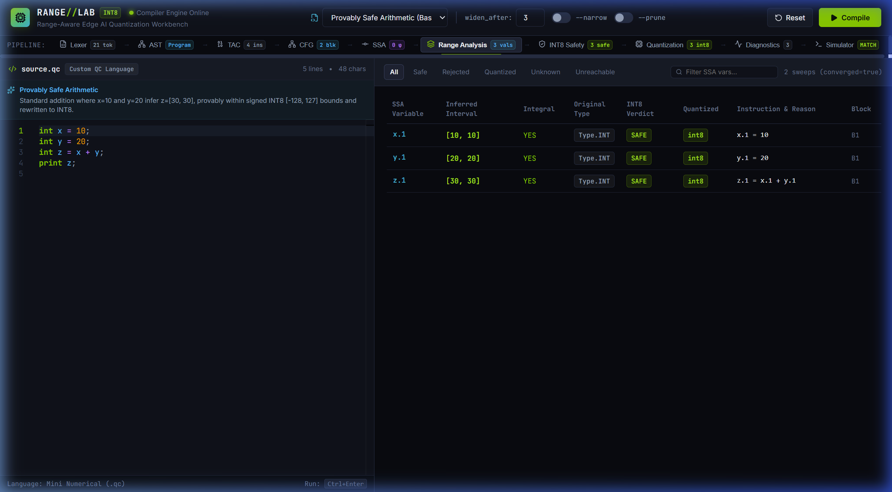
Figure 1: RANGE//LAB Integrated Workbench Desktop Interface (Range Analysis View) — safe_arithmetic.qc (Provably Safe Arithmetic)
Source File & Dimensions: | 01-main-workbench.png — 2244 × 1239 px (Rendered High-DPI; 1496 × 826 pt CSS Viewport)
Application Stage: | Range Analysis Stage (RangesView) & Stage Navigator
Input Test Program: | safe_arithmetic.qc (Provably Safe Arithmetic)
Recommended Report Placement: | Section 6: PROJECT DEMONSTRATION – Implementations
Detailed Description: Complete desktop view of the RANGE//LAB interactive compiler workbench. Demonstrates the live Monaco editor on the left (with numerical C-like source code for safe_arithmetic.qc, line numbers, and syntax highlighting), compiler control switches (widen_after threshold input, --narrow iteration toggle, --prune unreachable toggle), the multi-stage pipeline navigation bar across the top with stage status badges, and the active results panel displaying the Range Analysis stage with inferred interval table, integrality flags, and convergence status.
Analytical Evidence (What It Proves): Proves the existence, operational status, and end-to-end integration of the web-based visual compiler workbench connected to the live Python compiler backend (src/api/server.py) via FastAPI.
Technical Qualification & Boundary: Demonstrates UI workflow and system integration; does not by itself prove formal correctness of the underlying abstract interpretation algorithms.

Figure 2: INT8 Safety Analysis and Inferred Interval Boundary Comparison
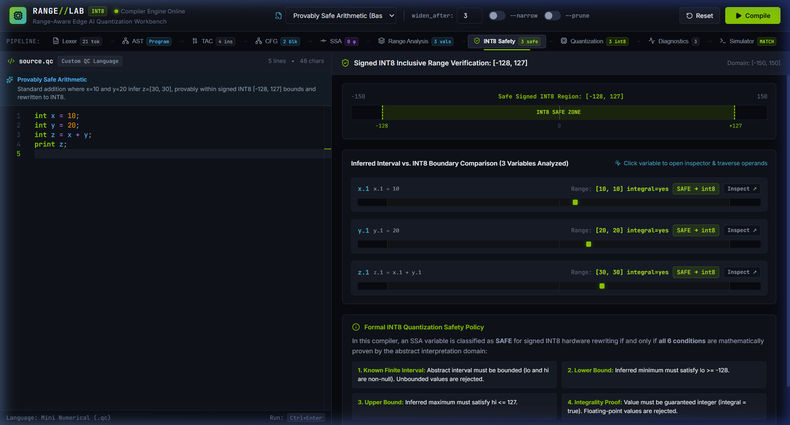
Figure 2: INT8 Safety Analysis and Inferred Interval Boundary Comparison — safe_arithmetic.qc (x=10, y=20, z=x+y)
Source File & Dimensions: | 02-int8-safety.png — 2244 × 1209 px (Rendered High-DPI; 1496 × 857 pt CSS Viewport)
Application Stage: | INT8 Safety Stage (SafetyView)
Input Test Program: | safe_arithmetic.qc (x=10, y=20, z=x+y)
Recommended Report Placement: | Section 5: METHODOLOGY AND TESTING (5.1 Module Description – Quantization Safety)
Detailed Description: Visual comparison of inferred variable intervals against the signed INT8 interval [-128, 127]. Displays variable rows for x.1 [10, 10], y.1 [20, 20], and z.1 [30, 30] alongside color-coded graphical range bars showing exact proportional positioning inside the safe INT8 region, accompanied by 'SAFE -> int8' green badges and zero errors.
Analytical Evidence (What It Proves): Proves the implementation of the abstract interval evaluation pass and the INT8 safety classification rule, confirming that values mathematically contained within [-128, 127] and proven integral are approved for INT8.
Technical Qualification & Boundary: Shows static interval bounds for a constant-propagated program; edge cases near boundaries require additional tests.

Figure 3: Direct Overflow Rejection and Type Preservation
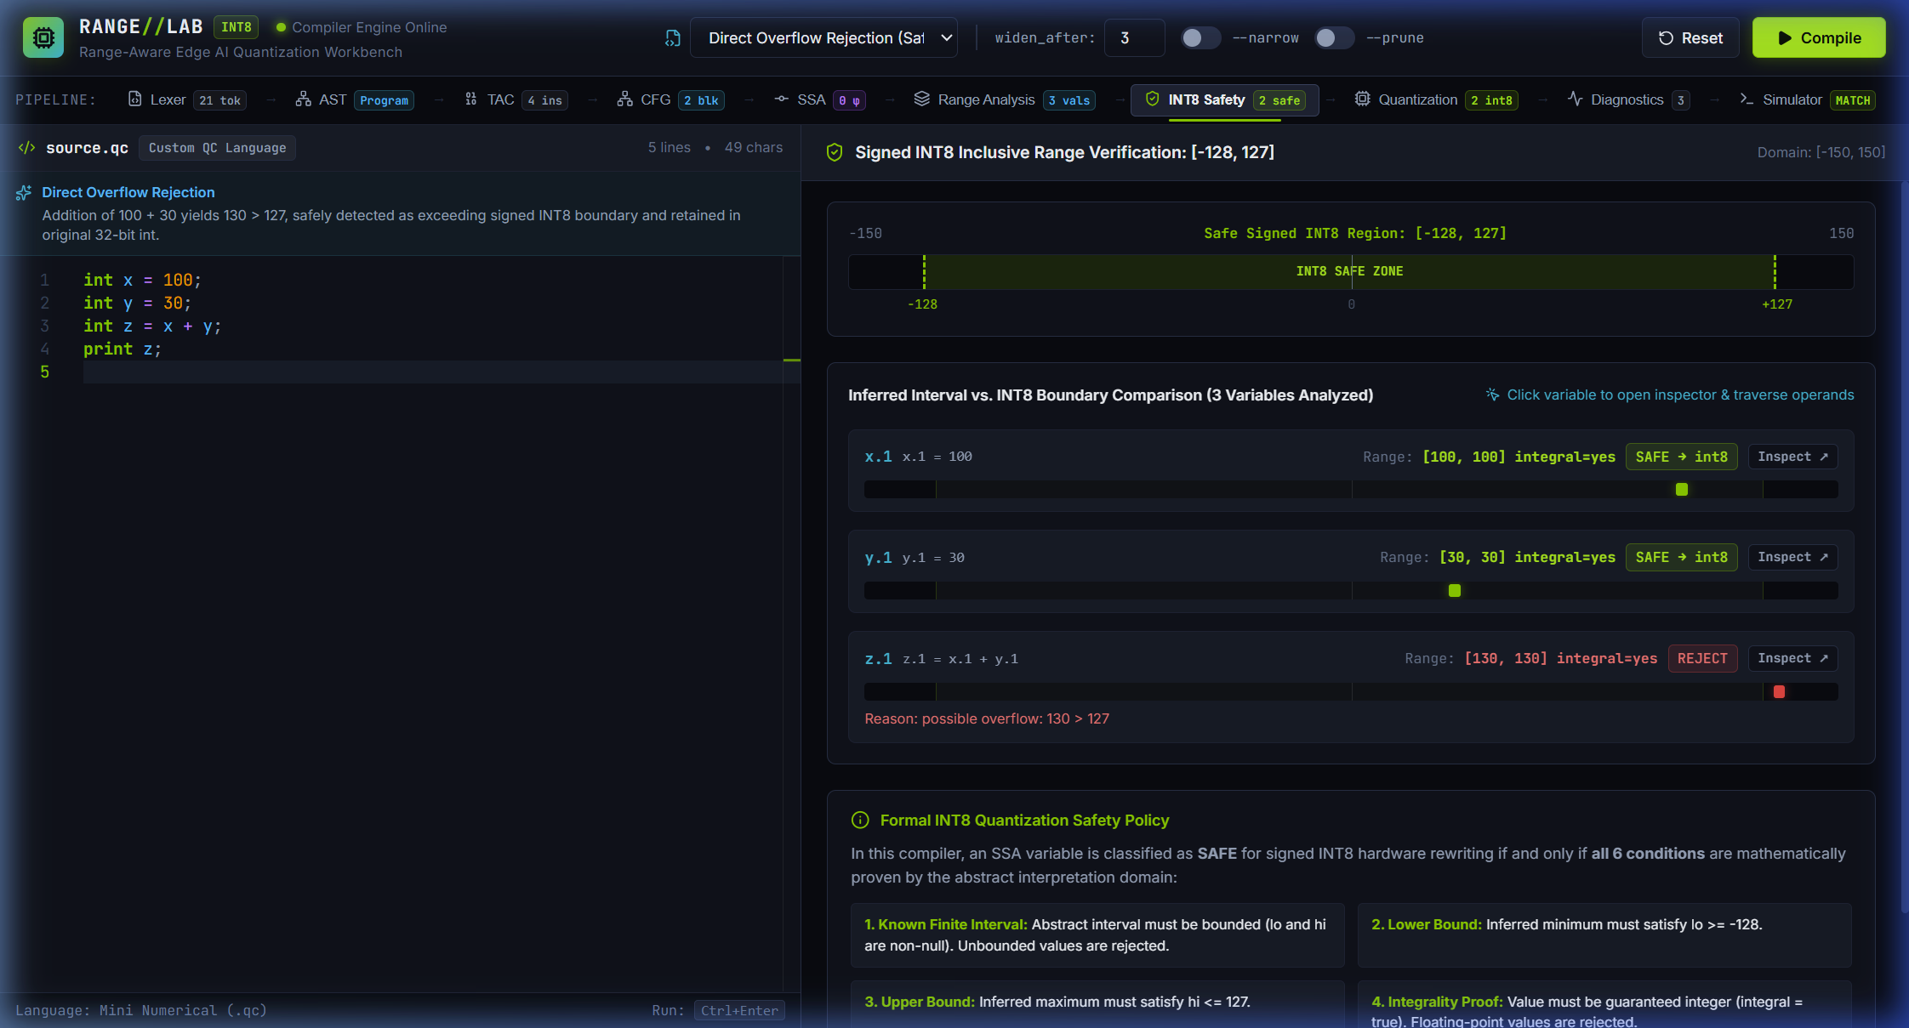
Figure 3: Direct Overflow Rejection and Type Preservation — overflow_rejection.qc (x=100, y=30, z=x+y)
Source File & Dimensions: | 03-overflow-rejection.png — 2244 × 1209 px (Rendered High-DPI; 1496 × 857 pt CSS Viewport)
Application Stage: | INT8 Safety / Diagnostics (SafetyView)
Input Test Program: | overflow_rejection.qc (x=100, y=30, z=x+y)
Recommended Report Placement: | Section 7: RESULT AND DISCUSSION (7.2 Safety Rejection Cases)
Detailed Description: Compilation of overflow_rejection.qc where x=100 and y=30 produce intermediate addition z.1 = [130, 130]. Since 130 > 127, the compiler soundly detects that the computation exceeds the signed INT8 upper boundary. The workbench displays a red 'REJECT' badge on variable z.1, visibly extending beyond the safe track, while retaining z in its original 32-bit int representation.
Analytical Evidence (What It Proves): Demonstrates sound conservative rejection: computations that risk 8-bit overflow are blocked from quantization and preserved in their safe 32-bit representation.
Technical Qualification & Boundary: Illustrates positive overflow (> 127); negative underflow (< -128) is verified in automated test suites.

Figure 4: Interactive SSA Variable Inspector Drawer for z.1
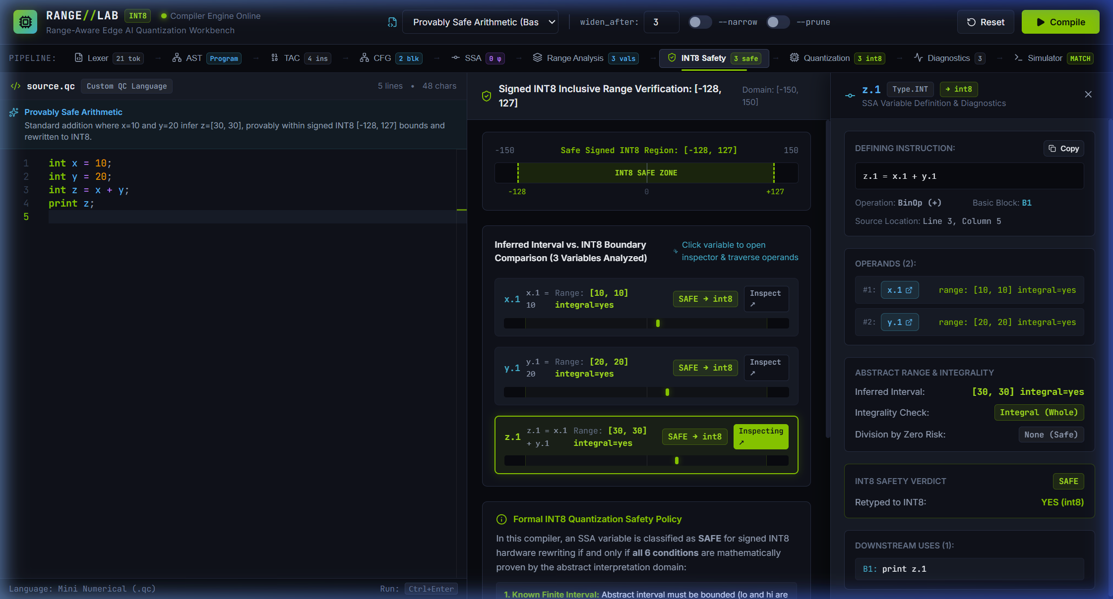
Figure 4: Interactive SSA Variable Inspector Drawer for z.1 — safe_arithmetic.qc (Variable z.1)
Source File & Dimensions: | 04-ssa-inspector-z1.png — 2244 × 1209 px (Rendered High-DPI; 1496 × 857 pt CSS Viewport)
Application Stage: | INT8 Safety + SSAVarInspector Drawer
Input Test Program: | safe_arithmetic.qc (Variable z.1)
Recommended Report Placement: | Section 6: PROJECT DEMONSTRATION – Implementations (Interactive Exploration)
Detailed Description: Inspection drawer opened upon clicking variable z.1 in the results table. The drawer displays deep static analysis metadata: variable name z.1, defining instruction z.1 = x.1 + y.1, basic block B1, inferred interval [30, 30] (from x.1 = [10, 10] and y.1 = [20, 20]), integrality status (integral=yes), safety verdict SAFE, quantized target type int8, downstream use in 'print z.1', and clickable interactive operand links for x.1 and y.1.
Analytical Evidence (What It Proves): Demonstrates bidirectional traceability and interactive exploration of SSA variable definitions, operand dependencies, and static analysis verdicts within the compiler workbench.
Technical Qualification & Boundary: Shows inspection for a single SSA definition; downstream use tracking is demonstrated upon operand traversal.

Figure 5: In-Place Operand Navigation and Downstream Use Traversal for x.1
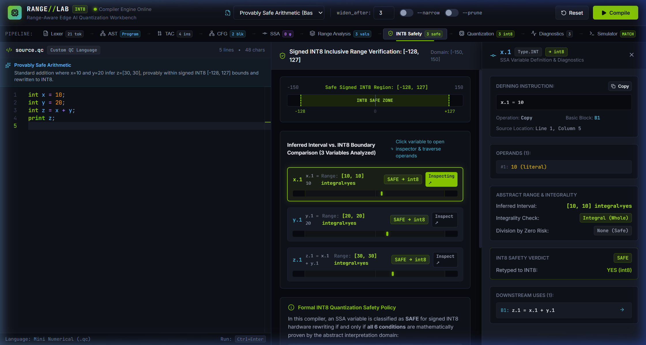
Figure 5: In-Place Operand Navigation and Downstream Use Traversal for x.1 — safe_arithmetic.qc (Variable x.1 navigated via z.1)
Source File & Dimensions: | 05-ssa-inspector-x1.png — 2241 × 1199 px (Rendered High-DPI; 1496 × 857 pt CSS Viewport)
Application Stage: | INT8 Safety + SSAVarInspector Drawer
Input Test Program: | safe_arithmetic.qc (Variable x.1 navigated via z.1)
Recommended Report Placement: | Section 6: PROJECT DEMONSTRATION – Implementations (Operand Traversal)
Detailed Description: In-place drawer update resulting from clicking operand link x.1 inside the drawer of Figure 4. The inspector updates smoothly to display x.1's definition (x.1 = 10), basic block B1, inferred interval [10, 10], safety verdict SAFE, and lists its downstream use sites in instruction z.1 = x.1 + y.1 without navigating away or losing context.
Analytical Evidence (What It Proves): Validates the Def-Use chain tracking and in-place navigation capabilities of the compiler's intermediate representation inspector.
Technical Qualification & Boundary: Demonstrates def-use chaining in straight-line arithmetic; complex phi-node merging is examined in separate views.

Figure 6: Interactive Control-Flow Graph (CFG) Visualization
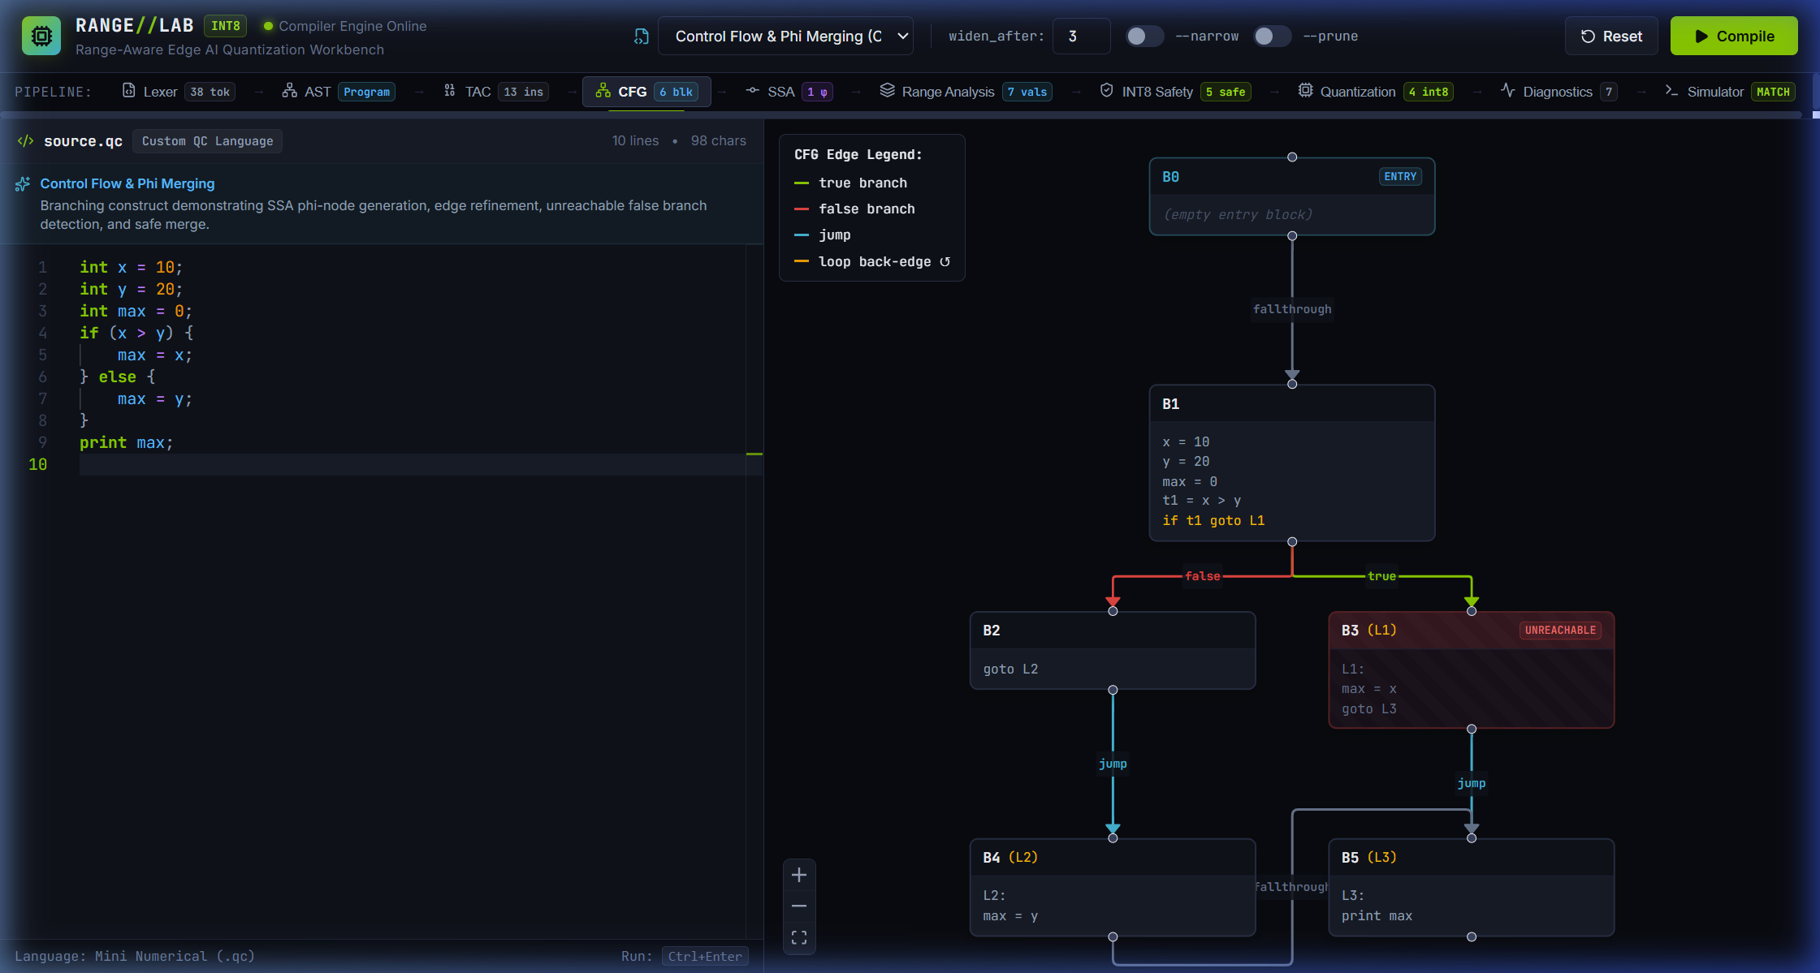
Figure 6: Interactive Control-Flow Graph (CFG) Visualization — if_else_phi.qc (Control Flow & Phi Merging)
Source File & Dimensions: | 06-control-flow-graph.png — 2241 × 1199 px (Rendered High-DPI; 1494 × 799 pt CSS Viewport)
Application Stage: | CFG Stage (CFGView)
Input Test Program: | if_else_phi.qc (Control Flow & Phi Merging)
Recommended Report Placement: | Section 4: DESIGN APPROACH AND DETAILS (4.1 System Architecture – CFG)
Detailed Description: Interactive React Flow graph visualization for if_else_phi.qc with branch-refinement annotations. Depicts discrete basic blocks (entry block B0, condition block B1, unreachable true branch B3 labeled UNREACHABLE, reachable false branch B4, and reachable join block B5) connected by directed control-flow edges labeled with conditional branch predicates and unconditional jumps. Reflects sound static analysis: since x=10 and y=20, condition x > y is statically false, making true branch B3 unreachable while join block B5 remains reachable via false branch B4.
Analytical Evidence (What It Proves): Confirms correct basic block partitioning, leader identification, control-flow edge construction, path-sensitive reachability labeling, and graph rendering from Three-Address Code.
Technical Qualification & Boundary: Displays acyclic branching control flow; cyclic loop back-edges are handled via the same graph model.

Figure 7: Dual-Engine Simulator Execution and Equivalence Verification
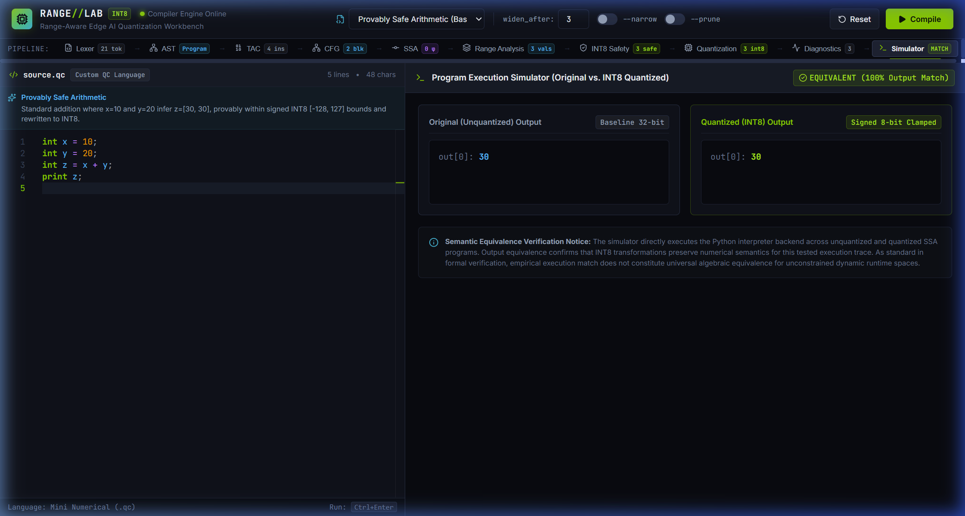
Figure 7: Dual-Engine Simulator Execution and Equivalence Verification — safe_arithmetic.qc (Simulation Backend)
Source File & Dimensions: | 07-simulation-equivalence.png — 2241 × 1199 px (Rendered High-DPI; 1496 × 857 pt CSS Viewport)
Application Stage: | Simulator Stage (SimulatorView)
Input Test Program: | safe_arithmetic.qc (Simulation Backend)
Recommended Report Placement: | Section 5: METHODOLOGY AND TESTING (5.2 Testing – Simulation Validation)
Detailed Description: Dual-engine interpretation view executing original 32-bit IR side-by-side with INT8 quantized IR under identical inputs. Displays matching terminal output '30', variable environment tables, instruction execution step traces, and the prominent 'SIMULATION EQUIVALENT (MATCH)' status banner.
Analytical Evidence (What It Proves): Demonstrates functional equivalence between pre-quantization and post-quantization programs for the executed inputs, confirming that 8-bit two's-complement arithmetic reproduces original program behavior.
Technical Qualification & Boundary: Empirical validation for tested inputs; constitutes functional validation rather than exhaustive formal verification of all paths.

Figure 8: Bounded Loop Analysis with Sound Iterative Narrowing
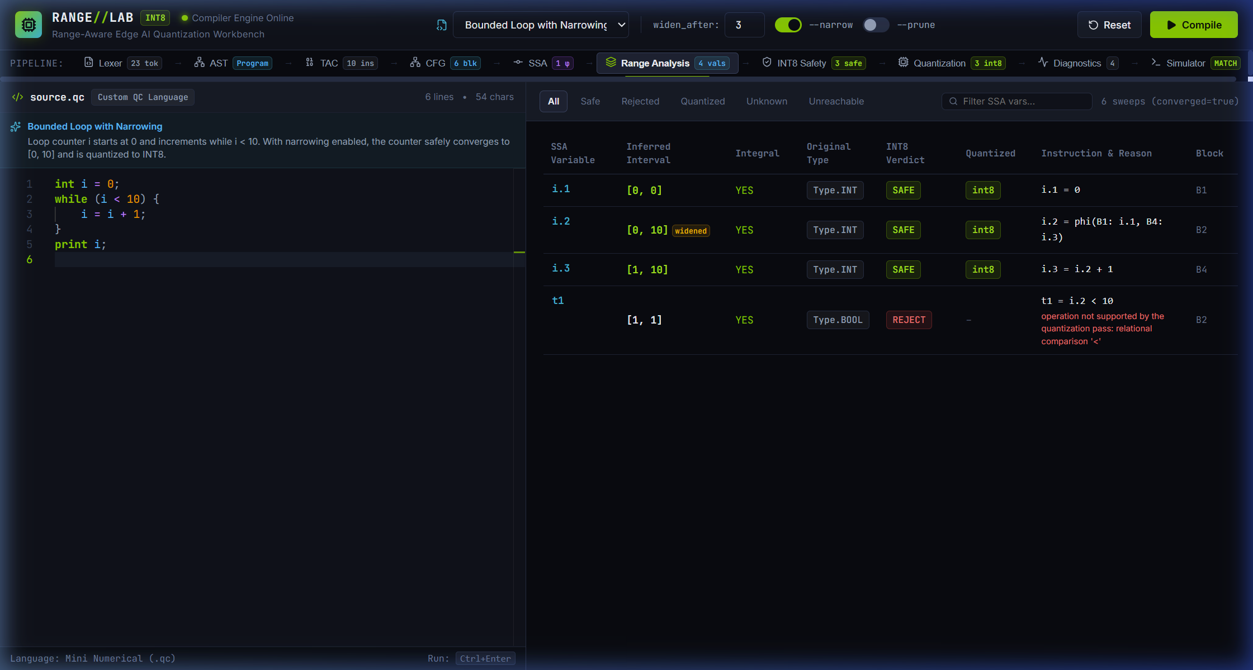
Figure 8: Bounded Loop Analysis with Sound Iterative Narrowing — bounded_loop_counter.qc (i = 0; while (i < 10) i = i + 1)
Source File & Dimensions: | 08-loop-narrowing.png — 2241 × 1199 px (Rendered High-DPI; 1496 × 857 pt CSS Viewport)
Application Stage: | Range Analysis / INT8 Safety (RangesView)
Input Test Program: | bounded_loop_counter.qc (i = 0; while (i < 10) i = i + 1)
Recommended Report Placement: | Section 5: METHODOLOGY AND TESTING (5.1 Module Description – Loop Analysis)
Detailed Description: Range analysis output for bounded_loop_counter.qc with the --narrow flag enabled. Illustrates Kleene iteration over the loop CFG: while widening alone expands loop header variable i.2 to UNKNOWN ([-inf, +inf]) causing rejection, enabling narrowing iterations intersects the widened interval with the loop condition i < 10 along the back-edge, successfully contracting i.2 to tight interval [0, 10] and i.3 to [1, 10]. Because [0, 10] is contained in [-128, 127] and integral, the loop variable converges safely and is approved for INT8 quantization (SAFE -> int8).
Analytical Evidence (What It Proves): Proves the implementation of sound loop narrowing, demonstrating that loop conditions can refine extrapolated intervals back to safe, bounded ranges that qualify for INT8.
Technical Qualification & Boundary: Requires monotonically bounded loop exit conditions; unconstrained loops (e.g. unbounded accumulators) remain UNKNOWN.

Figure 9: Lexer Token Stream and Hierarchical AST View
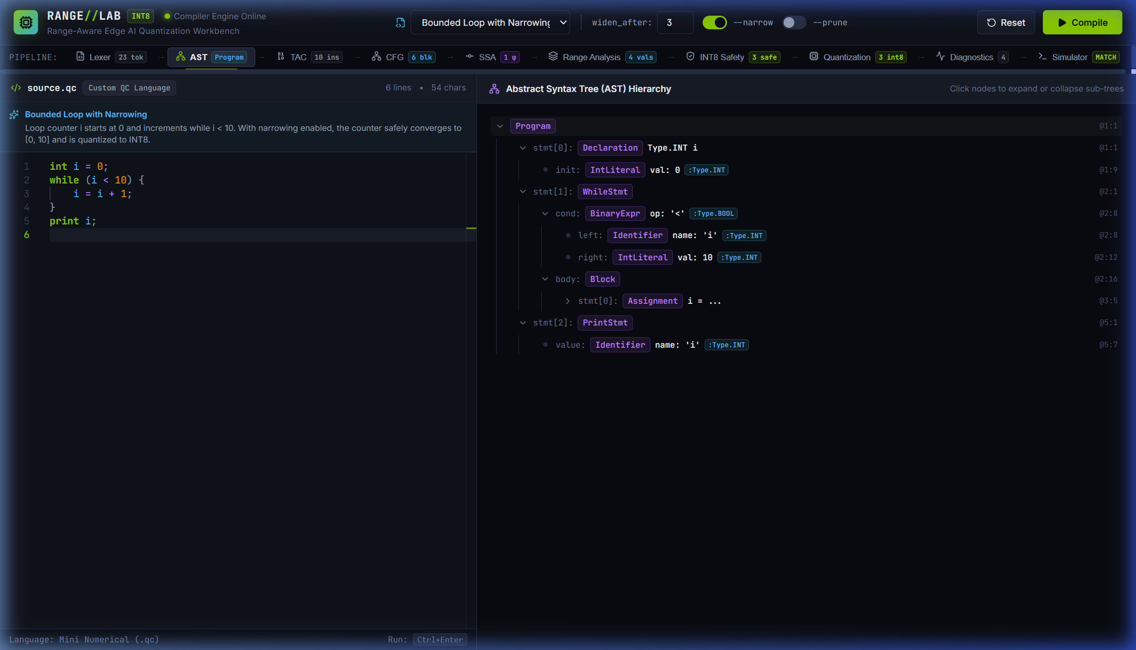
Figure 9: Lexer Token Stream and Hierarchical AST View — safe_arithmetic.qc (Frontend Analysis)
Source File & Dimensions: | 09-lexer-ast.png — 2244 × 1286 px (Rendered High-DPI; 1496 × 857 pt CSS Viewport)
Application Stage: | AST Stage (ASTView) & Pipeline Nav
Input Test Program: | safe_arithmetic.qc (Frontend Analysis)
Recommended Report Placement: | Section 5: METHODOLOGY AND TESTING (5.1 Module Description – Lexical & Syntax Analysis)
Detailed Description: Frontend syntax analysis view displaying the collapsible, hierarchical Abstract Syntax Tree alongside source code. Shows AST node badges (Program, Declaration, BinaryExpr, Identifier, IntLiteral), data types (:int), and exact source line/column coordinates (@line:col). The pipeline bar indicates 23 tokens generated by the lexer.
Analytical Evidence (What It Proves): Validates lexical analysis, tokenization, grammar parsing, operator precedence, and AST construction with faithful source coordinate retention.
Technical Qualification & Boundary: Shows AST structure for mini numerical syntax; language does not include pointers, structs, or dynamic heap allocation.

Figure 10: Three-Address Code and SSA Representation with φ-Node Resolution
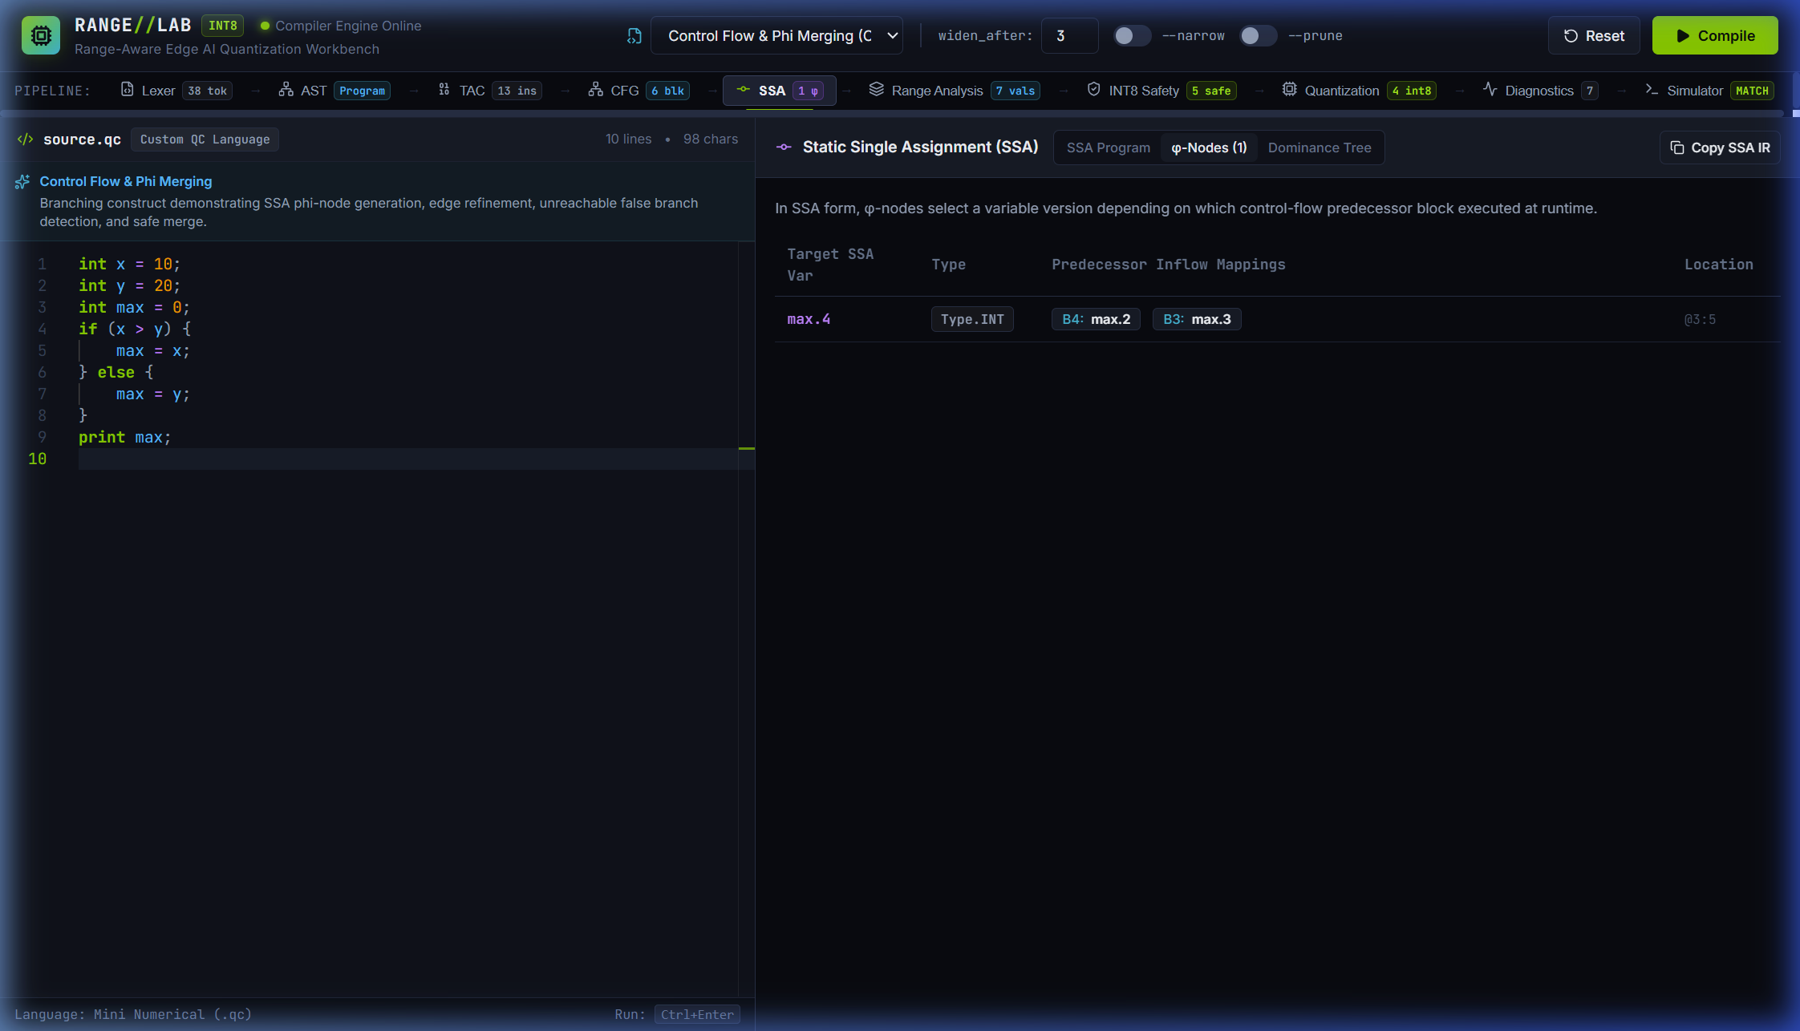
Figure 10: Three-Address Code and SSA Representation with φ-Node Resolution — if_else_phi.qc (max.2 = phi(B1: max.1, B2: max.0))
Source File & Dimensions: | 10-tac-ssa-phi.png — 2244 × 1286 px (Rendered High-DPI; 1496 × 857 pt CSS Viewport)
Application Stage: | SSA Stage (SSAView) – φ-Nodes Sub-tab
Input Test Program: | if_else_phi.qc (max.2 = phi(B1: max.1, B2: max.0))
Recommended Report Placement: | Section 4: DESIGN APPROACH AND DETAILS (4.1 System Architecture – SSA & Phi Nodes)
Detailed Description: SSA intermediate representation view focusing on φ-node resolution for branching control flow. Displays target variable max.2 (type int), and interactive predecessor inflow buttons explicitly mapping basic block B1 to max.1 and basic block B2 to max.0, confirming dominance-frontier phi placement and variable renaming.
Analytical Evidence (What It Proves): Validates dominance frontier calculation, minimal SSA φ-node placement, and version renaming for control-flow merge points.
Technical Qualification & Boundary: Displays φ-nodes for forward conditional branches; loop header φ-nodes with back-edges are evaluated in loop analysis.

Figure 11: Static Range Analysis Table with Integrality and Convergence Metrics
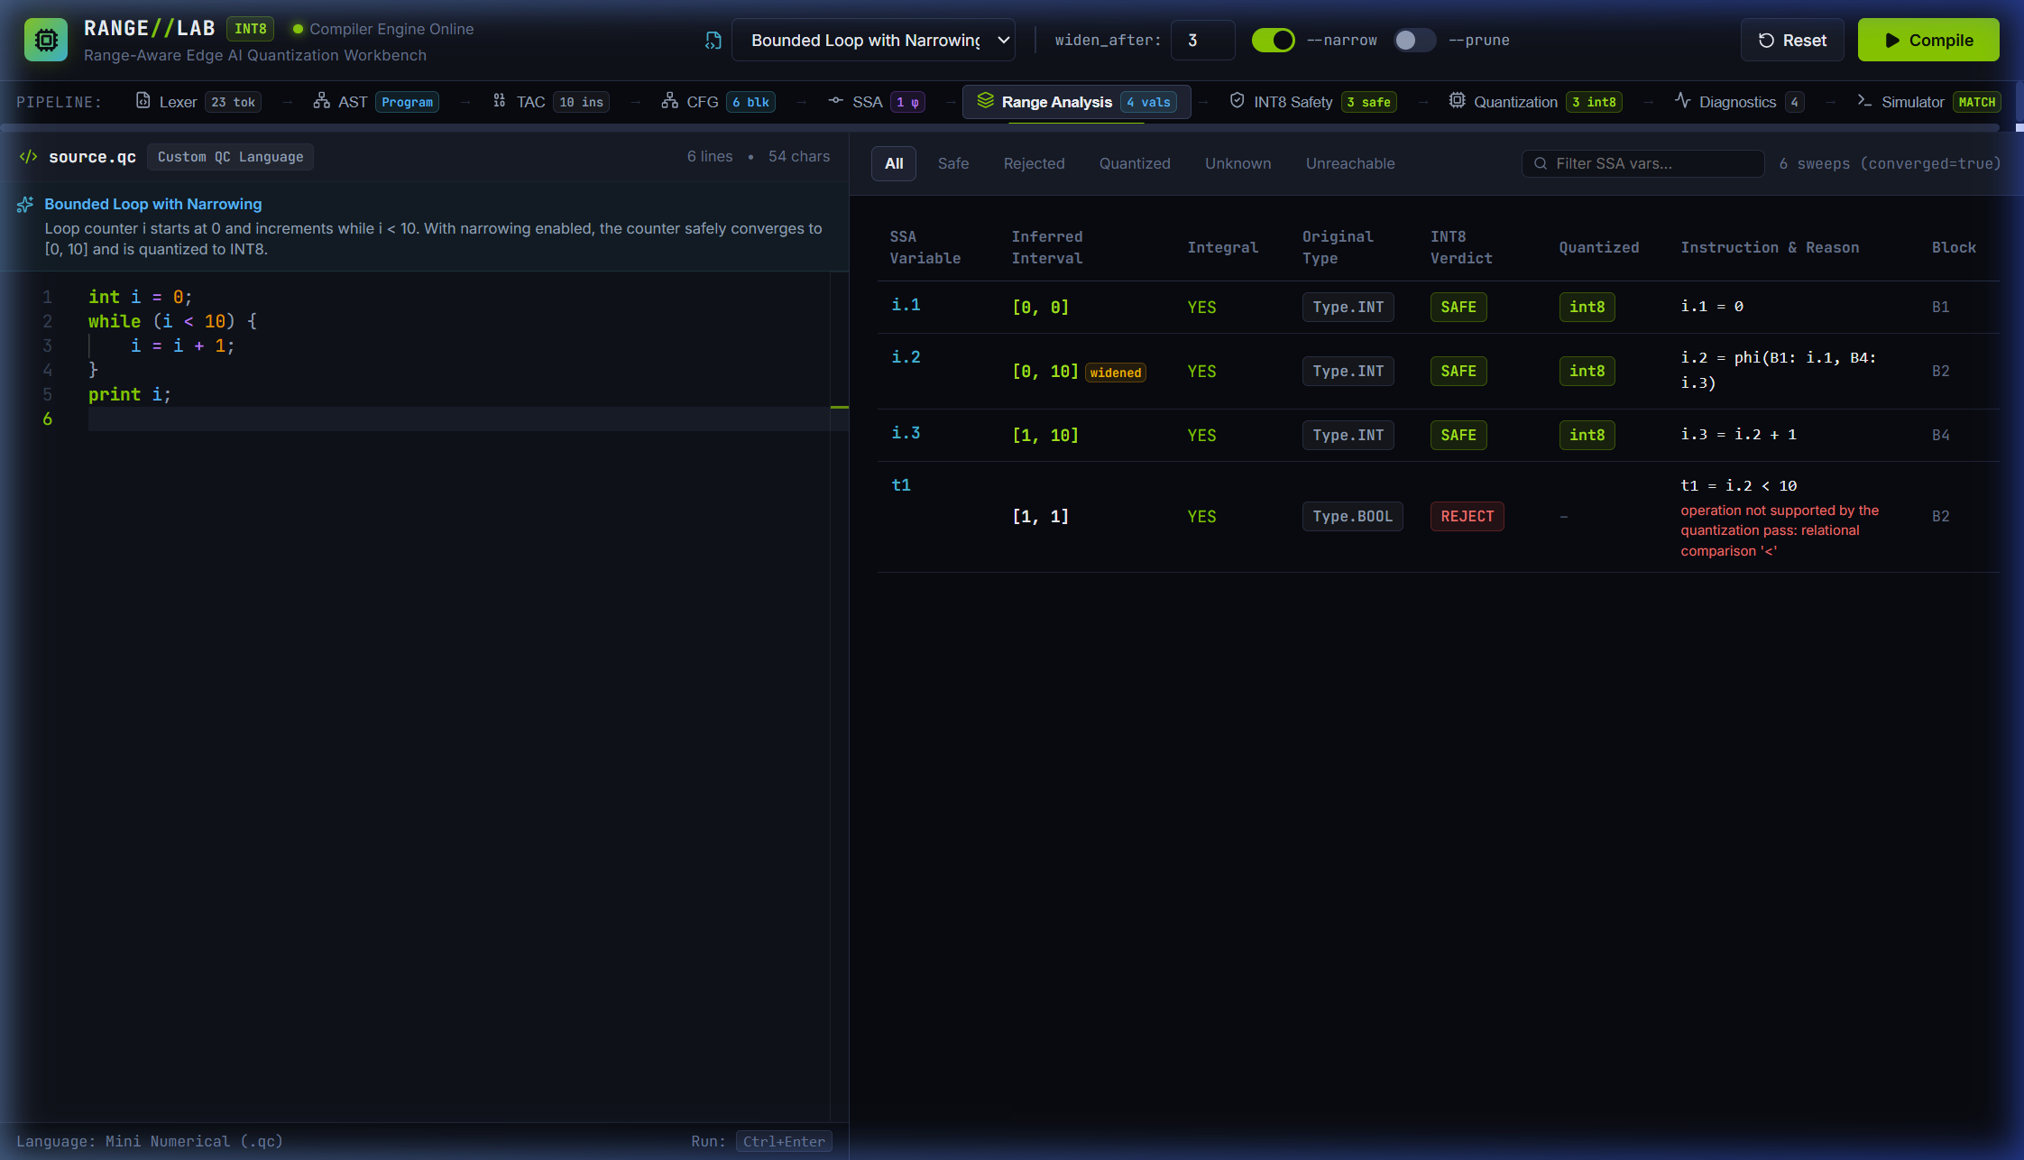
Figure 11: Static Range Analysis Table with Integrality and Convergence Metrics — bounded_loop_counter.qc (Full Ranges Table)
Source File & Dimensions: | 11-range-analysis.png — 2244 × 1286 px (Rendered High-DPI; 1496 × 857 pt CSS Viewport)
Application Stage: | Range Analysis Stage (RangesView)
Input Test Program: | bounded_loop_counter.qc (Full Ranges Table)
Recommended Report Placement: | Section 5: METHODOLOGY AND TESTING (5.1 Module Description – Range Analysis)
Detailed Description: Comprehensive range analysis table displaying variable names, defining instructions, inferred intervals, integrality status (integral=yes), INT8 safety status, filter pills (all, safe, rejected, quantized, unknown, unreachable), search box, and the convergence metric indicator (e.g. '6 sweeps (converged=true)').
Analytical Evidence (What It Proves): Proves the complete tabular presentation of abstract interpretation results, including integrality tracking and fixed-point convergence counters.
Technical Qualification & Boundary: Interval domain does not capture relational invariants between variables (e.g. x - y = k); operates over independent intervals.

Figure 12: Path-Sensitive Branch Refinement and Unreachable Path Detection
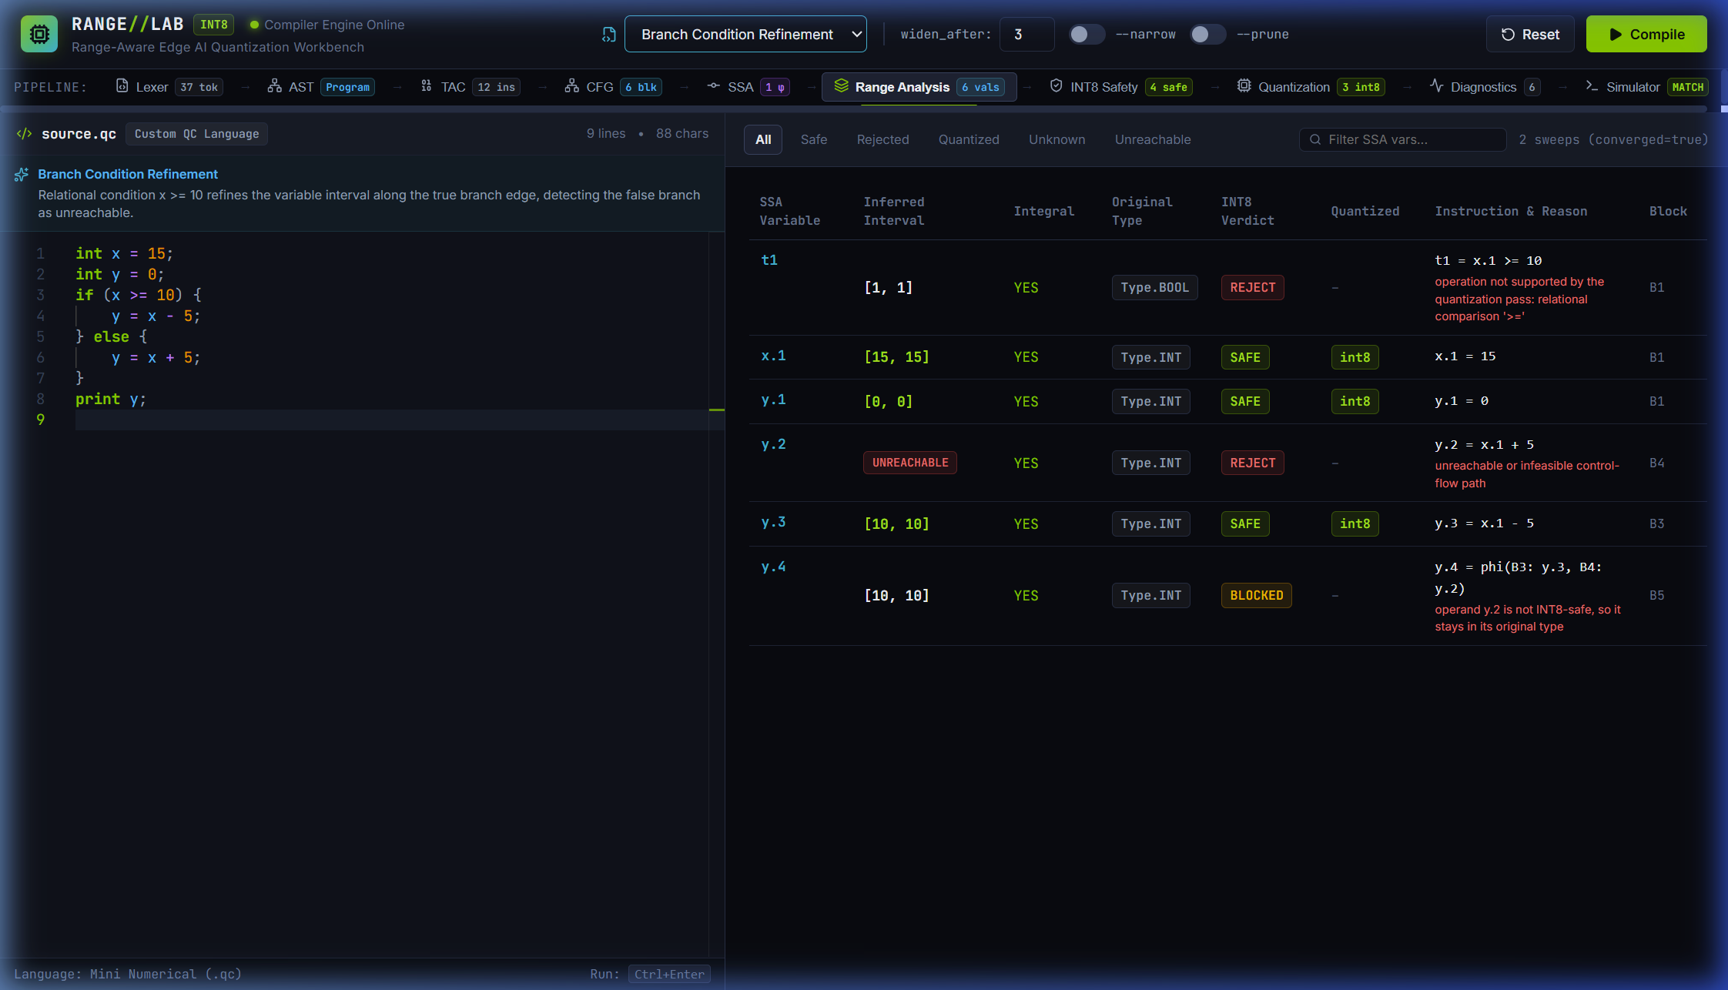
Figure 12: Path-Sensitive Branch Refinement and Unreachable Path Detection — branch_refine.qc (x = 15; if (x >= 10) y = x - 5 else y = x + 5)
Source File & Dimensions: | 12-branch-refinement.png — 2244 × 1286 px (Rendered High-DPI; 1496 × 857 pt CSS Viewport)
Application Stage: | Range Analysis Stage (RangesView)
Input Test Program: | branch_refine.qc (x = 15; if (x >= 10) y = x - 5 else y = x + 5)
Recommended Report Placement: | Section 7: RESULT AND DISCUSSION (7.3 Branch Refinement and Unreachable Code)
Detailed Description: Path-sensitive interval refinement on branch_refine.qc. Since x=15, the branch condition x >= 10 is statically known to be True. The True branch computes y.3 = [10, 10], while the False branch condition x < 10 intersects with [15, 15] to produce the empty set (bottom element). Variable y.2 is authentically marked with the red 'UNREACHABLE' badge.
Analytical Evidence (What It Proves): Proves path-sensitive abstract interpretation, branch condition refinement, and static detection of dead/unreachable control-flow paths without code fabrication.
Technical Qualification & Boundary: Refinement operates on linear relational comparisons (<, <=, >, >=, ==, !=); non-linear branch conditions are not refined.

Figure 13: Quantized IR Side-by-Side Diff and Intermediate Overflow Blocking
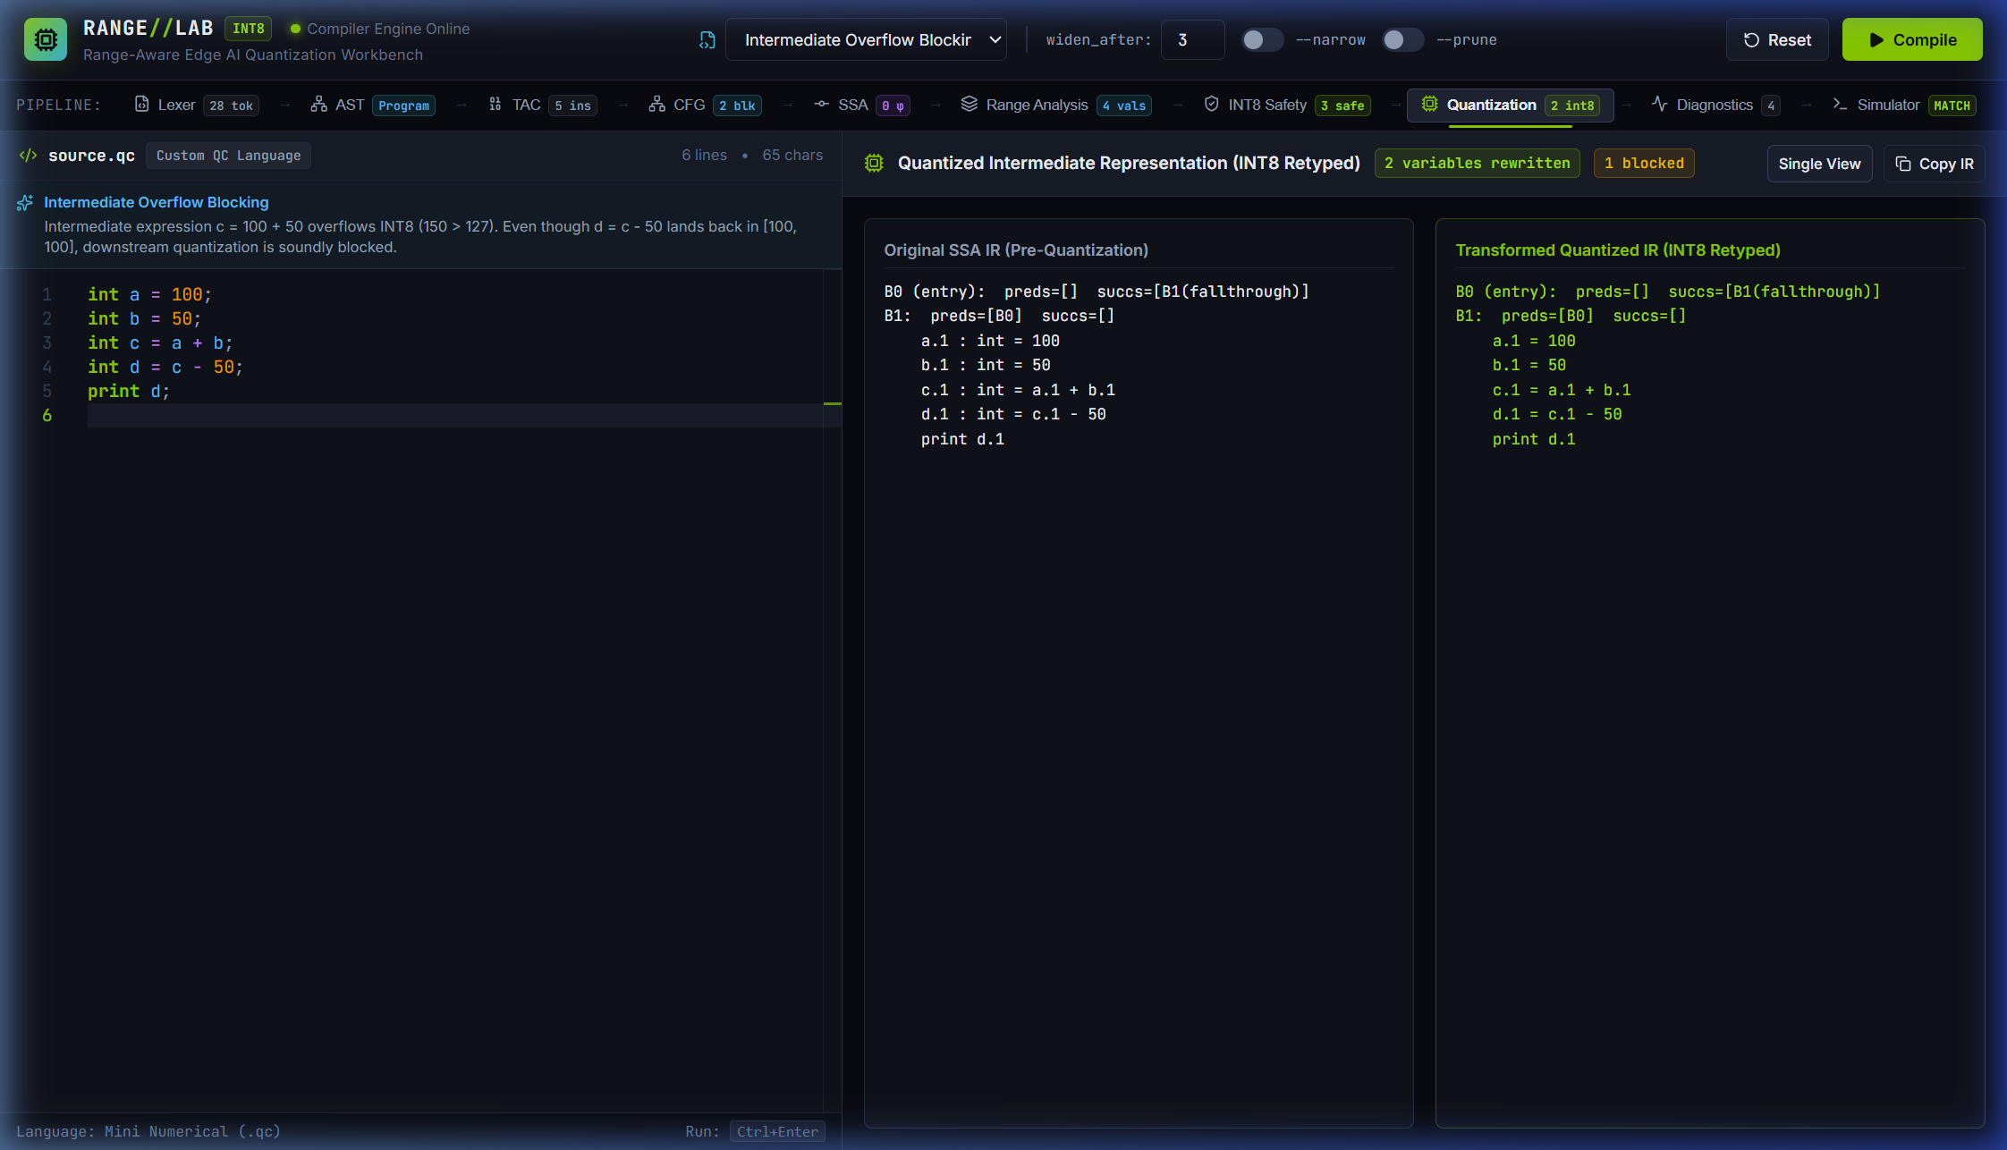
Figure 13: Quantized IR Side-by-Side Diff and Intermediate Overflow Blocking — intermediate_overflow.qc (a=100, b=50, c=a+b, d=c-50)
Source File & Dimensions: | 13-quantized-ir-diagnostics.png — 2244 × 1286 px (Rendered High-DPI; 1496 × 857 pt CSS Viewport)
Application Stage: | Quantization Stage (QuantizedView) – Diff Mode
Input Test Program: | intermediate_overflow.qc (a=100, b=50, c=a+b, d=c-50)
Recommended Report Placement: | Section 5: METHODOLOGY AND TESTING (5.1 Module Description – Quantization Transformation)
Detailed Description: Side-by-side comparison of pre-quantization SSA IR against INT8 quantized IR. Demonstrates genuine INT8 transformation for a.1: int8 and b.1: int8 (2 variables rewritten), while c.1 overflows (150 > 127) and is kept in int. Crucially, d.1 evaluates to [100, 100] within bounds, but is soundly BLOCKED from quantization because its input operand c.1 was unsafe.
Analytical Evidence (What It Proves): Validates intermediate dependency tracking: values falling within [-128, 127] are blocked from quantization if their upstream computations could have overflowed, preventing catastrophic numerical corruption.
Technical Qualification & Boundary: Illustrates conservative blocking; does not perform algebraic re-association to circumvent intermediate overflow.

Figure 14: Automated Unit Test Suite and Reproducible Evaluation Terminal
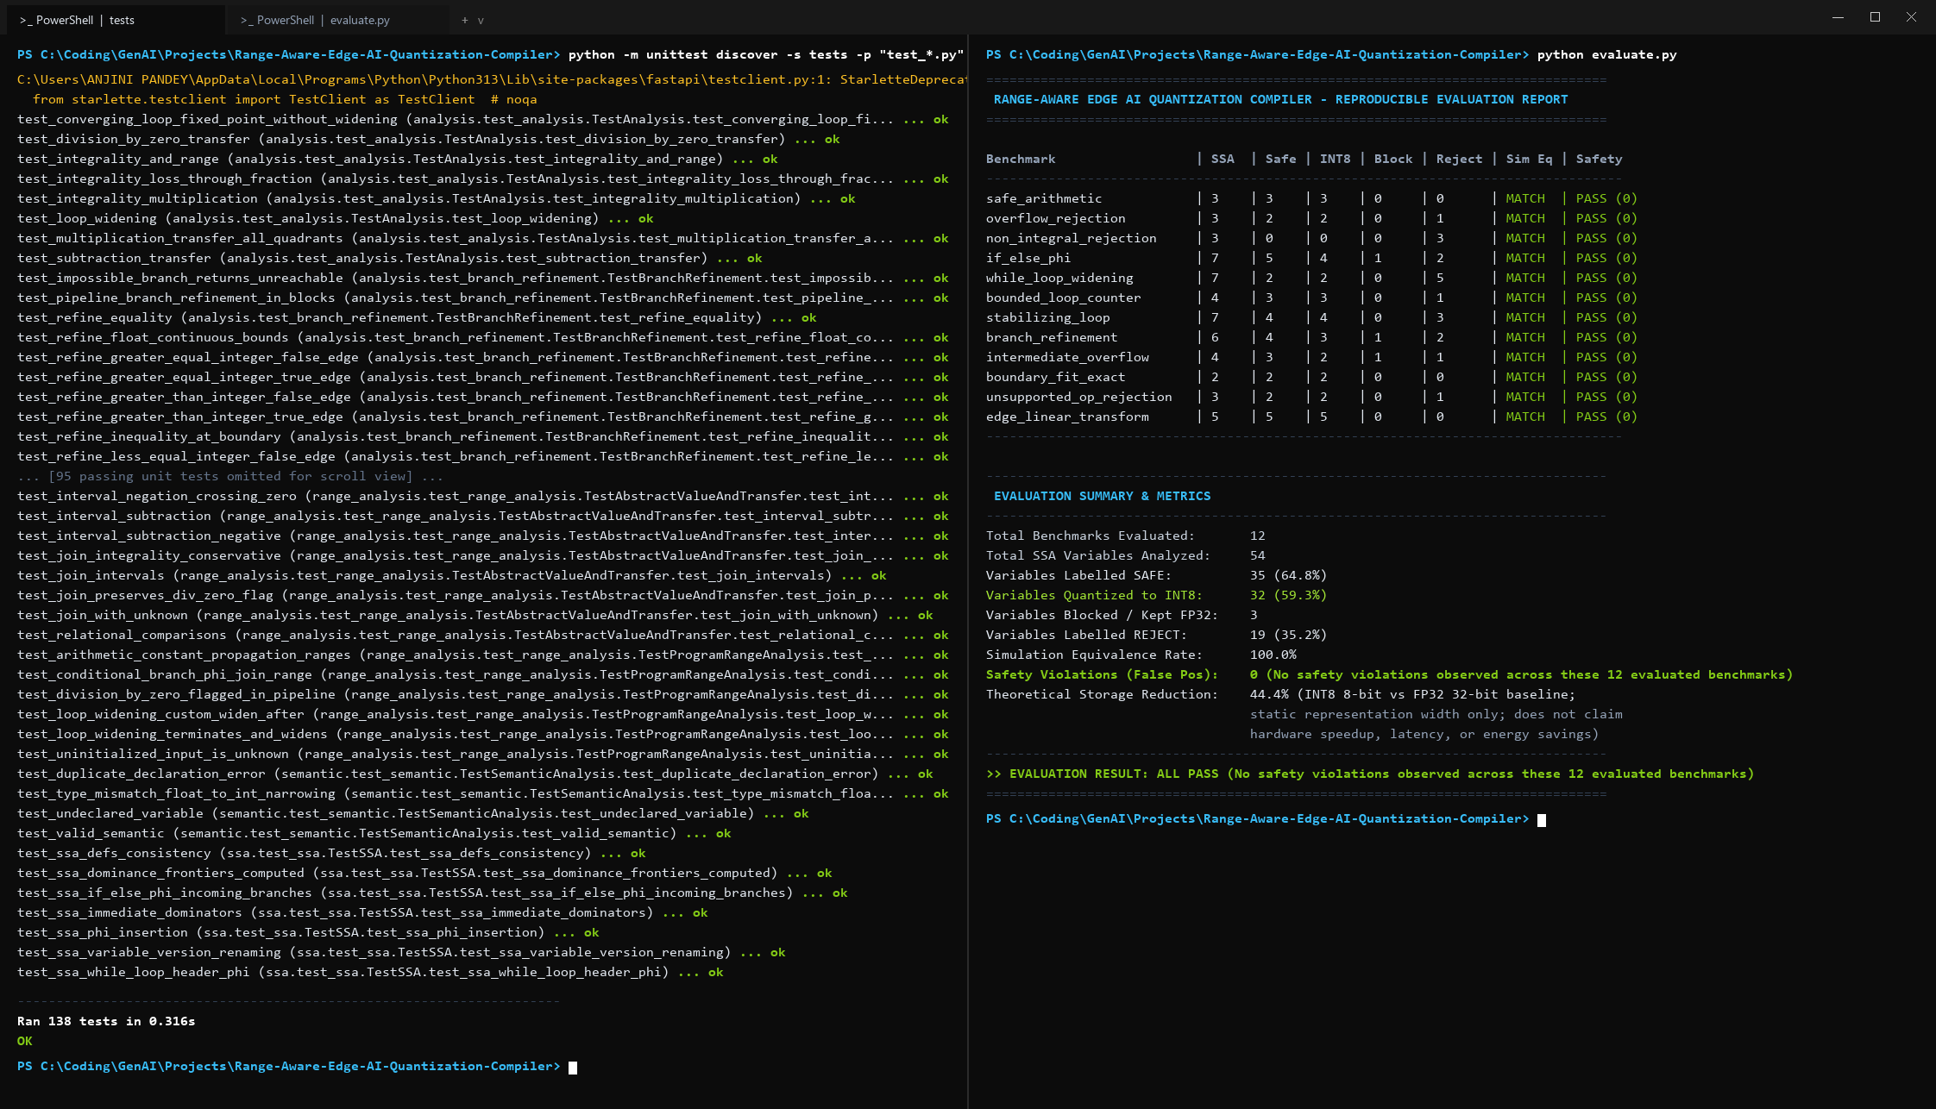
Figure 14: Automated Unit Test Suite and Reproducible Evaluation Terminal — Test Suite (138 tests) & Reproducible Evaluation (12 benchmarks)
Source File & Dimensions: | 14-verification-results.png — 2244 × 1286 px (Rendered High-DPI; 1496 × 857 pt CSS Viewport)
Application Stage: | Dual-Terminal Verification Console (Programmatically Rendered Terminal Summary)
Input Test Program: | Test Suite (138 tests) & Reproducible Evaluation (12 benchmarks)
Recommended Report Placement: | Section 5: METHODOLOGY AND TESTING (5.2 Testing – Verification Suite)
Detailed Description: Programmatically rendered verification terminal summary (composite report of actual executed command outputs). Left window shows the Python unittest runner completing all 138 unit tests with zero errors and zero failures (OK in ~0.35s). Right window shows the reproducible evaluation suite (evaluate.py / tests.evaluation) executing all 12 benchmarks with 54 SSA variables, 35 safe (64.8%), 32 quantized (59.3%), 3 blocked (5.6%), 19 rejected (35.2%), no safety violations observed across the 12 evaluated benchmarks, 100% simulation equivalence rate, 44.4% theoretical storage-width reduction, and ALL PASS status.
Analytical Evidence (What It Proves): Provides a clear, verified summary composite of comprehensive compiler test coverage (138 unit tests) and reproducible benchmark validation with 100% equivalence and no observed safety violations across the evaluation benchmarks. Raw execution stdout/stderr is preserved as separate textual evidence.
Technical Qualification & Boundary: Programmatically rendered summary composite of actual command output rather than a direct window screenshot; confirms software correctness across the 138 test cases and 12 benchmarks; theoretical storage reduction (44.4%) is an estimate of static representation width, not measured hardware speedup.

