Working directory – the folder of the directory locally on the computer

Staging area – a file that stores information about what will go into the next commit

Branch – a lightweight movable pointer to any one commit

Origin – refers to the remote repository and has a certain branch **need to expand on this**

Fetch – updates the branches in your local repo by looking at the branches at the remote and brings them to the local **it doesn’t change your repository files.**

Pull – brings a local branch up to date with the remote branches it also update you branches with remote branches

Diff – shows the changes between the working directory and changing area you can give it a branch name it it will show the difference to it, you can give it a commit hash, it generally comperes between the working directory and what you give it but you can give it certien flags to compere with something else like –-staged

Checkout – you can use checkout to also create branch using -b flag

Git rebase – instead of merging it will transfer the commits to the branch listed.

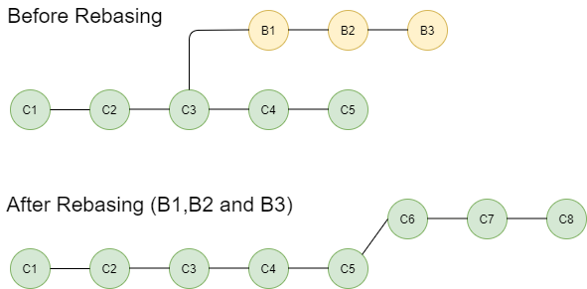

Cherry pick – let you pick a commit to move to the current branch

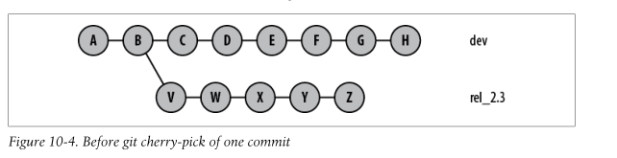

Cherry picking from dev to rel commit f:

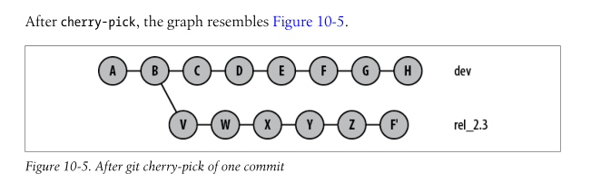

Stash – takes from the working directory the changes from the last commit and put them in the stash, the stash is a stack with the changes added to it

Stash list – lists the stashes saved in the stack uses stash@{0} as the first and increases the number to symbol lower items in the stash.

Apply – takes the first item in the stack and applies the changes to the working folder and keeps the stash as is.

Pop – does as apply but removes the item from the stack

Drop – removes from the stack

Clear – removes all from the stack

You can stash untracked files using -u flag

-a to stash all files including those ignored by gitignore

Stack – use cases: function calls- to where to jump in memory for the next line of code, its used in compiles to check syntax of code. Its being used often in cyber security because you crash or even invade programs by abusing the stack and causing an overflow, for example stack overflow and buffer overflow.

Bisect – uses binary search to try and find a bug you start by letting it now the bad commit usealy the head or current commit your working on and you give it the last commit you checked that was good then it starts asking you by binary searching the commits between them if they were good or bad.

Git reset soft – keeps the staging area and working directory unchanged but moves the head pointer to specified commit.

Hard – resets also the staging area and working directory.

Changelog – between releases you put a change log that will describe what has changed in this release uses it shows the bugs fixed the new features added. You can add what ever you want to it because its also a MD file that you can change in what ever way you want.

Git attributes – it’s a file that has some file configurations for the repo for example EOL configuration, binary files ending, custom drivers for diff command and merge. Etc

Git commit hash – uses SHA-1 its based on the contents of the files, metadta, time etc of the commit.

Git head – the pointer which points to the current branch you are working on.

Git reference is a way to reference commits relative to the head commit using mainly using ~ and ^

^- symbolises the perant commit meaning the commit you can use it to travel thru the perants meaning ^2 will go to the perant of the perant.

~ - symbolises the direct commit before it. ~2 two direct commits before it on the same **line (branch)**

They can be combined.

Tags – are being used to mark specific points in your repository history as being important. They are often used to mark release points

There are two types of tags:

Lightweight – marking a commit these tags are just pointers to a specific commit.

Annotated – by using -a flag you create an annotated tag, they are stored as full objects, including checksum, tagger name, email, date, and a tagging message you can also sign it in order to authenticate its creator, you should generally use annotated because of its extra data that being stored, but if you want to create a temp tag you can use lightweight tags.

Semantic versioning – when giving a version the convention is MAJOR.MINOR.PATCH so when tagging you should use this convention for the tag name.

Release – being used adjacent to tags to mark specific points in the repository history.

**Clean code:**

meaningful names:  
intention-revealing names names should clearly express the intent of the variable function or class.

Avoid disinformation – names should not be misleading or ambiguous.

Prononcable names – you should use names that are easy to pronounce because it will be easy to discuss and remember.

Searchable names – names should be easy to find in the code.

Avoid encodings – do not use prefixes or Hungarian (_name) notation keep names clean and simple.

Functions:

Small functions – should be small and preform a single task

Do one thing – each function should do one thing and do it well.

Depictive names – function names should describe what they do.

Avoid side effect – functions should not have hidden effects and variables that are not clear from the function name or signature.

Functions arguments – should be kept to a minimum.

Comments:

Use comments to explain why something is done and not what is done. Avoid redundant, misleading or obvious comments.

You should strive to write a code that Is clear enough to be understood without comments.

Formatting:

Consistent – pick a format and stick to it.

Vertical – group related lines of code together and use spacing to separate different logical sections.

Horizontal – keep lines short typically less than 80-100 characters. use proper indentations and spacing around operators.

Objects and data structures:

Objects hide their data behind methods, while structs expose their data and have no significant behavior.

DTOS – use DTOs to transfer data between components. For example web applications should not receive from the beckend the full user object but should receive a part of it instead of nulling values In the object create a new object to send.

Error handling:

Use exceptions and not error codes: exceptions are preferred over error codes.

Define exception classes – create specific exception classes for different error types.

Don’t return null - avoid returning null instead exceptions.

Don’t pass null – avoid passing null arguments to functions.

Boundaries:

Third party code – treat third party code as a black box and minimize dependencies.

Encapsulate boundaries: try to isolate external libraries to isolate the rest of the code from changes by using interfaces or adapters.

Unit testing:

Test driven development: write tests before writing code they test.

Clean tests: tests should be readable, maintainable and act as documentation for the code.

Fast, independent, repeatable: tests should run quickly, be independent of each other, and produce the same results every time.

Clases:

Small classes: classes should be small and focused on a single responsibility.

Single responsibility: a class should have only one reason to change.

Conhesion: methods within a class should be related and work together towards a common purpose.

Systems:

Separations of concerns: different aspects of the system should be managed by different parts of the system.

Dependency injection: use dependency injection to manage dependencies and improve testabily.

Keep the system under control: regularly refactor and clean the code to maintain control over the systems complexity.

Emergence:

Simple design: follow kent becks four rules of simple design: passes all tests reveals intentions no duplication minimal number of classes and methods.

Concurrency:

Keep it simple: concurrency adds complexity, so keep concurrent code as simple as possible.

Limit the scope of data sharding: minimize the amount of data shared between threads.

Smells and heuristics:  
code smells: be aware of common signs of porly written code (eg., large classes lone methods and excessive comments)

Refactor regularly: continuously improve the code by refactoring to eliminate smels and improve design.

Continuous learning – stay updated with best practices and new techniques in software development.

**Design patterns**

Factory – instead of having in a main function a code that will give you an object delegate the mission to a dedicated class you can enhance it by using a hashmap to create the object instead of using ifs.

Abstract factory - is a way of organizing how you create groups of things that are related to each other. In other words its a factory of a factory

Builder – when having an an object with a lot of options, you should create an interface with those attributes and the implementation will be in the builder, an engineer object will be in charge of creating object by getting the builder instance and having a method for creating the robot from the engineer object.

Prototype– by using the clonable interface you can easily clone objects

Singleton – if you want one instance of an object you can use it, by creating a static class that will have one instance of that object and have a function to return that instance if it exists else create and return it, its realy useful when multi-threading.

Adapter – when having different functions in different objects that do the same thing or even with different units you can create an adapter to one of the object into another for example to robots that attack one another but one has different functions signatures so you create an adapter in order for them to communicate easily

Bridge – sperates an objects interface from its implemantations allowing the two to vary indepndendly, for example colored shapes instead of having multiple shapes that are named with different colors move the color to a class and have it as an attribute to the shape.

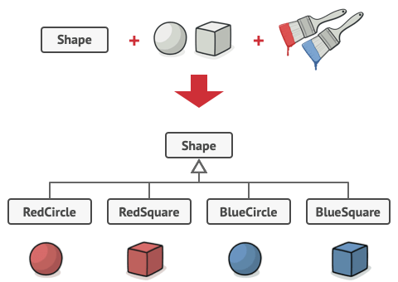

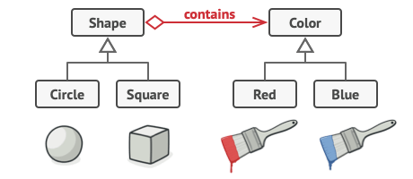

Composite – when wanting to structure a box that can have multiple boxes and items in it you need to define it in that way you can do it by creating a common interface for it and later storing that common interface as an array that can be unpacked later

Decorator – when wanting to have an unknown amount of decorators on an object for example pizza you can do it by unwrapping layer by layer from the main object by creating an abstract class that will function as the main object example pizza and having a decorator class that inherits the pizza you can create decorators on to of one another therefore making it easy to calculate a price of the pizza by recursively delayering from the pizza and seeing what is it its very similar to a linked list in that sense because in practice it is a linked list.

Façade – when calling a shop for an order instead of going thru all of the options an operator in this case the façade is the one who knows were to move you too, the same can be said when you want to convert from certien file types you might need to run different process to do so but instead of needing to go to them one by one you can have a façade and use it for that.

Flyweight – when having a lot of objects that are the same instead of creaeting millions of copys of them you can share those objects instead, lets say you want to paint a million rectangles in different color instead of creating a million rectangles you can use the same cetangle but paint it in different colros, therefore saving a lot of memory and processing time.

Proxy – when wanting to hide certain states or functions from the users for example an atm cache amount. So you create a class that acts as a proxy

Chian of responsibility – it allows you to send a command without knowing who is responsible to handle the request, the request is passed along by the handlers until one handles it. For example routes in express/fastapi.

Command – instead of having to call a function and limiting Extensibility you can create commands and excuter to execute this commands by creating a common interface to have an excute function that will be called on each command.

Iterator – when you want to traverse through elements without needing to understand the underlying data structure, and easing the use of the data structure, you do it by litigating the traveling thru the data structure to a dedicated class.

Mediator – in order to reduce coupling between components that communicate between them is by passing their communications thru a mediator. For example when brokers want to trade stocks instead of communicating between them they should use a mediator that will collect to buys and sell offers and see if there is an acceptable offer.

Memento - used to capture and restore an object's internal state without violating encapsulation, allowing you to revert an object to a previous state. By saving an instance of the state as a memento you can store and use the state of said object later on with ease.

Observer – when having objects watching for one object changes that one object should store and notify the other objects on his changes.

State – instead of having a lot of switch cases to swap between states you can have an interface and classes to describe the states and what states should follow when something specific is done.

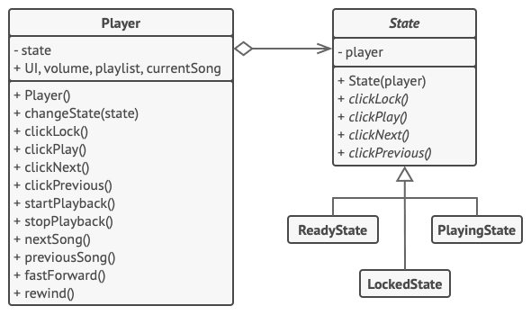

Strategy – instead of having functions wich will raise errors or wont do anything you need to use interface to the wanted classes who has these behaviors.

Template - is being used to serve as a template to an algorithm by only overriding the stepps in the template abstract object you can adapt the template as wanted

Visitor – when having multiple shapes instead of adding to the wanted shapes a specific feture you can create a class that will implement an interface called a visitor that will have a function for all of the different shapes and the specific class you can implement them as needed to do what you want them to for example export them to XML.

