Imubit Challenge by Yotam Ben-shoshan 15/6/20

Work report:

At the first stage I wanted to have a baseline result for cifar 10 classification task.
After several unsuccessful attempts of trying to use some cifar10 classifiers from Kaggle.
I decided to use a VGG16 with pretrained imagenet weights. I trained the model for 10 epochs over all the data set and I got ~86% accuracy result of test set.

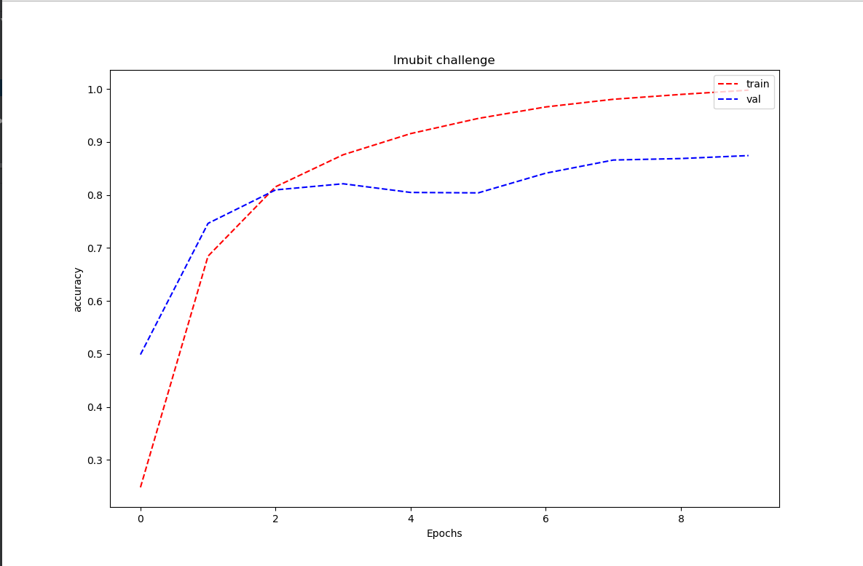

In my next step I wanted to test how the partial labels would effect the result. I retrained the same model with the data set as defined in the Imubit challenge. After 10 epochs I got ~40% accuracy on the validation set (during train I use 5% of data as validation), but surprisingly I got ~72% accuracy on the test set.

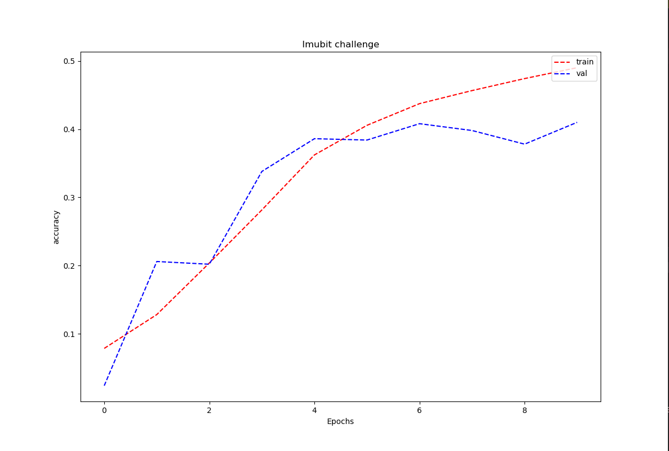

To address the partial label problem I decided train the model in a number of iteration. At the end of each iteration I updated the labels by strengthening the label with the higher confidence

Example:

iteration 0:

Image label → [0 0 0 1 0 0 1 0 0 0]

At the end of iteration 1 update labels:

model.predict(image) → [ 0.01 0.01 0.01 0.8 0.01 0.01 0.12 0.01 0.01]
new image lable → [ 0 0 0 0.8*1.1 0 0 0.12*0.9 0 0 ]

iteration 1:

now the image new label is→ [0 0 0 0.88 0 0 0.108 0 0 0]

*after each iteration the labels would be updated.

My intuition of doing so is to use the “wisdom” of the last train model by giving a relatively higher weight to the class the model had higher confidence for, while decreasing the weight for the class with the less confidence.

Unfortunately, this method turned out only to increase over fit and did not tackle the problem.
After running 3 iteration with labels update I got ~74% on the test set which is pretty similarity to what I got before iterating.

Iteration 1: iteration 2:
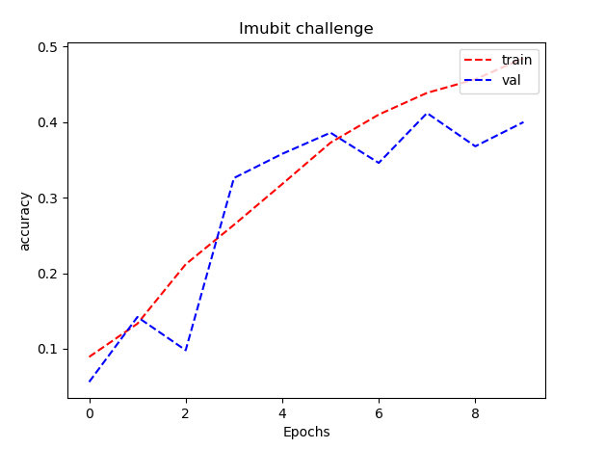
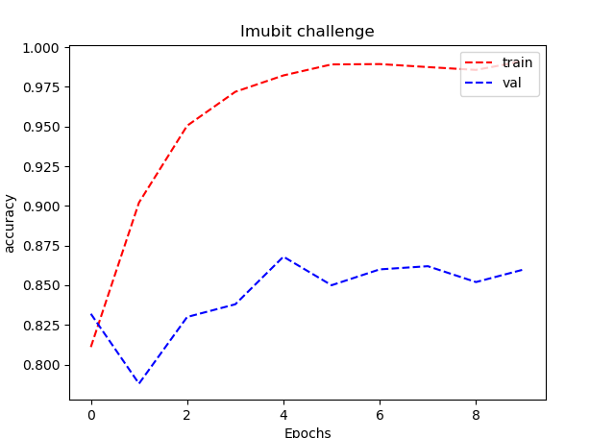

iteration 3:
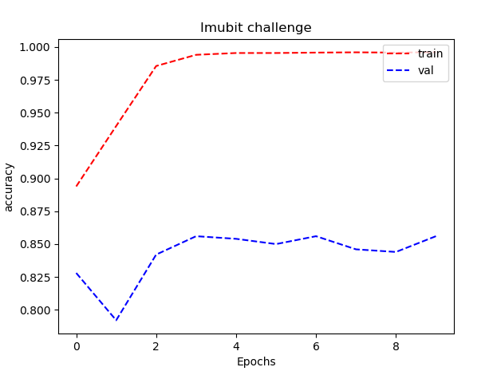

Code usage:

For external code usage I used the following:

parser = argparse.ArgumentParser(description='Imubit challange')
parser.add_argument('--lr', default=1e-3, type=float, dest='learning_rate')
parser.add_argument('--opt',default='sgd', type=str, dest='optimizer')
parser.add_argument('--nn', default='vgg16', type=str, dest='nueral_net_architecture')
parser.add_argument('--bsz',default=32, type=int, dest='batch_size')
parser.add_argument('--dropout',default=0.25, type=float, dest='dropout')
parser.add_argument('--epoch',default=10, type=int, dest='epoch')
parser.add_argument('--steps_per_epoch',default=15, type=int, dest='steps_per_epoch')
parser.add_argument('--lr_schedule',default=[10,20,60,110,200], type=int,nargs='+', dest='lr_schedule')
parser.add_argument('--loss', default='categorical_crossentropy', type=str, dest='loss')
parser.add_argument('--comments', default='', type=str, dest='comments')

run example:

python Imubit_challange.py --nn 'vgg16' --epoch 30 --opt 'adam' --bsz 64

python Imubit_challange.py --nn ‘vgg16_with_weights’ --opt ‘sgd’ --bsz 32
--data ‘regular’

