Blending and Hybrid Image Construction

Yotam Gardosh – 208541334 – ex3

**Introduction**

The goal of this exercise is to implement two image blending techniques: Laplacian Pyramid Blending and Hybrid Image Construction. These techniques enable the seamless blending of two images with distinct features, such as textures and structures, to create visually appealing composite images. The main concept utilized in both techniques is the Laplacian Pyramid, which decomposes an image into multiple resolution levels.

**Algorithm**

**Laplacian Pyramid Blending:**

**i. Description:**

The Laplacian Pyramid Blending algorithm involves several steps:

1. Read and reformat size of images and mask.
2. Construct Gaussian pyramids for both input images.
3. Generate Laplacian pyramids from the Gaussian pyramids.
4. Blend the Laplacian pyramids using a formatted mask.
5. Reconstruct the blended image from the blended Laplacian pyramid.

The blending operation is performed by combining corresponding levels of the Laplacian pyramids of the input images based on a binary mask.

**ii. Implementation Details:**

The implementation leverages OpenCV for Gaussian and Laplacian pyramid construction with function such as pyrDown pyrUp for scaling up and down both types of pyramids.

Created a method for formatting the dimensions of a binary filter for 3 channelled RGB images.

The blending operation is achieved by linearly combining Laplacian pyramid levels using the mask’s values.

Hyperparameters for the function are image dimensions, the amount of pyramid levels.

One challenge I faced when creating the blended image was that I had odd colores in the seam between the 2 blended images, to fix this I needed to clip the values back to the range correct range (0,255) .

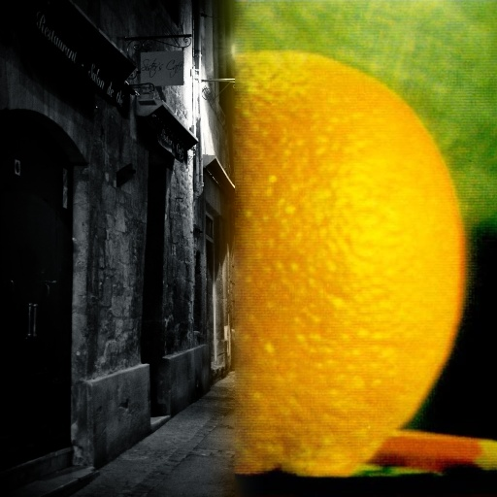**Results:**

* Bad looking blend

the result of the first blend is not good because the background of the 2 images is very different both in color and in the subject of the image making it a bad match for blending.

- good looking blend

The result of the second blend is much better. The general color of the 2 images is very similar in the blended area leading to a smooth transition between the 2 images and a natural look in the final blend.

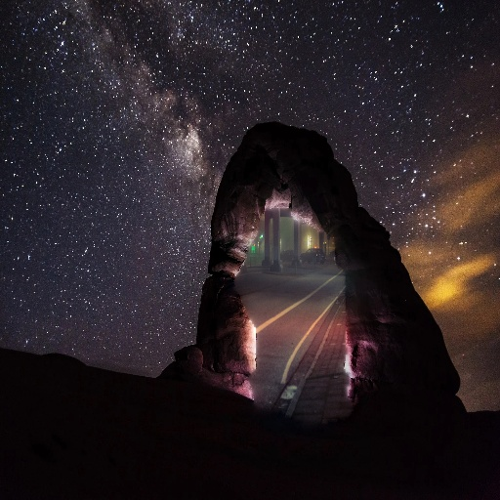

**Hybrid Image Construction:**

**i. Description:**

The Hybrid Image Construction algorithm combines low-frequency components from one image with high-frequency components from another.

Steps involved:

1. Read into Grayscale and reformat size of the images.
2. Construct Gaussian and Laplacian pyramids for both input images.
3. Selectively combine levels of the Laplacian pyramids based on a cutoff threshold.
4. Reconstruct the hybrid image from the blended Laplacian pyramid.

**ii. Implementation Details:**

Similar to Laplacian Pyramid Blending, Gaussian and Laplacian pyramids are constructed using OpenCV.

The hybrid pyramid is formed by combining Laplacian pyramid levels from both input images based on a specified cutoff threshold, taking values from the Laplacian pyramid bellow the cutoff gives us high-frequency components and above low-frequency ones.

Hyperparameters for the function are image dimensions and the cutoff level in the pyramid for the low and high frequencies.

One challenge I faced when creating the hybrid image was that finding the best cutoff value to create a good-looking hybrid image. This took trial and error to find the best value.

**Results**bad-looking hybrid-

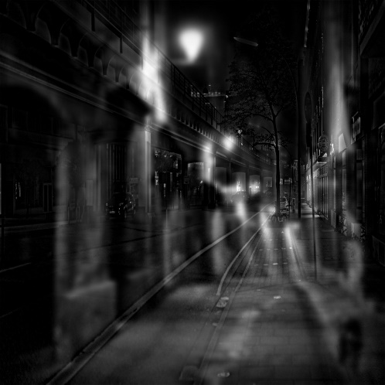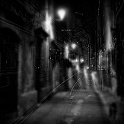

In the bad hybrid image, the presence of very high values for the streetlights results in a noticeable artifact. These high values manifest in both the high and low frequencies of the image. As a result, the streetlights appear in both images.

good-looking hybrid-

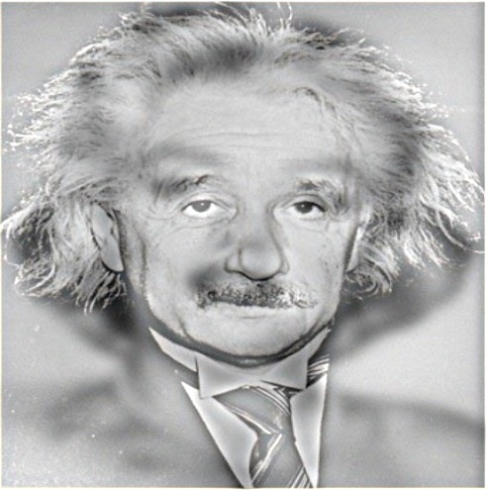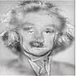

In the good hybrid image both the images have similar subjects within similar places in the image and relatively even values throughout the images therefor we get a good hybrid.

**Pyramids**

Gaussian-

Laplacian-

* From the gaussian pyramids we can see that at each layer we get a smaller and more pixelated image
* From the Laplacian pyramids we see that as we get higher in the pyramid, we get more details loss and lower resolution image.

**Conclusion**

In conclusion, after implementing both the blending and hybrid image construction only from the Gaussian and Laplacian pyramids showed me how much information we have just from quantizing and resizing images. Being able to create mind boggling images from these relatively simple techniques tough me how cleaver algorithms can trick our brain and eyes with supernatural images and illusions.