Database Systems – Assignment1

# q01

## Assumptions and remarks

Assuming there is more than one correct answer, it will return all

## Query

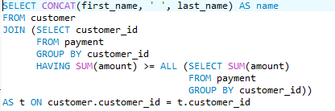

## Result

|  |
| --- |
| name |
| KARL SEAL |

# q02

## Assumptions and remarks

1. assuming if there is a tie in sales numbers, all aligable stores should be returned.
2. first is the most rentals in july 2005, second is the least

## Query

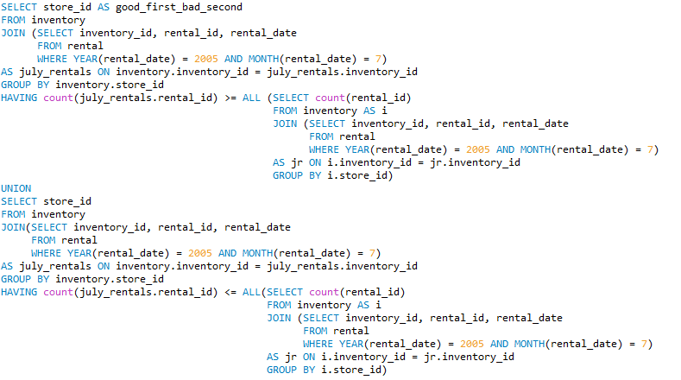

## Result

|  |
| --- |
| good_first_bad_second |
| 2 |
| 1 |

# q03

## Assumptions and remarks

Assuming there is more than one correct answer, it will return all

## Query

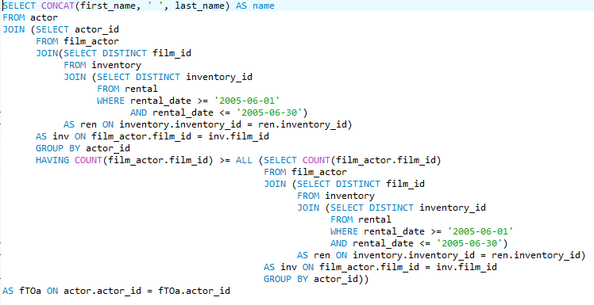

## Result

|  |
| --- |
| name |
| GINA DEGENERES |

# q04

## Assumptions and remarks

None

## Query



## Result

|  |
| --- |
| most_common_letter |
| S |

# q05

## Assumptions and remarks

Assuming there is more than one correct answer, it will return all

## Query

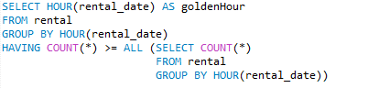

## Result

|  |
| --- |
| goldenHour |
| 15 |

# q06

## Assumptions and remarks

1. There are no store names, so the query shows the id

## Query

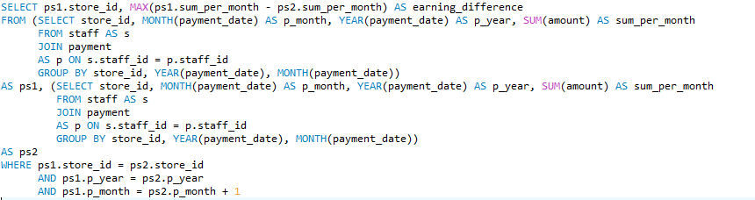

## Result

|  |  |
| --- | --- |
| store_id | earning_difference |
| 1 | 9514.83 |

# q07

## Assumptions and remarks

None

## Query



## Result

|  |
| --- |
| name |
| Sports |
| Games |
| Foreign |
| Drama |
| Comedy |
| Family |
| Music |
| Travel |
| Horror |
| Classics |
| Action |
| New |
| Animation |
| Children |
| Documentary |
| Sci-Fi |

# q08

## Assumptions and remarks

1. assuming that if more than one actor answers the condition, we should return them all

## Query



## Result

|  |
| --- |
| actor_name |
| JULIANNE DENCH |
| MATTHEW LEIGH |
| SIDNEY CROWE |
| WARREN JACKMAN |

# q09

## Assumptions and remarks

Only the first 50

## Query

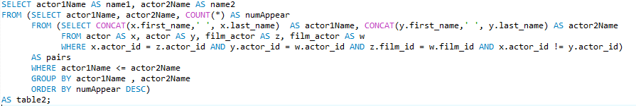

## Result

|  |  |
| --- | --- |
| Name1 | Name2 |
| HENRY BERRY | JULIA MCQUEEN |
| MORGAN MCDORMAND | WILL WILSON |
| ROCK DUKAKIS | VAL BOLGER |
| KIRSTEN PALTROW | WARREN NOLTE |
| BEN WILLIS | HARVEY HOPE |
| CUBA OLIVIER | MARY KEITEL |
| JAYNE NOLTE | MENA TEMPLE |
| JOHNNY LOLLOBRIGIDA | SUSAN DAVIS |
| ED MANSFIELD | NATALIE HOPKINS |
| CAMERON ZELLWEGER | ELLEN PRESLEY |
| ANGELA HUDSON | CUBA ALLEN |
| ED GUINESS | JOHNNY LOLLOBRIGIDA |
| GENE MCKELLEN | JON CHASE |
| JEFF SILVERSTONE | SYLVESTER DERN |
| ED GUINESS | MERYL GIBSON |
| ROCK DUKAKIS | SUSAN DAVIS |
| SCARLETT BENING | SUSAN DAVIS |
| ANGELINA ASTAIRE | SUSAN DAVIS |
| BEN WILLIS | SUSAN DAVIS |
| HENRY BERRY | LIZA BERGMAN |
| DARYL WAHLBERG | MATTHEW CARREY |
| EWAN GOODING | WALTER TORN |
| MARY KEITEL | SEAN GUINESS |
| ALAN DREYFUSS | ANGELA HUDSON |
| DARYL CRAWFORD | HARVEY HOPE |
| JOHNNY LOLLOBRIGIDA | MICHAEL BOLGER |
| CARMEN HUNT | MARY TANDY |
| JENNIFER DAVIS | PENELOPE GUINESS |
| CAMERON STREEP | GROUCHO DUNST |
| AUDREY BAILEY | HELEN VOIGHT |
| CHARLIZE DENCH | SANDRA KILMER |
| ED GUINESS | GRETA MALDEN |
| CHRISTIAN AKROYD | SANDRA KILMER |
| ALBERT JOHANSSON | KARL BERRY |
| MATTHEW CARREY | UMA WOOD |
| CHRIS BRIDGES | LAURENCE BULLOCK |
| GRETA MALDEN | WALTER TORN |
| CAMERON ZELLWEGER | JULIA BARRYMORE |
| RENEE TRACY | SIDNEY CROWE |
| REESE KILMER | VAL BOLGER |
| MORGAN WILLIAMS | RIP CRAWFORD |
| CAMERON STREEP | GINA DEGENERES |
| LAURA BRODY | WOODY JOLIE |
| GINA DEGENERES | LUCILLE TRACY |
| GRACE MOSTEL | JULIA BARRYMORE |
| RAY JOHANSSON | VAL BOLGER |
| CHRISTIAN NEESON | GENE MCKELLEN |
| CHRISTIAN NEESON | SIDNEY CROWE |
| CHRISTIAN AKROYD | WOODY JOLIE |
| KENNETH TORN | ROCK DUKAKIS |

# q10 – Our very own query

## Assumptions and remarks

1. "Diversity isn't all" – return the name of the actor who played the most kinds (categories) of movies, but didn't star in the most movies overall.
2. assuming one film only has one category

## Query



## Result

|  |
| --- |
| actor_name |
| DARYL WAHLBERG |
| EWAN GOODING |
| GROUCHO DUNST |
| HARVEY HOPE |
| IAN TANDY |
| KEVIN GARLAND |
| MICHAEL BOLGER |
| REESE WEST |
| SEAN WILLIAMS |
| UMA WOOD |