Introduction to Computational Learning Theory – HW 3

מגישים:

יותם זילברמן 313532418

נוי חסיד

1. We loaded the training dataset and displayed it by using the matplotlib Python library:

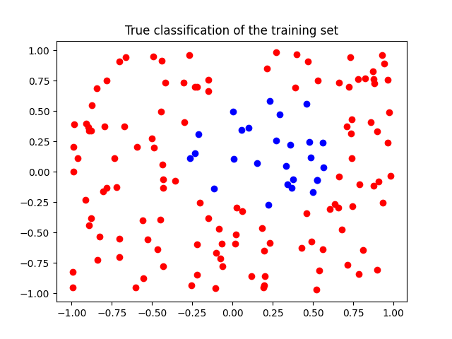

Blue dots represent a sample with a label of 1, and red dots represent a sample with a label of -1.

By using a loop to iterate over different combinations of values for the algorithm parameters (*q*, *T* and $σ$), we found one which achieved 0 empirical error:

*q* = 5, *T* = 6, $σ$ = 0.5.  
  
The following plots show the estimated labels as produced by the Perceptron algorithm, using the RBF and polynomial kernels:

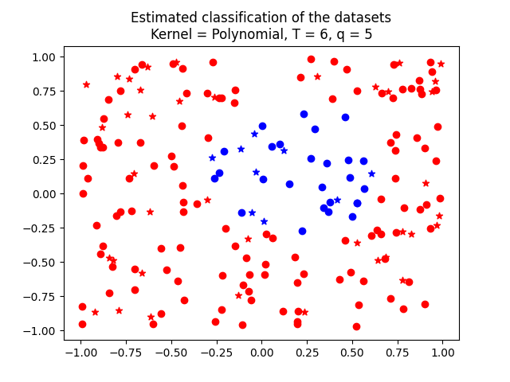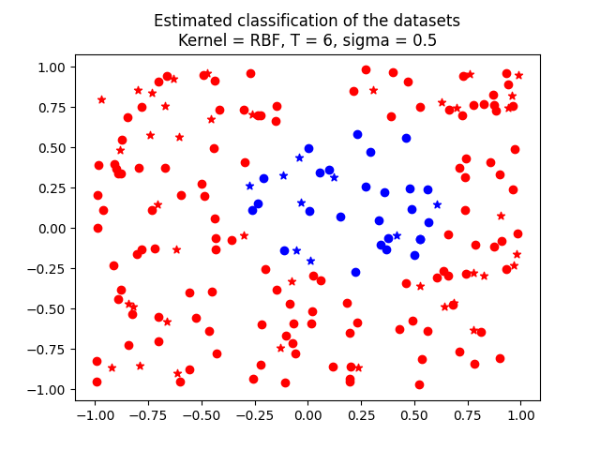

The star markers represent samples from the test dataset.