**THIN User Manual**

In order to get the most out of THIN, please read this manual.

**Getting Started:**

In order to start using The HAL Interconnection Network, hereby referred to as THIN, navigate to the login page in your favorite web browser. If you have an account, skip to Logging in/Logging out.

**Creating an Account:**

Once you are at the login page of THIN, click on the ‘Create an Account’ button to get to the account creation page. When you are at the account creation page, enter all the information as prompted. After you’ve created an account, the login page will automatically appear.

*Note: Your password must be at least 8 characters long.*

*Note: A valid email address is required.*

**Logging in/Logging out:**

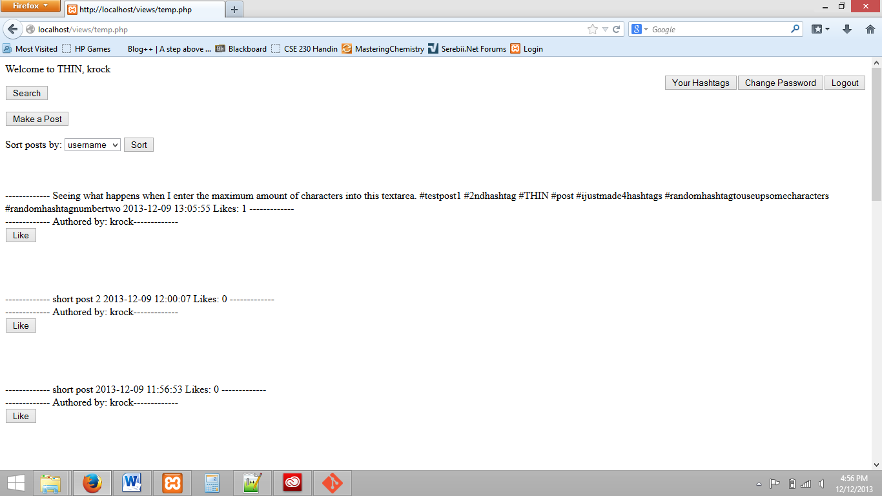Once you are on the login page, enter your username and password in the specified boxes. Once logged in, you may logout by clicking the ‘Logout’ button in the upper right hand corner.

(Figure 1. The Home Page of THIN)

**Navigating the Home Page:**

Referring to Figure 1, click on the Make a Post button to compose a post. The Search button takes you to the search page. In the upper right, you can see hashtags you are following, change your password, or logout. Selecting a sorting strategy is described later.

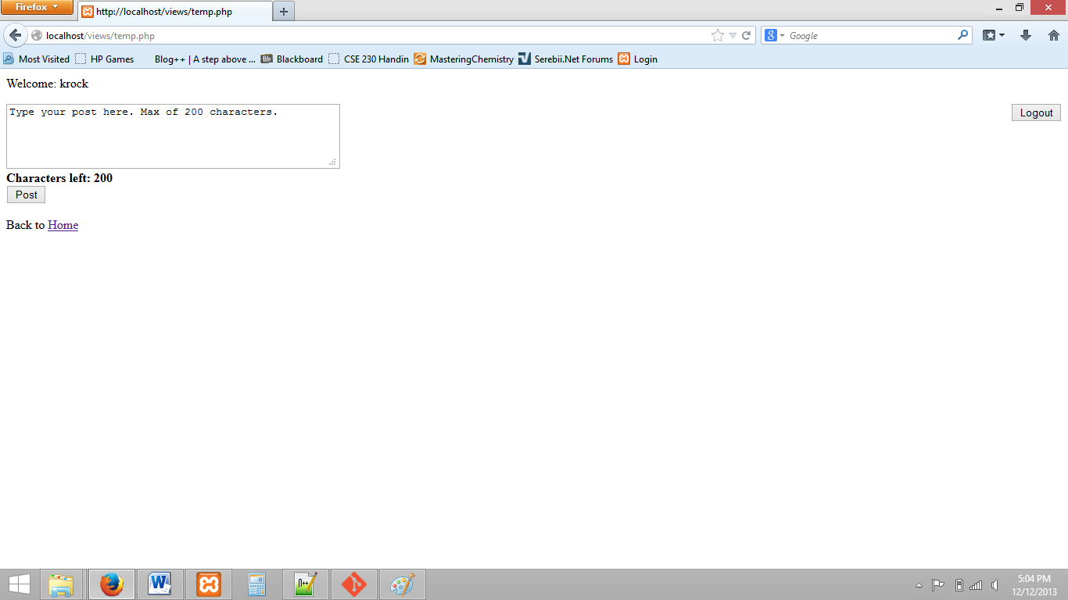

(Figure 2. The Post page)

**Making a Post:**

To make a post from the Home Page, simply click on the ‘Make a Post’ button. This will take you to the post page, as shown in Figure 2. Type your post in the textbox and push the ‘Post’ button. Once you submit your post, you are automatically returned to the home page.

**Important: As there is no way to delete posts, double check to make sure the post is how you want it before pushing the ‘Post’ button!**

*Note: hashtags must be separated by spaces to be properly recognized.*

*Note: A character count is provided for your reference. You are unable to type once the count has reached zero.*

**Liking a Post:**

To like a post, simply click on the ‘Like’ button on the homepage.

**Searching:**

Once you are on the home page, click on the ‘Search’ button to go to the search page. Here you can type in your search term, choose whether it’s a user or a hashtag and click the search button to display results.

*Note: To list a list of all users, leave the search term blank and select user.*

*Note: To see a list of all hashtags, enter the hashtag character ‘#’ in the search term and select hashtag.*

*Note: To search for a hashtag, precede the search term with the Hashtag character ‘#’.*

**Changing your password:**

Click on the ‘Change Password’ Button to change your password. Rules are the same as when your account was created. After you change your password, you will be forced to log in again.

**Sorting:**

On the home page, the default sorting is by time (i.e. Most recent is on top). By clicking on the drop down menu, you can select an alternative sorting strategy. They are described below.

*Note: If two posts are ‘equal’ (ex. They have the same number of likes) then the most recent is shown on top of the least recent.*

*Note: if a post has no hashtag, it will be displayed below posts that have hashtags when sorting by hashtag.*

*Note: hashtags starting with numbers come below hashtags starting with letters.*

*Note: if you choose a sorting option and push sort, you will have to navigate to a different page and navigate back to the home page to sort by date.*

Like Count: The post most likes at top.

Username: Alphabetically by the user who posted the post.

Hashtag: The post with a hashtag that is alphabetically before a post with a different hashtag, will be displayed first.

Hashtag sorting example:

Post 1 has hashtags: #bbb, #abc, #xyz

Post 2 has hashtags: #kl #aad #bbc

After sorting by hashtags, Post 2 would come first because #aad comes before #abc.

**Password Recovery:**

If you forget your password, click on the ‘Forgot Password’ button on the login page. On the forgot password page, enter the email associated with the account you want to recover. An email will be sent to that account with the password associated with it. To log in, simply copy the password from the email into the password field and enter the username.