Market: NIFTY 50 (^NSEI)

|  |  |
| --- | --- |
| **Chosen Stock** | **Efficient Portfolio Weight** |
| Titan Company Limited (TITAN.NS) | 0.17594 |
| Asian Paints Limited (ASIANPAINT.NS) | 0.273634 |
| Hindustan Unilever Limited (HINDUNILVR.NS) | 0.091123 |
| ITC Limited (ITC.NS) | 0.084017 |
| Apollo Hospitals Enterprise Limited (APOLLOHOSP.NS) | 0.279322 |
| HDFC Bank Limited (HDFCBANK.NS) | 0.063662 |
| Housing Development Finance Corporation Limited (HDFC.NS) | 0.032302 |

Stocks were chosen from different sectors for diversification.

Kept number of stocks relatively low just for the sake of avoiding clutter in visualizations.

While making a real portfolio, it would make sense to go for a higher number of stocks.

**Answer 1:**

Annual Expected Return (Train vs Test)

Note that that the market trended positively during the train period and negatively during the test period.

Also note that APOLLOHOSP.NS performed extremely well during the train period and the worst during the test period.

Annual Standard Deviation of Return (Train vs Test)

Train and test standard deviations are closer than train and test expected returns.

**Answer 2:**

Beta of chosen stocks

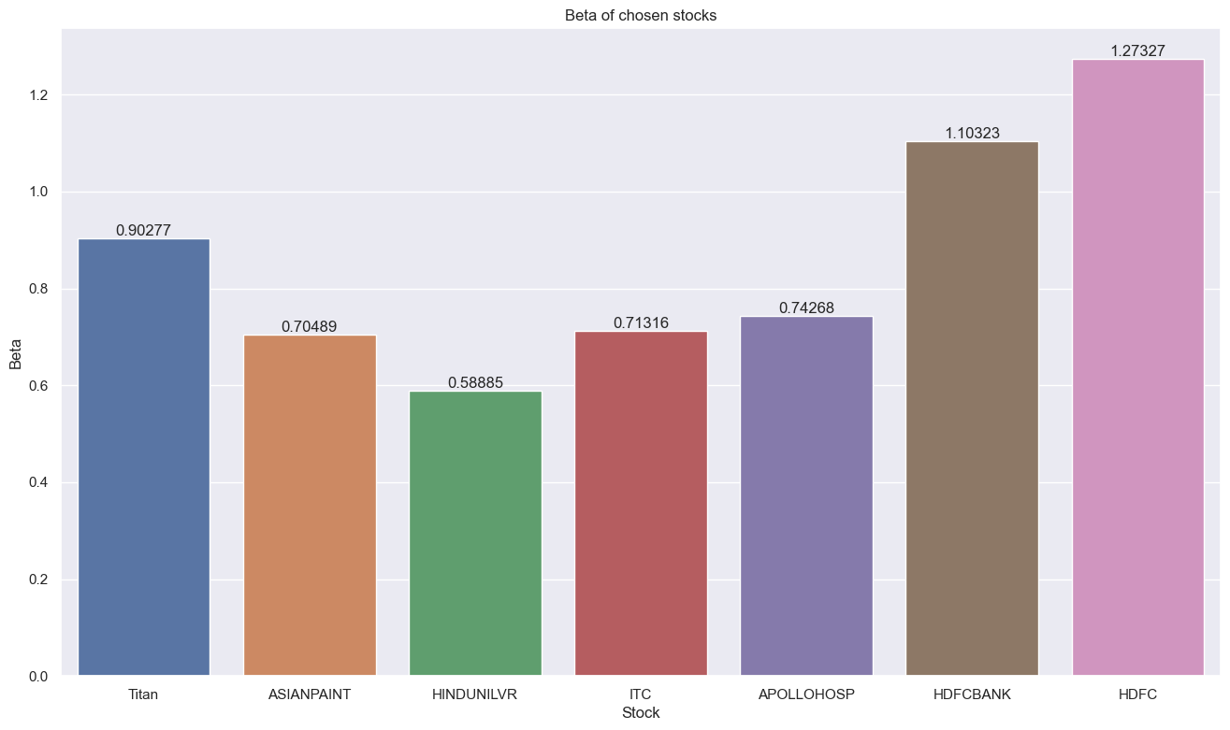

Low beta stocks have low correlation to market and low standard deviations - the opposite is true for high beta stocks.

R2 score of chosen stocks

**Answer 3:**

Plotting Efficient Frontier (10000 portfolios generated)

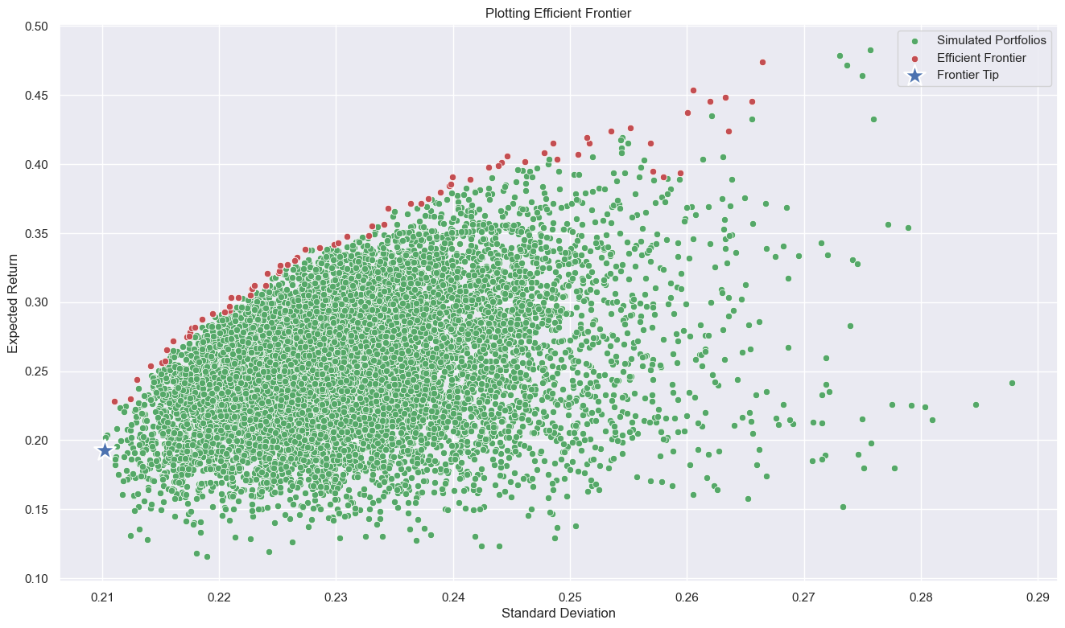

Efficient portfolio for chosen risk level (standard deviation) = 0.23 (with tolerance of 0.005) 

For reference, market standard deviation during train period = 0.148

Efficient Portfolio vs market performance during train period

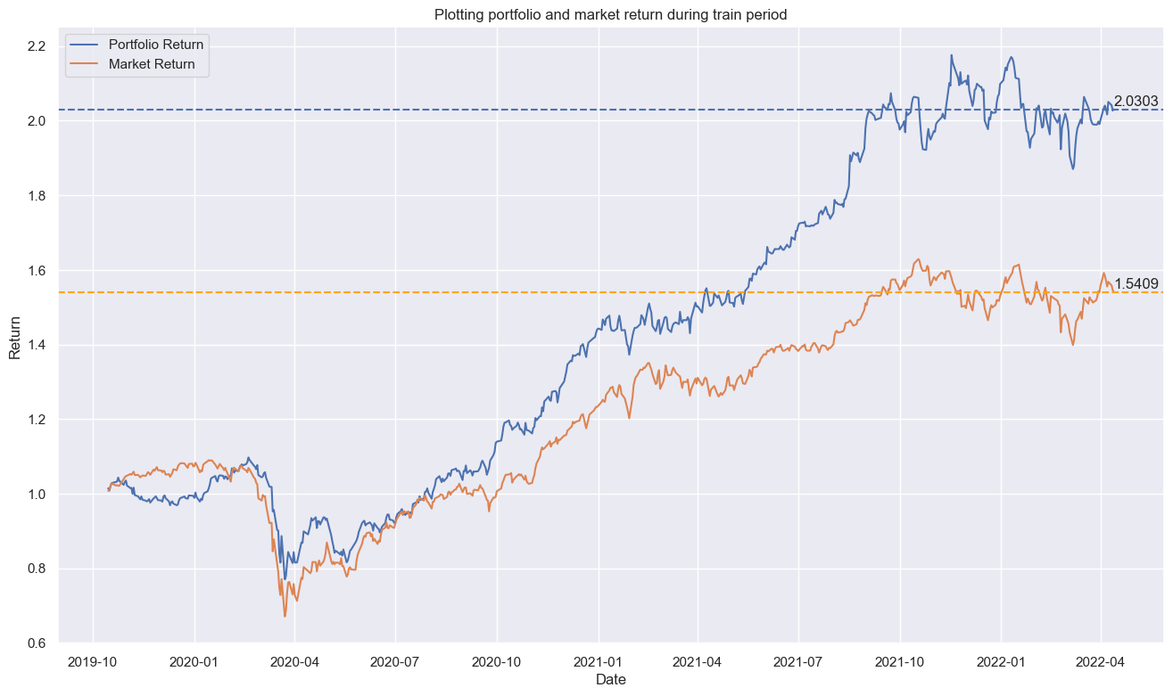

Efficient Portfolio vs market performance during test period

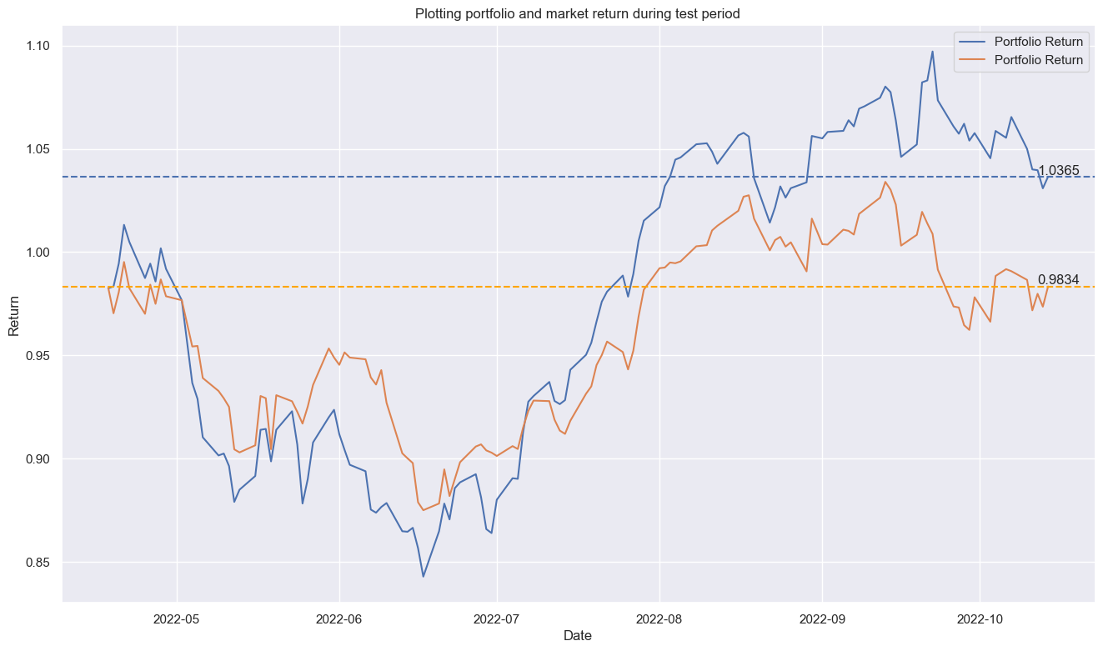

Efficient Portfolio vs market performance during entire period

Conclusion: Efficient portfolio outperformed market in both train and test periods.

But we should note that the risk level is higher (0.23 vs 0.148 standard deviation).

**Answer 4:**

* A lot of real-world factors came in during the test period, and the market behaviour during the test period and train period is very different because of that
* One of the chosen stocks - Apollo Hospitals Enterprise Limited (APOLLOHOSP.NS) – seems to be quite volatile. But it was kept in the chosen stocks for the sake of studying the visualizations/calculations which come up for such stocks.
* If we use closing price minus opening price for daily return, the expected daily return for almost all stocks was negative during the train period. This caused the efficient frontier plot to look quite different and all efficient portfolios had negative expected return. This issue was solved by using previous days closing price instead of todays opening price while calculating daily returns.

**Answer 5:**

Beta of efficient portfolio = 0.784102

This is equal to the weighted average of the individual stocks’ beta in the portfolio.

The notebook has more graphs and uses yahoo finance to get up-to-date stocks data. Chosen stocks, market, risk level and risk tolerance can be modified in the notebook.