Initial Range: 30-70 F

Which season?
New Range: 30 – 50 F
Answer = Winter
Historical average?
New Range: 40 – 50 F
Answer = 46
Max temp today?
Final Prediction = 44 F
Answer = 43

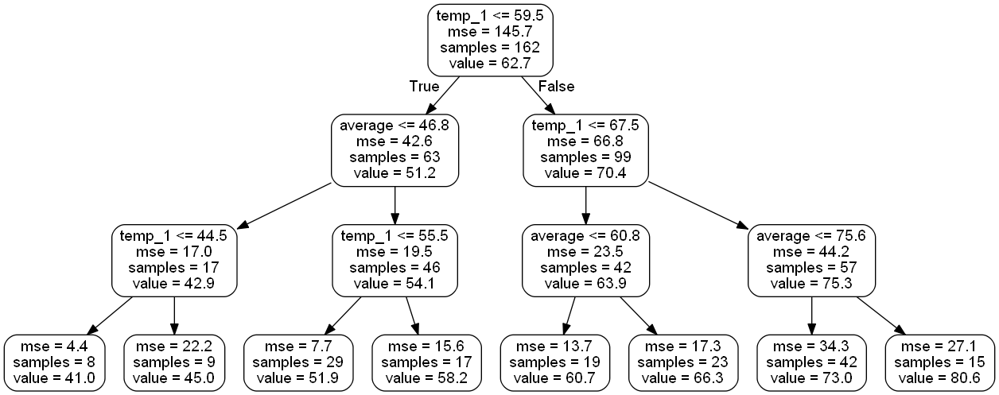
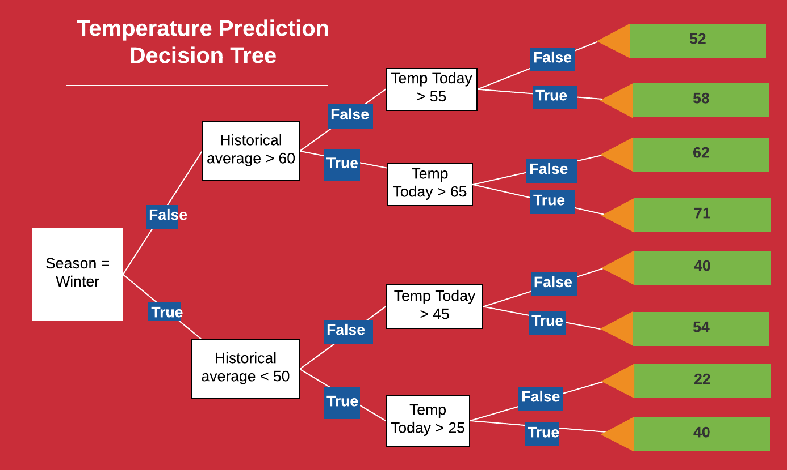
Root Node
Variable and Value to split Node on
Number of data points in this node
Prediction (in degrees) for all data points in node
Mean Squared Error of Node
Leaf Nodes
Predictions

