create table S(

S varchar(20) primary key, #学号

SN varchar(10),#姓名

SD varchar(20) default '长沙理工大学',#所属单位

SA int, #年龄

check(SA>=0 and SA<=150)

);

create table C(

C varchar(20) primary key,#编号

CN varchar(20)#课程名称

);

select * from S;

select * from C;

select * from SC;

drop table SC;

drop table S;

drop table C;

create table SC(

S varchar(20),

C varchar(20),

G decimal(4,1) default 0.0,

CONSTRAINT S_1 FOREIGN key (S) REFERENCES S(S),

CONSTRAINT C_1 FOREIGN key (C) REFERENCES C(C)

);

insert into S(S,SN,SA) values('2023001','甲','20'),

('2023002','乙','19'),

('2023003','丙','21'),

('2023004','丁','22'),

('2023005','戊','23'),

('2023006','己','21'),

('2023007','庚','21'),

('2023008','辛','22'),

('2023009','壬','23'),

('2023010','葵','21'),

('2023011','甲1','20'),

('2023012','乙2','19'),

('2023013','丙3','21'),

('2023014','丁4','22'),

('2023015','戊5','23'),

('2023016','己6','21'),

('2023017','庚7','21'),

('2023018','辛8','22'),

('2023019','壬9','23'),

('2023020','葵10','21');

insert into C values('1','语文'),

('2','数学'),

('3','英语'),

('4','物理'),

('5','化学'),

('6','生物'),

('7','历史'),

('8','地理'),

('9','政治'),

('10','体育'),

('11','语文1'),

('12','数学2'),

('13','英语3'),

('14','物理4'),

('15','化学5'),

('16','生物6'),

('17','历史7'),

('18','地理8'),

('19','政治9'),

('20','体育10');

insert into SC values('2023001','1',60),

('2023002','2',61),

('2023003','3',62),

('2023004','4',63),

('2023005','5',64),

('2023006','6',65),

('2023007','7',66),

('2023008','8',67),

('2023009','9',68),

('2023010','10',69),

('2023011','11',60),

('2023012','12',61),

('2023013','13',62),

('2023014','14',63),

('2023015','15',64),

('2023016','16',65),

('2023017','17',66),

('2023018','18',67),

('2023019','19',68),

('2023020','20',69);

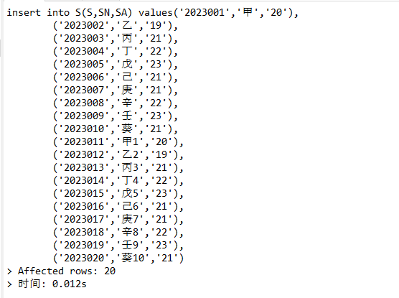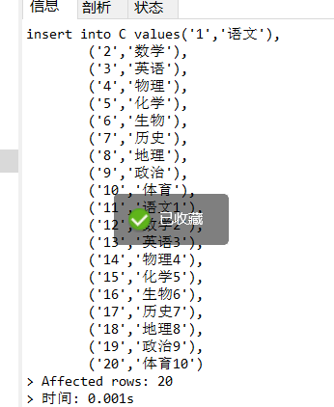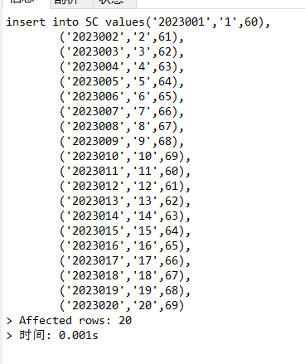

2.

select * from S where S in (select s.S from (select S from SC where C='1' ORDER BY G desc limit 3) as s);

select * from S where S in (select s.S from (select S from SC where C='2' ORDER BY G asc limit 3) as s);