Linear Algebra: Matrix Inversion
Using Gaussian Elimination
Exported: 2/6/2026, 6:20:34 PM

Problem & Solution

Invert Matrix A

Find the inverse of the following matrix:
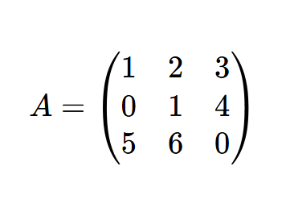

STEP 1 | Augment with Identity

Form the augmented matrix [A | I]:
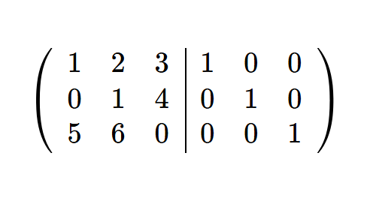

STEP 2 | Row Operations

Subtract 5 * R1 from R3:
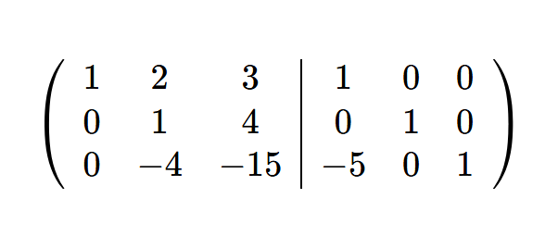

Resulting Inverse

The inverse matrix is:

