Calculus: Definite Integral
Exported: 2/6/2026, 6:20:39 PM

Integration by Parts

Evaluate Integral

Calculate the following definite integral:
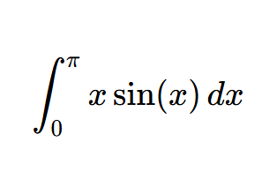

STEP 1 | Setup Parts

Let u = x and dv = sin(x) dx. Then:
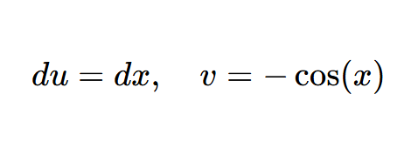

STEP 2 | Apply Formula

Using integration by parts formula:
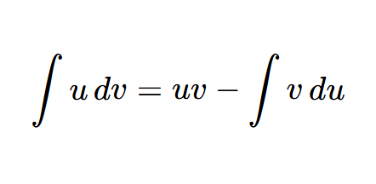
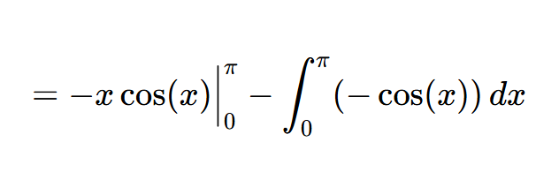

Computed Value

The value is:

