Chat Export Smoke
Exported: 2/12/2026, 12:00:00 PM

Page 1

Problem

Simplify (x^2-1)/(x-1)
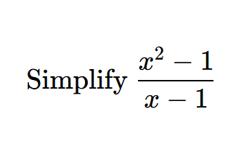

STEP 1 | Factor and cancel

Factor numerator; valid when x != 1
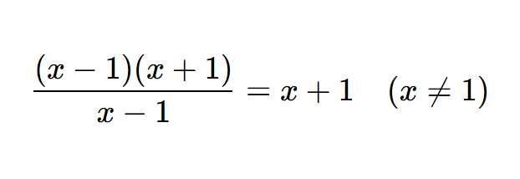

Final Result

x+1 (for x != 1)
