FCES:A Framework for Computer Experimental Service in the Cloud

Youbin Liu
Services Computing Technology and System Lab
Cluster and Grid Computing Lab
School of Computer Science and Technology
Huazhong University of Science and Technology
Wuhan, China
China.YoubinLiu@gmail.com

Abstract
With the increasing development of Cloud Computing, there are more and more resources on the network. Sharing, management and on-demand allocation of network resources are particularly important in Cloud Computing. Platform as a Service (PaaS) is one of the key services in Cloud Computing. PaaS is very attractive for schools, research institutions and enterprises, which need reducing IT costs, improving computing platform sharing and meeting license constraints. However, all current available Cloud Computing platforms are either proprietary or their software infrastructure is invisible to the research community except for a few open-source platforms. For universities and research institutes, a large number of open and testable experimental platforms are needed in a lab-level with PCs. In this paper, an open platform for computer experimental service called FCES is developed. The experimental platform will be an effective solution for general problems of experimental resources in universities. The platform implements the access management, resource management, environment sharing. The system has good expandability and can improve resource’s sharing and utilization.
Keywords-Computer Experimental Platform; Virtualized Environment; Cloud Computing

Introduction
As an advanced technology in IT field, Cloud Computing [1] grows rapidly in recent years. Cloud Computing provides both platforms and on-demand applications through Internet. There are some examples of emerging Cloud Computing platforms, e.g.: Google App Engine, IBM blue Cloud, Amazon EC2 and Microsoft Azure. The Cloud allows sharing, allocation and aggregation of software, computational and storage network resources on-demand. The key benefits of Cloud Computing include hiding and abstraction of complexity, virtualized resources and efficient use of distributed resources; [2] Cloud Computing is still considered in its infancy, there are many challenging issues waiting for tackling. PaaS is one of the key services in Cloud Computing. “PaaS is the delivery of a computing platform and solution stack as a service without software downloads or installation for developers, IT managers or end-users,…, It's also known as Cloudware.”.[3] It is very important to develop an on-demand resource management system for PaaS in Cloud environments. In this paper, an open platform as a service called FCES is developed. FCES is also possible to apply the proposed solution to real and virtual Cloud Computing environment. The system implements the user management, resource management and remote access and open API.
Currently, almost every kind of education organization faces the same problems that huge expenses of money and human resources in the information construction process. For all kinds of schools, [4] the devotion of software resources and hardware resources for scientific research and experiment is a huge expenditure. Among them, the more prominent and common problems is that the rapid development of technology makes the computer hardware and software update frequently. In addition, along with higher education, the scale of universities expands continuously and the majority of colleges have more than one school district. The instruction and scientific research are cannot leave experiment resources. The repetitive construction of experimental resources is a greater financial pressure for colleges. The technology of Cloud Computing will greatly improve the situation. Cloud Computing and Cloud services provide a powerful level online application service function for all levels of the school, which greatly improve the informational level of all kinds of school.[5] The advantage of Cloud Computing is integration of resources, to reduce cost of software and hardware in the procession of construction and save huge fund. With the expansion of the scale of universities and the demand update, Cloud Computing platform only need to consider the cast of enlarging the memories of servers, adding hard drivers and updating cloud terminal etc. But the traditional method is not only to consider expenses of updating host equipment, but also to consider the cost of updating each computer’s software; it will be far more than the updating cost of "Cloud Computing" platform. At the same time, thinking about the energy, the total energy consumption of host (average about 300 W) is more than the total energy consumption of clouds terminal (mean < 5 W). Through the "Cloud Computing" and "Cloud Services", university can save 70% to 80% of the experiment resources construction investment, improve the ability of school running. [6] So, to build experimental platform based on Cloud Computing technique is an effective solution for the common problems such as lack of funds for changing equipment, personnel training because of updating computer software and hardware technology and how to recycle old equipment.
In the following sections, we consider a framework of design and implementation of PaaS in the Cloud, especially focusing on the resource management. Section II discusses the design architecture and the implementation technologies; section III introduces a case which uses FCES to build a platform for computer experiment; related works in the literature are introduced in Section IV; finally a conclusion is provided in section V.

Design and Implementation
In this section, we present the system design and implementation of FCES. First it is the system design, and then we discuss the system implement.

Architecture
FCES using a layered architecture design, followed by infrastructure layer from the bottom the open interface layer, experimental platform layer, and the user interface layer, as shown in Figure 1.
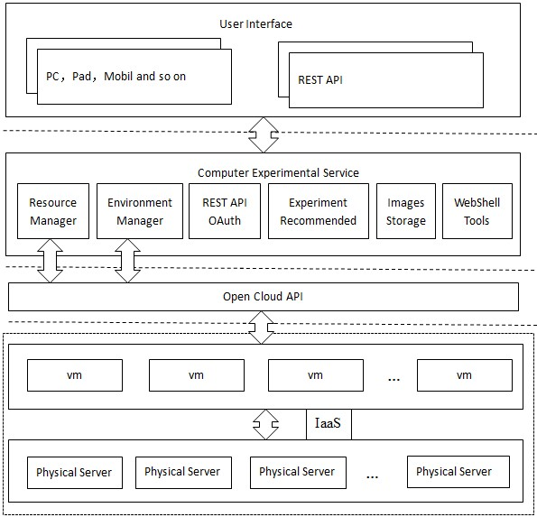
Figure 1.The architecture of FCES
The infrastructure layer cloud platform provides infrastructure services, mainly divided into two types of the underlying hardware and virtual resources services. The underlying hardware refers to the physical servers, workstations, a cluster of servers, network switches and other equipment, these devices are interconnected by a network, the level of abstraction of computing resources, network and storage resources. The service of virtual machine resources based virtualization technology, physical layer shielding unfolded Cloud Computing resources. Each physical host is based on fully virtualized KVM or Paravirtualization XEN [7] virtual resources, mainly to install the virtual machine operating system and scientific experiments related software. The user or administrator can choose to install the virtual machine operating system according to their experimental requirements. Based on the physical performance of the server, you can create different computers ranging from the number of virtual computers. Operating system installed, install the experimental software needed, according to the different operating systems and experimental needs of different tools and platforms. By the cloud platform management and maintenance of the current virtual machine created and all virtualized computer system in accordance with the actual needs of one or more of the components of the virtual machine cluster.
Open interface layer between encapsulate the functionality of the experimental platform layer and the infrastructure layer. For cloud platform security, and Cloud Computing openness, infrastructure layer will provide resources services package REST [8] interface for third-party call. Apply to the platform for a client id as a user that uniquely identifies the public token platform provides user authentication platform launched, including user registration and user login. Certification by, the cloud platform will be returned to the caller a MD5 digest refresh token of which belong to the user's token, as the user is currently accessing resources certification valid certificate. Later, the user can through client id and refresh token to visit infrastructure resources.
Experimental platform layer is actually a PaaS, to provide users with scientific experiments, based on the experimental platform to carry out their own research experiments, and experiments need to apply for their own experimental resources to create and maintain their own experimental environment, interested in mining related experiments. Moreover, experimental platform layer also provides a set of browser-based access to resources tools for example WebShell, users no longer need to download and install the client software, direct experimental by WebShell access resources. The third party can also develop experiments of their own needs, easy to use tool or application of the experimental platform. OAuth License-based authentication [9] is also convenient for third-party developers can be based on the development and application of experimental platform.
The user interface layer is divided into two parts, one is based on the browser to access the User Interface, the user can through the Internet browser on the experimental system to operate, and the other part is the REST API for developers, which is a set of the interface operations after the experimental platform system package. Developers can API-based plug-ins, third-party applications and tools to develop and improve the efficiency of scientific experiments.

Key technologies in implementation

Experimental Environment Store and Reuse
Reuse experimental environment is an urgent need to address the problem. Experimental environment through the user scenarios incremental storage mechanism, the system will become separate incremental file storage. Reduces storage space and transport overhead migration clone. The experimental environment shared by image cloned and saved, as shown in Figure 2.
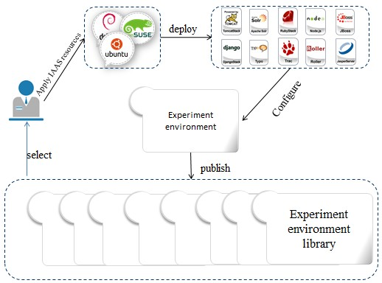
Figure 2.Experimental environment library
Each experiment is an independent user scenario. But scenes generally take up a lot of space. The system needs to save a lot of user scenarios, so the storage overhead of the system will be very great. And application templates for each virtual machine are provided to other virtual machines sharing. But at the same time on a virtual machine template image data read and write operations, will inevitably result in the destruction of the base image. And this mode, there is no way to save the user scenarios. So the user must exclusively a complete base image. It is clear that this will lead to a large number of copies of the base image and storage. Template incremental mechanism COW [10] is thought a good solution to these problems.
COW thought the basic principle is to use two files at the same time to create a virtual block device. Read-only block device to a virtual machine shared data files are stored, and the other is an incremental file based on a read-only block device. The file is readable and writable, used to store the modified data. Incremental file to create a new virtual machine block device, the modified data will be stored in the incremental file, and will not affect the original file shared.
The system uses the incremental mechanism to store experimental environment, so the format of the image file is required. There are two common traditional image file data format, RAW and qcow2. [11] RAW is direct reading the straight very common data format, and qcow2 is a special data format which QEMU supports as the performance of a fixed-size block device. Compared with the RAW data format, qcow2 format has unique advantages. The most significant is supporting snapshot technology and supporting the incremental base image storage. Incremental file modified data stored in the base image data is not modified and the file length is smaller, and dynamically modify the file with the base image.
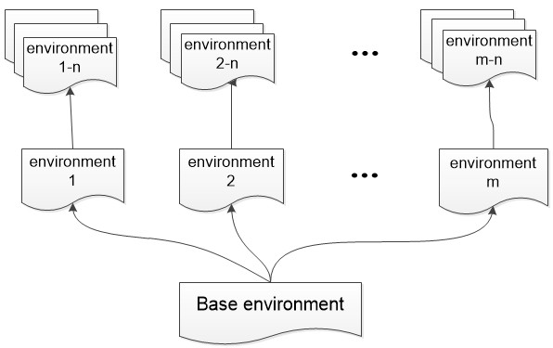
Figure 3.Experimental environment storage
Shown in Figure 3, the storage of the experimental environment is based on the underlying image. Base image is installed Linux or Windows operating system. Above the base image is application software or configuration of the experimental parameters. The experimental environment saved can then re-form a new foundation for the environment. And then based on the first layer incremental experimental environment, you can continue to build a new experimental environment. Based on this hierarchy, system greatly reduces the storage space overhead.
The experimental environment is very important for the maintenance of the computer system of scientific experiments. As shown in Figure 4, the maintenance of the experimental environment will experience many of the processes and state changes. The entire life cycle of an experimental environment experienced initialized instance is running, deployment, save, disable, enable, public and private to the demise of state.
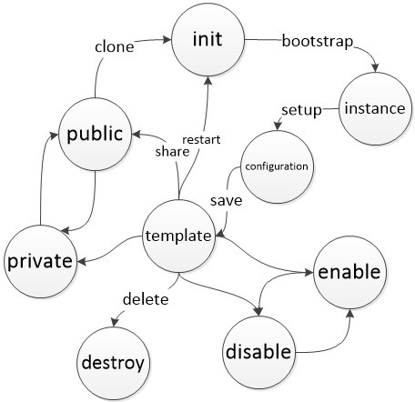
Figure 4.Experimental environment state
- Initialization stage. The system provides the basic type of operating system, Linux series and windows series. There is no extra software to initialize the environment.
- Environmental deployment stage. Access to basic experimental environment, according to personalized experimental requirements, deploy the appropriate software or system, and modify the configuration and so on.
- Environment storage stage. Environment need to be saved in time for later to continue the experiment. Experimental environment preservation will be the end of the current running instance. The environment has enable state, disable state, private sate and public state. After disabled, the experimental environment would not be among the alternatives. Public experimental environment can be provided to other users of the experimental system.
- Environmental cloning stage. After the publication of the experimental environment, it can become the basis of environment, user-based environment to deploy or configure a new experimental environment.
- Environment demise stage. You can delete the abandoned experimental environment.

OAuth and Open API
FCES uses OAuth open license agreement, authorization and access in the experiment of third-party tools or plug-ins. Shown in Figure 5, the authorization process when the user to use the system tools or plug-ins are as follows.
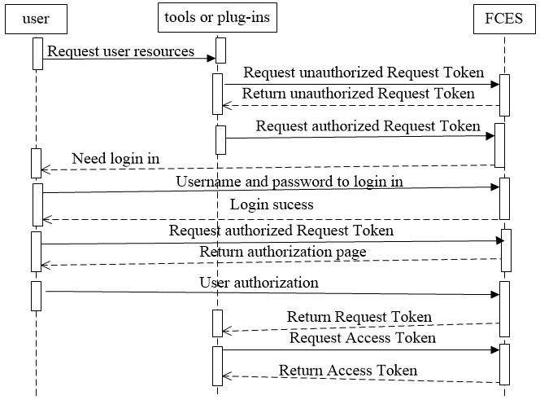
Figure 5.Authentication process in FCES
- First, the user requests to third-party applications experimental resources, third-party applications operating in the FCES resource permissions. Therefore, the third-party applications to request the request token unauthorized user request is received, to experiment platform.
- If the user is not logged on FCES, FCES is not provided to third party authorized request token. Due to insufficient permissions, the user's browser will be redirected to the login screen of the experimental system.
- Jump to the login page, enter the user name and password, requesting authentication.
- FCES certified by the user's browser will be redirected to the application before the Request Token interface. User initiated the Request Token authorization request to FCES again, because now the user has logged in the experimental system, FCES will return the user authorization page. The user select licensed to third-party applications.
- FCES receives the user authorization command, will be authorized Request Token returned to the third-party applications.
- The third-party applications take to the Request token authorization of the experimental system. The next with the Request Token to FCES in exchange for access to resources of Access token.
- FCES Access Token returned to the third-party applications. At this point, third-party applications can use the Access Token request of experimental resources.
Typical experiment management, resource management, experimental environment maintenance package into the API, released a REST style using OAuth authentication. To third-party developers based on the FCES tools or plug-ins, or the second development based on the FCES. User requests and return data are used in JSON format data.

IaaS-based Resource Manager
Resource management is a very important part in the framework, the FCES and Cloud Computing resources most closely associated part. Resource management is divided into four parts, including key management, resource statistics, virtual machine management and virtual machine cluster management.
Key management is an essential part of resource management. All virtual machines or virtual machine clusters access by the key. Virtual machine or virtual machine cluster need to upload the key. Log on to the virtual machine via SSH. This section included creating a key, deleting a key, and downloading a key, key list several functions.
In order to give users an intuitive resource usage statistics, FCES provide statistical functions. The resource statistics related to the number of virtual machines, VCPU number, CPU time, memory size​​ and so on. Intuitive way to show by forms and figures, FCES provide the user with a clear and intuitive understanding.
The virtual machine management is about life-cycle management of the virtual machine. First of all the attributes of a virtual machine include virtual machine image, key, VCPU, number of memory, and experiment name. Create a virtual machine, the virtual machine access to information obtained from the cloud platform, including access to the domain name, the port, the ipv6 address. Use IP address and key to access the virtual machine. There is slight difference between virtual machine clusters and virtual machine. The description of the property to multiple virtual machines, FCES return the head node access for the user. The image will be limited in the cloud platform, only provided a virtual machine cluster image.

Related Experiment Recommended
Experimental recommend is an important way to help users find the same type of experiments and user interest in. For a given experiment, FCES could get experiment keyword extraction and an analysis of the experimental segments. According to the keyword and the field correlation, find the nearest N correlation experiments. The main use of the algorithm is based on semantic association. For the entire system users and the relationship of the experiment, based on user ratings. Experimental K neighbors based on item-based collaborative filtering algorithm TOP N experimental. Because of the sparse scoring matrix, content-based prediction algorithm can be a good solution to this problem [12].
At present, most of the document similarity calculation is the vector space model. The idea of the vector space model is the document into individual words. And the meaning of each word in the document is separate. Therefore, the vector space model has a lot of deficiencies. Document would be cut into individual separate terms, but not the semantics of the word association. For particularly close before and after the text of the document, the semantic association between the feature items is very important. The system uses a semantic association algorithm based on the characteristics between computing document similarity.
According to the system particularity, research in the field of computer research laboratory here, so you can carry out from the field above segments semantic association studies. Experiment because of the difference of the content of this description, the type of the pins can classify it in different segments, such as a distributed, network, storage, etc. And for different areas, the most representative of the keywords of the field is usually not the same, that is, used to represent the characteristics of the experimental content properties can also be classified into different segments. On the other hand, it can use already defined characteristics of a segment to represent this area, which can be defined in the same field of keywords that have the same semantic association. Simply put, in the definition of the semantic association of the experiment, not directly define the semantic association between the experimental feature items, but by examining the characteristics of items attributable to the field to define the association between them. Specific description of the field can be specified in accordance with the relevant experts in this area most represents the domain knowledge of the characteristics of a collection of items.
For the experiment, the experiment can be used a series of criteria to be represented. These keywords usually belong to a number of different small fields. So we can use these keywords to calculate the similarity of the experiment. The algorithm is as follows.
Knowledge of computer science is divided into n field. Here F represents a collection of all the segments, F = {F₁, F₂, …, F_{N}}. In each segment, the experts in the field decided the keywords that best represents the characteristics of this area of knowledge. F_{i} is the set of the i-th segments keywords. For an experiment document E, selected wherein a plurality of the most embodies the keywords of the content of this experiment, composed of a set of keywords of the document M (E) means. E (X) = {E₁, E₂, ..., E_{n}}, which means that each component vector E_{i} presents E and the i-th fields set of keywords match the semantic correlation. E_{i} is calculated by (1):
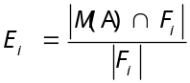(1)
Degree of semantic relatedness between the experimental documents A and B from Simi (A (X), B (X)), by (2):
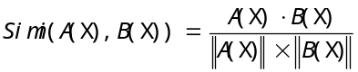(2)
The set threshold value a (0 ≤ a ≤ 1), if Simi (A (X), B (X)) ≥ A, to consider experiment A (X) and B (X) effective similarity Otherwise, no similarity. Similarity algorithm based on domain, through experiments on behalf of the keyword field keyword set of semantic association, classification accuracy in the field of the key factors for the experimental similarity calculation accuracy. Based on semantically related, you can find the most relevant K experiment, presented to the user as a result of the recommendation for a specific experiment.
This system is mainly the semantic association algorithm based experimental similarity recommended experimental recommended to do performance testing. Found that experiments based on semantic association recommended improved accuracy compared with the traditional way of TF-IDF-based feature vector, [13] and the greater the degree of breakdown of the field of knowledge, the higher the degree of accuracy, shown in Figure 6.
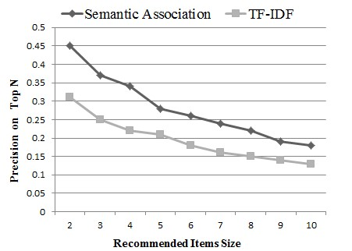
Figure 6.Precision on top N

WebShell Tool
Computer research experiment has a very significant feature which is the frequent use of the SSH client, log in to the server above operation. With the development of Cloud Computing, terminal access increase in the number of ways, the idea of software as a service widely recognized. Experiment management, resource application and access more convenient to carry out scientific experiments, through the browser. HTML5 technology [14] development has brought great changes to the Web. FCES uses the new interfaces WebSocket of the HTML5, to achieve TCP communication between the browser and the server. The WebShell real-time user on the browser side input command or operation to be transfered to the WebSocket server, by the WebSocket server forwards to the virtual machine. The WebSocket server only need to deploy a very lightweight scripts, listen on the specified port, and the architecture shown in Figure 7.
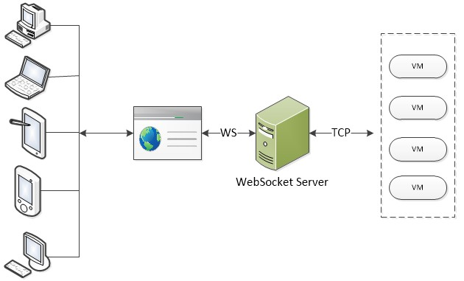
Figure 7.Communication of WebShell based on WebSocket
HTML 5 WebSockets, on the other hand, defines a JavaScript API for a bidirectional, full-duplex communication channel over a single TCP socket. A WebSocket connection is established by upgrading the connection from the HTTP protocol to the WebSocket protocol during the initial handshake between the client and the server, providing integration with the existing HTTP architecture of the Web. Once the handshake is completed, the protocol is upgraded from HTTP request-response to WebSocket data framing, and text messages can be sent back and forth between the client and the server at any time, shown in Figure 8.
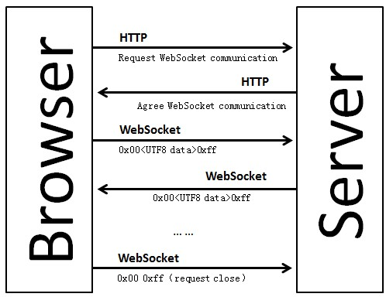
Figure 8.WebSocket communication mode
The HTML 5 WebSocket standard addresses the fundamental limitations of the HTTP request-response paradigm, by eliminating HTTP from the equation after the initial WebSocket handshake over HTTP. This minimizes the amount of network traffic needed to send messages between browser and server in either direction, because no HTTP headers are included after the protocol upgrade is complete.

Use Case
The second phase of construction of the China Education and Research Grid (ChinaGrid), the key disciplines resource cloud project, use this framework to build university computer science experiment platform. World-class university is a sign of a country's scientific and cultural and educational level of development. Key disciplines resource cloud by calling the grid middleware ChinaGrid application interface, provides a Cloud Computing technology as the core of a virtual research environment for the development of disciplines. Computer science experimental platform in accordance with the needs of users,
mainly complete the experimental regulation and management of the resources needed to create a maintenance management, experimental, experiments used experimental environment, experimental diary, user authentication and other functions. The various modules are as follows: authentication module, the experiment management module, the resource management module, a typical experiment module, the experimental environment module, experimental diary module, experimental recommending module the WebShell tool module, open interface module and experimental portal module. The system is developed using open resources including Apache web server, MySQL database server, Codeigniter framework; also ChinaGrid IaaS is used to create virtual platforms.

Related Works
Seattle [15] is community-driven — universities donate available compute resources on multi-user machines to the platform. These donations can come from systems with a wide variety of operating systems and architectures, removing the need for a dedicated infrastructure. Seattle is also surprisingly flexible and supports a variety of pedagogical uses because as a platform it represents a common denominator for Cloud Computing, grid computing, peer-to-peer networking, distributed systems, and networking. Seattle programs are portable. Students’ code can run across different operating systems and architectures without change, while the Seattle programming language is expressive enough for experimentation at a fine-grained level. Our current deployment of Seattle consists of about one thousand computers that are distributed around the world. We invite the computer science education community to employ Seattle in their courses.
Virtual Computing Lab (VCL), [16] initiated at North Carolina State University, is an open source remote access system that dynamically provisions computing resources to end users. VCL became an Apache incubator project and was released under the Apache license in 2008. A typical VCL system consists of a VCL web front-end, a management node, an application image library and a blade center. The VCL web frond-end runs VCL Manager Software and functions as the web server, the scheduler and the schedule database. The web server provides the user interface and the management interface for image reservation and administration. The scheduler is responsible for locating a server preloaded with the user-requested image or for instructing the management node to load user-requested image onto a server. The schedule database stores system data such as user information, image information, image revisions, server information, user requests and user privileges, etc [17]. Behind the web front-end, the management node loads images on servers based on requests from the scheduler. In a compact implementation, the web front-end, the management node and the image library can reside on a single computer (blade) or on a virtual machine. In a large VCL network, there can be one or more web front-ends, multiple management nodes, image storage servers, and blade centers at different locations, shared by different institutions.
Grid'5000 [18] is a scientific instrument for the study of large scale parallel and distributed systems. It aims at providing a highly reconfigurable, controlable and monitorable experimental platform to its users. The initial aim (circa 2003) was to reach 5000 processors in the platform. It has been reframed at 5000 cores, and was reached during winter 2008-2009.The infrastructure of Grid'5000 is geographically distributed on different sites hosting the instrument, initially 9 sites in France (10 since 2011).
The FutureGrid [19] Project provides a capability that makes it possible for researchers to tackle complex research challenges in computer science related to the use and security of grids and clouds. These include topics ranging from authentication, authorization, scheduling, virtualization, middleware design, interface design and cybersecurity, to the optimization of grid-enabled and cloud-enabled computational schemes for researchers in astronomy, chemistry, biology, engineering, atmospheric science and epidemiology. The project team provides a significant new experimental computing grid and cloud test-bed, named FutureGrid, to the research community, together with user support for third-party researchers conducting experiments on FutureGrid.
Now there are a lot of computer research laboratory systems or platforms. However, these platforms are directed to one or more computer research field. System or platform does not extract the public module. [20] We can only use them, but not based on their build your own system. This paper presents an experimental system framework based on Cloud Computing. This framework able to use Cloud Computing resources, facilitates the construction of computer experimental system for their own needs.

Conclusion and Future work
In this paper, a framework implementing and managing platform as a service in a virtual Cloud Computing lab is developed. The system has good expandability and can improve resource’s sharing and utilization.
Take full advantage of Cloud Computing and virtualization technology, design and save user scenarios based on incremental storage mechanism, and the experimental environment mirror clone shared services. User interrupt experiment in the experimental system can be started again. Administrators can also configure the computer lab environment, and share the students to use. Whether for scientific research or experimental teaching, FCES provide a good service.
The system makes full use platform data resources, recommendations and mining experimental data. The system has the particularity of computer research laboratory. Content-based collaborative filtering method to provide a specified experiment experimental recommendations and TOP N recommended.
For platform development, and meet the diversity and complexity of the research laboratory, to provide users with open REST API. Based on OAuth License, FCES keeps safety and security of the user resources. Experimental tools and plug-ins to third-party developers are provided a safe and open manner. Cocaine based on their own needs for customization, and other functions.
Based on HTML5 and WebSocket protocol, FCES provides a browser-based WebShell remote terminal access tools. Because of computer science research experiment characteristics, WebShell help user to avoid the trouble of excessive switching browsers and client. Improve the diversity of the experimental system the access terminal.
In the future we will extend the framework to include imaging of software and hardware platforms, load balancing and complete automatic provisioning of resources so that the system can be applied in large-scale and distributed environment.

References
- M. Armbrust, A. Fox, R. Griffith, A. D. Joseph, R. Katz, and A. Konwinski, “A view of Cloud Computing,” Communications of the ACM, vol. 53, pp. 50-58, 2010.
- Ostermann, Simon, et al. "A performance analysis of EC2 cloud computing services for scientific computing." Cloud Computing. Springer Berlin Heidelberg, 2010. 115-131.
- Subashini, S., and V. Kavitha. "A survey on security issues in service delivery models of cloud computing." Journal of Network and Computer Applications 34.1 (2011): 1-11.
- Dreher, Patrick, et al. "Evidence for a cost effective cloud computing implementation based upon the NC state virtual computing laboratory model." High Speed and Large Scale Scientific Computing 18 (2010): 236.
- Buyya, Rajkumar, et al. "Cloud computing and emerging IT platforms: Vision, hype, and reality for delivering computing as the 5th utility." Future Generation computer systems 25.6 (2009): 599-616.
- Baliga, Jayant, et al. "Green cloud computing: Balancing energy in processing, storage, and transport." Proceedings of the IEEE 99.1 (2011): 149-167.
- Chierici, Andrea, and Riccardo Veraldi. "A quantitative comparison between xen and kvm." Journal of Physics: Conference Series. Vol. 219. No. 4. IOP Publishing, 2010.
- Mitsopoulou, Evangelia, et al. "Connecting medical educational resources to the Linked Data cloud: the mEducator RDF Schema, store and API." Proceedings of Linked Learning (2011).
- Pai, Suhas, et al. "Formal verification of OAuth 2.0 using Alloy framework." Communication Systems and Network Technologies (CSNT), 2011 International Conference on. IEEE, 2011.
- Liu, Haikun, et al. "Live virtual machine migration via asynchronous replication and state synchronization." Parallel and Distributed Systems, IEEE Transactions on 22.12 (2011): 1986-1999.
- Armstrong, Django, and Karim Djemame. "A Performance Evaluation of Block I/O Paravirtualization and Virtual Machine Images." Cloud Computing and Services Science. Springer New York, 2012. 315-332.
- Jamali, Mohsen, and Martin Ester. "TrustWalker: a random walk model for combining trust-based and item-based recommendation." Proceedings of the 15th ACM SIGKDD international conference on Knowledge discovery and data mining. ACM, 2009
- Zhang, Wen, Taketoshi Yoshida, and Xijin Tang. "A comparative study of TF* IDF, LSI and multi-words for text classification." Expert Systems with Applications 38.3 (2011): 2758-2765.
- Lin, Hai, et al. "Moving the entire service logic to the network to facilitate IMS-based services introduction." Intelligence in Next Generation Networks (ICIN), 2010 14th International Conference on. IEEE, 2010.
- J. Cappos , I. Beschastnikh , A. Krishnamurthy and T. Anderson "Seattle: A platform for educational cloud computing", Proc. 40th ACM SIGCSE, pp.111 -115 2009.
- Schaffer, Henry E., et al. "NCSU's virtual computing lab: a cloud computing solution." Computer 42.7 (2009): 94-97.
- Dreher, Patrick, et al. "Evidence for a cost effective cloud computing implementation based upon the NC state virtual computing laboratory model." High Speed and Large Scale Scientific Computing 18 (2010): 236.
- Bolze, Raphaël, et al. "Grid'5000: a large scale and highly reconfigurable experimental grid testbed." International Journal of High Performance Computing Applications 20.4 (2006): 481-494.
- von Laszewski, Gregor, et al. "Design of the futuregrid experiment management framework." Gateway Computing Environments Workshop (GCE), 2010. IEEE, 2010.
- Tian, Wenhong, Sheng Su, and Guoming Lu. "A framework for implementing and managing platform as a service in a virtual cloud computing lab." Education Technology and Computer Science (ETCS), 2010 Second International Workshop on. Vol. 2. IEEE, 2010.

