Group Bravo

Caleb Rummel, James Bailey, Joel Mardock, Nicholas Werner

CSD 310

Module 10.3 Assignment

07/09/2022

* Revised ORD

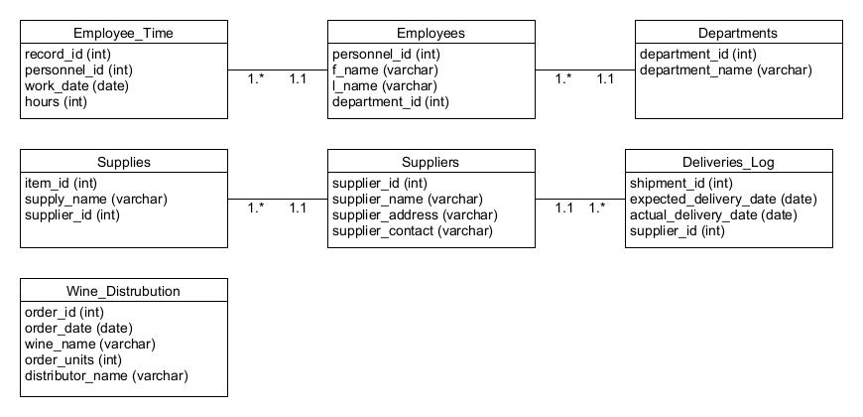

* Screenshot of the tables with there corresponding contents
  + 
   