Joel Mardock

8-14-2022

Module 2.2 Assignment: Building a Web Page Exercise, Part 1

GitHub Repository Link:

<https://github.com/youcanfly93/csd-340>

HTML Errors:

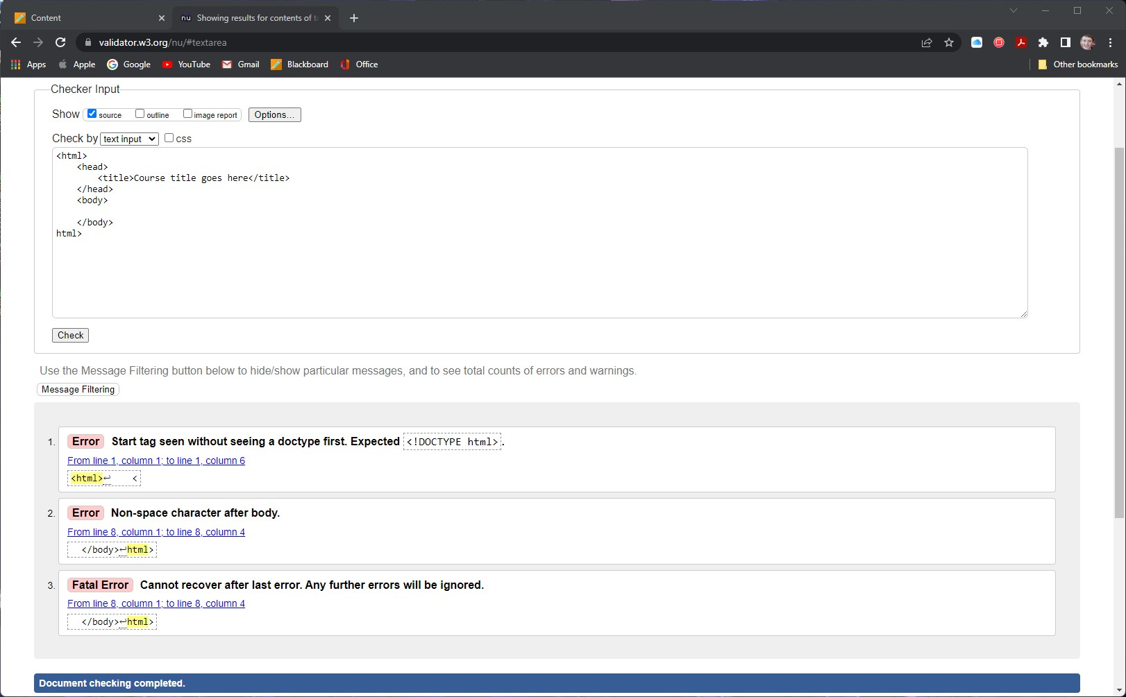

HTML No Errors:

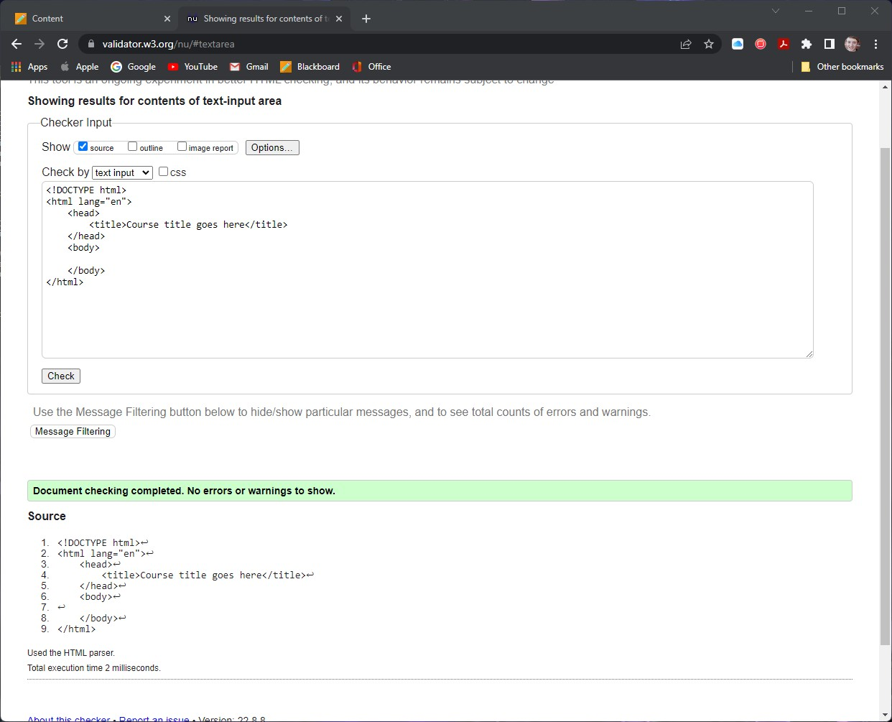

HTML Updated Fields No Errors:

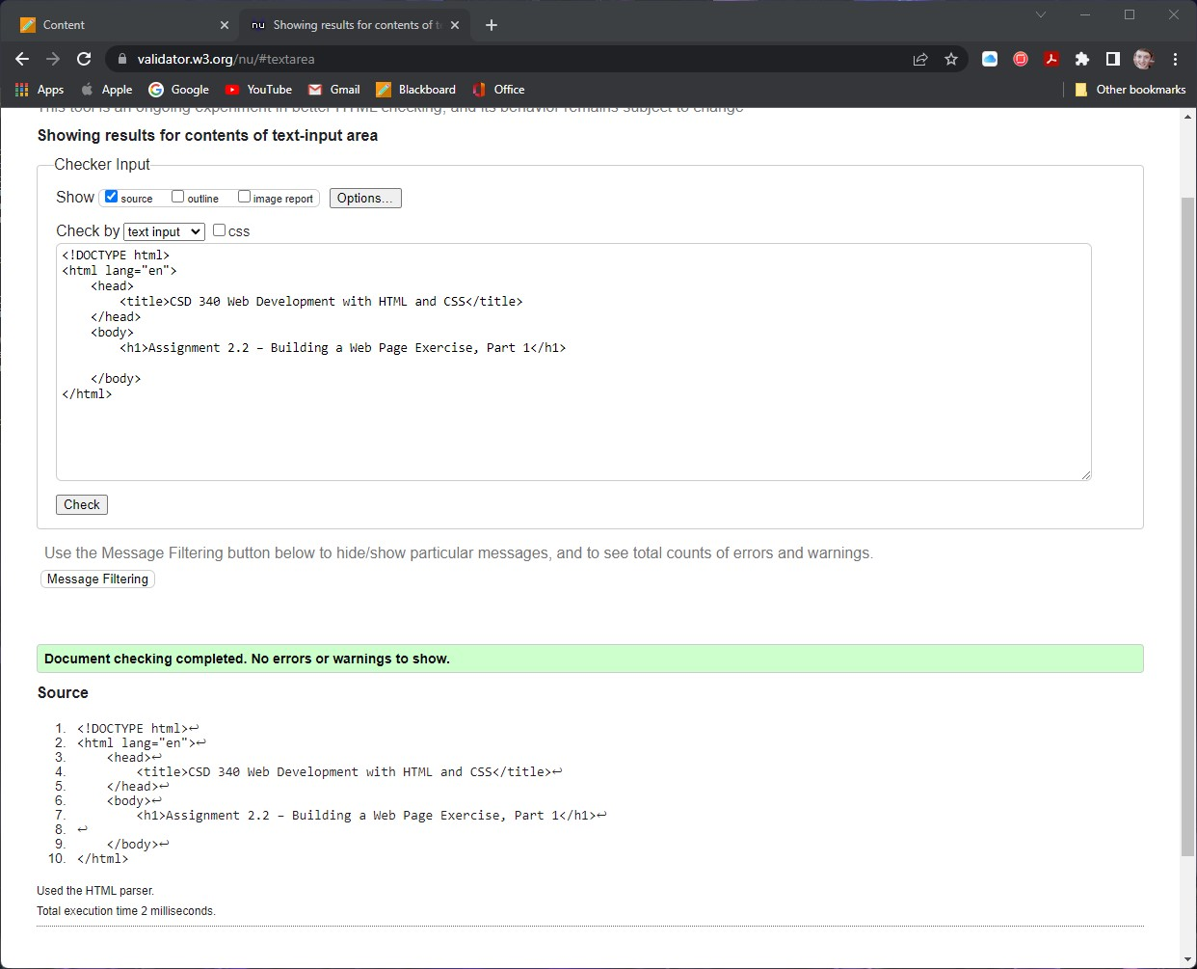

Web Page View:

