SE3313 – Assignment 3

2.

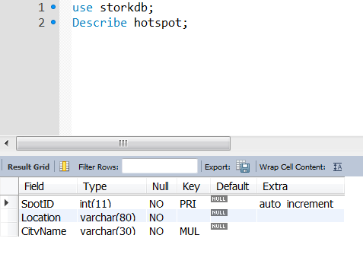

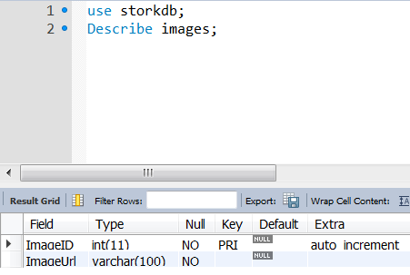

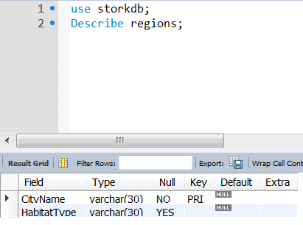

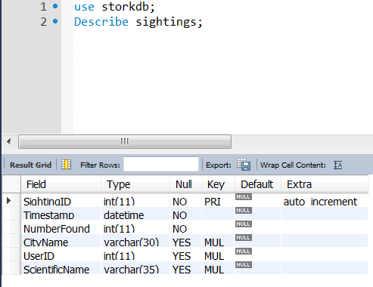

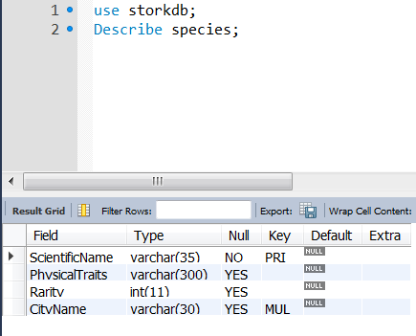

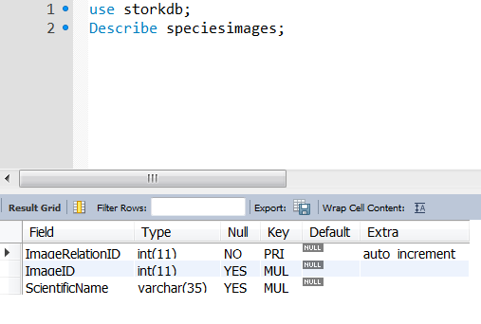

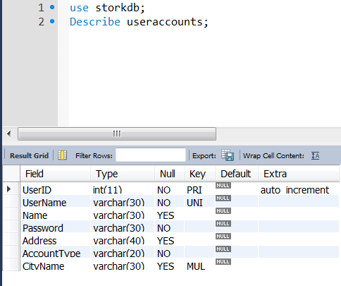

3. All inserts will be provided through github.

4. 10 Records for each relation displayed.

Hotspot:

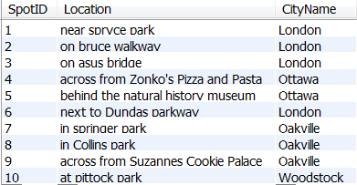

Images:

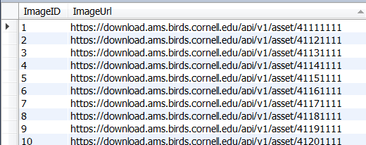

Regions:

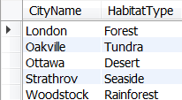

Sightings:

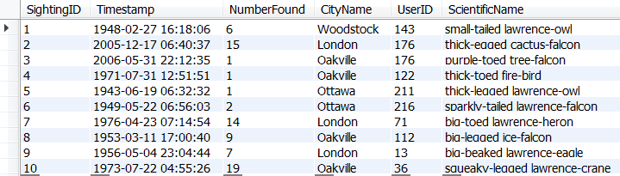

Species:

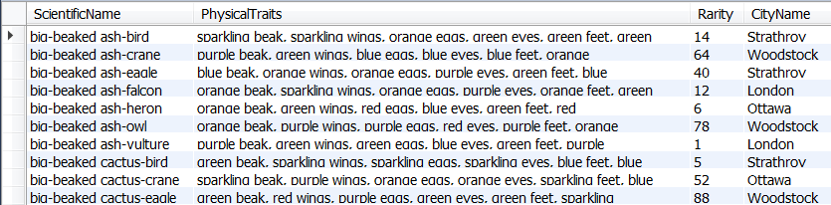

SpeciesImages:

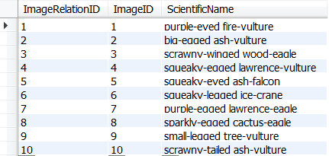

UserAccounts:

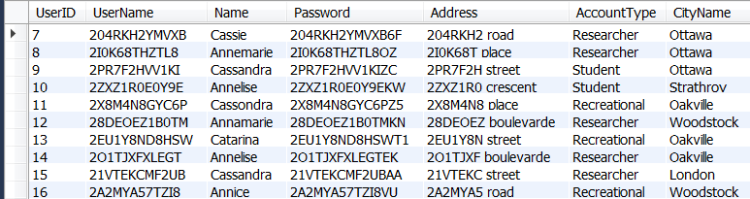

5.

Query1:

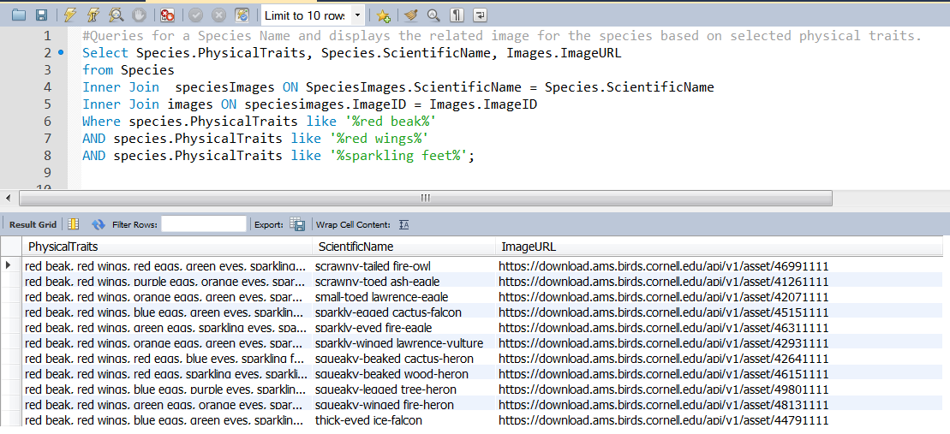

Query2:

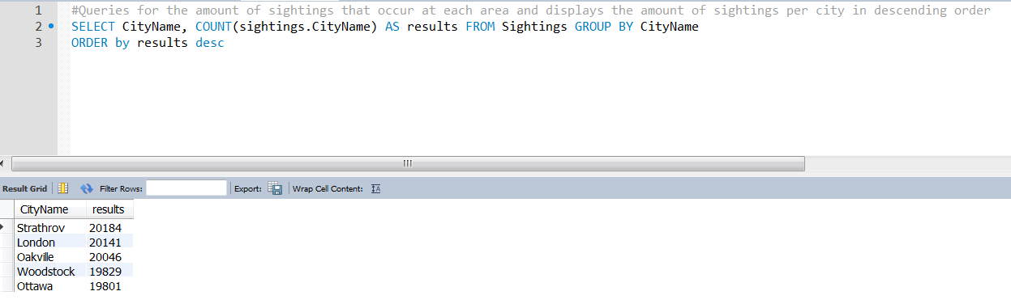

Query3:

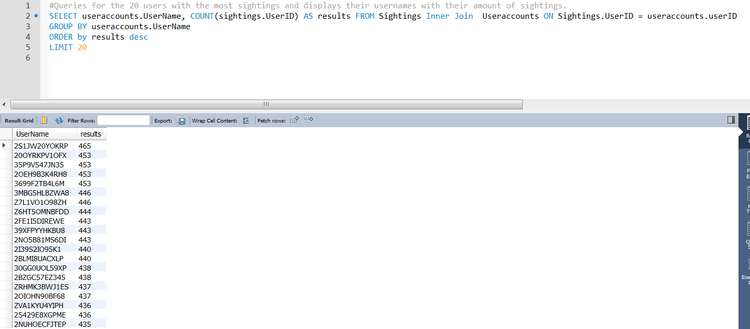

Query4:

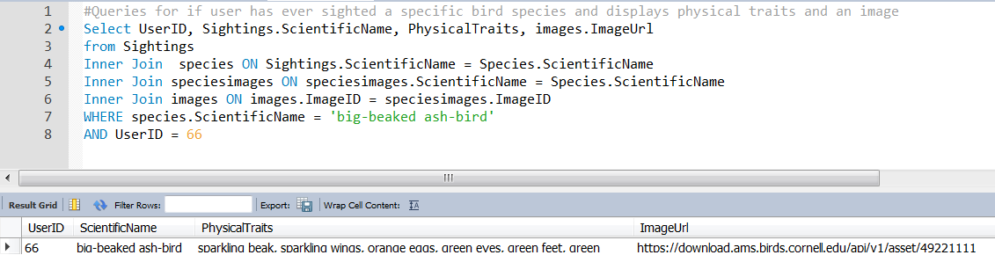

Query5:

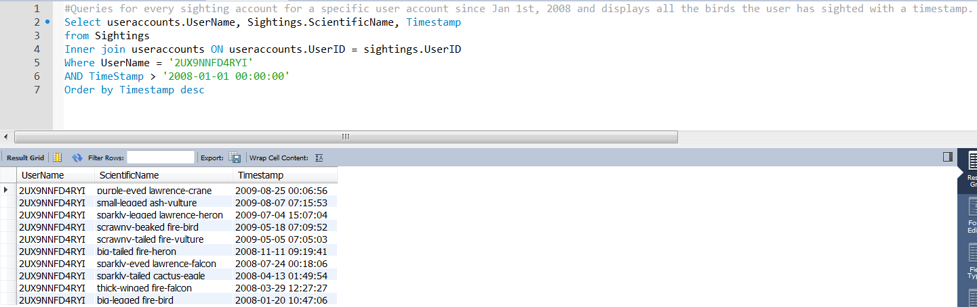

Query6:

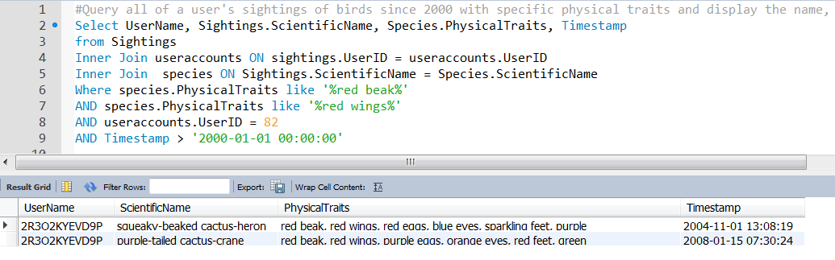

6. Delete group command.

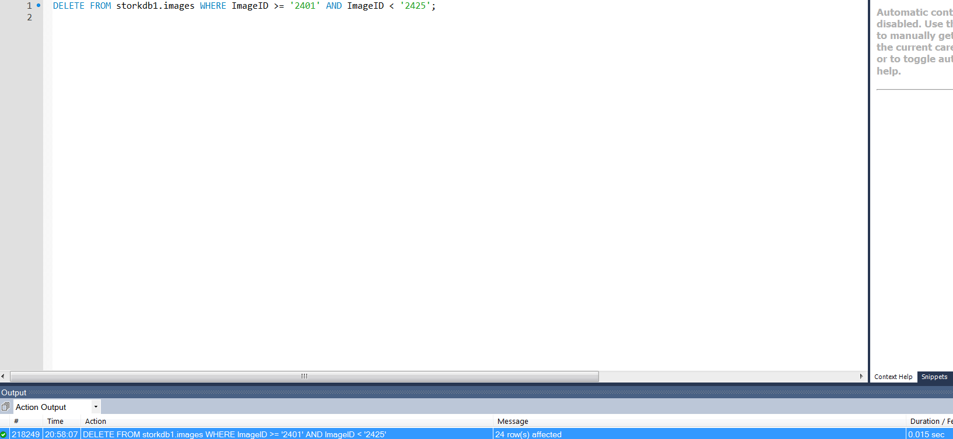

\*\*\*\*\* Created database to get original response, recreated database with files that will be provided to you therefore name differs\*\*\*\*\*

Updated 26 rows.

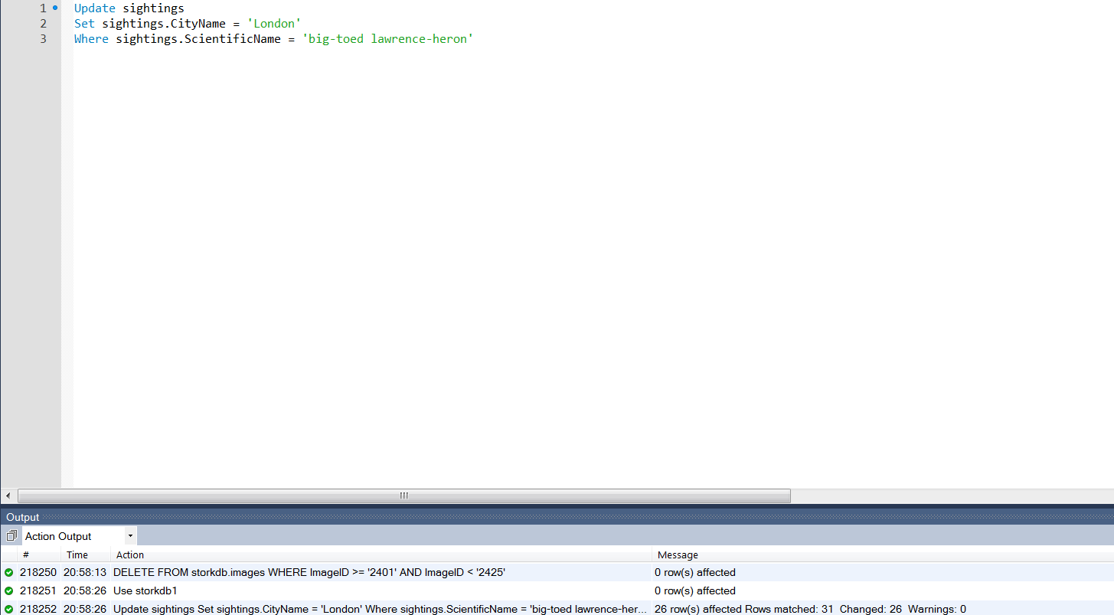

Changed information based on Query

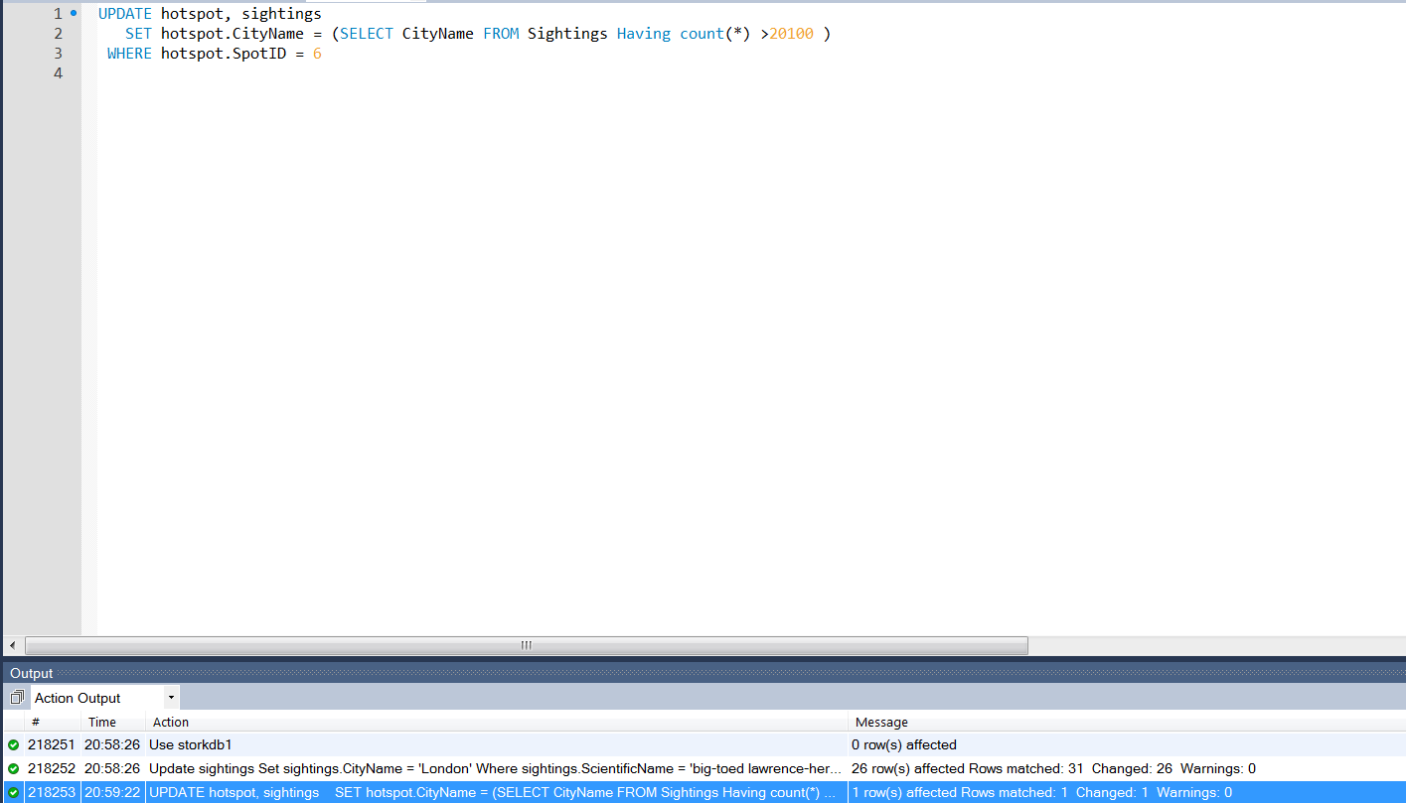

7.

Querying within a view of sightings after 2008.

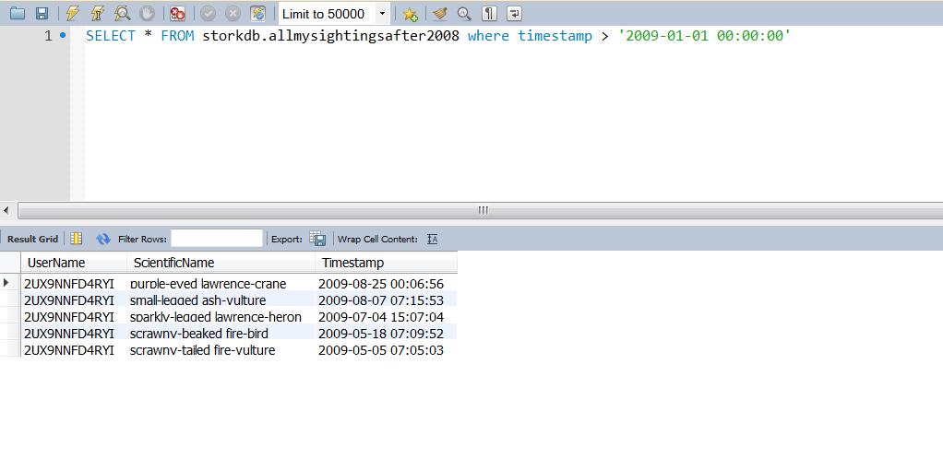

Querying within a view of whether an individual has sighted a specific bird

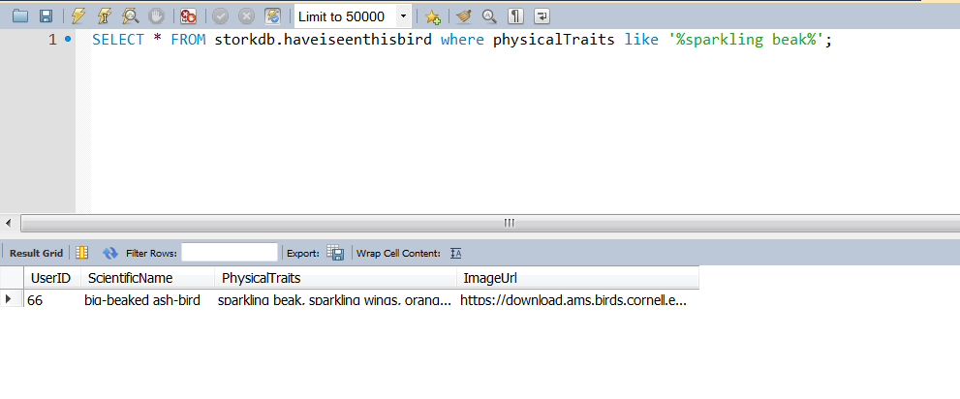

Querying within a view of most sightings by individual users

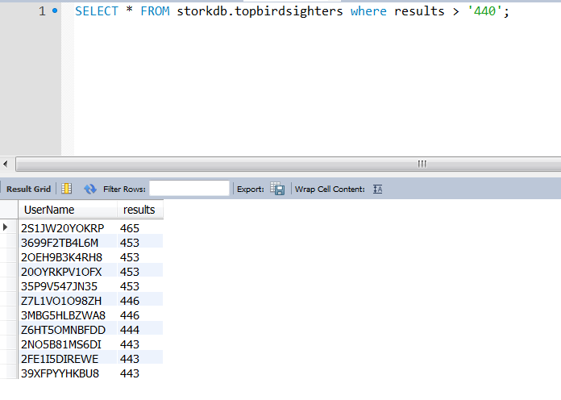

Inserting into a view

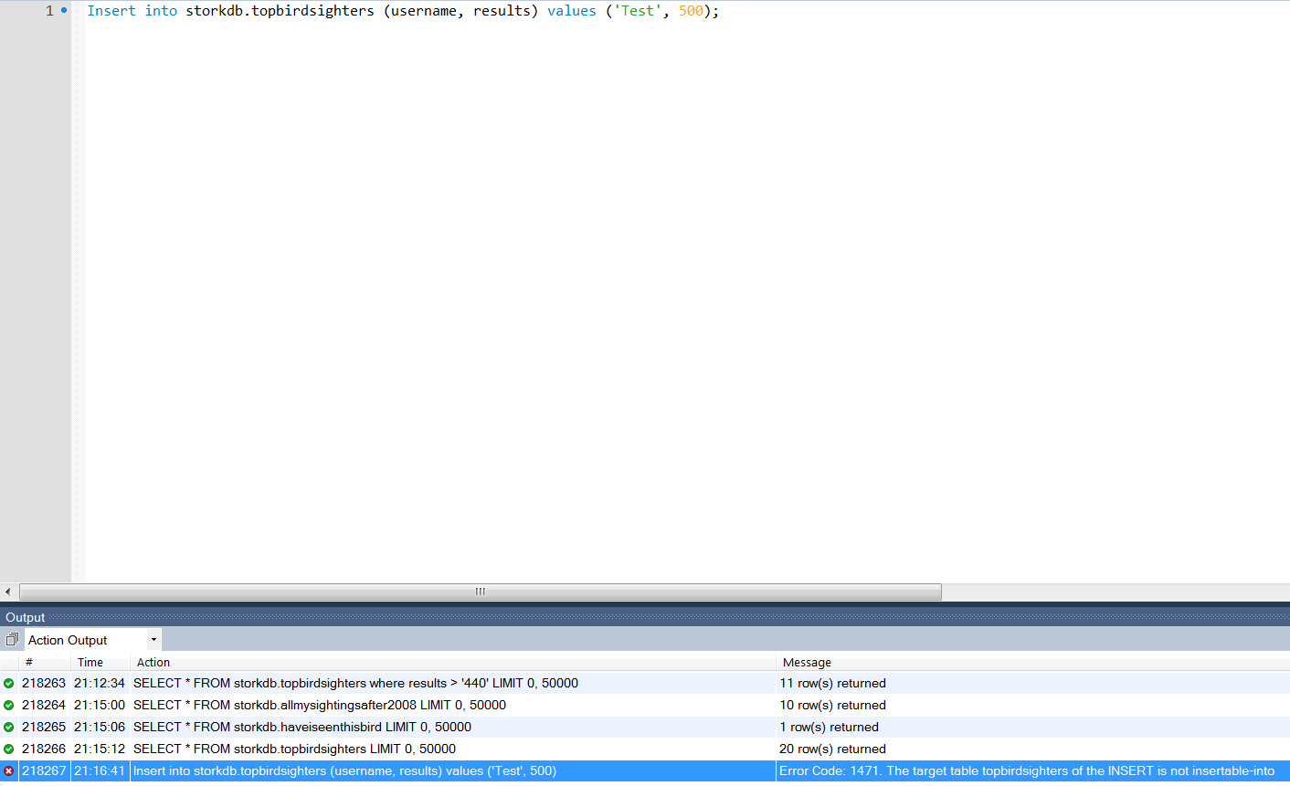 No views were possible for us to insert because every view used was a multi table view and therefore could not be updated with that information.

8. The only feature we wanted to use in SQL that we were not able to implement was the CHECK constraint. We wanted to bind the field “account type” to Researcher, Student or Recreational, but mySQL does not feature checks. As an alternative, our team used triggers to ensure that the data entered matched our requirements.