Pavel V. Afonine,

Alexandre Urzhumtsev

Appendix B. Formulae for rotation in angles of Euler.

B2. Rotation convention

The standard convention of rigid body rotation in Eulerian angles (see for example CCP4 programs, AMoRe by Navaza, 1994) describes this rotation as follows: the model is associated with a vectors OX’, OY’, OZ’ whose initial direction coincides with the direction of corresponding axes of a Cartesian coordinate system; then model is rotated first by angle α around the axis OZ’=OZ, then by angle β around the obtained position of the vector OY’, and finally by γ around the obtained position of OZ’.
R(α,β,γ)= R_{z’}(γ)R_{y’}(β)R_{z’}(α) = R_{z’}(γ)R_{y’}(β)R_{z}(α)=
= R_{z’}(γ) [R_{z}(α)R_{y}(β)R_{z}(-α)] R_{z}(α) = R_{z’}(γ) [R_{z}(α)R_{y}(β)] = (B0)
= [R_{z}(α)R_{y}(β)R_{z}(γ)R_{y}(-β)R_{z}(-α)][R_{z}(α)R_{y}(β)] = R_{z}(α)R_{y}(β)R_{z}(γ)
This proves that this procedure is equivalent to a rotation of a body around fixed coordinate axes: first, by γ around OZ, then by β around OY, then by α around OX (Urzhumtsev & Urzhumtseva, 1997).
The corresponding rotation matrix R(α,β,γ) is:
R(α,β,γ) = 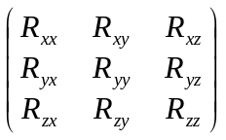= R_{z}(α)R_{y}(β)R_{z}(γ) =
=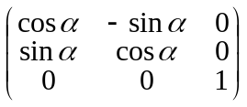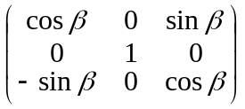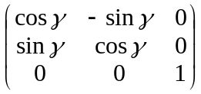=
=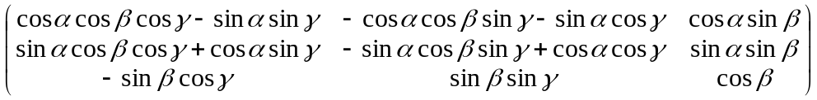 (B1)

As a rule, the start model is taken in its current orientation, and therefore the start values for all these rotation angles are 0. It is easy to see that for β=0 (B1) becomes
R(α,β,γ) =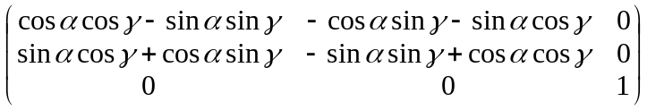=
=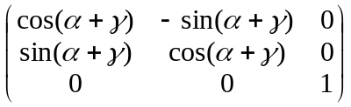
Therefore, for β=0 the rotation is defined by a parameter α+γ that is impossible to decompose into individual α and γ. Eventually, this singularity might be in origin of some difficulties during refinement of rigid body orientation near the point (0,0,0).

B3. Transformation of gradients

Let’s suppose that we already calculated the gradient ∇_{r}Φ of the total target Φ with respect to the individual atomic coordinates: 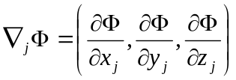 for each atom j. Now we need first to invert the step (b) and obtain the components of the gradient of Φ with respect to all components of the rotation matrix and the translation vector (12 components in total):
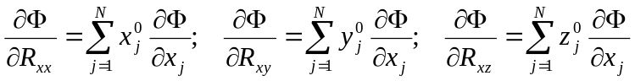
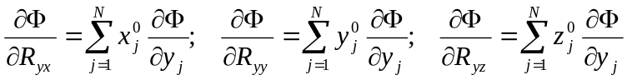 (B2=A2)
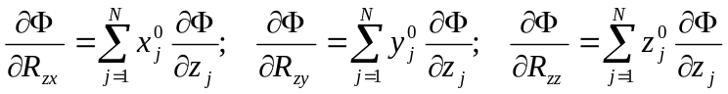
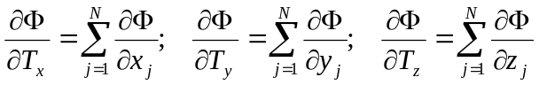 (B3=A3)

Naturally, these formulae are irrelevant to the choice of independent parameters that describe the rotation (α,β,γ in our case). On the contrary, coordinates 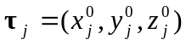 of the atoms inside the rigid group are important.
Then we need to apply the chain rule and to calculate the gradients with respect to the independent parameters. The transformation of translational components is trivial and these components of the gradient are simply conserved. The partial derivatives with respect to rotation parameters are obtained accordingly to the general formula:

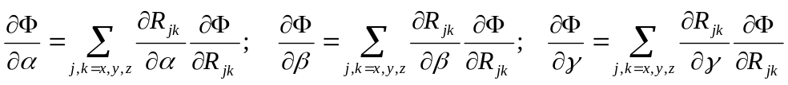 (B4)

We calculate first all partial derivatives of each element R_{jk} of the matrix R(α,β,γ) (9 by 3 elements in total) that we present in form of matrices (we remind that this matrix presentation is simply a short form to give partial derivatives of 9 functions):

R_{α} =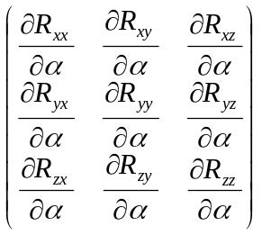=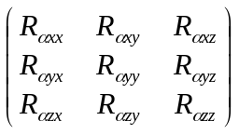= (B5)
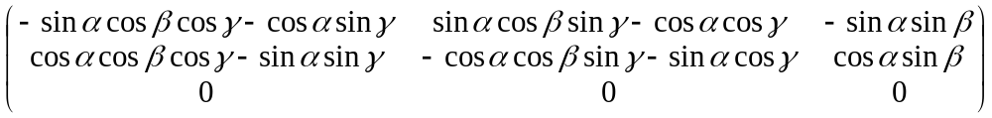;
R_{β} = 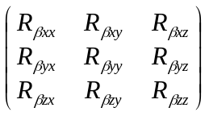= (B6)
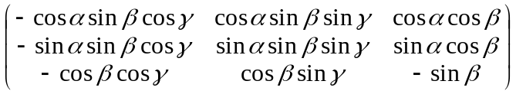
R_{γ}=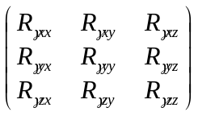= (B7)
=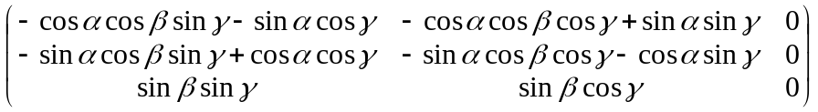

(B5-B7) show that in (B4) some terms are equal to 0.

B4. Getting start parameters

The first question is to identify the origin around which the rigid group will be rotated. If there is no any special point indicated for the group, the origin is superposed with the geometric center of the rigid body, T=(T_{x}, T_{y}, T_{z}). This defines the relative atomic coordinates t_{j} = r_{j} – T with respect to this origin. Otherwise, if the user wants to fix some point during refinement, the origin (T_{x}, T_{y}, T_{z}) should coincide with this point.
When there is no any limitation on the rotation of the rigid group, the simplest (but very dangerous!!! – see below for an alternative) choice of starting rotation parameters is (α,β,γ) = (0,0,0) ; in this case obviously τ_{j} = t_{j} = r_{j} – T.

Another special case of rigid body motion is a rotation around a given direction (in other words, rotation keeping one axis fixed). This direction may be defined by 2 points A and B. A vector indicating the fixed direction is now D=B-A =(d_{x},d_{y},d_{z}). It forms the angle β₀ with the OZ, and its projection into the plane XOY forms the angle α₀ with the axis OX. These angles are calculated as
β₀=arccos{d_{z}/|D|}={d_{z}/√(d_{x}²+d_{y}²+d_{z}²)};
cosα₀ =d_{x}/√(d_{x}²+d_{y}²); sinα₀ = d_{y}/√(d_{x}²+d_{y}²).

The rotation R‘=R_{y}(-β₀)R_{z}(-α₀) where
R‘(β,α)=R_{y}(β)R_{z}(α) = 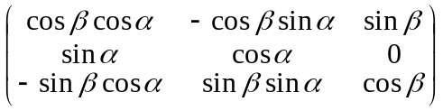 (B8)

aligns this vector with OZ. Summarizing, in this case:
- the atomic coordinates inside the rigid group are τ_{j} = R‘t_{j} = R‘(r_{j} – T)
- the start values for (α,β,γ) are (α₀,β₀,0);
- for the refinement, the angle γ is free but other two angles are fixes as α=α₀ and β=β₀

Remark. The point (0,0,0) is a singular point for this description of rotation. This singularity means that for β =0 it is the sum α+γ that is defined but not each of these angles individually. A trick to avoid this problem is to introduce an artificial initial pre-rotation (B8) of the model even when there is no direction fixed. In this case the we take α₀=0, β₀=90, but now all three parameters α,β,γ are refinable.

