Pavel V. Afonine,

Alexandre Urzhumtsev

Appendix. Some technical aspects of rigid-body refinement algorithm

A rigid group has a point around which it may be rotated and which is considered as its origin (usually, its center of mass). Therefore, the group is defined by the rotation parameters, the vector of translation parameters and by the list of atoms that belong to this group. These atomic coordinates are defined as the relative position 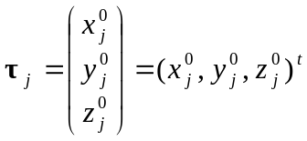 with respect to the origin of the rigid group in its initial orientation and of course are fixed and independent of further model rotations and translations (t here and below stands for transposition operation).

Rotation convention

The following convention (Urzhumtsev et al., 1989) is used to describe the rigid group rotation: the model is rotated first by ϕ around the axis OZ, then by ψ around the axis OY, and then by θ around the axis OX, all axes are fixed. The start model is taken in its current orientation and therefore the start values for all rotation parameters are 0. Note that singularity point (ψ = 90°) of this convention is far beyond the shift values normally achieved in refinement (~20° maximum).
For the rotation parameters θ,ψ,ϕ introduced above, the corresponding rotation matrix R(θ,ψ,ϕ) is:
R(θ,ψ,ϕ) = 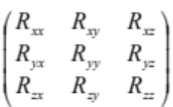= R_{x}(θ)R_{y}(ψ)R_{z}(ϕ) =
=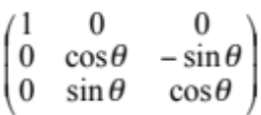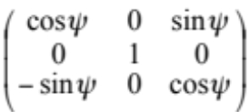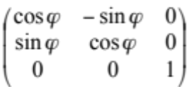=
=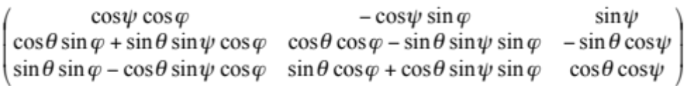 (A1)

The atomic position corresponding to rotation R and translation vector T is r_{j} = Rτ_{j} + T, 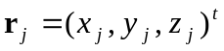.

Transformation of gradients

First, to make the formula shorter, we introduce some notations.
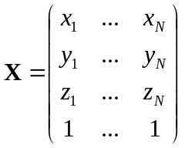; 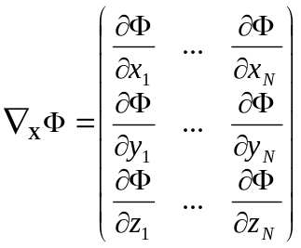; 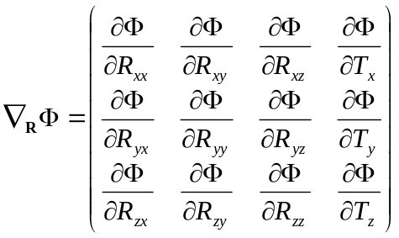 (A2)

and
R_{θ}=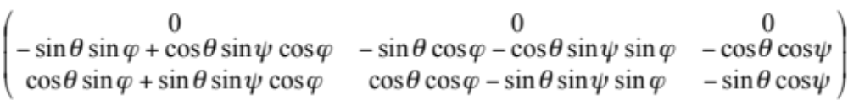.
R_{ψ} = 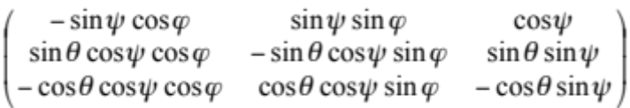 (A3)
R_{ϕ} =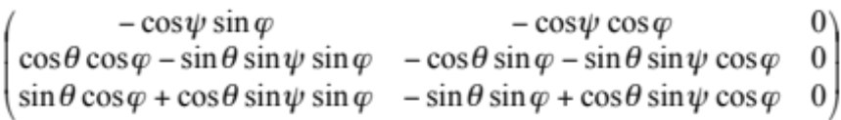

where R_{θ} , R_{ψ} , R_{ϕ} are component by component partial derivatives of the matrix R(θ,ψ,ϕ) with respect to the Euler angles θ,ψ,ϕ .
Following the general theory (Kim et al., 1984; Baur & Strassen, 1983; Lunin & Urzhumtsev, 1985), the optimal way to calculate the gradient is to follow, in the inversed order, the chain of calculation of the target. Therefore, let’s suppose that we already calculated the gradient ∇_{X}Φ (see notation above) of the total target Φ with respect to the individual atomic coordinates for each atom j. Now we need first to obtain the components of the gradient of Φ with respect to all components of the rotation matrix and the translation vector (12 components in total) as
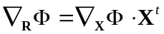 (A4)

The last column of 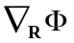 already contains the components for the translation. Then we need to apply the chain rule further to calculate the gradients with respect to the independent rotational parameters as:

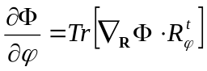; 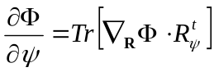;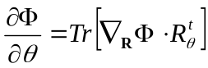 , (A5)

where Tr stands for the trace of a quadratic matrix.

