**2022**

**Contents**

Task 3

Work progress 4

Questions&Conclusions 8

# **Task**

1. Create a topology in figure

2. Assign addresses to computers, according to option “v”. “v” - is your last digit of your HDU ID

3.Run the ping utility, according to the table.



4. In "simulation Mode", track the movement of packets and the protocols used

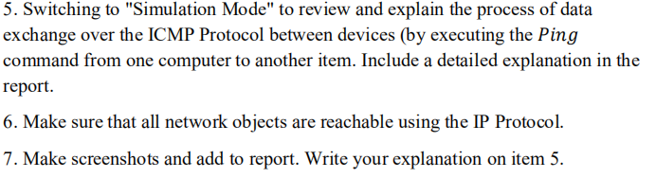

# **Work progress**

**Step1: the topology**

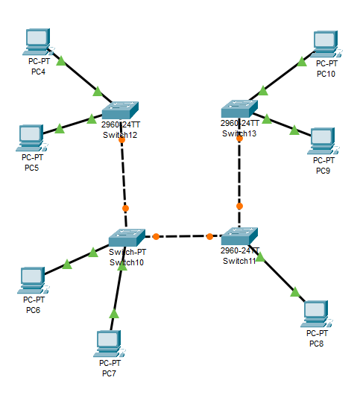

**Step2: set the IP address**

|  |  |  |
| --- | --- | --- |
| **Host** | **IP Address** | **Subnet Mask** |
| **PC4** | **30.3.1.1** | **255.255.255.0** |
| **PC5** | **30.3.1.2** |
| **PC6** | **30.3.1.3** |
| **PC7** | **30.3.1.4** |
| **PC8** | **30.3.1.5** |
| **PC9** | **30.3.1.6** |
| **PC10** | **30.3.1.7** |

**Step3:Run ping**

**Here my version is to ping from PC6 to PC4**

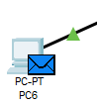

**Step4: See the result**

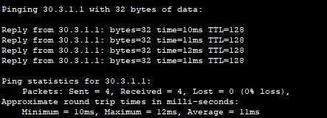

The result seems work fine

**Step5: Exploration of the process**

**When the message is about to sent**

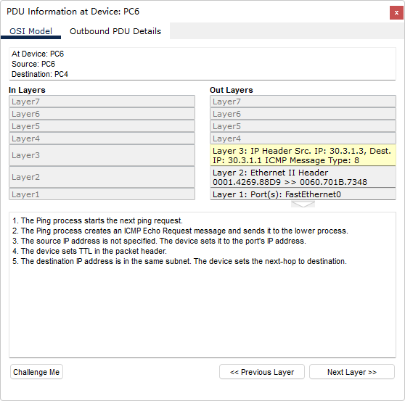

The ICMP message will first reach the PC4 and reply to the PC6

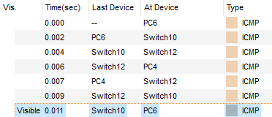

For each step, we can give a detailed information

Firstly, PC6 to the Switch10

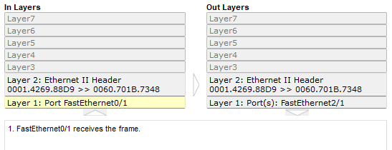

**Secondly, Switch10 to the switch12**

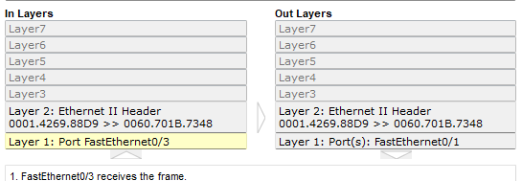

Then, the PC4 will get message from the Switch12

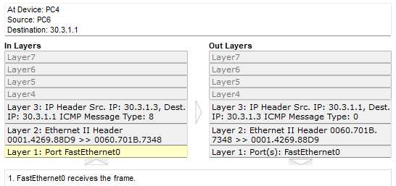

After that, the PC4 reply message to the switch12

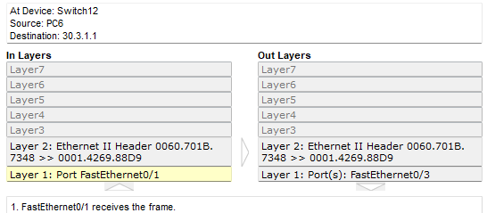

Then, the switch12 to switch10

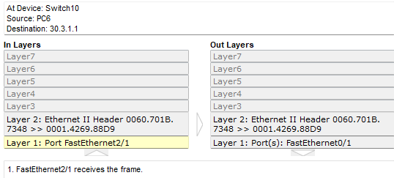

**Finally, the PC6 get the reply message**

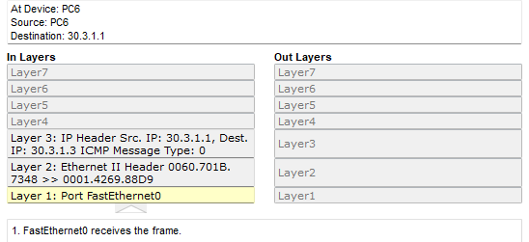

This is the whole process of the ping process.

# **Questions&Conclusions**

**Questions:**

1. **What is difference between hub and switch?**

A hub can be understood as a centralized device that connects a number of machines to a centralized device for information exchange via transmission lines, and this centralized device is a hub. Switch and it have similar functions, both of them connect devices to themselves for information exchange, and they both work at the data link layer. But there is a significant difference between the two. The hub works with a shared bandwidth, but the switch works with an exclusive bandwidth.

1. **What layer of OSI model is used for the switching?**

Network Layer

1. **Describe the aims of subnet mask?**

The subnet mask specifies which bits of the IP address indicate the network portion and which bits indicate the host portion, and determines whether the target host is on the local network or on a remote network.

1. **Do we have one subnetwork or 4 (because we have 4 switches)? Explain.**

It should be one, because each host uses the same subcode mask, which means that the connections are under the same subnet

1. **What will happen if we will change the address of PC6 to v*10. v.2.6 and make ping-request from PC1 to PC6? Is it successful or not? Explain, please, why**

It depends.

If we use the C kind subnet mask(255.255.255.0), then it won’t get request, because the first three bytes are different with each other.

But actually my varient IP address(30.3.x.x) should use the A kind subnet mask(255.0.0.0), in this situation the first byte address are in the same, so they can get request with each other.