**2022**

**Contents**

Task 3

Work progress 4

Questions&Conclusions 8

# **Task**

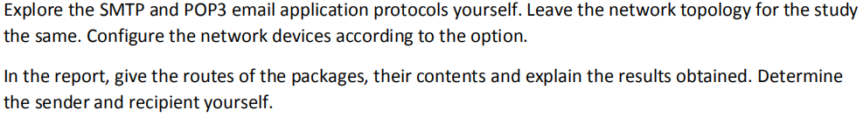

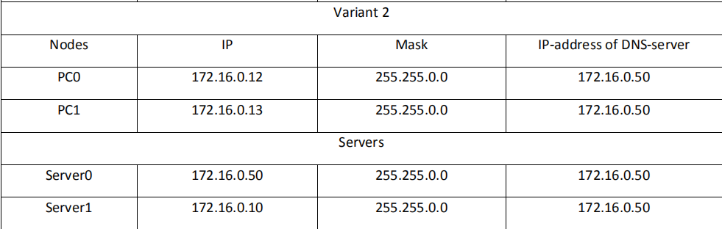

# **Work progress**

### Preparation

**The topology of the networks(with IP config and DNS)**

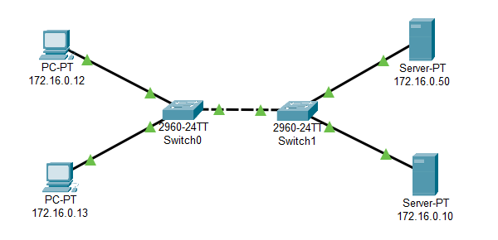

**The configuration**

**172.16.0.50**

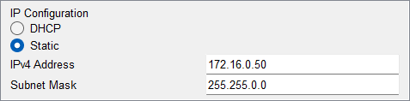

**172.16.0.10**

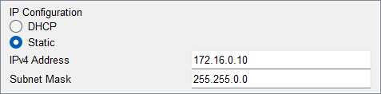

**172.16.0.12**

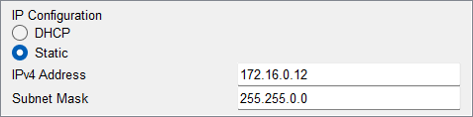

**172.16.0.13**

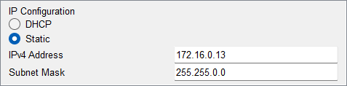

**The SMTP and POP3 service**

**172.16.0.50**

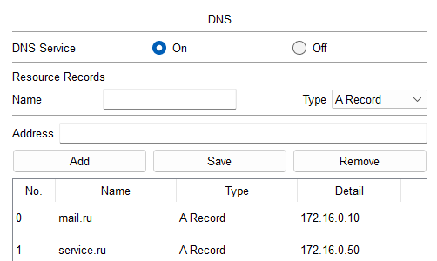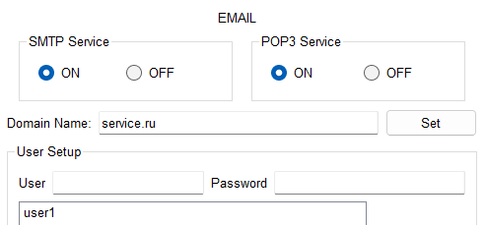

**172.16.0.10**

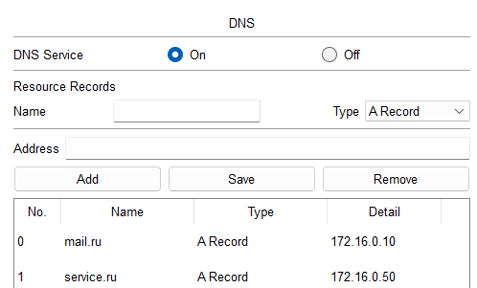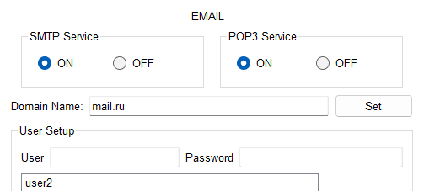

**Login in to the PC**

User1:172.16.0.12

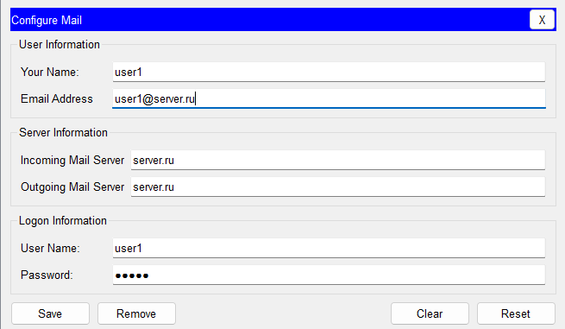

User2:172.16.0.13

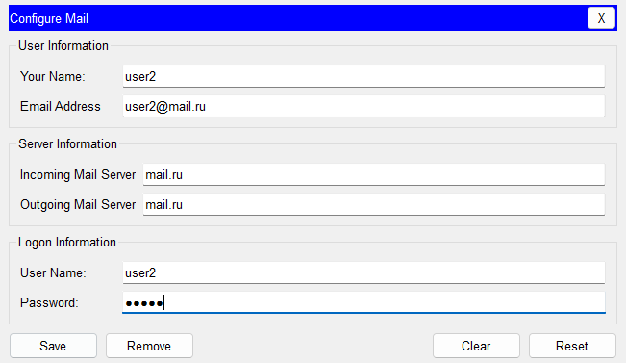

### Simulation

#### The SMTP procedure

Here we send a email from the user1 to the user2

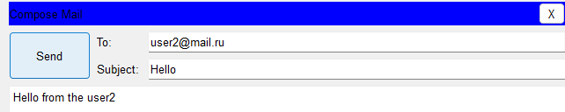

Now we can see that the package is ready to be sent from user1.

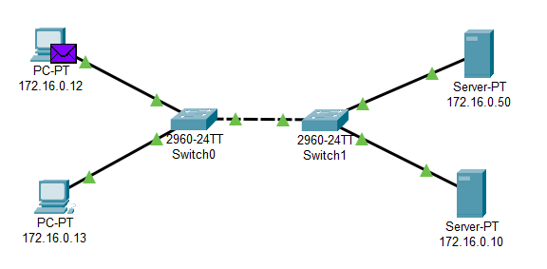

From the package we can see that the IP of the SMTP address is defined(172.16.0.20) as we have email domain.Also from the TCP header we can see that the destination port is also defined (25).From this we can make sure that this file is created correctly.

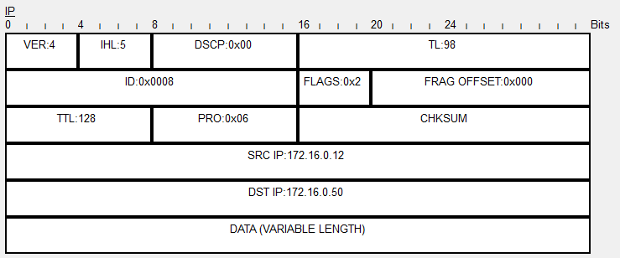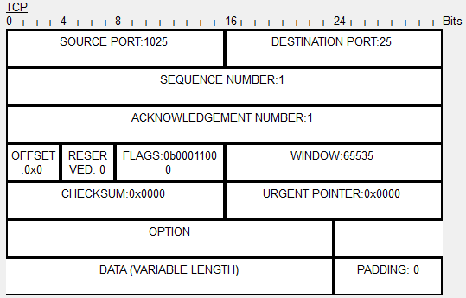

Than the package will go through two switches to reach the target SMTP server.

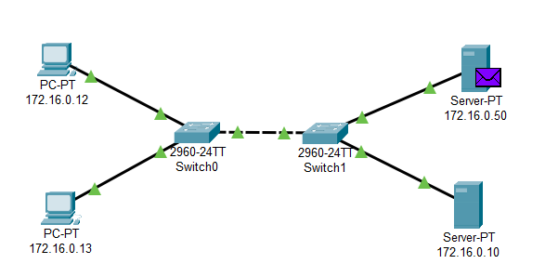

As soon as it reach the server, it will create another package to the user1, in order to inform that the email is already reached the SMTP server.

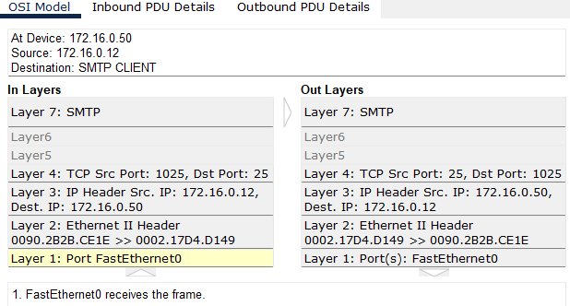

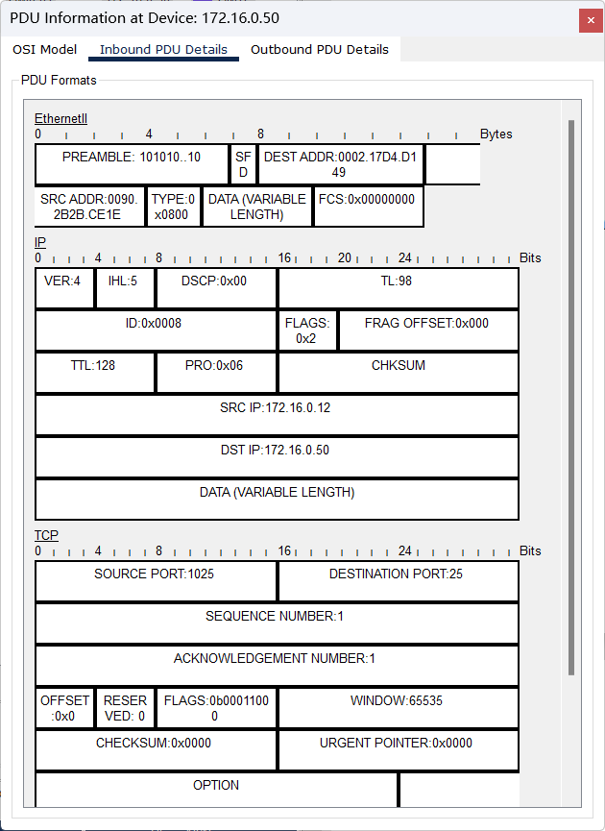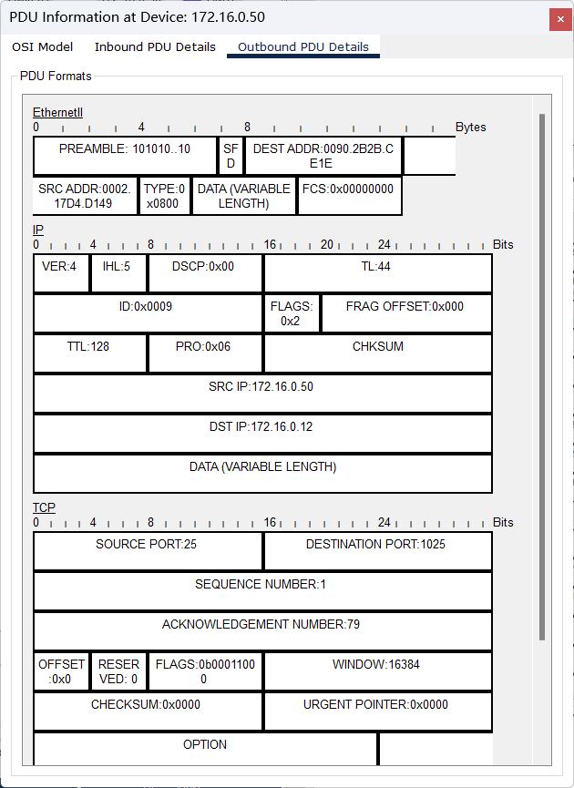

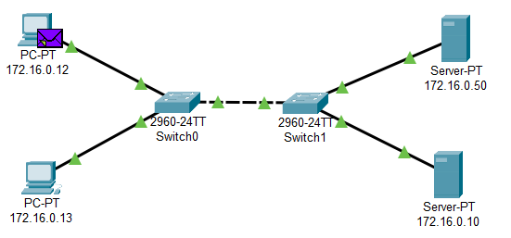

Then the email will loaded into the SMTP server, and check which target SMTP server will be sent, for the result, the mail.ru server (172.16.0.10) is written into the package.

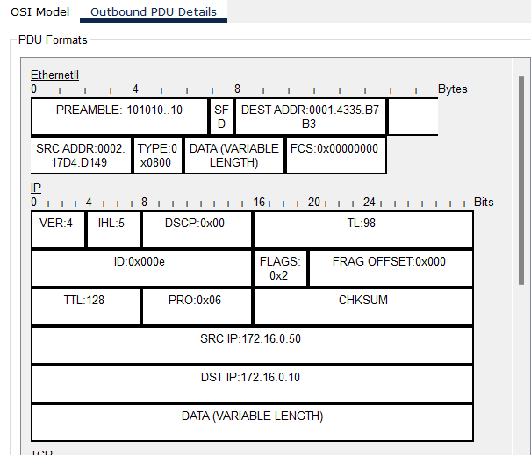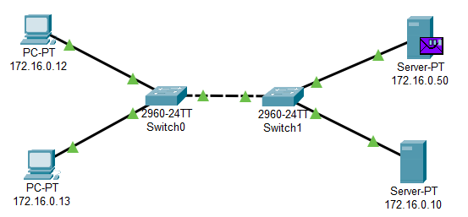

The

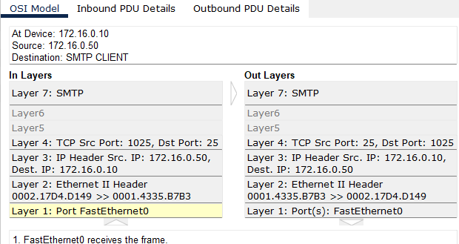

The SMTP response will go form 172.16.0.10 to the 172.16.0.50, to from whether the mail is stored correctly in the server.

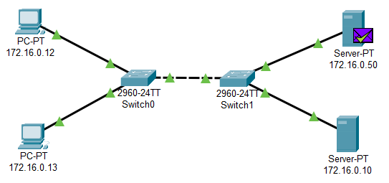

From this we can see that the email sent from user1 is stored into the user2’s SMTP server.

So this is the procedure of the SMTP protocols.

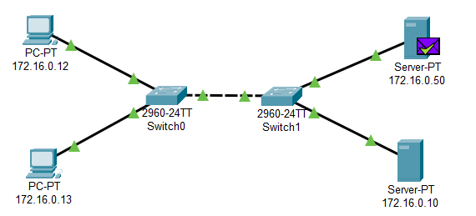

#### The POP3 procedure

Here we click the “Receive” button of the user2’s interface.



There will be package of POP3 created form user2’s PC

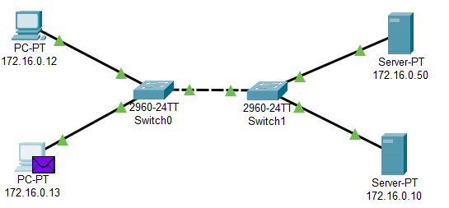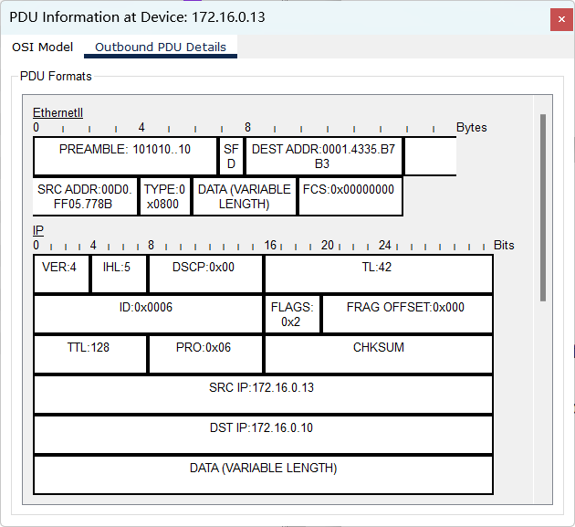

The destination server is 172.16.0.10 [(@mail.ru),](mailto:(@mail.ru),) and the port is 110. Now the package will go through two switches to reach the server.

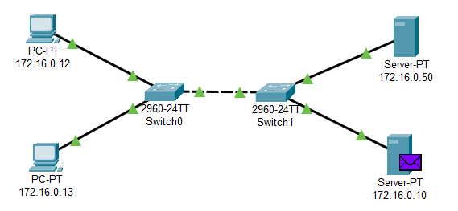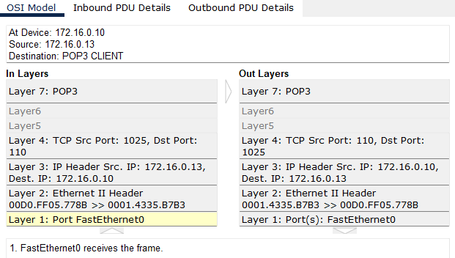

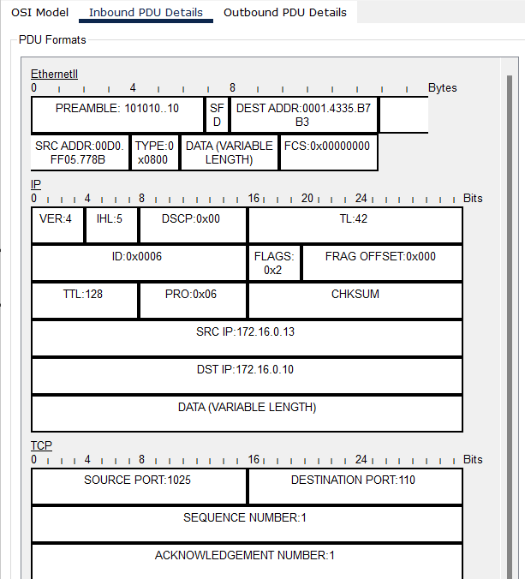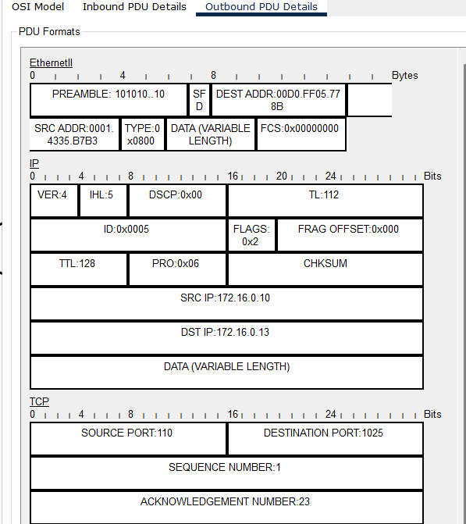

The source port is 110. The response came from server 172.16.0.10 with some POP3 data. Using the POP3 protocol, node 172.16.0.13received an email form the server sent there by node 172.16.0.12

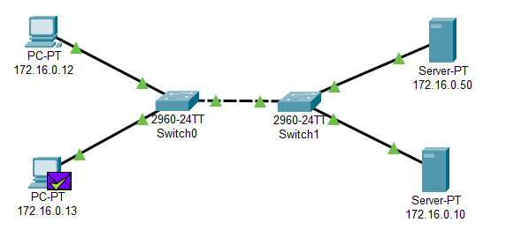

We can see that form the user interface that the mail have already reached the local mail box.

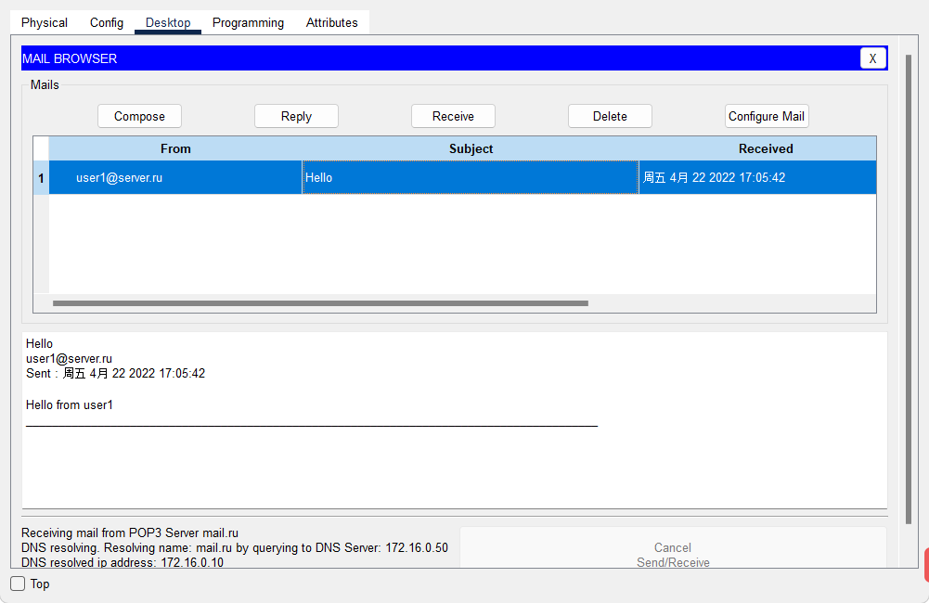

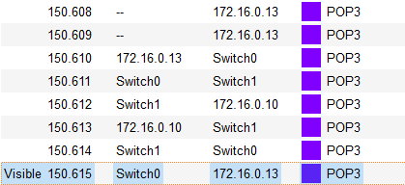

# **Conclusions**

pop3 is the service responsible for allowing the client to receive mail, the default port is 110

smtp is responsible for allowing the client to send emails, the default port is 25

The differences between POP3 and SMTP protocols are as follows:

**1. The two functions are different**

POP3 allows users to store emails from the server to the local host (that is, their own computer), and delete the emails stored on the email server, while the SMTP server is a receiving email server that follows the POP3 protocol and is used to receive emails.

**2. The feedback of the two client operations is different**

The POP3 protocol allows the email client to download the mail on the server, but the operation on the client (such as moving the mail, marking it as read, etc.) will not be fed back to the server. And IMAP provides two-way communication between webmail and e-mail client, the operation of the client will be fed back to the server, and the operation of the e-mail, the e-mail on the server will also do the corresponding action.

**3, the two services are different**

POP3 provides a convenient mail download service, allowing users to read offline. The summary browsing function provided by IMAP allows you to make a decision whether to download or not after reading all the information such as arrival time, subject, sender, and size of the mail.