**2022**

**Contents**

Task 3

Work progress 4

Questions&Conclusions 8

# **Task**

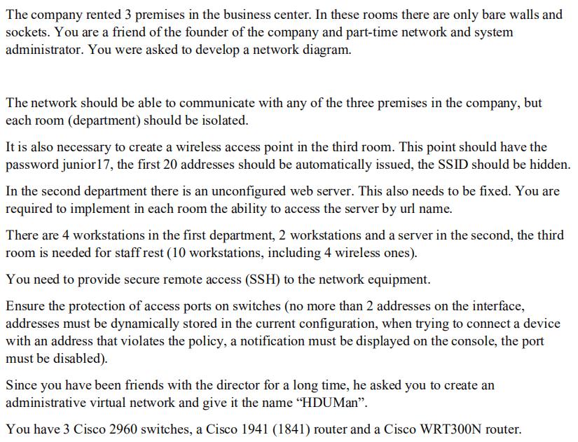

# **Work progress**

### Preparation

**The topology of the networks**

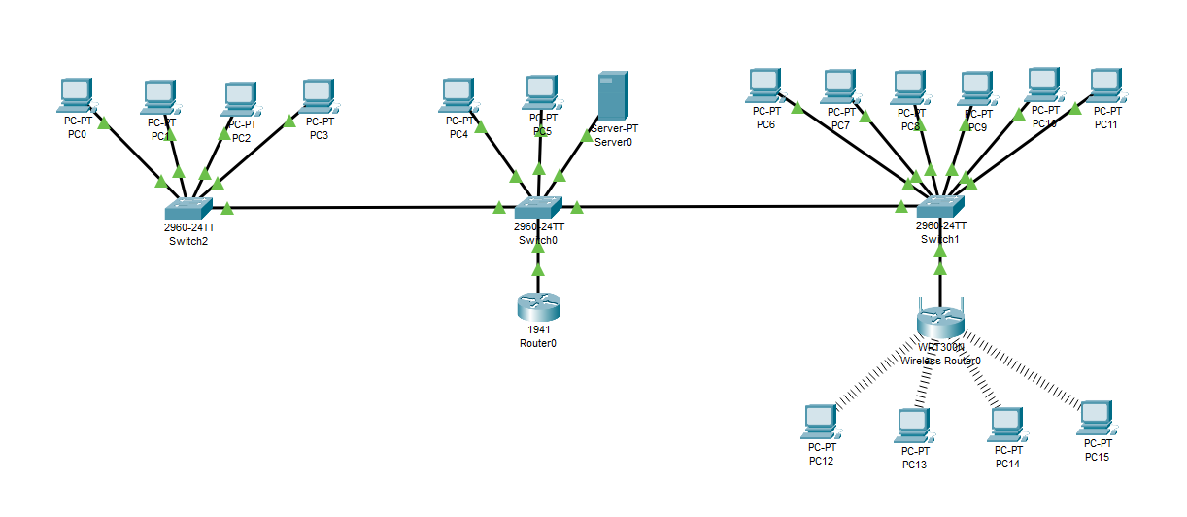

**The configuration Department1**

For this department we have 4 computer users with a switcher connected to it, so we need to commit then into one sub-network. Here we should conclude then into VLAN 10 (this setting should be done in the port configuration of the switchers)

Here is a example of how I set VLAN10 and named it as Office1.

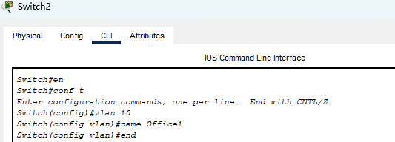

**Condition of the switcher:**

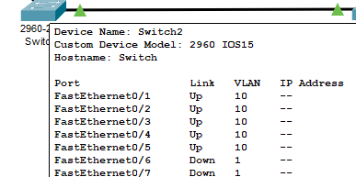

**PC0:**

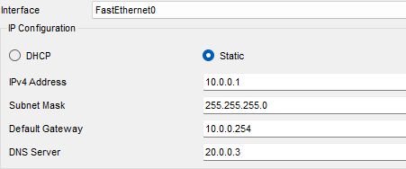

**PC1:**

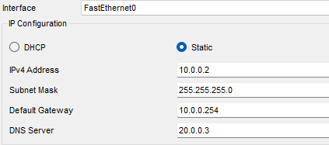

**PC2:**

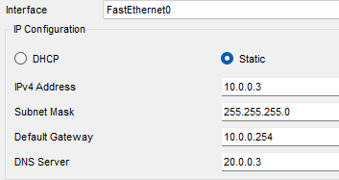

**PC3:**

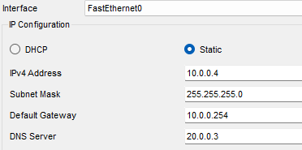

**The configuration Department2**

In this department, there is a router that can control the whole sub-network, first we should connect all the device within this network.

First, we should set the VLAN of the switcher in order to divide the sub-networks:

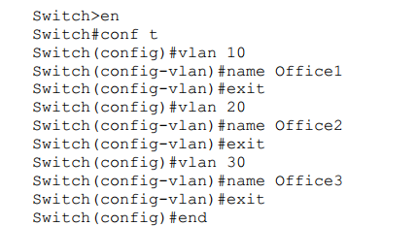

**Condition of the switch1**

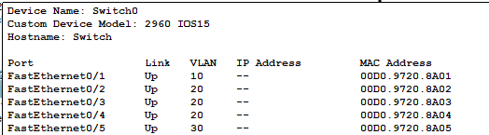



Here the port for the router should be set into Truck mode:

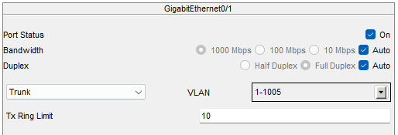

**Configuration of the PCs**

PC4:

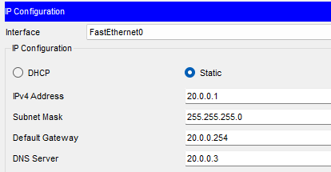

PC5:

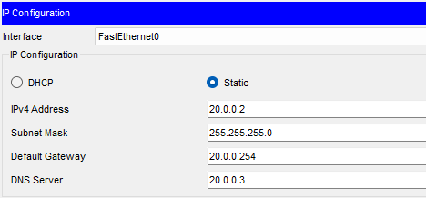

PC6:

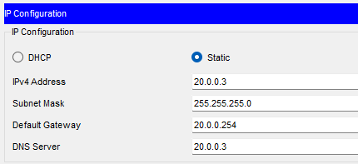

**The configuration of department3**

In this department, we divide it into two parts: WIFI user and connected user:

First we should define the VLAN 30 of the switch:

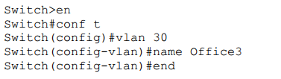

**Condition of the switch**

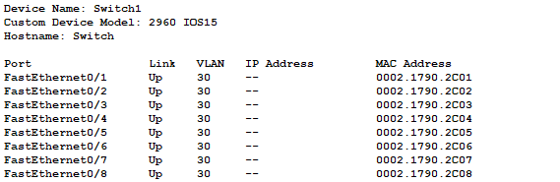

**Configuration of the PCs:**

**PC6:**

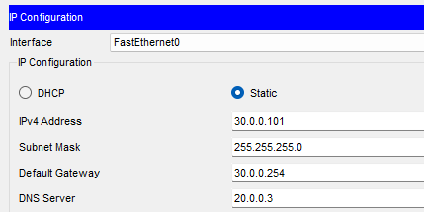

**PC7:**

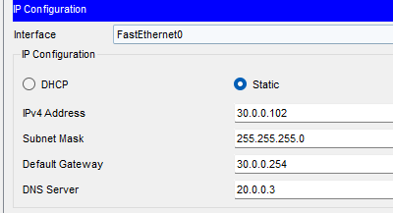

**PC8:**

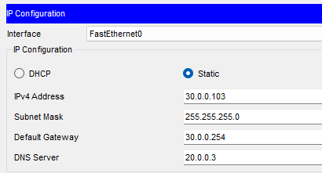

**PC9:**

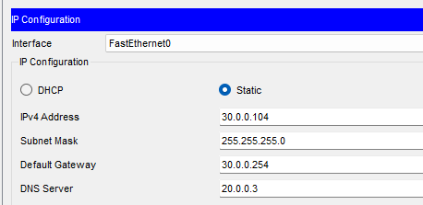

**PC10:**

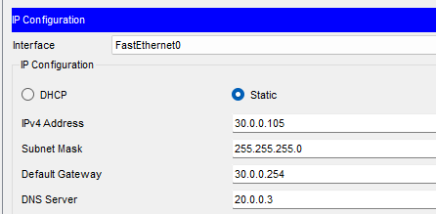

**PC11:**

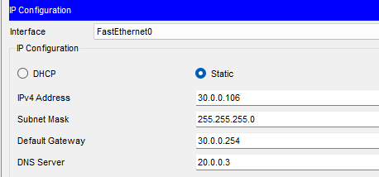

**PC12:**

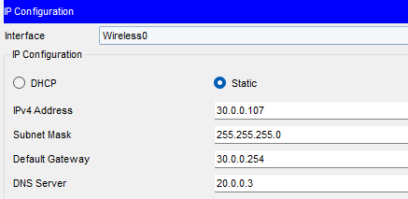

**PC13:**

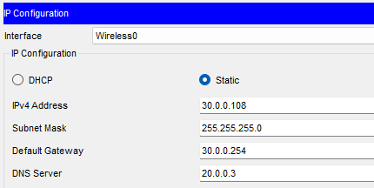

**PC14:**

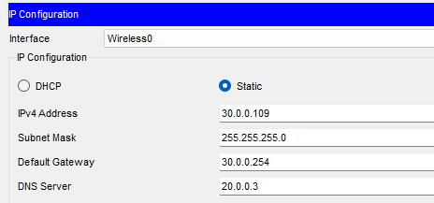

**PC15:**

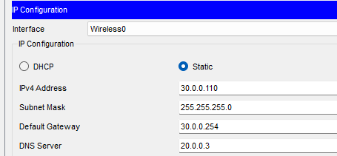

**The configuration of the Router**

Now we should config the router to work with the VLAN:

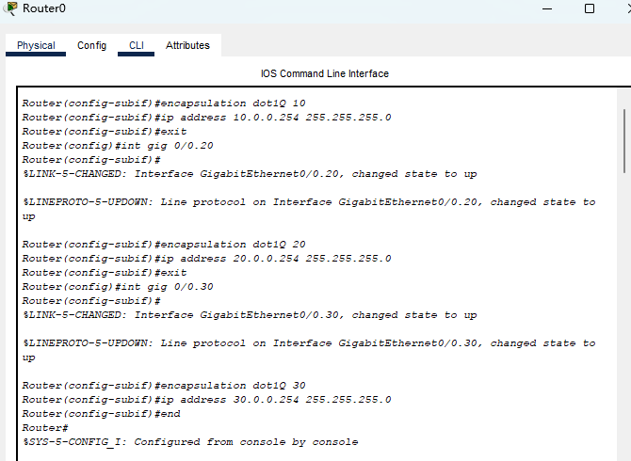

**The configuration of the Wireless Router**

First we should set up the IP and mask.

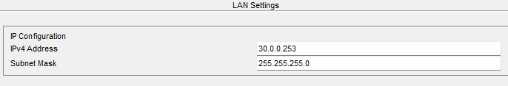

The DNS setting are as follows:

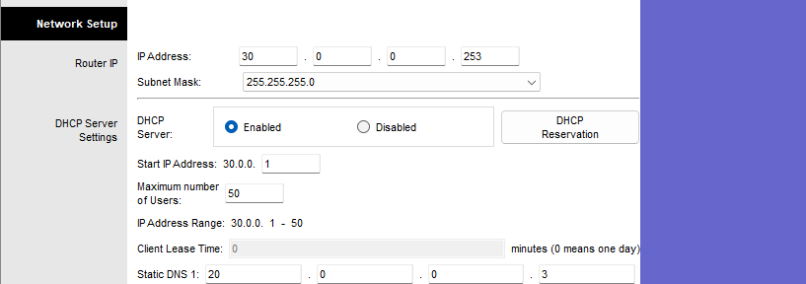

For wireless, we need to set the network name and disable the SSID boradcast.

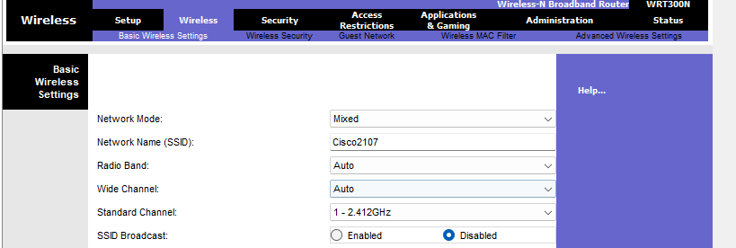

Than change the security mode into “WPA2 Personal” and set the Passphrase

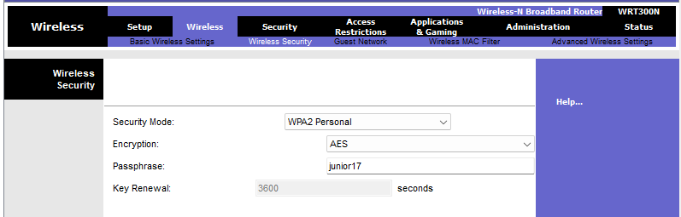

For the PCs which are connected to this router, they should be set WPA2-PSK and change the SSID as well as the PSK Pass phrase. All other PCs using WIFI should also be set up like this.

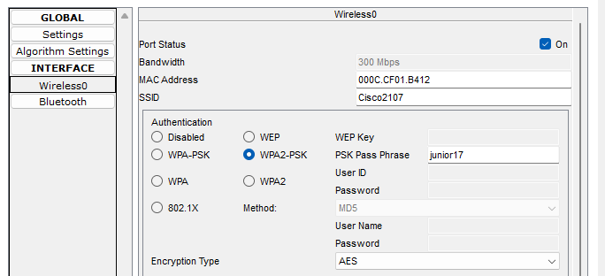

**The ping result**

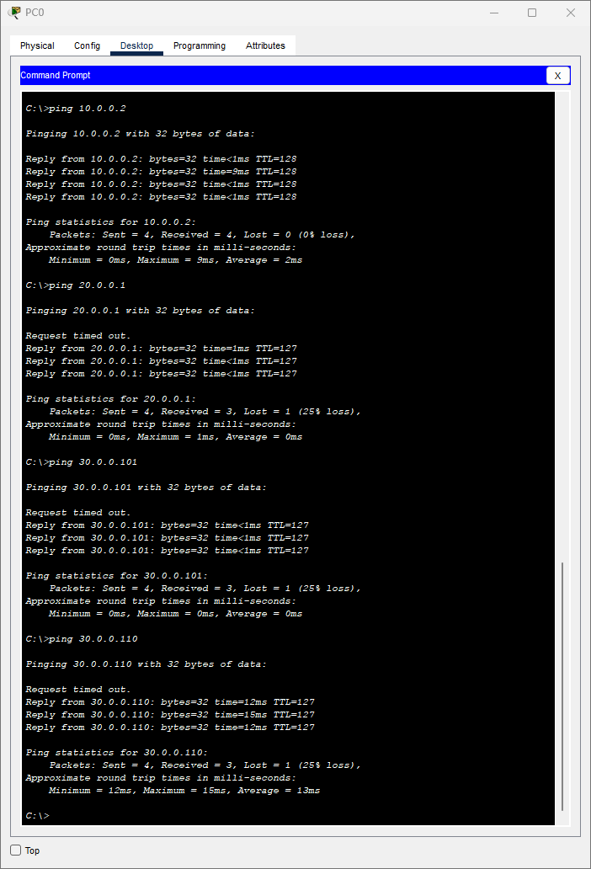

Ping result from PC0(Office 1)

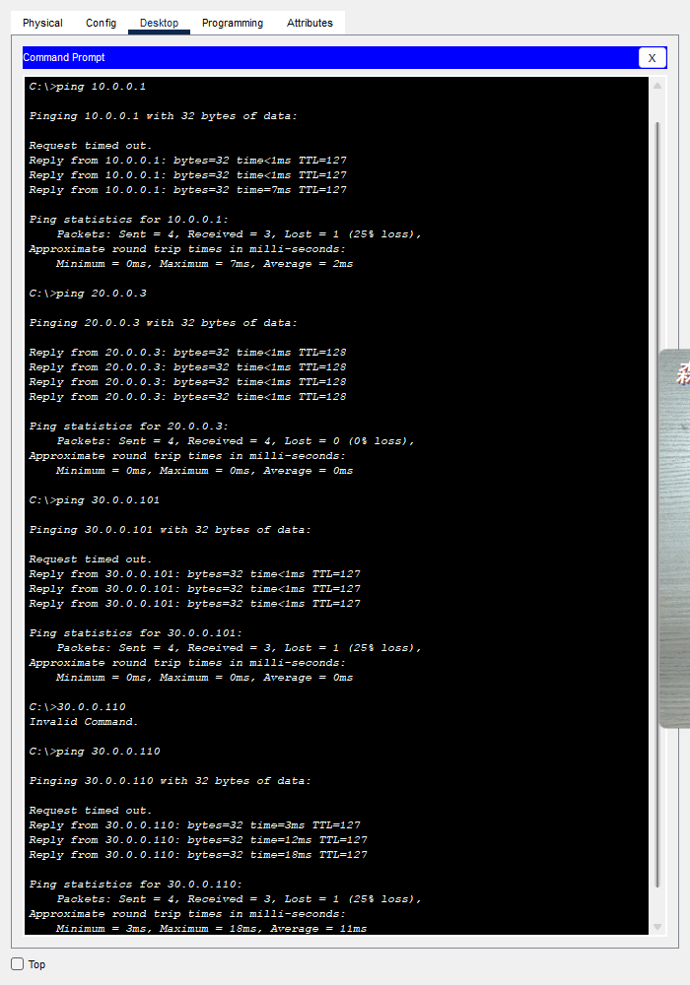

Ping result of PC4 (Office 2)

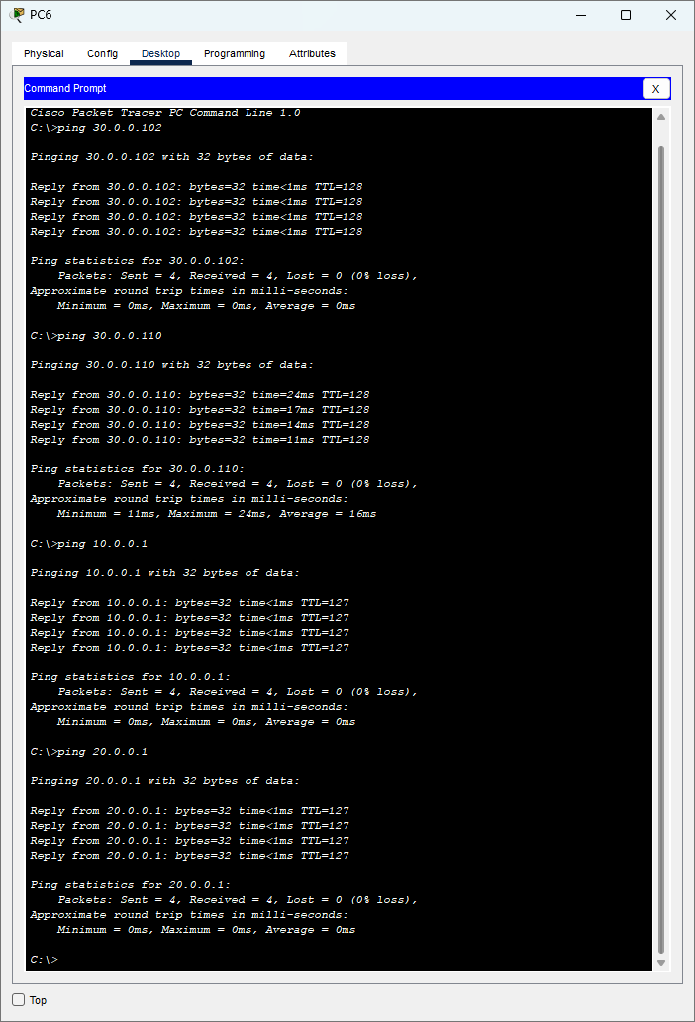

Ping result of the PC6 (Connected part of Office3)

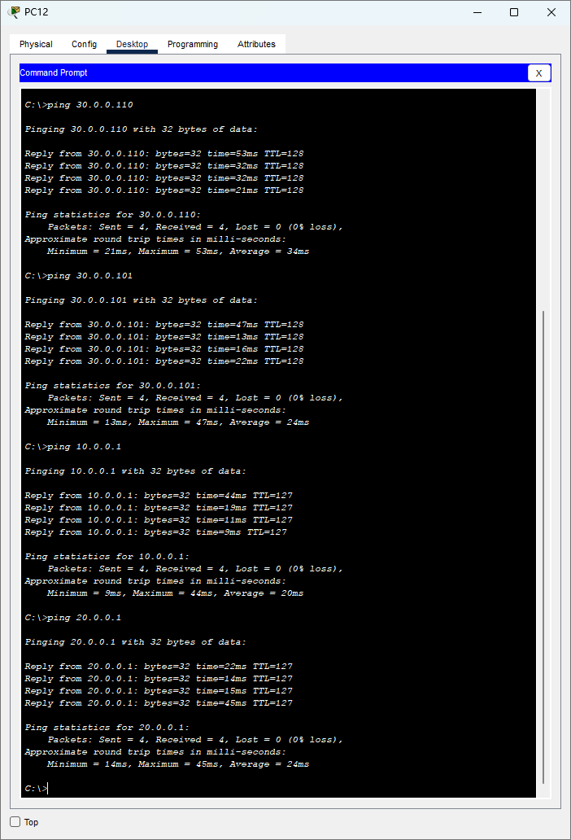

Result of the PC12 (WIFI user of the Office3)

**Server setup**

Here we will set up the DNS server with the website “ [www.cisco.com](http://www.cisco.com) ”

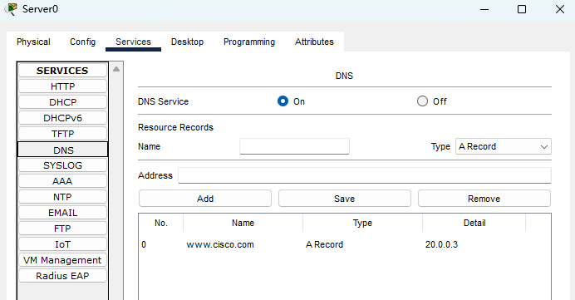

We can get access with this website by using any of the PC:

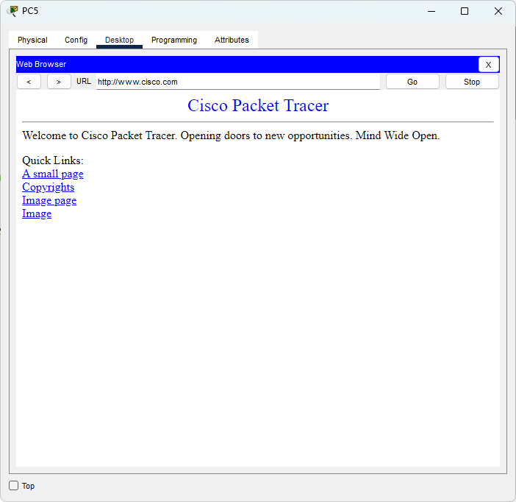

**SSH Configuration**

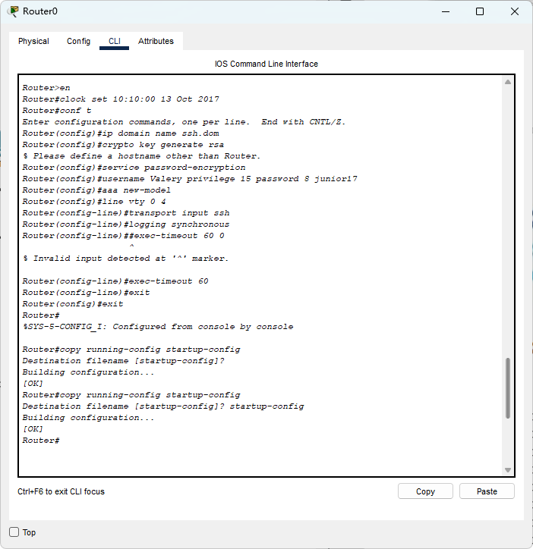

**Protection against each switch**

**Switch0:**

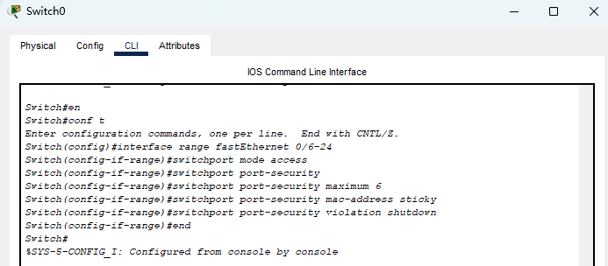

**Switch1:**

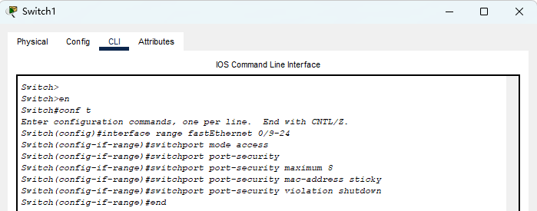

**Switch2:**

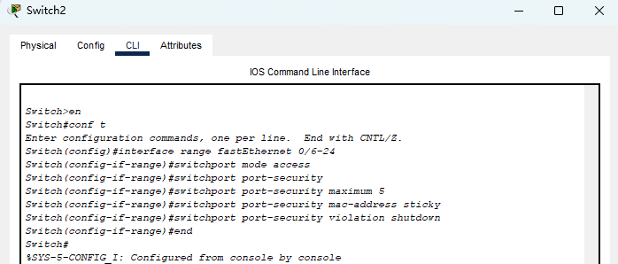

# **Conclusions**

This experiment has experienced the creation of large-scale networking and the configuration and use of VLAN.

As we all know, the scalability of the second layer flat network is not good. Before sending data packets, each site needs to broadcast the MAC address of the query destination. Since a large number of application layer software needs to broadcast certain data packets, and these data broadcast packets only need to be sent to a certain group of users, if there is no VLAN (Virtual Local Area Network), these data packets will occupy a lot of network resources, making Normal data packets cannot obtain bandwidth, which seriously affects network efficiency and performance. VLAN relies on the user's logical setting to divide a physical interconnected local area network into multiple virtual network segments, that is, logically divide several LANs (broadcast domains) on the two-layer switch, and restrict broadcast information, multicast information, etc. On a specific group of ports, it provides an effective means to limit the broadcast and multicast of the whole network. In network design, a feasible technology should be selected for flexible division of VAN. The division can be based on the The result of the division is that the data in the same VLAN can communicate freely. The data exchange between different VLANs needs to be completed through the third layer exchange. That is, by dividing the VLAN across the switch, the high performance can be realized. Routing between VLANs improves bandwidth utilization and network performance, and enhances the flexibility and security of network applications.