Electrical Engineering

Laboratory report 1

Research on DC electric source characteristics

Student name: Zhu Haibin

Student ID: 19321133

# The circuit

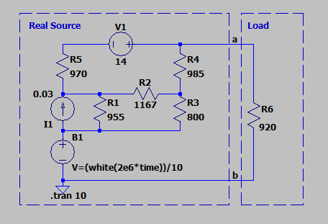

Fig. 1.1 – The Equivalent circuit of the real electrical energy source with

the load in the LTspice application.

# The Table of measurements and calculations

|  |  |  |  |  |  |  |
| --- | --- | --- | --- | --- | --- | --- |
| k | Measurements | | Calculations  r =925.072[Ω], E = 20.341[V], Isc =22.110 [mA] | | | |
|  | Rn [Ω] | Un [V] | In [mA] | Pn [W] | η | r [Ω] |
| 1 | 920 | 20.341 | 11.024 | 0 | 1.00000 |  |
| 2 | 10000 | 18.618 | 1.8618 | 0.034662992 | 0.91533 | 925.216 |
| 3 | 8000 | 18.232 | 2.279 | 0.041550728 | 0.89635 | 925.298 |
| 4 | 6000 | 17.623 | 2.937 | 0.051761688 | 0.86642 | 923.697 |
| 5 | 5000 | 17.165 | 3.433 | 0.058927445 | 0.84387 | 925.601 |
| 6 | 2500 | 14.846 | 5.9384 | 0.088161486 | 0.72991 | 925.302 |
| 7 | 1000 | 10.565 | 10.565 | 0.111619225 | 0.51946 | 925.007 |
| 8 | 500 | 7.136 | 14.272 | 0.101844992 | 0.35086 | 925.231 |
| 9 | 250 | 4.327 | 17.308 | 0.074891716 | 0.21275 | 925.355 |
| 10 | 100 | 1.984 | 19.84 | 0.03936256 | 0.09755 | 924.942 |
| 11 | 0 | 0.000 | 21.985 | 0 | 0.00000 |  |

Example of the calculations for =6000[Ω]

Current in the load:In=/=17.623/6000*1000=2.937[mA]

Power dissipated in the load:17.623*17.623/6000=0.051761688W

Efficiency:

6000/(6000+925.072)=0.86642

Internal resistance:（18.232-17.623）/（2.937-2.279）*1000=923.697Ω

Root mean square value of the internal resistance:（（925.216^2+925.298^2+923.697^2+925.601^2+925.302^2+925.007^2+925.231^2+925.355^2+924.942^2）/9)^0.5=925.072[Ω]

Short-circuit current of the source:20.341/920*1000=22.110mA

# Calculated and experimental characteristic of the source

# Power vs. current

# Efficiency vs. current