Electrical Engineering

Laboratory report 4

Research on DC transients

Student name: Zhu Haibin

Student ITMO ID: 293656

# Transients in RC two-terminal load.

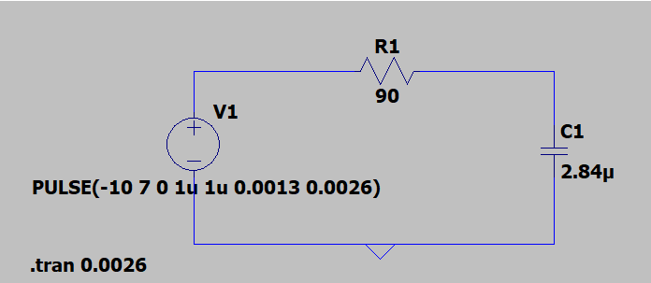Fig. 1.1 – Equivalent circuit of square wave generator with RC load.

Table 4.2

|  |  |  |  |  |  |  |  |
| --- | --- | --- | --- | --- | --- | --- | --- |
| R,  [Ω] | C,  [μF] | Data Type | I(0+),  [mA] | I(∞),  [mA] | UC(0+),  [V] | UC(∞),  [V] | τ,  [ms] |
| 90 | 4.95 | exp. | 187.27 | 1.29 | -9.89 | 6.89 | 2.5849976 |
| calc. | 188.90 | 0.00 | -10.00 | 7.00 | 0.26 |

|  |  |
| --- | --- |
|  |  |
| a) Calculations | b) Experiment |

Fig. 1.2 – Current transients in the circuit with RC load.

|  |  |
| --- | --- |
|  |  |
| a) Calculations | b) Experiment |

Fig. 1.3 – Voltage UC transients in the circuit with RC load.

# Transients in RL two-terminal load.

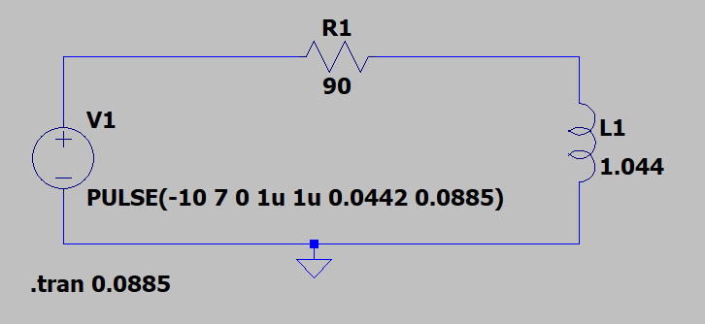Fig. 2.1 – Equivalent circuit of square wave generator with RL load.

Table 4.3

|  |  |  |  |  |  |  |  |  |
| --- | --- | --- | --- | --- | --- | --- | --- | --- |
| R,  [Ω] | L,  [mH] | Rk,  [Ω] | Data Type | I(0+),  [mA] | I(∞),  [mA] | UL(0+),  [V] | UL(∞),  [V] | τ,  [ms] |
| 90 | 1044 | 26 | exp. | 59.02 | -83.54 | -27 | -2.67 | 8.55 |
| calc. | 59.32 | -84.74 | -27 | -2.37 | 8.85 |

|  |  |
| --- | --- |
|  |  |
| a) Calculations | b) Experiment |

Fig. 2.2 – Current transients in the circuit with RL load.

|  |  |
| --- | --- |
|  |  |
| a) Calculations | b) Experiment |

Fig. 2.3 – Voltage UL transients in the circuit with RL load.

# Overdamped transients in RLC two-terminal load.

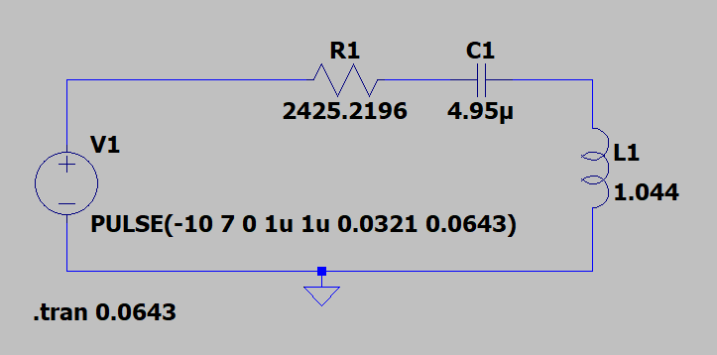Fig. 3.1 – Equivalent circuit of square wave generator with RLC load.

Table 4.4

|  |  |  |  |  |  |  |  |  |  |  |
| --- | --- | --- | --- | --- | --- | --- | --- | --- | --- | --- |
| Elements parameters | | | UC(0+) | | UL(0+) | | I(0+) | | tp | |
| R [Ω] | L [mH] | C [μF] | calc [V] | exp [V] | calc [V] | exp [V] | calc [mA] | exp [mA] | calc [ms] | exp [ms] |
| 2425.2196 | 1044 | 4.95 | 7 | 6.8 | -17 | -17 | 0 | 0.032 | 19.28 | 18.78 |

|  |  |
| --- | --- |
|  |  |
| a) Calculations | b) Experiment |

Fig. 3.2 – Voltage UC transients in the circuit with RLC load.

|  |  |
| --- | --- |
|  |  |
| a) Calculations | b) Experiment |

Fig. 3.3 – Voltage UL transients in the circuit with RLC load.

|  |  |
| --- | --- |
|  |  |
| a) Calculations | b) Experiment |

Fig. 3.4 – Current transients in the circuit with RLC load.

# Underdamped transients in RLC two-terminal load.

Table 4.5

|  |  |  |  |  |  |  |
| --- | --- | --- | --- | --- | --- | --- |
| Elements parameters | | | δ | | ω | |
| R [Ω] | L [mH] | C [μF] | calc [s-1] | exp [s-1] | calc [s-1] | exp [s-1] |
| 303.15 | 1044 | 4.95 | 145.188 | 150.7821 | 416.3189 | 414.3189 |

|  |  |
| --- | --- |
|  |  |
| a) Calculations | b) Experiment |

Fig. 4.1 – Voltage UC transients in the circuit with RLC load.

|  |  |
| --- | --- |
|  |  |
| a) Calculations | b) Experiment |

Fig. 4.2 – Voltage UL transients in the circuit with RLC load.

|  |  |
| --- | --- |
|  |  |
| a) Calculations | b) Experiment |

Fig. 4.3 – Current transients in the circuit with RLC load.