 

**Electronics and Electrical Communications Engineering  
Department**

**Faculty of Engineering**

**Cairo University**

**Implementation and Comparative Analysis of Huffman and Fano Source Coding Algorithms**

**ELC4020 “Advanced Communication Systems “**

**4th Year**

**1st Semester - Academic Year 2025/2026**

**Prepared by:**

|  |  |  |
| --- | --- | --- |
| **NAME** | **SECTION** | **ID** |
| **Mohamed Ahmed Abd El Hakam** | **3** | **9220647** |
| **Yousef Khaled Omar Mahmoud** | **4** | **9220984** |

**Submission Date:** 2 November 2025

**Instructor: Eng. Mohamed Khaled**

**Dr. Mohammed Nafie & Dr. Mohamed Khairy**

# Contents

A. **Contents** 2

**B.** **Table of Figures** 3

**C.** **Role of Each Member** 4

**D.** **Project Description** 5

**E.** **Introduction** 5

**F.** **Control Flags** 5

**G.** **Generation of Data** 6

**H.** **polar NRZ ensemble creation** 6

**I.** **Uni polar NRZ ensemble creation** 7

**J.** **polarRZ ensemble creation** 8

**K.** **Random initial time shift** 9

**L.** **Getting cell arrays ready to calculate the statistical mean and autocorrelation:** 10

**M.** **Questions** 12

**1.** **Statistical Mean** 12

**1.1.** **Hand Analysis** 12

**1.2.**  **Code Snippet** 12

**1.3.** **Plotting the Statistical Mean:** 13

**2.** **Statistical Autocorrelation** 14

**2.1.** **Hand Analysis** 14

**2.2.** **Code Snippet** 15

**2.3.** **Plotting the statistical autocorrelation** 16

**3.** **Is the Process Stationary** 18

**4.** **The time mean and autocorrelation function for one waveform** 19

**4.1.** **Time Mean** 19

**4.3.** **Time Auto Correlation** 22

**4.4.** **Time Auto Correlation for one wave form:** 23

**5.** **Is The Random Process Ergodic?** 24

**6.** **the PSD & Bandwidth of the Ensemble** 26

**6.1.** **PSD using fft:** 26

**6.2.** **Theoritical PSD:** 28

**N.** **References:** 29

**O.** **Appendix** 29

# Table of Figures

Figure 1 Rx and Tx path 5

Figure 2 ADC Binary Output 6

Figure 3 PolarNRZ Realizations 7

Figure 4 Uni Polar Realizations 8

Figure 5 PolarRZ Realization 9

Figure 6 Realization Shifted 10

Figure 7 Plot of Statistical Mean 13

Figure 8 Statistical Auto Correction plot 16

Figure 9 Statistical Auto Correction plot zoomed 16

Figure 10 autocorrelation at two different times 18

Figure 11 Time Mean for Uni Polar 19

Figure 12 Time Mean for Polar NRZ 20

Figure 13 Time Mean for Polar RZ 20

Figure 14 Time Mean Vs Realization 21

Figure 15 Time Auto Correction plot zoomed 23

Figure 16 Time Auto Correction plot 23

Figure 17 Time Mean vs Statistical 24

Figure 18 Time Auto Correlation Vs Statistical 24

Figure 19 PSD plot of the Ensemble 27

# Role of Each Member

|  |  |
| --- | --- |
| Role | Name |
| code the Huffman source coding | Youssef Khaled |
| compute the realization calculation | Ahmed Mohamed |
| compute the time calculation | Shahd Hamed |
| Report and Hand Analysis | Mohamed Ahmed |
| Report and Hand Analysis | Omar Ahmed |

# Project Description

Using software radio technique (SDR) to transmit stream of randomness bits through an ideal channel (which performing a small delay) using Matlab. Performing measures and analysis to see the performance of the system through three main line codes (unipolar, polar nrz and polar rz).

هنا ممكن تشرحله انه تشرحله انه  
source code implementqation using matlab

# Introduction

Software radio is a revolutionary approach that brings the programming code directly to the antenna, minimizing reliance on traditional radio hardware as shown in figure 1.

By doing so, it transforms challenges associated with radio hardware into software- related issues. Unlike conventional radios, where signal processing primarily relies on analog circuitry or a combination of analog and digital chips, software radio operates by having software dictate both the transmitted and received waveforms.

هنا ممكن تشرحله انه تشرحله انه  
what’s source coding and why it’s important

This paradigm shift allows for greater flexibility and adaptability in radio systems, as they can be easily reconfigured and optimized through software updates, rather than hardware modifications.

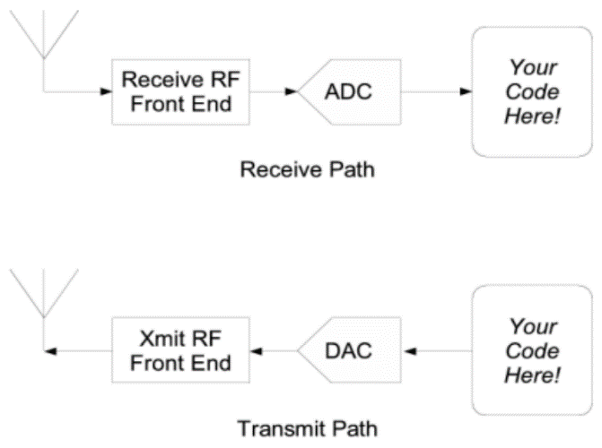

Figure 1 Rx and Tx path

# Control Flags

مفيش المرة ده ممكن تمسحها لو عاوز

|  |  |  |
| --- | --- | --- |
| Flag | Value | Description |
| A | 4 | Amplitude of line code |
| N_realizations | 500 | Number of waveforms (ensemble size) |
| num_bits | 101 | Bits per waveform and one extra bit for shifting |
| bit_duration | 70e-3 | Duration of each bit |
| dac_interval | 10e-3 | DAC update interval |

# Input Data Symbols

As seen this is the input given

كمل هنا عشان معيش أفكار

# Huffman Source Coding

حط هنا شوية معلومات عنه زي مثلا انه ممكن يوصل ل 100% لو كان عددهم ما لا نهاية

## Algorithm Overview[2]

اشرحه عادي زي ما هو شرح في السيكشن

## Hand Analysis

|  |  |  |  |  |  |  |  |  |  |  |  |  |
| --- | --- | --- | --- | --- | --- | --- | --- | --- | --- | --- | --- | --- |
| Symbol | P0 | C0 | P1 | C1 | P2 | C2 | P3 | C3 | P4 | C4 | P5 | C5 |
| A | 0.35 | 00 | 0.35 | 00 | 0.35 | 00 | 0.35 | 00 | 0.35 | 1 | 0.65 | 0 |
| B | 0.3 | 01 | 0.3 | 01 | 0.3 | 01 | 0.3 | 01 | 0.35 | 00 | 0.35 | 1 |
| C | 0.2 | 10 | 0.2 | 10 | 0.2 | 10 | 0.2 | 10 | 0.3 | 01 |  |  |
| D | 0.1 | 110 | 0.1 | 110 | 0.1 | 110 | 0.15 | 11 |  |  |  |  |
| E | 0.04 | 1110 | 0.04 | 1110 | 0.05 | 111 |  |  |  |  |  |  |
| F | 0.005 | 11110 | 0.01 | 1111 |  |  |  |  |  |  |  |  |
| G | 0.005 | 11110 |  |  |  |  |  |  |  |  |  |  |

So here’s the output that we are aiming for.

With the Kraft’s Sum,entropy, average length and efficiency:

So by calculating them we can find that:

And

So the overall efficiency is

احسب هنا ال  
kraft   
,اقله  
stratify   
,ارسمله الشجرة

## MatLab Implementation[3]

### Calculations Functions

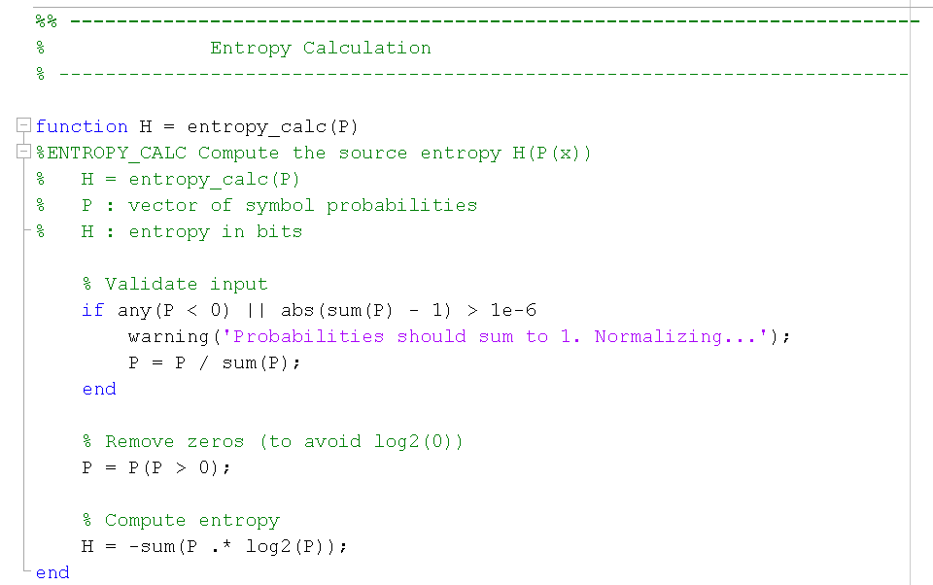First we got the calculations Functions:

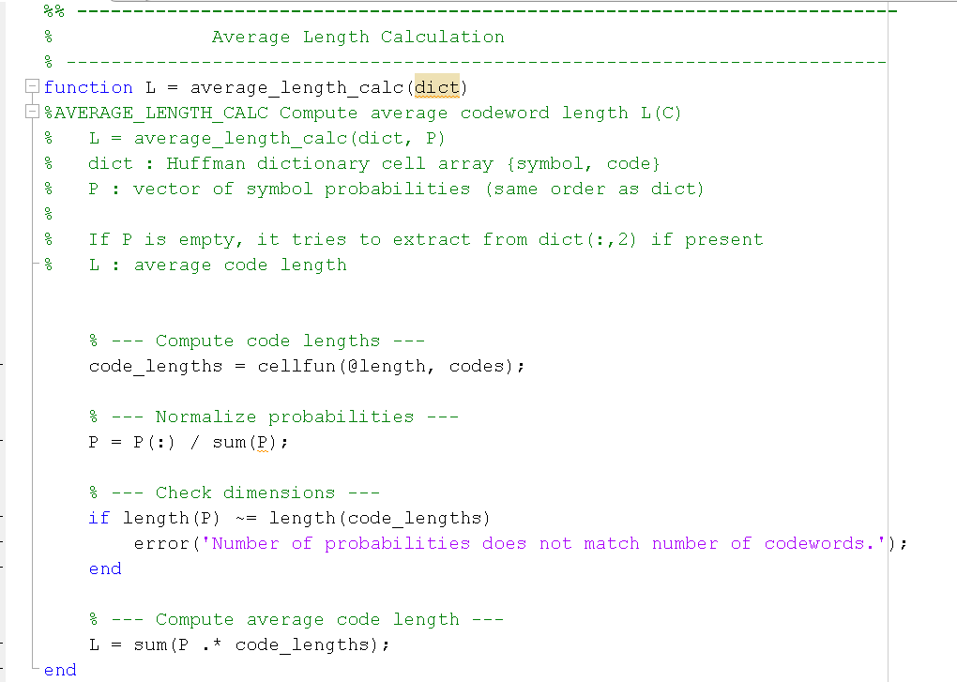And

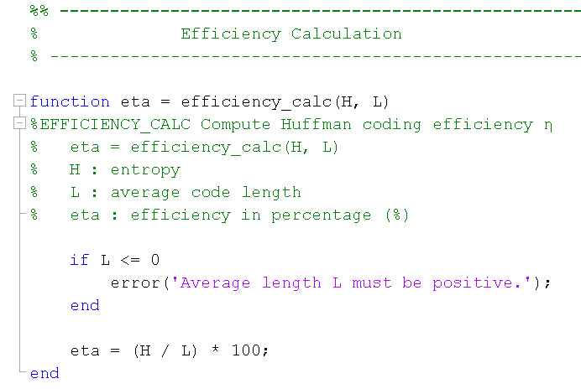And

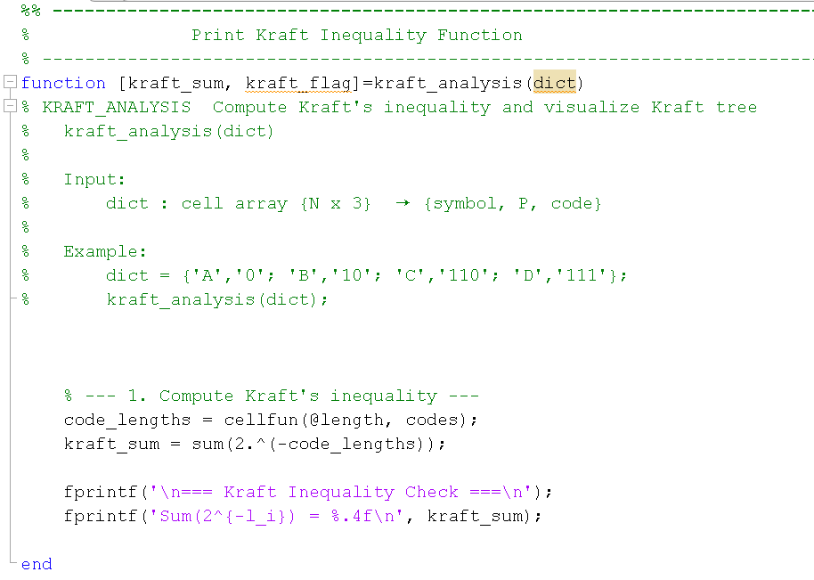And

### Getting input data

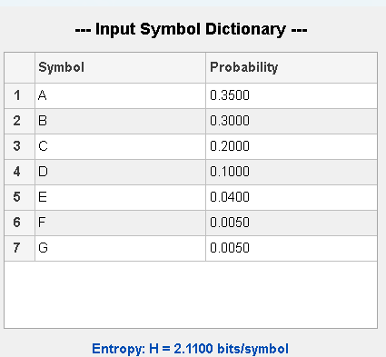So the output is:

### Huffman Function

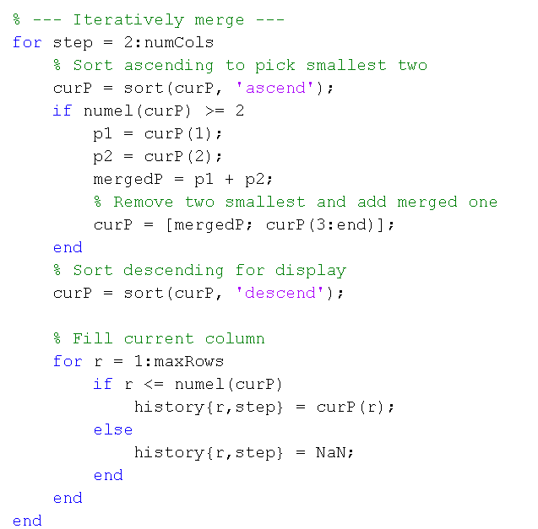First I merged the last 2 probabilities to have in last just 2 probabilities

Then I assign the codes from last column to first

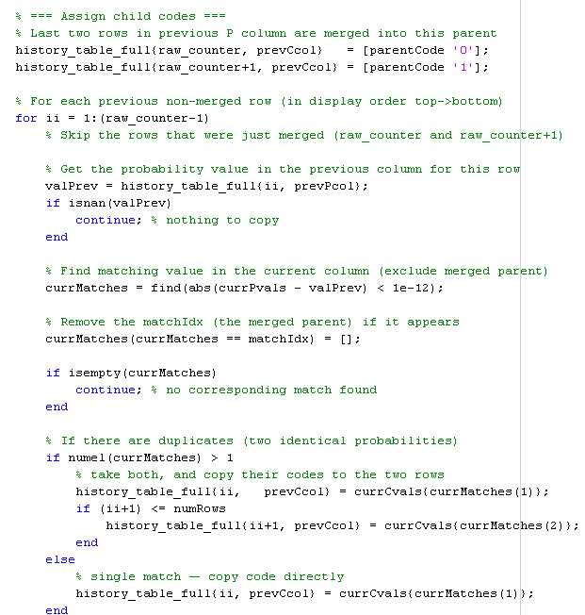

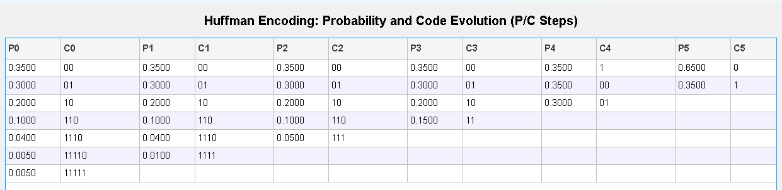So the output is:

### Theoretical Vs Practical

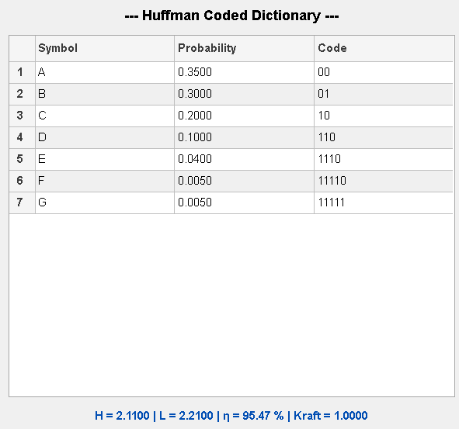 The results are:

As theoretical

# Generation of Data



Using the function: “**Randi**” to generate random binary data of size 500x101[3]

(500 waveforms each with 101 bits). This data represents the binary bits that need to be encoded.

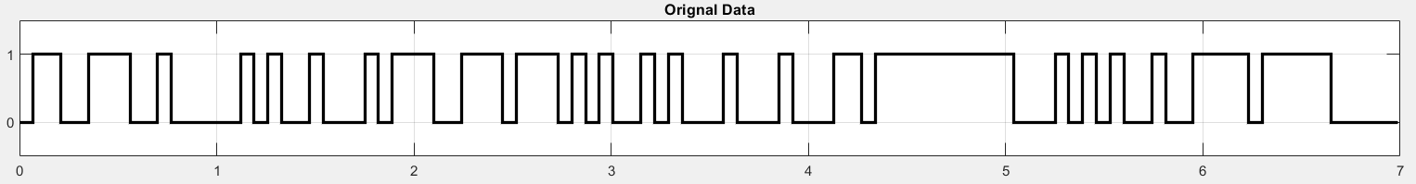

Figure 2 ADC Binary Output

For the line codes we will use this function:

# polar NRZ ensemble creation

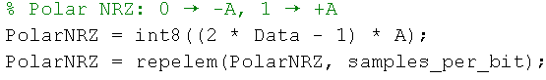

* The data consists of 0s and 1s. We converted these values to A and -A respectively.
* Then, we utilized the “**repelem”** function to repeat each element seven times (samples_num).

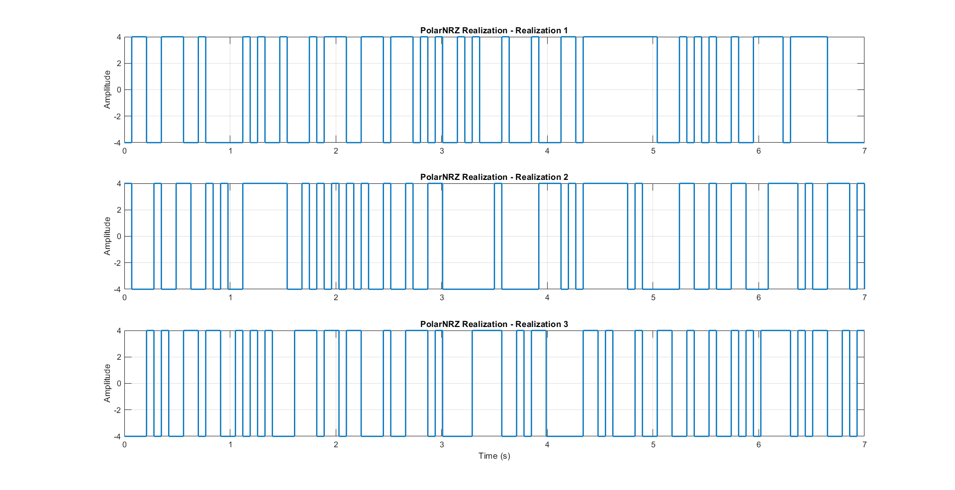

Figure 3 PolarNRZ Realizations

# Uni polar NRZ ensemble creation

* We then generate unipolar NRZ amplitudes along with its realization.
* We convert data (1,0) to 1 →A ,0→ 0 to have uni_polar_NRZ.

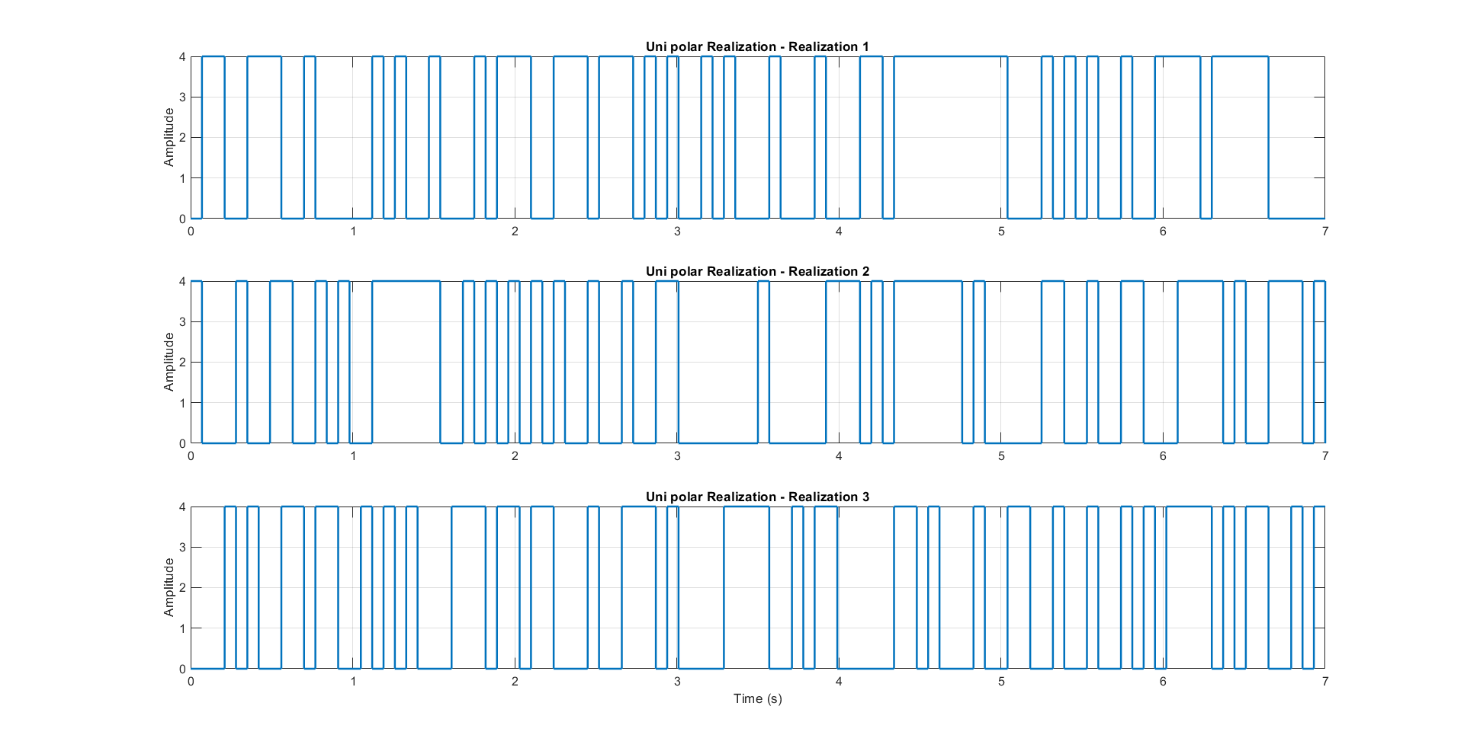

Figure 4 Uni Polar Realizations

# polarRZ ensemble creation

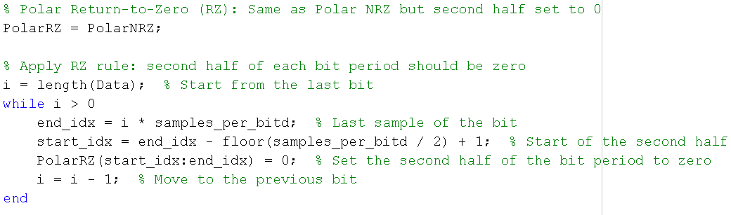

* The data consists of 0s and 1s. We first convert these values to amplitudes:  
  **0 → -A, 1 → +A** (this is the standard **Polar NRZ** encoding).
* Then, we utilized the repelem function to repeat each amplitude value samples_per_bit times. This creates a constant level for each bit across its time duration.
* To convert **Polar NRZ** to **Polar Return-to-Zero (RZ)**, we start with the Polar NRZ waveform.
* We apply the RZ rule by modifying the **second half of each bit period**:  
  For every bit, we calculate the index range that corresponds to the second half of its duration and set those values to zero.
* This creates a waveform where the signal returns to zero in the second half of each bit period, while the first half retains the Polar NRZ value (+A or -A).
* The result is a **Polar RZ** line code that has a non-zero level only during the first half of each bit, making it more suitable for synchronization at the receiver.

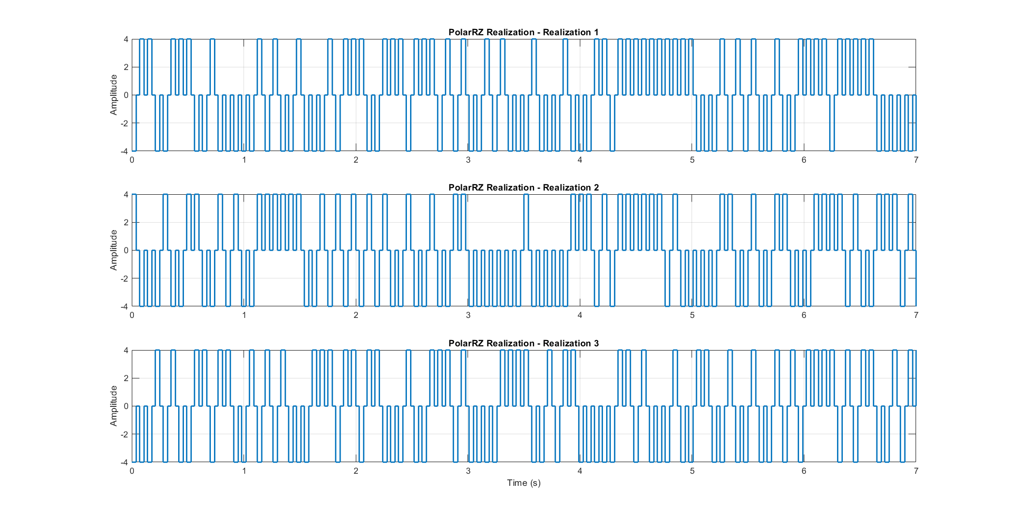

Figure 5 PolarRZ Realization

# Random initial time shift

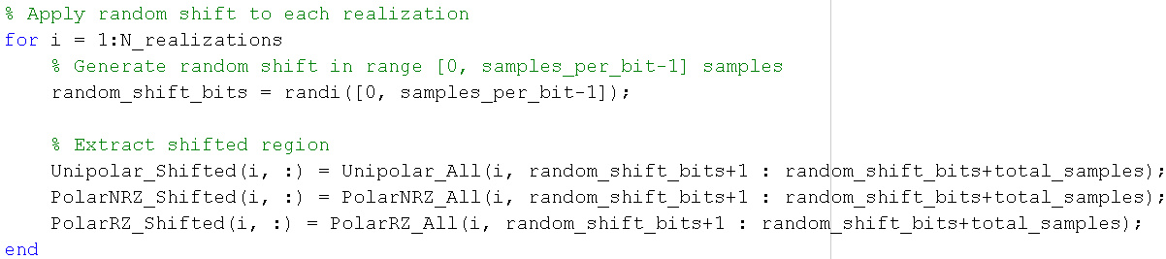For the random shift we made this function:

* Generating a single random initial time delay that can range from ‘0’ to ‘6’ samples for each waveform using the function “randi”.
* Then, we utilized the randi function to generate a random number ranging from 0 to 6, which represents the delay or start time, then we take the elements from this random index (start_indices) to 700+( start_indices).

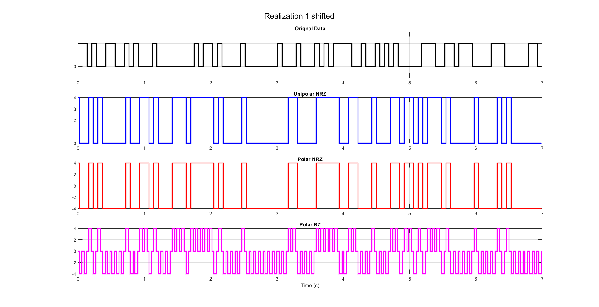

Figure 6 Realization Shifted

# Getting cell arrays ready to calculate the statistical mean and autocorrelation:

For the mean the cells are ready, as for the autocorrelation we’re going to use this function:

In which we’re making the array ready by shifting it with tau.

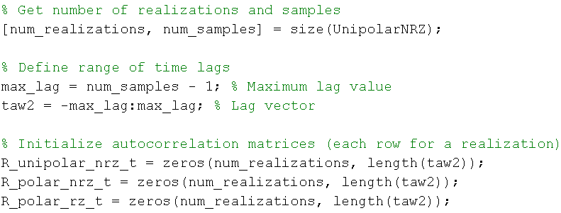

So the array will have the length of max tau which is 700.

# Questions

## Statistical Mean

### Hand Analysis

For the “Statistical Mean” which represents the average of all the realizations at the same time instant, let us consider the first line code method “Unipolar NRZ”

𝜇𝑋(𝑡) = 0 ∗ 0.5 + 4 ∗ 0.5 = 2 (𝐶𝑜𝑛𝑠𝑡𝑎𝑛𝑡 𝑎𝑐𝑟𝑜𝑠𝑠 𝑡𝑖𝑚𝑒)

And in the same matter, we can calculate the “Statistical Mean” for both “Polar NRZ” and “Polar RZ” as following:

𝜇𝑋_𝑃𝑁𝑅𝑍(𝑡) = 4 ∗ 0.5 + (−4) ∗ 0.5 = 0 (𝐶𝑜𝑛𝑠𝑡𝑎𝑛𝑡 𝑎𝑐𝑟𝑜𝑠𝑠 𝑡𝑖𝑚𝑒).

𝜇𝑋_𝑃𝑅𝑍(𝑡) = 4 ∗ 0.5 + (−4) ∗ 0.5 = 0 (𝐶𝑜𝑛𝑠𝑡𝑎𝑛𝑡 𝑎𝑐𝑟𝑜𝑠𝑠 𝑡𝑖𝑚𝑒).

### Code Snippet

* The mean is calculated as μ=ΣΧ/N (the sum divided by the number of the elements).

### Plotting the Statistical Mean:

Figure 7 Plot of Statistical Mean

* As expected, polar RZ & NRZ have almost zero mean and the uni polar has mean around 2 Bec its amplitude ranges from 0:4.

## Statistical Autocorrelation

### Hand Analysis

𝑹𝑿(𝝉) = 𝑬[𝑿(𝝉) 𝑿(𝒕 + 𝝉)] = ∑ 𝑿(𝝉) 𝑿(𝒕 + 𝝉) 𝑷(𝑿(𝝉) 𝑿(𝒕 + 𝝉))

* + **For Unipolar NRZ:**

We have 2 cases **(Considering T to be 70ms or 7 samples),**

1. |𝝉| < 𝑻

𝑅𝑋(𝜏) = 𝐸[𝑋(𝜏) 𝑋(𝑡 + 𝜏)]

= 42 ∗ 𝑃(4,4) + 02 ∗ 𝑃(0,0) + 4 ∗ 0 ∗ 𝑃(0,4) + 0 ∗ 4 ∗ 𝑃(4,0)

= 42 ∗ 𝑃(4,4)

𝑃(4,4) = 𝑃(𝑋(𝑡 + 𝜏) = 4 | 𝑋(𝑡) = 4) ∗ 𝑃(𝑋(𝑡) = 4)

𝑃(𝑋(𝑡 + 𝜏) = 4 | 𝑋(𝑡) = 4) = 𝑃(𝑇̅) + 𝑃(𝑇) ∗ 𝑃(𝑋(𝑡 + 𝜏) = 4)

1. |𝝉| > 𝑻

𝑅𝑋(𝜏) = 𝐸[𝑋(𝜏) 𝑋(𝑡 + 𝜏)]

= 42 ∗ 0.5 ∗ 0.5 + 02 ∗ 0.5 ∗ 0.5 + 4 ∗ 0 ∗ 0.5 ∗ 0.5 + 0 ∗ 4 ∗ 0.5 ∗ 0.5

= 42 ∗ 0.5 ∗ 0.5

= 4

* + And using the same flow, we can find that the ACF for “**Polar NRZ**” is
  + And similarly, the ACF for “**Polar RZ**” is

**And as we know:**

𝑇𝑜𝑡𝑎𝑙 𝑃𝑜𝑤𝑒𝑟 = 𝑅𝑋(0) & 𝐷𝐶 𝑃𝑜𝑤𝑒𝑟 = 𝑅𝑋(∞).

𝐴𝐶 𝑃𝑜𝑤𝑒𝑟 = 𝑇𝑜𝑡𝑎𝑙 𝑃𝑜𝑤𝑒𝑟 − 𝐷𝐶 𝑃𝑜𝑤𝑒𝑟.

|  |  |  |  |
| --- | --- | --- | --- |
|  | **Unipolar NRZ** | **Polar NRZ** | **Polar RZ** |
| **Total Power** | **8** | **16** | **9.147** |
| **DC Power** | **4** | **0** | **0** |
| **AC Power** | **4** | **16** | **9.147** |

### Code Snippet

**Annotations**

* The Statistical Autocorrelation is created by taking the element-wise product of each column with the first column of a selected matrix of data points, then averaging the resulting column-wise products.
* To guarantee that Autocorr is an even fun we concatenate between the result of fliplr fun & the averages vector before flipping (2:700 to ensure no repeated value at zero).

### Plotting the statistical autocorrelation

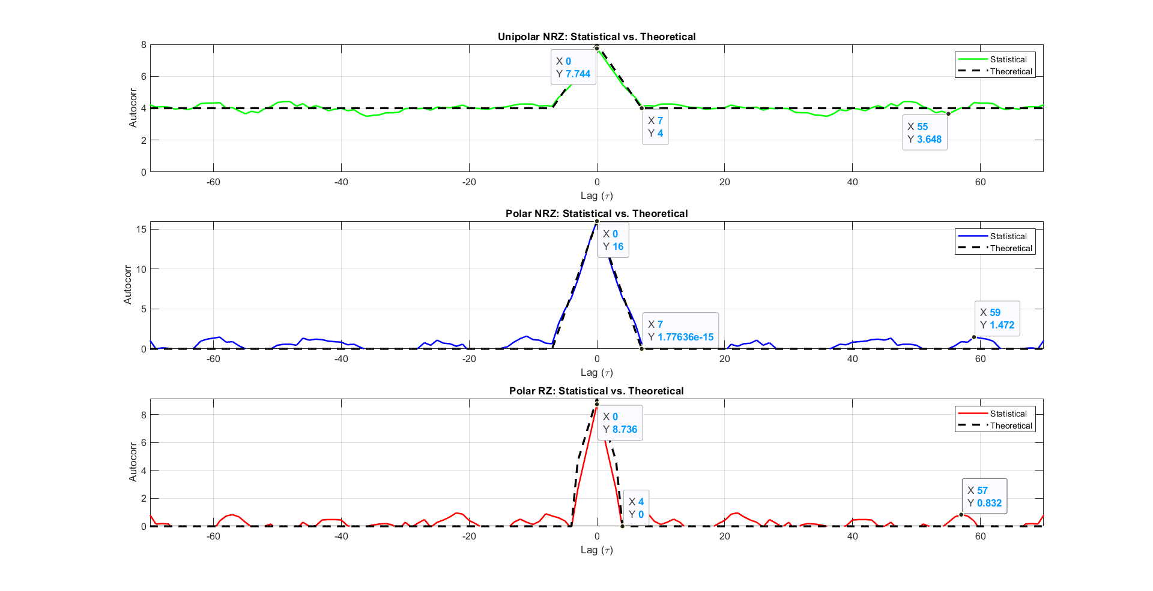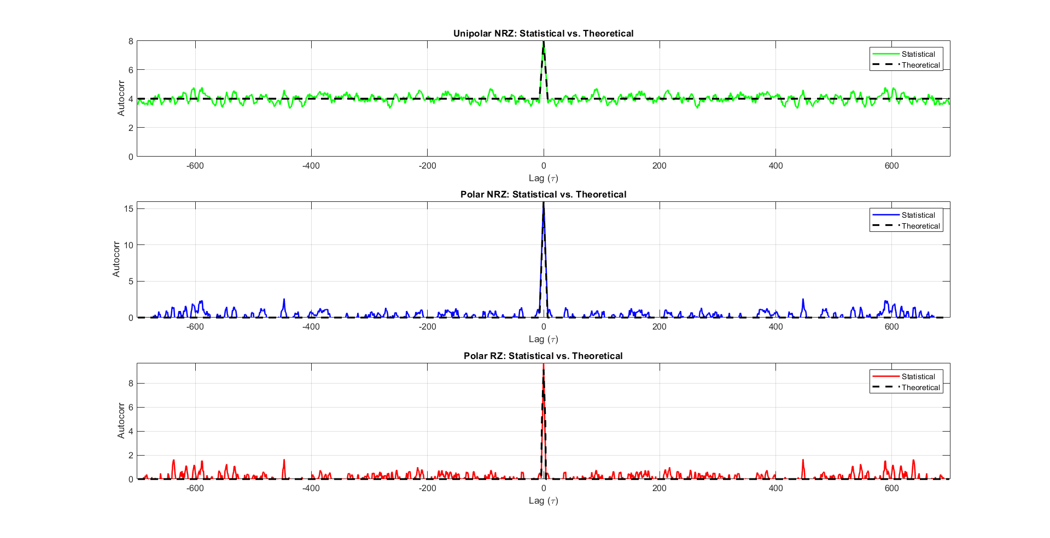

Figure 8 Statistical Auto Correction plot

Figure 9 Statistical Auto Correction plot zoomed

The resulting autocorrelation values are plotted against the corresponding time delays (τ). We observe that at τ = 0 the autocorrelation with the point itself is maximum, indicating perfect correlation.

* **Uni polar:** The autocorrelation becomes constant after 7 samples, as we calculated to be the bit duration and it’s around 4, The maximum at zero equals 7.744 ≈ 8.
* **Polar NRZ:** The autocorrelation becomes constant after 7 samples, as we calculated to be the bit duration and it’s around zero, The maximum at zero equals 16.
* **Polar RZ:** The autocorrelation becomes constant after 4 samples, as we calculated to be the half bit duration and it’s around zero, The maximum at zero equals 8.736 ≈ 9.147.

## Is the Process Stationary

Figure 10 autocorrelation at two different times

* For the **mean**, as shown in section 1 figure 7 the **mean** ≈ **constant with time**.
* For the **autocorrelation**, as shown in figure 9 the **autocorrelation R(t1=1)** ≈ **R(t2=8).**

Yes, the process is stationary (WSSP) because the mean is constant function in time as shown in Figure 7 Plot of Statistical Mean and the autocorrelation depends only on the time difference not the absolute time.

## The time mean and autocorrelation function for one waveform

### Time Mean

* We add the values of a realization across time instant then divide by the number of samples (700 sample per realization).

Figure 11 Time Mean for Uni Polar

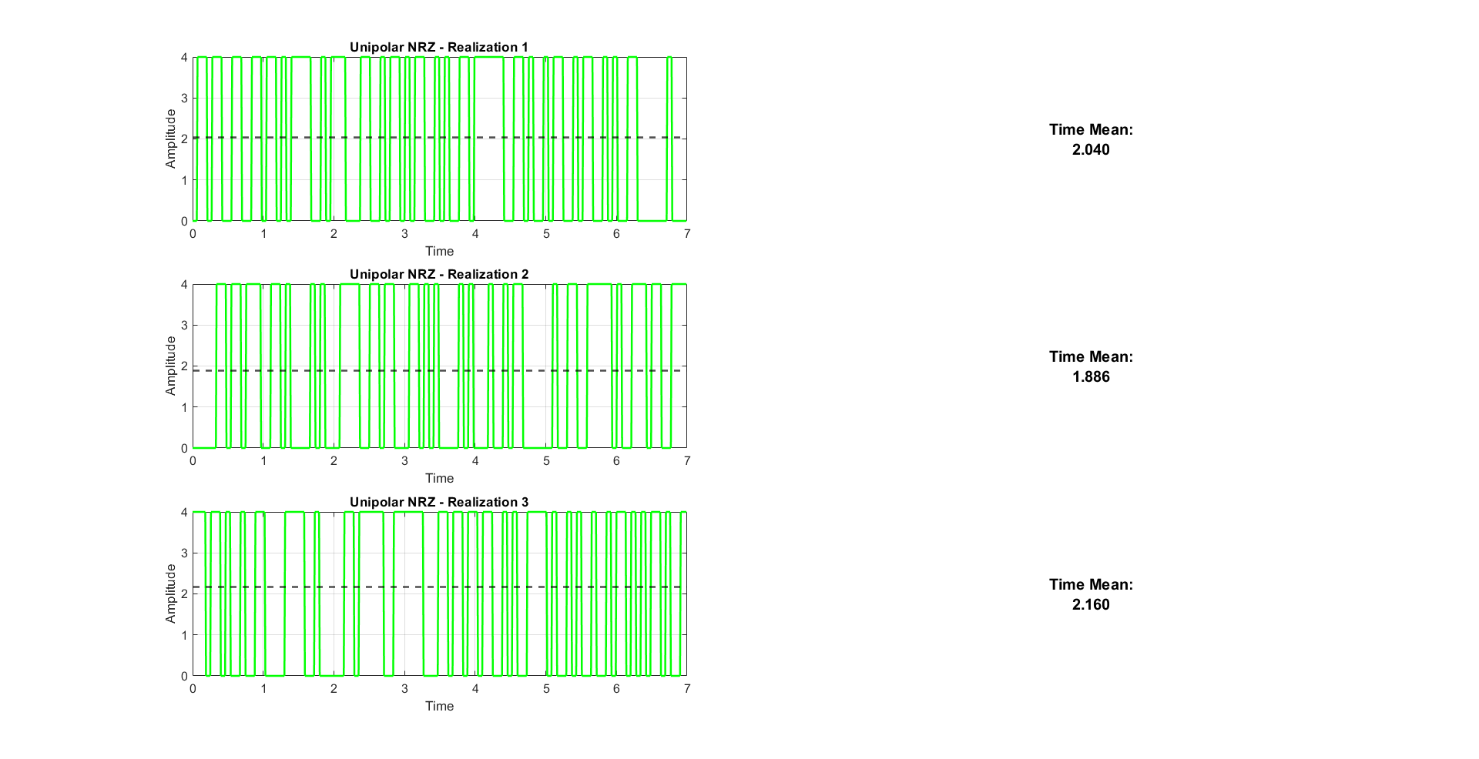

* 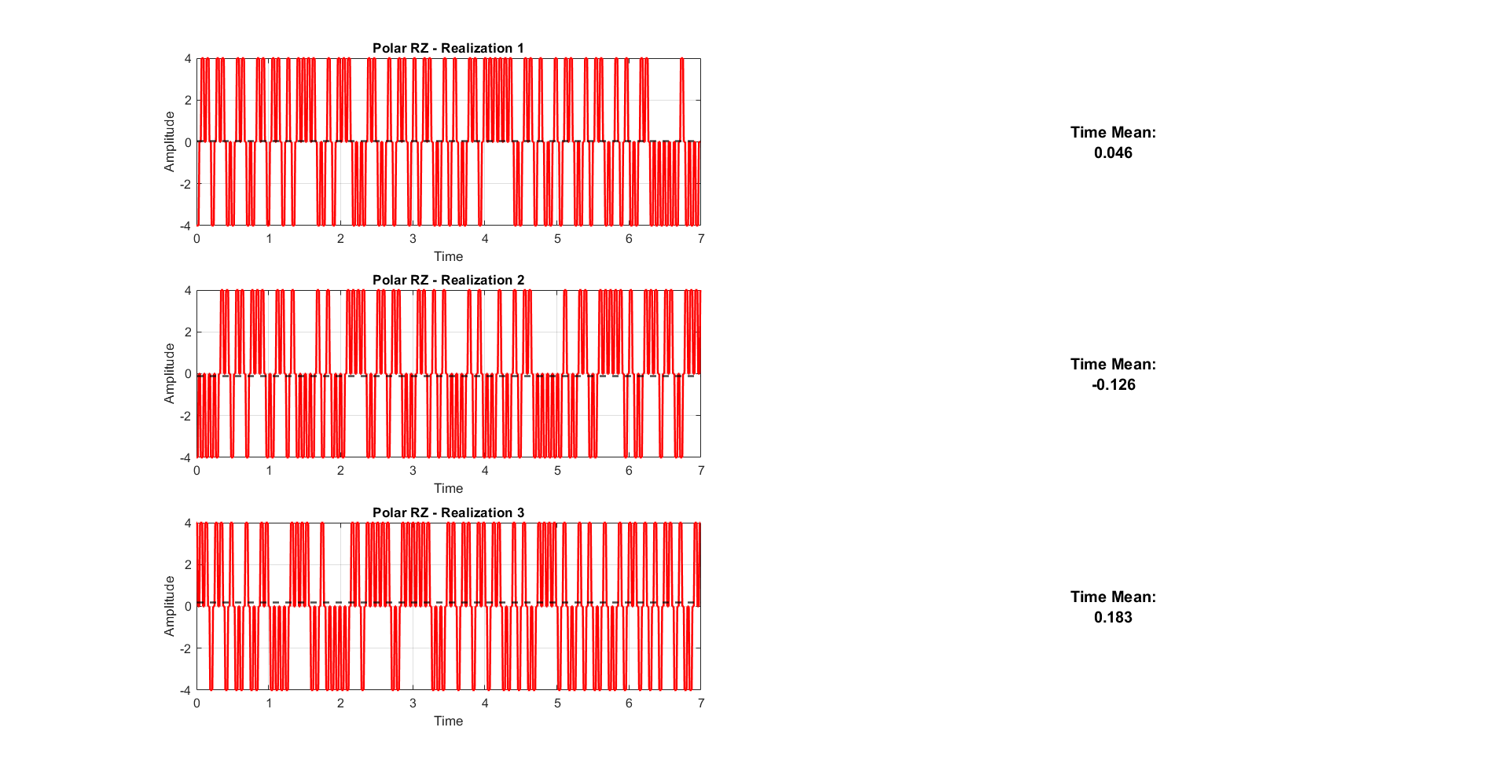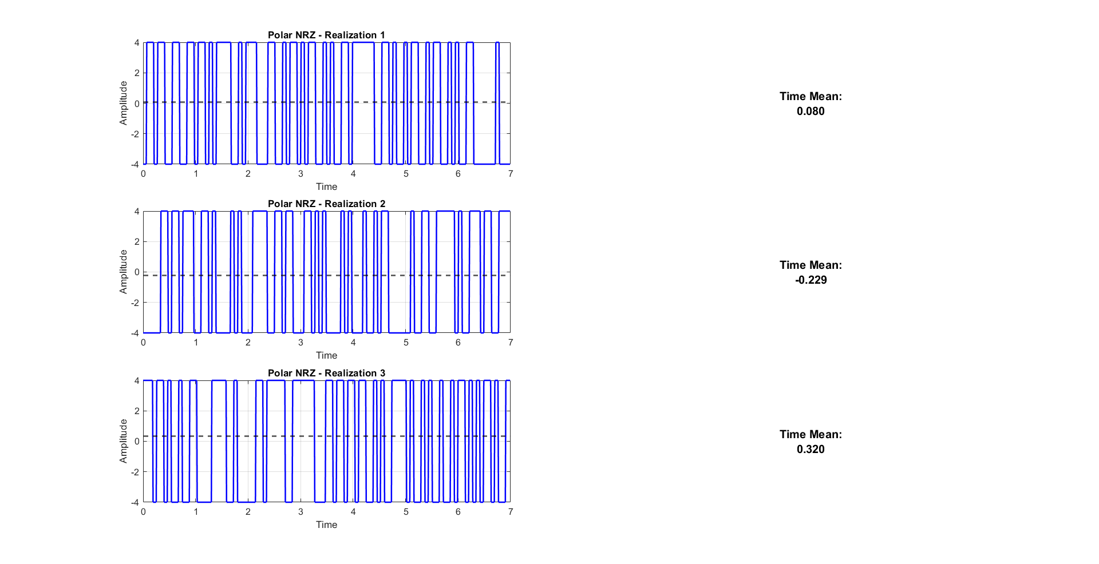As expected, polar RZ & NRZ have almost zero mean and the uni polar has mean around 2 Because its amplitude ranges from 0 : 4

Figure 12 Time Mean for Polar NRZ

Figure 13 Time Mean for Polar RZ

### Time Mean Vs Realization

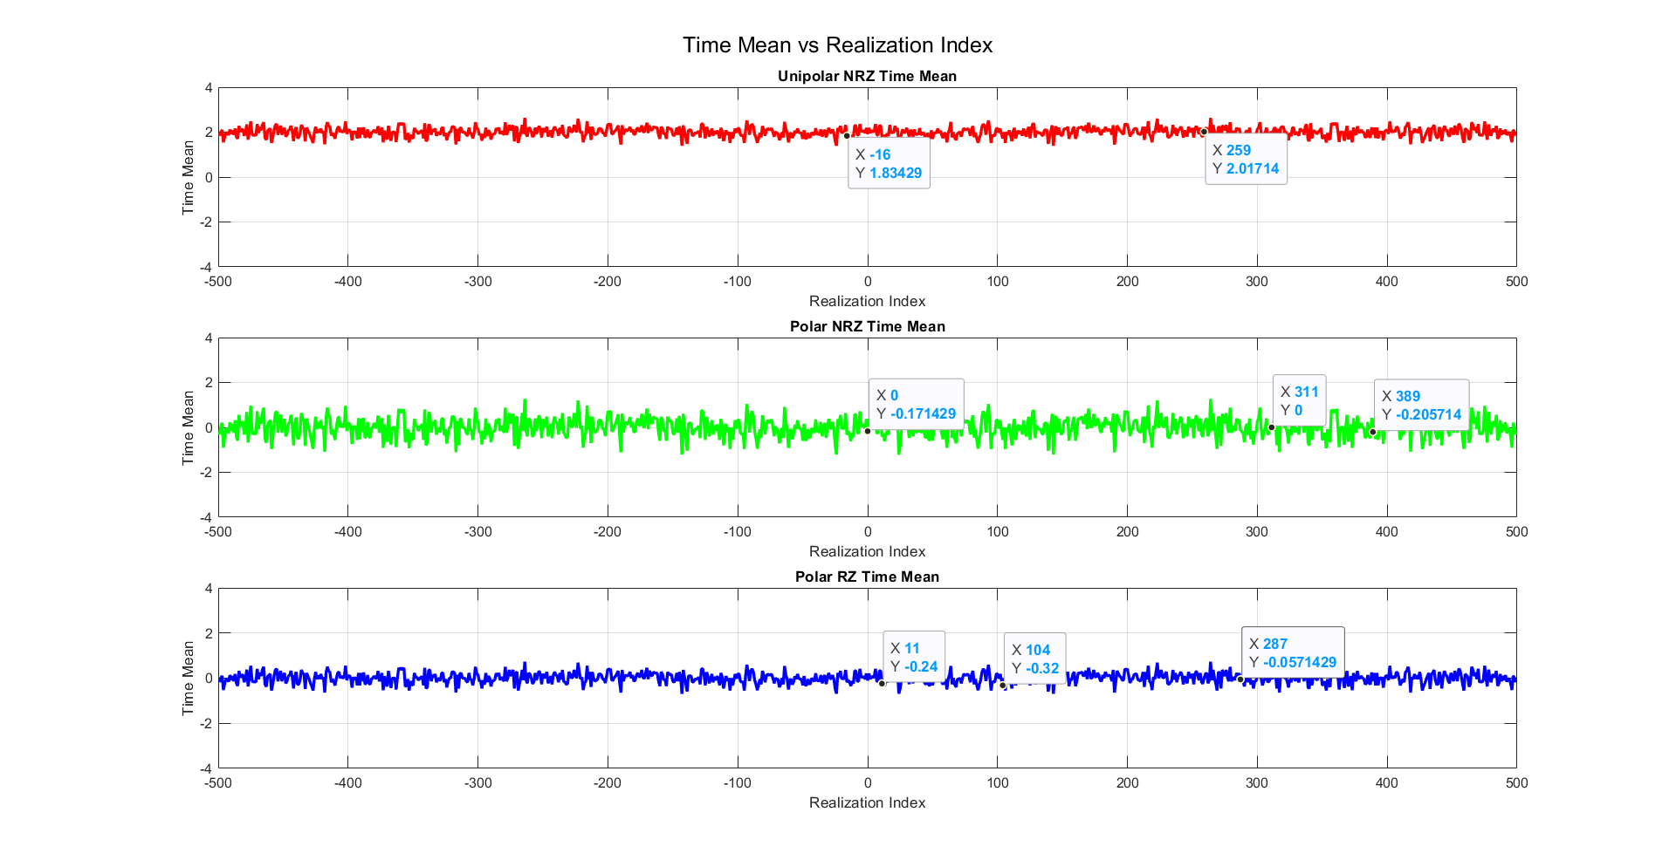

Figure 14 Time Mean Vs Realization

* As expected the time mean is almost equal to the statistical mean.
* Polar RZ & NRZ have almost zero mean and the uni polar has mean around 2.

### Time Auto Correlation

For the time Auto Correlation we’re going to use this function

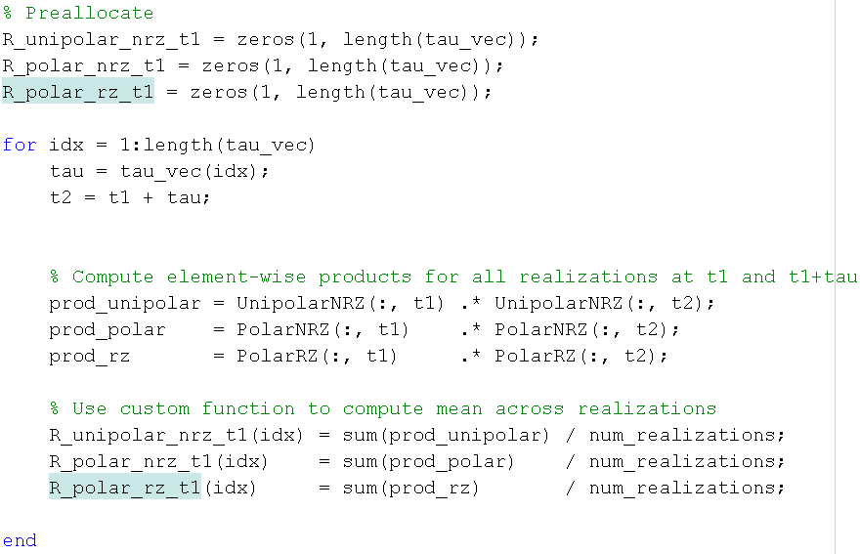

### Time Auto Correlation for one wave form:

Figure 15 Time Auto Correction plot zoomed

Figure 16 Time Auto Correction plot

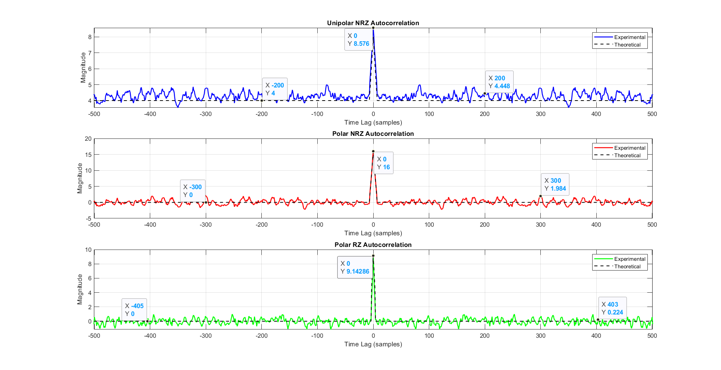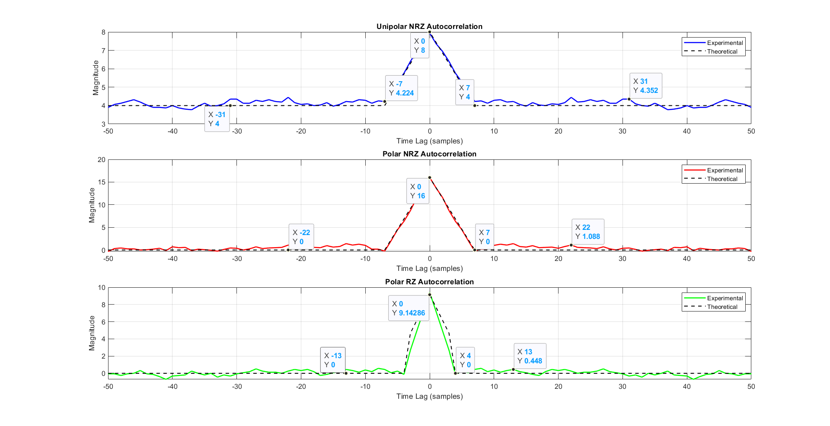

As shown in the graphs:

* The time autocorrelation is closely same as the ensemble  
  autocorrelation.
* The autocorrelation function has maximum at 𝛕 = 𝟎 and it is an even function.

## Is The Random Process Ergodic?

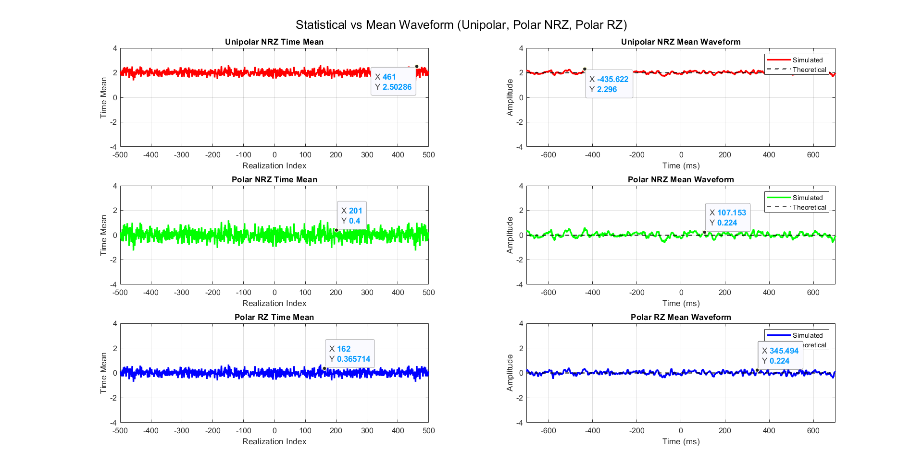

Figure 17 Time Mean vs Statistical

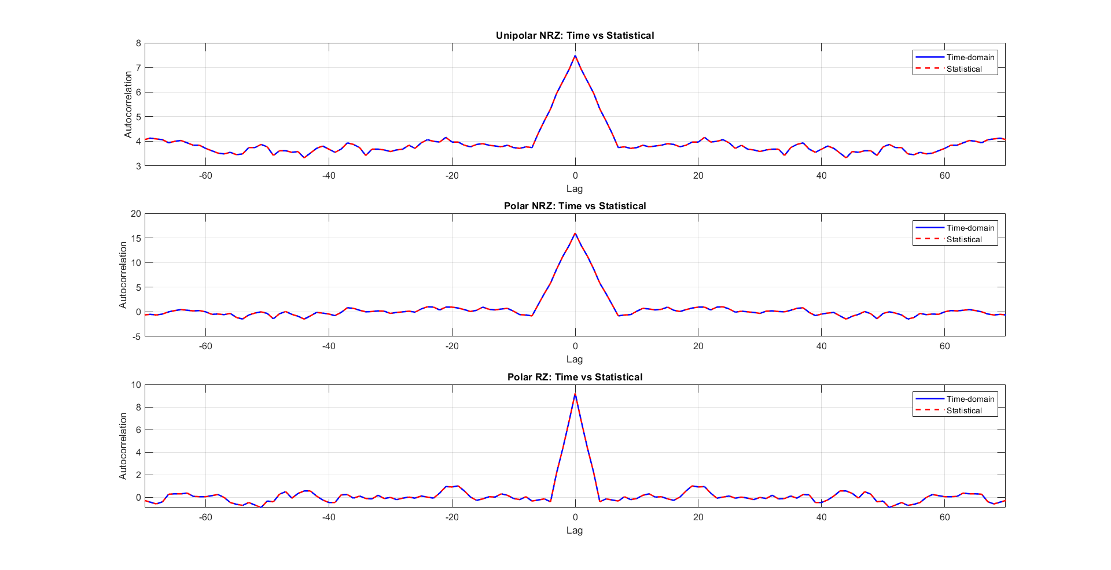

Figure 18 Time Auto Correlation Vs Statistical

* For the **mean**, the Time mean is almost equal to the statistical mean.
* For the **Auto Correlation,** the Time looks almost identical to the statistical.

But, There not fully identical as we ran this code snippet



And the result was **0.5760, so they are almost Identical.**

* Yes, because the time mean ≈ the Statistical mean and the time autocorrelation is ≈ the ensemble autocorrelation.

**Then this process is ergodic**

## the PSD & Bandwidth of the Ensemble

### PSD using fft:

For the **PSD,** we are going to use this function:

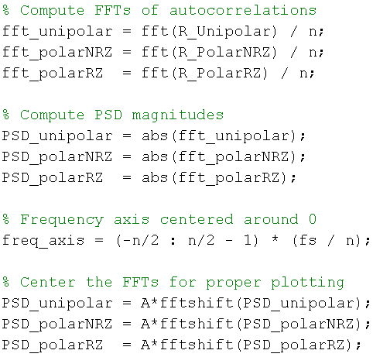

* We take the Fourier transform of the avg time autocorrelation **= 0.5*(R(t1)+ R(t2))** then centralize the graph around zero.
* since
* **For the BW**
* the BW is the frequency of the first zero of sinc^2 function (intersection with frequency-axis)

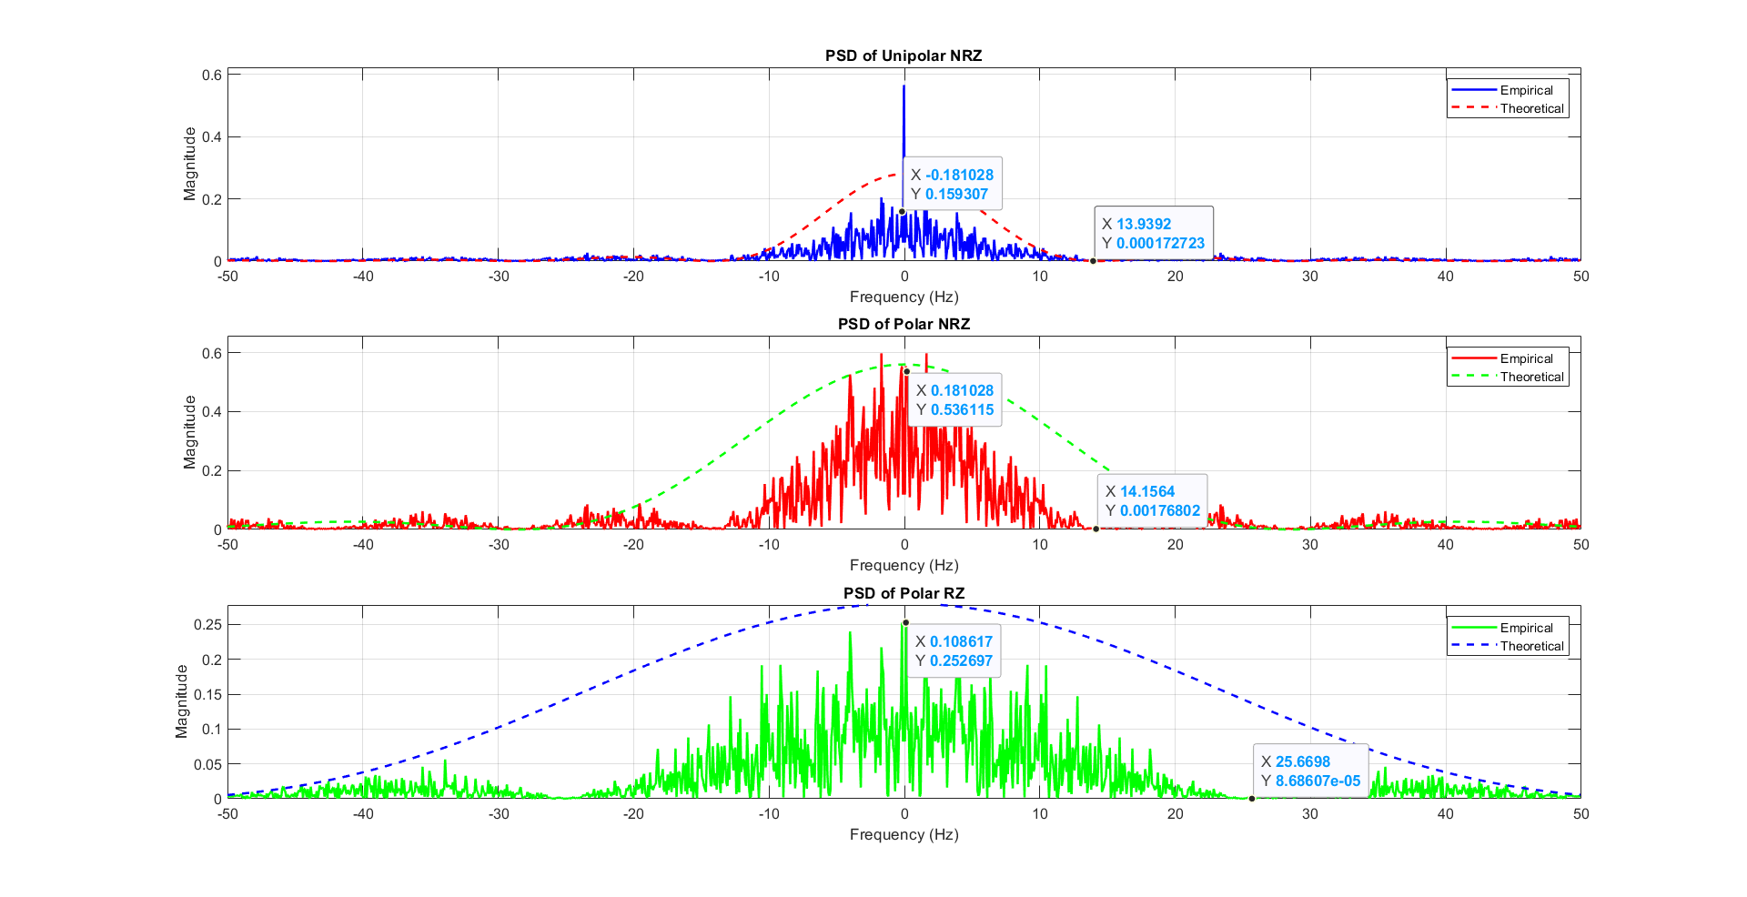

Figure 19 PSD plot of the Ensemble

**Annotations**

* in polar RZ & NRZ : we have sinc^2 function without delta at zero frequency (NO DC)
* in uni polar NRZ : we have sinc^2 function with delta at zero frequency (there is DC)
* BW of the unipolar NRZ & polar NRZ is the bitrate which approximately equal 14 hz
* BW of the polar RZ is the double of bitrate which approximately equal 25.66 hz

### Theoritical PSD:

From **references[1], [2]**, we found out that the PSDs are:

|  |  |
| --- | --- |
| Line Code | PSD |
| Uni Polar | S(f)=A2/4*Tb*(sin(πfTb)/πfTb)2 + A2/4* δ(f) |
| Polar NRZ | S(f)=A2*Tb*(sin(πfTb/2)/πfTb/2)2 |
| Polar RZ | S(f)=A2*Tb*(sin(πfTb/4)/πfTb/4)2 |

Note that:

* Uni polar has a DC pulse which is noticeable in figure 19
* Polar don’t have the DC pulse
* Polar RZ has double the frequency of Polar NRZ
* A=4, Tb = 70 ms

So by comparing the practical vs theoretical:

|  |  |  |
| --- | --- | --- |
| Line Code | Theoritcal PSD at f=0 | Paractical PSD at f=0 |
| Uni Polar | A2/4*Tb =0.28 | 0.159 |
| Polar NRZ | A2/2*Tb =0.56 | 0.536 |
| Polar RZ | A2/4*Tb =0.28 | 0.252 |

For **BW:**

|  |  |  |
| --- | --- | --- |
| Line Code | Theoritcal BW | Paractical BW |
| Uni Polar | 1/Tb = 14.285 Hz | 13.972 Hz |
| Polar NRZ | 1/Tb = 14.285 Hz | 14.15 Hz |
| Polar RZ | 2/Tb = 28.57 Hz | 25.66 Hz |

# References:

[1] **Dr. Mohammed Nafie,** "Lecture Slides in Advanced Communications," ELC4020 Advanced Communication Systems, Cairo University, 2025.

[2] **Eng. Mohamed Khaled,** "Section Slides in Advanced Communications," ELC4020 Advanced Communication Systems, Cairo University, 2025.

[**3]** <https://github.com/youefkh05/Advanced_Communication_Coding>

# Appendix

%%------------------------------------------------------------

% Problem 1: Binary Huffman Coding

%------------------------------------------------------------

clc; clear; close all force;

% Given Symbols probabilities

symbols = {'A','B','C','D','E','F','G'};

P = [0.35 0.30 0.20 0.10 0.04 0.005 0.005];

% Create Input Dictionary

[dict_input,err_flag, H] = create_symbols_dictionary(symbols, P);

% Check Input

if err_flag ==1

disp('? Stopping execution due to invalid dictionary.');

return; % exits the current script or function

end

% Print the dictionary neatly

print_symbols_dic(dict_input, H);

% -------------------------------------------------------------------------

% Manual Huffman Coding (with custom output)

% -------------------------------------------------------------------------

dict_huffman = huffman_encoding_visual(dict_input);

disp('--- Manual Huffman Encoding ---');

disp(dict_huffman);

% Print the codded dictionary neatly

print_coded_dict(dict_huffman, H);

%%------------------------------------------------------------

% Problem 2: Binary Fano Coding

%------------------------------------------------------------

%{

????? ??????? ?? ?????

???????? ?? ??

input

???????

dict_input

??

funtions

H

L

eta

??? ?????? ?????

???? ?????? ?????? ??

dict_Fano = Fano_encoding_visual(dict_input);

???? ?? ?? function

???? ??? ????

%}

% -------------------------------------------------------------------------

% Manual Fano Coding (with custom output)

% -------------------------------------------------------------------------

dict_Fano = Fano_encoding_visual(dict_input);

disp('--- Manual Fano Encoding ---');

disp(dict_Fano);

% Print the codded dictionary neatly

print_coded_dict(dict_Fano, H);

%%

% -------------------------------------------------------------------------

% Function Definition

% -------------------------------------------------------------------------

%% -------------------------------------------------------------------------

% Entropy Calculation

% -------------------------------------------------------------------------

function H = entropy_calc(P)

%ENTROPY_CALC Compute the source entropy H(P(x))

% H = entropy_calc(P)

% P : vector of symbol probabilities

% H : entropy in bits

% Validate input

if any(P < 0) || abs(sum(P) - 1) > 1e-6

warning('Probabilities should sum to 1. Normalizing...');

P = P / sum(P);

end

% Remove zeros (to avoid log2(0))

P = P(P > 0);

% Compute entropy

H = -sum(P .* log2(P));

end

%% -------------------------------------------------------------------------

% Average Length Calculation

% -------------------------------------------------------------------------

function L = average_length_calc(dict)

%AVERAGE_LENGTH_CALC Compute average codeword length L(C)

% L = average_length_calc(dict, P)

% dict : Huffman dictionary cell array {symbol, code}

% P : vector of symbol probabilities (same order as dict)

%

% If P is empty, it tries to extract from dict(:,2) if present

% L : average code length

P = dict(:,2);

% --- Handle inputs ---

if nargin < 2 || isempty(P)

% Check if dict has a probability column (3 columns)

if size(dict, 2) >= 3 && isnumeric(dict{1,2})

P = cell2mat(dict(:,2));

codes = dict(:,3);

else

error('Probability vector P is required or must be in dict(:,2)');

end

else

% Extract codes (assumed in 2nd column)

codes = dict(:,3);

end

% --- Compute code lengths ---

code_lengths = cellfun(@length, codes);

% --- Normalize probabilities ---

P = P(:) / sum(P);

% --- Check dimensions ---

if length(P) ~= length(code_lengths)

error('Number of probabilities does not match number of codewords.');

end

% --- Compute average code length ---

L = sum(P .* code_lengths);

end

%% -------------------------------------------------------------------------

% Efficiency Calculation

% -------------------------------------------------------------------------

function eta = efficiency_calc(H, L)

%EFFICIENCY_CALC Compute Huffman coding efficiency ?

% eta = efficiency_calc(H, L)

% H : entropy

% L : average code length

% eta : efficiency in percentage (%)

if L <= 0

error('Average length L must be positive.');

end

eta = (H / L) * 100;

end

%% -------------------------------------------------------------------------

% Print Kraft Inequality Function

% -------------------------------------------------------------------------

function [kraft_sum, kraft_flag]=kraft_analysis(dict)

% KRAFT_ANALYSIS Compute Kraft's inequality and visualize Kraft tree

% kraft_analysis(dict)

%

% Input:

% dict : cell array {N x 3} ? {symbol, P, code}

%

% Example:

% dict = {'A','0'; 'B','10'; 'C','110'; 'D','111'};

% kraft_analysis(dict);

if ~iscell(dict) || size(dict,2) < 2

error('Input must be a cell array {symbol, code}');

end

% Extract codes

codes = dict(:,3);

N = length(codes);

% --- 1. Compute Kraft's inequality ---

code_lengths = cellfun(@length, codes);

kraft_sum = sum(2.^(-code_lengths));

fprintf('\n=== Kraft Inequality Check ===\n');

fprintf('Sum(2^{-l_i}) = %.4f\n', kraft_sum);

if abs(kraft_sum - 1) < 1e-6

fprintf('? Code satisfies equality ? Complete Prefix Code.\n');

kraft_flag=2;

elseif kraft_sum < 1

fprintf('? Code satisfies inequality (valid but not complete).\n');

kraft_flag=1;

else

fprintf('? Invalid prefix code (violates Kraft''s inequality).\n');

kraft_flag=0;

end

end

%% -------------------------------------------------------------------------

% Create Dictionary Input Definition

% -------------------------------------------------------------------------

function [dict_input,err_flag, H] = create_symbols_dictionary(symbols, P)

%CREATE_DICTIONARY Combines symbols and probabilities into a validated dictionary.

%

% dict_input = create_dictionary(symbols, P)

%

% Inputs:

% symbols - cell array of symbols, e.g. {'A','B','C'}

% P - corresponding probabilities (row or column vector)

%

% Output:

% dict_input - cell array {symbol, probability}

%

% Example:

% symbols = {'A','B','C'};

% P = [0.5 0.3 0.2];

% dict_input = create_dictionary(symbols, P);

% Combine into dictionary-like cell array

dict_input = [symbols(:), num2cell(P(:))];

% Assume not great until great

err_flag = 1;

% Validate using the check_symbols() function

[ok, msg] = check_symbols(dict_input);

% Display validation result

if ok

disp('? Dictionary is valid!');

err_flag =0;

else

disp(['? Error: ' msg]);

err_flag = 1;

end

% ---------------------------------------------------------------------

% Compute entropy (only if valid)

% ---------------------------------------------------------------------

H = entropy_calc(P)

end

%% -------------------------------------------------------------------------

% Check Input Validation Function

% -------------------------------------------------------------------------

function [isValid, errMsg] = check_symbols(dict_input)

% CHECK_SYMBOLS Validates a symbol-probability dictionary

%

% [isValid, errMsg] = check_symbols(dict_input)

%

% Input:

% dict_input : Cell array {N×2}, where first column = symbols,

% second column = probabilities

%

% Output:

% isValid : Logical true if valid, false otherwise

% errMsg : String describing validation error (if any)

% Default output

isValid = false;

errMsg = '';

try

% Extract symbols and probabilities

symbols = dict_input(:, 1);

P = cell2mat(dict_input(:, 2));

% Check same length

if numel(symbols) ~= numel(P)

errMsg = 'Symbols and probabilities must have the same length.';

return;

end

% Check probabilities sum to 1 (within tolerance)

if abs(sum(P) - 1) > 1e-6

errMsg = sprintf('Probabilities do not sum to 1 (sum = %.6f).', sum(P));

return;

end

% Check all probabilities are positive

if any(P <= 0)

errMsg = 'All probabilities must be positive.';

return;

end

% If all checks passed

isValid = true;

catch ME

errMsg = ['Invalid dictionary input: ' ME.message];

end

end

%% -------------------------------------------------------------------------

% Print Dictionary Function

% -------------------------------------------------------------------------

function print_symbols_dic(dict_input, H)

% PRINT_SYMBOLS_DIC Displays a formatted version of the symbol dictionary in a figure,

% and shows the calculated source entropy.

%

% print_symbols_dic(dict_input, H)

%

% Inputs:

% dict_input - cell array {symbol, probability}

% H - source entropy (bits/symbol)

% Validate input

if nargin < 1 || isempty(dict_input)

error('Input dictionary is empty or missing.');

return;

end

% Convert symbols to char (uitable can't handle string objects)

symbols = cellfun(@char, dict_input(:,1), 'UniformOutput', false);

probs = cell2mat(dict_input(:,2));

% Display result in Command Window

fprintf('\nInformation Source Entropy: H = %.4f bits/symbol\n', H);

fprintf('-----------------------------------------------------\n');

% Create a responsive UI figure

f = uifigure('Name', 'Symbol Dictionary', ...

'NumberTitle', 'off', ...

'Color', 'w', ...

'Position', [500 400 350 320]);

% Format probabilities as strings

probStr = arrayfun(@(p) sprintf('%.4f', p), probs, 'UniformOutput', false);

% Combine into table data

data = [symbols probStr];

% Create a grid layout (auto-resizes)

gl = uigridlayout(f, [3,1]);

gl.RowHeight = {'fit', '1x', 'fit'}; % title, table, entropy

gl.ColumnWidth = {'1x'};

gl.Padding = [10 10 10 10];

% --- Title ---

uilabel(gl, ...

'Text', '--- Input Symbol Dictionary ---', ...

'FontSize', 14, ...

'FontWeight', 'bold', ...

'HorizontalAlignment', 'center');

% --- Table ---

uitable(gl, ...

'Data', data, ...

'ColumnName', {'Symbol', 'Probability'}, ...

'FontSize', 12, ...

'ColumnWidth', {'1x', '1x'}, ...

'RowStriping', 'on');

% --- Entropy Display ---

uilabel(gl, ...

'Text', sprintf('Entropy: H = %.4f bits/symbol', H), ...

'FontSize', 12, ...

'FontWeight', 'bold', ...

'FontColor', [0 0.3 0.7], ...

'HorizontalAlignment', 'center');

end

%% -------------------------------------------------------------------------

% Print Coded Dictionary Function (with Kraft Tree)

% -------------------------------------------------------------------------

function print_coded_dict(dict, H)

% PRINT_CODED_DICT Display Huffman dictionary with entropy, avg length, efficiency, and Kraft tree.

%

% print_coded_dict(dict, H)

%

% Inputs:

% dict - cell array {symbol, probability, code}

% H - entropy (bits/symbol)

%

% This function:

% • Calculates average length L(C)

% • Calculates efficiency ? = (H / L) * 100%

% • Checks Kraft’s inequality and plots the Kraft tree

% • Displays all results in MATLAB UI + console

% === Validate input ===

if nargin < 1 || isempty(dict)

disp('Input Huffman dictionary is missing or empty.');

return;

end

if size(dict,2) < 3

disp('Dictionary must have 3 columns: {symbol, probability, code}.');

return;

end

% === Extract data ===

symbols = cellfun(@char, dict(:,1), 'UniformOutput', false);

P = cell2mat(dict(:,2));

codes = dict(:,3);

% === Compute metrics ===

L = average_length_calc(dict);

eta = efficiency_calc(H, L);

[kraft_sum, kraft_flag] = kraft_analysis(dict);

% === Print to Command Window ===

fprintf('\n--- Final Huffman Coding Results ---\n');

fprintf('Symbol\tProb.\t\tCode\n');

fprintf('-----------------------------------------\n');

for i = 1:length(symbols)

fprintf('%s\t%.4f\t\t%s\n', symbols{i}, P(i), codes{i});

end

fprintf('-----------------------------------------\n');

fprintf('Entropy (H): %.4f bits/symbol\n', H);

fprintf('Average length (L): %.4f bits/symbol\n', L);

fprintf('Efficiency (?): %.2f %%\n', eta);

fprintf('Kraft Sum: %.4f\n', kraft_sum);

if kraft_flag == 2

fprintf('Kraft Result: ? Complete Prefix Code\n');

elseif kraft_flag == 1

fprintf('Kraft Result: ? Valid but Not Complete\n');

else

fprintf('Kraft Result: ? Invalid Code\n');

end

% === UI Figure ===

f = uifigure('Name','Huffman Dictionary Summary', ...

'NumberTitle','off', ...

'Color','w', ...

'Position',[500 200 480 450]);

gl = uigridlayout(f,[3 1]);

gl.RowHeight = {'fit', '1x', 'fit'};

gl.Padding = [10 10 10 10];

% --- Title ---

uilabel(gl, ...

'Text','--- Huffman Coded Dictionary ---', ...

'FontSize',14, ...

'FontWeight','bold', ...

'HorizontalAlignment','center');

% --- Table ---

data = [symbols, arrayfun(@(p) sprintf('%.4f',p), P,'UniformOutput',false), codes];

uitable(gl, ...

'Data',data, ...

'ColumnName',{'Symbol','Probability','Code'}, ...

'FontSize',12, ...

'RowStriping','on', ...

'ColumnWidth',{'1x','1x','1x'});

% --- Summary Labels ---

uilabel(gl, ...

'Text', sprintf('H = %.4f | L = %.4f | ? = %.2f %% | Kraft = %.4f', H, L, eta, kraft_sum), ...

'FontSize',12, ...

'FontWeight','bold', ...

'FontColor',[0 0.3 0.7], ...

'HorizontalAlignment','center');

end

%% -------------------------------------------------------------------------

% Huffman Encoding with Visualization Function

% -------------------------------------------------------------------------

function dict = huffman_encoding_visual(dict_input)

%HUFFMAN_ENCODING_VISUAL Visual Huffman encoding with full table output (UI-based)

%

% dict = huffman_encoding_visual(symbols, P)

% - symbols: cell array of symbol names (e.g. {'A','B','C','D','E','F','G'})

% - P: vector of probabilities (same length as symbols)

%

% Creates a UI figure showing the probability & code propagation table,

% and prints the final Huffman dictionary.

% get the info from dictionary

symbols = dict_input(:,1);

P = cell2mat(dict_input(:,2));

% === Input Validation ===

if numel(symbols) ~= numel(P)

error('Symbols and probabilities must have same length.');

end

% === Normalize probabilities ===

P = P(:);

P = P / sum(P);

% === Step 1: Generate merging history ===

history_table = merge_probabilities(P);

% === Step 2: Assign Huffman codes ===

history_table_full = assign_coding(history_table);

% === Step 3: Prepare data for visualization ===

% Convert numeric NaNs to empty strings for table display

final_visual_data = cell(size(history_table_full));

for r = 1:size(history_table_full,1)

for c = 1:size(history_table_full,2)

val = history_table_full{r,c};

if isnumeric(val)

if isnan(val)

final_visual_data{r,c} = '';

else

final_visual_data{r,c} = num2str(val, '%.4f');

end

else

final_visual_data{r,c} = val;

end

end

end

% Generate column headers (P1, C1, P2, C2, ...)

numCols = size(history_table_full,2);

final_visual_headers = cell(1,numCols);

for c = 1:numCols

if mod(c,2)==1

final_visual_headers{c} = sprintf('P%d', ceil(c/2)-1);

else

final_visual_headers{c} = sprintf('C%d', ceil(c/2)-1);

end

end

% === Step 4: Build UI Visualization ===

close all;

f = uifigure('Name','Huffman Encoding Visualization', ...

'Position',[100 100 1000 500]);

gl = uigridlayout(f,[2 1]);

gl.RowHeight = {'fit','1x'};

uilabel(gl, ...

'Text','Huffman Encoding: Probability and Code Evolution (P/C Steps)', ...

'FontSize',16, ...

'FontWeight','bold', ...

'HorizontalAlignment','center');

% Column widths (narrow for numeric columns, wider for code columns)

col_widths = repmat({70}, 1, numCols);

col_widths(2:2:end) = {100}; % widen code columns

uitable(gl, ...

'Data',final_visual_data, ...

'ColumnName',final_visual_headers, ...

'RowName',{}, ...

'FontSize',12, ...

'ColumnWidth',col_widths, ...

'RowStriping','on', ...

'BackgroundColor',[1 1 1; 0.95 0.95 1]);

% === Step 5: Extract Final Huffman Dictionary ===

% Make a copy

dict = dict_input;

% Ensure dict has at least 3 columns

if size(dict,2) < 3

dict(:,end+1:3) = {[]};

end

dict(:,3)=history_table_full(:,2);

% === Step 6: Console Output ===

firstPcol = 1;

firstCcol = 2;

probs = cell2mat(history_table_full(:, firstPcol));

codes = history_table_full(:, firstCcol);

validIdx = ~isnan(probs);

symbols = symbols(validIdx);

codes = codes(validIdx);

probs = probs(validIdx);

fprintf('\n--- Final Huffman Codes ---\n');

for i = 1:length(symbols)

fprintf('Symbol %s (%.4f): %s\n', symbols{i}, probs(i), codes{i});

end

fprintf('===============================================================\n\n');

end

% === Probability Merge helper function ===

function history_table = merge_probabilities(P)

%MERGE_PROBABILITIES Builds Huffman probability merging history (descending)

%

% history_table = merge_probabilities(P)

%

% Input:

% P - vector of symbol probabilities

%

% Output:

% history_table - table of probabilities after each merge

% Columns: P0, P1, P2, ... (N-1 total)

%

% Note: Probabilities are shown in descending order.

% --- Input check ---

if numel(P) < 2

error('At least two probabilities are required.');

end

% --- Initialization ---

P = P(:);

P = sort(P, 'descend'); % sort descending

N = numel(P);

% Number of P columns = N - 1

numCols = N - 1;

maxRows = N;

% Initialize history as cell

history = cell(maxRows, numCols);

% --- Step 0: Fill P0 (descending order) ---

for i = 1:maxRows

history{i,1} = P(i);

end

curP = P;

% --- Iteratively merge ---

for step = 2:numCols

% Sort ascending to pick smallest two

curP = sort(curP, 'ascend');

if numel(curP) >= 2

p1 = curP(1);

p2 = curP(2);

mergedP = p1 + p2;

% Remove two smallest and add merged one

curP = [mergedP; curP(3:end)];

end

% Sort descending for display

curP = sort(curP, 'descend');

% Fill current column

for r = 1:maxRows

if r <= numel(curP)

history{r,step} = curP(r);

else

history{r,step} = NaN;

end

end

end

% --- Column names ---

colNames = cell(1,numCols);

for i = 1:numCols

colNames{i} = sprintf('P%d', i-1);

end

% --- Convert to table ---

history_table = cell2table(history, 'VariableNames', colNames);

end

% === Assign code helper function ===

function history_table_full = assign_coding(history_table)

% assign_coding - expands the history table and assigns Huffman codes

%

% Input:

% history_table : numeric matrix or table (probability merging history)

%

% Output:

% history_table_full : cell array with 2N columns

% Odd columns: probability values

% Even columns: assigned codes

% If table, convert to numeric array

if istable(history_table)

history_table = table2array(history_table);

end

% Determine size

[numRows, numCols] = size(history_table);

newCols = 2 * numCols;

% Initialize

history_table_full = cell(numRows, newCols);

% === Fill odd columns with probabilities ===

for col = 1:numCols

history_table_full(:, 2 * col - 1) = num2cell(history_table(:, col));

end

% === Initialize last code column (start with last merge) ===

lastPcol = 2 * numCols - 1;

lastCcol = lastPcol + 1;

history_table_full{1, lastCcol} = '0';

history_table_full{2, lastCcol} = '1';

raw_counter=1; %for parent assignment

% === Backward propagation of codes ===

for col = numCols:-1:2 % start from last column going backward

currPcol = 2 * col - 1;

currCcol = currPcol + 1;

prevPcol = 2 * (col - 1) - 1;

prevCcol = prevPcol + 1;

raw_counter = raw_counter+1;

% Get non-NaN values from P prev column

prevPvals = cell2mat(history_table_full(:, prevPcol));

prevPvals = prevPvals(~isnan(prevPvals));

% Get non-NaN values from C curr column

currCvals = history_table_full(:, currCcol);

% Identify merged value

if length(prevPvals) >= 2

mergedVal = prevPvals(end) + prevPvals(end-1);

else

continue;

end

% Find which row in current P col matches the mergedVal

currPvals = cell2mat(history_table_full(:, currPcol));

matchIdx = find(abs(currPvals - mergedVal) < 1e-12);

if numel(matchIdx) > 1

matchIdx = matchIdx(1); % take top one if duplicate

end

% Get parent code

parentCode = history_table_full{matchIdx, currCcol};

if isempty(parentCode)

parentCode = '';

end

% === Assign child codes ===

% Last two rows in previous P column are merged into this parent

history_table_full{raw_counter, prevCcol} = [parentCode '0'];

history_table_full{raw_counter+1, prevCcol} = [parentCode '1'];

% For each previous non-merged row (in display order top->bottom)

for ii = 1:(raw_counter-1)

% Skip the rows that were just merged (raw_counter and raw_counter+1)

% Get the probability value in the previous column for this row

valPrev = history_table_full{ii, prevPcol};

if isnan(valPrev)

continue; % nothing to copy

end

% Find matching value in the current column (exclude merged parent)

currMatches = find(abs(currPvals - valPrev) < 1e-12);

% Remove the matchIdx (the merged parent) if it appears

currMatches(currMatches == matchIdx) = [];

if isempty(currMatches)

continue; % no corresponding match found

end

% If there are duplicates (two identical probabilities)

if numel(currMatches) > 1

% take both, and copy their codes to the two rows

history_table_full{ii, prevCcol} = currCvals{currMatches(1)};

if (ii+1) <= numRows

history_table_full{ii+1, prevCcol} = currCvals{currMatches(2)};

end

else

% single match — copy code directly

history_table_full{ii, prevCcol} = currCvals{currMatches(1)};

end

end

end

end

%% -------------------------------------------------------------------------

% Fano Encoding with Visualization Function

% -------------------------------------------------------------------------

function dict = Fano_encoding_visual(dict_input)

%{??? ??????

%}

dict = [];

end