

Electronics and Electrical Communications Engineering
Department
Faculty of Engineering

Cairo University

Implementation and Comparative Analysis of Huffman and Fano Source Coding Algorithms
ELC4020 “Advanced Communication Systems “
4th Year
1st Semester - Academic Year 2025/2026

Prepared by:

NAME | SECTION | ID
Mohamed Ahmed Abd El Hakam | 3 | 9220647
Yousef Khaled Omar Mahmoud | 4 | 9220984
Ahmed Wagdy Mohy Ibrahim | 1 | 9220120
Abdelrahman Essa Elsayed | 2 | 9220469

Instructor: Eng. Mohamed Khaled
Dr. Mohammed Nafie & Dr. Mohamed Khairy

Contents
1. Contents 2
2. Table of Figures 3
3. Introduction 4
4. Huffman Source Coding 4
4.1. Algorithm Overview _{[2]} 4
4.2. Hand Analysis 5
4.3. Conclusion 6
4.4. MATLAB Implementation _{[3]} 7
4.4.1. Calculations Functions 7
4.4.2. Theoretical vs practical 12
5. Fano Source Coding 13
5.1. Algorithm Overview _{[2]} 13
5.2. Hand Analysis 13
5.2.1. Fano Function_{[3]} 15
5.2.1. Theoretical Vs Practical 16
6. Comparison and conclusion 17
7. References: 17
8. Appendix 17

Table of Figures
Figure 1 Huffman Output Kraft's Tree 6
Figure 2 Entropy Calculation 7
Figure 3 Efficiency Calculation 8
Figure 4 Average length Calculation 8
Figure 5 Kraft's Inequality 9
Figure 6 Input Validation 9
Figure 7 Input Symbols 10
Figure 8 Probability Merge 10
Figure 9 Merged Probabilities 11
Figure 10 Code Assignment 11
Figure 11 Huffman Steps 12
Figure 12 Practical Results 12
Figure 13 Fano Algorithm 13
Figure 14 Fano Output Kraft's Tree 14
Figure 15 Group Splitting 15
Figure 16 Group Code Assignment 15
Figure 17 Fano Steps 16
Figure 18 Fano Output 16

Introduction
Source Coding is a fundamental area of information theory that deals with the representation of data generated by a source. The primary goal is to reduce the average number of bits required to represent the source symbols, making data transmission and storage more efficient.[1]
Source coding is vital because it addresses the inherent redundancy in information sources. By assigning shorter codewords to frequently occurring symbols and longer codewords to less frequent ones, it achieves significant benefits:
- Efficiency: It minimizes the bandwidth or storage space needed to convey information, leading to faster transmission and lower costs.
- Information Theory: It provides a practical way to approach the theoretical limit of compression, known as the source entropy (the minimum average number of bits needed per symbol).
- Ubiquity: It's the underlying principle for almost all digital file formats and communication protocols, including ZIP files, JPEG images, MP3 audio, and wireless communication standards.
In this project we implement and compare between two classic variable-length source coding algorithms, Huffman and Fano

Huffman Source Coding

Algorithm Overview _{[2]}

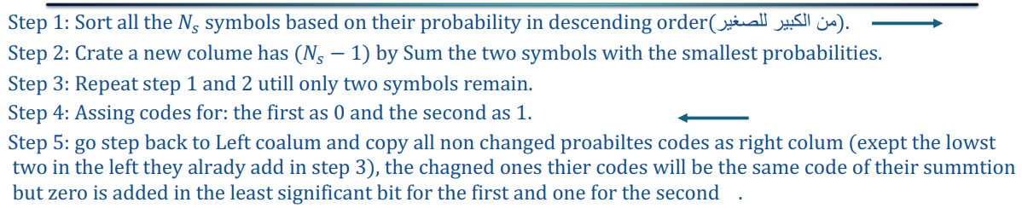
Huffman Algorithm

Hand Analysis

Symbol | P0 | C0 | P1 | C1 | P2 | C2 | P3 | C3 | P4 | C4 | P5 | C5
A | 0.35 | 00 | 0.35 | 00 | 0.35 | 00 | 0.35 | 00 | 0.35 | 1 | 0.65 | 0
B | 0.3 | 01 | 0.3 | 01 | 0.3 | 01 | 0.3 | 01 | 0.35 | 00 | 0.35 | 1
C | 0.2 | 10 | 0.2 | 10 | 0.2 | 10 | 0.2 | 10 | 0.3 | 01
D | 0.1 | 110 | 0.1 | 110 | 0.1 | 110 | 0.15 | 11
E | 0.04 | 1110 | 0.04 | 1110 | 0.05 | 111
F | 0.005 | 11110 | 0.01 | 1111
G | 0.005 | 11111

So, here’s the output that we are aiming for.

With the Kraft’s Sum, entropy, average length and efficiency:

$$The Entropy of the Source H\left(P\left(x\right)\right)=- \sum_{xi}^{ }{P(xi)\log_{2}{P(xi)}}$$
$$The Length of the Codeword L\left(C\right)=- \sum_{xi}^{ }{P(xi)L(xi)}$$
$$Efficiency η= \frac{H(P(x))}{L(C)}*100\%$$
$$Kraft's Sum = \sum_{Li}^{ }{2^{-Li}} Kraft's Inequality : Kraft's Sum<=1$$

So, by calculating them we can find that:

Entropy of the code Average codeword length

$$H\left(P\left(x\right)\right) =2.11 bits/symbol L\left(C\right) =2.21 bits/symbol$$

So the overall efficiency is $η= \frac{L(C)}{H(P(x))}*100\% = \frac{2.11}{2.21} *100\% = 95.475\%$

And Kraft’s Sum = 1
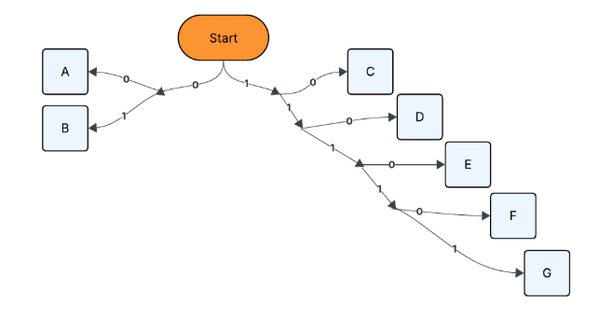
Figure 1 Huffman Output Kraft's Tree

Conclusion

The results show that Huffman coding provides a relatively efficient prefix-free code, with an average code length (2.21 bits) that is close to but slightly higher than the entropy (2.11 bits). Also, since the Kraft inequality is satisfied with equality, the Huffman code is optimal among all binary prefix codes for this source.
And also from the Huffman Kraft tree, it can be observed that no codeword is assigned to an internal node, meaning that no codeword is the prefix of another. Therefore, the Huffman code is an instantaneous (prefix-free) code, ensuring unique and immediate decodable without the need for lookahead.

MATLAB Implementation _{[3]}

Calculations Functions

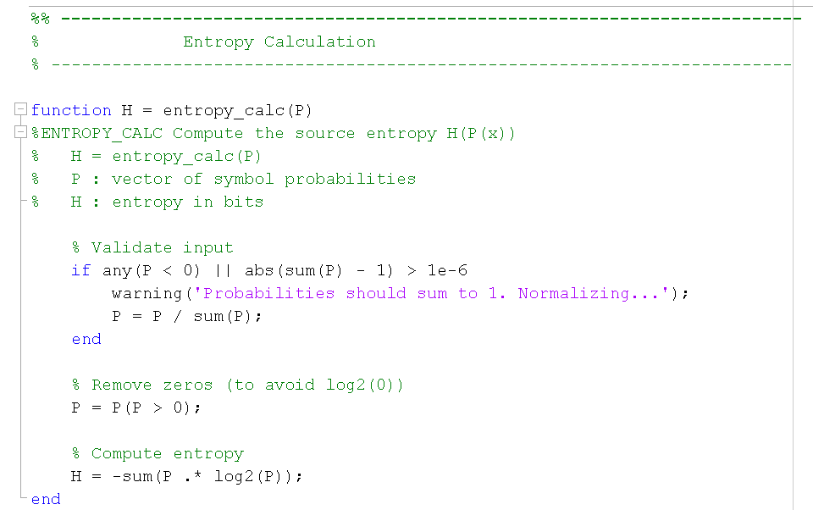
First, we got the calculations Functions:
Figure 2 Entropy Calculation

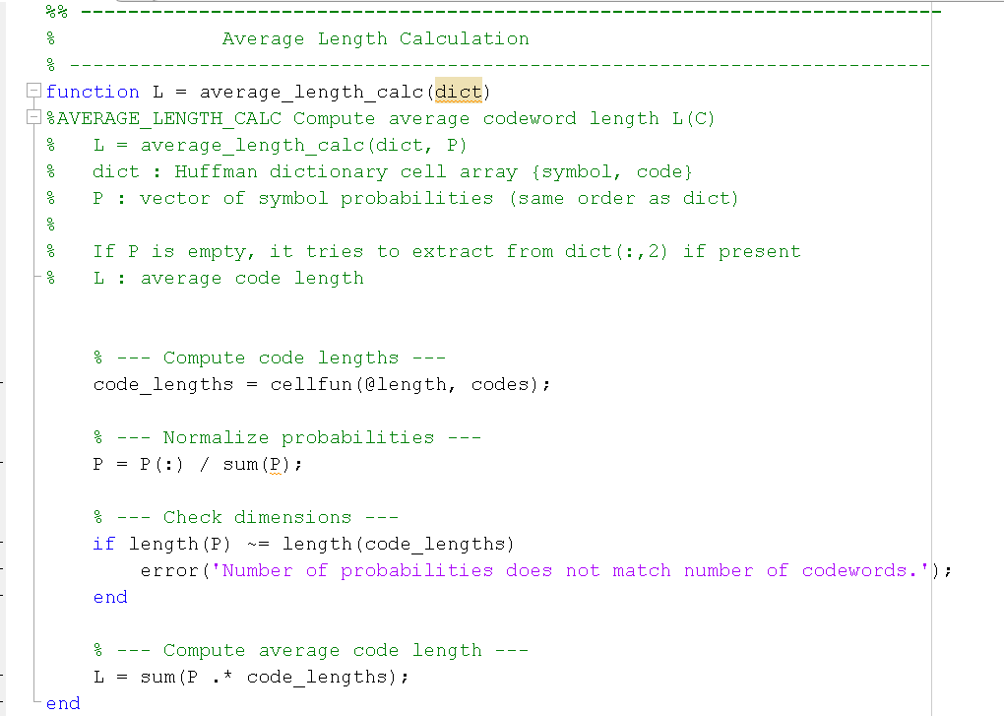
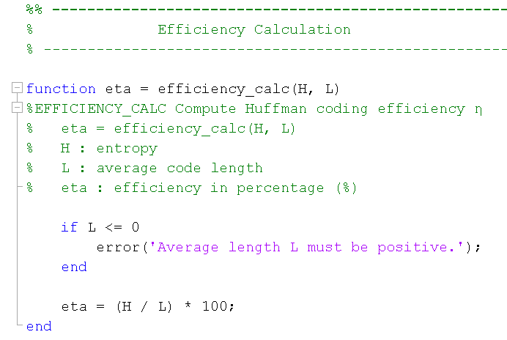
And
Figure 3 Efficiency Calculation
Figure 4 Average length Calculation

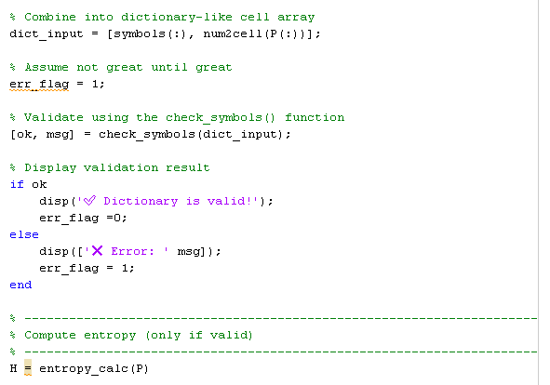
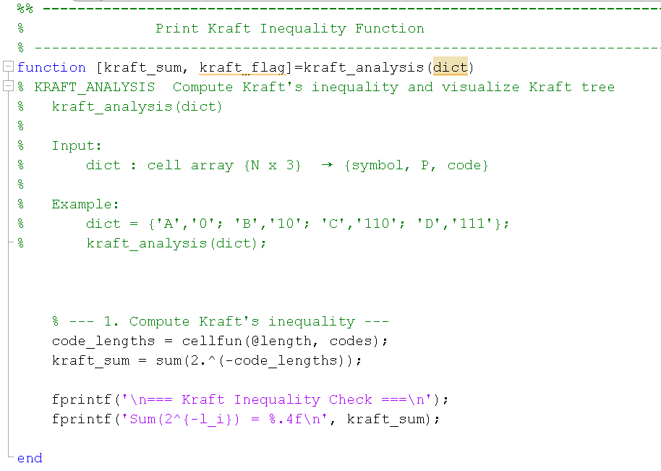
And
Figure 5 Kraft's Inequality
Figure 6 Input Validation
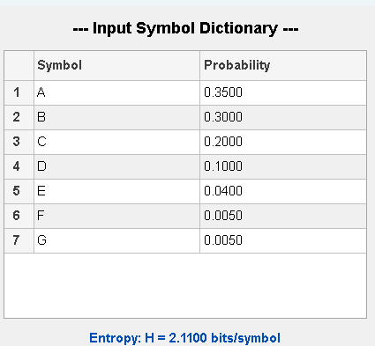

So, the inputs are the following

Figure 7 Input Symbols

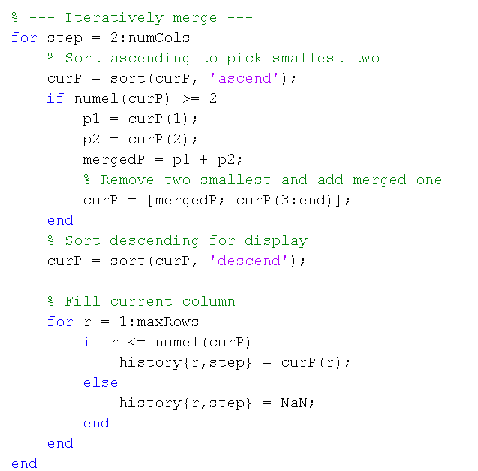
And then we apply Huffman functions as follows, we merge the probabilities
Figure 8 Probability Merge

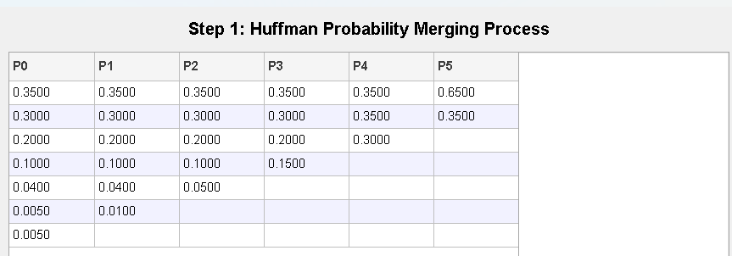
So, we got:
Figure 9 Merged Probabilities

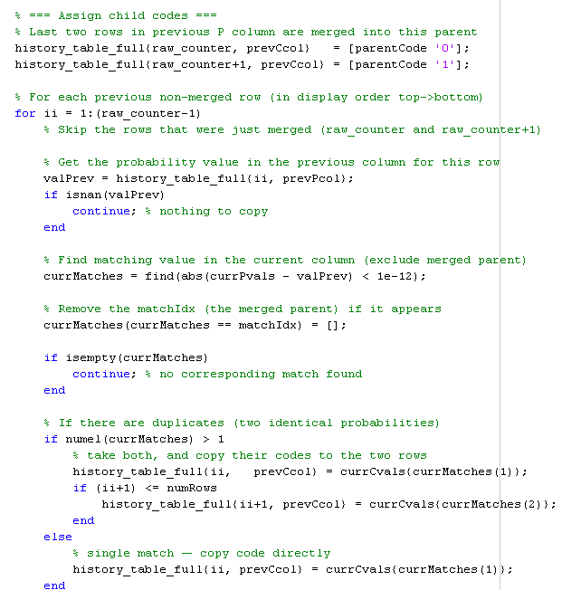
Then we assign the codes from last column to first
Figure 10 Code Assignment
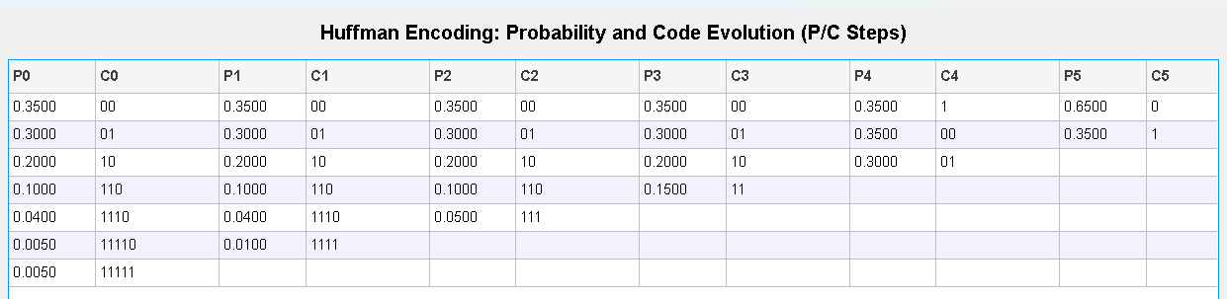
and the output after applying the steps is:
Figure 11 Huffman Steps

Theoretical vs practical
Figure 12 Practical Results
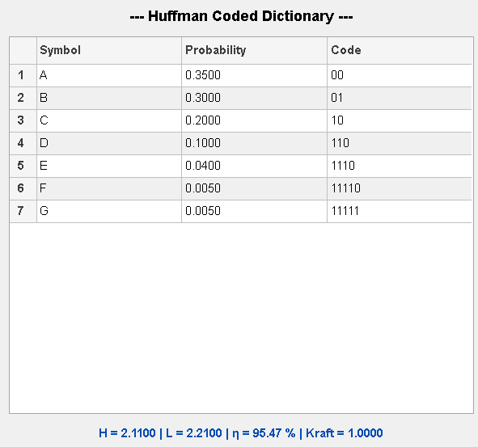
The MATLAB simulations produced results identical to the Theoretical one

Fano Source Coding

Fano source coding, also known as Shannon–Fano coding, is an early method of variable-length, prefix-free coding used in lossless data compression. The algorithm works by dividing the set of symbols into two groups with nearly equal total probabilities and assigning binary digits (‘0’ and ‘1’) to each group recursively.
Although Fano coding produces a prefix-free and uniquely decodable code, it is not always optimal, as its average code length can be slightly higher than that of Huffman coding. Nonetheless, it provides a useful foundation for understanding how symbol probabilities influence efficient code design.

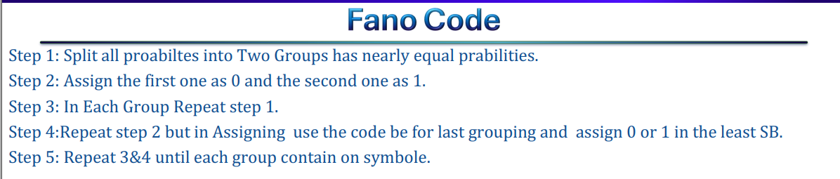
Algorithm Overview _{[2]}
Figure 13 Fano Algorithm

As the Steps above shows, the hand analysis of the Fano Shannon code is the following

Hand Analysis

Symbol | P0 | C0 | P1 | C1 | P2 | C2 | P3 | C3 | P4 | C4 | Final Code
A | 0.35 | 0 | 0.35 | 00 | 0.35 | 00 | 0.35 | 00 | 0.35 | 00 | 00
B | 0.3 | 0 | 0.3 | 01 | 0.3 | 01 | 0.3 | 01 | 0.3 | 01 | 01
C | 0.2 | 1 | 0.2 | 10 | 0.2 | 10 | 0.2 | 10 | 0.2 | 10 | 10
D | 0.1 | 1 | 0.1 | 11 | 0.1 | 110 | 0.1 | 110 | 0.1 | 110 | 110
E | 0.04 | 1 | 0.04 | 11 | 0.04 | 111 | 0.04 | 1110 | 0.04 | 1110 | 1110
F | 0.005 | 1 | 0.005 | 11 | 0.005 | 111 | 0.005 | 1111 | 0.005 | 11110 | 11110
G | 0.005 | 1 | 0.005 | 11 | 0.005 | 111 | 0.005 | 1111 | 0.005 | 11111 | 11111

Kraft’s tree:
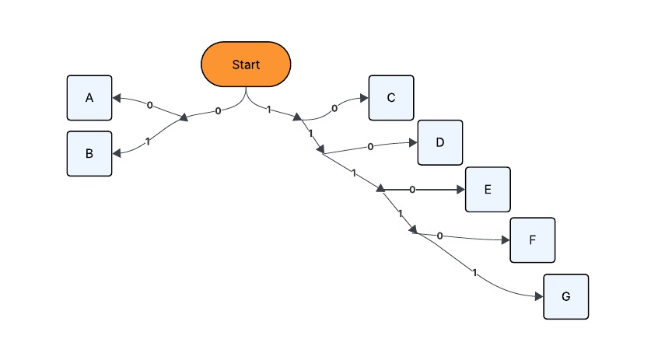
Figure 14 Fano Output Kraft's Tree
So the Output we are aiming for with the Following Entropy, Codeword Length, and Efficiency

Entropy of the code Average codeword length

$$H\left(P\left(x\right)\right) =2.11 bits/symbol L\left(C\right) =2.21 bits/symbol$$

So the overall efficiency is $η= \frac{L(C)}{H(P(x))}*100\% = \frac{2.11}{2.21} *100\% = 95.475\%$

And Kraft’s Sum = 1

Fano Function_{[3]}
First we splited the probabilities into groups
Then we assign the codes to each group

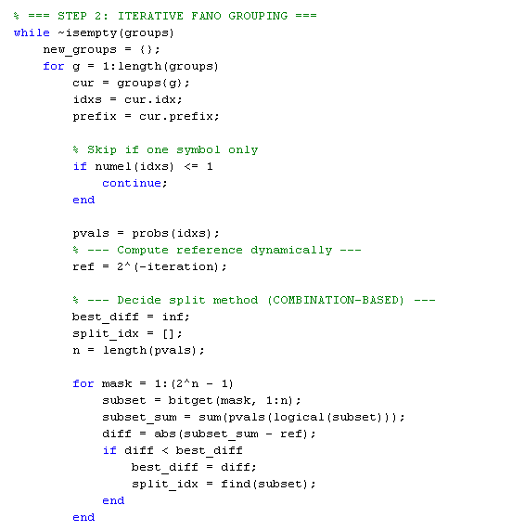

Figure 15 Group Splitting

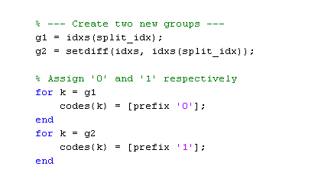

Figure 16 Group Code Assignment

So the output steps is
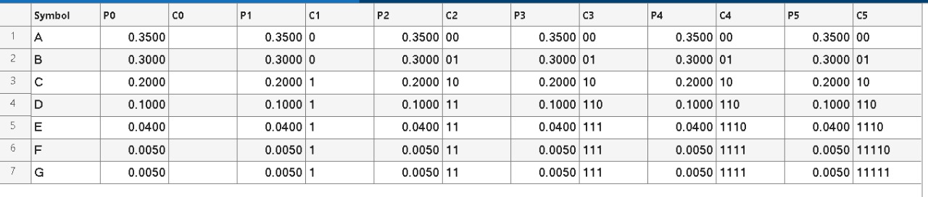
Figure 17 Fano Steps

Theoretical Vs Practical
The results are shown are the same as the theoretical

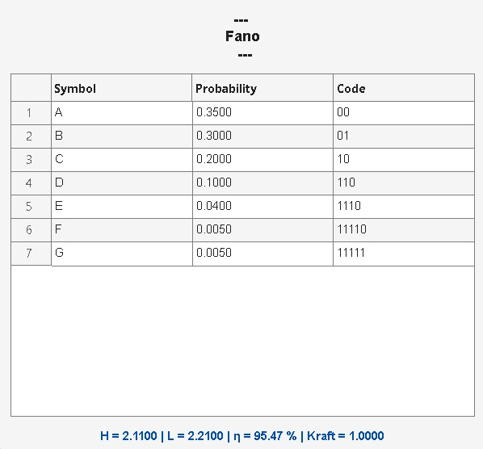
Figure 18 Fano Output

Comparison and conclusion
For this particular source, Huffman and Shannon–Fano coding produce identical results —
the same set of codeword lengths, average length (2.21 bits), and efficiency (≈ 95.5 %)
However, in general:
- Huffman coding always yields the optimal prefix-free code for a given probability
distribution.
- Fano coding, while simpler and faster to implement, may occasionally produce a slightly
larger average code length.

Thus, Huffman coding is preferred when optimal compression efficiency is required, while Fano
coding is mainly of educational or conceptual value for illustrating the principles of probabilistic
source coding.

And also, Huffman coding generally performs better for larger symbol sets or skewed probability
distributions, where precision in tree construction becomes more significant

References:
[1] Dr. Mohammed Nafie, "Lecture Slides in Advanced Communications," ELC4020 Advanced Communication Systems, Cairo University, 2025.
[2] Eng. Mohamed Khaled, "Section Slides in Advanced Communications," ELC4020 Advanced Communication Systems, Cairo University, 2025.
[3] https://github.com/youefkh05/Advanced_Communication_Coding

Appendix
%%------------------------------------------------------------
% Problem 1: Binary Huffman Coding
%------------------------------------------------------------

clc; clear; close all force;

% Given Symbols probabilities
symbols = {'A','B','C','D','E','F','G'};
P = [0.35 0.30 0.20 0.10 0.04 0.005 0.005];

% Create Input Dictionary
[dict_input,err_flag, H] = create_symbols_dictionary(symbols, P);

% Check Input
if err_flag ==1
disp('? Stopping execution due to invalid dictionary.');
return; % exits the current script or function
end

% Print the dictionary neatly
print_symbols_dic(dict_input, H);

% -------------------------------------------------------------------------
% Manual Huffman Coding (with custom output)
% -------------------------------------------------------------------------
dict_huffman = huffman_encoding_visual(dict_input);

disp('--- Manual Huffman Encoding ---');
disp(dict_huffman);

% Print the codded dictionary neatly
print_coded_dict(dict_huffman, H,"Huffman");

%%------------------------------------------------------------
% Problem 2: Binary Fano Coding
%------------------------------------------------------------

% -------------------------------------------------------------------------
% Manual Fano Coding (with custom output)
% -------------------------------------------------------------------------
dict_Fano = fano_encoding_visual(dict_input)

disp('--- Manual Fano Encoding ---');
disp(dict_Fano);

% Print the codded dictionary neatly
print_coded_dict(dict_Fano, H,"Fano");

%%
% -------------------------------------------------------------------------
% Function Definition
% -------------------------------------------------------------------------

%% -------------------------------------------------------------------------
% Entropy Calculation
% -------------------------------------------------------------------------

function H = entropy_calc(P)
%ENTROPY_CALC Compute the source entropy H(P(x))
% H = entropy_calc(P)
% P : vector of symbol probabilities
% H : entropy in bits

% Validate input
if any(P < 0) || abs(sum(P) - 1) > 1e-6
warning('Probabilities should sum to 1. Normalizing...');
P = P / sum(P);
end

% Remove zeros (to avoid log2(0))
P = P(P > 0);

% Compute entropy
H = -sum(P .* log2(P));
end

%% -------------------------------------------------------------------------
% Average Length Calculation
% -------------------------------------------------------------------------
function L = average_length_calc(dict)
%AVERAGE_LENGTH_CALC Compute average codeword length L(C)
% L = average_length_calc(dict, P)
% dict : Huffman dictionary cell array {symbol, code}
% P : vector of symbol probabilities (same order as dict)
%
% If P is empty, it tries to extract from dict(:,2) if present
% L : average code length

P = dict(:,2);
% --- Handle inputs ---
if nargin < 2 || isempty(P)
% Check if dict has a probability column (3 columns)
if size(dict, 2) >= 3 && isnumeric(dict{1,2})
P = cell2mat(dict(:,2));
codes = dict(:,3);
else
error('Probability vector P is required or must be in dict(:,2)');
end
else
% Extract codes (assumed in 2nd column)
codes = dict(:,3);
end

% --- Compute code lengths ---
code_lengths = cellfun(@length, codes);

% --- Normalize probabilities ---
P = P(:) / sum(P);

% --- Check dimensions ---
if length(P) ~= length(code_lengths)
error('Number of probabilities does not match number of codewords.');
end

% --- Compute average code length ---
L = sum(P .* code_lengths);
end

%% -------------------------------------------------------------------------
% Efficiency Calculation
% -------------------------------------------------------------------------

function eta = efficiency_calc(H, L)
%EFFICIENCY_CALC Compute Huffman coding efficiency ?
% eta = efficiency_calc(H, L)
% H : entropy
% L : average code length
% eta : efficiency in percentage (%)

if L <= 0
error('Average length L must be positive.');
end

eta = (H / L) * 100;
end

%% -------------------------------------------------------------------------
% Print Kraft Inequality Function
% -------------------------------------------------------------------------

function [kraft_sum, kraft_flag]=kraft_analysis(dict)
% KRAFT_ANALYSIS Compute Kraft's inequality and visualize Kraft tree
% kraft_analysis(dict)
%
% Input:
% dict : cell array {N x 3} ? {symbol, P, code}
%
% Example:
% dict = {'A','0'; 'B','10'; 'C','110'; 'D','111'};
% kraft_analysis(dict);

if ~iscell(dict) || size(dict,2) < 2
error('Input must be a cell array {symbol, code}');
end

% Extract codes
codes = dict(:,3);
N = length(codes);

% --- 1. Compute Kraft's inequality ---
code_lengths = cellfun(@length, codes);
kraft_sum = sum(2.^(-code_lengths));

fprintf('\n=== Kraft Inequality Check ===\n');
fprintf('Sum(2^{-l_i}) = %.4f\n', kraft_sum);

if abs(kraft_sum - 1) < 1e-6
fprintf('? Code satisfies equality ? Complete Prefix Code.\n');
kraft_flag=2;
elseif kraft_sum < 1
fprintf('? Code satisfies inequality (valid but not complete).\n');
kraft_flag=1;
else
fprintf('? Invalid prefix code (violates Kraft''s inequality).\n');
kraft_flag=0;
end

end

%% -------------------------------------------------------------------------
% Create Dictionary Input Definition
% -------------------------------------------------------------------------
function [dict_input,err_flag, H] = create_symbols_dictionary(symbols, P)
%CREATE_DICTIONARY Combines symbols and probabilities into a validated dictionary.
%
% dict_input = create_dictionary(symbols, P)
%
% Inputs:
% symbols - cell array of symbols, e.g. {'A','B','C'}
% P - corresponding probabilities (row or column vector)
%
% Output:
% dict_input - cell array {symbol, probability}
%
% Example:
% symbols = {'A','B','C'};
% P = [0.5 0.3 0.2];
% dict_input = create_dictionary(symbols, P);

% Combine into dictionary-like cell array
dict_input = [symbols(:), num2cell(P(:))];

% Assume not great until great
err_flag = 1;

% Validate using the check_symbols() function
[ok, msg] = check_symbols(dict_input);

% Display validation result
if ok
disp('? Dictionary is valid!');
err_flag =0;
else
disp(['? Error: ' msg]);
err_flag = 1;
end

% ---------------------------------------------------------------------
% Compute entropy (only if valid)
% ---------------------------------------------------------------------
H = entropy_calc(P)

end

%% -------------------------------------------------------------------------
% Check Input Validation Function
% -------------------------------------------------------------------------
function [isValid, errMsg] = check_symbols(dict_input)
% CHECK_SYMBOLS Validates a symbol-probability dictionary
%
% [isValid, errMsg] = check_symbols(dict_input)
%
% Input:
% dict_input : Cell array {N×2}, where first column = symbols,
% second column = probabilities
%
% Output:
% isValid : Logical true if valid, false otherwise
% errMsg : String describing validation error (if any)

% Default output
isValid = false;
errMsg = '';

try
% Extract symbols and probabilities
symbols = dict_input(:, 1);
P = cell2mat(dict_input(:, 2));

% Check same length
if numel(symbols) ~= numel(P)
errMsg = 'Symbols and probabilities must have the same length.';
return;
end

% Check probabilities sum to 1 (within tolerance)
if abs(sum(P) - 1) > 1e-6
errMsg = sprintf('Probabilities do not sum to 1 (sum = %.6f).', sum(P));
return;
end

% Check all probabilities are positive
if any(P <= 0)
errMsg = 'All probabilities must be positive.';
return;
end

% If all checks passed
isValid = true;

catch ME
errMsg = ['Invalid dictionary input: ' ME.message];
end
end

%% -------------------------------------------------------------------------
% Print Dictionary Function
% -------------------------------------------------------------------------
function print_symbols_dic(dict_input, H)
% PRINT_SYMBOLS_DIC Displays a formatted version of the symbol dictionary in a figure,
% and shows the calculated source entropy.
%
% print_symbols_dic(dict_input, H)
%
% Inputs:
% dict_input - cell array {symbol, probability}
% H - source entropy (bits/symbol)

% Validate input
if nargin < 1 || isempty(dict_input)
error('Input dictionary is empty or missing.');
return;
end

% Convert symbols to char (uitable can't handle string objects)
symbols = cellfun(@char, dict_input(:,1), 'UniformOutput', false);
probs = cell2mat(dict_input(:,2));

% Display result in Command Window
fprintf('\nInformation Source Entropy: H = %.4f bits/symbol\n', H);
fprintf('-----------------------------------------------------\n');

% Create a responsive UI figure
f = uifigure('Name', 'Symbol Dictionary', ...
'NumberTitle', 'off', ...
'Color', 'w', ...
'Position', [500 400 350 320]);

% Format probabilities as strings
probStr = arrayfun(@(p) sprintf('%.4f', p), probs, 'UniformOutput', false);

% Combine into table data
data = [symbols probStr];

% Create a grid layout (auto-resizes)
gl = uigridlayout(f, [3,1]);
gl.RowHeight = {'fit', '1x', 'fit'}; % title, table, entropy
gl.ColumnWidth = {'1x'};
gl.Padding = [10 10 10 10];

% --- Title ---
uilabel(gl, ...
'Text', '--- Input Symbol Dictionary ---', ...
'FontSize', 14, ...
'FontWeight', 'bold', ...
'HorizontalAlignment', 'center');

% --- Table ---
uitable(gl, ...
'Data', data, ...
'ColumnName', {'Symbol', 'Probability'}, ...
'FontSize', 12, ...
'ColumnWidth', {'1x', '1x'}, ...
'RowStriping', 'on');

% --- Entropy Display ---
uilabel(gl, ...
'Text', sprintf('Entropy: H = %.4f bits/symbol', H), ...
'FontSize', 12, ...
'FontWeight', 'bold', ...
'FontColor', [0 0.3 0.7], ...
'HorizontalAlignment', 'center');
end

%% -------------------------------------------------------------------------
% Print Coded Dictionary Function (General Purpose)
% -------------------------------------------------------------------------
function print_coded_dict(dict, H, title_str)
% PRINT_CODED_DICT Display coding dictionary with entropy, avg length, efficiency, and Kraft analysis.
%
% print_coded_dict(dict, H, title_str)
%
% Inputs:
% dict - cell array {symbol, probability, code}
% H - entropy (bits/symbol)
% title_str - string title for the table window (e.g. 'Fano Coding Results')
%
% This function:
% • Calculates average codeword length L(C)
% • Calculates efficiency ? = (H / L) * 100%
% • Checks Kraft’s inequality
% • Displays results in MATLAB UI + command window
%
% Example:
% print_coded_dict(fano_dict, H, 'Fano Coding Summary');

% === Validate input ===
if nargin < 1 || isempty(dict)
disp('Input dictionary is missing or empty.');
return;
end

if size(dict,2) < 3
disp('Dictionary must have 3 columns: {symbol, probability, code}.');
return;
end

if nargin < 3 || isempty(title_str)
title_str = 'Coded Dictionary Summary';
end

% === Extract data ===
symbols = cellfun(@char, dict(:,1), 'UniformOutput', false);
P = cell2mat(dict(:,2));
codes = dict(:,3);

% === Compute metrics ===
L = average_length_calc(dict);
eta = efficiency_calc(H, L);
[kraft_sum, kraft_flag] = kraft_analysis(dict);

% === Print to Command Window ===
fprintf('\n--- %s ---\n', title_str);
fprintf('Symbol\tProb.\t\tCode\n');
fprintf('-----------------------------------------\n');
for i = 1:length(symbols)
fprintf('%s\t%.4f\t\t%s\n', symbols{i}, P(i), codes{i});
end
fprintf('-----------------------------------------\n');
fprintf('Entropy (H): %.4f bits/symbol\n', H);
fprintf('Average length (L): %.4f bits/symbol\n', L);
fprintf('Efficiency (?): %.2f %%\n', eta);
fprintf('Kraft Sum: %.4f\n', kraft_sum);
if kraft_flag == 2
fprintf('Kraft Result: ? Complete Prefix Code\n');
elseif kraft_flag == 1
fprintf('Kraft Result: ? Valid but Not Complete\n');
else
fprintf('Kraft Result: ? Invalid Code\n');
end

% === UI Figure ===
f = uifigure('Name', title_str, ...
'NumberTitle', 'off', ...
'Color', 'w', ...
'Position', [500 200 480 450]);

gl = uigridlayout(f, [3 1]);
gl.RowHeight = {'fit', '1x', 'fit'};
gl.Padding = [10 10 10 10];

% --- Title ---
uilabel(gl, ...
'Text', ['--- ' title_str ' ---'], ...
'FontSize', 14, ...
'FontWeight', 'bold', ...
'HorizontalAlignment', 'center');

% --- Table ---
data = [symbols, arrayfun(@(p) sprintf('%.4f', p), P, 'UniformOutput', false), codes];
uitable(gl, ...
'Data', data, ...
'ColumnName', {'Symbol', 'Probability', 'Code'}, ...
'FontSize', 12, ...
'RowStriping', 'on', ...
'ColumnWidth', {'1x', '1x', '1x'});

% --- Summary Line ---
uilabel(gl, ...
'Text', sprintf('H = %.4f | L = %.4f | ? = %.2f %% | Kraft = %.4f', H, L, eta, kraft_sum), ...
'FontSize', 12, ...
'FontWeight', 'bold', ...
'FontColor', [0 0.3 0.7], ...
'HorizontalAlignment', 'center');
end

%% -------------------------------------------------------------------------
% Huffman Encoding with Visualization Function
% -------------------------------------------------------------------------

function dict = huffman_encoding_visual(dict_input)
%HUFFMAN_ENCODING_VISUAL Visual Huffman encoding with full table output (UI-based)
%
% dict = huffman_encoding_visual(symbols, P)
% - symbols: cell array of symbol names (e.g. {'A','B','C','D','E','F','G'})
% - P: vector of probabilities (same length as symbols)
%
% Creates a UI figure showing the probability & code propagation table,
% and prints the final Huffman dictionary.

% get the info from dictionary
symbols = dict_input(:,1);
P = cell2mat(dict_input(:,2));
% === Input Validation ===
if numel(symbols) ~= numel(P)
error('Symbols and probabilities must have same length.');
end

% === Normalize probabilities ===
P = P(:);
P = P / sum(P);

% === Step 1: Generate merging history ===
history_table = merge_probabilities(P);

% === Step 1 Visualization ===
visualize_merging_process(P, history_table);

% === Step 2: Assign Huffman codes ===
history_table_full = assign_coding(history_table);

% === Step 3: Prepare data for visualization ===
% Convert numeric NaNs to empty strings for table display
final_visual_data = cell(size(history_table_full));
for r = 1:size(history_table_full,1)
for c = 1:size(history_table_full,2)
val = history_table_full{r,c};
if isnumeric(val)
if isnan(val)
final_visual_data{r,c} = '';
else
final_visual_data{r,c} = num2str(val, '%.4f');
end
else
final_visual_data{r,c} = val;
end
end
end

% Generate column headers (P1, C1, P2, C2, ...)
numCols = size(history_table_full,2);
final_visual_headers = cell(1,numCols);
for c = 1:numCols
if mod(c,2)==1
final_visual_headers{c} = sprintf('P%d', ceil(c/2)-1);
else
final_visual_headers{c} = sprintf('C%d', ceil(c/2)-1);
end
end

% === Step 4: Build UI Visualization ===
close all;
f = uifigure('Name','Huffman Encoding Visualization', ...
'Position',[100 100 1000 500]);
gl = uigridlayout(f,[2 1]);
gl.RowHeight = {'fit','1x'};

uilabel(gl, ...
'Text','Huffman Encoding: Probability and Code Evolution (P/C Steps)', ...
'FontSize',16, ...
'FontWeight','bold', ...
'HorizontalAlignment','center');

% Column widths (narrow for numeric columns, wider for code columns)
col_widths = repmat({70}, 1, numCols);
col_widths(2:2:end) = {100}; % widen code columns

uitable(gl, ...
'Data',final_visual_data, ...
'ColumnName',final_visual_headers, ...
'RowName',{}, ...
'FontSize',12, ...
'ColumnWidth',col_widths, ...
'RowStriping','on', ...
'BackgroundColor',[1 1 1; 0.95 0.95 1]);

% === Step 5: Extract Final Huffman Dictionary ===

% Make a copy
dict = dict_input;

% Ensure dict has at least 3 columns
if size(dict,2) < 3
dict(:,end+1:3) = {[]};
end
dict(:,3)=history_table_full(:,2);

% === Step 6: Console Output ===
firstPcol = 1;
firstCcol = 2;

probs = cell2mat(history_table_full(:, firstPcol));
codes = history_table_full(:, firstCcol);
validIdx = ~isnan(probs);

symbols = symbols(validIdx);
codes = codes(validIdx);
probs = probs(validIdx);

fprintf('\n--- Final Huffman Codes ---\n');
for i = 1:length(symbols)
fprintf('Symbol %s (%.4f): %s\n', symbols{i}, probs(i), codes{i});
end
fprintf('===============================================================\n\n');
end

% === Probability Merge helper function ===
function history_table = merge_probabilities(P)
%MERGE_PROBABILITIES Builds Huffman probability merging history (descending)
%
% history_table = merge_probabilities(P)
%
% Input:
% P - vector of symbol probabilities
%
% Output:
% history_table - table of probabilities after each merge
% Columns: P0, P1, P2, ... (N-1 total)
%
% Note: Probabilities are shown in descending order.

% --- Input check ---
if numel(P) < 2
error('At least two probabilities are required.');
end

% --- Initialization ---
P = P(:);
P = sort(P, 'descend'); % sort descending
N = numel(P);

% Number of P columns = N - 1
numCols = N - 1;
maxRows = N;

% Initialize history as cell
history = cell(maxRows, numCols);

% --- Step 0: Fill P0 (descending order) ---
for i = 1:maxRows
history{i,1} = P(i);
end

curP = P;

% --- Iteratively merge ---
for step = 2:numCols
% Sort ascending to pick smallest two
curP = sort(curP, 'ascend');
if numel(curP) >= 2
p1 = curP(1);
p2 = curP(2);
mergedP = p1 + p2;
% Remove two smallest and add merged one
curP = [mergedP; curP(3:end)];
end
% Sort descending for display
curP = sort(curP, 'descend');

% Fill current column
for r = 1:maxRows
if r <= numel(curP)
history{r,step} = curP(r);
else
history{r,step} = NaN;
end
end
end

% --- Column names ---
colNames = cell(1,numCols);
for i = 1:numCols
colNames{i} = sprintf('P%d', i-1);
end

% --- Convert to table ---
history_table = cell2table(history, 'VariableNames', colNames);
end

% === Visualization of Probability Merging Process ===
function visualize_merging_process(P, history_table)
% VISUALIZE_MERGING_PROCESS Display a UI table of Huffman probability merging
%
% visualize_merging_process(P, history_table)
%
% Displays the merging steps used in Huffman encoding as a clean table UI.
%
% Inputs:
% P - Original probability vector (used for scaling)
% history_table - Table of merging probabilities (output of merge_probabilities)
%
% Example:
% history_table = merge_probabilities([0.4 0.2 0.15 0.15 0.1]);
% visualize_merging_process([0.4 0.2 0.15 0.15 0.1], history_table);

% --- Input validation ---
if nargin < 2
error('Usage: visualize_merging_process(P, history_table)');
end
if ~istable(history_table)
error('history_table must be a MATLAB table.');
end

% === Step 1: Convert numeric values (NaN ? empty string for display) ===
merge_visual_data = cell(size(history_table));
for r = 1:size(history_table,1)
for c = 1:size(history_table,2)
val = history_table{r,c};
if isnumeric(val)
if isnan(val)
merge_visual_data{r,c} = '';
else
merge_visual_data{r,c} = num2str(val, '%.4f');
end
else
merge_visual_data{r,c} = val;
end
end
end

% === Step 2: Build UI Table Figure ===
f_merge = uifigure('Name','Step 1: Probability Merging History', ...
'Position',[150 150 700 400]);

gl_merge = uigridlayout(f_merge,[2 1]);
gl_merge.RowHeight = {'fit','1x'};

uilabel(gl_merge, ...
'Text','Step 1: Huffman Probability Merging Process', ...
'FontSize',16, ...
'FontWeight','bold', ...
'HorizontalAlignment','center');

uitable(gl_merge, ...
'Data',merge_visual_data, ...
'ColumnName',history_table.Properties.VariableNames, ...
'RowName',{}, ...
'FontSize',12, ...
'ColumnWidth',repmat({80}, 1, width(history_table)), ...
'RowStriping','on', ...
'BackgroundColor',[1 1 1; 0.95 0.95 1]);

% === Step 3: Optional console summary ===
fprintf('\n--- Probability Merging Steps ---\n');
disp(history_table);
fprintf('=================================\n\n');
end

% === Assign code helper function ===
function history_table_full = assign_coding(history_table)
% assign_coding - expands the history table and assigns Huffman codes
%
% Input:
% history_table : numeric matrix or table (probability merging history)
%
% Output:
% history_table_full : cell array with 2N columns
% Odd columns: probability values
% Even columns: assigned codes

% If table, convert to numeric array
if istable(history_table)
history_table = table2array(history_table);
end

% Determine size
[numRows, numCols] = size(history_table);
newCols = 2 * numCols;

% Initialize
history_table_full = cell(numRows, newCols);

% === Fill odd columns with probabilities ===
for col = 1:numCols
history_table_full(:, 2 * col - 1) = num2cell(history_table(:, col));
end

% === Initialize last code column (start with last merge) ===
lastPcol = 2 * numCols - 1;
lastCcol = lastPcol + 1;
history_table_full{1, lastCcol} = '0';
history_table_full{2, lastCcol} = '1';
raw_counter=1; %for parent assignment

% === Backward propagation of codes ===
for col = numCols:-1:2 % start from last column going backward
currPcol = 2 * col - 1;
currCcol = currPcol + 1;
prevPcol = 2 * (col - 1) - 1;
prevCcol = prevPcol + 1;
raw_counter = raw_counter+1;

% Get non-NaN values from P prev column
prevPvals = cell2mat(history_table_full(:, prevPcol));
prevPvals = prevPvals(~isnan(prevPvals));

% Get non-NaN values from C curr column
currCvals = history_table_full(:, currCcol);

% Identify merged value
if length(prevPvals) >= 2
mergedVal = prevPvals(end) + prevPvals(end-1);
else
continue;
end

% Find which row in current P col matches the mergedVal
currPvals = cell2mat(history_table_full(:, currPcol));
matchIdx = find(abs(currPvals - mergedVal) < 1e-12);
if numel(matchIdx) > 1
matchIdx = matchIdx(1); % take top one if duplicate
end

% Get parent code
parentCode = history_table_full{matchIdx, currCcol};
if isempty(parentCode)
parentCode = '';
end

% === Assign child codes ===
% Last two rows in previous P column are merged into this parent
history_table_full{raw_counter, prevCcol} = [parentCode '0'];
history_table_full{raw_counter+1, prevCcol} = [parentCode '1'];

% For each previous non-merged row (in display order top->bottom)
for ii = 1:(raw_counter-1)
% Skip the rows that were just merged (raw_counter and raw_counter+1)

% Get the probability value in the previous column for this row
valPrev = history_table_full{ii, prevPcol};
if isnan(valPrev)
continue; % nothing to copy
end

% Find matching value in the current column (exclude merged parent)
currMatches = find(abs(currPvals - valPrev) < 1e-12);

% Remove the matchIdx (the merged parent) if it appears
currMatches(currMatches == matchIdx) = [];

if isempty(currMatches)
continue; % no corresponding match found
end

% If there are duplicates (two identical probabilities)
if numel(currMatches) > 1
% take both, and copy their codes to the two rows
history_table_full{ii, prevCcol} = currCvals{currMatches(1)};
if (ii+1) <= numRows
history_table_full{ii+1, prevCcol} = currCvals{currMatches(2)};
end
else
% single match — copy code directly
history_table_full{ii, prevCcol} = currCvals{currMatches(1)};
end
end

end
end
%% -------------------------------------------------------------------------
% Fano Encoding with Visualization Function
% -------------------------------------------------------------------------

function table_out = fano_encoding_visual(dict_input)
% FANO_ENCODING_VISUAL
% Classic Fano encoding: split groups into two with nearly equal probabilities
%
% Output table columns:
% Symbol | P0 | C0 | P1 | C1 | ... until convergence

% === STEP 1: INITIALIZE ===
symbols = dict_input(:,1);
probs = cell2mat(dict_input(:,2));

% Normalize and sort descending
probs = probs / sum(probs);
[probs, idx] = sort(probs, 'descend');
symbols = symbols(idx);

n = length(symbols);

% Initialize codes and history
codes = repmat({''}, n, 1);
history = cell(n, 0);

% Add first columns P0 and C0
history(:, end+1) = num2cell(probs); % P0
history(:, end+1) = codes; % C0

% Start with one full group
groups = {struct('indices', 1:n, 'prefix', '')};

% === STEP 2: ITERATIVE FANO GROUPING ===
while ~isempty(groups)
new_groups = {};

for g = 1:length(groups)
cur_group = groups{g};
group_indices = cur_group.indices;
prefix = cur_group.prefix;

% Skip if one symbol only
if numel(group_indices) <= 1
continue;
end

group_probs = probs(group_indices);

% --- Split into two groups with nearly equal probabilities ---
split_point = find_equal_split(group_probs);

% Group 1: indices 1 to split_point
g1_indices = group_indices(1:split_point);
% Group 2: indices split_point+1 to end
g2_indices = group_indices(split_point+1:end);

% Assign '0' to first group, '1' to second group
for k = g1_indices
codes{k} = [prefix '0'];
end
for k = g2_indices
codes{k} = [prefix '1'];
end

% Queue for next stage
if ~isempty(g1_indices)
new_groups{end+1} = struct('indices', g1_indices, 'prefix', [prefix '0']);
end
if ~isempty(g2_indices)
new_groups{end+1} = struct('indices', g2_indices, 'prefix', [prefix '1']);
end
end

% Stop if all groups are singletons
if isempty(new_groups)
break;
end

% Record stage snapshot
history(:, end+1) = num2cell(probs); % Pi
history(:, end+1) = codes; % Ci

groups = new_groups;
end

% === STEP 3: COMPILE OUTPUT TABLE ===
cols = {'Symbol'};
for i = 0:(size(history,2)/2 - 1)
cols{end+1} = sprintf('P%d', i);
cols{end+1} = sprintf('C%d', i);
end

table_out = [symbols history];

% Display as uitable
figure('Name','Fano Encoding Table','Position',[300 200 1100 400]);
uitable('Data', table_out, 'ColumnName', cols, ...
'ColumnWidth', num2cell(repmat(80,1,numel(cols))), ...
'FontSize', 11, 'Units','normalized', 'Position',[0 0 1 1]);

% === STEP 4: FINAL OUTPUT (Symbol, Prob, Code) ===
table_out = [symbols num2cell(probs) codes];
end

function split_point = find_equal_split(group_probs)
% FIND_EQUAL_SPLIT Find split point that makes two groups with nearly equal probabilities
%
% Strategy: Find the split point where |sum(top_group) - sum(bottom_group)| is minimized
%
% Input: group_probs (already sorted descending)
% Output: split_point (index where to split)

n = length(group_probs);

if n == 1
split_point = 1;
return;
end

total_sum = sum(group_probs);
best_diff = inf;
best_split = 1;

% Try each possible split point
for i = 1:(n-1)
top_sum = sum(group_probs(1:i));
bottom_sum = sum(group_probs(i+1:end));
diff = abs(top_sum - bottom_sum);

if diff < best_diff
best_diff = diff;
best_split = i;
end
end

split_point = best_split;
end

