Ok first of all, we will talk about sensors we had 3 options:

1) IR sensor : It’s a really famous sensor used in competition, cheep and works with infared but it’s a little slow

2) ToF: it uses lighr as a signal which make it vonurable to any bright environment, but it’svery fast

3) Ultra sonic: It’s cheep uses sound, but it’s slow and has a big size

So after comparing each sensor we decided to use the IR as we don’t garnetee a free bright environment

About the placement we will use 5 IRs in this shape:

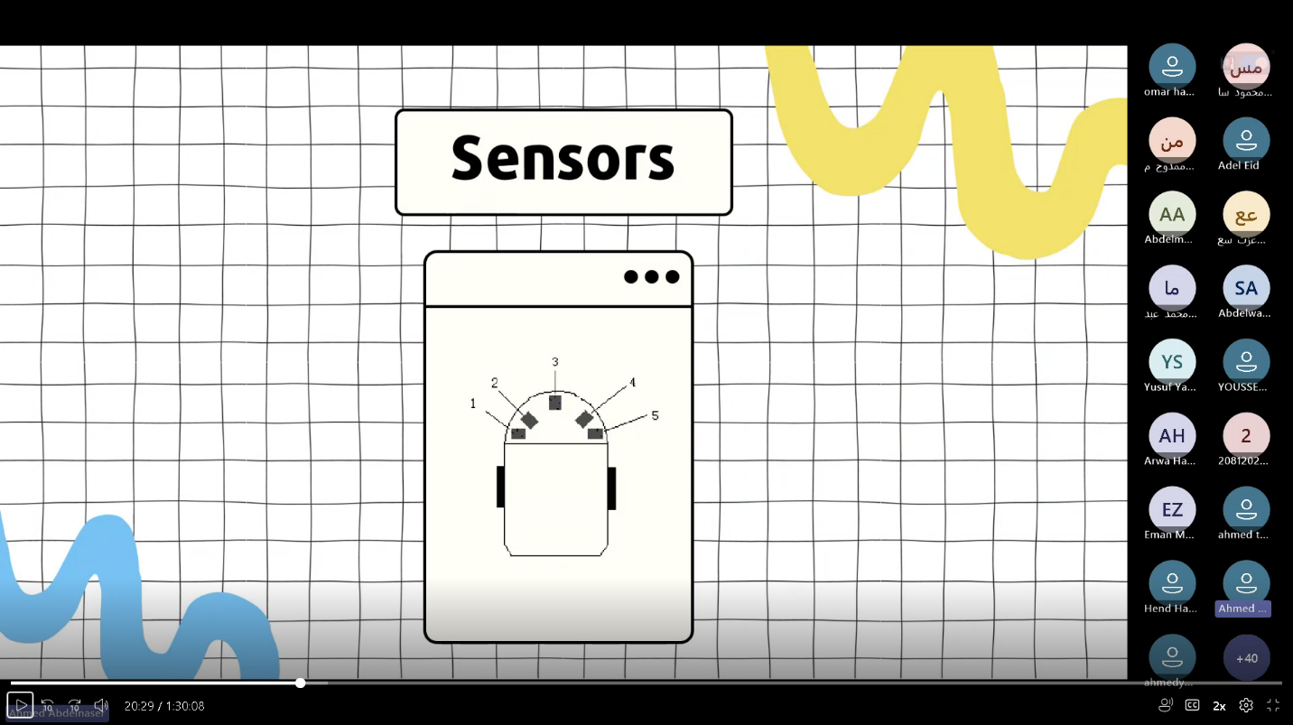

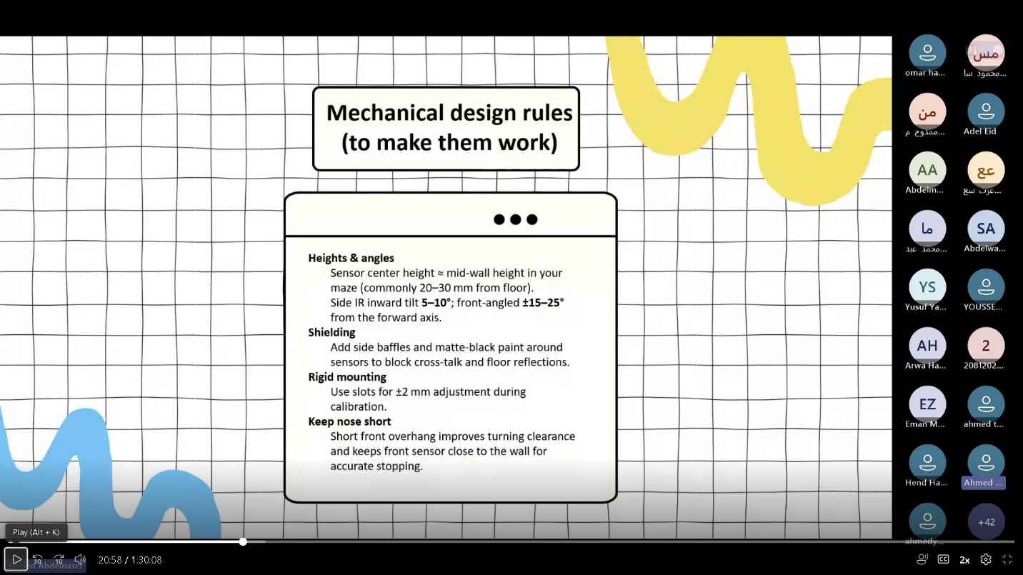With this rules:

Making sure that we don’t put any refelective material such as aluminum so it don’t miss with the IR

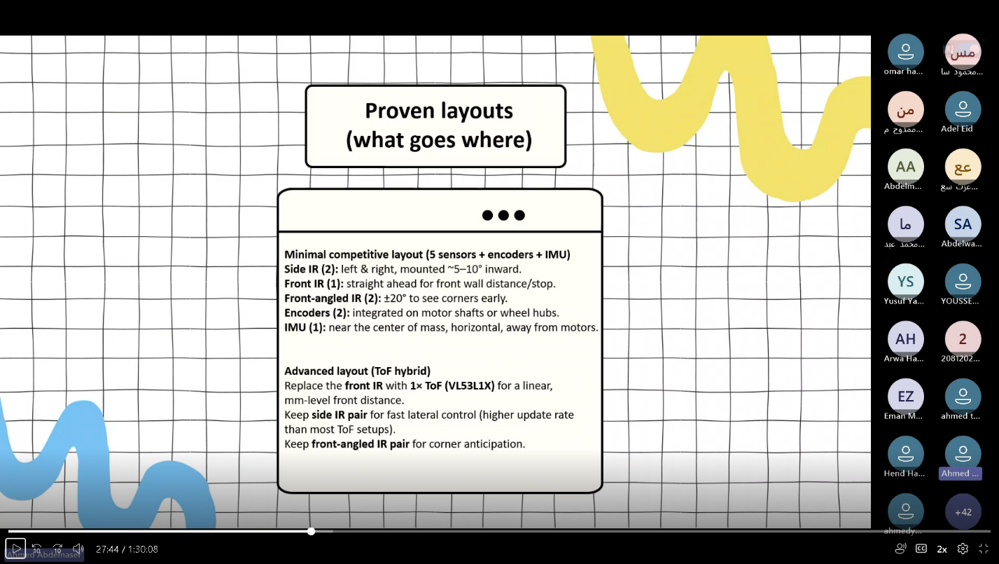With the proved layout:

As for the motor:

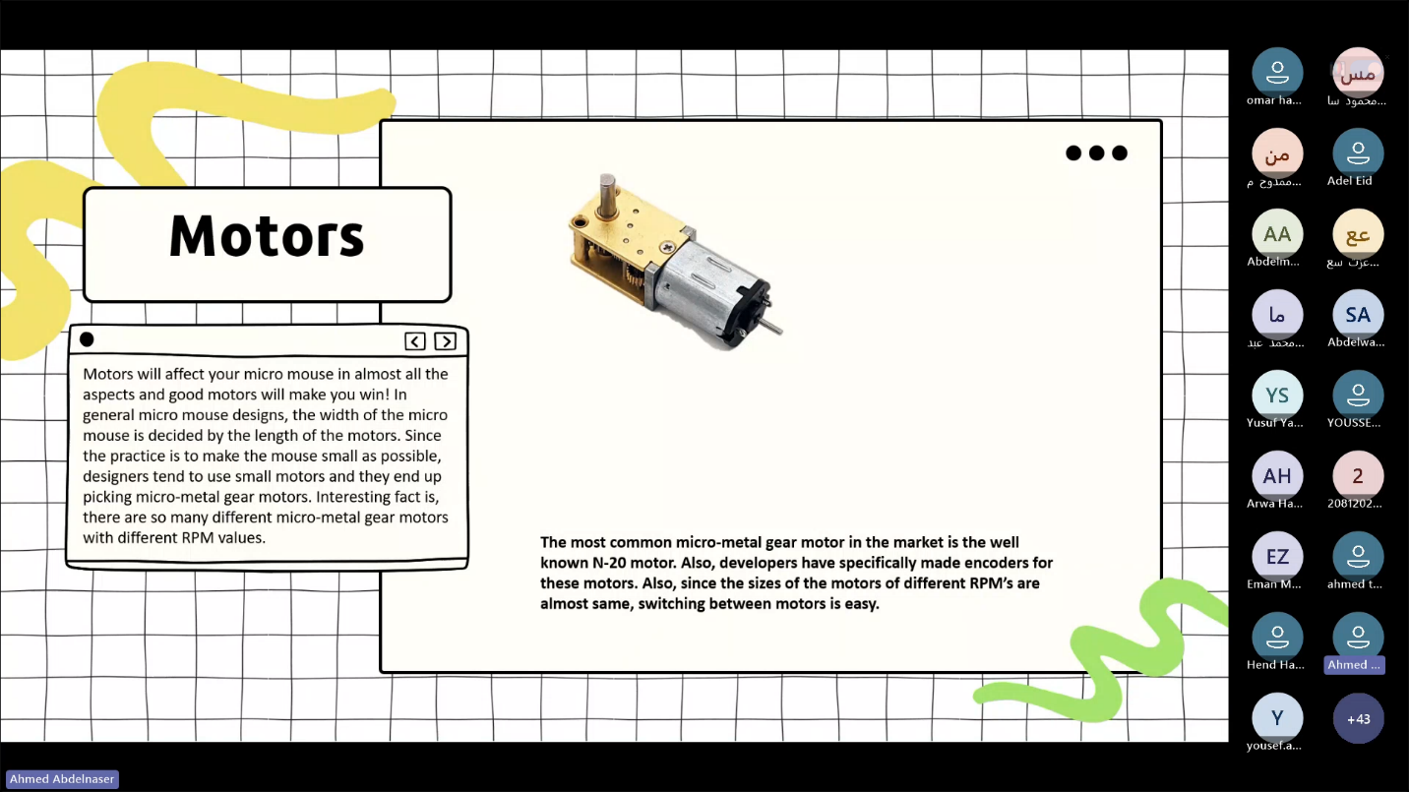We’ll use N-20 as it’s a light with understandable speed and torque

And it’s also equipped with encoder to control it.

So what we need to do is to figure out which gear ratio we’re gonna use in the gearbox assuring good RPM and speed.

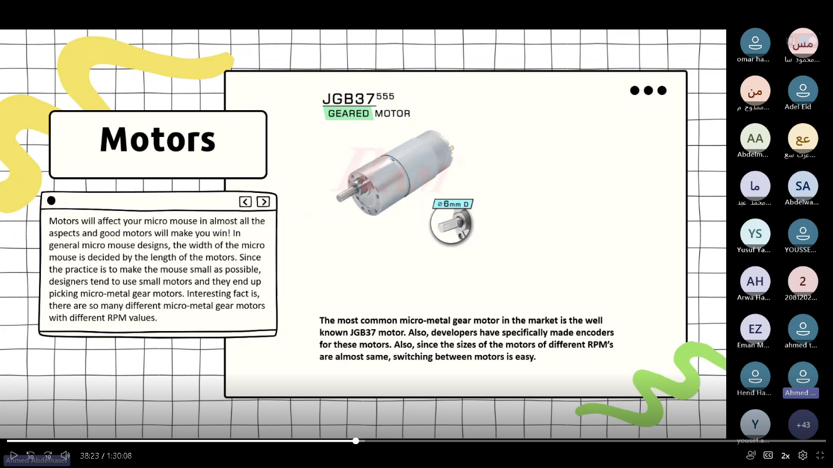There’s the upgraded N-20:

But considering that we’ll make a small robot we prefred N-20.