Integration of IoT Technology with AI in Egypt's Aquaculture Industry: AquaVision Prototype for Sustainable Fish Farming
Yousef Khaled Omar Mahmoud, Engineering, E-mail: yousef.mahmoud03@eng-st.cu.edu.eg
Gamaa Street, Giza, Egypt

Abstract
The aquaculture sector of Egypt encounters difficulties in managing water quality while optimizing resources and achieving sustainable operations. The research presents AquaVision which serves as an Internet of Things (IoT) based prototype to boost fish farm operational efficiency. The AquaVision system operates through real-time sensor data measurement which enables precise water parameter control that enhances fish growth while minimizing resource consumption. The system provides remote monitoring capabilities and control functions that help users make informed decisions and data analytics tools that generate valuable insights about farm productivity. the innovative system tackles fundamental issues while advancing sustainable aquaculture operations that operate in Egypt.

INTRODUCTION
Egyptian aquaculture operations encounter major obstacles when handling water quality while optimizing resources and maintaining environmental equilibrium. Internet of Things technology enables fish farmers to solve their challenges through innovative solutions which transform traditional aquaculture operations. The research examines how IoT technology can be applied to Egyptian aquaculture through the development of AquaVision a prototype system which improves fish farm operations by providing automated monitoring capabilities._{[1]}
Recent studies show that IoT technology has great potential to enhance small-scale aquaponics systems through aquaculture automation. The combination of IoT technology enables reduced manual labor together with resource optimization and detailed water quality monitoring to create optimal conditions for fish and plants. Small-scale aquaculture operators encounter difficulties because they lack expertise in water chemistry and system maintenance while facing financial obstacles from expensive operational costs and power-hungry equipment._{[1]}
The AquaVision prototype aims to address these challenges by leveraging IoT technology to automate and optimize various aspects of fish farming. The system incorporates real-time sensors to monitor water quality parameters, such as pH, dissolved oxygen, and temperature, and uses this data to adjust water circulation, aeration, and feeding schedules. This not only ensures optimal growing conditions for the fish but also helps to minimize water and energy consumption, thereby enhancing the environmental sustainability of the operation.
AquaVision combines IoT technology to give fish farm owners the capability to track and operate their operations from anywhere which helps them base their decisions on data and react to environmental changes. Through its analytics features the system delivers essential information about fish development patterns together with feeding behaviors and farm productivity which helps farmers enhance their operational efficiency and increase their profits.
AquaVision implementation within Egypt's aquaculture sector stands to solve the fundamental issues which affect fish farmers including water control and resource utilization along with environmental conservation._{[2]} This engineering prototype uses IoT technology to transform fish farming operations which will drive the aquaculture sector's overall growth and advancement throughout Egypt.

CHALLANGES IN EGYPT’S AQUACULTURE SECTOR
The Egyptian aquaculture sector functions as an essential component of national food security together with economic development. Fish farmers face multiple problems because of water contamination together with inefficient resource management and environmental problems that stem from climate change. Traditional methods of aquaculture depend entirely on human monitoring which both requires extensive labor and results in frequent errors. The increasing prices of energy together with feed costs create significant financial pressure on fish farms that operate at small and medium scales._{[1]}

The proper maintenance of water conditions stands as a primary concern in aquaculture because temperature and pH level variations and dissolved oxygen changes result in decreased fish growth as well as increased death rates. Improper disposal of fish waste along with excess feed creates water pollution that affects both the farm site and nearby aquatic ecosystems as shown in fig 1[3]. The solution to these problems requires an automated system which can perform continuous monitoring and control of essential parameters.

Fig 1 Challenges in aquaculture systems

The Role of IoT and AI in Smart Aquaculture
The Internet of Things technology offers fish farmers a solution to their operational challenges which includes water quality management and resource optimization and environmental sustainability through its integration into aquaculture operations. IoT-based systems enable real-time data collection and automated responses to environmental changes, as demonstrated in Fig 2. Smart feeders along with water quality sensors and automated aeration systems operate to maintain optimal conditions which eliminates the need for constant human monitoring._{[2]}

Fig 2 Smart Aquaculture System

Artificial Intelligence (AI) when integrated with IoT-based aquaculture systems enables improved decision-making through fish behavior pattern prediction and feeding schedule optimization and early warning system detection. Machine learning algorithms examine both historical and present data to provide recommendations which enhance fish growth performance and decrease waste production and better allocate resources. The adaptability of AI-based smart aquaculture systems towards environmental changes outperforms traditional systems which leads to better cost-effectiveness and enhanced resilience in the long term.
By integrating AI into IoT-based aquaculture systems, AquaVision aims to bridge the gap between traditional and modern fish farming methods. This research explores how a smart, automated system can transform Egypt’s aquaculture sector, making it more sustainable, profitable, and resilient to external challenges.

LITERATURE REVIEW
The implementation of IoT technology within aquaculture represents a forward-looking solution which addresses the problems of fish farmers especially in developing nations such as Egypt. Research demonstrates that implementing IoT-based systems within fish farms generates better productivity together with scalability and sustainability. According to a systematic review[2] IoT shows great potential to enhance both operational efficiency and financial returns in small-scale aquaponics systems which combine fish farming with hydroponics. The authors highlight IoT's vital role in resource optimization and constant water quality tracking and maintaining ideal conditions for fish and plant growth. Research has proven that smart monitoring and management systems based on IoT deliver improved business development alongside increased productivity to fish farming operations which utilize next-generation technologies.

IoT in Aquaculture: Enhancing Monitoring and Environmental Control
The achievement of aquaculture systems depends heavily on maintaining high water quality. Multiple research investigations have proven that IoT-based monitoring provides benefits for maximizing environmental condition optimization.
- A systematic review shows how IoT brings value to small-scale aquaponics through resource optimization and detailed water quality monitoring of pH and dissolved oxygen and temperature and ammonia levels._{[3]}
- The research "Enhancing Tilapia Fish Farming Through IoT-driven Monitoring and Automatic Feeding Technology" presents real-time data collection evidence which demonstrates automated monitoring produces enhanced fish growth rates and better farm efficiency through cloud-based analytics._{[4]}
These Research shows that IoT technology-based real-time monitoring helps fish farmers achieve optimal conditions while lowering environmental threats and reducing the number of fish deaths..

Automation in Fish Farming: Smart Feeding and Resource Optimization
Automated feeding systems function as a fundamental element for IoT-based fish farming operations because they solve problems caused by manual feeding processes.
- The "Improving Fish Quality and Yield: An Automated Monitoring System for Intensive Aquaculture." presents an IoT-based feeding solution which maximizes feeding times to prevent excessive feeding and feed loss._{[6]}
- The "Design of Automated Fish Feeder Using IoT" highlights how adjustable feeding patterns together with remote management and optimized portions lead to better fish health outcomes and higher farm efficiency_{[7].}
These Research shows that automated feed management based on IoT technology delivers higher operational efficiency together with decreased human mistakes and reduced operational expenses in fish farming operations.

IoT-Driven Management Strategies and Business Development
The Internet of Things (IoT) technology assists farm operators by enhancing their ability to make decisions and manage their operations together with its monitoring and feeding capabilities.
- The “IoT-Based Smart Monitoring and Management System for Fish Farming,” describes how computer and communication technology enables operators to remotely supervise and control their fish farms._{[8]}
- A case study at the University of Rwanda Fish Farming and Research Station (UR-FFRs) shows that real-time alerts combined with cloud computing improve data analysis and decision-making through IoT implementation_{[9].}

These studies indicate that IoT implementation stands as a transformative force for aquaculture because it allows precise farming methods and boosts productivity and promotes sustainable business growth.

Summary of Literature Findings
The examined studies reveal these crucial points which represent the main findings:
The use of real-time environmental parameter monitoring enables fish mortality reduction alongside improved resource utilization. Automated feeding systems enhance operational efficiency by stopping excess feeding which lowers feed waste and supports better fish development. IoT-based management approaches lead to improved decision-making and lower operational expenses and advance sustainable aquaculture operations.
The collected knowledge forms an essential base for creating AquaVision which will function as a smart aquaculture prototype to connect IoT systems for improved fish farm efficiency through automated operations and immediate monitoring.

METHODOLOGY

Sensor Data Collection
Our monitoring system employs multiple sensors for water quality and environmental conditions detection in aquaculture systems which track essential parameters. These parameters include:
- Water Level measures available water quantity for fish survival together with optimal growth conditions.
- The pH Level system tracks aquatic acidity levels which directly influences fish metabolic processes and their wellness.
- The temperature value (T) directly influences fish growth speed together with metabolic processes and dissolved oxygen capacity. Our system defines T &gt; 32°C as an initial critical threshold for temperature measurement.
- The dissolved oxygen level (DO) is necessary for aquatic life respiration and total water health with DO & gt; 8 mg/L as its standard critical threshold.
- Sunlight intensity determines the rate of photosynthesis among aquatic plants and algae which subsequently modifies oxygen production and nutrient cycling.

System Components in Egyptian Fish Farms
The proposed system combines multiple essential elements to optimize fish farming operations in Egypt as shown in fig 3_{[2]}. The aquatic tanks function as the main habitat for cultured fish while the water filtration system operates to preserve water quality through removal of debris and oxygen level management. The pipeline system enables water to move efficiently between fish tanks and filtration units. The system integrates plant cultivation to enable aquaponic practices which use fish waste as a natural fertilizer for plant growth. The system controls lighting to support both fish and plant growth and uses a water pump to control fluid movement and maintain system stability. The system achieves sustainable fish farming through the integrated operation of its components.

Fig 3 The Overall Aquaponic System

Prototype Development

The proposed system combines multiple essential elements to optimize fish farming operations in Egypt as shown in fig 3:_{[2]}
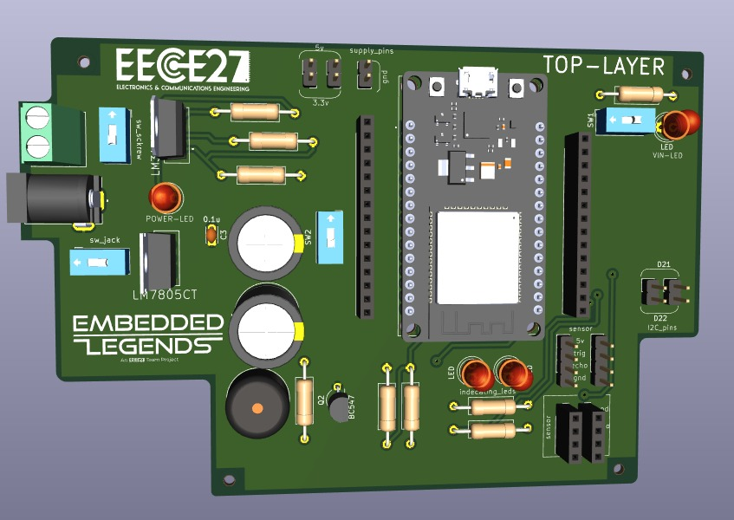
Figure 4 Prototype PCB with ESP32

The aquatic tanks function as the main habitat for cultured fish while the water filtration system operates to preserve water quality through removal of debris and oxygen level management. The pipeline system enables water to move efficiently between fish tanks and filtration units. The system integrates plant cultivation to enable aquaponic practices which use fish waste as a natural fertilizer for plant growth. The system controls lighting to support both fish and plant growth and uses a water pump to control fluid movement and maintain system stability. The system achieves sustainable fish farming through the integrated operation of its components.

For real-time control and monitoring of this process, two ESP32 microcontrollers are utilized. The first ESP32 is utilized for sensor parameter detection data acquisition such as water temperature, pH, and oxygen level. The second ESP32 is utilized for control and communication such as data uploading to a cloud server and downloading a remote smart phone application control command. This setup of two microcontrollers allows for real-time remote control and secure data acquisition, which permits users to make the correct decision and act on any irregularity in the aquaculture condition in real time.

Algorithm for System Monitoring

The system employs a pre-programmed algorithm which takes sensor readings as an input and triggers the required action based on pre-programmed threshold values. The algorithm, as presented in fig 5_{[2]}, keeps on monitoring real-time sensor readings and makes required modifications to the control system.
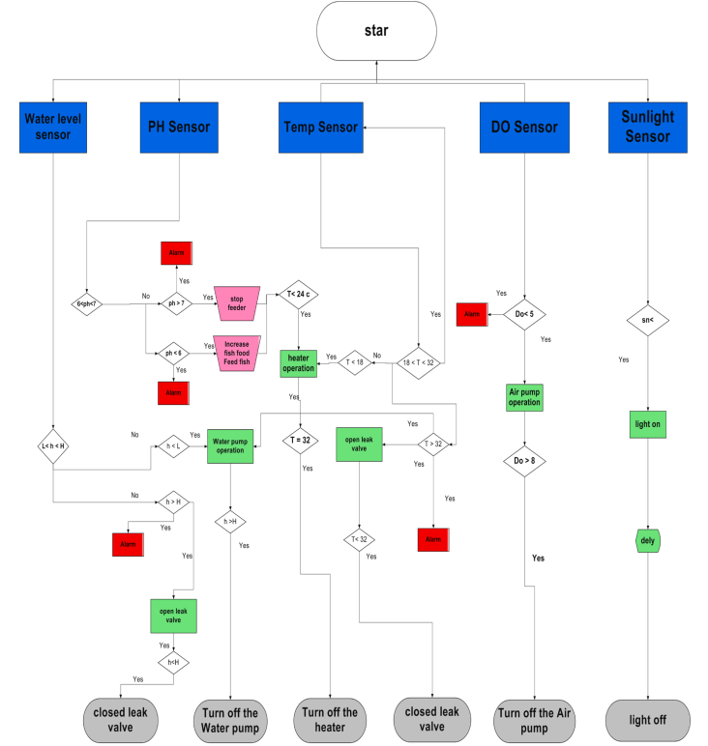
Fig 5 Flow Chart for the System

The algorithm operates as follows:
- Read Sensor Data – It takes input from temperature, pH, DO, water level, and sunlight sensors.
- Threshold Comparison – Compares values rising or falling below set thresholds (e.g., T > 32°C, DO > 8 mg/L).
- Triggers Control Actions – Upon a parameter reaching its critical value, control actions such as the start of operation of aerators, water pumps, or shading systems are initiated.
- Data Log and Alert System – Stores all the readings to be analyzed and sends alerts in the event of anomalies.

Adaptive AI-Based Optimization

We use basic threshold-based control systems, but our extension introduces an AI-based adaptive control to dynamically adjust threshold levels based on environment conditions and trend histories.

- The AI model analyzes past sensor readings for correlations and trends.
- Instead of using constant limits (e.g., T > 32°C, DO > 8 mg/L), the AI adjusts them based on external inputs such as weather outlooks, phases of fish growth, and seasons.
- This optimization maximizes water quality, reduces energy consumption, and improves fish health by keeping the parameters within an optimal range rather than fixed pre-set values.

CONCLUSION
Application of IoT technology to Egypt's aquaculture industry is a new idea of water quality management, being environment conserving, and an environmental guardian. The process here demonstrates the worth of real-time monitoring, automated control, and machine learning analysis in fish farm productivity, enhancement of fish health, and cost reduction. The AquaVision demonstrator demonstrates the potential for sensor networks and cloud computing to work towards delivering data-driven decision-making, ideal farming conditions with maximum possible resource utilization.
Despite advancements, large application of IoT in aquaculture is constrained by the demands of start-up capital-expenditure investment, cyberattacks, and technical expertise. It will increase use of the technology in solving the above challenges through cost-saving methods, enhanced security mechanisms, and farmers' capacity building. Egypt's aquaculture fishery sector can increase productivity, sustainability, and profitability through the utilization of IoT, the path to a robust and evidence-based aquaculture
ACKNOWLEDGEMENT
I also want to extend my sincerest thanks to Dr. Samah El-Shafiey for her valuable comments, suggestions, and constant facilitation in this research. Her experience and knowledge that date back for decades have played a very significant role in guiding this study. I am much indebted to her for guidance on boundary demarcation in research and for literature support that was instrumental in crafting the postulates of this study.

REFERENCES
- M.A.H. bin Zamnuri, S. Qiu, M.A.A. bin Rizalmy, W. He, S. Yusoff, K.A. Roeroe, J. Du, and K.-H. Loh, "Integration of IoT in Small-Scale Aquaponics to Enhance Efficiency and Profitability: A Systematic Review," Animals, vol. 14, no. 17, pp. 2555, 2024.

- M.M.M. Mahmoud, R. Darwish, and A.M. Bassiuny, "Development of an Economic Smart Aquaponic System Based on IoT," Journal of Engineering Research, vol. 12, no. 4, pp. 886-894, 2024.

- R. Basso-Sartori, “Current status of the microalgae application in agriculture and aquaculture,” [accessed 22 Mar 2025].

- D. N. Purnamasari, I. R. Dhani, D. T. Laksono, M. Ulum, M. Hardiwansyah, and R. Alfita, "Enhancing Tilapia Fish Farming Through IoT-driven Monitoring and Automatic Feeding Technology," in Proceedings of the IEEE International Conference on Information Technology and Information Systems (ITIS), Oct. 2023.

- Karim et al, “IoT-Based Smart Fish Farming Aquaculture Monitoring System,” Apr. 2021.

- Kannan, Anne Dashini, et al. "Improving Fish Quality and Yield: An Automated Monitoring System for Intensive Aquaculture." Malaysian Journal of Science and Advanced Technology (2024).

- P. Gade, M. Vaidya, D. Jaiswal, A. Titarmare, and R. Bambodkar, "Design of Automated Fish Feeder Using IoT," International Journal for Research in Applied Science and Engineering Technology, vol. 11, no. 6, pp. 715–718, 2023.

- M. I. H. Bhuiyan, T. T. Mishuk, M. M. Islam, and M. S. Hossain, “IoT-Based Smart Monitoring and Management System for Fish Farming,” Bulletin of Electrical Engineering and Informatics, vol. 11, no. 6, pp. 3183–3191, Dec. 2022. [Online]. Available: https://journal.beei.org/index.php/EEI/article/view/3365.

- J. R. Mugisha, A. Ndagijimana, and C. Mugisha, “IoT Monitoring Systems in Fish Farming: Case Study of University of Rwanda Fish Farming and Research Station (UR-FFRs),” European Journal of Technology, vol. 6, no. 1, pp. 12–25, 2023. [Online]. Available: https://ajpojournals.org/journals/index.php/EJT/article/view/1559.

